|  |  |  |  |  |  |  |
| --- | --- | --- | --- | --- | --- | --- |
| **Case** | **Test 1 score** | **Test 2 score** | **Test 3 score** | **Total score** | **Average** | **Prediction** |
| **1** | 50 | 60 | 80 | 190 | 63.3 | It’ll calculate it correctly |
| **2** | 200 | 190 | 3000 | 3390 | 1130 | It’ll give me an error |
| **3** | 10 | 12 | 30 | 60 | 20 | It’ll calculate correctly |

Test 1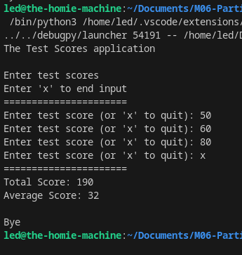

Test 2

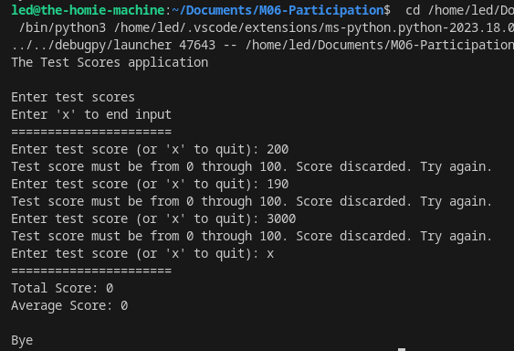

Test 3 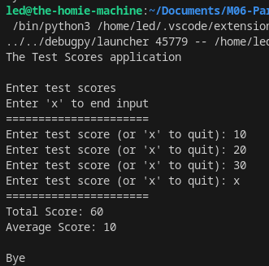  
  
  
  
  
  
  
  
  
  
  
  
  
  
  
  
  
  
  
  
  
  
  
  
----- Results AFTER debugging -------  
  
Test 1 and Test 2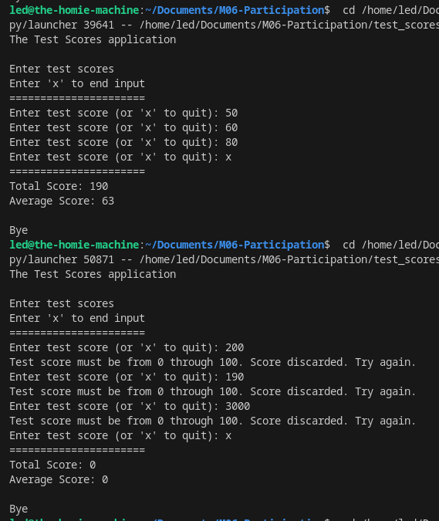  
  
  
  
  
Test 3   
  
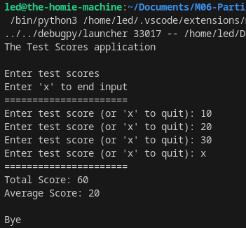  
  
  
  
  
  
  
  
  
  
  
  
  
  
  
  
  
  
  
  
  
  
  
  
  
  
  
  
  
  
  
  
  
  
  
  
  
  
  
  
  
  
  
  
**Part 2 – M06**

