Case | Test 1 score | Test 2 score | Test 3 score | Total score | Average | Prediction
1 | 50 | 60 | 80 | 190 | 63.3 | It’ll calculate it correctly
2 | 200 | 190 | 3000 | 3390 | 1130 | It’ll give me an error
3 | 10 | 12 | 30 | 60 | 20 | It’ll calculate correctly

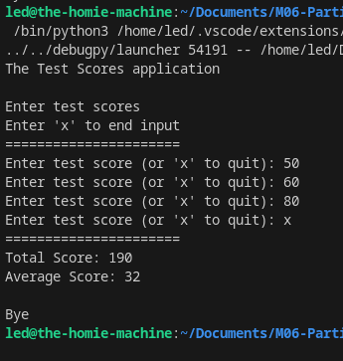
Test 1

Test 2
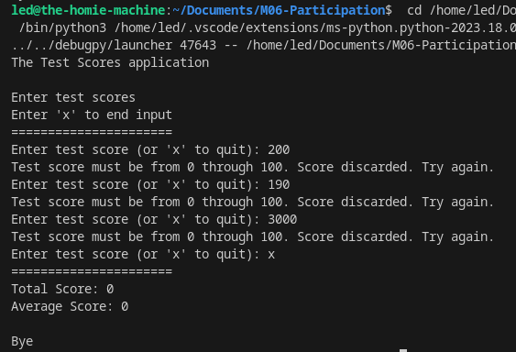

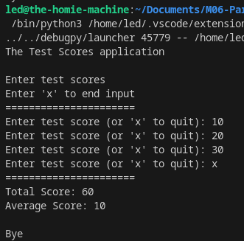
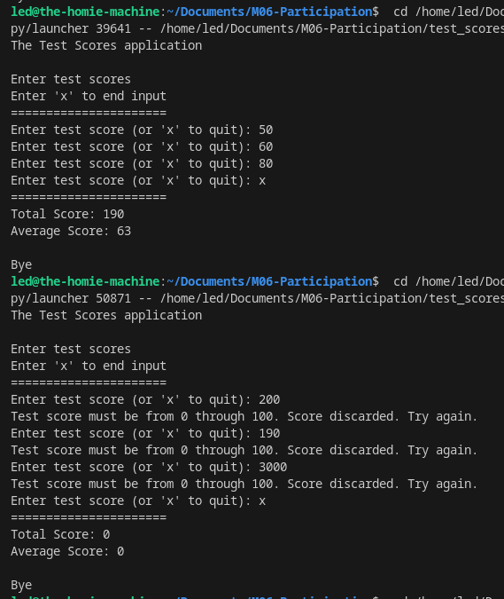
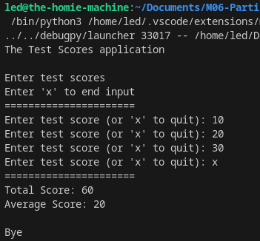
Test 3
----- Results AFTER debugging -------
Test 1 and Test 2
Test 3
Part 2 – M06

