Check-In Crew
Moderator usage guide
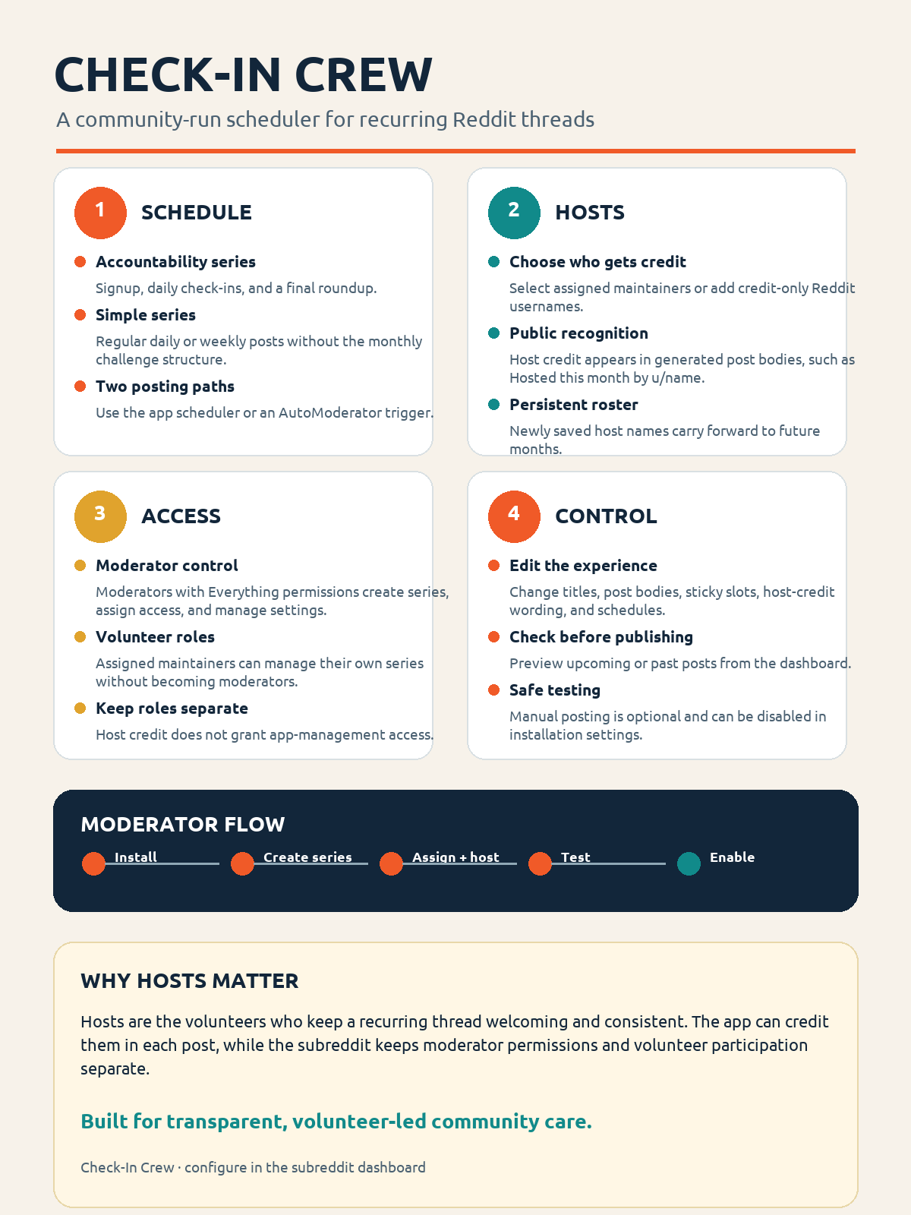
A practical guide for setting up recurring community threads, sharing volunteer credit, and keeping control with the subreddit team.

What Check-In Crew does
Check-In Crew creates and manages recurring Reddit text posts for a subreddit. It is designed for volunteer-run accountability threads, but it can also run ordinary daily or weekly discussion series.
- Accountability series: a signup thread on Day 1, daily check-ins, and a roundup on the final calendar day.
- Simple series: one regular post on a daily or weekly cadence, without signup and roundup behavior.
- Posting paths: the app scheduler or an AutoModerator trigger.
- Dashboard controls: pause and resume, upcoming schedule, post previews, title and body editing, sticky placement, host credit, and optional manual publishing.
The community application model
Moderators own the installation and its settings. Volunteers can be assigned to a series without being made subreddit moderators. Host credit is public recognition in a post body; it is separate from permission to manage the app.

Roles and permissions

Moderators with Everything permissions
- Create and remove series.
- Choose scheduler or AutoModerator mode.
- Assign and revoke maintainer access.
- Set posting times, time zones, series type, frequency, weekday, sticky slots, templates, and host credit.
- Assign hosts and add credit-only Reddit usernames.

Assigned maintainers
- See and manage the series they are assigned to.
- Change that series' schedule and paused state.
- Preview posts and publish today's post when manual posting is enabled.
- They cannot grant access, edit another series, or change installation settings.

Hosts
A host is the volunteer or Reddit account credited for keeping a recurring thread welcoming and consistent. Hosts can be selected from assigned maintainers, or added as credit-only usernames. Credit-only hosts receive public attribution in generated posts but do not receive Check-In Crew access.
Newly saved host names become the series' default roster and carry forward to future months. A monthly assignment can override the roster. To remove someone, open Show/add hosts, uncheck the maintainer or delete the credit-only username, then save. Clear all hosts creates a generic volunteer-team credit.

Initial setup
- Install Check-In Crew in the target subreddit and open the subreddit app settings.
- Review the default title formats, post-body templates, host-credit format, and footer setting.
- Leave Allow manual posting of posts disabled for normal operation. Enable it only when moderators want a Publish today or Publish now action for testing or recovery.
- Open the Check-In Crew dashboard and create the series.
- Choose Accountability challenge or Simple scheduled posts. For a simple series, choose Daily or Weekly and select the weekly posting day.
- Set the time zone and posting time. Use a time in the series' local time zone.
- Assign maintainers through the access control, then assign hosts through Show/add hosts.
- Preview a post, check the generated title and body, and leave the series paused until the team is ready.
- Resume the series when the schedule is approved.

Installation settings
Setting | Purpose
Allow manual posting of posts | Controls only manual Publish today / Publish now actions. It does not affect automatic scheduler or AutoModerator posting. When disabled, the publish action is hidden and stale publish requests are rejected.
Show the Check-In Crew footer in posts | Adds or removes the optional Scheduled with Check-In Crew. footer. It does not change scheduling, templates, or host credit.
Default post bodies | Installation-wide starting templates. A series can override them in the dashboard.
Default title formats | Installation-wide starting title formats. A series can override them in the dashboard.
Default host credit format | Installation-wide starting wording for host attribution. Use {hosts}, {series}, and {month}.
Manual posting setting check
After changing the setting, refresh or reopen the dashboard. The dashboard reports whether manual posting is enabled. Automatic scheduled posting should continue either way. If Publish today still appears after a fresh dashboard load, upload the updated app version and verify that the setting was changed for the current subreddit installation.

Daily moderator workflow
- Open the dashboard and select the month you want to review.
- Expand a series to see its schedule. Dates in the past show Posted or Not posted; future dates show Scheduled.
- Use Preview to check the final title and body before a new series starts.
- Use Pause selected or Resume selected for a temporary stop or restart.
- Use Show/add hosts in the Host credit section to update the persistent host roster.
- Use Publish today only when manual posting is enabled and a moderator has intentionally chosen to create the post immediately.
The dashboard is the clearest place to review the live schedule. The native Check-In Crew menu remains available as a fallback for access management, host credits, previews, history, and recovery.

Templates and host credit
Post-body and title formats are installation defaults until a series overrides them. Accountability series expose signup, daily, and roundup templates. Simple series use the regular daily template and title for their recurring post.
Supported body placeholders include {month}, {day}, {series}, {host_credit}, {community_note}, {signup_link}, and {previous_link}. Title formats support {month}, {day}, and {series}. Host-credit formats support {hosts}, {series}, and {month}.
Host credit example
Hosted this month by {hosts}. becomes Hosted this month by u/Volunteer and u/CoHost. Credit-only usernames can be named even when they do not have app-management access.

AutoModerator mode
AutoModerator mode uses a scheduled text post as a trigger. Configure an exact title such as [check-in-crew:eu]. The app verifies the canonical author, subreddit, marker, and local creation date before publishing the configured series threads. It removes the trigger only after every required post has been recorded successfully.
For a weekly simple series, schedule the trigger on the configured weekly day. A trigger on another day is ignored and remains in place.

Testing and recovery
- Enable manual posting only for a deliberate test or recovery window, then disable it again.
- Use Preview before publishing. Publishing is limited to today's date in the series time zone.
- The app reserves each series/date/thread slot so scheduler, manual, and AutoModerator attempts do not create duplicates.
- Pending or uncertain attempts are not blindly retried. Check Reddit and publication history first.
- Already-published posts keep their original host credit and body, even if settings change later.

Suggested rollout checklist
- ☐ Choose one test subreddit and one test series.
- ☐ Assign one moderator administrator and one volunteer maintainer.
- ☐ Add a host and confirm the host credit appears in Preview.
- ☐ Test a daily or weekly simple series if the subreddit needs ordinary recurring threads.
- ☐ Confirm the two sticky slots are used intentionally.
- ☐ Test manual posting with the setting enabled, then disable it and confirm Publish today disappears after refresh.
- ☐ Run one automatic scheduled or AutoModerator cycle before enabling the main series.

Check-In Crew - moderator guide

