Singapore Private Property Transaction Pipeline
  - An end-to-end ELT pipeline, data-quality framework and descriptive analysis of 170,224 URA private residential transactions

Group 5 · Module 2 Assignment
Members: Adelene Soh, JenHo, Siew Yin

1. Executive summary
We built an end-to-end ELT pipeline that transforms 19 raw URA CSV exports into a queryable star schema in Google BigQuery, checks data quality with dbt and Great Expectations, and analyses the resulting data in Python. The report brings together the pipeline design, validation results and four descriptive analyses.
What was built | Result
Rows carried end to end, source files to fact table | 170,224 — unchanged at every stage
Warehouse models (dbt) | 4 — one staging, two dimensions, one fact
dbt data tests | 20, all passing (PASS=24 SKIP=0 TOTAL=24, including the 4 models)
Great Expectations expectations | 15 — 12 pass, 3 fail by design
Python analyses | 4, each reported as a chart in section 7
Period covered | 1 April 2013 – 17 April 2022 (109 consecutive months, no gaps)
Table 1 — Pipeline scale and validation summary
Three findings stand out.
- Median price per square foot increased by 74% from the July 2015 trough (S$1,044) to April 2022 (S$1,813). Monthly transaction volume did not follow the same pattern and peaked at 3,662 transactions in March 2018.
- Regional differences are substantial in this dataset: the Central Region's median of S$1,689 per sq ft is 1.59 times the North Region's S$1,065. This is the largest gap among the attributes compared in this analysis.
- Transactions with an HDB address indicator had a median total price of S$1,100,260, compared with S$1,420,000 for the private-address group. The difference was narrower on a price-per-square-foot basis (S$1,327 versus S$1,452), alongside a smaller median unit size for the HDB-address group. These are group-level associations, not evidence of individual buyer motivations.

2. Dataset and scope

2.1 Dataset
This project uses private residential property transaction records published by the Urban Redevelopment Authority (URA) of Singapore, spanning 1 April 2013 to 17 April 2022

2.2 What the raw data looks like
All 21 source columns arrive as text. Prices carry thousands separators ("1,350,000"), missing numerics are a literal hyphen, dates are formatted "17 Apr 2022", and one column mixes three different kinds of value. Loading this with type inference would silently discard values, so the pipeline loads everything as text and does all casting in SQL, where the logic is visible, reviewable and testable.
Column | What arrives | Rows | How the pipeline handles it
transacted_price | "1,350,000" with separators | 170,224 | strip non-numeric, SAFE_CAST to NUMERIC
sale_date | "17 Apr 2022" | 170,224 | SAFE.PARSE_DATE('%d %b %Y', …)
nett_price | literal "-" when not published | 169,291 null | NULLIF(…, '-') then SAFE_CAST
completion_date | a 4-digit year | 87,301 | kept as text, trimmed only (no case change)
completion_date | the literal "Uncompleted" | 81,453 | kept as text
completion_date | the literal "-" | 1,470 | kept as text, not nulled
Table 2 — The cleaning problems that drove the staging design. Counts measured across all 19 raw CSV files.

3. Architecture
The pipeline runs in three stages. The architectural point worth noticing is where each stage executes: only dbt's SQL runs inside BigQuery. dbt itself, Meltano, Great Expectations and the analysis notebook all run on the analyst's machine — dbt compiles SQL and sends it to the warehouse, so no data is pulled down to transform it.
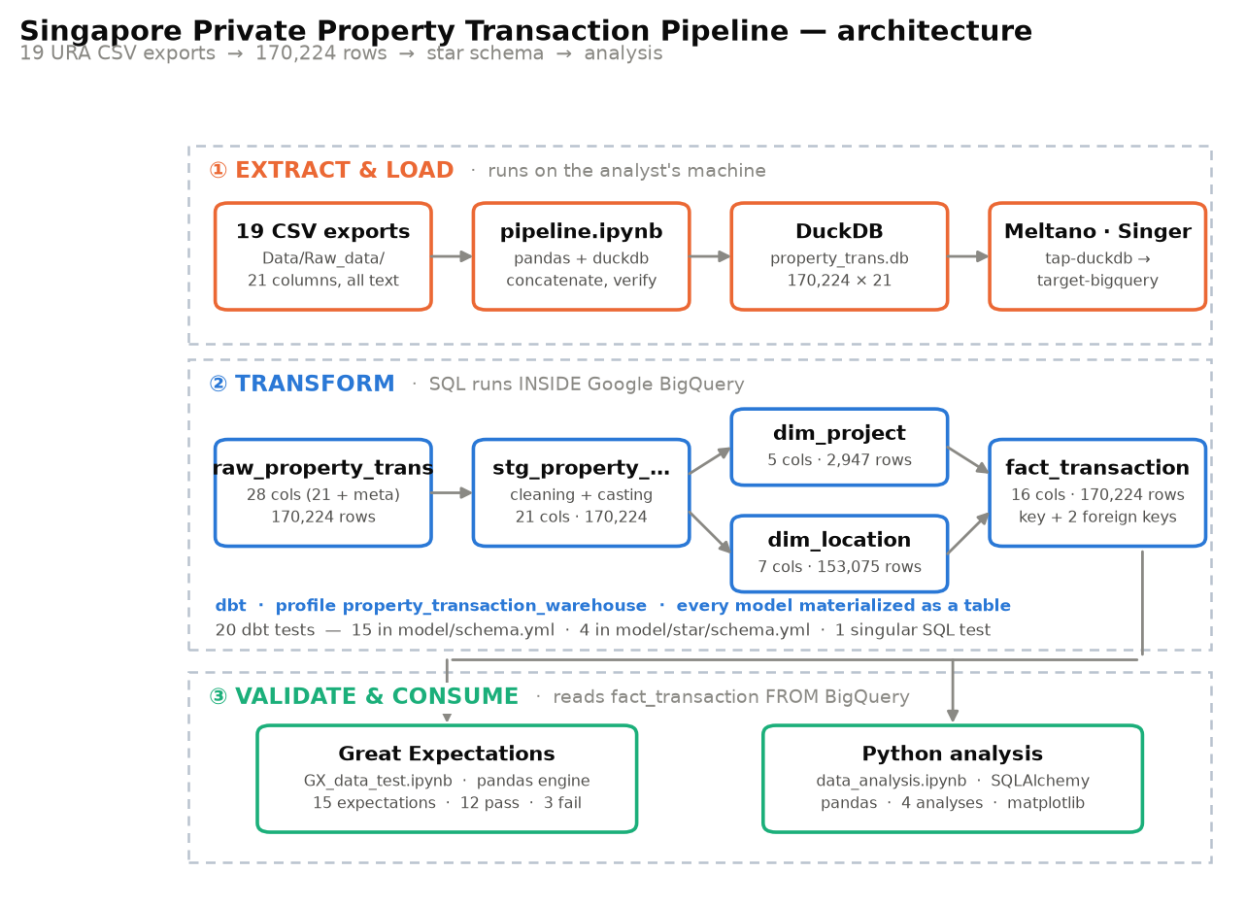
Figure 1. Pipeline architecture. Orange indicates local execution, blue indicates execution inside BigQuery, and green indicates data read back from the warehouse.

3.1 Tools used
Stage | Tools used | Considered instead | Why the choice
Local staging | DuckDB | a combined CSV or Parquet file; loading the 19 CSVs straight to BigQuery | pandas concatenates the files; DuckDB persists the result as a single durable table that stage 1b can read, and lets the row count be verified with one SQL query before anything leaves the machine. A flat file would give no way to query it; going straight to BigQuery would put unverified data in the warehouse.
Load | Meltano (tap-duckdb → target-bigquery) | a hand-written Python loader | The Singer spec gives a verifiable record count at the boundary; the alternative would have to re-implement batching and schema mapping.
Transform | dbt | raw SQL scripts; stored procedures | Lineage is inferred from ref() and source() rather than declared, and tests live beside the models they test. dbt build also interleaves models and tests, so a model whose tests fail does not pass bad data to its children.
Warehouse | Google BigQuery | staying in DuckDB; PostgreSQL | Separates storage from the analyst's laptop and gives a realistic cloud target.
Quality | Great Expectations + dbt tests | dbt tests alone | dbt's four built-in tests cover sets, nulls, uniqueness and referential integrity. Numeric ranges and comparisons between two columns need hand-written SQL in dbt — Section 6.2 quantifies how many such rules GX supplies instead.
Analysis | SQLAlchemy + pandas + matplotlib | SQL alone | The four analyses end in charts, which SQL cannot produce; notebooks also keep the reasoning beside the pipeline in the same repository.
Table 3 — Tools used

4. Data warehouse design

4.1 The star schema
One fact table carries the measures; two dimensions carry the descriptive attributes. The grain of the fact table is one row per source transaction — the same 170,224 rows that entered the pipeline.
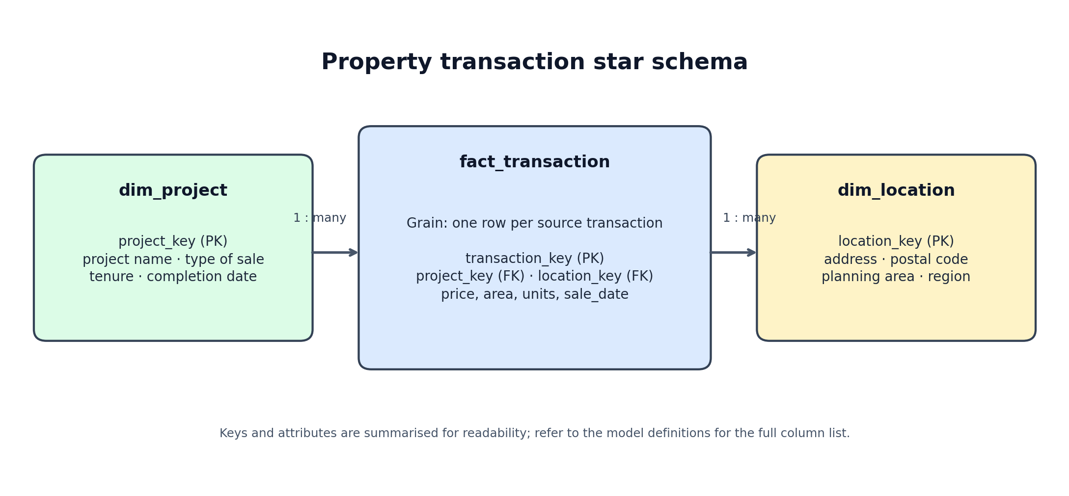
Table | Type | Grain — one row per… | Columns | Rows
fact_transaction | Fact | source transaction | 16 | 170,224
dim_project | Dimension | distinct project + type + tenure + completion_date | 5 | 2,947
dim_location | Dimension | distinct address + postal + planning area | 7 | 153,075
stg_property_transactions | Staging | source transaction (cleaned, typed) | 21 | 170,224
raw_property_trans | Raw landing | source transaction (all text) | 21 | 170,224
Figure 2. Star-schema overview. The fact table joins to the project and location dimensions through surrogate keys.

4.2 Why a star schema, and how it supports querying
The design supports the analysis in Section 7 in three practical ways.
- Every analytical question becomes one join, never a chain. "Median price per square foot by planning region" is fact → dim_location and nothing else. A normalised design would route the same question through a project → address → postal code → planning area chain.
- The dimensions are small enough to broadcast. dim_project is 2,947 rows against a 170,224-row fact table, so BigQuery can hold it in memory on every worker rather than shuffling the fact table across the cluster.
- Descriptive text is stored once per distinct combination, not once per transaction. The project name "Treasure At Tampines" is stored once in dim_project, not repeated across its 2,208 transactions.
The surrogate keys are generated with FARM_FINGERPRINT over the dimension's natural key combination. This matters because the natural keys are not unique on their own: of the 2,947 project rows, several project names carry more than one completion date, so project name alone would fan the fact table out and inflate every sum. Both dimension keys carry not_null and unique tests precisely to catch that.

5. The ELT pipeline, stage by stage

5.1 Ingestion — 1a_data_ingestion/notebook/pipeline.ipynb
Reads all 19 CSVs from Data/Raw_data/, detecting encoding per file (UTF-8 with a cp1252 fallback — the files contain non-breaking spaces that break a strict UTF-8 read), concatenates them, and writes a single DuckDB table. The notebook then reopens the database read-only and asserts that the persisted row count matches what was ingested.

5.2 Extract and load — 1b_data_extraction/meltano.yml
Meltano moves the DuckDB table to BigQuery using tap-duckdb and target-bigquery, landing it as raw_property_trans. Every column lands as a string. This is deliberate: type inference at the loader would turn "987,000" into a null and leave no record of what was there. Loading as text and casting in SQL means nothing is lost in transit, and the cleaning rules appear in version control where they can be reviewed and tested.

5.3 Transform — the staging model
stg_property_transactions applies one cleaning rule per column and nothing else. It does not filter rows, so it is a faithful typed copy of the source: 170,224 rows in, 170,224 out.
Rule | Applied to | What it fixes
SAFE_CAST after stripping non-numerics | 7 price and area columns | Thousands separators; a failed cast yields null instead of aborting the build
SAFE.PARSE_DATE('%d %b %Y', …) | sale_date | Text dates; an unparseable date yields null rather than a wrong date
NULLIF(TRIM(x), '-') | numeric columns | The hyphen used as a not-applicable marker
UPPER(TRIM(x)) | 9 text columns | Mixed case and padding, so joins and GROUP BY behave
REGEXP_REPLACE(…, r'\s+', ' ') | project_name, address | Repeated and non-breaking whitespace inside names
Table 4 — Staging cleaning rules. Every rule is SQL in the repository, not a notebook step.

5.4 Derived columns
The fact table builds three, each serving a purpose the source cannot.
Derived column | Definition | Why it exists
transaction_key | FARM_FINGERPRINT over all 21 attributes plus a row number | The source has no transaction identifier. Identical-looking rows are real repeat sales, so a row number is appended to keep the key unique without deleting data.
new_trans_price | area_sqft × unit_price_psf | Rebuilds the price from URA's own published components, so the two can be compared.
percentage_difference | (new_trans_price − transacted_price) ÷ transacted_price | Measures how far the rebuilt price sits from the published price. Drives quality check C.
Table 5 — Derived columns in fact_transaction.

6. Data quality testing
Quality is tested twice, in two different places, by two different tools. dbt tests the tables inside BigQuery as they are built. Great Expectations tests the pandas dataframe the analysis actually reads, after the data has left the warehouse.

6.1 dbt — 20 tests, run by dbt build
Test type | Uses | Applied to | Category in the brief
unique | 3 | transaction_key, project_key, location_key | duplicates
not_null | 10 | the same three keys, plus 7 cast columns in staging | null values
relationships | 2 | fact → dim_project, fact → dim_location | referential integrity
accepted_values | 4 | type_of_sale, property_type, planning_region, purchaser_address_indicator | business logic
custom SQL test | 1 | all 7 measures must be greater than zero | business logic
Table 6 — The 20 dbt tests
We use dbt build rather than dbt run precisely because it interleaves models and tests in dependency order. A model whose tests fail does not pass its rows to the models downstream — they are skipped instead. SKIP=0 in that summary therefore means something: nothing was quietly bypassed.

6.2 Great Expectations — 15 expectations on the fact table
The GX suite runs on the pandas dataframe loaded out of BigQuery, not on the warehouse table. That makes it a genuinely independent second opinion: it checks what the analyst actually holds in memory. Of its 15 expectations, 9 restate a rule dbt already enforces and 6 state something dbt cannot.
Expectation | Field and condition | Relationship to dbt | Result
BeBetween ×1 | number_of_units = 1 | adds | FAIL · 180 rows
BeBetween ×1 | transacted_price ≤ S$75,000,000 | adds | FAIL · 72 rows
BeBetween ×1 | percentage_difference within ±2.5% | adds | FAIL · 202 rows
BeBetween > 0 ×8 | the 7 measures in the custom SQL test, plus new_trans_price | 7 repeat · 1 adds | pass
NotBeNull ×1 | sale_date — dbt tests this in staging only | adds | pass
NotBeNull ×1 | transaction_key | repeats dbt | pass
BeUnique ×1 | transaction_key | repeats dbt | pass
ColumnToExist ×1 | transaction_key | adds | pass
Table 7 — All 15 expectations: 12 pass, 3 failed
What dbt's four built-in tests cannot express is a numeric range or a comparison between two columns. That is the entire reason Great Expectations is in the stack, and the table above quantifies it: 6 of the 15 expectations are rules we would otherwise have had to hand-write as custom SQL.

6.3 What the three failures mean
The three failing Great Expectations checks were designed to investigate different aspects of the transaction data. Rather than treating every failure as a data error, we use the checks to identify transactions that require further review and to understand whether the results are consistent with the characteristics of the dataset.
Check A — Number of units. The purpose is to identify transactions involving more than one unit. The expectation is written as number_of_units = 1, so it fails when a row records more than one unit. The 180 flagged rows can then be recognised in downstream analysis rather than being mistaken for ordinary single-unit purchases.
Check B — Transaction price above S$75 million. We use S$75 million as an assumed upper price threshold for a single residential unit. Transactions above this amount are flagged because they may represent bulk purchases. This is a screening assumption, not an absolute rule proving that a transaction is invalid or contains multiple units.
Check C — Price reconstruction within ±2.5%. We reconstruct the transaction price as area_sqft × unit_price_psf and compare it with transacted_price. The ±2.5% tolerance is used to flag differences that warrant investigation; it is an analytical tolerance, not an official URA standard. The 202 flagged rows remain unresolved because rounding unit_price_psf to whole dollars does not explain the observed differences.

Check and result | What it establishes | What it does not establish
A number_of_units = 1  FAIL · 180 rows | The check flags the 180 rows where more than one unit is recorded. This supports the analysis by distinguishing multi-unit transactions from single-unit transactions. These records may be legitimate bulk sales and are not automatically errors; their treatment depends on the analytical question. | That the rows are wrong. They are retained in the dataset, but should be identified when analysing typical single-unit prices or transaction values.
B transacted_price ≤ S$75,000,000  FAIL · 72 rows | S$75 million is used as an assumed upper price threshold for a single unit. The check flags 72 transactions above this amount for review. Of these, 71 also appear among the multi-unit transactions, suggesting that bulk sales explain most of the high-price flags. | That a flagged transaction is invalid or must involve multiple units. The threshold is a screening assumption, not proof. One flagged transaction was not identified as multi-unit and warrants further investigation.
C percentage_difference within ±2.5%  FAIL · 202 rows | This check compares transacted_price with the reconstructed price area_sqft × unit_price_psf. The ±2.5% tolerance flags records where the difference is large enough to warrant investigation. It identified 202 transactions outside the tolerance. Rounding unit_price_psf to whole dollars was investigated but was too small to explain the observed differences. | Why the differences occur. Both component values and the published price come from the source data, but the cause of the remaining discrepancies has not been established. The records are therefore reported as unresolved and raise for further investigation.
Table 8 — The three failing expectations. Each row separates what the evidence supports from what it does not.
These checks are screening mechanisms for understanding the data, not simply pass-or-fail rules. The multi-unit and high-price checks identify transactions that may need different treatment in particular analyses, while the price-reconstruction check highlights records requiring further investigation. We retain the source transactions and make the analytical treatment explicit rather than deleting records or changing thresholds solely to obtain passing results.

7. Analysis and findings
The analysis connects to BigQuery with SQLAlchemy, loads the fact and dimension tables into pandas, and joins them on the warehouse keys. Medians are used throughout rather than means: property prices are strongly right-skewed, and the 180 bulk rows in section 6.3 would distort every average.

7.1 Price and volume over time
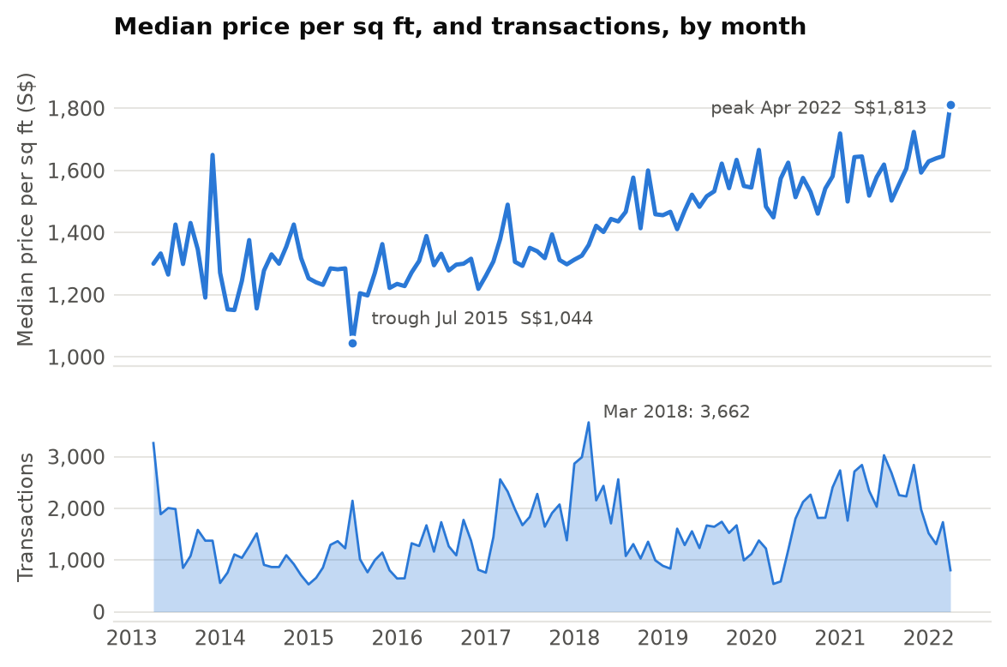
Figure 3. Monthly median price per sq ft (upper) and transaction count (lower). Both panels use the same time axis and separate y-axes.
Median price per square foot rose 74% from its July 2015 trough of S$1,044 to S$1,813 in April 2022. The rise is not smooth — there is a clear plateau through 2015 and 2016 and a sharp step up from mid-2017. April 2022 is a partial month because the source data ends on 17 April, so it should not be compared with complete months without that qualification.
The two panels do not show a consistent month-by-month relationship between transaction volume and median price per square foot. March 2018, the busiest month at 3,662 transactions, occurs in the middle of the observed price range rather than at its peak. The quietest months recorded 529 transactions. Note that April 2022 is a partial month because the source period ends on 17 April.

7.2 The most-traded projects
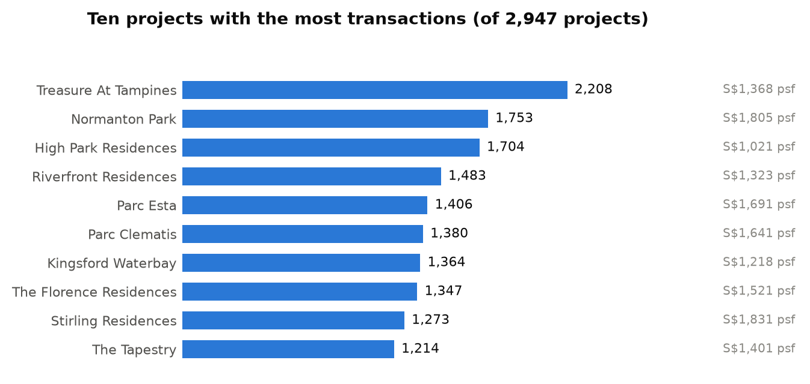
Figure 4. Ten projects ranked by recorded transaction count, with median price per sq ft shown for context. Transaction count is not a measure of desirability.
Treasure At Tampines leads with 2,208 transactions — 1.3% of the whole dataset by itself. All ten are large new launches, which is what the transaction count is really measuring: these are not the most desirable projects, they are the biggest ones, selling many units in a short window.
Reading count and price together is what makes the chart useful. High Park Residences records 1,704 transactions at a median of S$1,021 per sq ft, while Stirling Residences records 1,273 at S$1,831 — nearly double the price for a comparable volume. Volume and price per square foot are close to independent in this group.

7.3 Location
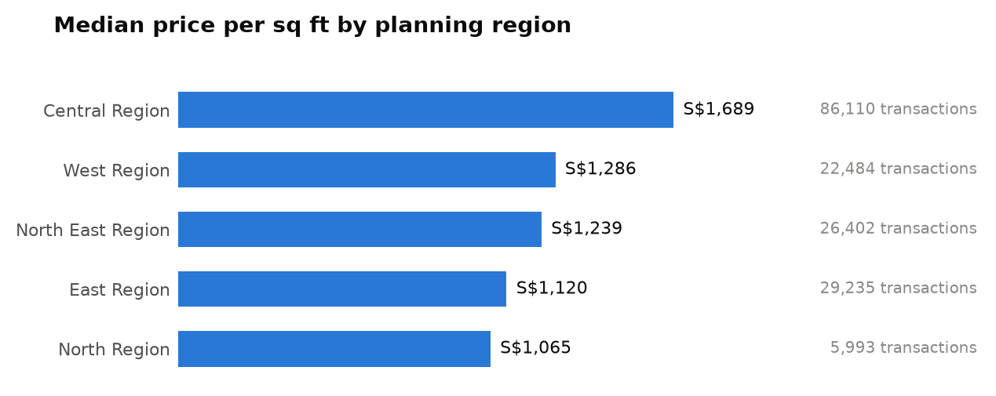
Figure 5. Median price per sq ft by planning region, with transaction counts. The five regions account for all 170,224 transactions.
Among the attributes compared in this analysis, region shows a substantial difference in median price per square foot. The Central Region's median of S$1,689 is 1.59 times the North Region's S$1,065. This is a descriptive comparison, not an estimate of the causal effect of location.
Volume and price again diverge. Central carries 86,110 transactions, more than half the market, at the highest price; North carries 5,993, the fewest, at the lowest. But East has more transactions than West (29,235 against 22,484) while being cheaper per square foot (S$1,120 against S$1,286), so the ranking by volume is not the ranking by price.

7.4 Buyer groups
The brief asks for customer segmentation by purchase behaviour. This dataset has no customer entity at all — URA publishes transactions, not buyers, and there is no identifier that persists across two sales. We therefore segment by purchaser_address_indicator, which records the kind of address the buyer gave: HDB, private, or not available. It is a proxy for buyer type, and we treat it as one.
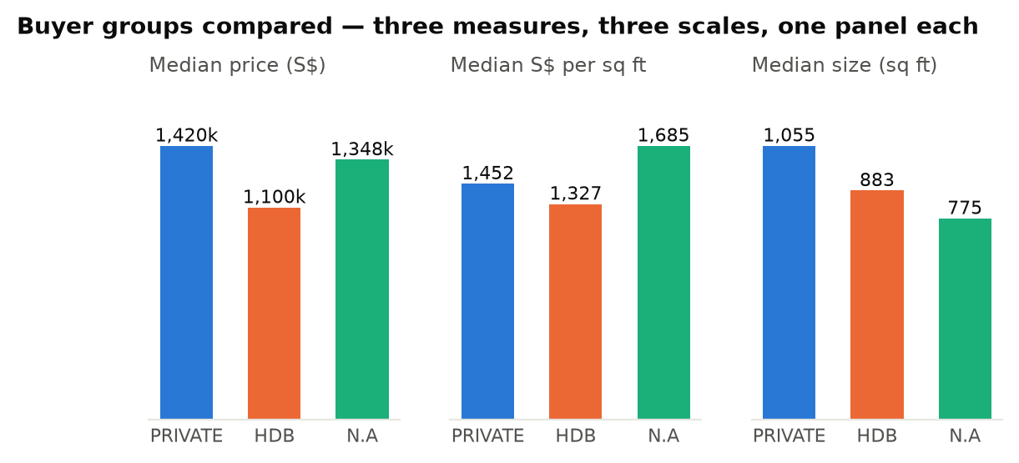
Figure 6. Three transaction measures across three recorded address groups, shown in separate panels because their units and scales differ.
The headline gap is smaller than it first appears. Buyers with an HDB address paid a median of S$1,100,260 against S$1,420,000 for buyers with a private address — a 23% gap in total price. But in price per square foot the gap narrows to 9% (S$1,327 against S$1,452), and the median home bought is 883 sq ft against 1,055. HDB-address buyers are mostly buying smaller homes, not materially cheaper space.
The N.A. group has the fewest transactions (12,782), the smallest median homes (775 sq ft), and the highest median price per square foot (S$1,685). These figures describe the recorded transactions only. The dataset does not identify buyer nationality, investment intent or the reasons for the observed price differences.

8. Repository map
Path | What it contains
Data/Raw_data/ | 19 URA CSV exports, unmodified
1a_data_ingestion/notebook/pipeline.ipynb | CSV → DuckDB, with a row-count assertion
1b_data_extraction/meltano.yml | tap-duckdb → target-bigquery configuration
2n3_data_transform/model/ | dbt staging model and fact table, with schema.yml tests
2n3_data_transform/model/star/ | dim_project, dim_location and their tests
2n3_data_transform/tests/ | The singular SQL test on the seven measures
4_data_quality_test_GX/GX_data_test.ipynb | The 15-expectation Great Expectations suite
5_data_analysis_pathon/data_analysis.ipynb | SQLAlchemy + pandas analysis behind section 7
Table 9 — Where each component lives

