Welcome to Campus!

ss
Whether you are anew student or a first- time visitor this guide helps you explore our most important campus spaces _where learning creativity, and connection come alive
CAMPUS SPACES GUIDE
- The courtyard oat tree is about 80 years old
- The studio hosts exhibition every semester
- The café serves locally roasted coffee
- The library offers 24/7 digital access
Fun Facts
s s
SHOPPING CENTER
HOSTELS

CAFFETRIA
FITNESS CLUB

LIBRARY
SPORTS COMPLEX

Explore the heart of our campus -spaces designed to inspired learning, creativity and community.
Simple Campus Plan
Here’s a simple map for you to find your relative space
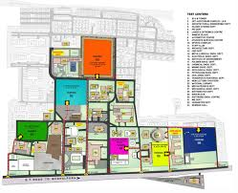

Campus Information Desk Main Building Ground Floor
+92 - 42-89029109
@uet.edu.pk

Contact Us

