Analysis on:
How Real Is Your Online Personality?

Submitted by:
- Zaineb 2025-CS-244
- Iqra Sarfraz 2025-CS-255
- Yumna bint e Akhtar 2025-CS-260
- Meerab Usman 2025-CS-275
- Ayesha Sarwar 2025-CS-281
Submitted to:
Ma’am Ramsha Khalid

Google Form Link:
https://forms.gle/TubWhbvsndXsFowf9
Contents
Introduction 3
Data Summary And Observations 4
Social media usage patterns 4
Analysis of most frequently used online platforms 5
Usage of Real Name and Photo on Online Platforms 6
Realness of Online Personality 7
Perceived Superiority: Online vs Real-Life Self 8
Confidence level 9
Findings and Discussions 10
Conclusion 11
Suggestions 12

Introduction
In today’s digital age, people often present versions of themselves online that may not fully reflect their real-life personalities. Social media platforms, online classrooms, and other digital communication tools make it easier than ever to create an “online identity” that can differ from face-to-face behavior. Understanding the authenticity of these online personalities has become an important area of study, as it reveals how people perceive themselves and interact with others in digital spaces.
This project explores how individuals view their own online personalities and how closely these identities correspond to their real selves. A survey was conducted using a Google Form to collect responses from participants regarding their behavior, confidence, emotional expression, and communication style in online environments. The survey aimed to capture a comprehensive understanding of how people present themselves digitally.
The purpose of this report is to analyze the collected responses, identify patterns, and determine whether people tend to be more confident, reserved, expressive, or behave differently when using digital platforms. Through this analysis, the study seeks to provide insight into the relationship between a person’s real-life identity and the version of themselves they present online, highlighting the similarities and differences between online and offline behaviors.

Data Summary And Observations

Social media usage patterns

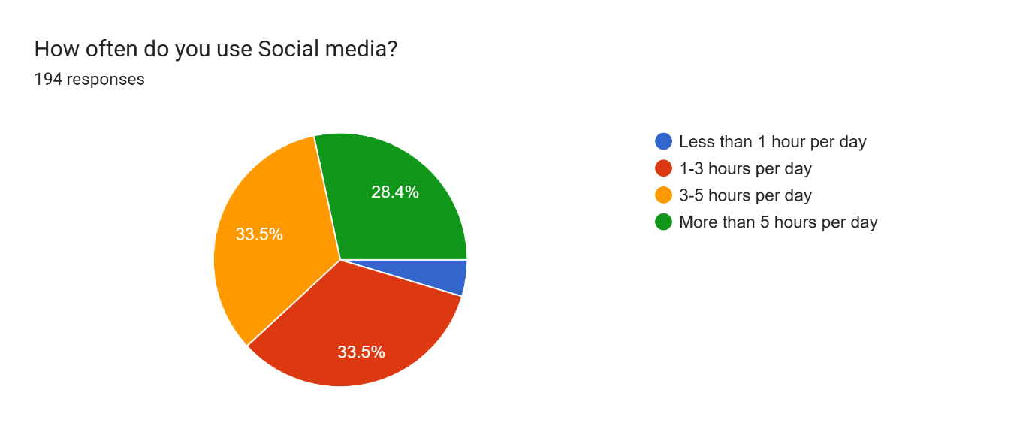

- The chart shows that most respondents spend a significant amount of time on social media. About 33.5% use it for 3–5 hours per day.
- Another 33.5% use social media for 1–3 hours daily, which means that together 67% of users spend more than one hour per day on social platforms.
- About 28.4% of respondents use social media for more than 5 hours per day, indicating a high level of daily usage among many individuals.
- Only a very small portion of users (blue section) spend less than 1 hour per day on social media, showing that low usage is uncommon.
- Overall, the trend suggests that the majority of participants are moderate to heavy users of social media, with very few using it minimally.

Analysis of most frequently used online platforms

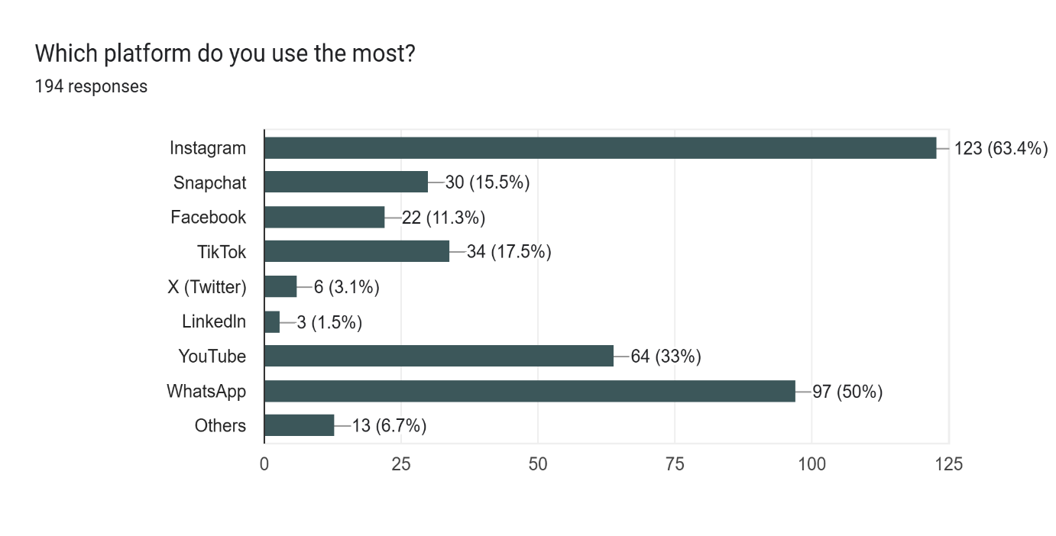

- Instagram is the most used platform, with 63.4% (123 respondents) choosing it, making it the dominant choice among all platforms.
- WhatsApp is the second most popular, used by 50% (97 respondents), showing that messaging apps are also widely preferred.
- YouTube ranks third, with 33% (64 respondents) indicating they use it the most, reflecting high interest in video content.
- TikTok is used by 17.5% (34 respondents), showing a moderate but noticeable user base.
- Snapchat (15.5%) and Facebook (11.3%) have smaller but still significant groups of users.
- X (Twitter) and LinkedIn are among the least used platforms, with only 3.1% and 1.5% of respondents respectively.
- A small percentage (6.7%) selected “Others”, indicating the presence of additional niche platforms.

Usage of Real Name and Photo on Online Platforms

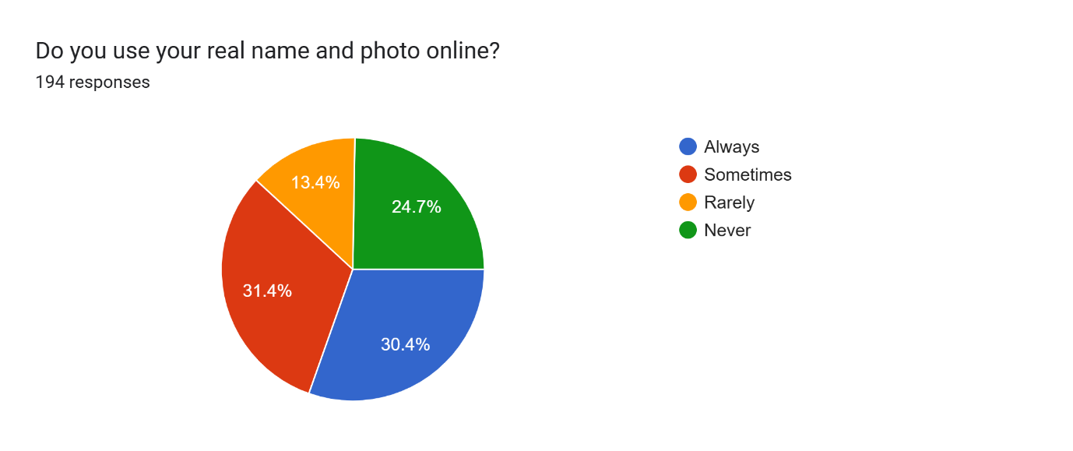

- The chart shows that a significant portion of respondents sometimes use their real name and photo online, with 31.4% choosing this option — the highest among all groups.
- About 30.4% of respondents always use their real name and photo, indicating a considerable number of users are comfortable sharing their identity online.
- 24.7% of participants never use their real name or photo, showing a noteworthy level of privacy-conscious behavior.
- Only 13.4% of respondents rarely share their real identity online, making it the smallest category.
- Overall, the data suggests a mixed trend, where many users share their identity at least sometimes, while a significant group also prefers to remain private.

Realness of Online Personality
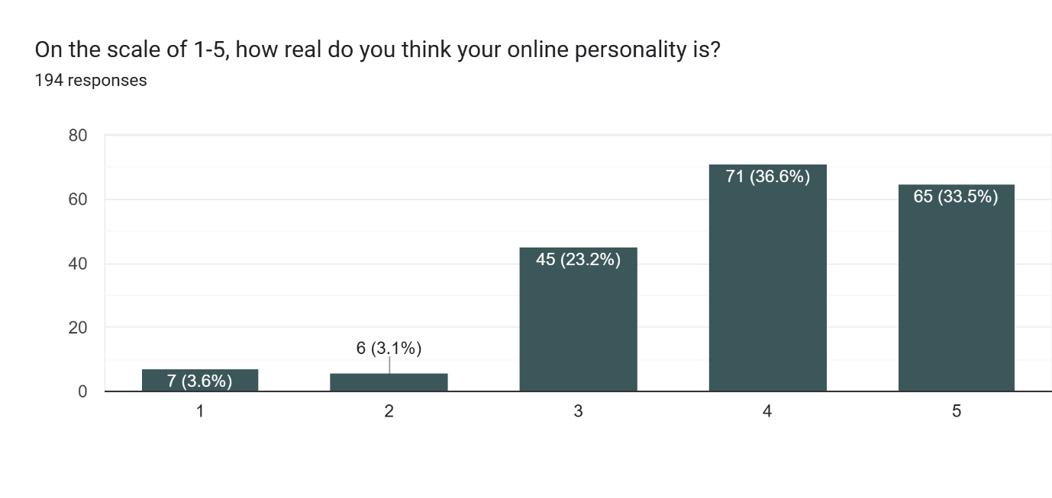
- Most people perceive their online personality as real: Over 70% of respondents selected scale 4 or 5, indicating they feel their online persona closely reflects their true self.
- Only a small minority see their online identity as fake: Just 6.7% chose scale 1 or 2, suggesting very few people view their online presence as inauthentic or misleading.
- About 23.2% of respondents chose the middle ground (scale 3): This suggests they see their online personality as partially real but not fully authentic — possibly a mix of genuine traits and curated behaviour.

Perceived Superiority: Online vs Real-Life Self
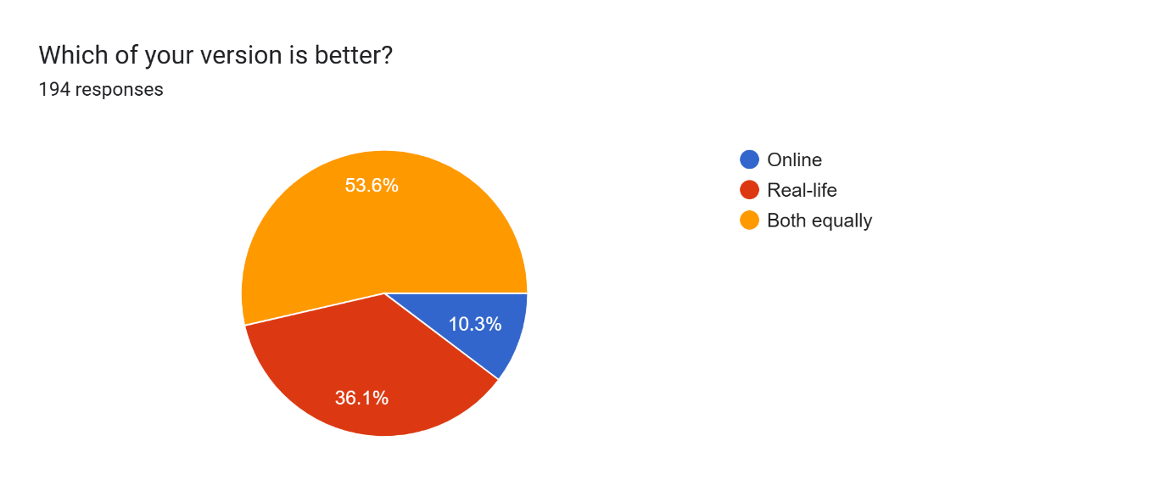

- Majority (53.6%) believe both versions are equally good: This reflects a balanced self-image, where people feel their online and offline personas complement each other.
- 36.1% prefer their real-life self: These individuals may feel more authentic, confident, or grounded in face-to-face interactions compared to digital spaces.
- Only 10.3% think their online version is better: This could indicate that a small group feels more expressive, creative, or socially successful online than in real life.
- Digital identity isn’t dominating real-life identity: Despite the rise of social media, most people still value their offline self — either equally or more.
- Self-perception leans toward integration, not replacement: The data suggests people don’t see their online self as a substitute, but rather as an extension of who they are.

Confidence level
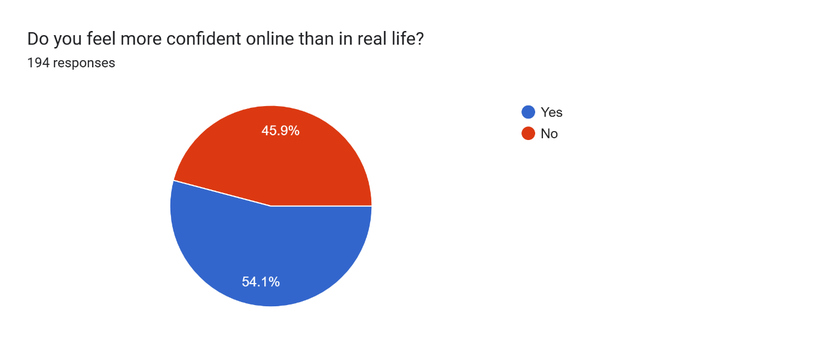

- This chart shows that 54.1 % of respondents are more confident online than in real life suggesting that digital spaces allow many individuals to express themselves more freely.
- However, 45.9% are those who do not feel like they are more confident online than in real life, indicating that a significant portion of people maintain similar confidence levels offline and online.

Findings and Discussions

Level of Authenticity:
The majority of participants do not behave 100% the same online as in real life. This indicates that online spaces allow selective self-presentation.
Confidence Factor:
The data suggests that online platforms give users a sense of safety, making them more confident and expressive. This aligns with psychology studies on the “online disinhibition effect.”
Level of equality:
Majority (53.6%) believe both versions are equally good. This reflects a balanced self-image, where people feel their online and offline personas complement each other.
Social Image Building:
Many respondents intentionally present a polished version of themselves (better photos, selective achievements). This shows that social platforms promote impression management.
Privacy Concerns:
Respondents worried about oversharing or negative comments, so they hide personal traits. This shows how social pressures shape online behaviour.
Generational Trend:
Young adults tend to adapt their personality according to the platform (Instagram, WhatsApp, TikTok). This indicates that online personality is flexible rather than fixed.

Conclusion

Overall, the findings of this study clearly highlight that online personalities do not fully represent an individual's real-life self. While certain aspects of a person’s genuine character do appear in digital interactions, they are often blended with modified or carefully crafted traits. Most participants admitted that they consciously or unconsciously adjust their behaviour, tone, and self-presentation when they communicate on social media or other online platforms. This adjustment may include exaggerating positive qualities, hiding flaws, or presenting a more confident, sociable, or interesting version of themselves than they display offline.
The online environment plays a significant role in shaping this behaviour. Digital spaces provide a sense of freedom, anonymity, and control that real-life interactions do not always offer. People are able to choose what to show and what to hide, which naturally leads to selective self-presentation. At the same time, online communities and platforms create new forms of social pressure. Users feel the need to fit in, gain approval, or avoid judgement, and these expectations influence how they behave and express themselves. As a result, online personality becomes a mixture of authenticity and performance.
Another important factor is privacy and safety. Many participants expressed that they intentionally filter their personality to protect personal information or avoid vulnerability. This need for caution encourages people to adopt a safer, more guarded online identity. Additionally, the desire to maintain a positive image or achieve specific goals—such as popularity, acceptance, or influence—also pushes individuals to enhance or polish their digital selves.
Therefore, the overall conclusion is that online personality is partially real but significantly shaped by platform norms, social expectations, privacy concerns, and self-image goals. It is neither completely fake nor completely authentic; rather, it exists as a dynamic combination of who people genuinely are and who they choose or aspire to be in the digital world. The study suggests that understanding this blended identity is essential for interpreting online behaviour and recognizing the complex relationship between technology and human self-expression.

Suggestions

- Users should be encouraged to present a more honest and genuine version of themselves when interacting online.
- It is important for students to maintain a balanced lifestyle by managing both online and offline interactions.
- Educational institutions should organize workshops, seminars, or awareness sessions to help students understand the impact of posting fake, exaggerated, or misleading content.
- Students should also be taught how to use privacy settings effectively to protect their personal information and build confidence in sharing authentic content.
- It is essential for individuals to avoid constant comparison with others on social media.
- By practicing mindful usage—such as questioning what they see, taking breaks from social media, and focusing on their own progress—users can maintain a healthier self-image and reduce the negative emotional effects of comparison.
- People should avoid using online spaces for validation , and instead focus on using social media for meaningful communication.
- Social media platforms should promote healthy digital behaviour by encouraging real interactions instead of algorithm-driven comparisons.

