Linear Regression on Ames House Prices: Pipeline and Findings
Codes: E = EDA figures, F = model figures, T = tables (attached under each step; same numbers as report.md). Generated by model/export_docx.py from model/results/.

1. Data and setup
- Chronological split from the team's preprocessing: train = 1,168 sales (2006-01..2009-07), test = 292 sales (2009-07..2010-07) (T1).
- Target is log1p(SalePrice); dollar metrics use expm1 of the prediction.
- Features: 290 in total = 48 original non-dummy + 225 one-hot + 17 engineered (T2).
- Log transform decided per fit: the team's rule (log1p if skewness > 0.75) is re-applied to raw values on each fold's training rows only, then applied unchanged to its validation rows (and to the test set for the final model).
- The team's preprocessing picks this list once on the whole training set (mapping/skewed_features.json); re-deciding it per fold keeps the choice from seeing the CV validation folds.
- Outlier removal, |r| feature ranking and the scaler are also fitted on each training fold only and applied unchanged to its validation fold.
- Ref: https://doi.org/10.1145/2382577.2382579
Split | Period | Houses | Median price ($k)
Train | 2006-01..2009-07 | 1168 | 165.0
Test | 2009-07..2010-07 | 292 | 157.9
Table 1: Chronological train / test split.
Feature group | Count | Examples
Original (non-dummy) | 48 | GrLivArea, OverallQual, YearBuilt
One-hot dummies | 225 | Neighborhood_…, SaleCondition_…
Engineered | 17 | TotalArea, HouseAge, Qual_x_Area
Greedy list (models/) | 96 | 91 original + 5 engineered
Total | 290
Table 2: Feature groups after pre-processing.
Fold | Train rows | Validation rows | Validation period
1 | 198 | 194 | 2006-07..2007-05
2 | 392 | 194 | 2007-05..2007-10
3 | 586 | 194 | 2007-10..2008-06
4 | 780 | 194 | 2008-06..2009-03
5 | 974 | 194 | 2009-03..2009-07
Table 3: Time-series cross-validation folds (expanding window) inside the training set.

2. Exploratory feature analysis (§4)
- Evidence (training set only)
- Raw price is right-skewed (skew 1.92); log1p reduces it to 0.16, so the model predicts log price (E1).
- By Cohen's bands, 24 features have large |r| (≥ 0.5), 31 medium, 75 small and 160 negligible (E2, T4).
- Ref: https://www.taylorfrancis.com/books/mono/10.4324/9780203771587/statistical-power-analysis-behavioral-sciences-jacob-cohen
- Strongest: Qual_x_Area (r = 0.85), OverallQual (r = 0.82), TotalArea (r = 0.81); 4 of the top 10 are engineered (E2).
- Strong features relate roughly linearly to log price (E3); area, quality, garage and age features form correlated blocks (E4).
- 17 of 65 non-dummy features drift by |SMD| > 0.1 from train to test; apart from YrSold (+2.67, by construction) shifts are small (E5, T5).
- Neighbourhood separates price levels strongly (E6).
- Keep / transform / drop
- Keep strong and medium features and the location dummies (E2, E6).
- Transform the target and skewed areas to log scale (E1, E3), calendar years to ages, and month to sin/cos.
- Combine correlated parts into aggregates and add a quality × size interaction (E4, E2).
- Drop weak features with a CV-tuned correlation threshold (§5.2); handle redundancy with the penalty instead of deleting features.
- Hypotheses (T6), tested in §7.2 and §8.1:
- H1: Size: larger houses cost more; log price is roughly linear in log size — r(TotalArea) = +0.81, r(GrLivArea) = +0.75; linear trend in E3.
- H2: Quality: overall quality is among the strongest drivers of price — r(OverallQual) = +0.82, the strongest original feature (E2).
- H3: Age: older houses are cheaper even at the same size and quality — r(HouseAge) = -0.57, but age correlates with quality (E4).
- H4: Location: neighbourhood and zoning shift the price level — median price ranges $94k–$318k across neighbourhoods (E6).
- H5: Luxury premium: quality matters more in bigger houses (quality × size) — r(Qual_x_Area) = +0.85, the highest of all features (E2).
- H6: Engineered features add predictive value beyond the raw columns — 4 of the 10 strongest features are engineered (E2).
- H7: Collinear blocks make a penalised model better than plain OLS — area, quality, garage and age features form correlated blocks (E4).
Feature | Type | r | Effect size (Cohen)
Qual_x_Area | engineered | +0.848 | large
OverallQual | original | +0.818 | large
TotalArea | engineered | +0.806 | large
GrLivArea | original | +0.746 | large
GarageCars | original | +0.682 | large
TotalBaths | engineered | +0.668 | large
ExterQual | original | +0.664 | large
KitchenQual | original | +0.659 | large
GarageArea | original | +0.651 | large
TotalQualCond | engineered | +0.647 | large
BsmtQual | original | +0.617 | large
1stFlrSF | original | +0.604 | large
Table 4: Twelve features most correlated with log price on the training set (Pearson r; Cohen's bands 0.1 / 0.3 / 0.5).
Feature | SMD (test − train) | KS p
YrSold | +2.67 | <0.001
cos_MoSold | +0.30 | <0.001
MiscVal | +0.18 | 0.816
HouseAge | +0.15 | 0.004
HeatingQC | -0.14 | 0.077
RemodAge | +0.14 | 0.014
GarageAge | +0.14 | 0.009
BsmtFullBath | +0.13 | 0.154
Table 5: Largest train → test shifts among non-dummy features (standardised mean difference; Kolmogorov-Smirnov p).
ID | Hypothesis | Evidence (training set) | Tested in
H1 | Size: larger houses cost more; log price is roughly linear in log size | r(TotalArea) = +0.81, r(GrLivArea) = +0.75; linear trend in E3 | §8.1 (β > 0)
H2 | Quality: overall quality is among the strongest drivers of price | r(OverallQual) = +0.82, the strongest original feature (E2) | §8.1 (β > 0)
H3 | Age: older houses are cheaper even at the same size and quality | r(HouseAge) = -0.57, but age correlates with quality (E4) | §8.1 (β < 0)
H4 | Location: neighbourhood and zoning shift the price level | median price ranges $94k–$318k across neighbourhoods (E6) | §8.1 (dummies, GVIF)
H5 | Luxury premium: quality matters more in bigger houses (quality × size) | r(Qual_x_Area) = +0.85, the highest of all features (E2) | §8.1 (β > 0)
H6 | Engineered features add predictive value beyond the raw columns | 4 of the 10 strongest features are engineered (E2) | §7.2 (Set B vs A)
H7 | Collinear blocks make a penalised model better than plain OLS | area, quality, garage and age features form correlated blocks (E4) | §5.2 / §7.1 (CV, OLS vs penalised)
Table 6: Hypotheses derived from the exploratory analysis and where they are tested.
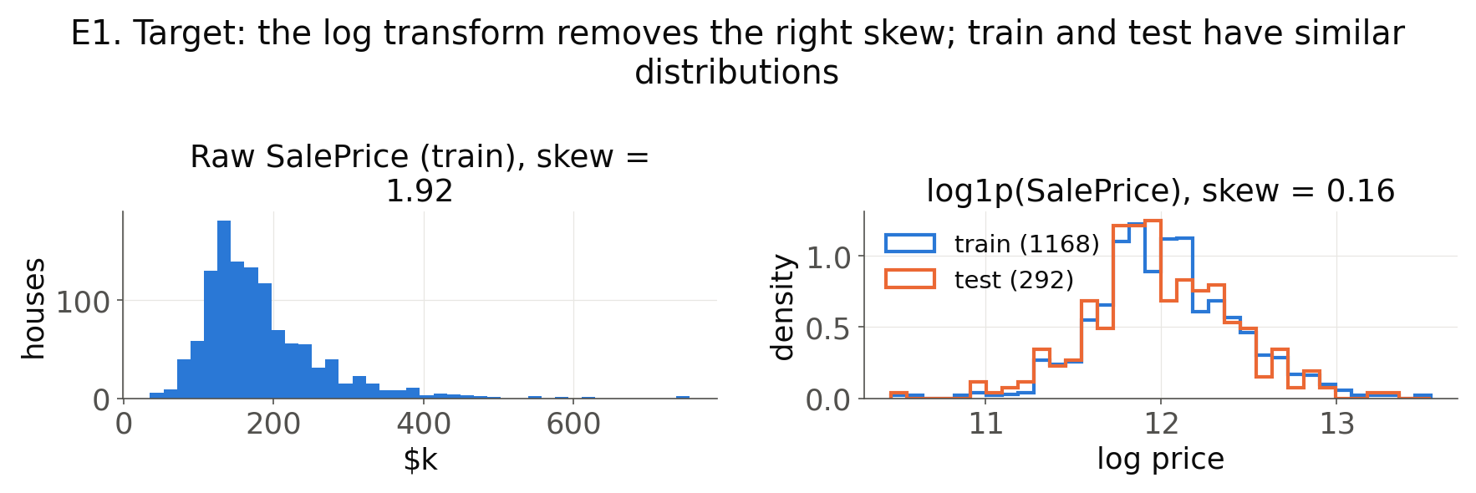
Figure E1: Target distribution: raw SalePrice and log1p(SalePrice), train vs. test.
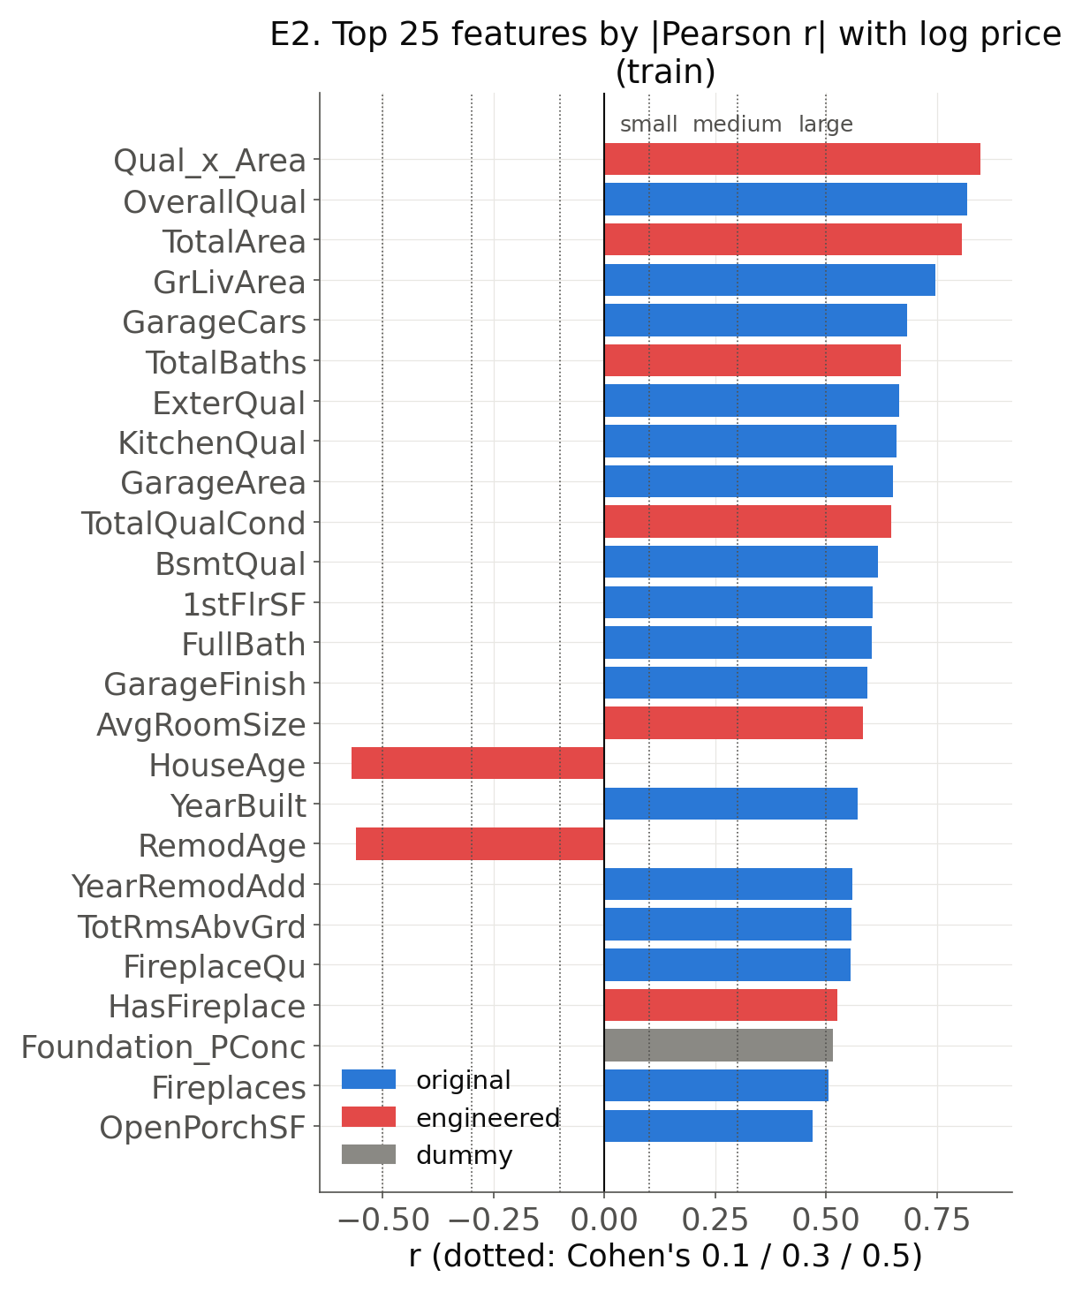
Figure E2: Top 25 features by |Pearson r| with log price (train), coloured by feature type.
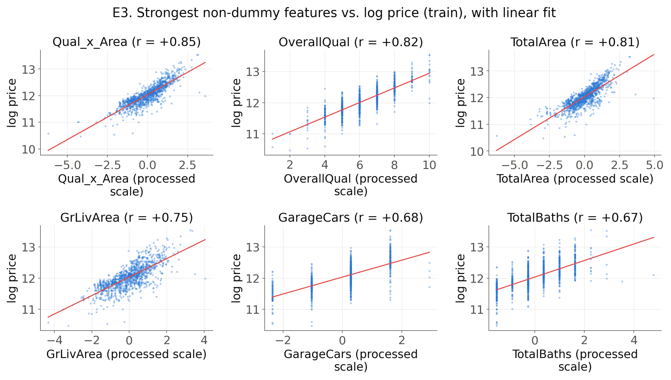
Figure E3: Six strongest non-dummy features vs. log price with linear fit.
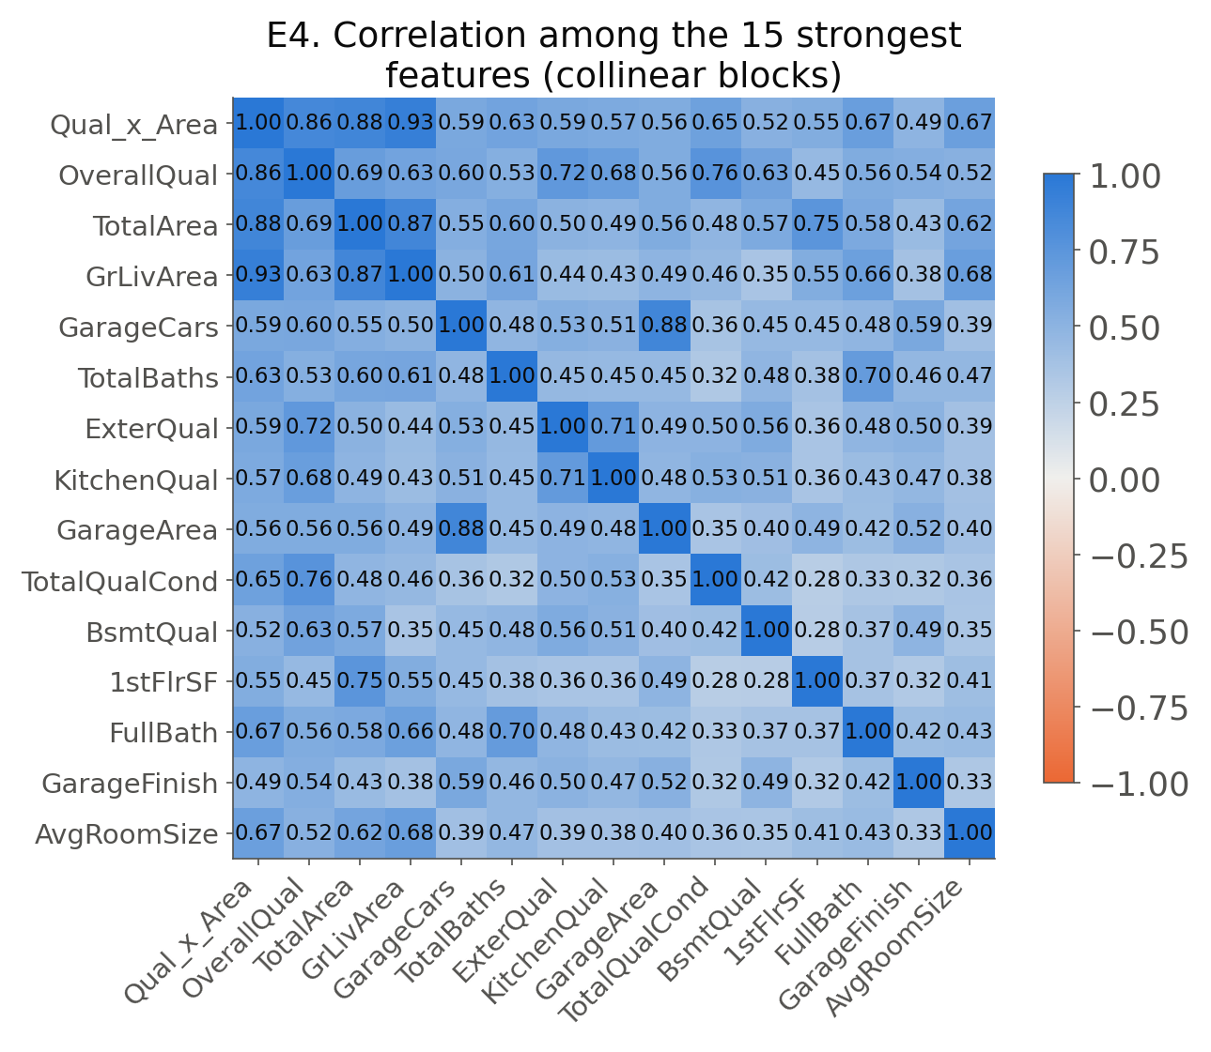
Figure E4: Correlation among the 15 strongest features (collinear blocks).
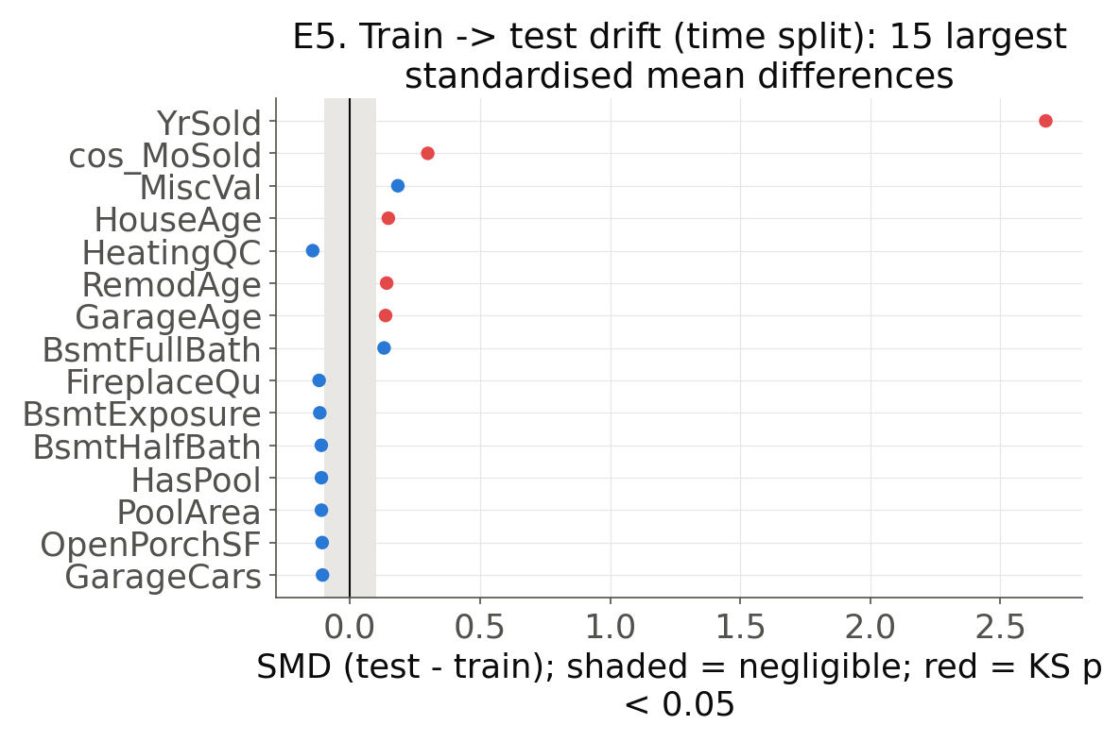
Figure E5: Train → test drift: largest standardised mean differences.
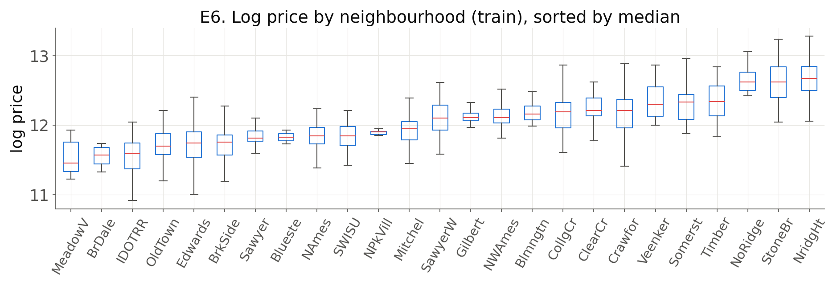
Figure E6: Log price by neighbourhood (train).

3. Pipeline and feature engineering (§5.1)
- Raw data → preprocessing → feature engineering → feature selection → linear model → prediction & evaluation; every data-dependent step is fitted on training rows only (F15).
- Transforms (log1p of skewed numerics (skew > 0.75, decided per fit); sin/cos of MoSold): makes area–price relations linear in logs; month becomes cyclic so Dec and Jan are neighbours [H1].
- Interactions (Qual_x_Area, TotalQualCond): lets the quality effect grow with size (luxury premium); one combined condition score [H2, H5].
- Aggregates (TotalArea, TotalBaths, TotalPorchArea): buyers value total usable space; one strong feature replaces several correlated parts [H1, H7].
- Domain-derived (HouseAge, RemodAge, GarageAge; AvgRoomSize, LotUtilization): age at sale is what a buyer sees, not the calendar year; room size and lot use measure spaciousness [H1, H3].
- Presence flags (HasBasement, HasFireplace, HasPool, HasGarage, IsRemod): capture the price step of having an amenity, separate from its size [H6].
- Whether the groups help as a whole is tested in the ablation (§7.2, Set B vs A).
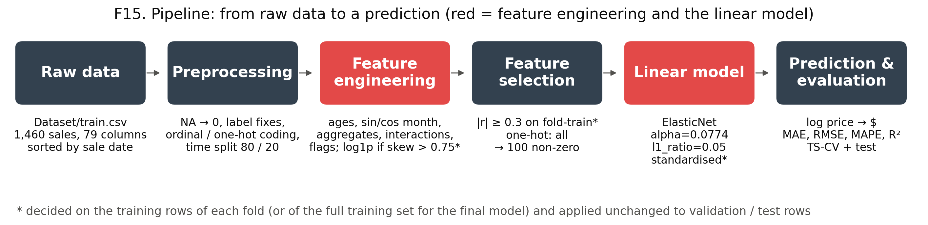
Figure F15: Pipeline: from raw data to a prediction, with each stage's input and output.
Group | Features | Why it should help | Hypothesis
Transforms | log1p of skewed numerics (skew > 0.75, decided per fit); sin/cos of MoSold | makes area–price relations linear in logs; month becomes cyclic so Dec and Jan are neighbours | H1
Interactions | Qual_x_Area, TotalQualCond | lets the quality effect grow with size (luxury premium); one combined condition score | H2, H5
Aggregates | TotalArea, TotalBaths, TotalPorchArea | buyers value total usable space; one strong feature replaces several correlated parts | H1, H7
Domain-derived | HouseAge, RemodAge, GarageAge; AvgRoomSize, LotUtilization | age at sale is what a buyer sees, not the calendar year; room size and lot use measure spaciousness | H1, H3
Presence flags | HasBasement, HasFireplace, HasPool, HasGarage, IsRemod | capture the price step of having an amenity, separate from its size | H6
Table 7: Engineered feature groups, the rationale for each and the hypothesis it addresses (§4).

4. Model choice and hyper-parameter tuning (§5.2)
- Model choice
- 47 features have VIF ≥ 10 and there are 290 candidate features for 1,168 sales, mostly weak one-hot dummies, so we use ElasticNet: it shrinks correlated coefficients together and drops useless ones.
- Ref: https://doi.org/10.1111/j.1467-9868.2005.00503.x
- Confirmed by CV: every penalised model beats OLS (CV RMSE 0.1519 vs. 0.1334); Ridge, Lasso and Huber are compared too.
- Feature selection
- Correlation coefficient (r) threshold: [0, 0.1, 0.3, 0.5], where 0 keeps all features; ranking recomputed on each training fold.
- Best threshold: 0.3 for all five model families (F1).
- Ref: https://www.taylorfrancis.com/books/mono/10.4324/9780203771587/statistical-power-analysis-behavioral-sciences-jacob-cohen
- Cohen considers r = 0.1 a small effect, 0.3 medium and 0.5 large.
- Collinearity threshold: |r| > 0.7, applied in preprocessing (greedy selection), not re-tuned.
- Ref: https://nsojournals.onlinelibrary.wiley.com/doi/10.1111/j.1600-0587.2012.07348.x
- Outliers: dropping houses with GrLivArea > 4000 from training folds only was tried; this raised CV error for every model, so the best configuration keeps them (F3).
- Ref: https://doi.org/10.1080/10691898.2011.11889627
- Hyper-parameter ranges
- Lasso / ElasticNet α: 100 log-spaced values from α_max (all coefficients zero) down to 1e-4·α_max (F4).
- Ref: https://www.jstatsoft.org/article/view/v033i01
- Ridge α: 30 values spanning effective degrees of freedom from about the rank down to 1 (α = 4.6 … 3.1e+05).
- Ref: https://doi.org/10.1007/978-0-387-84858-7
- ElasticNet l1_ratio: [0.01, 0.05, 0.1, 0.5, 0.7, 0.9, 0.95, 0.99]; 0.01 and 0.05 were added because the optimum sat on the lower edge.
- Huber ε: [1.345, 2.0]; 1.345 gives 95% efficiency under normal errors.
- Ref: https://doi.org/10.1002/0471725250
- All grids use log spacing.
- Ref: https://www.jmlr.org/papers/v13/bergstra12a.html
- Time-series CV: k = 5 (training period only)
- Selected: ElasticNet (alpha=0.0774, l1_ratio=0.05), threshold 0.3, dummies = all, outliers kept; CV RMSE 0.1334 ± 0.0294 (T10, F5).
- Tuning curve (T8): CV RMSE stays within one standard error of the optimum for α ≈ 0.00756–0.343; larger α over-shrinks (F4).
- Ref: https://www.sciencedirect.com/science/article/abs/pii/S0020025511006773
α | CV MAE ($k) | CV RMSE
0.000673 | 20.1 | 0.1643
0.00206 | 19.4 | 0.1570
0.00628 | 18.2 | 0.1474
0.0192 | 17.0 | 0.1388
0.0586 | 16.3 | 0.1337
0.0774 | 16.3 | 0.1334
0.179 | 16.9 | 0.1372
0.546 | 19.8 | 0.1545
1.67 | 29.9 | 0.2153
5.09 | 53.5 | 0.3774
6.73 | 56.7 | 0.4011
Table 8: Tuning curve of ElasticNet (l1_ratio = 0.05, threshold 0.3): time-series CV error along the α path. Bold = selected α.
Setting | Values searched | Source
Correlation threshold | 0, 0.1, 0.3, 0.5 | Cohen (1988)
One-hot dummies | none, filtered, all | —
Drop GrLivArea > 4000 (train folds) | False, True | De Cock (2011)
Lasso / ElasticNet α | 100 values, α_max → 0.0001·α_max (log) | Friedman et al. (2010)
ElasticNet l1_ratio | 0.01, 0.05, 0.1, 0.5, 0.7, 0.9, 0.95, 0.99 | Zou & Hastie (2005)
Ridge α | 30 values, df 1 → 0.95·rank (4.58 … 3.12e+05) | Hastie et al. (2009) §3.4.1
Huber ε | 1.345, 2 | Huber (1981)
Huber α | 8 values from the ridge range | —
Grid spacing | logarithmic | Bergstra & Bengio (2012)
Cross-validation | TimeSeriesSplit, 5 folds | Bergmeir & Benítez (2012)
Top-k (ablation) | 5, 10, 15, 20, 30, 40, 60, 80, 120, 160, 200, 240, 260, 280 | —
Bootstrap resamples | B = 1000 | Efron & Tibshirani (1993)
Table 9: Tunable settings, the values searched and their sources.
Rank | Model | Hyperparameters | r threshold | Dummies | Drop outliers | CV RMSE ± SD | CV MAE ($k)
1 | ElasticNet | alpha=0.0774, l1_ratio=0.05 | 0.3 | all | no | 0.133370 ± 0.0294 | 16.3
2 | ElasticNet | alpha=0.0705, l1_ratio=0.05 | 0.3 | all | no | 0.133382 ± 0.0292 | 16.3
3 | ElasticNet | alpha=0.085, l1_ratio=0.05 | 0.3 | all | no | 0.133437 ± 0.0295 | 16.3
4 | ElasticNet | alpha=0.0643, l1_ratio=0.05 | 0.3 | all | no | 0.133487 ± 0.0291 | 16.3
5 | ElasticNet | alpha=0.0387, l1_ratio=0.1 | 0.3 | all | no | 0.133565 ± 0.0296 | 16.3
6 | ElasticNet | alpha=0.0932, l1_ratio=0.05 | 0.3 | all | no | 0.133597 ± 0.0295 | 16.4
7 | ElasticNet | alpha=0.0425, l1_ratio=0.1 | 0.3 | all | no | 0.133599 ± 0.0297 | 16.3
8 | ElasticNet | alpha=0.0353, l1_ratio=0.1 | 0.3 | all | no | 0.133610 ± 0.0295 | 16.3
9 | ElasticNet | alpha=0.0586, l1_ratio=0.05 | 0.3 | all | no | 0.133674 ± 0.0290 | 16.3
10 | ElasticNet | alpha=0.267, l1_ratio=0.01 | 0.3 | all | no | 0.133704 ± 0.0270 | 16.3
Table 10: Top 10 of all tuned configurations, ranked by time-series CV RMSE.
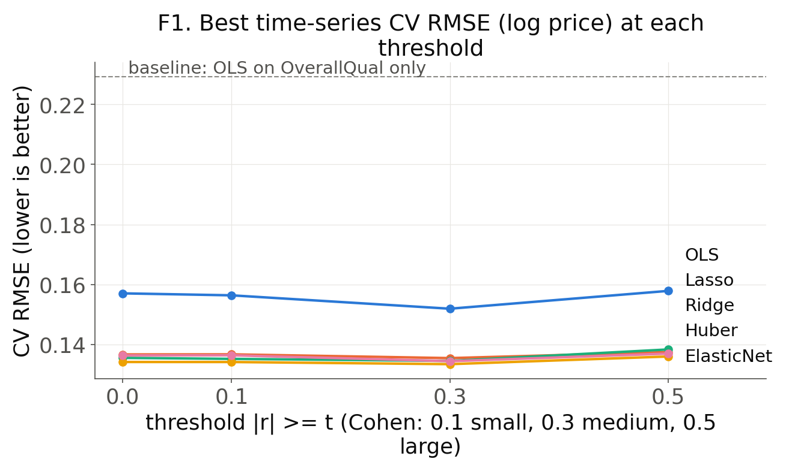
Figure F1: Best time-series CV RMSE at each correlation threshold, per model family.
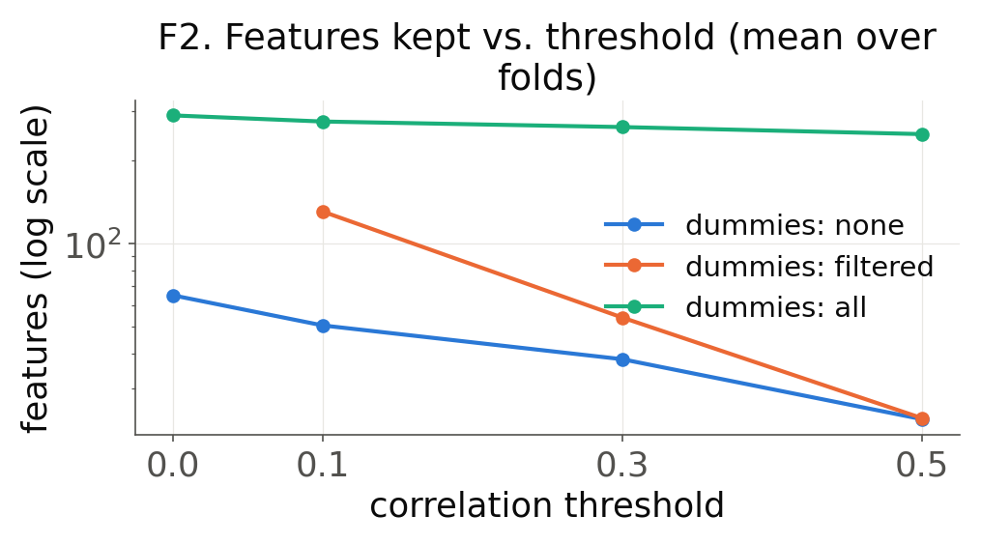
Figure F2: Number of selected features vs. threshold.
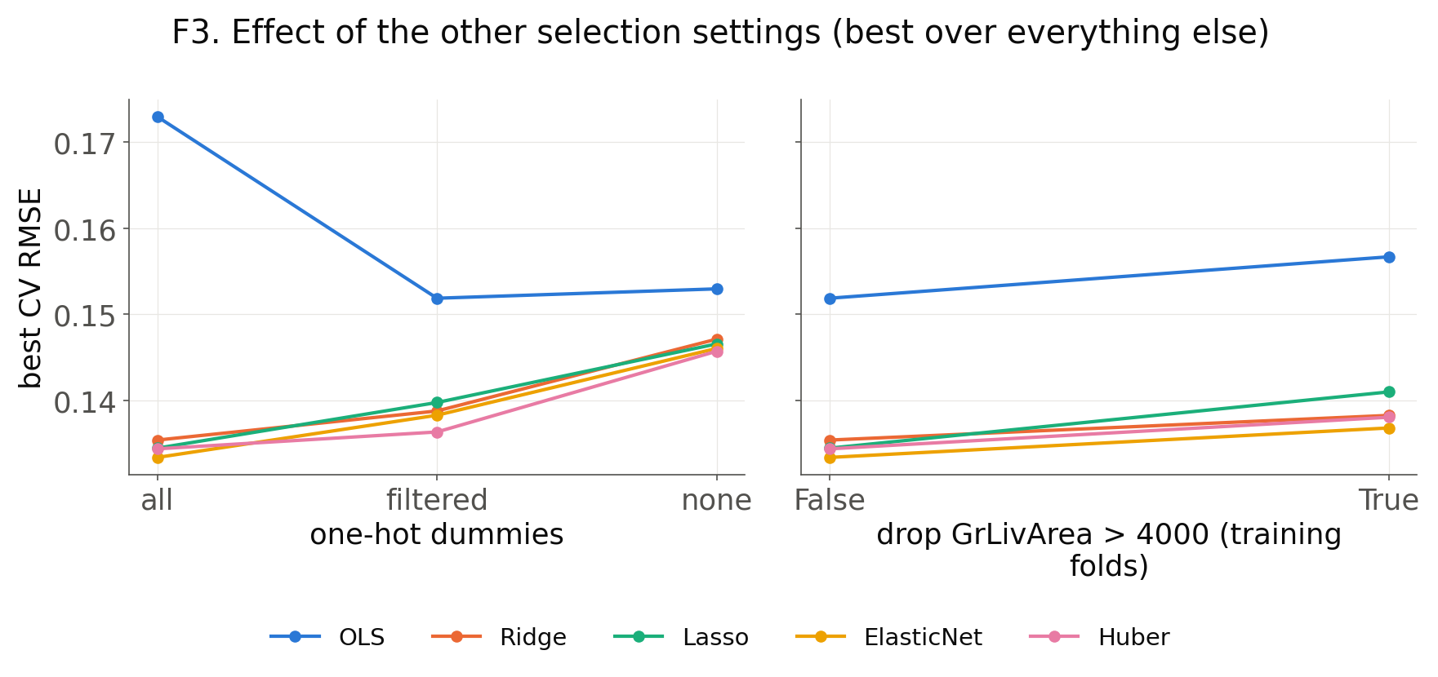
Figure F3: Effect of one-hot handling and outlier removal.
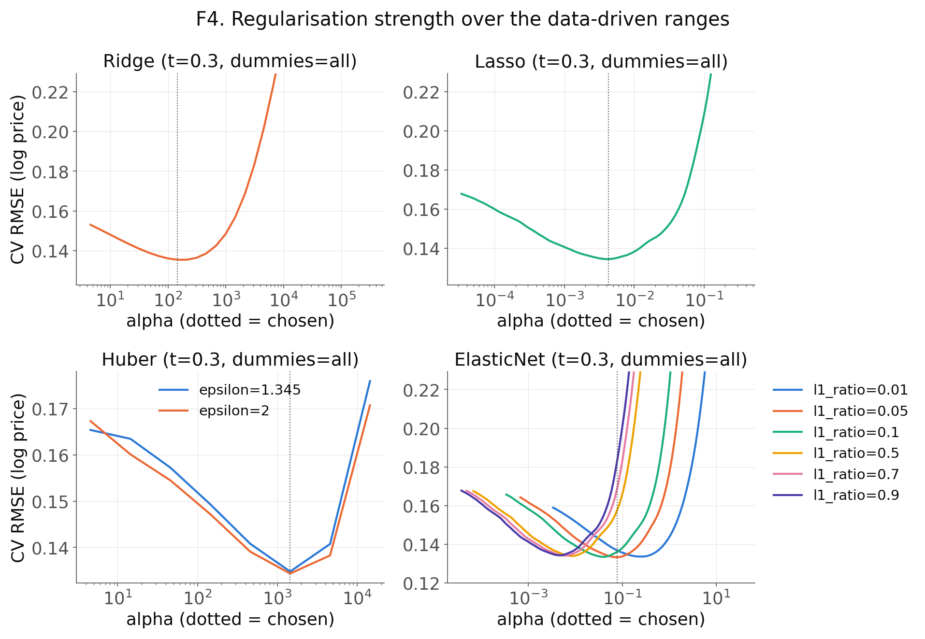
Figure F4: CV RMSE along the regularisation range (dotted = chosen α).
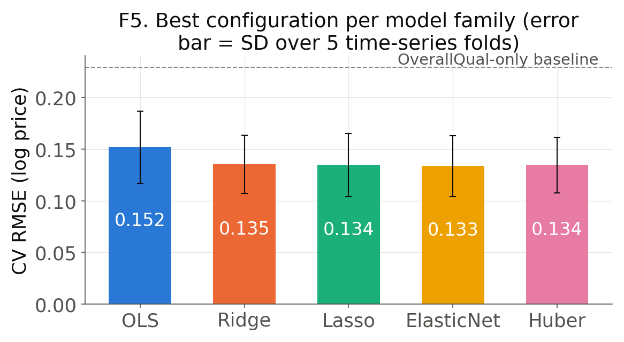
Figure F5: Best configuration per model family (error bar = fold SD).

5. Metrics and baselines (§6)
- Metrics
- MAE in dollars is primary: a buyer, seller or lender loses money in proportion to the dollar error.
- RMSE on log price is the training objective and penalises large relative misses; MAPE, R² and the share within ±10% support it.
- Decision threshold: MAE ≤ $16,500 (10% of the median training price, $165,000): below it an estimate is close enough to set a listing price or an offer; above it, the decision would change. This band is our assumption about the user.
- Baselines (same folds and test set as our model; tiers from the team's baseline2.py)
- Trivial: Training mean — none.
- Trivial: Persistence (last 3 months) — median price of the last 3 months of the training part.
- Simple: Single-feature OLS (OverallQual) — OverallQual (strongest original feature, E2).
- Simple: Single-feature OLS (log GrLivArea) — log living area (most intuitive size feature).
- Strong: Gradient boosting (raw inputs) — all raw columns (one-hot coded); best of 12 random-forest / gradient-boosting settings by the same CV (lr: 0.03, leaves: 8, l2: 0.0).
Metric | Unit | Emphasises | Caution | Why we use it
MAE | $ | typical error size | weights all errors linearly | the user's cost: dollars a buyer or seller would misjudge; carries the decision threshold
RMSE | log price | large (relative) errors | sensitive to outliers | the training objective and Kaggle metric; ≈ relative error
MAPE | % | relative error | unstable when y ≈ 0 | comparable across cheap and expensive houses (prices are never near 0)
R² | none | variance explained | can be negative on test data | shows how much better than predicting the mean
Within ±10% | % of houses | share of usable estimates | ignores the size of misses | how often an estimate is close enough to act on
Table 11: Evaluation metrics and the reason for each.
Tier | Baseline | Inputs | Tuning
Trivial | Training mean | none | —
Trivial | Persistence (last 3 months) | median price of the last 3 months of the training part | —
Simple | Single-feature OLS (OverallQual) | OverallQual (strongest original feature, E2) | —
Simple | Single-feature OLS (log GrLivArea) | log living area (most intuitive size feature) | —
Strong | Gradient boosting (raw inputs) | all raw columns (one-hot coded) | best of 12 random-forest / gradient-boosting settings by the same CV (lr: 0.03, leaves: 8, l2: 0.0)
Table 12: Baselines of increasing strength.

6. Main results (§7.1)
- On the test set Gradient boosting (raw inputs), Ours (ElasticNet + features) meet the $16.5k threshold; trivial and single-feature baselines miss it by a wide margin (T13, F16).
- Ours: CV MAE $16.3k, test MAE $15.3k, test R² 0.909; strongest baseline (Gradient boosting (raw inputs)): CV $19.3k, test $14.9k.
- Ours vs. Gradient boosting (raw inputs): better in CV by $2,981 (corrected t-test over folds, p = 0.058); test MAE higher by $414 (paired bootstrap 95% CI [−$1,840, +$944], Wilcoxon p = 0.406) → performance on par with the strong baseline, not a win.
- Ref: https://doi.org/10.1023/A:1024068626366
- The linear model's CV advantage is largest with the least training data (gap per fold: $5.5k, $2.5k, $2.2k, $2.2k, $2.5k) and fades with all 1,168 sales: the engineered features give it the shape of the relationships, while the trees must learn every curve from data.
- Diagnostics (T14, F7): mean residual -0.0077 (p = 0.287, no level shift); Breusch-Pagan p = 0.003 (variance grows with price, so bootstrap intervals); Durbin-Watson 1.89.
Method | CV MAE ($k) | CV RMSE | Test MAE ($k) | Test RMSE | Test R² | Within ±10% (%)
Training mean | 56.8 ± 3.3 | 0.4014 ± 0.0287 | 55.2 | 0.4092 | -0.010 | 18.5
Persistence (last 3 months) | 57.3 ± 3.5 | 0.4083 ± 0.0288 | 54.8 | 0.4076 | -0.003 | 18.2
Single-feature OLS (OverallQual) | 31.7 ± 2.5 | 0.2293 ± 0.0166 | 29.4 | 0.2371 | 0.661 | 38.4
Single-feature OLS (log GrLivArea) | 37.6 ± 1.9 | 0.2682 ± 0.0132 | 41.0 | 0.3038 | 0.443 | 28.1
Gradient boosting (raw inputs) | 19.3 ± 3.3 | 0.1526 ± 0.0253 | 14.9 | 0.1308 | 0.897 | 70.5
Ours (ElasticNet + features) | 16.3 ± 2.8 | 0.1334 ± 0.0294 | 15.3 | 0.1229 | 0.909 | 68.8
Table 13: Main results. CV: mean ± SD over 5 TimeSeriesSplit folds; test: chronological test set (292 sales). Bold = best in each column. Decision threshold: MAE ≤ $16.5k.
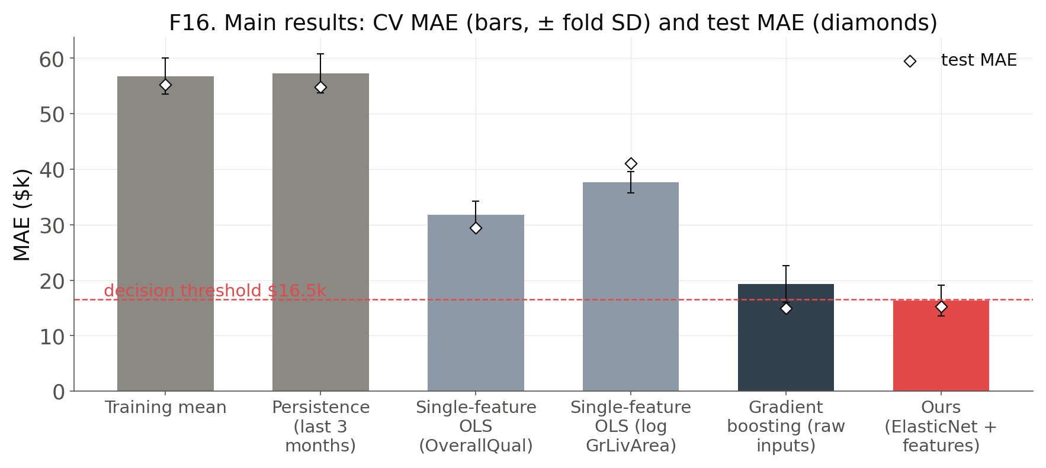
Figure F16: Main results: CV MAE (± fold SD) and test MAE of every baseline and our model, with the decision threshold.
Metric | Value | 95% CI / test
RMSE (log price) | 0.1229 | [0.1089, 0.1384]
MAE ($) | 15,309 | [13,529, 17,334]
Median absolute error ($) | 11,259 | —
MAPE (%) | 9.3 | —
R² (log price) | 0.909 | —
Mean residual (bias) | -0.0077 | t-test p = 0.287
Breusch-Pagan | — | p = 0.003
Durbin-Watson | 1.89 | —
Table 14: Final model (ElasticNet, 262 features, 100 non-zero) on the chronological test set; CIs from 1000 bootstrap resamples.
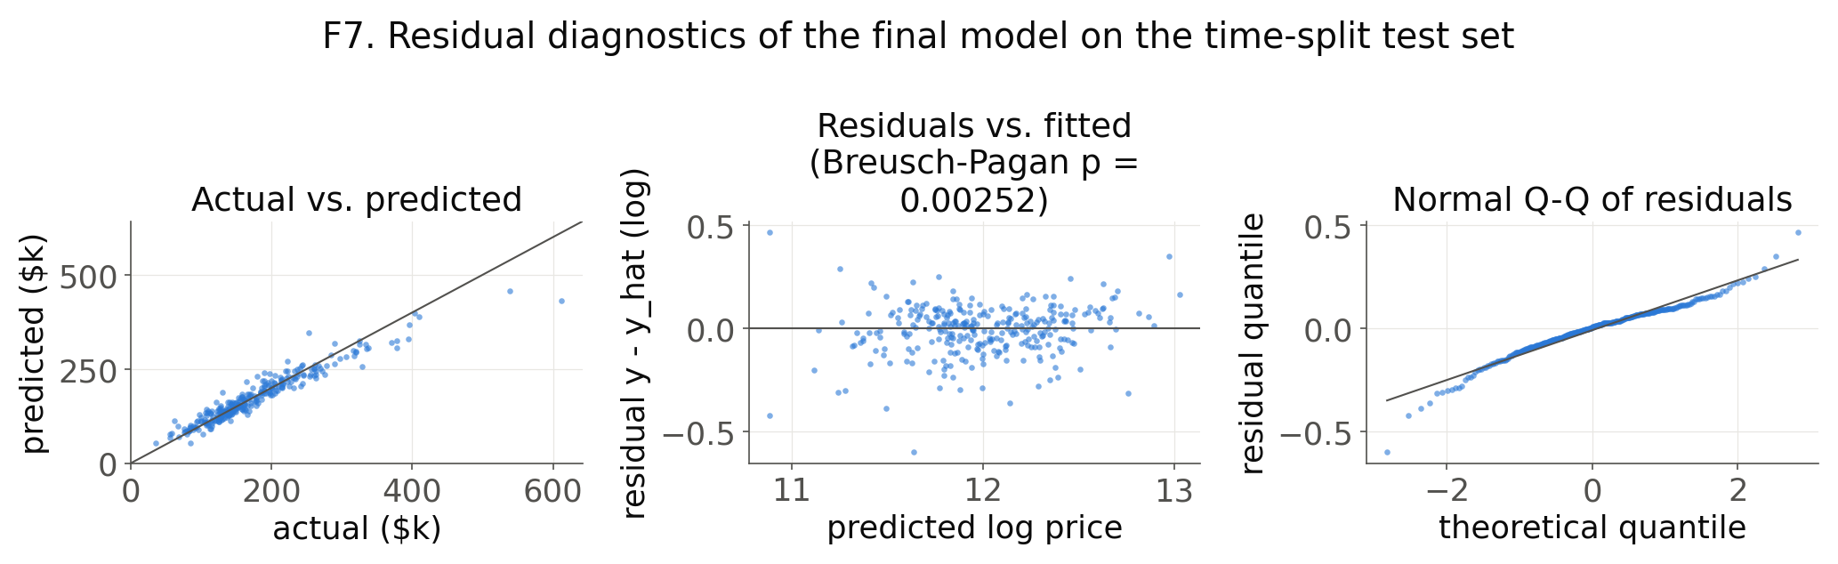
Figure F7: Residual diagnostics of the final model on the test set.

7. Ablation (§7.2)
- Setting
- Same model (ElasticNet), split, folds, tuning procedure and outlier rule for every set; only the features change.
- Set A: original features only + select all features
- Set B: original & engineered features + select all features
- Set C: original features only + simple top-k (|r| ranked inside each training fold; k tuned by CV)
- Set D: original & engineered features + simple top-k
- Set E: original features only + greedy feature selection
- Set F: original & engineered features + greedy feature selection
- Significance: corrected t-test on CV folds; paired bootstrap and Wilcoxon on test errors; Holm correction over the 15 pairs (T16, F10).
- Ref: https://doi.org/10.1023/A:1024068626366
- Ref: https://doi.org/10.2307/3001968
- Ref: https://www.jstor.org/stable/4615733
- Findings
- Engineered features (H6): B vs A, test MAE +$206 per house in favour of B [−$67, +$480], not significant after Holm (T15, F8).
- Top-k adds nothing: the tuned k keeps nearly every feature, so C = A and D = B; ElasticNet already zeroes what a correlation filter would drop (F9).
- Greedy selection needs engineered features: E is the worst set ($19.8k test MAE) and significantly worse than every other set on the test set.
- F vs B: 96 vs. 290 features, test MAE difference +$520 [−$345, +$1,342] (F − B), not significant: the greedy set matches B with a third of the features.
- E and F were selected on the whole training set, so their CV scores are optimistic; compare them on the test set.
- Ref: https://doi.org/10.1073/pnas.102102699
- By slice (B vs A): engineered features help most for Age: 11-50 y (+$458 MAE) and hurt for Age: new (<= 10 y), Sale: non-Normal (T17).
Set | Feature set | Features | CV MAE ($k) ± SD | Test MAE ($k) | Test RMSE
A | All original | 273 | 16.8 ± 3.1 | 15.4 | 0.1226
B | All original + engineered | 290 | 16.4 ± 3.0 | 15.2 | 0.1219
C | Top-k original | 260 | 16.8 ± 3.1 | 15.4 | 0.1226
D | Top-k original + engineered | 280 | 16.4 ± 3.0 | 15.2 | 0.1219
E | Greedy original | 91 | 21.7 ± 1.4 | 19.8 | 0.1574
F | Greedy original + engineered | 96 | 16.2 ± 2.1 | 15.7 | 0.1261
Table 15: Feature ablation. CV = time-series 5-fold on the training set (± fold SD); test = chronological test set. Bold = best.
Comparison | Δ CV MAE ($k) | p (CV, t) | Δ test MAE ($k) [95% CI] | p (boot.) | p (Wilcoxon)
A vs B | +0.44 | 0.959 | +0.21 [-0.07, +0.48] | 1.000 | 1.000
A vs C | +0.00 | 1.000 | +0.00 [+0.00, +0.00] | 0.280 | 0.127
A vs D | +0.44 | 0.959 | +0.21 [-0.07, +0.48] | 1.000 | 1.000
A vs E | -4.90 | 0.411 | -4.34 [-6.11, -2.57] | <0.001 | <0.001
A vs F | +0.57 | 1.000 | -0.31 [-1.18, +0.61] | 1.000 | 1.000
B vs C | -0.44 | 0.959 | -0.21 [-0.48, +0.07] | 1.000 | 1.000
B vs D | -0.00 | 1.000 | +0.00 [-0.00, +0.00] | 1.000 | 1.000
B vs E | -5.34 | 0.300 | -4.55 [-6.35, -2.72] | <0.001 | <0.001
B vs F | +0.13 | 1.000 | -0.52 [-1.34, +0.34] | 1.000 | 1.000
C vs D | +0.44 | 0.959 | +0.21 [-0.07, +0.48] | 1.000 | 1.000
C vs E | -4.90 | 0.411 | -4.34 [-6.11, -2.57] | <0.001 | <0.001
C vs F | +0.57 | 1.000 | -0.31 [-1.18, +0.61] | 1.000 | 1.000
D vs E | -5.34 | 0.300 | -4.55 [-6.35, -2.72] | <0.001 | <0.001
D vs F | +0.13 | 1.000 | -0.52 [-1.34, +0.34] | 1.000 | 1.000
E vs F | +5.47 | 0.054 | +4.03 [+2.47, +5.75] | <0.001 | <0.001
Table 16: Pairwise comparison of the feature sets (Holm-adjusted p; bold p < 0.05).
Slice | n | A | B | C | D | E | F
Age: new (<= 10 y) | 70 | 20.1 | 20.6 | 20.1 | 20.6 | 26.0 | 22.5
Age: 11-50 y | 123 | 14.8 | 14.3 | 14.8 | 14.3 | 19.7 | 14.5
Age: old (> 50 y) | 99 | 12.9 | 12.5 | 12.9 | 12.5 | 15.4 | 12.5
Size: small | 106 | 10.6 | 10.4 | 10.6 | 10.4 | 13.8 | 10.2
Size: medium | 90 | 13.9 | 13.7 | 13.9 | 13.7 | 17.8 | 14.7
Size: large | 96 | 22.2 | 21.9 | 22.2 | 21.9 | 28.2 | 22.8
Sale: Normal | 251 | 13.9 | 13.6 | 13.9 | 13.6 | 18.4 | 13.9
Sale: non-Normal | 41 | 25.1 | 25.2 | 25.1 | 25.2 | 28.2 | 26.8
Table 17: Test MAE ($k) by slice of the test set (bold = best set in the row).
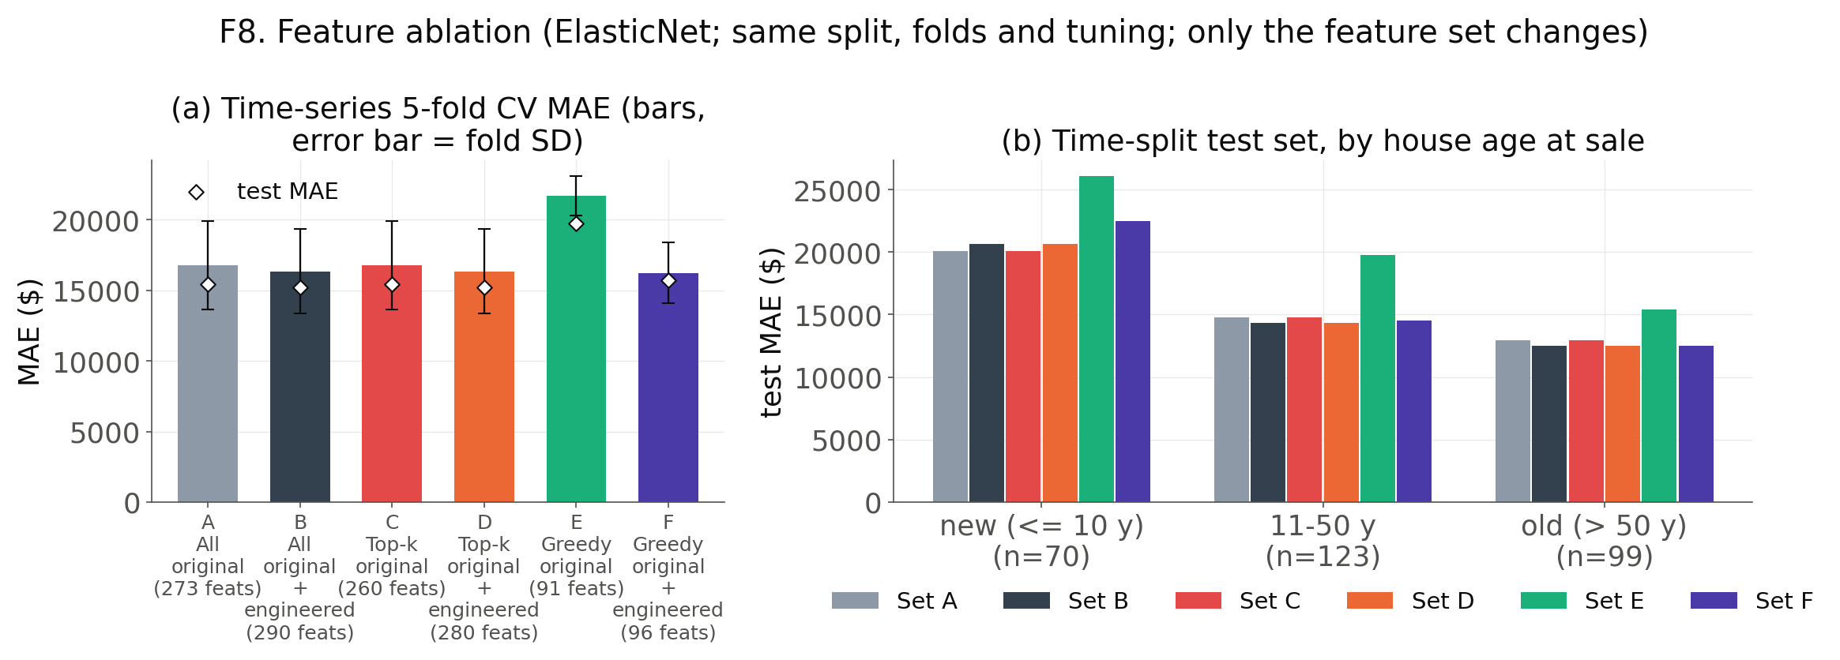
Figure F8: Feature ablation: CV MAE per set and test MAE by house age.
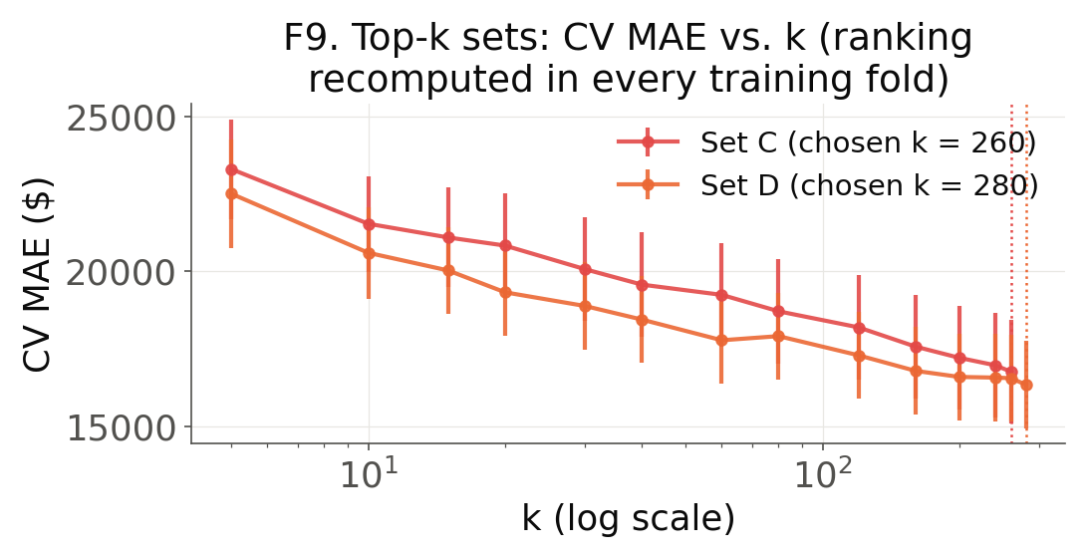
Figure F9: Top-k sets: CV MAE vs. k.
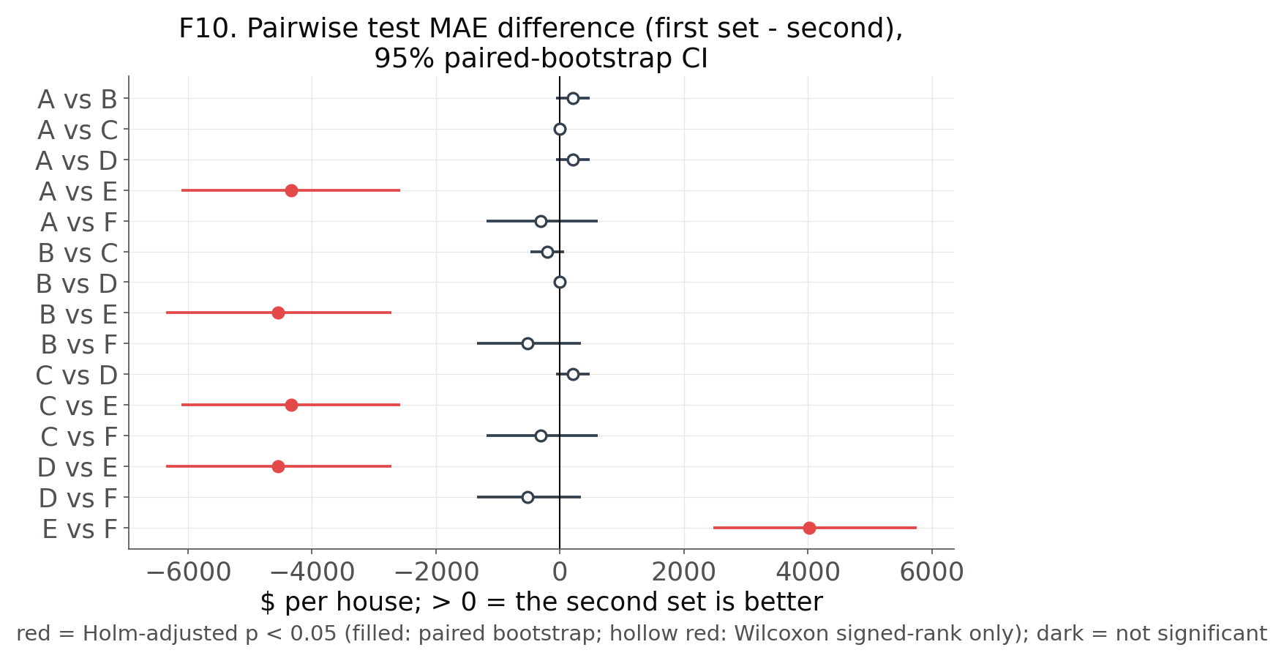
Figure F10: Pairwise test MAE differences between feature sets (95% paired-bootstrap CI).

8. Coefficient and statistical significance (§8.1)
- Setting
- Coefficients are standardised: β = change in log price per +1 SD of the feature.
- 95% CI and p-value from 1,000 bootstrap resamples, with the log choice, feature selection and fit repeated in each resample (F6).
- Ref: https://doi.org/10.1201/9780429246593
- Selection frequency = share of resamples with a non-zero coefficient (stability).
- Ref: https://doi.org/10.1111/j.1467-9868.2010.00740.x
- VIF on a reference-coded design (one level per categorical dropped); categoricals judged as a group by GVIF^(1/(2df)) against √10 ≈ 3.16.
- Ref: https://doi.org/10.1080/01621459.1992.10475190
- Ref: https://doi.org/10.1007/s11135-006-9018-6
- Practical significance: an effect below 1% of the median price ($1,650) is negligible.
- Ref: https://doi.org/10.1080/00031305.2016.1154108
- Findings
- 35 of 262 features are significant (p < 0.05); 31 are also practically relevant (T18).
- Strongest effects per +1 SD: TotalQualCond +$9.1k, TotalArea +$7.0k, LotArea +$5.6k, GrLivArea +$5.5k (T18, F6).
- Commercial zoning (MSZoning_C) lowers price by 29% (−$48.6k).
- Significant but practically negligible: ExterQual, FireplaceQu, RemodAge, YearRemodAdd.
- No sign reversals: all 23 features with a significant effect have the expected sign.
- 47 features have VIF ≥ 10, so the area, quality and age blocks must be read as groups.
- Above the GVIF threshold: BldgType (3.54) (T20).
- Hypotheses revisited (T19)
- H1 size: supported — TotalArea: β = +0.041 [+0.026, +0.051], p < 0.001; GrLivArea: β = +0.033 [+0.026, +0.040], p < 0.001.
- H2 quality: supported — OverallQual: β = +0.022 [+0.012, +0.032], p < 0.001; TotalQualCond: β = +0.054 [+0.043, +0.060], p < 0.001.
- H3 age: supported — HouseAge: β = -0.012 [-0.019, -0.005], p = 0.002 (size and quality held fixed).
- H4 location: supported — 4 neighbourhood dummies significant; zoning: MSZoning_C -29%, MSZoning_RM -3%.
- H5 luxury premium: supported — Qual_x_Area: β = +0.025 [+0.019, +0.033], p < 0.001.
- H6 engineered features: direction supported, not significant — Set B vs A: test MAE +206 $ [-67, +480] (§7.2).
- H7 penalised > OLS: supported — CV RMSE OLS 0.1519 vs. best penalised 0.1334 (S1).
Feature | Unit | β | 95% CI | p | Sel. freq. | VIF | Effect ($k)
TotalQualCond | +1 SD | +0.054 | [+0.043, +0.060] | <0.001 | 1.00 | 5.9 | +9.1
TotalArea | +1 SD | +0.041 | [+0.026, +0.051] | <0.001 | 1.00 | 75.0 | +7.0
LotArea | +1 SD | +0.034 | [+0.024, +0.042] | <0.001 | 1.00 | 5.3 | +5.6
GrLivArea | +1 SD | +0.033 | [+0.026, +0.040] | <0.001 | 1.00 | 286.7 | +5.5
TotalBaths | +1 SD | +0.026 | [+0.016, +0.035] | <0.001 | 1.00 | 5.6 | +4.4
Qual_x_Area | +1 SD | +0.025 | [+0.019, +0.033] | <0.001 | 1.00 | 204.3 | +4.2
GarageArea | +1 SD | +0.024 | [+0.012, +0.031] | <0.001 | 1.00 | 8.7 | +3.9
1stFlrSF | +1 SD | +0.023 | [+0.011, +0.033] | <0.001 | 1.00 | 19.8 | +3.8
MSZoning_C | 0 -> 1 | -0.023 | [-0.039, -0.001] | 0.038 | 0.98 | 1.8 | -48.6
OverallQual | +1 SD | +0.022 | [+0.012, +0.032] | <0.001 | 1.00 | 49.6 | +3.7
TotRmsAbvGrd | +1 SD | +0.021 | [+0.012, +0.031] | <0.001 | 1.00 | 59.9 | +3.5
Neighborhood_NridgHt | 0 -> 1 | +0.020 | [+0.011, +0.027] | <0.001 | 1.00 | 3.9 | +15.3
Table 18: Significant and practically relevant coefficients of the final model (bootstrap 95% CI; effect on the median house for +1 SD or 0 → 1). Bold VIF ≥ 10.
Hypothesis | Evidence | Verdict
H1 size | TotalArea: β = +0.041 [+0.026, +0.051], p < 0.001; GrLivArea: β = +0.033 [+0.026, +0.040], p < 0.001 | supported
H2 quality | OverallQual: β = +0.022 [+0.012, +0.032], p < 0.001; TotalQualCond: β = +0.054 [+0.043, +0.060], p < 0.001 | supported
H3 age | HouseAge: β = -0.012 [-0.019, -0.005], p = 0.002 (size and quality held fixed) | supported
H4 location | 4 neighbourhood dummies significant; zoning: MSZoning_C -29%, MSZoning_RM -3% | supported
H5 luxury premium | Qual_x_Area: β = +0.025 [+0.019, +0.033], p < 0.001 | supported
H6 engineered features | Set B vs A: test MAE +206 $ [-67, +480] (§7.2) | direction supported, not significant
H7 penalised > OLS | CV RMSE OLS 0.1519 vs. best penalised 0.1334 (S1) | supported
Table 19: The hypotheses of §4 revisited with the final model's coefficients and the ablation.
Categorical | df | GVIF^(1/(2df)) | Reference level
BldgType | 2 | 3.54 | BldgType_1Fam
HouseStyle | 7 | 3.09 | HouseStyle_1Story
MSSubClass | 13 | 2.52 | MSSubClass_20
Exterior1st | 12 | 2.40 | Exterior1st_VinylSd
Exterior2nd | 14 | 2.17 | Exterior2nd_VinylSd
SaleCondition | 5 | 1.69 | SaleCondition_Normal
MSZoning | 4 | 1.69 | MSZoning_RL
CentralAir | 1 | 1.65 | CentralAir_Y
RoofStyle | 4 | 1.56 | RoofStyle_Gable
Foundation | 5 | 1.55 | Foundation_PConc
Table 20: Generalised VIF of categorical variables (values above 3.16 correspond to VIF > 10).
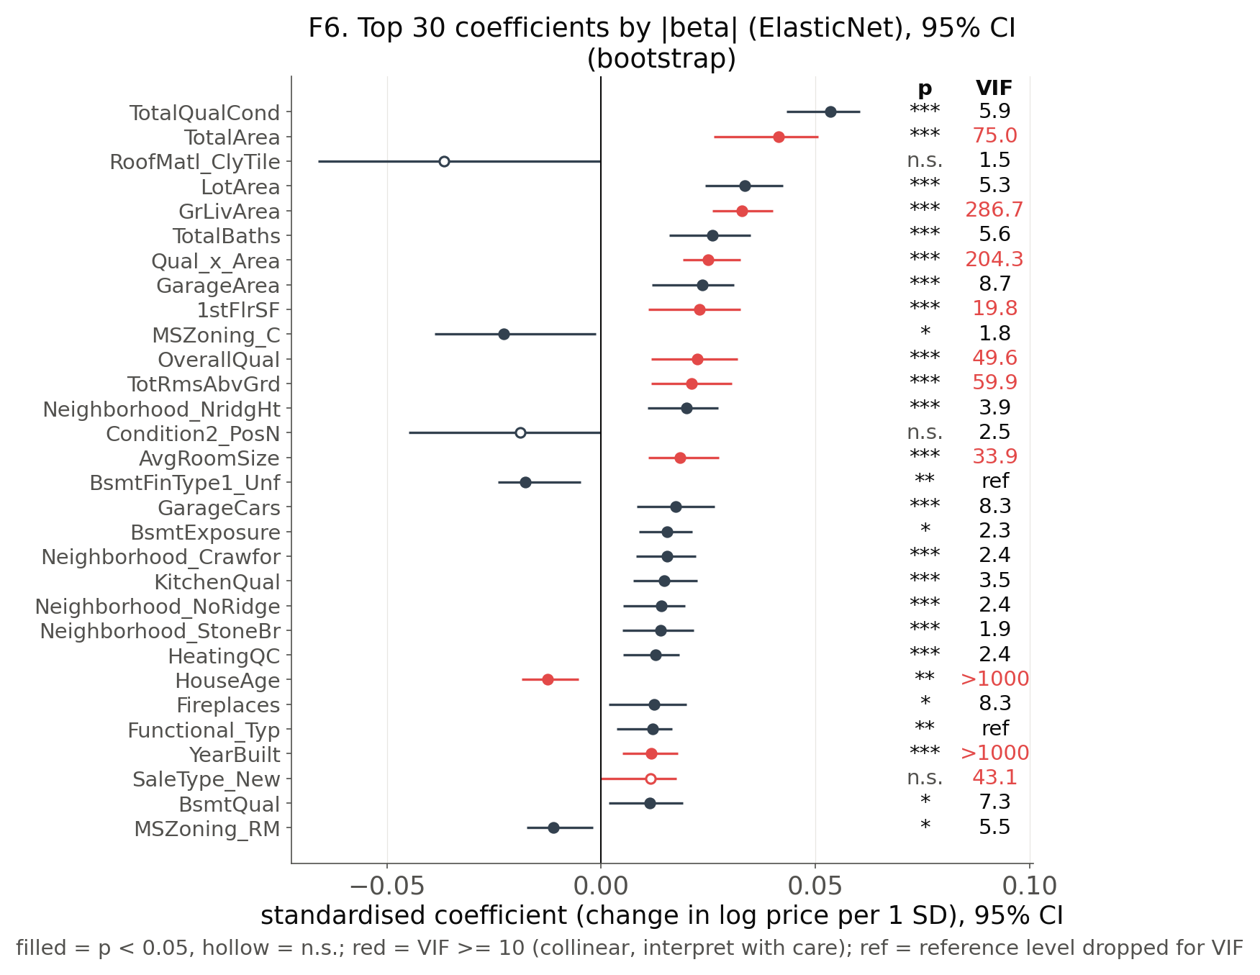
Figure F6: Top 30 standardised coefficients with bootstrap 95% CI, p-value stars and VIF.

9. Error analysis (§8.2)
- Setting
- A house is flagged if its residual (actual − predicted, log scale) is outside ±2 SD ≈ −22% / +28% of the price (F11).
- Each flagged house is compared with the median price of its 10 most similar training houses in the same neighbourhood.
- Ref: https://doi.org/10.1108/14635780310483656
- A rule-based cause is added: beyond the training range, non-Normal sale, or poor condition.
- The 5 largest errors are analysed one by one (T21, F13, F14).
- Findings
- 16 of 292 test houses are flagged (≈ 13 expected); 12 are over-predicted.
- Comparison with similar houses: 7 missing information, 5 model error, 2 atypical house, 2 price noise.
- Abnormal or partial sales make up 56% of flagged houses vs. 14% of all test houses (F12).
- Flagged houses are older (SMD -0.47), in worse condition (-0.33), lower quality (-0.30) and cheaper (-0.31) (T22).
- #1 (Id 463, Normal): sold $62.4k vs. $113.5k predicted; similar houses sold for $129.2k, verdict: missing information; rule-based cause: price outside train range.
- #2 (Id 89, Abnorml): sold $85.0k vs. $53.3k predicted; similar houses sold for $84.5k, verdict: model error; rule-based cause: abnormal sale, poor condition, commercial zone.
- #3 (Id 496, Abnorml): sold $34.9k vs. $53.2k predicted; similar houses sold for $103.2k, verdict: atypical house; rule-based cause: price outside train range, abnormal sale, commercial zone.
- First fix: model non-Normal sales separately, or add sale-condition × size/quality interactions.
# | Id | Sale | Actual ($k) | Pred. ($k) | Comps ($k) | Error ($k) | z | Comparable-sales verdict | Rule-based cause
#1 | 463 | Normal | 62.4 | 113.5 | 129.2 | -51.2 | -4.87 | missing information | price outside train range
#2 | 89 | Abnorml | 85.0 | 53.3 | 84.5 | +31.7 | +3.80 | model error | abnormal sale, poor condition, commercial zone
#3 | 496 | Abnorml | 34.9 | 53.2 | 103.2 | -18.3 | -3.44 | atypical house | price outside train range, abnormal sale, commercial zone
#4 | 875 | Abnorml | 66.5 | 97.9 | 109.5 | -31.4 | -3.15 | missing information | abnormal sale
#5 | 715 | Normal | 130.5 | 186.9 | 133.8 | -56.4 | -2.92 | model error | none found
Table 21: The 5 largest test errors (|residual| > 2 SD, ranked by |z|). Comps = median sale price of the 10 most similar training houses; error = actual − predicted.
Feature | Flagged mean | Other test houses | SMD
GrLivArea | 1,407.7 | 1,485.1 | -0.16
TotalBsmtSF | 1,086.4 | 1,047.1 | +0.08
LotArea | 10,771.4 | 9,936.2 | +0.18
OverallQual | 5.6 | 6.0 | -0.30
OverallCond | 5.2 | 5.6 | -0.33
YearBuilt | 1,955.7 | 1,970.3 | -0.47
SalePrice ($) | 143,593.9 | 177,239.9 | -0.31
Table 22: Flagged vs. other test houses (raw units; |SMD| > 0.1 = a real difference).
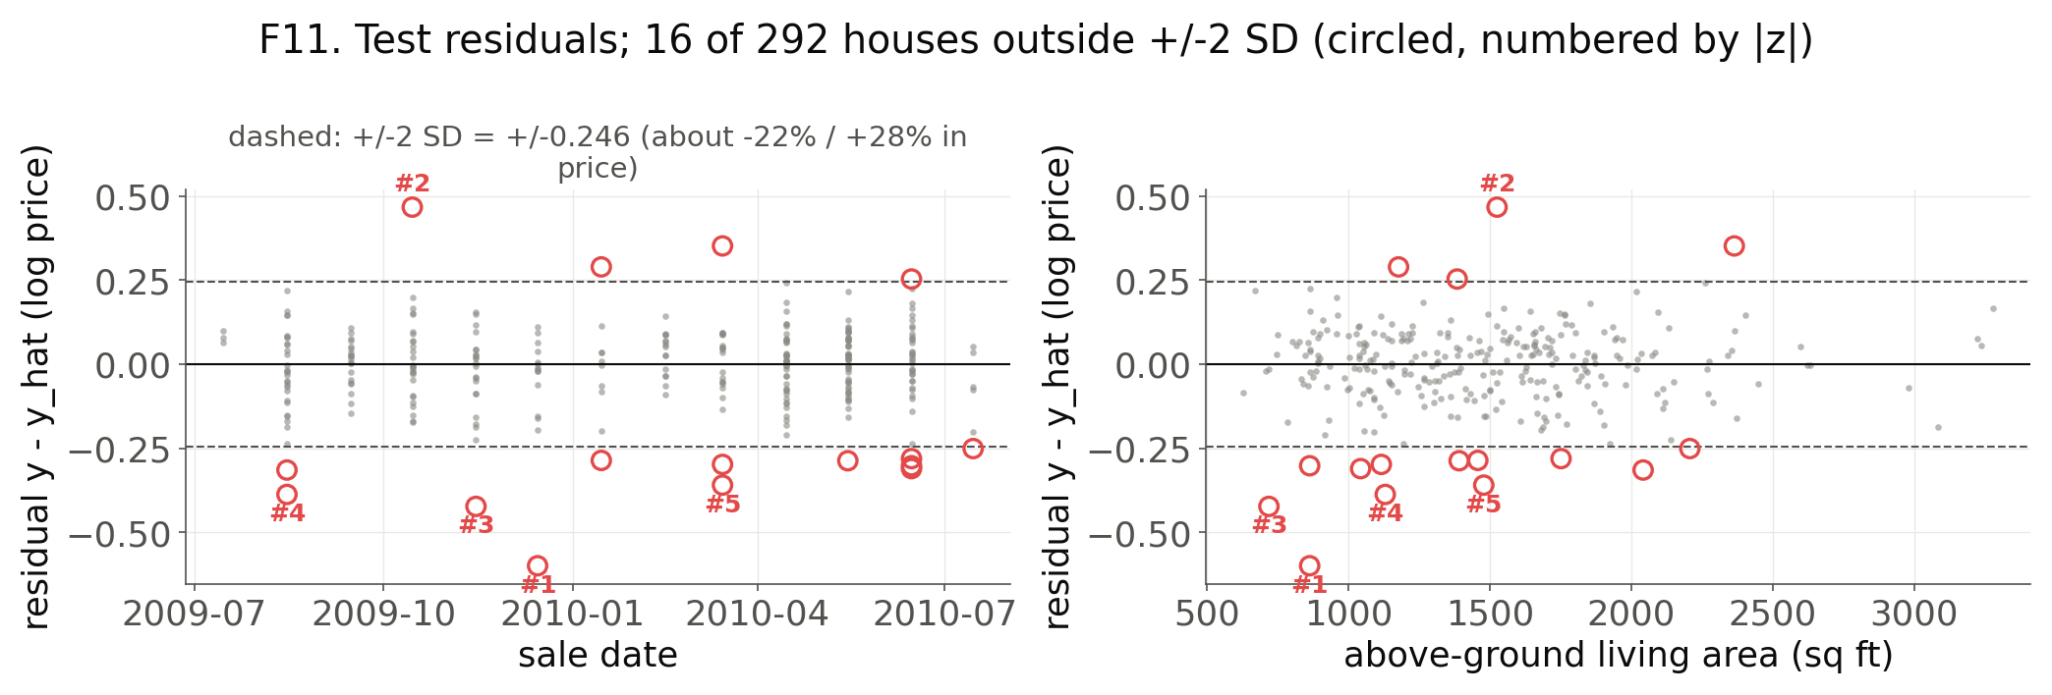
Figure F11: Test residuals; houses outside ±2 SD circled, five largest numbered.
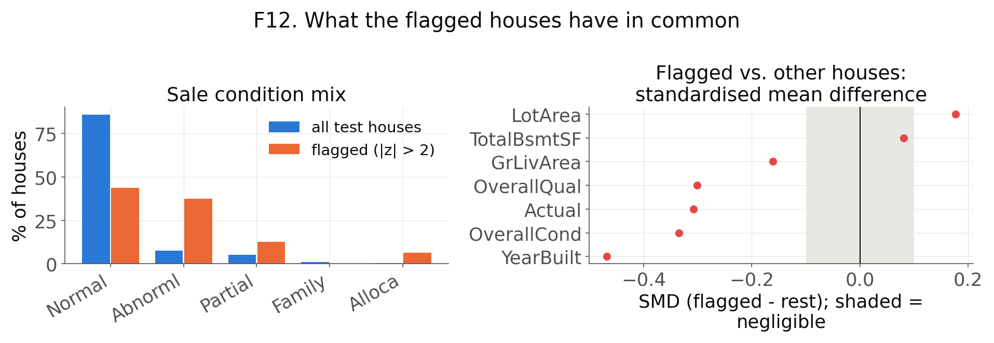
Figure F12: Sale-condition mix and feature differences of flagged houses.
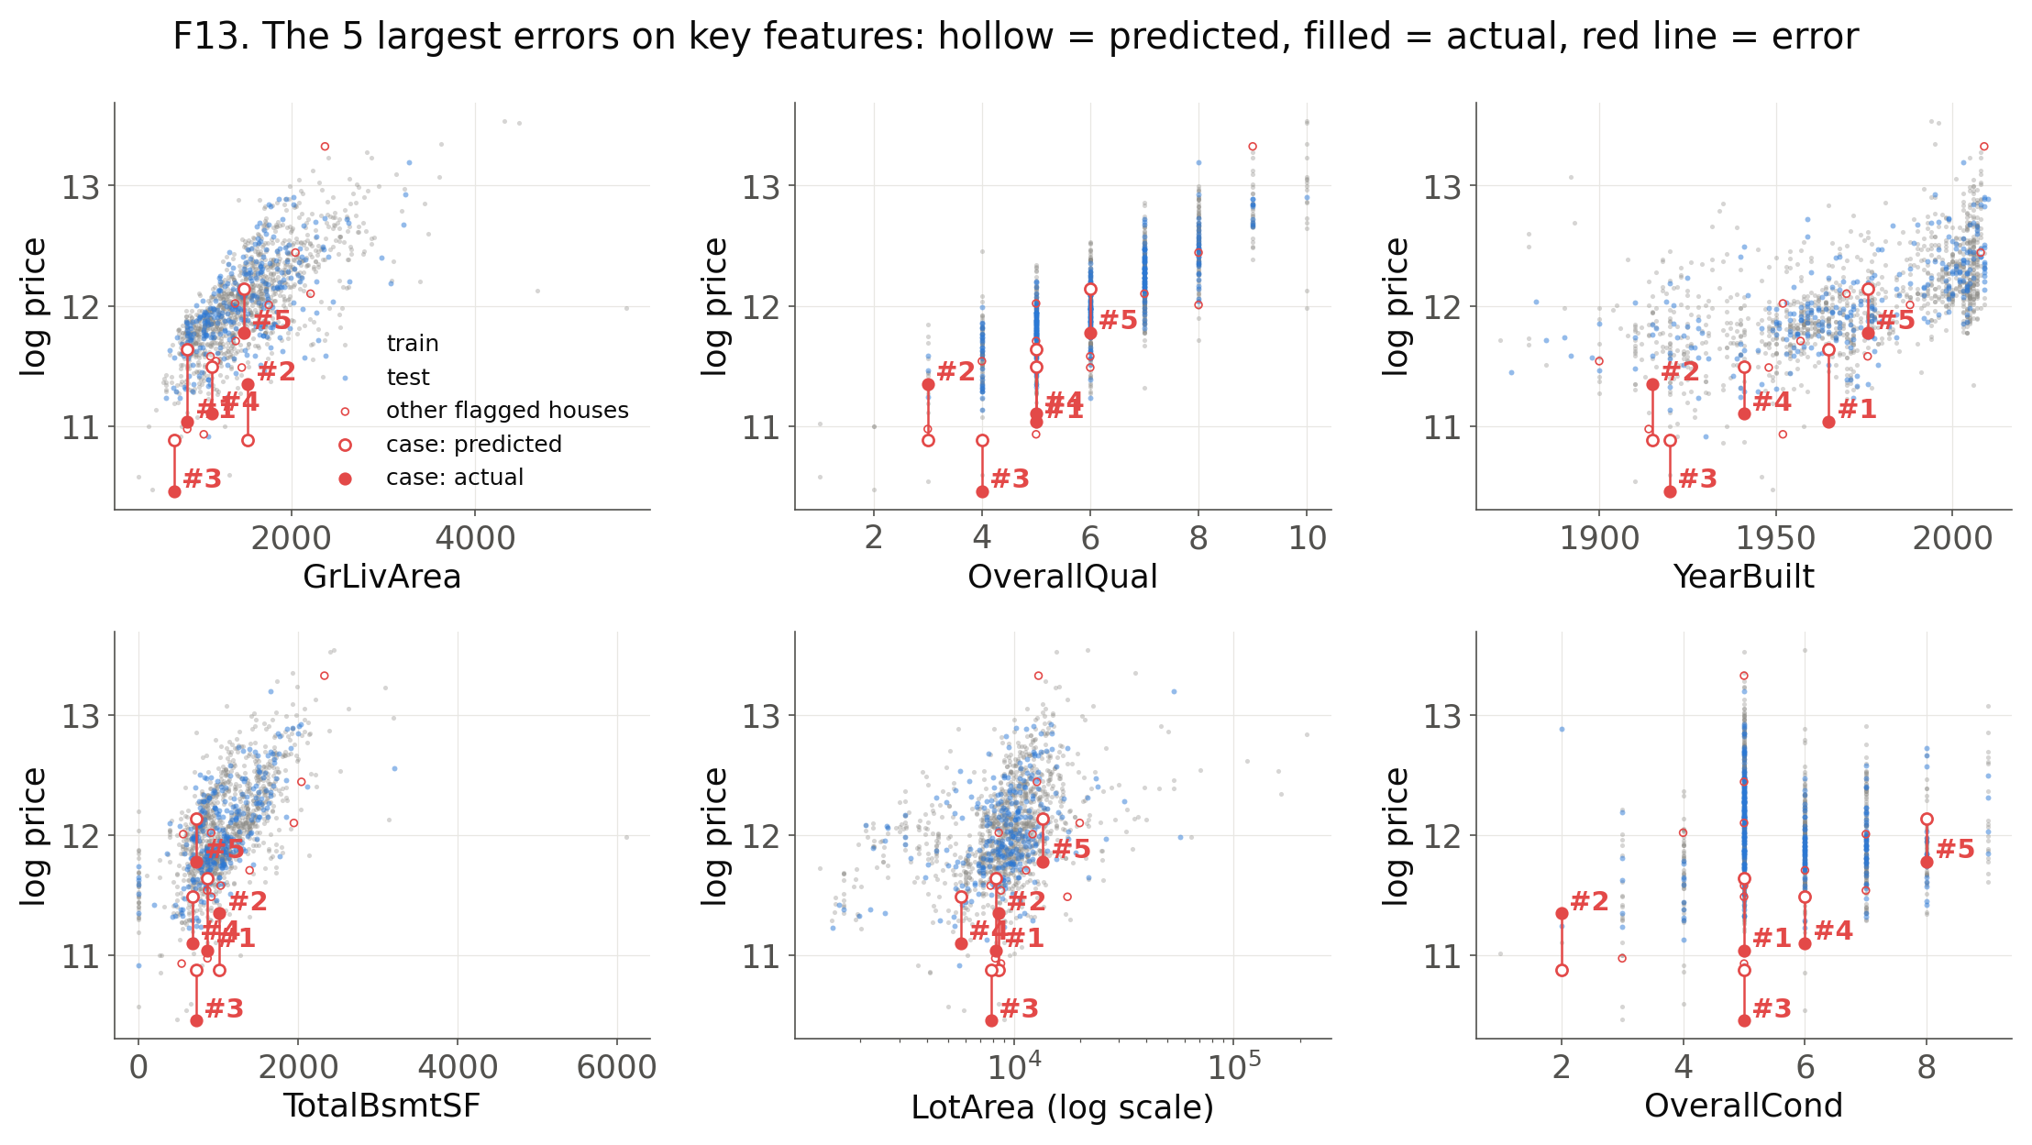
Figure F13: Five largest errors on key features (hollow = predicted, filled = actual).
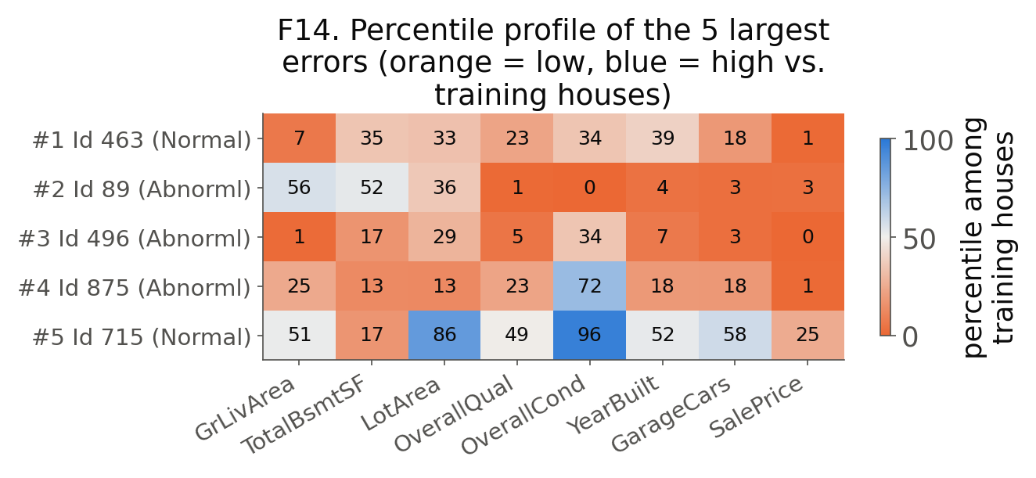
Figure F14: Percentile profile of the five largest errors among training houses.

