Student Name: Bishal Thapa
Student ID: bi96ej
Scenario-Based Database Assignment Evidence

Task 1: Database Setup
Figure 1: Successful creation of butwal_quickmart database
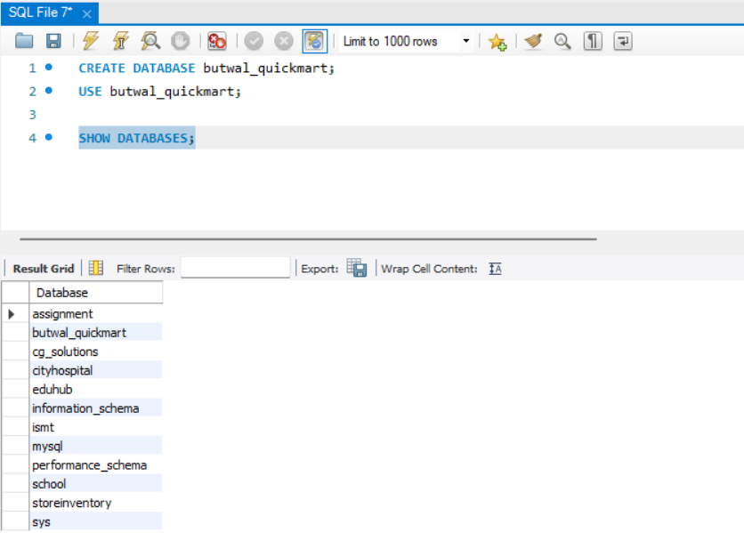
Explanation: The database was successfully created and verified using the SHOW DATABASES command, confirming that the system is ready for table creation.

Task 2: Table Creation with Constraints
Figure 2: customers table structure
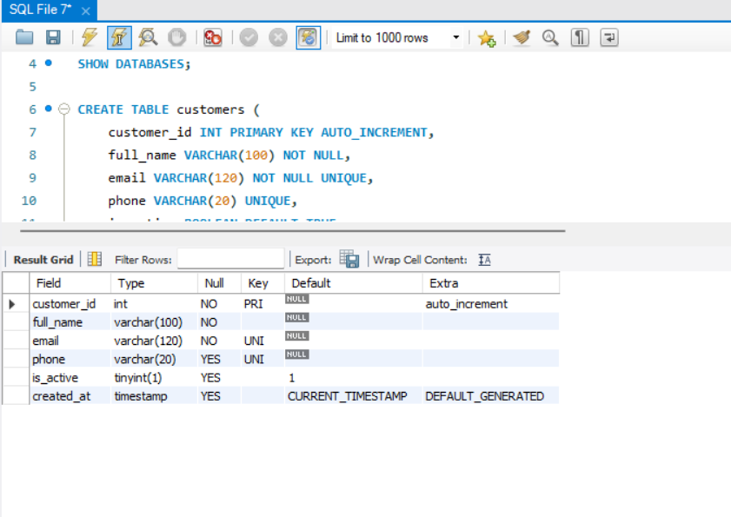
Explanation: The customers table uses primary key, unique, not null, and default constraints to ensure accurate, non-duplicated customer data and enforce business rules at the database level.
Figure 3: products table structure
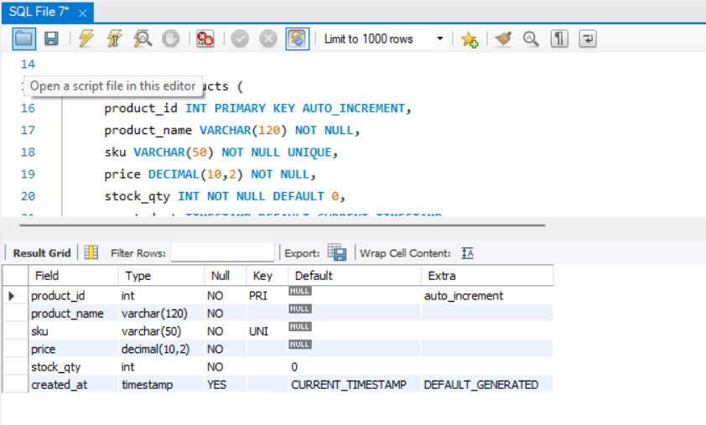
Explanation: The products table enforces unique product identification through SKU and ensures reliable stock management by defaulting stock quantity to zero.
Justifications: UNIQUE on email: Prevents duplicate customer accounts and ensures secure communication. DEFAULT 0 on stock_qty: Avoids NULL values and ensures accurate inventory tracking.

Task 3: Data Insertion
Figure 4: Inserted customer records
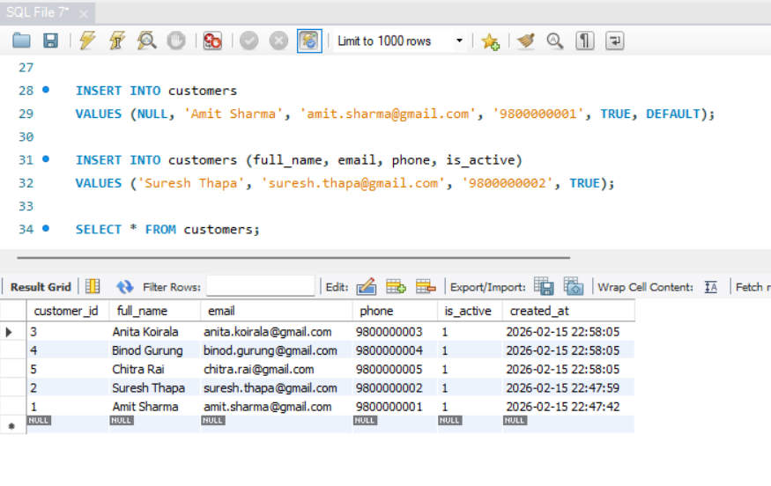
Explanation: Customer records were inserted using different INSERT techniques to demonstrate flexibility and correct use of default and auto-increment values.
Figure 5: Inserted product records
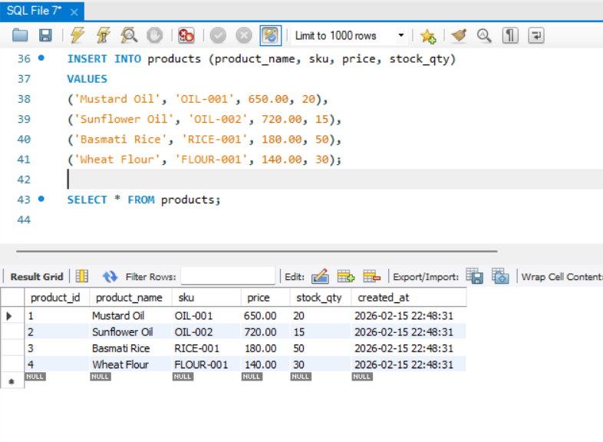
Explanation: Multiple product records were inserted in a single statement to efficiently populate the products table with realistic business data.

Task 4: Querying Data
Figure 6: Products filtered using BETWEEN clause
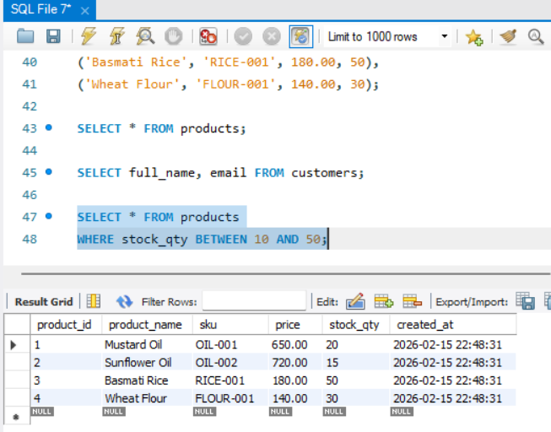
Explanation: This query retrieves products with moderate stock levels to support inventory monitoring and replenishment decisions.
Figure 7: Customer search using LIKE operator
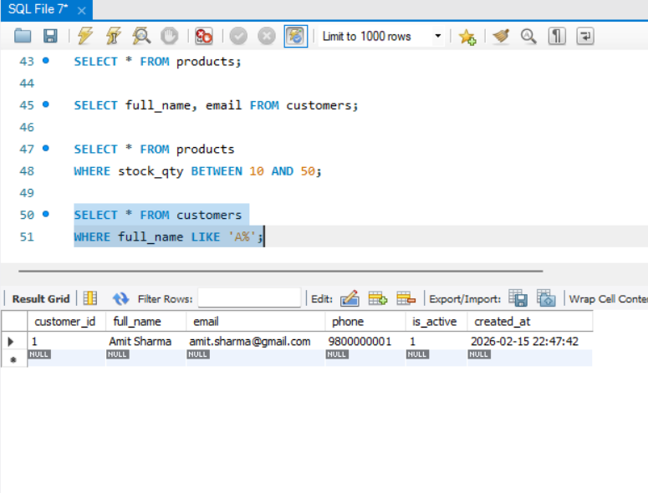
Explanation: The LIKE operator is used to perform pattern-based searches, allowing flexible customer name filtering.
Figure 8: Product filtering using AND condition
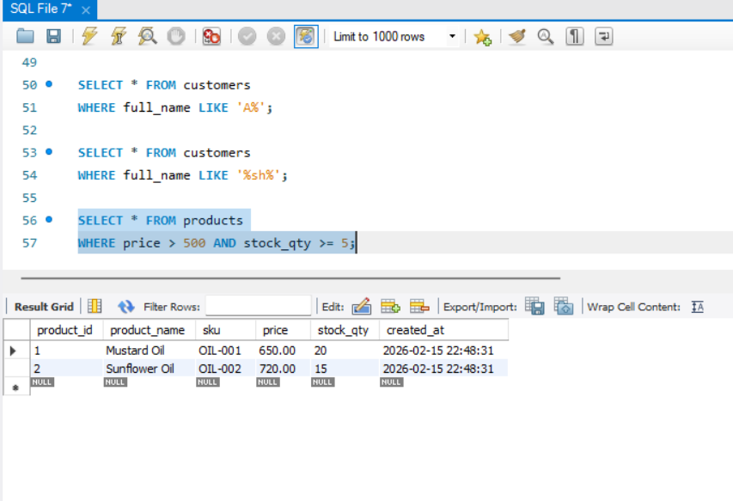
Explanation: This query filters high-value products that are sufficiently stocked, supporting pricing and sales decisions.

Task 5: Sorting and Limiting Outputs
Figure 9: Top 3 most expensive products
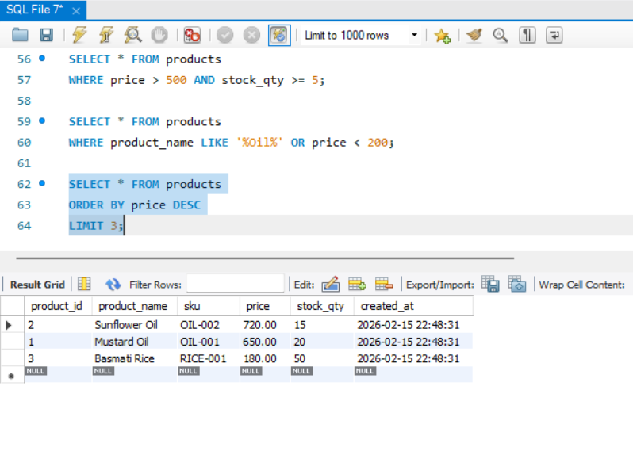
Explanation: This query retrieves the top 3 most expensive products to assist management in pricing analysis and premium product promotion.
Figure 10: Latest customers ordered by creation date
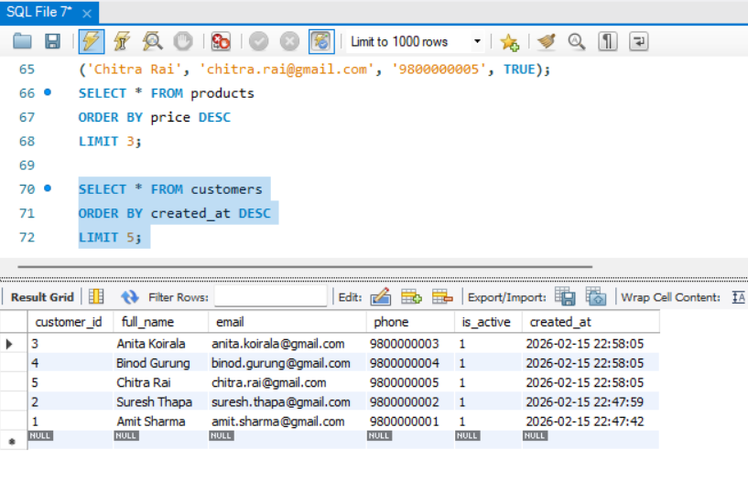
Explanation: Retrieving the most recent 5 customers allows the company to monitor new sign-ups and target recent clients for marketing campaigns.
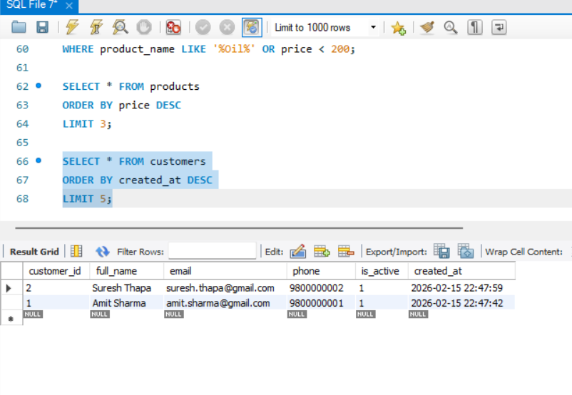
Explanation for first 2 customers alphabetically: This query shows the first 2 customers alphabetically, useful for reporting or generating client lists in a standard order.

Task 6: Rename Table
Figure 11: customers renamed to client_accounts [Insert Screenshot Here] Explanation: Table renaming supports evolving system requirements.
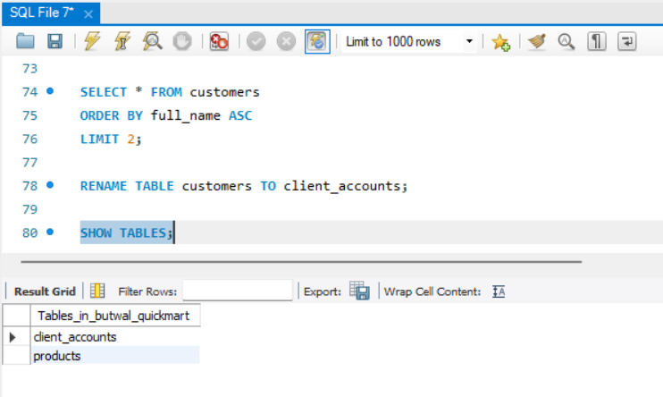

Task 7: Alter Table Structure
Figure 12: client_accounts with address column
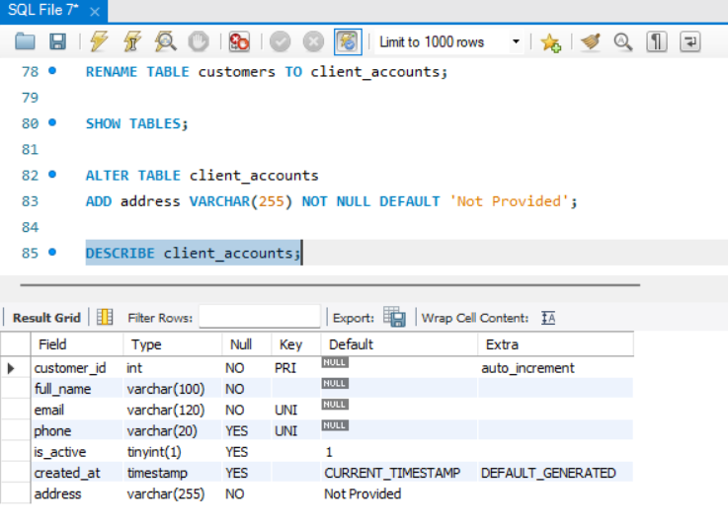
Explanation: The address column allows storing customer address information with a default of ‘Not Provided’.
Figure 13: products with category column
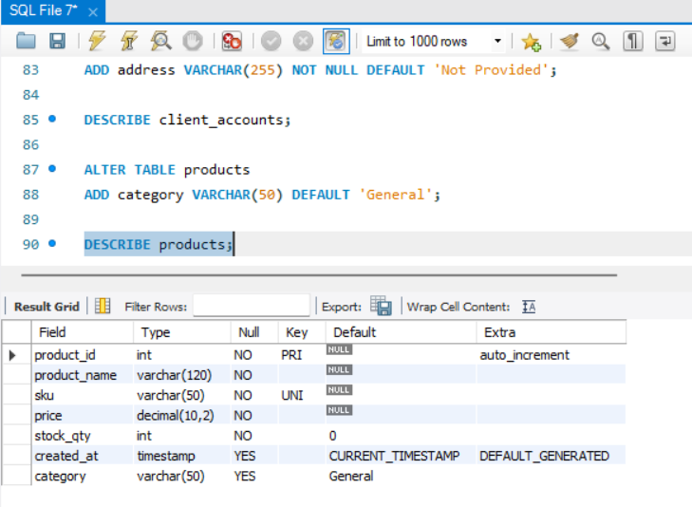
Explanation: Adding a category column allows product classification for reporting and inventory management.

Task 8: Move Column to First Position
Figure 14: sku moved to first position
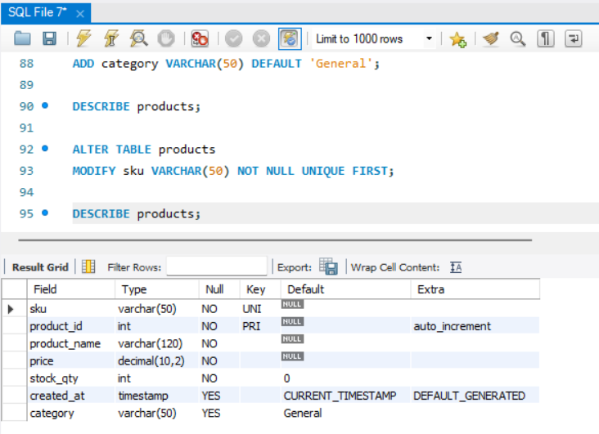
Explanation: Column order adjusted to match reporting format requirements.

Task 9: Data Integrity Testing
Figure 15: Duplicate SKU error
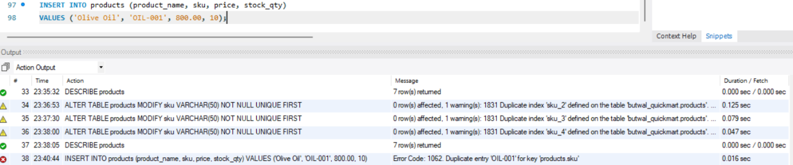
Explanation: UNIQUE constraints prevent duplicate product records, ensuring accurate inventory and avoiding business inconsistencies.
Figure 16: Duplicate email error
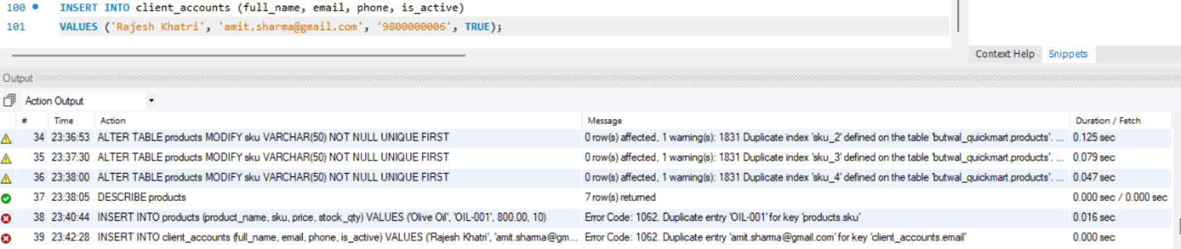
Explanation: UNIQUE constraints on customer email prevent duplicate accounts, maintaining data integrity and reliability.

Task 10: Drop Database
Figure 17: Database dropped
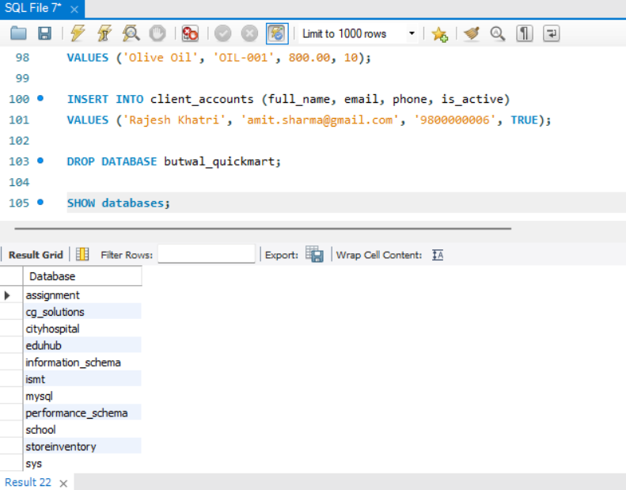
Explanation: Dropping a database permanently deletes all data. It should only be performed in testing or when backups are available.

