- 基于磁盘的存储池
注意：不应当将整个磁盘或块设备（如/dev/sdb）分配给虚拟机，而是将分区（/dev/sdb1）或LVM卷分配给虚拟机。
如果将整个磁盘传给虚拟机，虚拟机可能会在其中创建自己的LVM组，这会导致物理服务器会检测到这些分区就有可能导致错误。

注意：存储池的专用磁盘将重新格式化并删除其上所有数据。强烈推荐在使用之前面备份其上的所有数据。

下面，我们将创建一个基于磁盘的存储池。
首先，我们给KVM添加一个40GB的磁盘。然后，强制刷新存储。
# for i in /sys/class/scsi_host/*; do echo "- - -" > $i/scan; done
# fdisk -l

Disk /dev/sda: 21.5 GB, 21474836480 bytes, 41943040 sectors
Units = sectors of 1 * 512 = 512 bytes
Sector size (logical/physical): 512 bytes / 512 bytes
I/O size (minimum/optimal): 512 bytes / 512 bytes
Disk label type: dos
Disk identifier: 0x0008b8ea

Device Boot Start End Blocks Id System
/dev/sda1 * 2048 1026047 512000 83 Linux
/dev/sda2 1026048 41943039 20458496 8e Linux LVM

Disk /dev/sdb: 85.9 GB, 85899345920 bytes, 167772160 sectors
Units = sectors of 1 * 512 = 512 bytes
Sector size (logical/physical): 512 bytes / 512 bytes
I/O size (minimum/optimal): 512 bytes / 512 bytes

Disk /dev/mapper/centos-root: 18.8 GB, 18756927488 bytes, 36634624 sectors
Units = sectors of 1 * 512 = 512 bytes
Sector size (logical/physical): 512 bytes / 512 bytes
I/O size (minimum/optimal): 512 bytes / 512 bytes

Disk /dev/mapper/centos-swap: 2147 MB, 2147483648 bytes, 4194304 sectors
Units = sectors of 1 * 512 = 512 bytes
Sector size (logical/physical): 512 bytes / 512 bytes
I/O size (minimum/optimal): 512 bytes / 512 bytes

Disk /dev/mapper/vmvg-lvvm1: 85.9 GB, 85895151616 bytes, 167763968 sectors
Units = sectors of 1 * 512 = 512 bytes
Sector size (logical/physical): 512 bytes / 512 bytes
I/O size (minimum/optimal): 512 bytes / 512 bytes

Disk /dev/sdc: 42.9 GB, 42949672960 bytes, 83886080 sectors
Units = sectors of 1 * 512 = 512 bytes
Sector size (logical/physical): 512 bytes / 512 bytes
I/O size (minimum/optimal): 512 bytes / 512 bytes

新的磁盘的设备名为/dev/sdc。下面我们将其标记为GPT磁盘。
# parted /dev/sdc
GNU Parted 3.1
Using /dev/sdc
Welcome to GNU Parted! Type 'help' to view a list of commands.
(parted) mklabel
New disk label type? gpt
(parted) quit
Information: You may need to update /etc/fstab.

# fdisk -l /dev/sdc
WARNING: fdisk GPT support is currently new, and therefore in an experimental phase. Use at your own discretion.

Disk /dev/sdc: 42.9 GB, 42949672960 bytes, 83886080 sectors
Units = sectors of 1 * 512 = 512 bytes
Sector size (logical/physical): 512 bytes / 512 bytes
I/O size (minimum/optimal): 512 bytes / 512 bytes
Disk label type: gpt

# Start End Size Type Name

创建一个新的池定义XML文档
# vi /tmp/guest_images_disk.xml
添加如下的内容：
<pool type='disk'>
<name>guest_images_disk</name>
<source>
<device path='/dev/sdc'/>
<format type='gpt'/>
</source>
<target>
<path>/dev</path>
</target>
</pool>

根据XML文件的设置来创建新的存储池。
# virsh pool-define /tmp/guest_images_disk.xml
Pool guest_images_disk defined from /tmp/guest_images_disk.xml

# virsh pool-list
Name State Autostart
-------------------------------------------
default active yes
iso active yes
vm active yes

没有看到，是因为没有其激活。使用 --all list inactive & active pools
# virsh pool-list --all
Name State Autostart
-------------------------------------------
default active yes
guest_images_disk inactive no
iso active yes
vm active yes

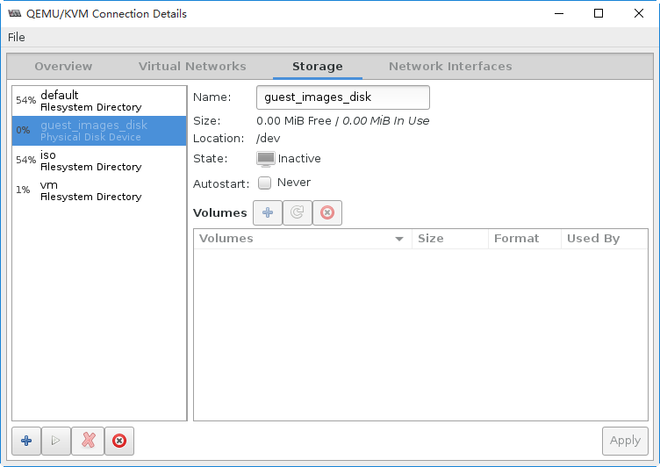

在kvm存储池配置文件中，会增加一个新的文件。
# ll /etc/libvirt/storage/
total 16
drwxr-xr-x. 2 root root 51 Mar 9 17:13 autostart
-rw-------. 1 root root 538 Mar 9 12:26 default.xml
-rw-------. 1 root root 595 Mar 14 18:26 guest_images_disk.xml
-rw-------. 1 root root 511 Mar 9 16:32 iso.xml
-rw-------. 1 root root 508 Mar 9 17:13 vm.xml

# cat /etc/libvirt/storage/guest_images_disk.xml
<!--
WARNING: THIS IS AN AUTO-GENERATED FILE. CHANGES TO IT ARE LIKELY TO BE
OVERWRITTEN AND LOST. Changes to this xml configuration should be made using:
virsh pool-edit guest_images_disk
or other application using the libvirt API.
-->

<pool type='disk'>
<name>guest_images_disk</name>
<uuid>8b4cfc87-2fd3-4507-8962-ac0d0005c2ff</uuid>
<capacity unit='bytes'>0</capacity>
<allocation unit='bytes'>0</allocation>
<available unit='bytes'>0</available>
<source>
<device path='/dev/sdc'/>
<format type='gpt'/>
</source>
<target>
<path>/dev</path>
</target>
</pool>

下面，我们将启动新创建的存储池
# virsh pool-start guest_images_disk
Pool guest_images_disk started

# virsh pool-list --all
Name State Autostart
-------------------------------------------
default active yes
guest_images_disk active no
iso active yes
vm active yes

# virsh pool-info guest_images_disk
Name: guest_images_disk
UUID: 8b4cfc87-2fd3-4507-8962-ac0d0005c2ff
State: running
Persistent: yes
Autostart: no
Capacity: 40.00 GiB
Allocation: 0.00 B
Available: 40.00 GiB

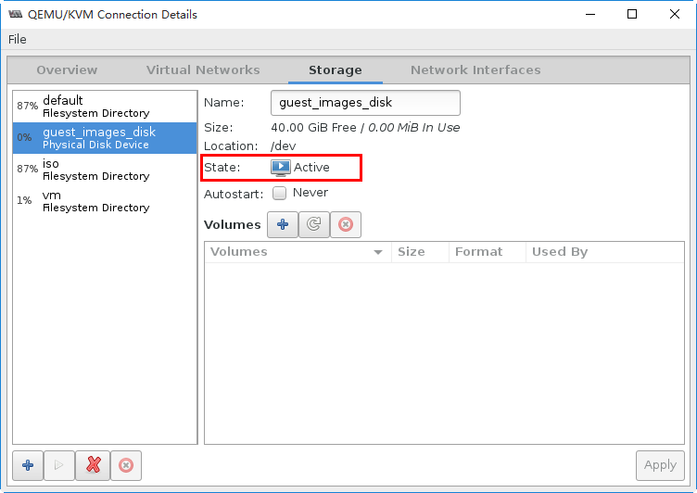

下面，我们将其设置为自动启动。

# virsh pool-autostart guest_images_disk
Pool guest_images_disk marked as autostarted

# virsh pool-list
Name State Autostart
-------------------------------------------
default active yes
guest_images_disk active yes
iso active yes
vm active yes

# ll /etc/libvirt/storage/autostart/
total 0
lrwxrwxrwx. 1 root root 32 Mar 16 18:17 default.xml -> /etc/libvirt/storage/default.xml
lrwxrwxrwx. 1 root root 42 Apr 25 16:32 guest_images_disk.xml -> /etc/libvirt/storage/guest_images_disk.xml
lrwxrwxrwx. 1 root root 28 Mar 17 15:08 iso.xml -> /etc/libvirt/storage/iso.xml
lrwxrwxrwx. 1 root root 27 Mar 17 15:09 vm.xml -> /etc/libvirt/storage/vm.xml

在virt-manager中查看存储池的状态。
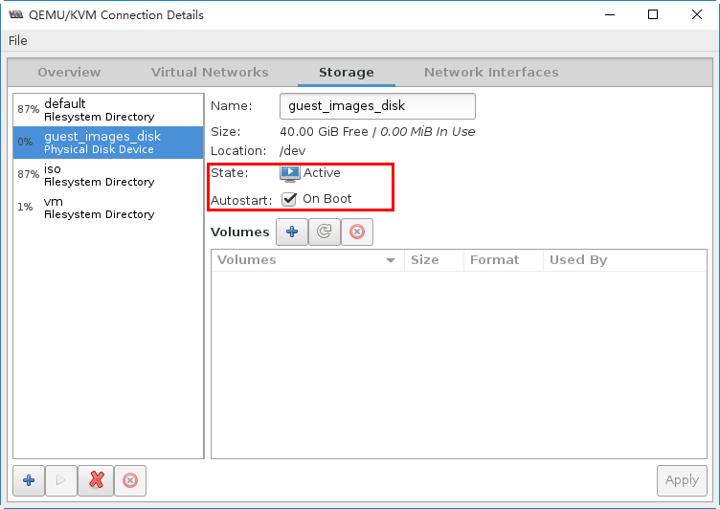

删除临时配置文件
# rm /tmp/guest_images_disk.xml
rm: remove regular file '/tmp/guest_images_disk.xml'? y

完成本实验，下面我们删除此存储池。
# virsh pool-destroy guest_images_disk
Pool guest_images_disk destroyed

# virsh pool-undefine guest_images_disk
Pool guest_images_disk has been undefined

# virsh pool-list --all
Name State Autostart
-------------------------------------------
default active yes
iso active yes
vm active yes

