- 基于LVM的存储池

LVM-based storage pools require a full disk partition. If activating a new partition/device with these procedures, the partition will be formatted and all data will be erased. If using the host's existing Volume Group (VG) nothing will be erased. It is recommended to back up the storage device before commencing the following procedure.

基于LVM的存储池要求全部磁盘分区。在此过程中，如果激活一个新分区/设备，分区将被格式化而且删除其上所有数据。如果使用Host已经存在的Volume Group (VG)，不会删除数据。推荐在进行下述操作时先进行必要的备份。
  - 使用virt-manager创建基于LVM的存储池
基于LVM存储池即可以使用已有的VG，也可以在新的空白分区上创建新的卷组。

使用已经有卷组
在下面的实验中，我们使用一块40GB的新磁盘。事先创建一个新的VG，然后创建一个存储池。

（在本实验环境中，可以将之前面已经设置为GPT格式的磁盘删除，重新创建一个新的磁盘）

# fdisk -l /dev/sdc
Disk /dev/sdc: 42.9 GB, 42949672960 bytes, 83886080 sectors
Units = sectors of 1 * 512 = 512 bytes
Sector size (logical/physical): 512 bytes / 512 bytes
I/O size (minimum/optimal): 512 bytes / 512 bytes
没有分区的新磁盘。

# fdisk /dev/sdc
创建一个新的分区，使用全部空间，并且将分区类型修改为8e，即LVM格式。

# fdisk -l /dev/sdc

Disk /dev/sdc: 42.9 GB, 42949672960 bytes, 83886080 sectors
Units = sectors of 1 * 512 = 512 bytes
Sector size (logical/physical): 512 bytes / 512 bytes
I/O size (minimum/optimal): 512 bytes / 512 bytes
Disk label type: dos
Disk identifier: 0xe7926887

Device Boot Start End Blocks Id System
/dev/sdc1 2048 83886079 41942016 8e Linux LVM

下面，我们创建名为guest_images_lvm的卷组。

# pvcreate /dev/sdc1
Physical volume "/dev/sdc1" successfully created
# vgcreate guest_images_lvm /dev/sdc1
Volume group "guest_images_lvm" successfully created

# vgdisplay guest_images_lvm
--- Volume group ---
VG Name guest_images_lvm
System ID
Format lvm2
Metadata Areas 1
Metadata Sequence No 1
VG Access read/write
VG Status resizable
MAX LV 0
Cur LV 0
Open LV 0
Max PV 0
Cur PV 1
Act PV 1
VG Size 40.00 GiB
PE Size 4.00 MiB
Total PE 10239
Alloc PE / Size 0 / 0
Free PE / Size 10239 / 40.00 GiB
VG UUID f4HPKT-OgV3-byDy-fu1I-HxRC-YOUx-cyc94w

打开virt-manager，Edit>Connection Details> Storage

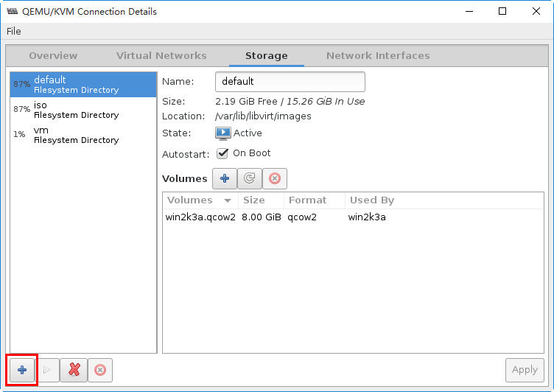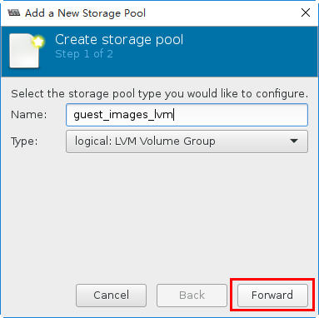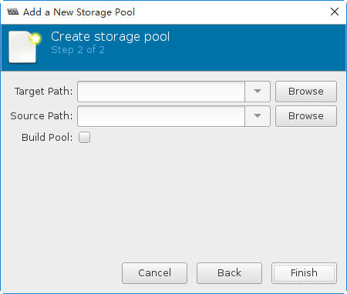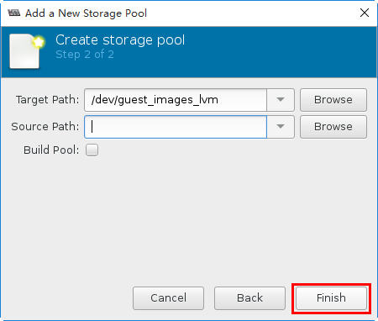
由于使用已经存在的卷组，所以仅需要在Target Path中输入刚才创建的存在卷组名：/dev/guest_images_lvm.

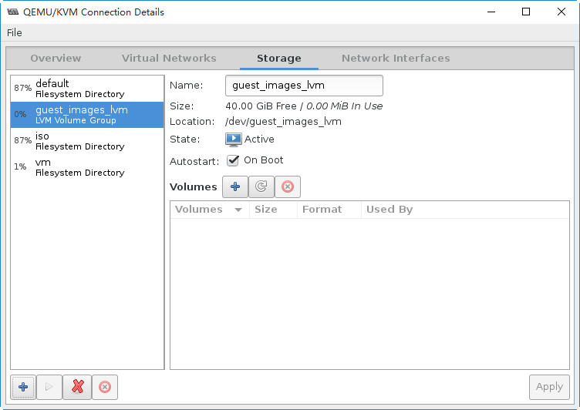

# virsh pool-list
Name State Autostart
-------------------------------------------
default active yes
guest_images_lvm active yes
iso active yes
vm active yes

# virsh pool-info guest_images_lvm
Name: guest_images_lvm
UUID: d0c3e54a-d517-4570-a6e2-91d42b35a394
State: running
Persistent: yes
Autostart: yes
Capacity: 40.00 GiB
Allocation: 0.00 B
Available: 40.00 GiB

# cat /etc/libvirt/storage/guest_images_lvm.xml
<!--
WARNING: THIS IS AN AUTO-GENERATED FILE. CHANGES TO IT ARE LIKELY TO BE OVERWRITTEN AND LOST. Changes to this xml configuration should be made using: virsh pool-edit guest_images_lvm or other application using the libvirt API.
-->

<pool type='logical'>
<name>guest_images_lvm</name>
<uuid>d0c3e54a-d517-4570-a6e2-91d42b35a394</uuid>
<capacity unit='bytes'>0</capacity>
<allocation unit='bytes'>0</allocation>
<available unit='bytes'>0</available>
<source>
<name>guest_images_lvm</name>
<format type='lvm2'/>
</source>
<target>
<path>/dev/guest_images_lvm</path>
</target>
</pool>

# vgdisplay guest_images_lvm
--- Volume group ---
VG Name guest_images_lvm
System ID
Format lvm2
Metadata Areas 1
Metadata Sequence No 1
VG Access read/write
VG Status resizable
MAX LV 0
Cur LV 0
Open LV 0
Max PV 0
Cur PV 1
Act PV 1
VG Size 40.00 GiB
PE Size 4.00 MiB
Total PE 10239
Alloc PE / Size 0 / 0
Free PE / Size 10239 / 40.00 GiB
VG UUID f4HPKT-OgV3-byDy-fu1I-HxRC-YOUx-cyc94w

为了后续的实验，我们将此新建的存储池删除，同时也删除VG。

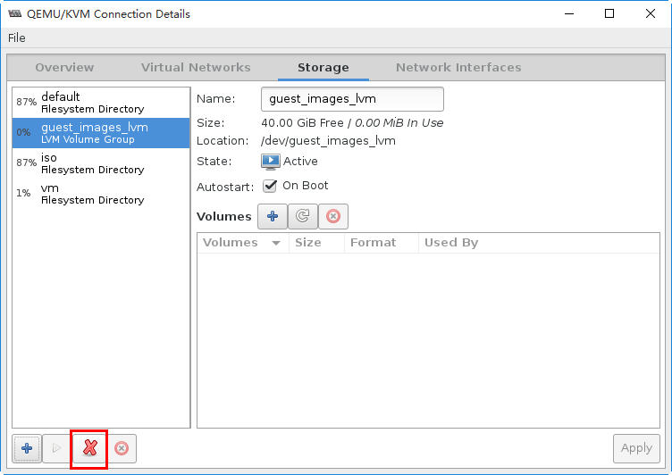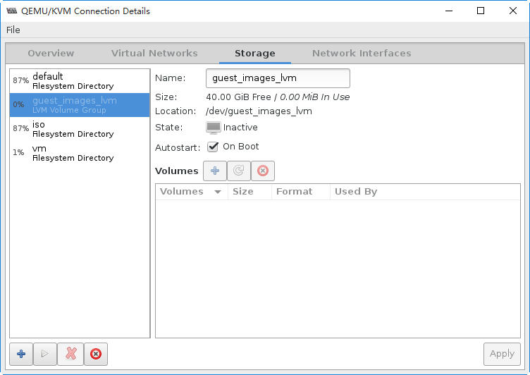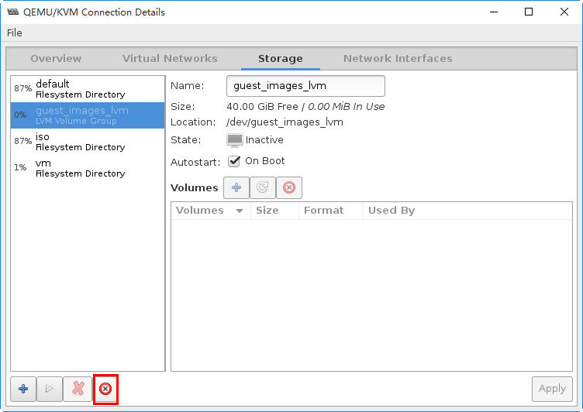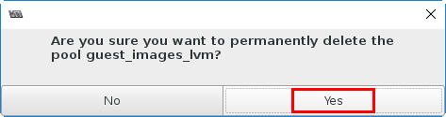

删除VG。
# vgscan
Reading all physical volumes. This may take a while...
Found volume group "guest_images_lvm" using metadata type lvm2
Found volume group "vmvg" using metadata type lvm2
Found volume group "centos" using metadata type lvm2

# vgremove guest_images_lvm
Volume group "guest_images_lvm" successfully removed
# vgscan
Reading all physical volumes. This may take a while...
Found volume group "vmvg" using metadata type lvm2
Found volume group "centos" using metadata type lvm2

下面删除PV。

# pvscan
PV /dev/sda2 VG centos lvm2 [19.51 GiB / 40.00 MiB free]
PV /dev/sdb VG vmvg lvm2 [80.00 GiB / 0 free]
PV /dev/sdc1 lvm2 [40.00 GiB]
Total: 3 [139.50 GiB] / in use: 2 [99.50 GiB] / in no VG: 1 [40.00 GiB]

# pvremove /dev/sdc1
Labels on physical volume "/dev/sdc1" successfully wiped

# pvscan
PV /dev/sda2 VG centos lvm2 [19.51 GiB / 40.00 MiB free]
PV /dev/sdb VG vmvg lvm2 [80.00 GiB / 0 free]
Total: 2 [99.50 GiB] / in use: 2 [99.50 GiB] / in no VG: 0 [0 ]

最后，删除分区。

# fdisk /dev/sdc
Welcome to fdisk (util-linux 2.23.2).

Changes will remain in memory only, until you decide to write them.
Be careful before using the write command.

Command (m for help): p

Disk /dev/sdc: 42.9 GB, 42949672960 bytes, 83886080 sectors
Units = sectors of 1 * 512 = 512 bytes
Sector size (logical/physical): 512 bytes / 512 bytes
I/O size (minimum/optimal): 512 bytes / 512 bytes
Disk label type: dos
Disk identifier: 0xe7926887

Device Boot Start End Blocks Id System
/dev/sdc1 2048 83886079 41942016 8e Linux LVM

Command (m for help): d
Selected partition 1
Partition 1 is deleted

Command (m for help): p

Disk /dev/sdc: 42.9 GB, 42949672960 bytes, 83886080 sectors
Units = sectors of 1 * 512 = 512 bytes
Sector size (logical/physical): 512 bytes / 512 bytes
I/O size (minimum/optimal): 512 bytes / 512 bytes
Disk label type: dos
Disk identifier: 0xe7926887

Device Boot Start End Blocks Id System

Command (m for help): w
The partition table has been altered!

Calling ioctl() to re-read partition table.
Syncing disks.

通过创建新的卷组来创建存储池

通过上述的清理过程，我们现有一个“干净”的40GB的磁盘。我们将通过virt-manger中的Build Pool功能来创建新的VG，然后创建新的存储池。
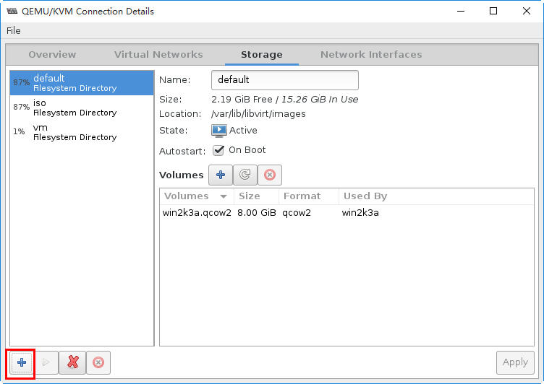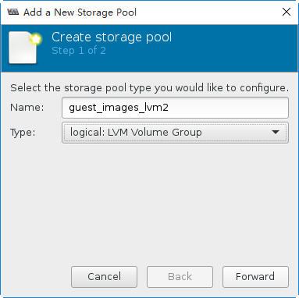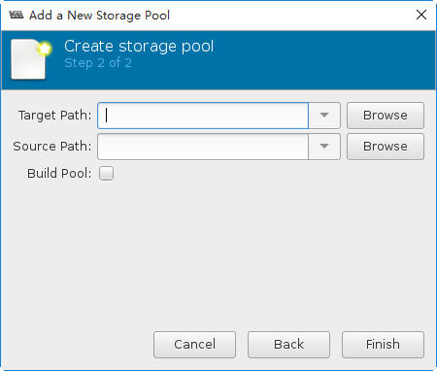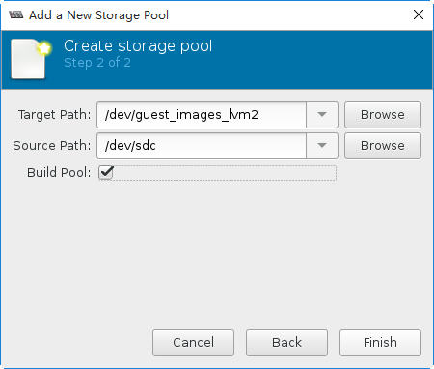

在Target Path中输入新的卷组名，本例中为guest_images_lvm2。
在Source Path中输入存储设备的位置，本例中为空磁盘/dev/sdc.
选中Build Pool，会创建新的VG.

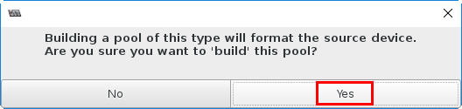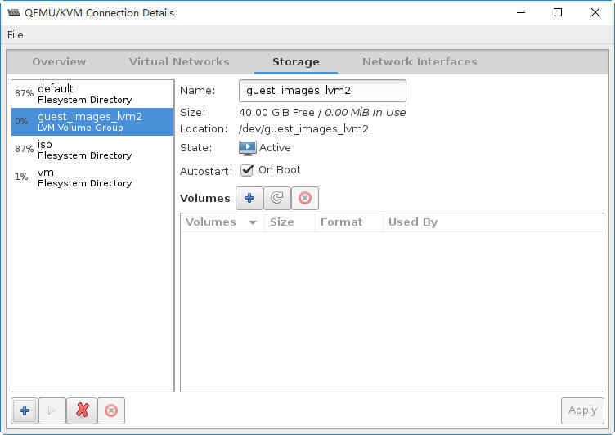

复查一下。
# virsh pool-list
Name State Autostart
-------------------------------------------
default active yes
guest_images_lvm2 active yes
iso active yes
vm active yes

# virsh pool-info guest_images_lvm2
Name: guest_images_lvm2
UUID: 466e1b77-c1d0-4853-aa54-1b3dab8b6610
State: running
Persistent: yes
Autostart: yes
Capacity: 40.00 GiB
Allocation: 0.00 B
Available: 40.00 GiB

# cat /etc/libvirt/storage/guest_images_lvm2.xml
<!--
WARNING: THIS IS AN AUTO-GENERATED FILE. CHANGES TO IT ARE LIKELY TO BE OVERWRITTEN AND LOST. Changes to this xml configuration should be made using: virsh pool-edit guest_images_lvm2 or other application using the libvirt API.
-->

<pool type='logical'>
<name>guest_images_lvm2</name>
<uuid>466e1b77-c1d0-4853-aa54-1b3dab8b6610</uuid>
<capacity unit='bytes'>0</capacity>
<allocation unit='bytes'>0</allocation>
<available unit='bytes'>0</available>
<source>
<device path='/dev/sdc'/>
<name>guest_images_lvm2</name>
<format type='lvm2'/>
</source>
<target>
<path>/dev/guest_images_lvm2</path>
</target>
</pool>

# pvscan
PV /dev/sda2 VG centos lvm2 [19.51 GiB / 40.00 MiB free]
PV /dev/sdb VG vmvg lvm2 [80.00 GiB / 0 free]
PV /dev/sdc VG guest_images_lvm2 lvm2 [40.00 GiB / 40.00 GiB free]
Total: 3 [139.50 GiB] / in use: 3 [139.50 GiB] / in no VG: 0 [0 ]

自动将整块磁盘创建为PV

# vgscan
Reading all physical volumes. This may take a while...
Found volume group "guest_images_lvm2" using metadata type lvm2
Found volume group "vmvg" using metadata type lvm2
Found volume group "centos" using metadata type lvm2
自动创建的VG。

# vgdisplay guest_images_lvm2
--- Volume group ---
VG Name guest_images_lvm2
System ID
Format lvm2
Metadata Areas 1
Metadata Sequence No 1
VG Access read/write
VG Status resizable
MAX LV 0
Cur LV 0
Open LV 0
Max PV 0
Cur PV 1
Act PV 1
VG Size 40.00 GiB
PE Size 4.00 MiB
Total PE 10239
Alloc PE / Size 0 / 0
Free PE / Size 10239 / 40.00 GiB
VG UUID v6rjve-jeJH-kaI5-1rfl-WOrg-dl6w-P1QX5s

为了后续的实验，我们将此新建的存储池删除，同时也删除VG、PV及分区。

操作过程与前面类似。

  - 使用virt-sh创建基于LVM的存储池
下面，我们将通过virt-sh在新的空白设备/dev/sdc上创建新的卷组。

查看一下当前的实验环境。
# vgscan
Reading all physical volumes. This may take a while...
Found volume group "vmvg" using metadata type lvm2
Found volume group "centos" using metadata type lvm2
# pvscan
PV /dev/sda2 VG centos lvm2 [19.51 GiB / 40.00 MiB free]
PV /dev/sdb VG vmvg lvm2 [80.00 GiB / 0 free]
Total: 2 [99.50 GiB] / in use: 2 [99.50 GiB] / in no VG: 0 [0 ]
# virsh pool-list
Name State Autostart
-------------------------------------------
default active yes
iso active yes
vm active yes

# virsh pool-define-as --help
NAME
pool-define-as - define a pool from a set of args

SYNOPSIS
pool-define-as <name> <type> [--print-xml] [--source-host <string>] [--source-path <string>] [--source-dev <string>] [--source-name <string>] [--target <string>] [--source-format <string>] [--auth-type <string>] [--auth-username <string>] [--secret-usage <string>] [--adapter-name <string>] [--adapter-wwnn <string>] [--adapter-wwpn <string>] [--adapter-parent <string>]

DESCRIPTION
Define a pool.

OPTIONS
[--name] <string> name of the pool
[--type] <string> type of the pool
--print-xml print XML document, but don't define/create
--source-host <string> source-host for underlying storage
--source-path <string> source path for underlying storage
--source-dev <string> source device for underlying storage
--source-name <string> source name for underlying storage
--target <string> target for underlying storage
--source-format <string> format for underlying storage
--auth-type <string> auth type to be used for underlying storage
--auth-username <string> auth username to be used for underlying storage
--secret-usage <string> auth secret usage to be used for underlying storage
--adapter-name <string> adapter name to be used for underlying storage
--adapter-wwnn <string> adapter wwnn to be used for underlying storage
--adapter-wwpn <string> adapter wwpn to be used for underlying storage
--adapter-parent <string> adapter parent to be used for underlying storage

# virsh pool-define-as guest_images_lvm3 logical \
--source-dev=/dev/sdc --source-name=libvirt_lvm \
--target=/dev/libvirt_vg
Pool guest_images_lvm3 defined

# virsh pool-list
Name State Autostart
-------------------------------------------
default active yes
iso active yes
vm active yes

# virsh pool-list --all
Name State Autostart
-------------------------------------------
default active yes
guest_images_lvm3 inactive no
iso active yes
vm active yes

# cat /etc/libvirt/storage/guest_images_lvm3.xml
<!--
WARNING: THIS IS AN AUTO-GENERATED FILE. CHANGES TO IT ARE LIKELY TO BE OVERWRITTEN AND LOST. Changes to this xml configuration should be made using: virsh pool-edit guest_images_lvm3 or other application using the libvirt API.
-->

<pool type='logical'>
<name>guest_images_lvm3</name>
<uuid>ad21a3c6-0265-4a64-8c77-a4f4c198e85f</uuid>
<capacity unit='bytes'>0</capacity>
<allocation unit='bytes'>0</allocation>
<available unit='bytes'>0</available>
<source>
<device path='/dev/sdc'/>
<name>libvirt_lvm</name>
<format type='lvm2'/>
</source>
<target>
<path>/dev/libvirt_lvm</path>
</target>
</pool>

查看LVM的信息。
# vgscan
Reading all physical volumes. This may take a while...
Found volume group "vmvg" using metadata type lvm2
Found volume group "centos" using metadata type lvm2
# pvscan
PV /dev/sda2 VG centos lvm2 [19.51 GiB / 40.00 MiB free]
PV /dev/sdb VG vmvg lvm2 [80.00 GiB / 0 free]
Total: 2 [99.50 GiB] / in use: 2 [99.50 GiB] / in no VG: 0 [0 ]

并没有发现新VG、PV等信息。我们需要使用pool-build命令来创建pool。
# virsh pool-build guest_images_lvm3
Pool guest_images_lvm3 built

# vgscan
Reading all physical volumes. This may take a while...
Found volume group "libvirt_lvm" using metadata type lvm2
Found volume group "vmvg" using metadata type lvm2
Found volume group "centos" using metadata type lvm2
# pvscan
PV /dev/sda2 VG centos lvm2 [19.51 GiB / 40.00 MiB free]
PV /dev/sdb VG vmvg lvm2 [80.00 GiB / 0 free]
PV /dev/sdc VG libvirt_lvm lvm2 [40.00 GiB / 40.00 GiB free]
Total: 3 [139.50 GiB] / in use: 3 [139.50 GiB] / in no VG: 0 [0 ]
# vgdisplay libvirt_lvm
--- Volume group ---
VG Name libvirt_lvm
System ID
Format lvm2
Metadata Areas 1
Metadata Sequence No 1
VG Access read/write
VG Status resizable
MAX LV 0
Cur LV 0
Open LV 0
Max PV 0
Cur PV 1
Act PV 1
VG Size 40.00 GiB
PE Size 4.00 MiB
Total PE 10239
Alloc PE / Size 0 / 0
Free PE / Size 10239 / 40.00 GiB
VG UUID niGY2W-8By2-j2BR-IZyG-fGrG-Liue-aiuiUw

会看到新创建VG、PV等信息。

# virsh pool-start guest_images_lvm3
Pool guest_images_lvm3 started

# virsh pool-autostart guest_images_lvm3
Pool guest_images_lvm3 marked as autostarted

# virsh pool-list
Name State Autostart
-------------------------------------------
default active yes
guest_images_lvm3 active yes
iso active yes
vm active yes

下面，我们通过vol-create-as来创建三个卷。此命令对应的virt-manager中操作为：
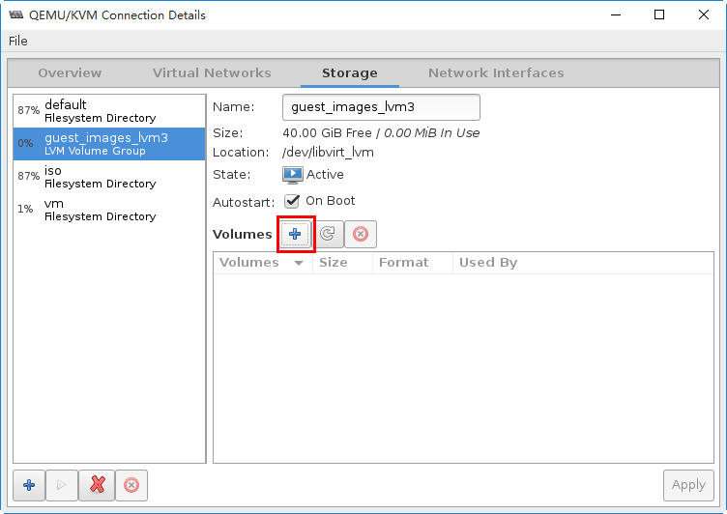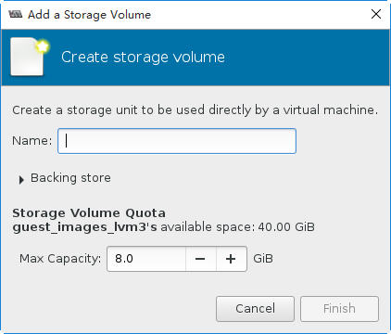

# virsh vol-create-as guest_images_lvm3 volume1 1G
Vol volume1 created

# virsh vol-create-as guest_images_lvm3 volume2 2G
Vol volume2 created

# virsh vol-create-as guest_images_lvm3 volume3 3G
Vol volume3 created

执行完三个命令，其效果如下所示：
# virsh vol-list guest_images_lvm3
Name Path
----------------------------------------------------------------
volume1 /dev/libvirt_lvm/volume1
volume2 /dev/libvirt_lvm/volume2
volume3 /dev/libvirt_lvm/volume3

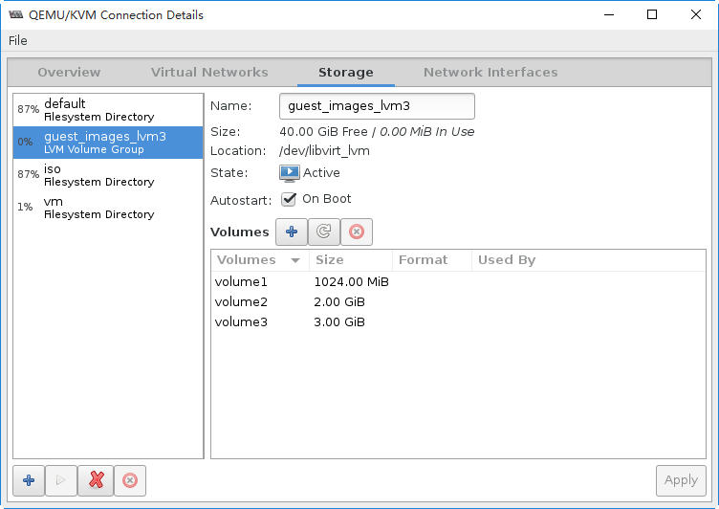

查看LVM的信息。
# lvscan
ACTIVE '/dev/libvirt_lvm/volume1' [1.00 GiB] inherit
ACTIVE '/dev/libvirt_lvm/volume2' [2.00 GiB] inherit
ACTIVE '/dev/libvirt_lvm/volume3' [3.00 GiB] inherit
ACTIVE '/dev/vmvg/lvvm1' [80.00 GiB] inherit
ACTIVE '/dev/centos/swap' [2.00 GiB] inherit
ACTIVE '/dev/centos/root' [17.47 GiB] inherit

# vgdisplay libvirt_lvm
--- Volume group ---
VG Name libvirt_lvm
System ID
Format lvm2
Metadata Areas 1
Metadata Sequence No 4
VG Access read/write
VG Status resizable
MAX LV 0
Cur LV 3
Open LV 0
Max PV 0
Cur PV 1
Act PV 1
VG Size 40.00 GiB
PE Size 4.00 MiB
Total PE 10239
Alloc PE / Size 1536 / 6.00 GiB
Free PE / Size 8703 / 34.00 GiB
VG UUID niGY2W-8By2-j2BR-IZyG-fGrG-Liue-aiuiUw

为了后续的实验，我们清除一下实验环境。首先，我们将停止存储池。

# virsh pool-destroy guest_images_lvm3
Pool guest_images_lvm3 destroyed

# virsh pool-list --all
Name State Autostart
-------------------------------------------
default active yes
guest_images_lvm3 inactive yes
iso active yes
vm active yes

# virsh pool-delete guest_images_lvm3
Pool guest_images_lvm3 deleted

# lvscan
ACTIVE '/dev/vmvg/lvvm1' [80.00 GiB] inherit
ACTIVE '/dev/centos/swap' [2.00 GiB] inherit
ACTIVE '/dev/centos/root' [17.47 GiB] inherit
# vgscan
Reading all physical volumes. This may take a while...
Found volume group "vmvg" using metadata type lvm2
Found volume group "centos" using metadata type lvm2
注意：删除存储池，也会清除LVM中的配置信息

# virsh pool-list --all
Name State Autostart
-------------------------------------------
default active yes
guest_images_lvm3 inactive yes ← 状态没有大的变化。
iso active yes
vm active yes

# virsh pool-undefine guest_images_lvm3
Pool guest_images_lvm3 has been undefined

# virsh pool-list --all
Name State Autostart
-------------------------------------------
default active yes
iso active yes

环境清理完毕

