1. 环境准备 1
1.1. 软件版本信息 1
1.2. 操作系统安装介质 2
1.3. 准备磁盘空间 3
1.3.1. 添加用于实验的新磁盘 3
1.3.2. 创建LV 10
1.3.3. 创建文件系统及挂载点 13
2. 创建Windows 2003 虚拟机 14
2.1. 使用向导默认配置来创建虚拟机 15
2.2. 排错：虚拟机的鼠标、键盘无响应 19
2.3. 安装操作系统 21
2.4. 考察虚拟机的配置 24
3. 创建32位CentOS 6虚拟机 26
3.1. 使用向导创建虚拟机 27
3.2. 安装操作系统 35

环境准备

软件版本信息
# uname -a
Linux localhost.localdomain 3.10.0-327.el7.x86_64 #1 SMP Thu Nov 19 22:10:57 UTC 2015 x86_64 x86_64 x86_64 GNU/Linux

# cat /etc/redhat-release
CentOS Linux release 7.2.1511 (Core)

# rpm -qa | grep kvm | sort
libvirt-daemon-kvm-1.2.17-13.el7.x86_64
qemu-kvm-1.5.3-105.el7.x86_64
qemu-kvm-common-1.5.3-105.el7.x86_64

# rpm -qa | grep virt | sort
libgovirt-0.3.3-1.el7.x86_64
libvirt-1.2.17-13.el7.x86_64
libvirt-client-1.2.17-13.el7.x86_64
libvirt-daemon-1.2.17-13.el7.x86_64
libvirt-daemon-config-network-1.2.17-13.el7.x86_64
libvirt-daemon-config-nwfilter-1.2.17-13.el7.x86_64
libvirt-daemon-driver-interface-1.2.17-13.el7.x86_64
libvirt-daemon-driver-lxc-1.2.17-13.el7.x86_64
libvirt-daemon-driver-network-1.2.17-13.el7.x86_64
libvirt-daemon-driver-nodedev-1.2.17-13.el7.x86_64
libvirt-daemon-driver-nwfilter-1.2.17-13.el7.x86_64
libvirt-daemon-driver-qemu-1.2.17-13.el7.x86_64
libvirt-daemon-driver-secret-1.2.17-13.el7.x86_64
libvirt-daemon-driver-storage-1.2.17-13.el7.x86_64
libvirt-daemon-kvm-1.2.17-13.el7.x86_64
libvirt-gconfig-0.1.9-1.el7.x86_64
libvirt-glib-0.1.9-1.el7.x86_64
libvirt-gobject-0.1.9-1.el7.x86_64
libvirt-python-1.2.17-2.el7.x86_64
virt-install-1.2.1-8.el7.noarch
virt-manager-1.2.1-8.el7.noarch
virt-manager-common-1.2.1-8.el7.noarch
virt-top-1.0.8-8.el7.x86_64
virt-viewer-2.0-6.el7.x86_64
virt-what-1.13-6.el7.x86_64
virt-who-0.14-9.el7.noarch

操作系统安装介质
将32位版的Windows 2003、CentOS 6的ISO文件复制的KVM服务器上的/iso目录下。
在后续的实验中，会用到它们进行操作系统的安装。
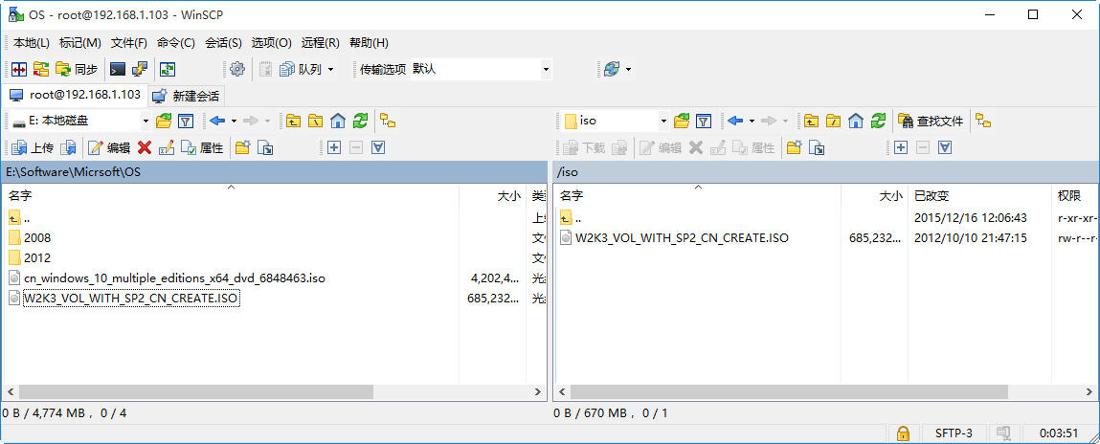

准备磁盘空间

添加用于实验的新磁盘
# fdisk -l

Disk /dev/sda: 21.5 GB, 21474836480 bytes, 41943040 sectors
Units = sectors of 1 * 512 = 512 bytes
Sector size (logical/physical): 512 bytes / 512 bytes
I/O size (minimum/optimal): 512 bytes / 512 bytes
Disk label type: dos
Disk identifier: 0x0008b8ea

Device Boot Start End Blocks Id System
/dev/sda1 * 2048 1026047 512000 83 Linux
/dev/sda2 1026048 41943039 20458496 8e Linux LVM

Disk /dev/mapper/centos-root: 18.8 GB, 18756927488 bytes, 36634624 sectors
Units = sectors of 1 * 512 = 512 bytes
Sector size (logical/physical): 512 bytes / 512 bytes
I/O size (minimum/optimal): 512 bytes / 512 bytes

Disk /dev/mapper/centos-swap: 2147 MB, 2147483648 bytes, 4194304 sectors
Units = sectors of 1 * 512 = 512 bytes
Sector size (logical/physical): 512 bytes / 512 bytes
I/O size (minimum/optimal): 512 bytes / 512 bytes

为了避免后续实验出现磁盘不足的状况，我们向KVM服务器添加一块80GB的磁盘。
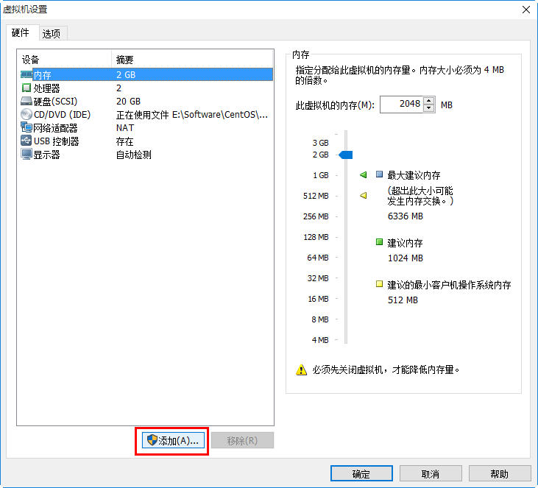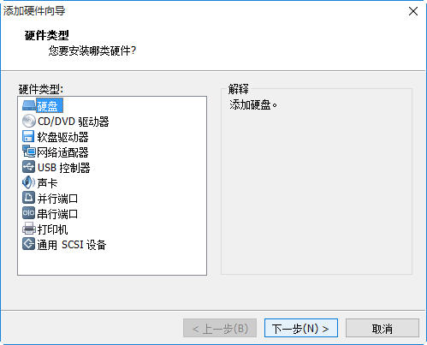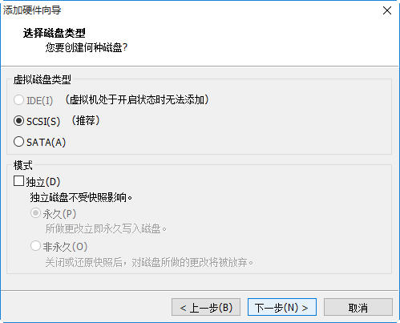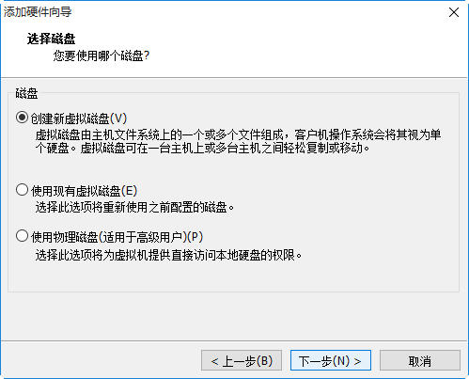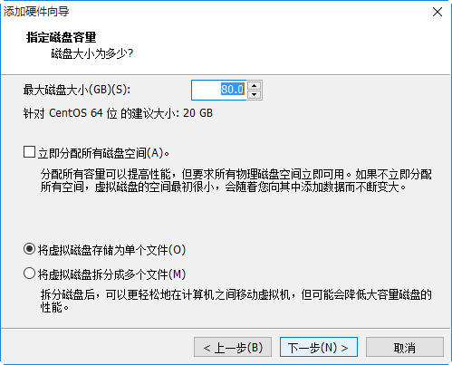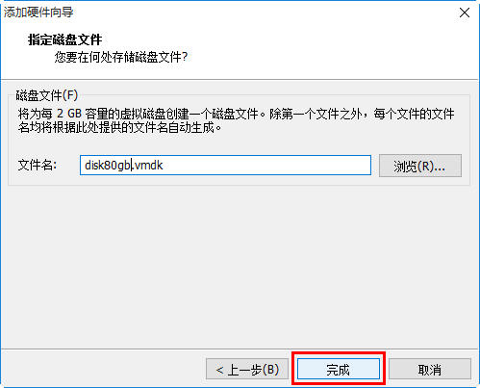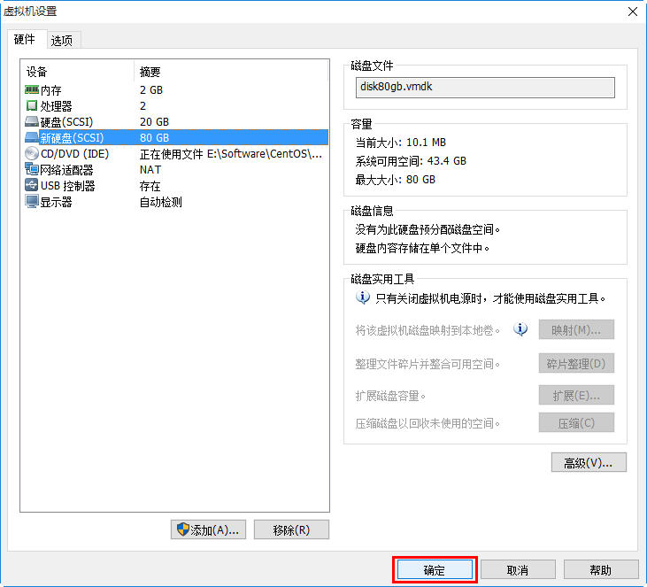

# ls /sys/class/scsi_host/
host0 host1 host2

本示例中，有三个目录，对应于三个设备文件
# ls /sys/class/scsi_host/ -l
total 0
lrwxrwxrwx. 1 root root 0 Mar 9 15:42 host0 -> ../../devices/pci0000:00/0000:00:07.1/ata1/host0/scsi_host/host0
lrwxrwxrwx. 1 root root 0 Mar 9 15:42 host1 -> ../../devices/pci0000:00/0000:00:07.1/ata2/host1/scsi_host/host1
lrwxrwxrwx. 1 root root 0 Mar 9 15:42 host2 -> ../../devices/pci0000:00/0000:00:10.0/host2/scsi_host/host2

执行以下命令
# echo "- - -" > /sys/class/scsi_host/host0/scan
# echo "- - -" > /sys/class/scsi_host/host1/scan
# echo "- - -" > /sys/class/scsi_host/host3/scan

然后，我们就会看到新的磁盘了。
# fdisk -l

Disk /dev/sda: 21.5 GB, 21474836480 bytes, 41943040 sectors
Units = sectors of 1 * 512 = 512 bytes
Sector size (logical/physical): 512 bytes / 512 bytes
I/O size (minimum/optimal): 512 bytes / 512 bytes
Disk label type: dos
Disk identifier: 0x0008b8ea

Device Boot Start End Blocks Id System
/dev/sda1 * 2048 1026047 512000 83 Linux
/dev/sda2 1026048 41943039 20458496 8e Linux LVM

Disk /dev/mapper/centos-root: 18.8 GB, 18756927488 bytes, 36634624 sectors
Units = sectors of 1 * 512 = 512 bytes
Sector size (logical/physical): 512 bytes / 512 bytes
I/O size (minimum/optimal): 512 bytes / 512 bytes

Disk /dev/mapper/centos-swap: 2147 MB, 2147483648 bytes, 4194304 sectors
Units = sectors of 1 * 512 = 512 bytes
Sector size (logical/physical): 512 bytes / 512 bytes
I/O size (minimum/optimal): 512 bytes / 512 bytes

Disk /dev/sdb: 85.9 GB, 85899345920 bytes, 167772160 sectors
Units = sectors of 1 * 512 = 512 bytes
Sector size (logical/physical): 512 bytes / 512 bytes
I/O size (minimum/optimal): 512 bytes / 512 bytes

在dmesg中，也会看到相应的信息
[13898.055185] scsi 2:0:1:0: Direct-Access VMware, VMware Virtual S 1.0 PQ: 0 ANSI: 2
[13898.055219] scsi target2:0:1: Beginning Domain Validation
[13898.055704] scsi target2:0:1: Domain Validation skipping write tests
[13898.055706] scsi target2:0:1: Ending Domain Validation
[13898.055731] scsi target2:0:1: FAST-40 WIDE SCSI 80.0 MB/s ST (25 ns, offset 127)
[13898.058322] sd 2:0:1:0: [sdb] 167772160 512-byte logical blocks: (85.8 GB/80.0 GiB)
[13898.058367] sd 2:0:1:0: [sdb] Write Protect is off
[13898.058369] sd 2:0:1:0: [sdb] Mode Sense: 61 00 00 00
[13898.058584] sd 2:0:1:0: [sdb] Cache data unavailable
[13898.058586] sd 2:0:1:0: [sdb] Assuming drive cache: write through
[13898.060390] sd 2:0:1:0: Attached scsi generic sg2 type 0
[13898.061657] sdb: unknown partition table
[13898.062018] sd 2:0:1:0: [sdb] Attached SCSI disk

在生产环境中，有可能会多个/sys/class/scsi_host/host?目录，可以使用以下命令来简化操作：
# for i in /sys/class/scsi_host/*; do echo "- - -" > $i/scan; done

创建LV
# fdisk -l

Disk /dev/sda: 21.5 GB, 21474836480 bytes, 41943040 sectors
Units = sectors of 1 * 512 = 512 bytes
Sector size (logical/physical): 512 bytes / 512 bytes
I/O size (minimum/optimal): 512 bytes / 512 bytes
Disk label type: dos
Disk identifier: 0x0008b8ea

Device Boot Start End Blocks Id System
/dev/sda1 * 2048 1026047 512000 83 Linux
/dev/sda2 1026048 41943039 20458496 8e Linux LVM

Disk /dev/mapper/centos-root: 18.8 GB, 18756927488 bytes, 36634624 sectors
Units = sectors of 1 * 512 = 512 bytes
Sector size (logical/physical): 512 bytes / 512 bytes
I/O size (minimum/optimal): 512 bytes / 512 bytes

Disk /dev/mapper/centos-swap: 2147 MB, 2147483648 bytes, 4194304 sectors
Units = sectors of 1 * 512 = 512 bytes
Sector size (logical/physical): 512 bytes / 512 bytes
I/O size (minimum/optimal): 512 bytes / 512 bytes

Disk /dev/sdb: 85.9 GB, 85899345920 bytes, 167772160 sectors
Units = sectors of 1 * 512 = 512 bytes
Sector size (logical/physical): 512 bytes / 512 bytes
I/O size (minimum/optimal): 512 bytes / 512 bytes

创建新的PV。
# pvscan
PV /dev/sda2 VG centos lvm2 [19.51 GiB / 40.00 MiB free]
Total: 1 [19.51 GiB] / in use: 1 [19.51 GiB] / in no VG: 0 [0 ]

# pvcreate /dev/sdb
Physical volume "/dev/sdb" successfully created

# pvscan
PV /dev/sda2 VG centos lvm2 [19.51 GiB / 40.00 MiB free]
PV /dev/sdb lvm2 [80.00 GiB]
Total: 2 [99.51 GiB] / in use: 1 [19.51 GiB] / in no VG: 1 [80.00 GiB]

创建新的VG
# vgscan
Reading all physical volumes. This may take a while...
Found volume group "centos" using metadata type lvm2

# vgcreate vmvg /dev/sdb
Volume group "vmvg" successfully created

# vgscan
Reading all physical volumes. This may take a while...
Found volume group "vmvg" using metadata type lvm2
Found volume group "centos" using metadata type lvm2

# vgdisplay vmvg
--- Volume group ---
VG Name vmvg
System ID
Format lvm2
Metadata Areas 1
Metadata Sequence No 1
VG Access read/write
VG Status resizable
MAX LV 0
Cur LV 0
Open LV 0
Max PV 0
Cur PV 1
Act PV 1
VG Size 80.00 GiB
PE Size 4.00 MiB
Total PE 20479 ← 等一会,将全部的PE分给新的LV
Alloc PE / Size 0 / 0
Free PE / Size 20479 / 80.00 GiB
VG UUID XhAFub-WnOL-3yjh-7NyB-3bk4-TS3S-lwcEcd

创建新的LV，使用VG的全部PE
# lvcreate -n lvvm1 -l 20479 vmvg
Logical volume "lvvm1" created.

# lvdisplay /dev/vmvg/lvvm1
--- Logical volume ---
LV Path /dev/vmvg/lvvm1
LV Name lvvm1
VG Name vmvg
LV UUID mt6JAe-Kyjq-9PTD-RNNM-JVCb-JNh8-ktWeyd
LV Write Access read/write
LV Creation host, time localhost.localdomain, 2016-03-09 16:05:13 +0800
LV Status available
# open 0
LV Size 80.00 GiB
Current LE 20479
Segments 1
Allocation inherit
Read ahead sectors auto
- currently set to 8192
Block device 253:2

# vgdisplay vmvg
--- Volume group ---
VG Name vmvg
System ID
Format lvm2
Metadata Areas 1
Metadata Sequence No 2
VG Access read/write
VG Status resizable
MAX LV 0
Cur LV 1
Open LV 0
Max PV 0
Cur PV 1
Act PV 1
VG Size 80.00 GiB
PE Size 4.00 MiB
Total PE 20479
Alloc PE / Size 20479 / 80.00 GiB
Free PE / Size 0 / 0
VG UUID XhAFub-WnOL-3yjh-7NyB-3bk4-TS3S-lwcEcd

创建文件系统及挂载点
# mkfs.ext4 /dev/vmvg/lvvm1
mke2fs 1.42.9 (28-Dec-2013)
Filesystem label=
OS type: Linux
Block size=4096 (log=2)
Fragment size=4096 (log=2)
Stride=0 blocks, Stripe width=0 blocks
5242880 inodes, 20970496 blocks
1048524 blocks (5.00%) reserved for the super user
First data block=0
Maximum filesystem blocks=2168455168
640 block groups
32768 blocks per group, 32768 fragments per group
8192 inodes per group
Superblock backups stored on blocks:
32768, 98304, 163840, 229376, 294912, 819200, 884736, 1605632, 2654208,
4096000, 7962624, 11239424, 20480000

Allocating group tables: done
Writing inode tables: done
Creating journal (32768 blocks): done
Writing superblocks and filesystem accounting information: done

# mkdir /vm
# vi /etc/fstab
在最后添加如下内容：
/dev/vmvg/lvvm1 /vm ext4 defaults 0 0

# mount /vm
# mount
……略
/dev/sr0 on /mnt/cdrom type iso9660 (ro,relatime)
/dev/mapper/vmvg-lvvm1 on /vm type ext4 (rw,relatime,seclabel,data=ordered)

# ls /vm -l
total 16
drwx------. 2 root root 16384 Mar 9 16:14 lost+found

补充：
RHEL 7 使用XFS来作为默认的文件系统。
# mkfs.xfs /dev/vmvg/lvvm1
meta-data=/dev/vmvg/lvvm1 isize=256 agcount=4, agsize=51471360 blks
= sectsz=4096 attr=2, projid32bit=1
= crc=0 finobt=0
data = bsize=4096 blocks=205885440, imaxpct=25
= sunit=0 swidth=0 blks
naming =version 2 bsize=4096 ascii-ci=0 ftype=0
log =internal log bsize=4096 blocks=100530, version=2
= sectsz=4096 sunit=1 blks, lazy-count=1
realtime =none extsz=4096 blocks=0, rtextents=0

创建Windows 2003 虚拟机
执行virt-manager，通过GUI来创建虚拟机，通过本地ISO文件进行安装。

Tip：有时启动virt-manger会出现到下警告，可以忽略这种警告
** (virt-manager:12215): WARNING **: Couldn't connect to accessibility bus: Failed to connect to socket /tmp/dbus-0vPCqQOFHy: Connection refused
这是由gtk的应用程序的发出的警告，详细请参考：
https://unix.stackexchange.com/questions/145167/gnome-programs-eog-gnome-terminal-have-a-slow-start-and-produce-a-dbus-error-n

使用向导默认配置来创建虚拟机
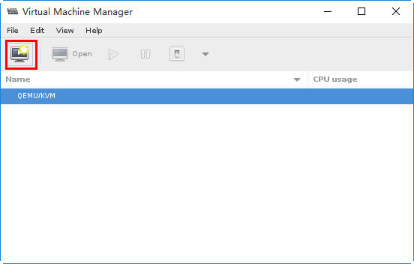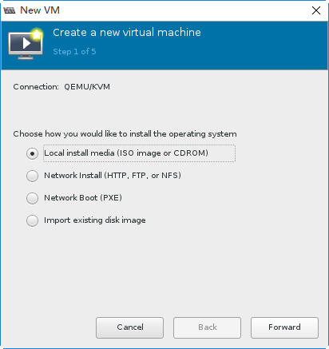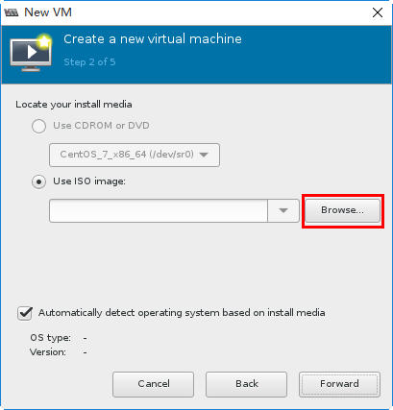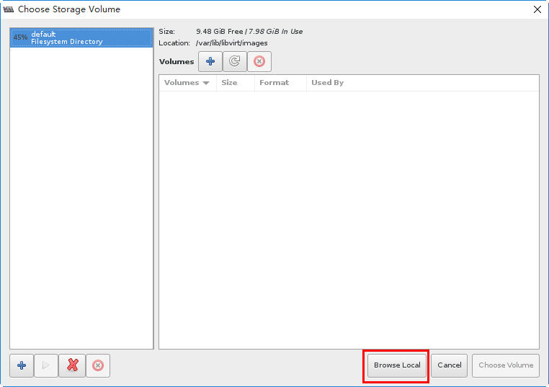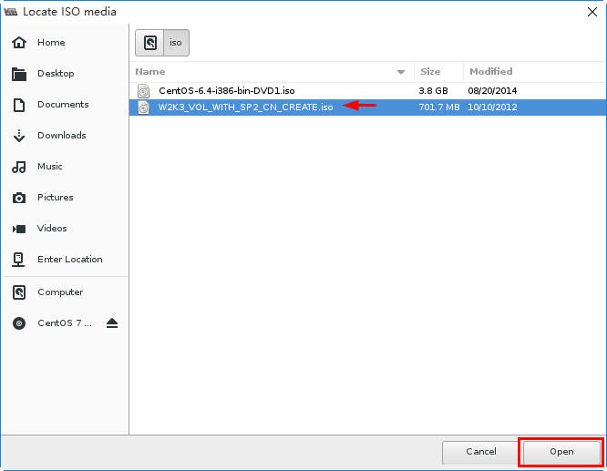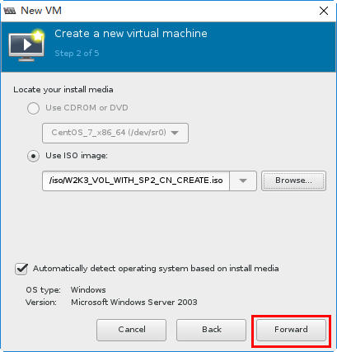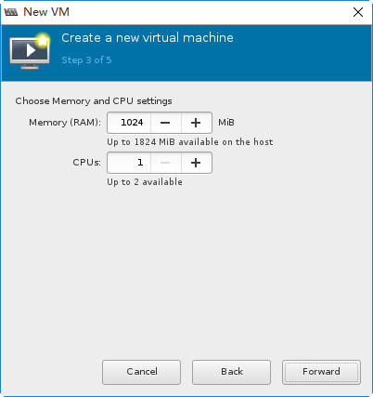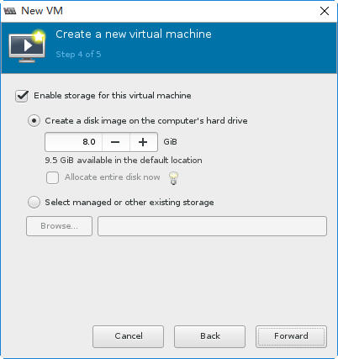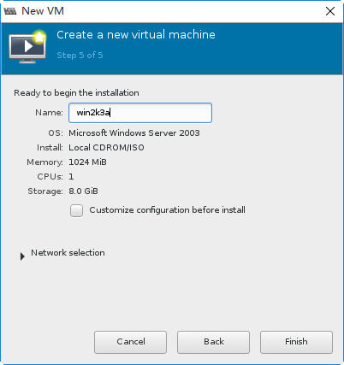

排错：虚拟机的鼠标、键盘无响应

强制将虚拟机关闭。修改虚拟机的显示模式。如下图所示，默认的类型是Spice。
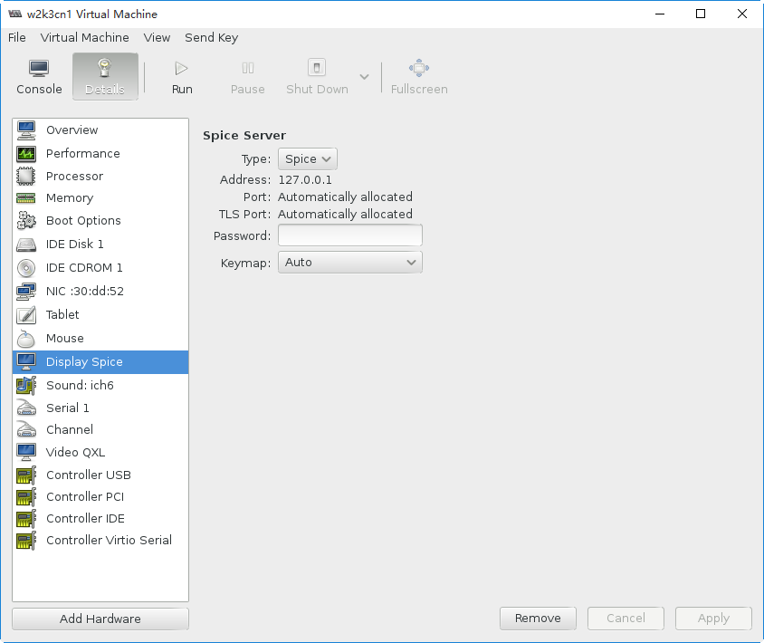
将其修改为VNC
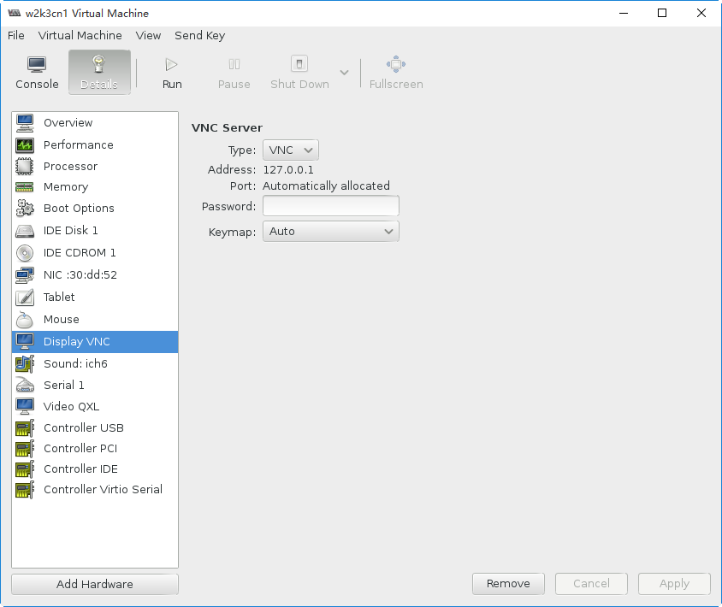
启动虚拟机，故障即排错。

安装操作系统
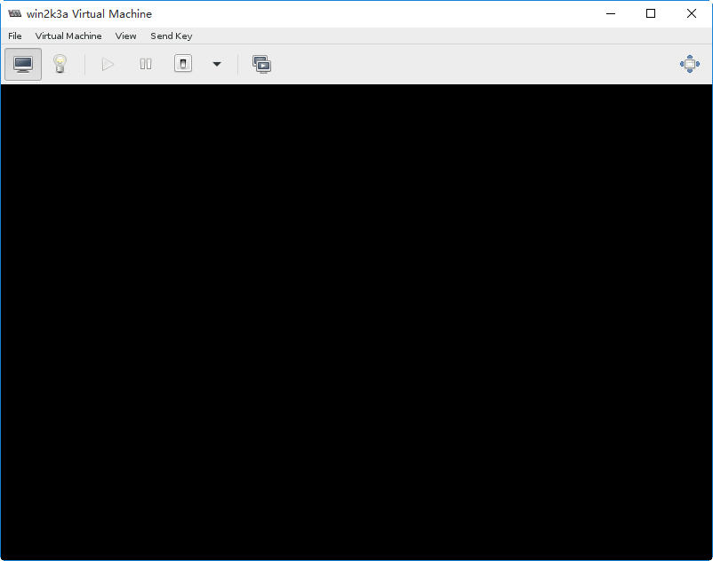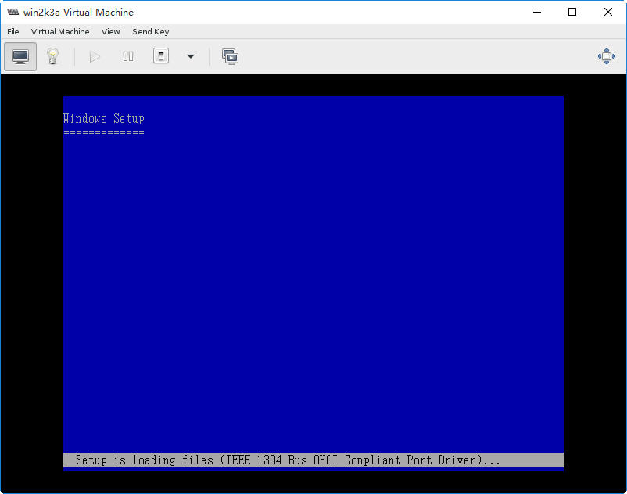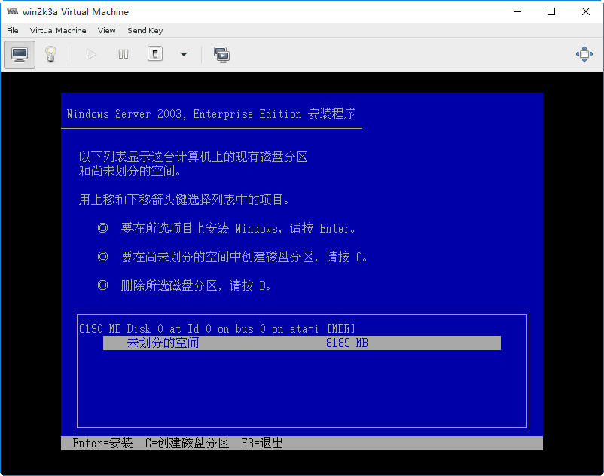
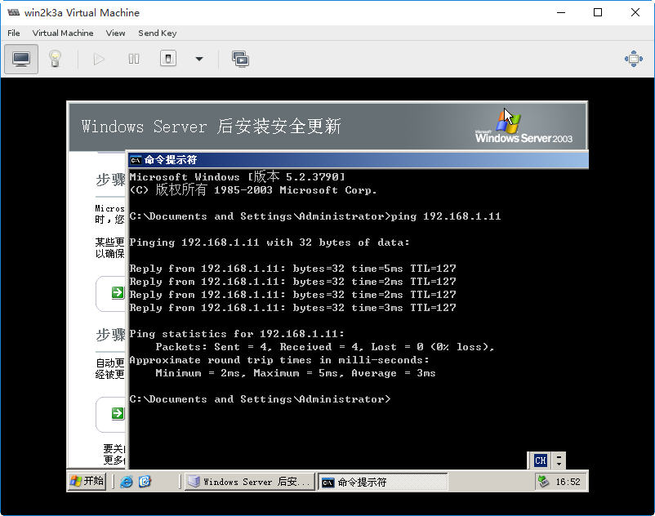

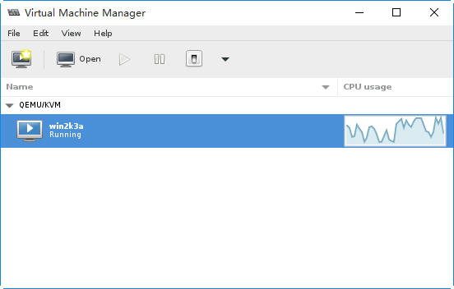

考察虚拟机的配置
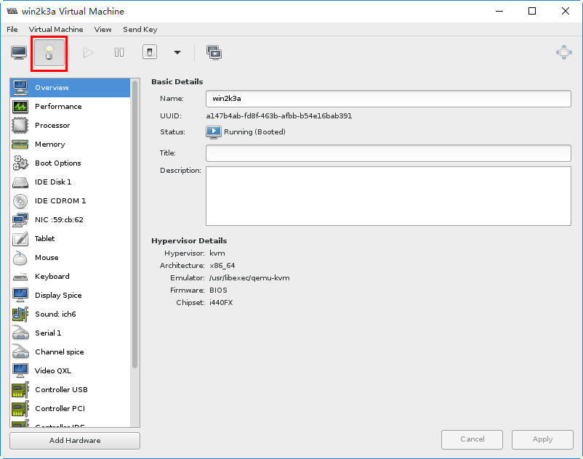

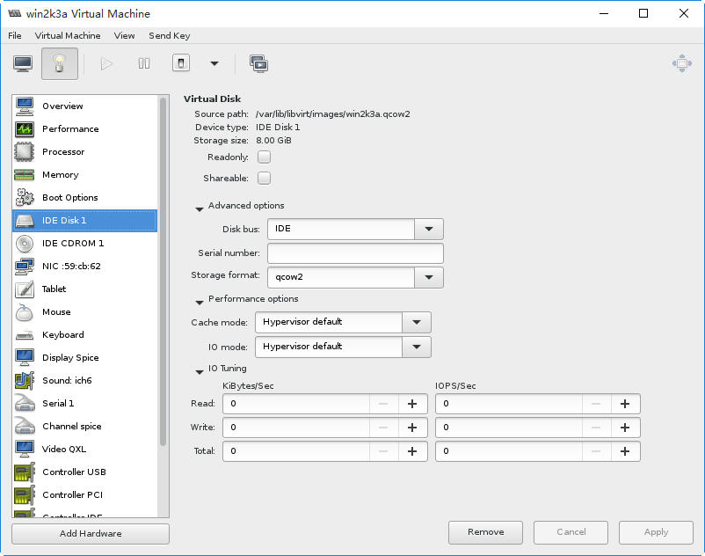
虚拟磁盘文件默认存储位置为/var/lib/libvirt/images。IDE接口，qcow2类型
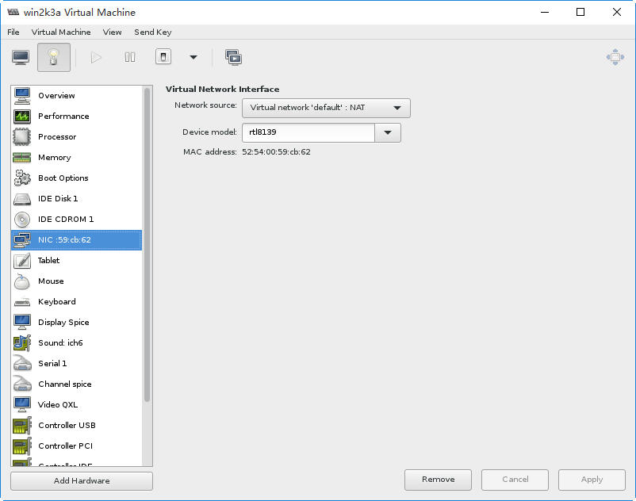
网卡是Realtek 8139，网络连接模式为NAT

排错

解决KVM中鼠标不同步问题
VNC Viewer中的鼠标走得总是比本地系统中的鼠标要慢，不同步，往往实体机中的鼠标都移出vnc窗口外边了，虚拟机中的鼠标指针还没移到需要点击的位置。
这可以通过向虚拟机添加USB接口的Tablet设备来解决。
方法1：
通过virt-manager添加新的设备
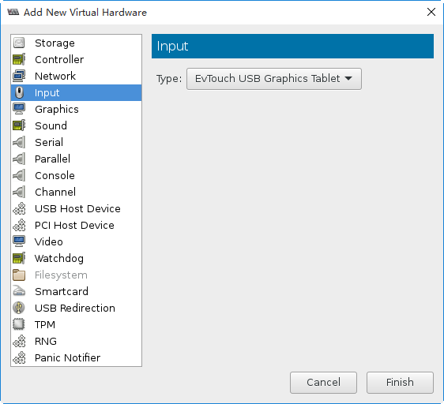
方法2：
编辑虚拟机配置文件，在虚拟机的配置文件中增加：
<input type='tablet' bus='usb'/>
注意：该句位于<devices>配置中

这两种方法本质是一样的。加上这个输入设备，重启虚拟机后VNC鼠标与系统鼠标同步问题解决!

创建32位CentOS 6虚拟机
与前面不同，这次我们将/vm目录下手工创建虚拟磁盘。

使用向导创建虚拟机
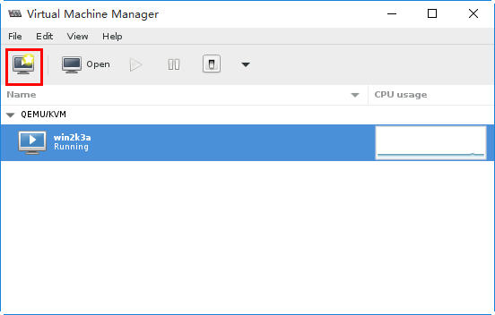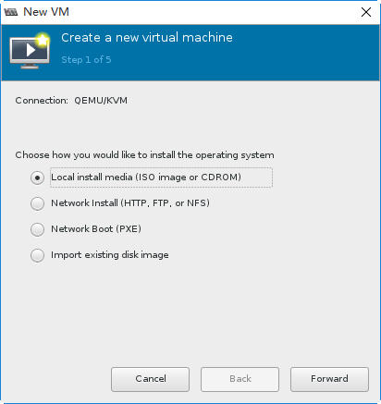
从本地的ISO文件进行安装。
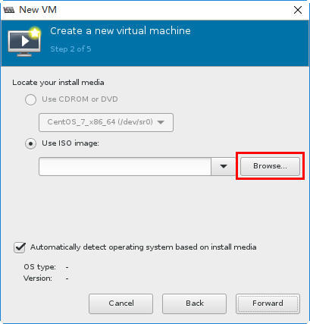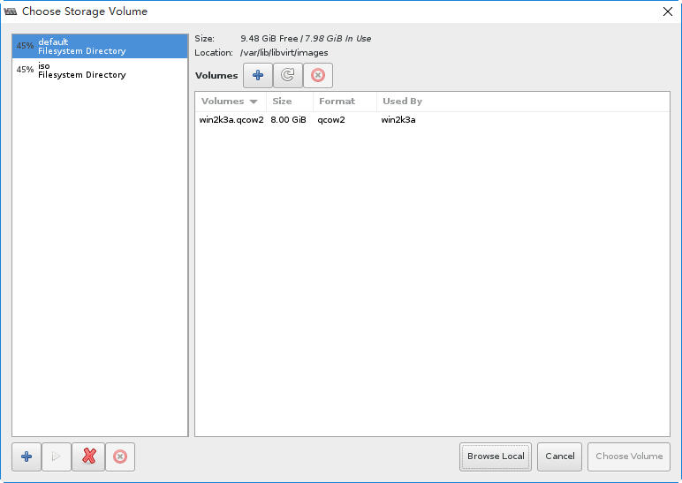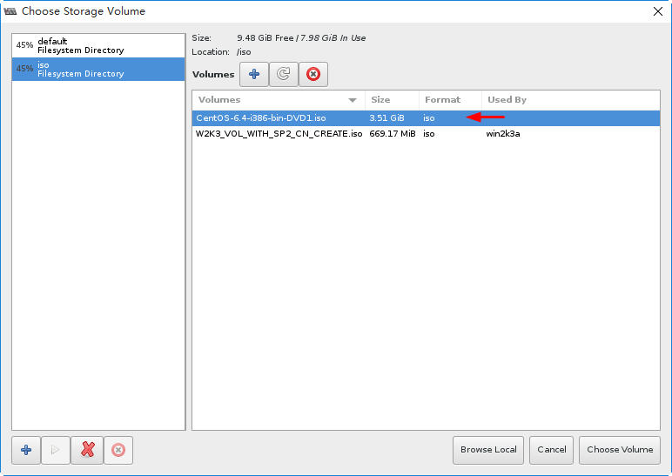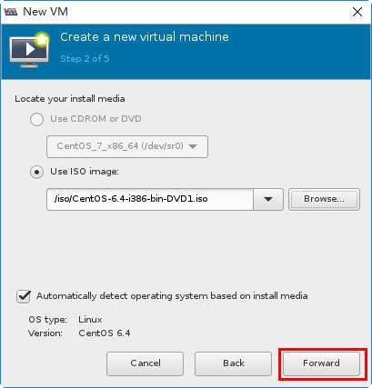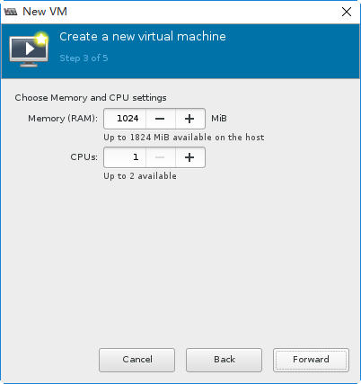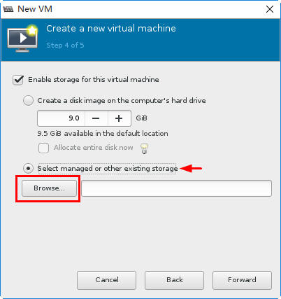
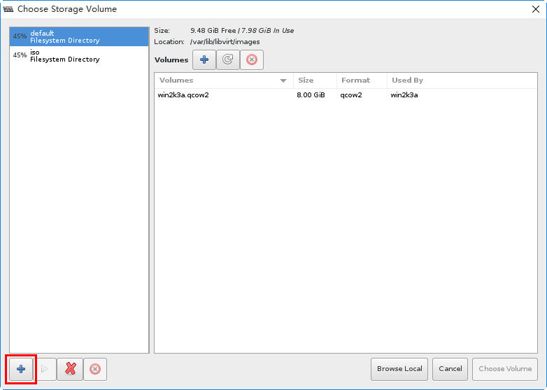
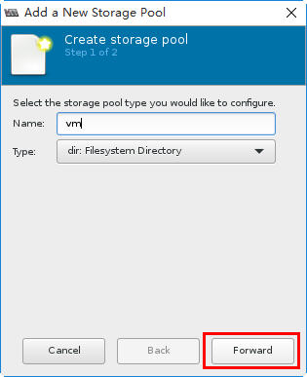
创建名为VM的文件系统型的存储池。
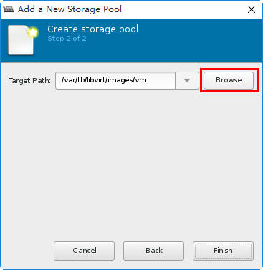
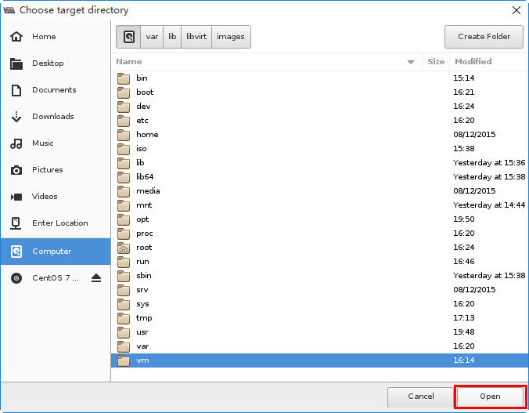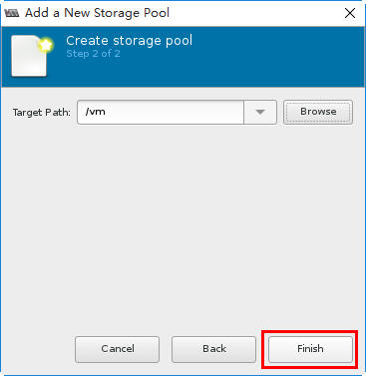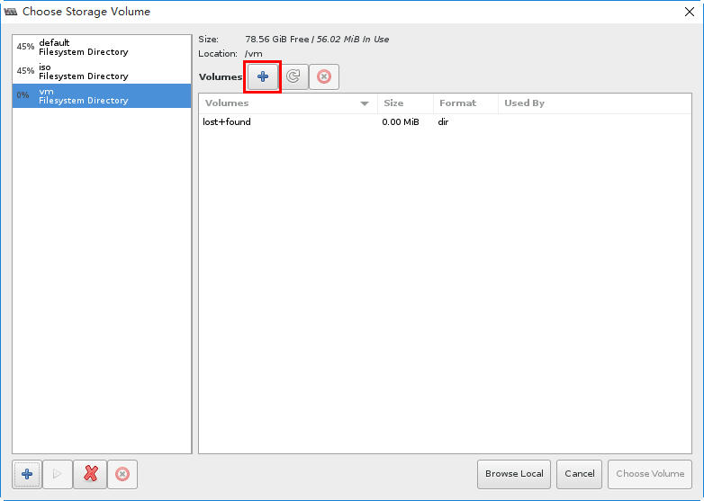
然后我们在存储池vm中创建一个Volume，即虚拟磁盘。
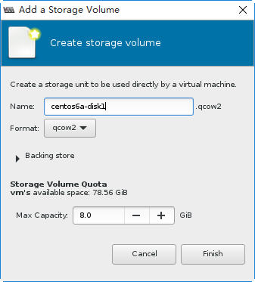
指定文件名，其他保持默认，即创建qcow2格式的虚拟磁盘文件。
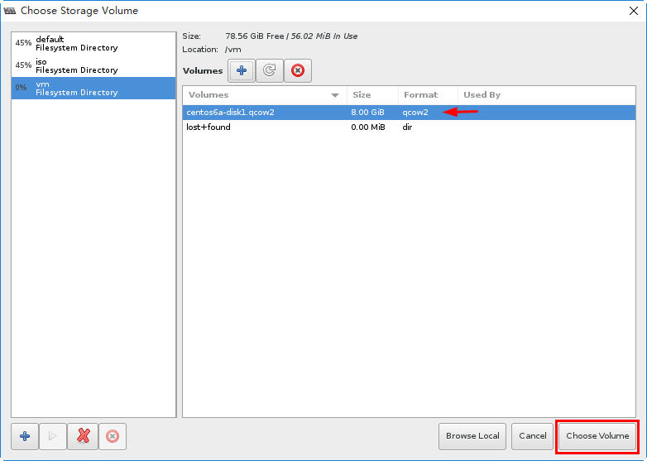

安装操作系统

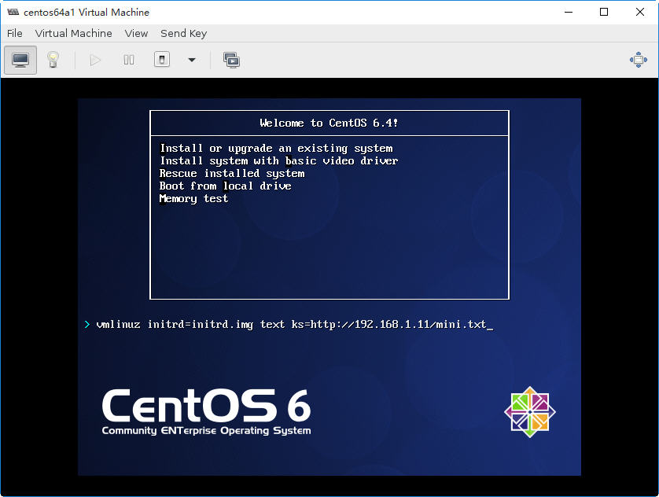
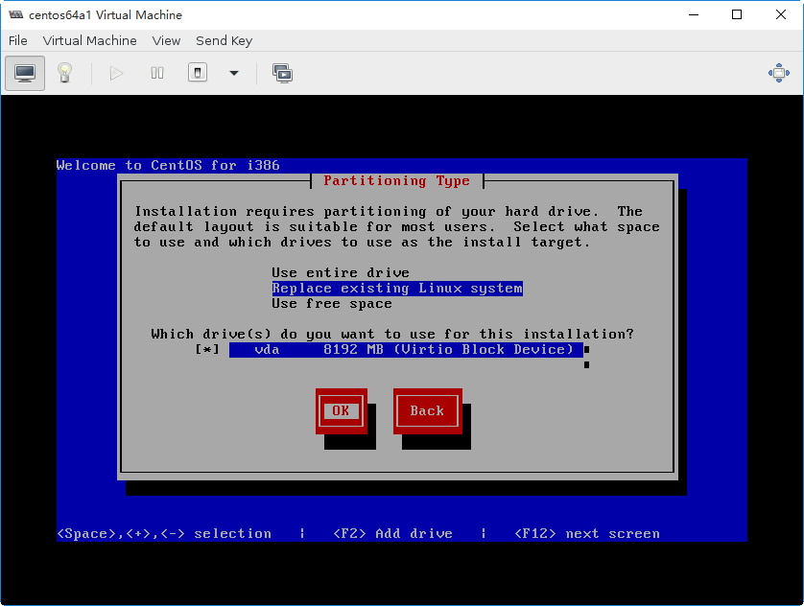
Tip: 可以通过回答文件简化Linux的安装。
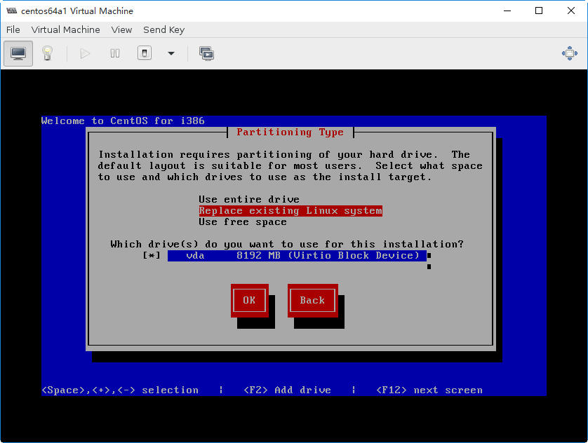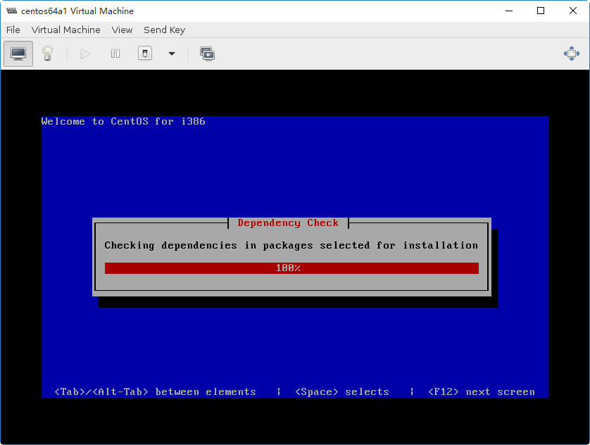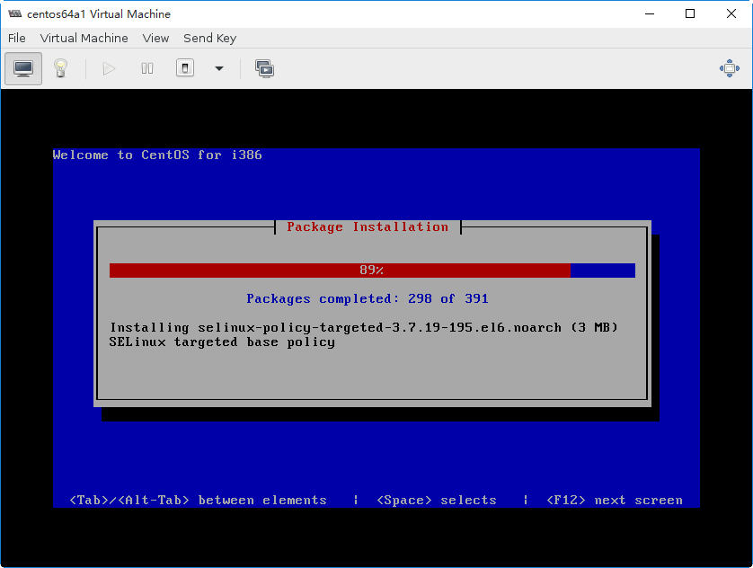
补充：可以通过以下kickstart文件简化安装
# 最小配置的VM, 用于测试
#
install
cdrom
text
lang en_US.UTF-8
keyboard us
network --onboot yes --device eth0 --bootproto dhcp --noipv6
rootpw 123456
firewall --disabled
authconfig --enableshadow --passalgo=sha512
selinux --disabled
timezone --utc Asia/Shanghai
bootloader --location=mbr --driveorder=sda --append="crashkernel=auto rhgb quiet"
reboot

# 下面是测试环境下，用于分区的操作，生产环境中不要使用
#clearpart --all --drives=vda
#part /boot --fstype=ext4 --size=100 --ondisk=vda
#part pv.008002 --grow --size=1 --grow --ondisk=vda
#volgroup VolGroup --pesize=4096 pv.008002
#logvol /home --fstype=ext4 --name=lv_home --vgname=VolGroup --grow --size=100
#logvol swap --name=lv_swap --vgname=VolGroup --grow --size=1024 --maxsize=1024
#logvol / --fstype=ext4 --name=lv_root --vgname=VolGroup --grow --size=1024
#

%packages
@base
@core
%end

