- 基于iSCSI的存储池

  - 环境准备：配置一个软件的iSCSI Target
在生产环境中，iSCSI存储很常见。为了后续的实验，我们在一台CentOS 7上安装软件包targetcli，将其配置为一台iSCSI Target，用来充当一个存储。

首先，我们安装一个基本的CentOS Linux。安装时使用的kickstart文件内容如下所示：

auth --enableshadow --passalgo=sha512

# Use CDROM installation media
cdrom
text
# Run the Setup Agent on first boot
firstboot --enable
ignoredisk --only-use=vda
# Keyboard layouts
keyboard --vckeymap=us --xlayouts='us'
# System language
lang en_US.UTF-8

# Network information
# Network information
#network --bootproto=dhcp --device=eno16777728 --onboot=no --ipv6=auto
#network --onboot yes -evice eno16777728 --bootproto dhcp --noipv6
network --onboot yes --bootproto dhcp --noipv6
network --hostname=localhost.localdomain
# Root password
rootpw 123456

firewall --disable
selinux --disable

# System timezone
timezone --utc Asia/Shanghai
# System bootloader configuration
bootloader --location=mbr --boot-drive=vda
autopart --type=lvm
# Partition clearing information
clearpart --none --initlabel

reboot
%packages
@core
@base
net-tools
%end

在我的环境中，有一个之前安装好的虚拟机。在虚拟机关闭时，可以通过它来快速创建一个虚拟机。
# cd /vm
# cp centos7-1511-disk0.qcow2 iscsitarget1-disk0.qcow2

# virt-install \
--import \
--name=iscsitarget1 \
--disk device=disk,bus=virtio,path=/vm/iscsitarget1-disk0.qcow2 \
--vcpus=1 --ram=1024 \
--network network=default,model=virtio \
--graphics vnc \
--os-type=linux \
--os-variant=rhel

在本示例中，iSCSI Target的IP地址是192.168.1.122，主机名为stor1

有一个块80GB磁盘/dev/vdb用于iSCSI Target使用。
[root@stor1 ~]# fdisk -l

Disk /dev/vda: 10.7 GB, 10737418240 bytes, 20971520 sectors
Units = sectors of 1 * 512 = 512 bytes
Sector size (logical/physical): 512 bytes / 512 bytes
I/O size (minimum/optimal): 512 bytes / 512 bytes
Disk label type: dos
Disk identifier: 0x000879f9

Device Boot Start End Blocks Id System
/dev/vda1 * 2048 1026047 512000 83 Linux
/dev/vda2 1026048 20971519 9972736 8e Linux LVM

Disk /dev/vdb: 85.9 GB, 85899345920 bytes, 167772160 sectors
Units = sectors of 1 * 512 = 512 bytes
Sector size (logical/physical): 512 bytes / 512 bytes
I/O size (minimum/optimal): 512 bytes / 512 bytes

Disk /dev/mapper/centos-root: 9093 MB, 9093251072 bytes, 17760256 sectors
Units = sectors of 1 * 512 = 512 bytes
Sector size (logical/physical): 512 bytes / 512 bytes
I/O size (minimum/optimal): 512 bytes / 512 bytes

Disk /dev/mapper/centos-swap: 1073 MB, 1073741824 bytes, 2097152 sectors
Units = sectors of 1 * 512 = 512 bytes
Sector size (logical/physical): 512 bytes / 512 bytes
I/O size (minimum/optimal): 512 bytes / 512 bytes

# fdisk /dev/vdb
创建一个分区，使用全部空间

# fdisk -l /dev/vdb

Disk /dev/vdb: 85.9 GB, 85899345920 bytes, 167772160 sectors
Units = sectors of 1 * 512 = 512 bytes
Sector size (logical/physical): 512 bytes / 512 bytes
I/O size (minimum/optimal): 512 bytes / 512 bytes
Disk label type: dos
Disk identifier: 0x23bb71b1

Device Boot Start End Blocks Id System
/dev/vdb1 2048 167772159 83885056 83 Linux

首先，我们来安装targetcli软件包
# yum -y install targetcli

运行targetcli，进入交互模式。这是一个很方便的程序，有Tab键自动补全功能。
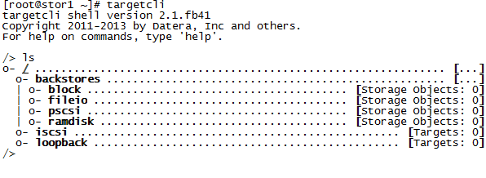

# targetcli
Warning: Could not load preferences file /root/.targetcli/prefs.bin.
targetcli shell version 2.1.fb41
Copyright 2011-2013 by Datera, Inc and others.
For help on commands, type 'help'.

/> help 查看帮助

创建一个块存储对象
/> cd backstores/block

/backstores/block> ls
o- block ............ [Storage Objects: 0]

/backstores/block> create block1 dev=/dev/vdb1
Created block storage object block1 using /dev/vdb1.

/backstores/block> ls
o- block ............ [Storage Objects: 1]
o- block1 ........ [/dev/vdb1 (80.0GiB) write-thru deactivated]

创建一个fileio对象
/backstores/block> cd /backstores/fileio

/backstores/fileio> ls
o- fileio ................... [Storage Objects: 0]

/backstores/fileio> create fileio1 /foo.img 50M
Created fileio fileio1 with size 52428800

/backstores/fileio> ls
o- fileio ............... [Storage Objects: 1]
o- fileio1 ....... [/foo.img (50.0MiB) write-back deactivated]

[root@tomstor1 ~]# ll /foo.img
-rw-r--r-- 1 root root 52428800 Aug 5 14:40 /foo.img
[root@tomstor1 ~]# file /foo.img
/foo.img: data
[root@tomstor1 ~]# du -l /foo.img
0 /foo.img
稀疏文件，也文件系统有关。

创建一个ramdisk对象
/backstores/fileio> cd /backstores/ramdisk
/backstores/ramdisk> ls
o- ramdisk .......................... [Storage Objects: 0]

/backstores/ramdisk> create ramdisk1 1M
Created ramdisk ramdisk1 with size 1M.

/backstores/ramdisk> ls
o- ramdisk .......................... [Storage Objects: 1]
o- ramdisk1 ....................... [(1.0MiB) deactivated]

切换到/iscsi目录
/backstores/ramdisk> cd /iscsi
/iscsi> ls
o- iscsi ................................... [Targets: 0]

下面，我们来创建一个iSCSI Target。有两种方式可选：
方法1：不带参数的create命令，会自动生成一个IQN
方法2: create iqn.2010-05.com.linuxplus.srv1:stor1

查看一下帮助
/iscsi> help create

SYNTAX
======
create [wwn]

DESCRIPTION
===========
Creates a new target. The wwn format depends on the transport(s) supported by the fabric module. If the wwn is ommited, then a target will be created using either a randomly generated WWN of the proper type, or the first unused WWN in the list of possible WWNs if one is available. If WWNs are constrained to a list (i.e. for hardware targets addresses) and all WWNs are in use, the target creation will fail. Use the info command to get more information abour WWN type and possible values.

SEE ALSO
========
info

/iscsi> create iqn.2010-05.org.linuxplus.srv1:stor1
Created target iqn.2010-05.com.linuxplus.srv1:stor1.
Created TPG 1.
Global pref auto_add_default_portal=true
Created default portal listening on all IPs (0.0.0.0), port 3260.

/iscsi> ls
o- iscsi ................................... [Targets: 1]
o- iqn.2010-05.com.linuxplus.srv1:stor1 ..... [TPGs: 1]
o- tpg1 ...................... [no-gen-acls, no-auth]
o- acls ................................. [ACLs: 0]
o- luns ................................. [LUNs: 0]
o- portals ........................... [Portals: 1]
o- 0.0.0.0:3260 ............................ [OK]
每个iSCSI target需要有一个target portal group (TPG)。默认有一个名为tpg1。我们要切换到其中

/iscsi> cd iqn.2010-05.com.linuxplus.srv1:stor1/tpg1/
/iscsi/iqn.20...v1:stor1/tpg1>
/iscsi/iqn.20...v1:stor1/tpg1> ls
o- tpg1 .......................... [no-gen-acls, no-auth]
o- acls ..................................... [ACLs: 0]
o- luns ..................................... [LUNs: 0]
o- portals ............................... [Portals: 1]
o- 0.0.0.0:3260 ................................ [OK]

为了通过iSCSI export块设备，我们需要先配置portals、LUN和ACL。下面，我们定义portal IP地址
/iscsi/iqn.20...v1:stor1/tpg1> pwd
/iscsi/iqn.2010-05.com.linuxplus.srv1:stor1/tpg1
/iscsi/iqn.20...v1:stor1/tpg1> cd portals/
/iscsi/iqn.20.../tpg1/portals> pwd
/iscsi/iqn.2010-05.com.linuxplus.srv1:stor1/tpg1/portals

/iscsi/iqn.20.../tpg1/portals> create
Using default IP port 3260
Binding to INADDR_ANY (0.0.0.0)
This NetworkPortal already exists in configFS

/iscsi/iqn.20.../tpg1/portals> ls
o- portals ................................. [Portals: 1]
o- 0.0.0.0:3260 .................................. [OK]
/iscsi/iqn.20.../tpg1/portals>

配置LUN并且将其分配给fabric。首先，我们需要进入到正确的目录中：
/iscsi/iqn.20.../tpg1/portals> cd /
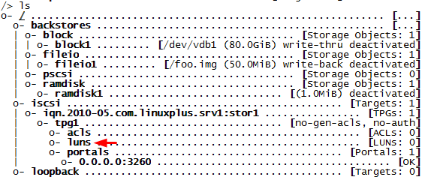
/> cd iscsi/iqn.2010-05.com.linuxplus.srv1:stor1/tpg1/luns

添加第一个LUN给ramdisk
/iscsi/iqn.20...or1/tpg1/luns> create /backstores/ramdisk/ramdisk1
Created LUN 0.

/iscsi/iqn.20...or1/tpg1/luns> ls
o- luns ............... [LUNs: 1]
o- lun0 .... [ramdisk/ramdisk1]

添加第二个LUN给块设备
/iscsi/iqn.20...or1/tpg1/luns> create /backstores/block/block1
Created LUN 1.
/iscsi/iqn.20...or1/tpg1/luns> ls
o- luns ....................... [LUNs: 2]
o- lun0 ............ [ramdisk/ramdisk1]
o- lun1 .... [block/block1 (/dev/vdb1)]

添加第三个LUN给fileio

/iscsi/iqn.20...or1/tpg1/luns> create /backstores/fileio/fileio1
Created LUN 2.
/iscsi/iqn.20...or1/tpg1/luns> ls
o- luns ....................... [LUNs: 3]
o- lun0 ............ [ramdisk/ramdisk1]
o- lun1 .... [block/block1 (/dev/vdb1)]
o- lun2 ... [fileio/fileio1 (/foo.img)]

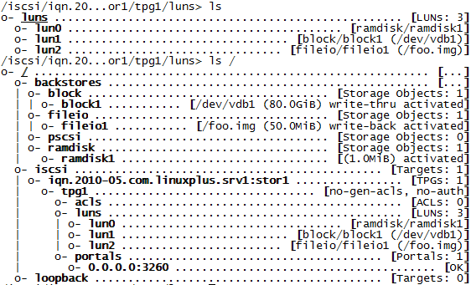
如上图所示，targetcli有一个很漂亮的树型结构。

现在，我们切换到KVM服务器上，即iSCSI initiator查看其IQN
[root@ctkvm2 ~]# cat /etc/iscsi/initiatorname.iscsi
InitiatorName=iqn.1994-05.com.redhat:d220758f94c4

为了方便查看，我们修改其名称。
[root@ctkvm2 ~]# cat /etc/iscsi/initiatorname.iscsi
InitiatorName=iqn.1994-05.com.redhat:ctkvm2

然后，我们再到target上，进入到ACSL目录中，为每个initiator创建ACL
/iscsi/iqn.20...or1/tpg1/luns> cd ../acls
/iscsi/iqn.20...or1/tpg1/acls> pwd
/iscsi/iqn.2010-05.com.linuxplus.srv1:stor1/tpg1/acls
/iscsi/iqn.20...or1/tpg1/acls> ls
o- acls .............................................. [ACLs: 0]

/iscsi/iqn.20...or1/tpg1/acls> create iqn.1994-05.com.redhat:ctkvm2
Created Node ACL for iqn.1994-05.com.redhat:ctkvm2
Created mapped LUN 2.
Created mapped LUN 1.
Created mapped LUN 0.

会自动创建mapping。
/iscsi/iqn.20...or1/tpg1/acls> ls
o- acls ............................................. [ACLs: 1]
o- iqn.1994-05.com.redhat:ctkvm2 ........... [Mapped LUNs: 3]
o- mapped_lun0 ................[lun0 ramdisk/ramdisk1 (rw)]
o- mapped_lun1 ................... [lun1 block/block1 (rw)]
o- mapped_lun2 ................. [lun2 fileio/fileio1 (rw)

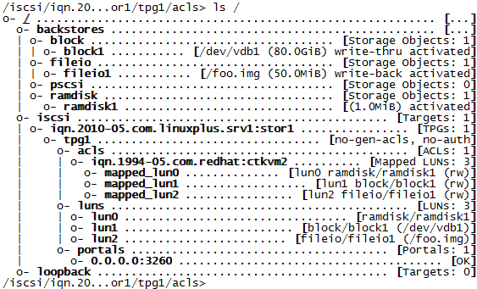

保存配置。
/iscsi/iqn.20...or1/tpg1/acls> cd /
/> saveconfig
Last 10 configs saved in /etc/target/backup.
Configuration saved to /etc/target/saveconfig.json

退出targetcli
/> exit
Global pref auto_save_on_exit=true
Last 10 configs saved in /etc/target/backup.
Configuration saved to /etc/target/saveconfig.json

设置target服务为自动启动。
[root@stor1 ~]# # systemctl enable target.service
Created symlink from /etc/systemd/system/multi-user.target.wants/target.service to /usr/lib/systemd/system/target.service.

重新启动服务，检查配置。
[root@stor1 ~]# systemctl restart target.service

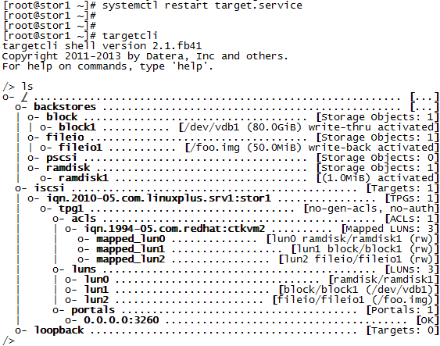

在KVM上测试连接。
# rpm -qa | grep iscsi
iscsi-initiator-utils-6.2.0.873-32.el7.x86_64
libiscsi-1.9.0-6.el7.x86_64
iscsi-initiator-utils-iscsiuio-6.2.0.873-32.el7.x86_64

# cat /etc/iscsi/initiatorname.iscsi
InitiatorName=iqn.1994-05.com.redhat:ctkvm2

检查是否可以发现。
# iscsiadm --mode discovery --type sendtargets --portal 192.168.1.122
192.168.1.122:3260,1 iqn.2010-05.com.linuxplus.srv1:stor1

测试挂载设备。
# iscsiadm -d2 -m node --login
iscsiadm: Max file limits 1024 4096

iscsiadm: default: Creating session 1/1
Logging in to [iface: default, target: iqn.2010-05.com.linuxplus.srv1:stor1, portal: 192.168.1.122,3260] (multiple)
Login to [iface: default, target: iqn.2010-05.com.linuxplus.srv1:stor1, portal: 192.168.1.122,3260] successful.

在/var/log/messages中会看到类似下面的信息

systemd: Starting Open-iSCSI...
iscsid: iSCSI logger with pid=11444 started!
systemd: Failed to read PID from file /var/run/iscsid.pid: Invalid argument
kernel: Loading iSCSI transport class v2.0-870.
systemd: Started Open-iSCSI.
kernel: iscsi: registered transport (tcp)
iscsid: iSCSI daemon with pid=11445 started!
kernel: scsi host3: iSCSI Initiator over TCP/IP
kernel: scsi 3:0:0:0: Direct-Access LIO-ORG ramdisk1 4.0 PQ: 0 ANSI: 5
kernel: scsi 3:0:0:0: alua: supports implicit and explicit TPGS
kernel: scsi 3:0:0:0: alua: port group 00 rel port 01
kernel: scsi 3:0:0:0: alua: port group 00 state A non-preferred supports TOlUSNA
kernel: scsi 3:0:0:0: alua: Attached
kernel: sd 3:0:0:0: Attached scsi generic sg4 type 0
kernel: scsi 3:0:0:1: Direct-Access LIO-ORG block1 4.0 PQ: 0 ANSI: 5
kernel: sd 3:0:0:0: [sdd] 2048 512-byte logical blocks: (1.04 MB/1.00 MiB)
kernel: scsi 3:0:0:1: alua: supports implicit and explicit TPGS
kernel: scsi 3:0:0:1: alua: port group 00 rel port 01
kernel: sd 3:0:0:0: [sdd] Write Protect is off
kernel: scsi 3:0:0:1: alua: port group 00 state A non-preferred supports TOlUSNA
kernel: scsi 3:0:0:1: alua: Attached
kernel: sd 3:0:0:1: Attached scsi generic sg5 type 0
kernel: scsi 3:0:0:2: Direct-Access LIO-ORG fileio1 4.0 PQ: 0 ANSI: 5
kernel: sd 3:0:0:0: [sdd] Write cache: disabled, read cache: enabled, doesn't support DPO or FUA
kernel: sd 3:0:0:1: [sde] 167770112 512-byte logical blocks: (85.8 GB/79.9 GiB)
kernel: scsi 3:0:0:2: alua: supports implicit and explicit TPGS
kernel: scsi 3:0:0:2: alua: port group 00 rel port 01
kernel: scsi 3:0:0:2: alua: port group 00 state A non-preferred supports TOlUSNA
kernel: scsi 3:0:0:2: alua: Attached
kernel: sd 3:0:0:1: [sde] Write Protect is off
kernel: sd 3:0:0:2: Attached scsi generic sg6 type 0
kernel: sd 3:0:0:1: [sde] Write cache: enabled, read cache: enabled, supports DPO and FUA
kernel: sd 3:0:0:2: [sdf] 102400 512-byte logical blocks: (52.4 MB/50.0 MiB)
kernel: sd 3:0:0:2: [sdf] Write Protect is off
kernel: sdd: unknown partition table
kernel: sd 3:0:0:2: [sdf] Write cache: enabled, read cache: enabled, supports DPO and FUA
kernel: sde: unknown partition table
kernel: sd 3:0:0:0: [sdd] Attached SCSI disk
kernel: sdf: unknown partition table
kernel: sd 3:0:0:1: [sde] Attached SCSI disk
kernel: sd 3:0:0:2: [sdf] Attached SCSI disk

# fdisk -l

Disk /dev/sdc: 42.9 GB, 42949672960 bytes, 83886080 sectors
Units = sectors of 1 * 512 = 512 bytes
Sector size (logical/physical): 512 bytes / 512 bytes
I/O size (minimum/optimal): 512 bytes / 512 bytes

Disk /dev/sdb: 85.9 GB, 85899345920 bytes, 167772160 sectors
Units = sectors of 1 * 512 = 512 bytes
Sector size (logical/physical): 512 bytes / 512 bytes
I/O size (minimum/optimal): 512 bytes / 512 bytes

Disk /dev/sda: 21.5 GB, 21474836480 bytes, 41943040 sectors
Units = sectors of 1 * 512 = 512 bytes
Sector size (logical/physical): 512 bytes / 512 bytes
I/O size (minimum/optimal): 512 bytes / 512 bytes
Disk label type: dos
Disk identifier: 0x0008b8ea

Device Boot Start End Blocks Id System
/dev/sda1 * 2048 1026047 512000 83 Linux
/dev/sda2 1026048 41943039 20458496 8e Linux LVM

Disk /dev/mapper/centos-root: 18.8 GB, 18756927488 bytes, 36634624 sectors
Units = sectors of 1 * 512 = 512 bytes
Sector size (logical/physical): 512 bytes / 512 bytes
I/O size (minimum/optimal): 512 bytes / 512 bytes

Disk /dev/mapper/centos-swap: 2147 MB, 2147483648 bytes, 4194304 sectors
Units = sectors of 1 * 512 = 512 bytes
Sector size (logical/physical): 512 bytes / 512 bytes
I/O size (minimum/optimal): 512 bytes / 512 bytes

Disk /dev/mapper/vmvg-lvvm1: 85.9 GB, 85895151616 bytes, 167763968 sectors
Units = sectors of 1 * 512 = 512 bytes
Sector size (logical/physical): 512 bytes / 512 bytes
I/O size (minimum/optimal): 512 bytes / 512 bytes

Disk /dev/sdd: 1 MB, 1048576 bytes, 2048 sectors
Units = sectors of 1 * 512 = 512 bytes
Sector size (logical/physical): 512 bytes / 512 bytes
I/O size (minimum/optimal): 512 bytes / 4294963200 bytes

Disk /dev/sde: 85.9 GB, 85898297344 bytes, 167770112 sectors
Units = sectors of 1 * 512 = 512 bytes
Sector size (logical/physical): 512 bytes / 512 bytes
I/O size (minimum/optimal): 512 bytes / 4294963200 bytes

Disk /dev/sdf: 52 MB, 52428800 bytes, 102400 sectors
Units = sectors of 1 * 512 = 512 bytes
Sector size (logical/physical): 512 bytes / 512 bytes
I/O size (minimum/optimal): 512 bytes / 8388608 bytes

会看到有三个新的设备。

下面，我们将设备断开。
# iscsiadm -d2 -m node --logout
iscsiadm: Max file limits 1024 4096

Logging out of session [sid: 1, target: iqn.2010-05.com.linuxplus.srv1:stor1, portal: 192.168.1.122,3260]
Logout of [sid: 1, target: iqn.2010-05.com.linuxplus.srv1:stor1, portal: 192.168.1.122,3260] successful.

# fdisk –l
看不到那三个设备了。

这样我们就完成的环境的准备。下面我们将在KVM服务器上添加iSCSI存储池。

  - 使用virt-manager创建基于iSCSI的存储池

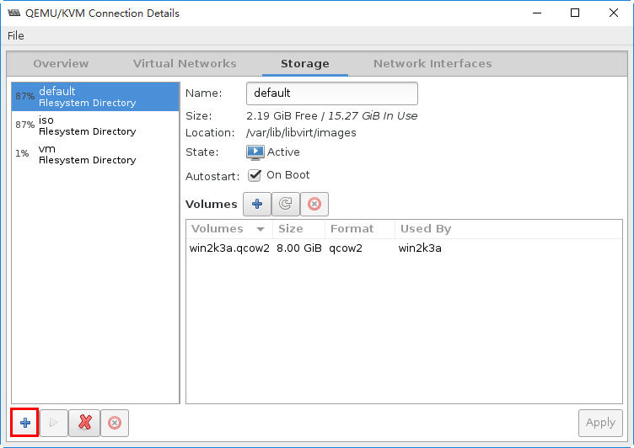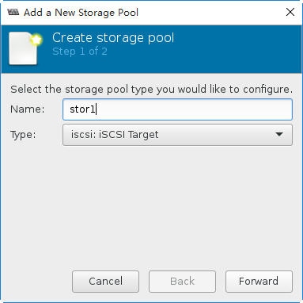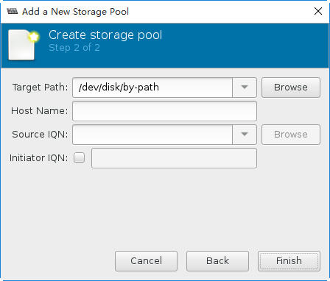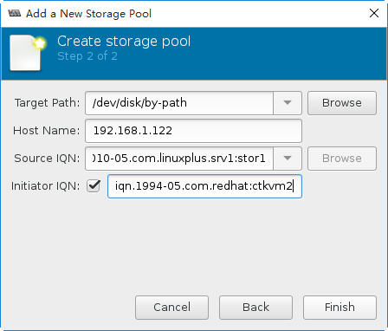
Source IQN: 输入在targetcli中设置的值：iqn.2010-05.com.linuxplus.srv1:stor1
Initiator IQN: 输入在initiator的/etc/iscsi/initiatorname.iscsi中的设置值。
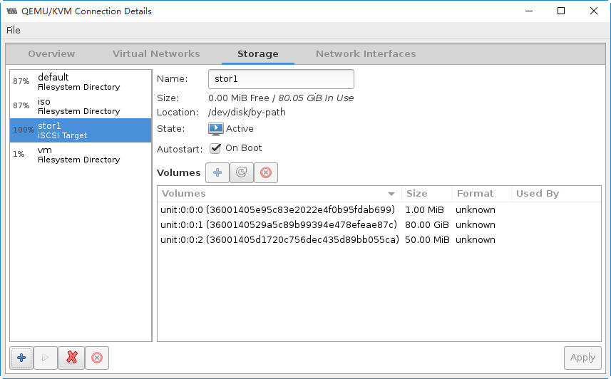

# virsh pool-list
Name State Autostart
-------------------------------------------
default active yes
iso active yes
stor1 active yes
vm active yes

# virsh pool-info stor1
Name: stor1
UUID: b061a1e5-07db-473c-9497-ab025ee02d7d
State: running
Persistent: yes
Autostart: yes
Capacity: 80.05 GiB
Allocation: 80.05 GiB
Available: 0.00 B

# cat /etc/libvirt/storage/stor1.xml
<!--
WARNING: THIS IS AN AUTO-GENERATED FILE. CHANGES TO IT ARE LIKELY TO BE OVERWRITTEN AND LOST. Changes to this xml configuration should be made using: virsh pool-edit stor1 or other application using the libvirt API.
-->

<pool type='iscsi'>
<name>stor1</name>
<uuid>b061a1e5-07db-473c-9497-ab025ee02d7d</uuid>
<capacity unit='bytes'>0</capacity>
<allocation unit='bytes'>0</allocation>
<available unit='bytes'>0</available>
<source>
<host name='192.168.1.122'/>
<device path='iqn.2010-05.com.linuxplus.srv1:stor1'/>
<initiator>
<iqn name='iqn.1994-05.com.redhat:ctkvm2'/>
</initiator>
</source>
<target>
<path>/dev/disk/by-path</path>
</target>
</pool>

# fdisk -l

Disk /dev/sdc: 42.9 GB, 42949672960 bytes, 83886080 sectors
Units = sectors of 1 * 512 = 512 bytes
Sector size (logical/physical): 512 bytes / 512 bytes
I/O size (minimum/optimal): 512 bytes / 512 bytes

Disk /dev/sdb: 85.9 GB, 85899345920 bytes, 167772160 sectors
Units = sectors of 1 * 512 = 512 bytes
Sector size (logical/physical): 512 bytes / 512 bytes
I/O size (minimum/optimal): 512 bytes / 512 bytes

Disk /dev/sda: 21.5 GB, 21474836480 bytes, 41943040 sectors
Units = sectors of 1 * 512 = 512 bytes
Sector size (logical/physical): 512 bytes / 512 bytes
I/O size (minimum/optimal): 512 bytes / 512 bytes
Disk label type: dos
Disk identifier: 0x0008b8ea

Device Boot Start End Blocks Id System
/dev/sda1 * 2048 1026047 512000 83 Linux
/dev/sda2 1026048 41943039 20458496 8e Linux LVM

Disk /dev/mapper/centos-root: 18.8 GB, 18756927488 bytes, 36634624 sectors
Units = sectors of 1 * 512 = 512 bytes
Sector size (logical/physical): 512 bytes / 512 bytes
I/O size (minimum/optimal): 512 bytes / 512 bytes

Disk /dev/mapper/centos-swap: 2147 MB, 2147483648 bytes, 4194304 sectors
Units = sectors of 1 * 512 = 512 bytes
Sector size (logical/physical): 512 bytes / 512 bytes
I/O size (minimum/optimal): 512 bytes / 512 bytes

Disk /dev/mapper/vmvg-lvvm1: 85.9 GB, 85895151616 bytes, 167763968 sectors
Units = sectors of 1 * 512 = 512 bytes
Sector size (logical/physical): 512 bytes / 512 bytes
I/O size (minimum/optimal): 512 bytes / 512 bytes

Disk /dev/sdd: 1 MB, 1048576 bytes, 2048 sectors
Units = sectors of 1 * 512 = 512 bytes
Sector size (logical/physical): 512 bytes / 512 bytes
I/O size (minimum/optimal): 512 bytes / 4294963200 bytes

Disk /dev/sde: 85.9 GB, 85898297344 bytes, 167770112 sectors
Units = sectors of 1 * 512 = 512 bytes
Sector size (logical/physical): 512 bytes / 512 bytes
I/O size (minimum/optimal): 512 bytes / 4294963200 bytes

Disk /dev/sdf: 52 MB, 52428800 bytes, 102400 sectors
Units = sectors of 1 * 512 = 512 bytes
Sector size (logical/physical): 512 bytes / 512 bytes
I/O size (minimum/optimal): 512 bytes / 8388608 bytes

我们看到libvirt会自动的连接iSCSI存储。

为了后续的实验，我们清除一下实验环境。下面，我们删除这个新创建的存储池。

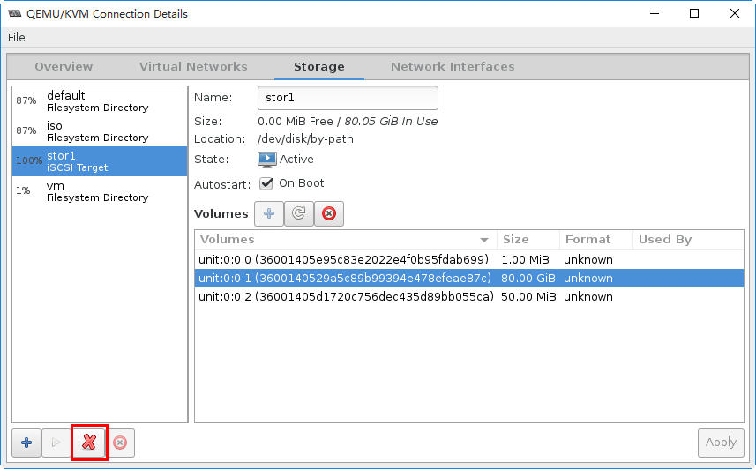

停止存储池后，我们使用fdisk –l命令查看磁盘的情况，会发现已经断开了与iSCSI Target的连接。

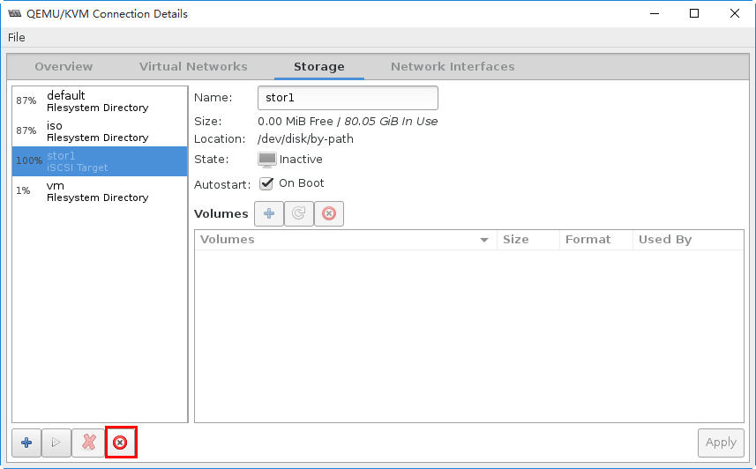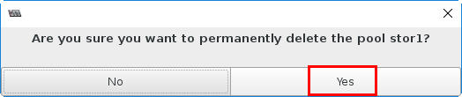

# virsh pool-list --all
Name State Autostart
-------------------------------------------
default active yes
iso active yes
vm active yes

  - 使用virt-sh创建基于iSCSI的存储池

# virsh pool-define-as --name stor2 --type iscsi \
--source-host 192.168.1.122 \
--source-dev iqn.2010-05.com.linuxplus.srv1:stor1 \
--target /dev/disk/by-path
Pool stor2 defined

# virsh pool-list --all
Name State Autostart
-------------------------------------------
default active yes
iso active yes
stor2 inactive no
vm active yes

# virsh pool-start stor2
Pool stor2 started

# virsh pool-list --all
Name State Autostart
-------------------------------------------
default active yes
iso active yes
stor2 active no
vm active yes

# fdisk –l
会看到有三个新的磁盘。

  - 【可选】虚拟机直接连接iSCSI存储池
下面，我们将一台Windows 2003的虚拟机直接使用iSCSI 存储上的LUN资源。
点击Add Hardware，添加新的硬盘。
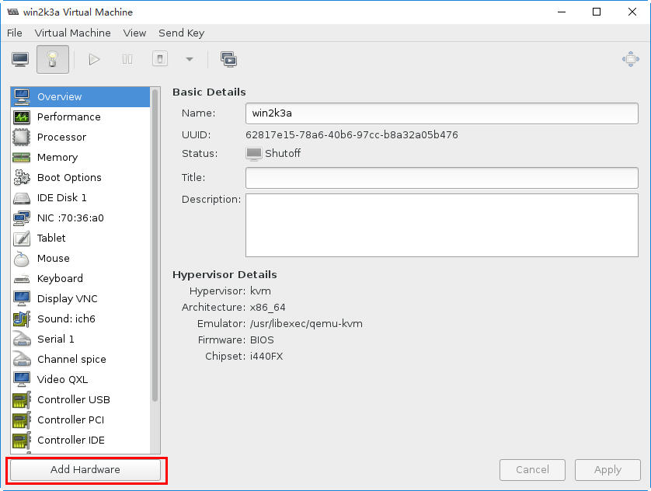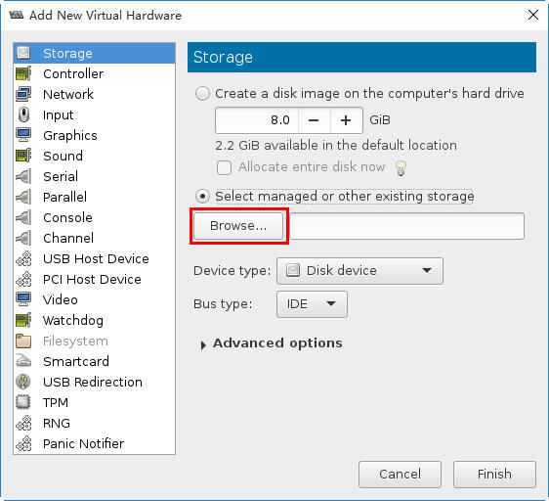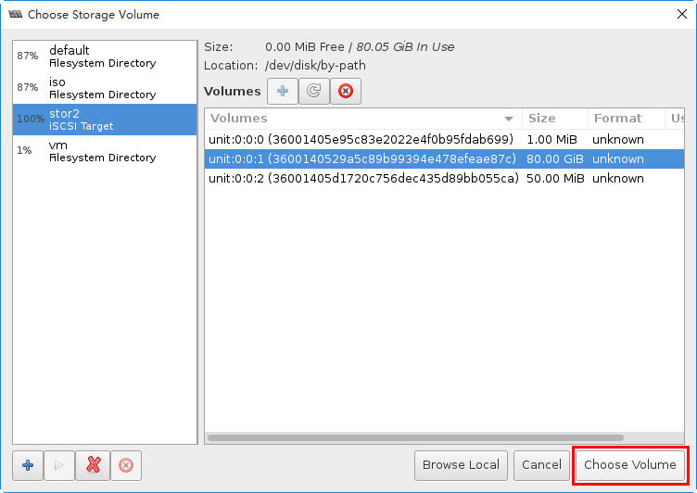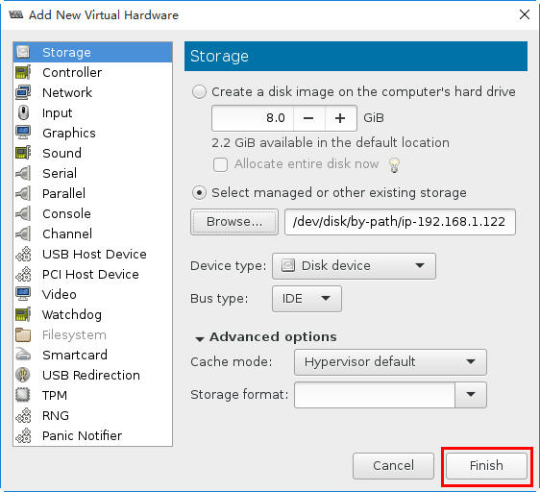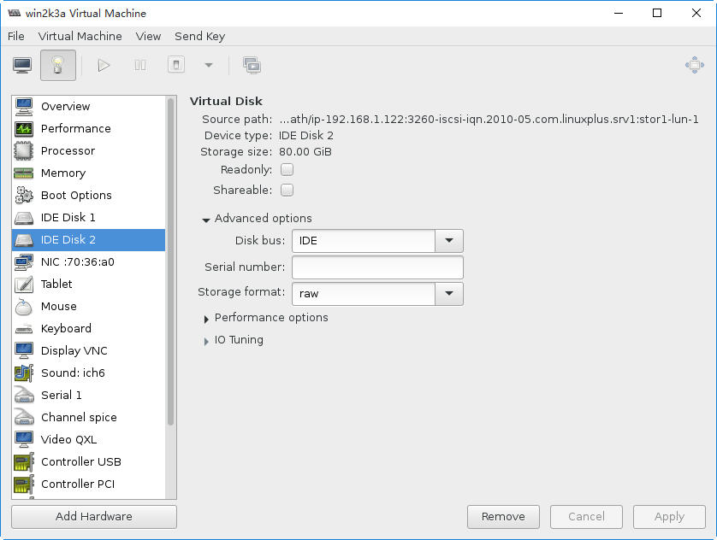
此操作反应在XML配置文件的变化是：
<disk type='block' device='disk'>
<driver name='qemu' type='raw' cache='none' io='native'/>
<source dev='/dev/disk/by-path/ip-192.168.1.122:3260-iscsi-iqn.2010-05.com.linuxplus.srv1:stor1-lun-1'/>
<target dev='hdb' bus='ide'/>
<address type='drive' controller='0' bus='0' target='0' unit='1'/>
</disk>

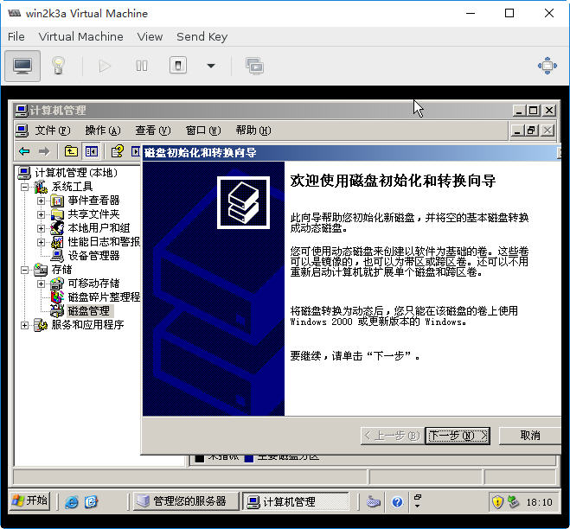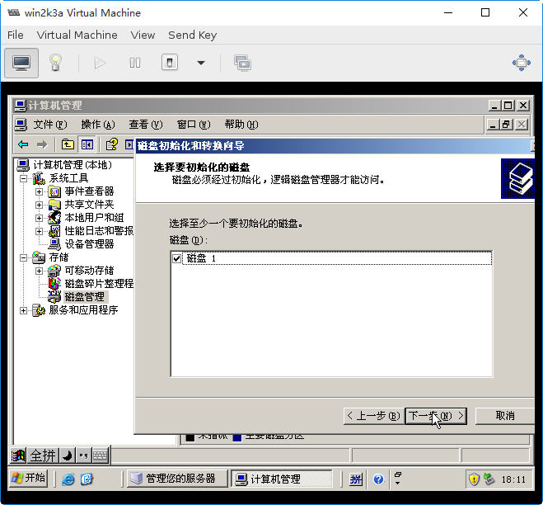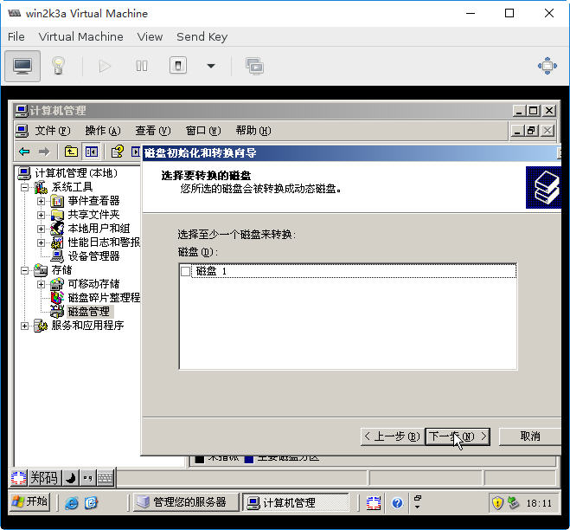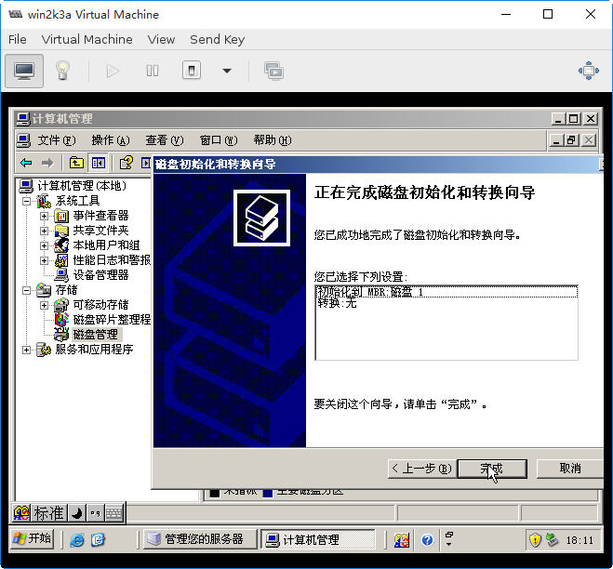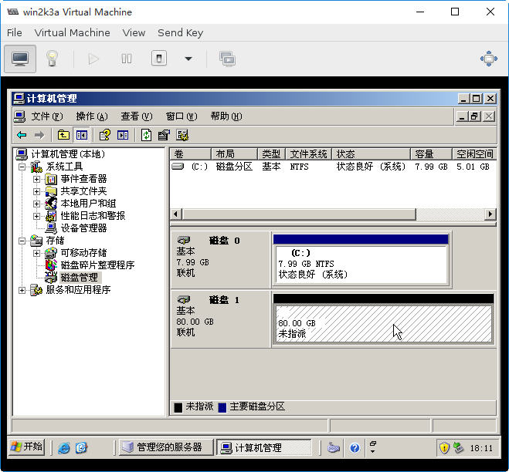

  - 【可选】iSCSI存储池安全
iSCSI存储可以通过用户名密码来提高安全性。
创建需要身份验证iSCSI的存储池，需要进行以下操作。
1、创建libvirt的安全凭证文件
# cat secret.xml
<secret ephemeral='no' private='yes'>
<description>Passphrase for the iSCSI example.com server</description>
<auth type='chap' username='redhat'/>
<usage type='iscsi'>
<target>iscsirhel7secret</target>
</usage>
</secret>

2、定义安全凭证文件
# virsh secret-define secret.xml

3、确认安全凭证文件的UUID
# virsh secret-list

UUID Usage
-----------------------------------------------------------------
2d7891af-20be-4e5e-af83-190e8a922360 iscsi iscsirhel7secret

4、分配安全凭证给UUID
# MYSECRET=`printf %s "password123" | base64`
# virsh secret-set-value 2d7891af-20be-4e5e-af83-190e8a922360 $MYSECRET

5、在存储池中添加身份验证条目

通过virsh修改资源池定义的XML文件的<source>，添加<auth>将指定authentication type, username, 和secret usage.

# cat iscsirhel7pool.xml
<pool type='iscsi'>
<name>iscsirhel7pool</name>
<source>
<host name='192.168.122.1'/>
<device path='iqn.2010-05.com.example.server1:iscsirhel7guest'/>
<auth type='chap' username='redhat'>
<secret usage='iscsirhel7secret'/>
</auth>
</source>
<target>
<path>/dev/disk/by-path</path>
</target>
</pool>

  - 删除iSCSI的存储池

# virsh pool-list
Name State Autostart
-------------------------------------------
default active yes
iso active yes
stor2 active no
vm active yes

# virsh pool-destroy stor2
Pool stor2 destroyed

# virsh pool-list --all
Name State Autostart
-------------------------------------------
default active yes
iso active yes
stor2 inactive no
vm active yes

# virsh pool-delete stor2
error: Failed to delete pool stor2
error: 连接驱动器不支持这个功能：池不支持池删除

# virsh pool-undefine stor2
Pool stor2 has been undefined

# virsh pool-list --all
Name State Autostart
-------------------------------------------
default active yes
iso active yes
vm active yes

