目的

在VMware ESXI 5.5中安装Linux虚拟机，用于KVM实验。

CentOS 7.6 安装

安装文件：CentOS-7-x86_64-DVD-1810.iso
采用以下kickstart文件进行最小化安装

# CentOS 7 64bit 最小化安装

# System authorization information
auth --enableshadow --passalgo=sha512

# Use CDROM installation media
cdrom
text

# Run the Setup Agent on first boot
firstboot --enable
ignoredisk --only-use=sda

# Keyboard layouts
keyboard --vckeymap=us --xlayouts='us'
# System language
lang en_US.UTF-8
# Network information
network --onboot yes --bootproto dhcp --noipv6
network --hostname=localhost.localdomain
# Root password
rootpw 123456

firewall --disable
selinux --disable

# System timezone
timezone --utc Asia/Shanghai
# System bootloader configuration
#bootloader --location=mbr --boot-drive=vda
bootloader --location=mbr --boot-drive=sda
autopart --type=lvm
# Partition clearing information
clearpart --none --initlabel

reboot
%packages
@core
@base
net-tools
%end

[root@kvmlab1 ~]# cat /etc/centos-release
CentOS Linux release 7.6.1810 (Core)

[root@kvmlab1 ~]# uname -a
Linux kvmlab1 3.10.0-957.el7.x86_64 #1 SMP Thu Nov 8 23:39:32 UTC 2018 x86_64 x86_64 x86_64 GNU/Linux

[root@kvmlab1 ~]# cat anaconda-ks.cfg

#version=DEVEL
# System authorization information
auth --enableshadow --passalgo=sha512
# Use CDROM installation media
cdrom
# Use text mode install
text
# Firewall configuration
firewall --disabled
# Run the Setup Agent on first boot
firstboot --enable
ignoredisk --only-use=sda
# Keyboard layouts
keyboard --vckeymap=us --xlayouts='us'
# System language
lang en_US.UTF-8

# Network information
network --bootproto=dhcp --device=link --noipv6 --activate
network --bootproto=dhcp --hostname=localhost.localdomain
# Reboot after installation
reboot
# Root password
rootpw --plaintext 123456
# SELinux configuration
selinux --disabled
# System services
services --enabled="chronyd"
# Do not configure the X Window System
skipx
# System timezone
timezone Asia/Shanghai --isUtc
# System bootloader configuration
bootloader --append=" crashkernel=auto" --location=mbr --boot-drive=sda
autopart --type=lvm
# Partition clearing information
clearpart --none --initlabel

%packages
@base
@core
chrony
kexec-tools
net-tools

%end

%addon com_redhat_kdump --enable --reserve-mb='auto'

%end

考察一下当前配置
[root@kvmlab1 ~]# ip a
1: lo: <LOOPBACK,UP,LOWER_UP> mtu 65536 qdisc noqueue state UNKNOWN group default qlen 1000
link/loopback 00:00:00:00:00:00 brd 00:00:00:00:00:00
inet 127.0.0.1/8 scope host lo
valid_lft forever preferred_lft forever
inet6 ::1/128 scope host
valid_lft forever preferred_lft forever
2: ens160: <BROADCAST,MULTICAST,UP,LOWER_UP> mtu 1500 qdisc pfifo_fast state UP group default qlen 1000
link/ether 00:50:56:b2:44:85 brd ff:ff:ff:ff:ff:ff
inet 192.168.1.238/24 brd 192.168.1.255 scope global noprefixroute ens160
valid_lft forever preferred_lft forever
inet6 fe80::250:56ff:feb2:4485/64 scope link
valid_lft forever preferred_lft forever

[root@kvmlab1 ~]# brctl show
bridge name bridge id STP enabled interfaces

[root@kvmlab1 ~]# ll /etc/sysconfig/network-scripts/ifcfg-*
-rw-r--r-- 1 root root 306 Jan 14 11:53 /etc/sysconfig/network-scripts/ifcfg-ens160
-rw-r--r--. 1 root root 254 Aug 24 18:23 /etc/sysconfig/network-scripts/ifcfg-lo

安装虚拟化相关组件

[root@kvmlab1 ~]# yum -y group install virtualization-hypervisor virtualization-platform virtualization-tools virtualization-client gnome-desktop

需要安装：
Install 231 Packages (+687 Dependent packages)
Upgrade ( 4 Dependent packages)

[root@kvmlab1 ~]# shutdown now –h

调大内存到8GB， 2个CPU，再添加一块160GB磁盘。

启动后，检查当前的环境

[root@kvmlab1 ~]# ip a
1: lo: <LOOPBACK,UP,LOWER_UP> mtu 65536 qdisc noqueue state UNKNOWN group default qlen 1000
link/loopback 00:00:00:00:00:00 brd 00:00:00:00:00:00
inet 127.0.0.1/8 scope host lo
valid_lft forever preferred_lft forever
inet6 ::1/128 scope host
valid_lft forever preferred_lft forever
2: ens160: <BROADCAST,MULTICAST,UP,LOWER_UP> mtu 1500 qdisc mq state UP group default qlen 1000
link/ether 00:50:56:b2:44:85 brd ff:ff:ff:ff:ff:ff
inet 192.168.1.238/24 brd 192.168.1.255 scope global noprefixroute ens160
valid_lft forever preferred_lft forever
inet6 fe80::250:56ff:feb2:4485/64 scope link
valid_lft forever preferred_lft forever
3: virbr0: <NO-CARRIER,BROADCAST,MULTICAST,UP> mtu 1500 qdisc noqueue state DOWN group default qlen 1000
link/ether 52:54:00:1b:e9:82 brd ff:ff:ff:ff:ff:ff
inet 192.168.122.1/24 brd 192.168.122.255 scope global virbr0
valid_lft forever preferred_lft forever
4: virbr0-nic: <BROADCAST,MULTICAST> mtu 1500 qdisc pfifo_fast master virbr0 state DOWN group default qlen 1000
link/ether 52:54:00:1b:e9:82 brd ff:ff:ff:ff:ff:ff

[root@kvmlab1 ~]# brctl show
bridge name bridge id STP enabled interfaces
virbr0 8000.5254001be982 yes virbr0-nic

[root@kvmlab1 ~]# iptables -L -n
Chain INPUT (policy ACCEPT)
target prot opt source destination
ACCEPT udp -- 0.0.0.0/0 0.0.0.0/0 udp dpt:53
ACCEPT tcp -- 0.0.0.0/0 0.0.0.0/0 tcp dpt:53
ACCEPT udp -- 0.0.0.0/0 0.0.0.0/0 udp dpt:67
ACCEPT tcp -- 0.0.0.0/0 0.0.0.0/0 tcp dpt:67

Chain FORWARD (policy ACCEPT)
target prot opt source destination
ACCEPT all -- 0.0.0.0/0 192.168.122.0/24 ctstate RELATED,ESTABLISHED
ACCEPT all -- 192.168.122.0/24 0.0.0.0/0
ACCEPT all -- 0.0.0.0/0 0.0.0.0/0
REJECT all -- 0.0.0.0/0 0.0.0.0/0 reject-with icmp-port-unreachable
REJECT all -- 0.0.0.0/0 0.0.0.0/0 reject-with icmp-port-unreachable

Chain OUTPUT (policy ACCEPT)
target prot opt source destination
ACCEPT udp -- 0.0.0.0/0 0.0.0.0/0 udp dpt:68

[root@kvmlab1 ~]# iptables -L -n -t nat
Chain PREROUTING (policy ACCEPT)
target prot opt source destination

Chain INPUT (policy ACCEPT)
target prot opt source destination

Chain OUTPUT (policy ACCEPT)
target prot opt source destination

Chain POSTROUTING (policy ACCEPT)
target prot opt source destination
RETURN all -- 192.168.122.0/24 224.0.0.0/24
RETURN all -- 192.168.122.0/24 255.255.255.255
MASQUERADE tcp -- 192.168.122.0/24 !192.168.122.0/24 masq ports: 1024-65535
MASQUERADE udp -- 192.168.122.0/24 !192.168.122.0/24 masq ports: 1024-65535
MASQUERADE all -- 192.168.122.0/24 !192.168.122.0/24
[root@kvmlab1 ~]#

考察libvirtd

[root@kvmlab1 ~]# systemctl status libvirtd
● libvirtd.service - Virtualization daemon
Loaded: loaded (/usr/lib/systemd/system/libvirtd.service; enabled; vendor preset: enabled)
Active: active (running) since Mon 2019-01-14 12:16:07 CST; 1min 53s ago
Docs: man:libvirtd(8)
https://libvirt.org
Main PID: 5174 (libvirtd)
Tasks: 19 (limit: 32768)
CGroup: /system.slice/libvirtd.service
├─5174 /usr/sbin/libvirtd
├─5788 /usr/sbin/dnsmasq --conf-file=/var/lib/libvirt/dnsmasq/default.conf --leasefile-ro --dhcp-script=/usr/libexec/libvirt_leaseshelper
└─5789 /usr/sbin/dnsmasq --conf-file=/var/lib/libvirt/dnsmasq/default.conf --leasefile-ro --dhcp-script=/usr/libexec/libvirt_leaseshelper

Jan 14 12:16:08 kvmlab1 dnsmasq[5788]: started, version 2.76 cachesize 150
Jan 14 12:16:08 kvmlab1 dnsmasq[5788]: compile time options: IPv6 GNU-getopt DBus no-i18n IDN DHCP DHCPv6 no-Lua TFTP no-conntrack ipset auth no-DNSSEC loop-detect inotify
Jan 14 12:16:08 kvmlab1 dnsmasq-dhcp[5788]: DHCP, IP range 192.168.122.2 -- 192.168.122.254, lease time 1h
Jan 14 12:16:08 kvmlab1 dnsmasq-dhcp[5788]: DHCP, sockets bound exclusively to interface virbr0
Jan 14 12:16:08 kvmlab1 dnsmasq[5788]: reading /etc/resolv.conf
Jan 14 12:16:08 kvmlab1 dnsmasq[5788]: using nameserver 192.168.1.11#53
Jan 14 12:16:08 kvmlab1 dnsmasq[5788]: using nameserver 8.8.8.8#53
Jan 14 12:16:08 kvmlab1 dnsmasq[5788]: read /etc/hosts - 2 addresses
Jan 14 12:16:08 kvmlab1 dnsmasq[5788]: read /var/lib/libvirt/dnsmasq/default.addnhosts - 0 addresses
Jan 14 12:16:08 kvmlab1 dnsmasq-dhcp[5788]: read /var/lib/libvirt/dnsmasq/default.hostsfile

[root@kvmlab1 ~]# virsh list
Id Name State
----------------------------------------------------

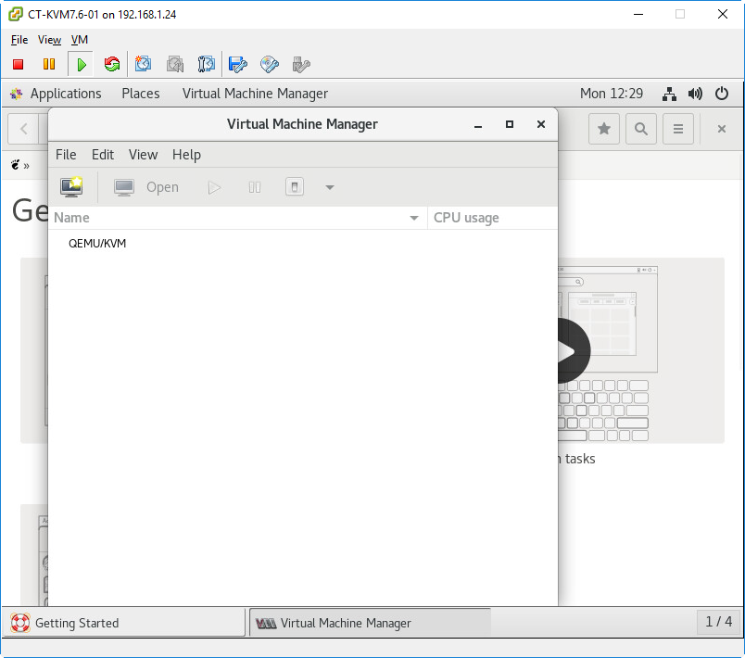

[root@kvmlab1 ~]# systemctl stop libvirtd
[root@kvmlab1 ~]# systemctl status libvirtd
● libvirtd.service - Virtualization daemon
Loaded: loaded (/usr/lib/systemd/system/libvirtd.service; enabled; vendor preset: enabled)
Active: inactive (dead) since Mon 2019-01-14 12:29:58 CST; 5s ago
Docs: man:libvirtd(8)
https://libvirt.org
Process: 5174 ExecStart=/usr/sbin/libvirtd $LIBVIRTD_ARGS (code=exited, status=0/SUCCESS)
Main PID: 5174 (code=exited, status=0/SUCCESS)
Tasks: 2 (limit: 32768)
CGroup: /system.slice/libvirtd.service
├─5788 /usr/sbin/dnsmasq --conf-file=/var/lib/libvirt/dnsmasq/default.conf --leasefile-ro --dhcp-script=/usr/libexec/libvirt_leaseshelper
└─5789 /usr/sbin/dnsmasq --conf-file=/var/lib/libvirt/dnsmasq/default.conf --leasefile-ro --dhcp-script=/usr/libexec/libvirt_leaseshelper

Jan 14 12:16:08 kvmlab1 dnsmasq-dhcp[5788]: DHCP, IP range 192.168.122.2 -- 192.168.122.254, lease time 1h
Jan 14 12:16:08 kvmlab1 dnsmasq-dhcp[5788]: DHCP, sockets bound exclusively to interface virbr0
Jan 14 12:16:08 kvmlab1 dnsmasq[5788]: reading /etc/resolv.conf
Jan 14 12:16:08 kvmlab1 dnsmasq[5788]: using nameserver 192.168.1.11#53
Jan 14 12:16:08 kvmlab1 dnsmasq[5788]: using nameserver 8.8.8.8#53
Jan 14 12:16:08 kvmlab1 dnsmasq[5788]: read /etc/hosts - 2 addresses
Jan 14 12:16:08 kvmlab1 dnsmasq[5788]: read /var/lib/libvirt/dnsmasq/default.addnhosts - 0 addresses
Jan 14 12:16:08 kvmlab1 dnsmasq-dhcp[5788]: read /var/lib/libvirt/dnsmasq/default.hostsfile
Jan 14 12:29:58 kvmlab1 systemd[1]: Stopping Virtualization daemon...
Jan 14 12:29:58 kvmlab1 systemd[1]: Stopped Virtualization daemon.

[root@kvmlab1 ~]# virsh list
error: failed to connect to the hypervisor
error: Failed to connect socket to '/var/run/libvirt/libvirt-sock': No such file or directory

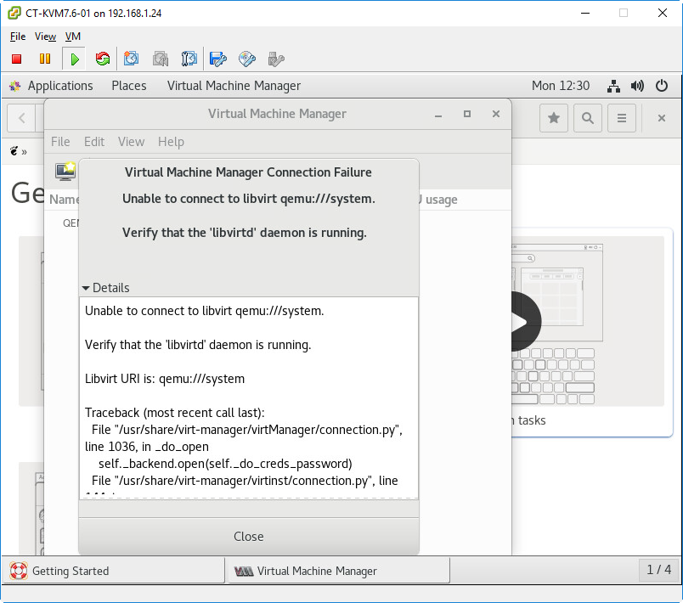

恢复原来状态

[root@kvmlab1 ~]# systemctl start libvirtd
[root@kvmlab1 ~]# tail -f /var/log/messages
Jan 14 12:30:28 kvmlab1 journal: JS ERROR: Exception in callback for signal: position-changed: TypeError: this._rect is undefined#012getCurrentRect@resource:///org/gnome/shell/ui/keyboard.js:553:22#012wrapper@resource:///org/gnome/gjs/modules/_legacy.js:82:22#012_onFocu
sPositionChanged@resource:///org/gnome/shell/ui/keyboard.js:635:20#012wrapper@resource:///org/gnome/gjs/modules/_legacy.js:82:22#012_emit@resource:///org/gnome/gjs/modules/signals.js:128:27#012_setCurrentWindow/this._currentWindowPositionId<@resource:///org/gnome/shell/ui/keyboard.js:534:21Jan 14 12:31:08 kvmlab1 systemd: Starting Cleanup of Temporary Directories...
Jan 14 12:31:08 kvmlab1 systemd: Started Cleanup of Temporary Directories.
Jan 14 12:31:41 kvmlab1 systemd: Starting Virtual Machine and Container Registration Service...
Jan 14 12:31:41 kvmlab1 systemd: Started Virtual Machine and Container Registration Service.
Jan 14 12:31:41 kvmlab1 systemd: Starting Virtualization daemon...
Jan 14 12:31:46 kvmlab1 systemd: Started Virtualization daemon.
Jan 14 12:31:47 kvmlab1 dnsmasq[5788]: read /etc/hosts - 2 addresses
Jan 14 12:31:47 kvmlab1 dnsmasq[5788]: read /var/lib/libvirt/dnsmasq/default.addnhosts - 0 addresses
Jan 14 12:31:47 kvmlab1 dnsmasq-dhcp[5788]: read /var/lib/libvirt/dnsmasq/default.hostsfile

配置嵌套虚拟化设置

[root@kvmlab1 ~]# grep vmx /proc/cpuinfo
[root@kvmlab1 ~]# egrep '^flags.*(vmx|svm)' /proc/cpuinfo

都没有输出

调整虚拟机配置
在向虚拟机中安装ESXI之前，我们需要先关机，并且对虚拟机的属性进行一些调整和复查。
1、升级虚拟机硬件版本，当前版本是8，升级到10
2、修改CPU中硬件虚拟化特性为“向客户机操作系统公开硬件辅助的虚拟化”
3、修改SCSI控制器的类型为LSI Logic Parallel
4、删除原有网卡。添加新的网卡，类型为E1000
5、虚拟机启动模式为BIOS
5、修改VMX配置文件，添加如下内容：
vhv.enable = "TRUE"
hypervisor.cpuid.v0="FALSE"

升级虚拟硬件
关闭虚拟机，调整ESXI虚拟机配置。
升级虚拟机硬件版本，当前版本是8，升级到10
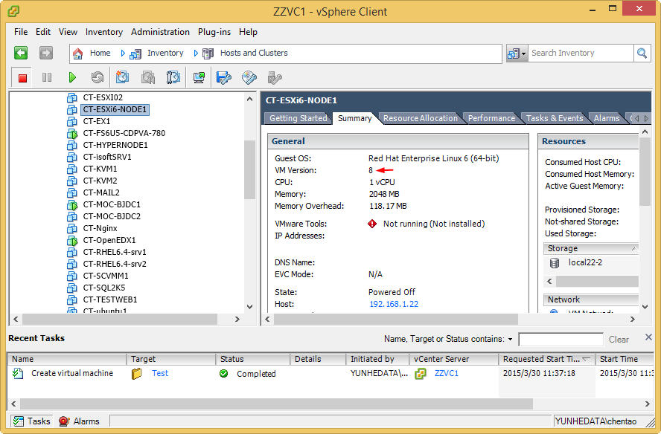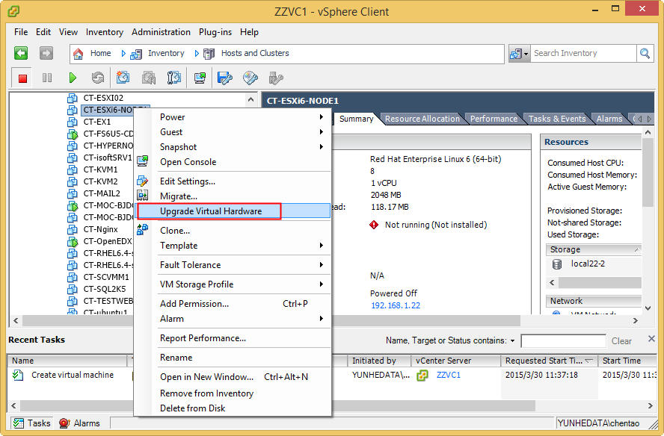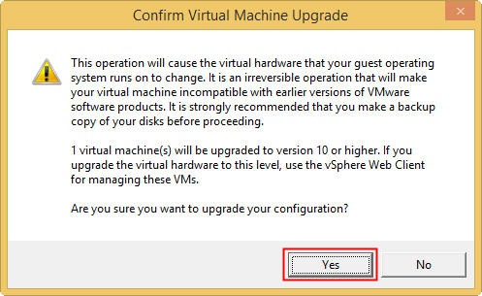
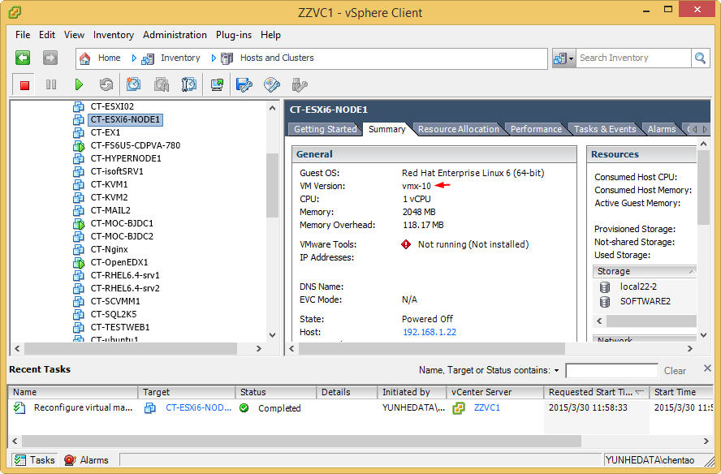

通过VMware Web Client来修改虚拟机配置
一但升级到10版本的虚拟机，就不能通过vSphere Client来进行配置修改了。所以需要通过vSphere Web Client来进行修改。
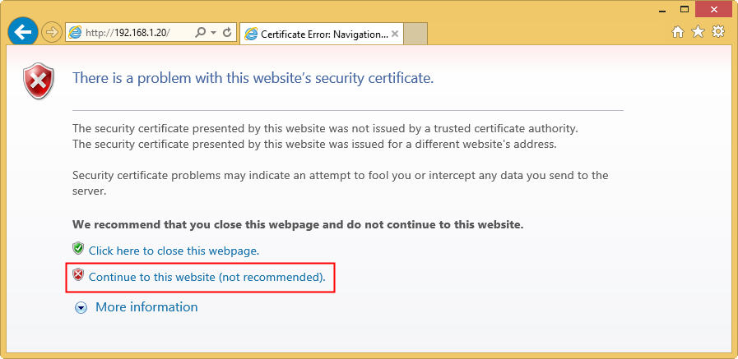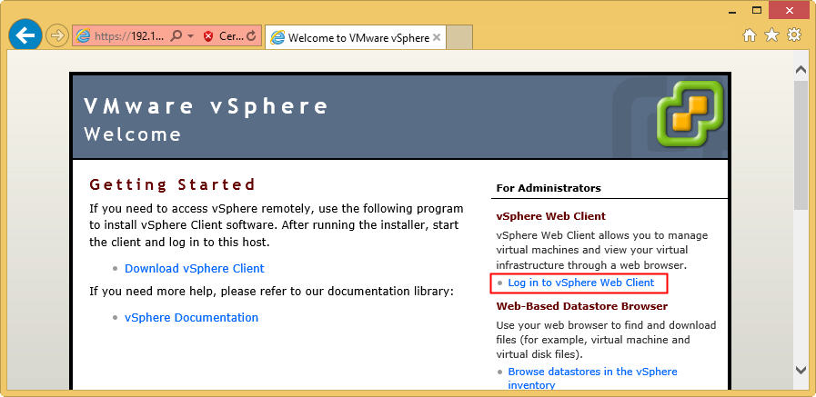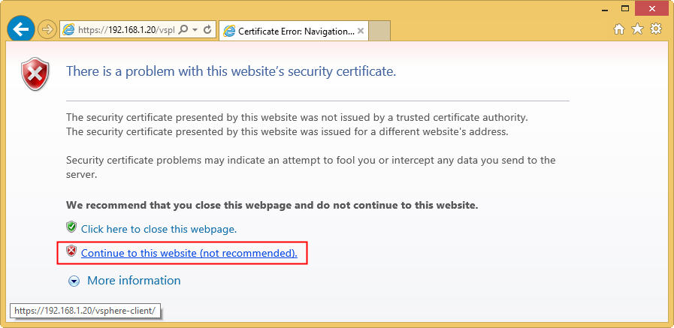
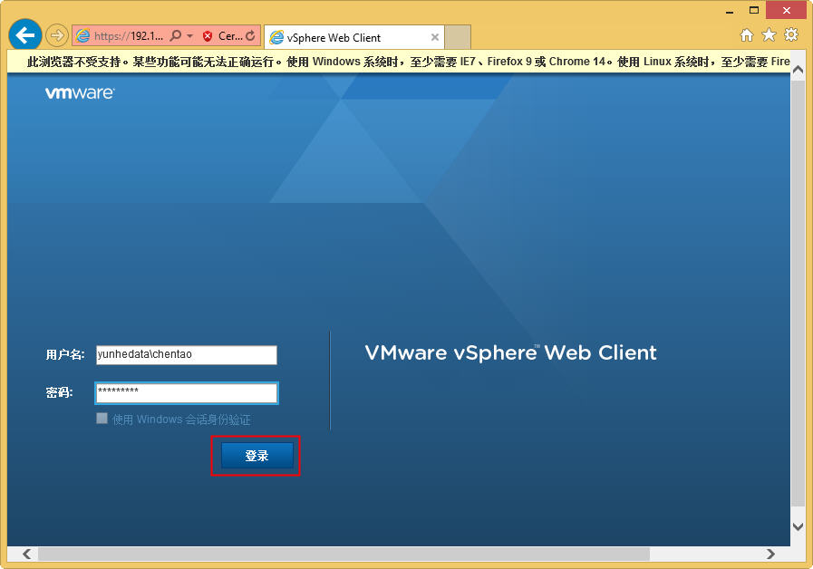
找到虚拟机，进行编辑设置。
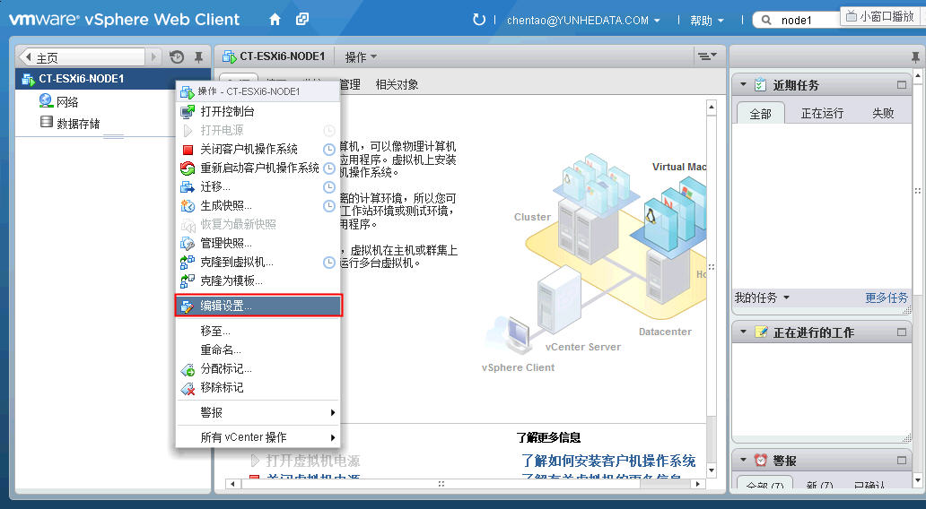

修改虚拟机的CPU中硬件虚拟化特性为“向客户机操作系统公开硬件辅助的虚拟化”
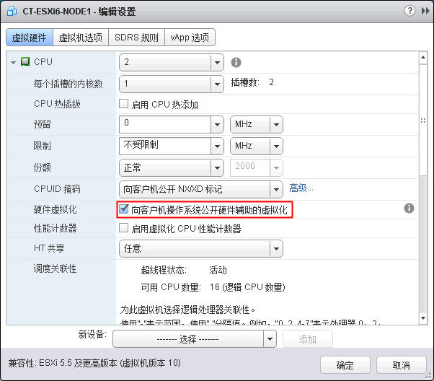
修改SCSI控制器的类型为LSI Logic Parallel。
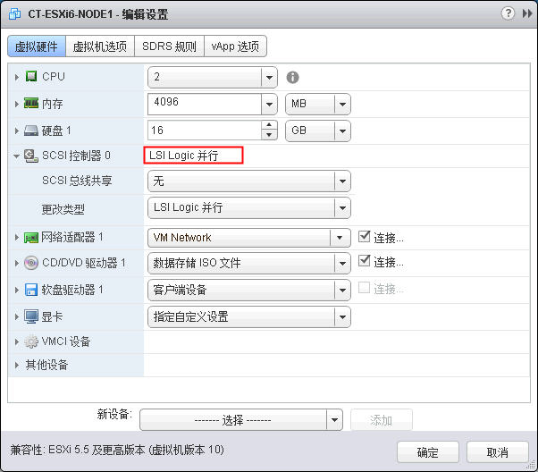
检查网卡类型是否为E1000。如果不是，需要删除原有网卡。添加新的网卡，类型为E1000
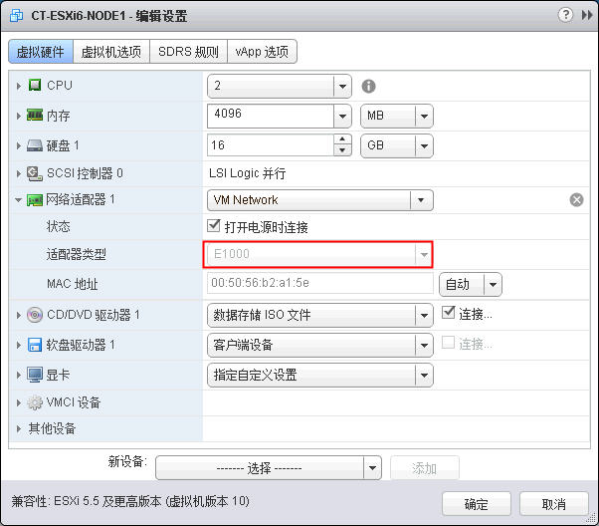
虚拟机启动模式为BIOS。
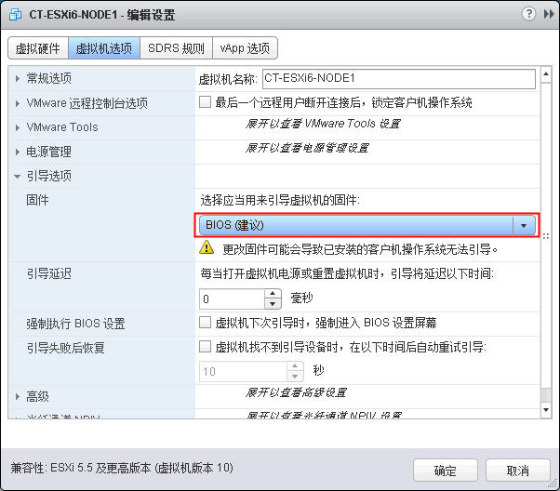
修改配置参数。
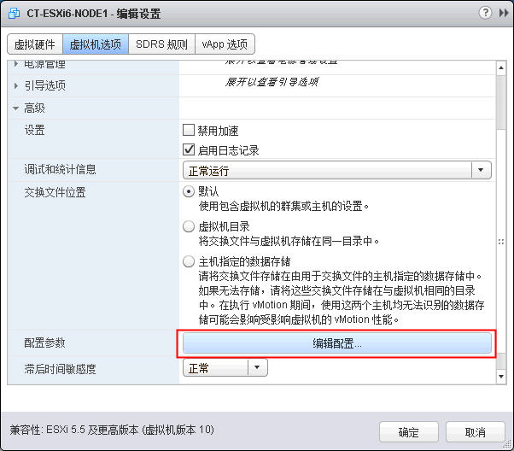
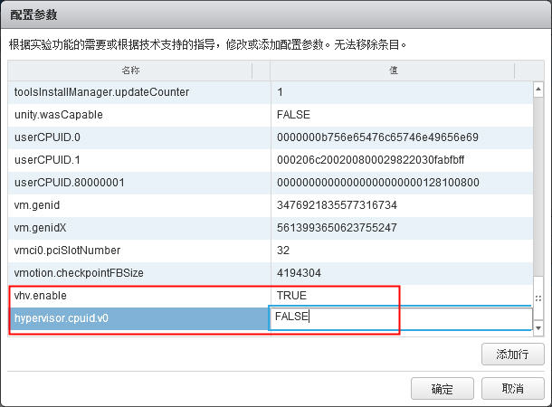
此操作其实就是修改VMX配置文件，添加如下内容：
vhv.enable = "TRUE"
hypervisor.cpuid.v0="FALSE"

调整虚拟交换机
将虚拟交换机置于混杂模式。这样才能使实现环境中Hyper-V上虚拟机才能正常进行网络通信。
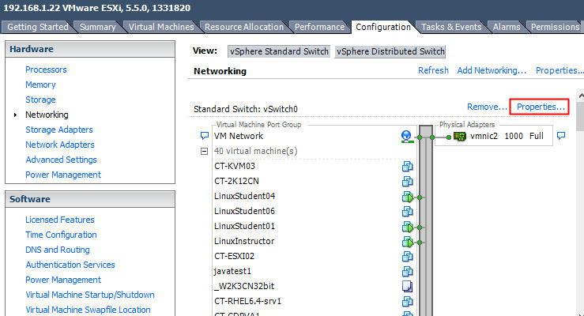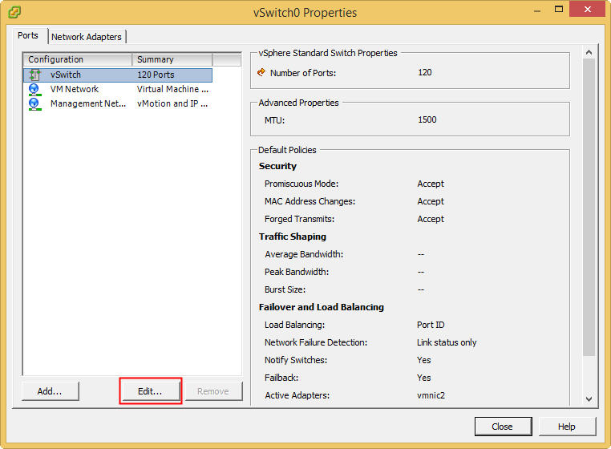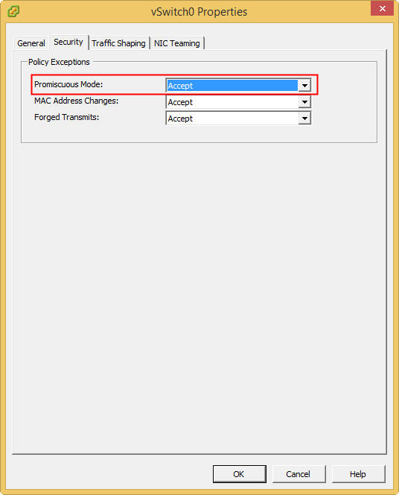

启动虚拟机

在上面的操作中，我是删除原有网卡，然后双添加e1000的网卡。所以网卡设备名称发生了变化 。
所以需要修改一个
# cd /etc/sysconfig/network-scripts/
# mv ifcfg-ens160 ifcfg-ens33
# vi ifcfg-ens33
# Generated by dracut initrd
NAME="ens33"
DEVICE="ens33"
ONBOOT="yes"
NETBOOT="yes"
IPV6INIT="no"
BOOTPROTO="static"
IPADDR=192.168.1.238
NETMASK=255.255.255.0
GATEWAY=192.168.1.1
DNS1=192.168.1.11
DNS2=8.8.8.8
TYPE="Ethernet"
PROXY_METHOD="none"
BROWSER_ONLY="no"
DEFROUTE="yes"
IPV4_FAILURE_FATAL="no"

[root@kvmlab1 ~]# systemctl restart network

[root@kvmlab1 ~]# brctl show
bridge name bridge id STP enabled interfaces
virbr0 8000.5254001be982 yes virbr0-nic
[root@kvmlab1 ~]# ip a
1: lo: <LOOPBACK,UP,LOWER_UP> mtu 65536 qdisc noqueue state UNKNOWN group default qlen 1000
link/loopback 00:00:00:00:00:00 brd 00:00:00:00:00:00
inet 127.0.0.1/8 scope host lo
valid_lft forever preferred_lft forever
inet6 ::1/128 scope host
valid_lft forever preferred_lft forever
2: ens33: <BROADCAST,MULTICAST,UP,LOWER_UP> mtu 1500 qdisc pfifo_fast state UP group default qlen 1000
link/ether 00:50:56:b2:94:af brd ff:ff:ff:ff:ff:ff
inet 192.168.1.238/24 brd 192.168.1.255 scope global noprefixroute ens33
valid_lft forever preferred_lft forever
inet6 fe80::250:56ff:feb2:94af/64 scope link
valid_lft forever preferred_lft forever
3: virbr0: <NO-CARRIER,BROADCAST,MULTICAST,UP> mtu 1500 qdisc noqueue state DOWN group default qlen 1000
link/ether 52:54:00:1b:e9:82 brd ff:ff:ff:ff:ff:ff
inet 192.168.122.1/24 brd 192.168.122.255 scope global virbr0
valid_lft forever preferred_lft forever
4: virbr0-nic: <BROADCAST,MULTICAST> mtu 1500 qdisc pfifo_fast master virbr0 state DOWN group default qlen 1000
link/ether 52:54:00:1b:e9:82 brd ff:ff:ff:ff:ff:ff

[root@kvmlab1 ~]# iptables -L -n
Chain INPUT (policy ACCEPT)
target prot opt source destination
ACCEPT udp -- 0.0.0.0/0 0.0.0.0/0 udp dpt:53
ACCEPT tcp -- 0.0.0.0/0 0.0.0.0/0 tcp dpt:53
ACCEPT udp -- 0.0.0.0/0 0.0.0.0/0 udp dpt:67
ACCEPT tcp -- 0.0.0.0/0 0.0.0.0/0 tcp dpt:67

Chain FORWARD (policy ACCEPT)
target prot opt source destination
ACCEPT all -- 0.0.0.0/0 192.168.122.0/24 ctstate RELATED,ESTABLISHED
ACCEPT all -- 192.168.122.0/24 0.0.0.0/0
ACCEPT all -- 0.0.0.0/0 0.0.0.0/0
REJECT all -- 0.0.0.0/0 0.0.0.0/0 reject-with icmp-port-unreachable
REJECT all -- 0.0.0.0/0 0.0.0.0/0 reject-with icmp-port-unreachable

Chain OUTPUT (policy ACCEPT)
target prot opt source destination
ACCEPT udp -- 0.0.0.0/0 0.0.0.0/0 udp dpt:68
[root@kvmlab1 ~]# iptables -L -n -t nat
Chain PREROUTING (policy ACCEPT)
target prot opt source destination

Chain INPUT (policy ACCEPT)
target prot opt source destination

Chain OUTPUT (policy ACCEPT)
target prot opt source destination

Chain POSTROUTING (policy ACCEPT)
target prot opt source destination
RETURN all -- 192.168.122.0/24 224.0.0.0/24
RETURN all -- 192.168.122.0/24 255.255.255.255
MASQUERADE tcp -- 192.168.122.0/24 !192.168.122.0/24 masq ports: 1024-65535
MASQUERADE udp -- 192.168.122.0/24 !192.168.122.0/24 masq ports: 1024-65535
MASQUERADE all -- 192.168.122.0/24 !192.168.122.0/24
46 brctl show

[root@kvmlab1 ~]# grep vmx /proc/cpuinfo
flags : fpu vme de pse tsc msr pae mce cx8 apic sep mtrr pge mca cmov pat pse36 clflush dts mmx fxsr sse sse2 ss syscall nx pdpe1gb rdtscp lm constant_tsc art arch_perfmon pebs bts nopl xtopology tsc_reliable nonstop_tsc aperfmperf eagerfpu pni pclmulqdq vmx s
sse3 fma cx16 pcid sse4_1 sse4_2 x2apic movbe popcnt aes xsave avx f16c rdrand lahf_lm 3dnowprefetch epb cat_l3 cdp_l3 mba tpr_shadow vnmi ept vpid fsgsbase smep xsavec xgetbv1 cqm_llc cqm_occup_llc cqm_mbm_total cqm_mbm_local dtherm ida arat pln ptsflags : fpu vme de pse tsc msr pae mce cx8 apic sep mtrr pge mca cmov pat pse36 clflush dts mmx fxsr sse sse2 ss syscall nx pdpe1gb rdtscp lm constant_tsc art arch_perfmon pebs bts nopl xtopology tsc_reliable nonstop_tsc aperfmperf eagerfpu pni pclmulqdq vmx s
sse3 fma cx16 pcid sse4_1 sse4_2 x2apic movbe popcnt aes xsave avx f16c rdrand lahf_lm 3dnowprefetch epb cat_l3 cdp_l3 mba tpr_shadow vnmi ept vpid fsgsbase smep xsavec xgetbv1 cqm_llc cqm_occup_llc cqm_mbm_total cqm_mbm_local dtherm ida arat pln pts

