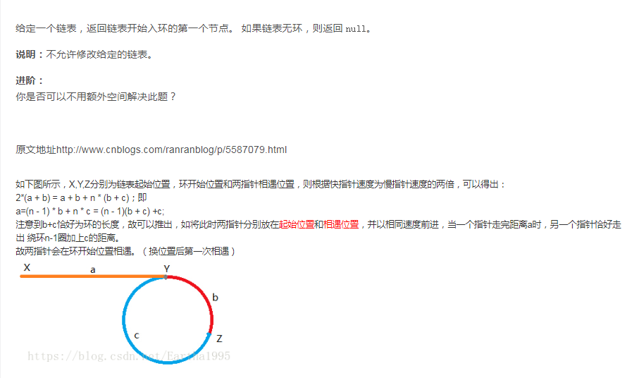

JAVA代码：
class CycleLinkedListIISolution{
public ListNode hasCycleIISolution(ListNode head) {
boolean cycle=false;
ListNode fast;
ListNode slow;
ListNode start = null;
fast=slow=head;
while(fast!=null&&fast.next!=null) {
slow=slow.next;
fast=fast.next.next;
if(slow==fast) {
cycle=true;
fast=head;
while(slow!=fast) {
slow=slow.next;
fast=fast.next;
}
start=slow;
break;
}
}
return cycle?start:null;
}
class ListNode{
int val;
ListNode next;
public ListNode(int x) {
val=x;
next=null;
}
}
}

