Synthetic Notes Import Fixture
This document contains invented content for DOCX import tests. It includes headings, emphasis, lists, a table, a formula source and one intentionally unsupported image.

Structured content
The importer should preserve bold text and ordinary paragraphs without treating this content as production data.
- First synthetic bullet
- Second synthetic bullet

Spreadsheet sample
Item | Q1 | Q2 | Formula source
Alpha | 12 | 14 | =SUM(B2:C2)
Beta | 8 | 11 | =SUM(B3:C3)
Total | 20 | 25 | =SUM(D2:D3)

Equation source
LaTeX: E = mc^2

Unsupported image case
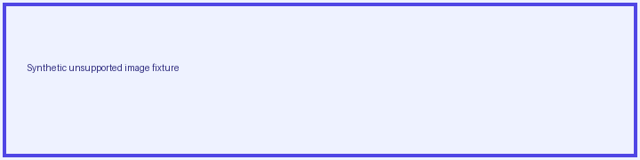
The first Notes release must report this image as unsupported.

