DASE7506 Project 1 Language Model BPB Technical Report
Frozen v3: driving the complete test BPB from 2.101265 to 1.571349

1. Background and Mission Objectives
A language model estimates the probability of the next token from the preceding context. The higher the probability it assigns to the correct token, the fewer bits are needed to encode the same text. This project therefore cares not only about whether the model fits the training text, but also about whether it produces accurate and reproducible probability distributions on text it has not been trained on.
The task is to train a decoder-only Transformer from random initialisation on the supplied WikiText-2 text and to minimise bits per byte (BPB) on the complete test split under a fixed BPE-2048 tokenizer, a 256-token context and the supplied CPU FP32 scorer. Only the training split updates parameters; architecture, hyperparameters, seeds and checkpoint selection are decided on validation alone; the test split is scored once, after the method is frozen.
This round builds on the frozen v2 predictor (test BPB 1.611178). The frozen v3 reaches 1.571349, 25.22% below the course baseline and 0.039830 below v2.
Table 1. Fixed conditions and rigid limits
Item | Fixed setting | Role or limit
Data | Supplied WikiText-2 | Train, validation and test splits strictly separated
Tokenizer | BPE-2048 | Vocabulary and segmentation are not modifiable
Context | 256 tokens | Training and evaluation share the maximum context
Windows | Independent, strictly causal | No future tokens and no cross-window state
Model choice | Validation only | Test never selects structure or hyperparameters
Final scoring | CPU FP32, complete test split | The reported score reproduces on a CPU
CPU time limit | At most 5x the baseline | Hard limit; a lower BPB cannot offset it
Memory limit | Peak RSS at most 4 GiB | Hard limit
Asset limit | At most 64 MiB uncompressed | Hard limit

2 Evaluation Indicators and Selection Agreement
The headline metric is bits per byte. With B the raw UTF-8 byte count of the split, the total negative log-likelihood is converted to bits through ln(2) and divided by B. Lower is better. A complete split must accumulate all target NLL first and divide once, never averaging the BPB of individual batches or windows.
Table 2. Reported metrics and assessment
Metric | Definition or measurement | Role | Direction or limit
BPB | total NLL / ln(2) / UTF-8 bytes | headline quality | lower better
Token PPL | exp(total NLL / targets) | token-level difficulty | lower better
CPU time ratio | candidate time / same-split baseline time | inference speed cost | at most 5x
Peak RSS | maximum resident memory of the scorer | evaluation memory | at most 4 GiB
Inference assets | uncompressed assets needed at inference | checkpoint and dependencies | at most 64 MiB

BPB is the ranking metric; the three resource limits are hard constraints that stand on their own and cannot be offset by a lower BPB. Quality and resources are therefore reported separately, and resources are re-measured with a median of five repetitions before freezing.

2.1 Data usage and freezing
Train updates parameters, validation selects structure, hyperparameters, seeds and checkpoints, and test is scored once after the freeze manifest has been written. The manifest records the SHA-256 of the checkpoint, the implementation files, the evaluator and the tokenizer, and it leaves the test-result field empty to show the freeze preceded any test number.
Comparisons must also hold the scorer, the context length and the number of processed targets fixed. Where training scale or duration changes, quality and cost are reported separately, so that "trained more" or "model larger" is never written up as a single mechanism.
Table 3. Scale and training budget of this round
Item | Value | Note
Training corpus | 3,613,343 BPE tokens | about 3.6M; the dominant data limit here
Screening budget | 9.83M to 28.9M processed targets | about 2.7 to 8.0 epochs
Final recipe budget | 28,909,568 targets | batch 4, 28,232 optimisation steps
Controlled runs | 32 runs this round | plus 33 runs during v1 and v2
Search cost | 773,704,448 targets | training size is unlimited, only disclosed
Final parameters | 10,488,640 | identical to v2

3 Models and Training Methods
The model is a pre-norm decoder-only Transformer: width 320, depth 8, four attention heads (head dimension 80), RMSNorm, a SwiGLU feed-forward with hidden size 853 (FLOP-matched to a 4x GELU MLP), RoPE positional encoding, and tied input and output weights, for a total of 10,488,640 parameters.
Training uses AdamW (weight decay 0.1, betas 0.9/0.95), gradient clipping at 1.0, a three percent warmup followed by cosine decay, and without-replacement window sampling over every legal window start. Relative to v2, v3 changes the seed, batch size, peak learning rate, decay floor and checkpoint location together, then divides the logits by a validation-fitted temperature of 1.075; only the before-and-after temperature comparison is assigned a separate causal interpretation, while the other changes are reported as a joint recipe difference.
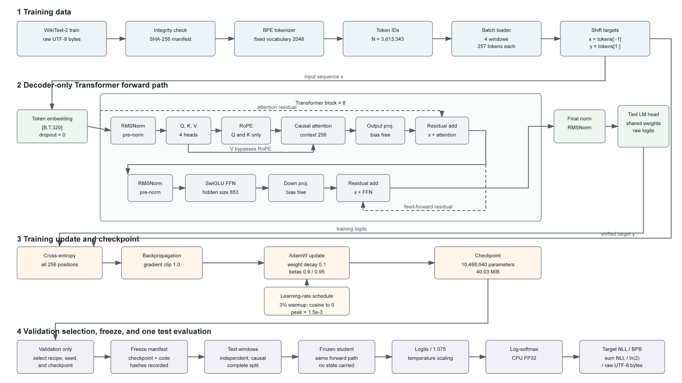
Fig. 1. Model structure, training data flow and evaluation path of frozen v3. The annotated batch size, learning rate and decay floor are the v3 values.
Table 4. Model and training recipe: v2 against v3
Setting | v2 | v3 | Effect on inference
Width / depth / heads | 320 / 8 / 4 | 320 / 8 / 4 | none
Norm / FFN / positional | RMSNorm / SwiGLU / RoPE | RMSNorm / SwiGLU / RoPE | none
Weight tying | tied | tied | none
Parameters | 10,488,640 | 10,488,640 | none
Batch (windows) | 32 | 4 | none, training only
Peak learning rate | 1e-3 | 1.5e-3 | none, training only
Decay floor | 0.1 x peak | 0 | none, training only
Calibration temperature | 1.00 | 1.075 | one elementwise scalar division
Inference assets | 40.033 MiB | 40.034 MiB | +1 KB

Batch size, learning rate and the decay floor affect training only, while temperature scaling adds one elementwise division to the inference graph without adding trainable parameters; the asset increase is about 1 KB and the operation is negligible beside the Transformer forward pass.

4 BPB Optimization Process and Judgment Methods
v1 used learned positional embeddings and froze RMSNorm, SwiGLU, tied weights and the trainer changes together; v2 introduced RoPE and selected among predeclared validation checkpoints during longer training; v3 keeps a 28.9M-target budget, changes the optimisation and checkpoint recipe jointly, and calibrates the output confidence on validation.

4.1 Numerical decomposition of the optimisation path
v3 lowers test BPB by 0.039830 relative to v2. On validation, the frozen v2 setting and the uncalibrated v3 setting differ by 0.031205, but that contrast combines the seed, batch, learning rate, decay floor and checkpoint location and is therefore a joint recipe gap rather than a causal contribution; the paired temperature comparison on the same v3 checkpoint gives a separately attributable calibration gain of 0.007392. These validation differences cannot be added and equated with the test delta. Earlier, v2 improved on v1 by 0.034974 and v1 on the baseline by 0.455113.
Table 5. Stage-to-stage deltas and their interpretation limits
Stage | Validation BPB | Test BPB | Delta | Interpretation limit
Course baseline | 2.071087 | 2.101265 | — | reference implementation
v1 structure + trainer | 1.622441 | 1.646152 | 0.455113 | structure, trainer and budget all change
v2 long run + selection | 1.588095 | 1.611178 | 0.034974 | duration and checkpoint rule both change
v3 joint recipe + calibration | 1.556890 | 1.571349 | 0.039830 | seed, optimisation, selection and calibration change

The path to v2 narrowed the search space in recorded steps. A 9.83M-target 2 by 2 factorial gave a SwiGLU main effect of -0.055444 and an RMSNorm main effect of -0.005725; width 320, depth 8 and a 1e-3 peak rate then became the capacity reference, while dropout 0.05 and weight decay 0.2 produced no reproducible gain. After the v1 long run with learned positions, short RoPE controls improved both tested seeds, whereas untying, larger capacity, EMA and multi-token prediction were rejected by resource or noise evidence. The first long RoPE run regressed after 19.66M targets, so three seed runs declared checkpoints at 9.83M, 19.66M and 28.91M in advance and selected the lowest complete-validation score; seed 137 at 19.66M was frozen and produced the one-shot v2 test BPB of 1.611178.

5 Basis for Decisions on Hyperparameters and Training Length
This section answers three questions: where the training budget should stop, what batch size and learning rate should be used, and how large the noise is before any of these choices can be judged. All comparisons use seed 17 and one scorer.
Table 6. Training-budget sweep (seed 17, batch 32, full anneal)
Processed targets | Validation BPB | Relative to 20M | Verdict
16.0M | 1.640587 | +0.035453 | insufficient
20.0M | 1.605134 | +0.000000 | saturated
24.0M | 1.605983 | +0.000848 | saturated
28.9M | 1.603377 | -0.001757 | saturated

This closes the ordinary route of training longer. Under a full anneal, pushing the budget from 20M to 28.9M buys only a noise-level difference, so the remaining improvement had to come from spending the same token budget more effectively.

5.1 Why training loss and validation must be read together
Training turned out not to be reproducible. The MPS bf16 kernels used for multiplication and reduction are non-deterministic and two runs of an identical configuration diverge in training loss from step 500 onwards. We therefore replicated one configuration three times to obtain a usable noise floor, and graded every later comparison against it.
Table 7. Noise floor and what it implies
Quantity | Value | Consequence
Mean of three runs | 1.613278 | the honest baseline for batch 32
Between-run standard deviation | 0.010223 | a single comparison must exceed about 2 sigma
Range of three runs | 0.020418 | about 2 sigma, as expected
Adoption criterion | monotone trend + paired replication | no conclusions from single points

This floor changed two earlier conclusions. The claimed overfitting turning point at 19.66M rests on a +0.015 rebound that sits inside the noise; the correct statement is a plateau around 20M. The claim that "1e-3 is the best learning rate" holds only at batch 32, as section 5.3 shows. Every mechanism adopted below is therefore supported by a paired comparison or a monotone trend.

5.2 Scope of application for regularisation results
To confirm that the gain comes from the recipe rather than from regularisation strength, three training-time regularisers were tested against the fixed batch-32 baseline of 1.605134 at 20M targets. All were negative or unresolved. Droppath 0.1 degrades validation BPB by 0.045020, far beyond noise; whole-token dropout and embedding dropout gain only 0.003067 and 0.000981, less than a third of the noise floor.
Table 8. Regularisation ablation (seed 17, 20M targets, batch 32)
Direction | Validation BPB | Relative | Verdict
baseline, no regulariser | 1.605134 | — | reference
droppath 0.1 | 1.650154 | +0.045020 | harmful
token dropout 0.05 | 1.602067 | -0.003067 | unresolved
embedding dropout 0.1 | 1.604153 | -0.000981 | unresolved
EMA 0.999 weight averaging | 1.610504 | +0.005370 | harmful

Read together with the capacity results in section 5.4, this gives the central judgement of the project: the model is neither under-regularised nor under-sized, but limited by the signal available in 3.6M training tokens. That is why adding regularisation and adding width both fail.

5.3 Joint choice of learning rate and batch size
This is the largest and most easily missed result of the round. At a fixed 20M targets, dropping the batch from 32 windows to 4 keeps the token budget and raises the number of optimisation steps from 2,442 to 19,532, moving validation BPB from 1.605134 to 1.568646. Continuing to 2 and 1 rebounds to 1.622860 and 1.660514, so the optimum is 4 rather than as small as possible.
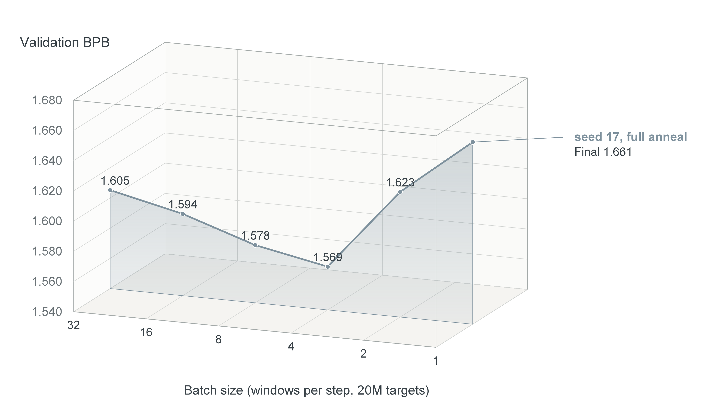
Fig. 2. Validation BPB against batch size. The curve bottoms out at four windows and degrades on both sides: smaller batches carry noisier gradients and going too far hurts the final quality.
Table 9. Batch size and optimisation steps (seed 17, 20M targets, full anneal)
Batch | Steps | Validation BPB | Relative to batch 32
32 | 2,442 | 1.605134 | +0.000000
16 | 4,883 | 1.594155 | -0.010979
8 | 9,766 | 1.578192 | -0.026942
4 | 19,532 | 1.568646 | -0.036488
2 | 39,063 | 1.622860 | +0.017726
1 | 78,125 | 1.660514 | +0.055380

At the common 20M-target budget, seed 17 and full anneal, validation BPB moves monotonically from 1.605134 to 1.582448 and 1.568646 as batch size falls from 32 to 8 and 4. The three batch-32 replications were run at 28.91M targets and can estimate run-to-run variability, but they cannot form a valid significance test against the single 20M-target batch-4 result; the earlier p-value is therefore removed, and the batch result is reported as a trend that still requires matched-budget replication.
Changing the batch invalidates the learning-rate sweep, and that is the most transferable lesson of the round. The rate of 1e-3 had been tuned at batch 32, where a step processes 8,192 tokens. At batch 4 a step processes 1,024 tokens, the gradient noise per step is far larger, and the optimum shifts upward.
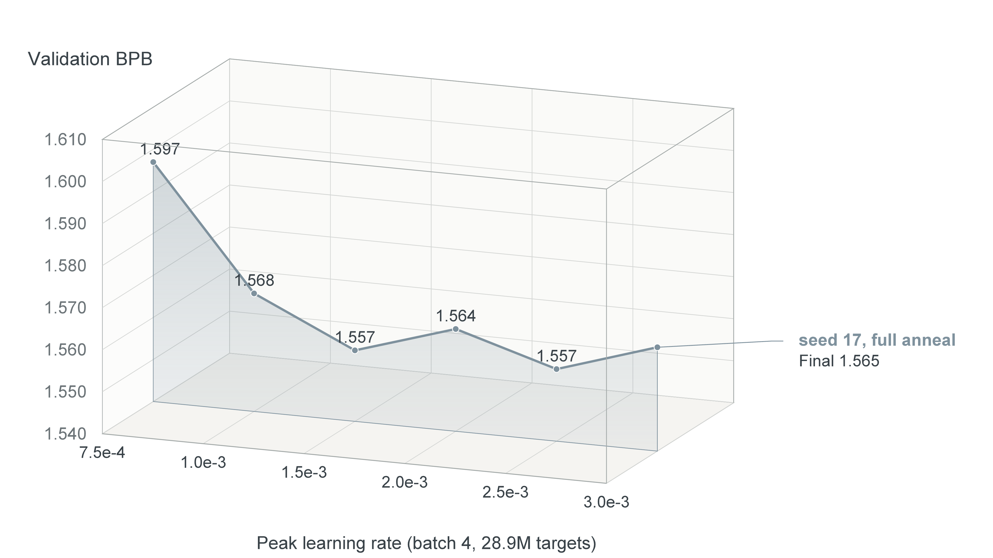
Fig. 3. Re-sweeping the peak learning rate after the batch was changed to 4; six points span 7.5e-4 to 3e-3. The single runs at 1.5e-3 and 2.5e-3 differ by 0.000259, while the intervening 2e-3 point and the 3e-3 point are about 0.0075 worse and lowering the rate is clearly harmful.
Table 10. Learning-rate re-sweep (seed 17, batch 4, 28.9M targets)
Peak learning rate | Validation BPB | Relative to 1e-3 | Verdict
7.5e-4 | 1.596950 | +0.028882 | too small
1.0e-3 | 1.568068 | +0.000000 | reference
1.5e-3 | 1.556890 | -0.011178 | strong candidate
2.0e-3 | 1.564327 | -0.003742 | weaker single run
2.5e-3 | 1.557149 | -0.010919 | strong candidate
3.0e-3 | 1.564697 | -0.003371 | weaker single run

Three conclusions follow. The earlier sweep stating that 1e-3 is best and 2e-3 clearly worse holds only at batch 32 and does not extrapolate; changing the batch invalidates the sweep, which is the most transferable lesson of the round. Second, extending the sweep to 3e-3 locates the two separated candidates at 1.5e-3 and 2.5e-3 differ by only 0.000259, but the worse 2e-3 result between them rules out describing the interval as a continuous plateau. With a run-to-run standard deviation near 0.010, the evidence supports 1.5e-3 as a sound frozen choice while leaving the precise learning-rate optimum unresolved pending paired replications.
A further cross-check exposes the coupling between batch size and learning rate. At lr 2e-3 and 28.9M targets, batches of 8, 4 and 2 give validation BPB of 1.572065, 1.564327 and 1.548231, still monotonically decreasing. In other words the "batch bottoms out at 4" result holds only at lr 1e-3; once the rate is raised, smaller batches keep improving, where batch 2 scored 1.622860 at lr 1e-3.
Under a common calibration regime that advantage almost disappears. The optimal temperature for batch 2 with lr 2e-3 is only 1.025 with a calibration gain of 0.000065, because the model is already well calibrated, giving 1.548165; v3 gains 0.007392 from calibration and reaches 1.549498. The gap shrinks from 0.008659 to 0.001333, about 0.13 standard deviations.
A paired replication of batch 2 with lr 2e-3, using an identical configuration, then returned 1.555356 against the original 1.548231, a spread of 0.007125 or about 0.7 standard deviations, for a two-sample mean of 1.551793. The original 0.008659 advantage was therefore mostly a single point fluctuation, and the two-sample mean is still worse than v3 under a common calibration regime (1.551793 against 1.549498). Pushing on to batch 1 degrades sharply to 1.660200, and batch 2 with a higher rate of 2.5e-3 is also worse at 1.560446, so the small-batch direction is closed.
This report therefore does not issue a new version, and records two methodological rules instead. Two recipes must be compared after each has been given its own optimal temperature, otherwise changes of the "smaller batch and higher rate" kind are systematically overstated because calibration headroom moves the other way. And any single-point difference near the noise floor must be replicated before it is believed: here a single point appeared to win by 0.0087 and the advantage vanished on replication.

5.4 Normalisation and feed-forward factorial
The structure of the frozen model comes from an earlier set of controlled comparisons, all at 9,830,400 processed targets, batch 32 and peak learning rate 1e-3: a cell-by-cell normalisation by feed-forward factorial, a paired comparison of position representation and weight sharing, two training-only mechanisms that cost nothing at inference, and a ladder that applies every trainer change to the supplied baseline model. The deltas below are what those four groups established; the full edition carries the per-cell values in sections 5.4 to 5.6.
Table 11. Summary of the structural comparisons: 9.83M targets, batch 32, peak learning rate 1e-3.
Comparison | Delta | Verdict
SwiGLU 2.667x replacing GELU 4x (factorial main effect) | -0.055444 | adopted
RMSNorm replacing LayerNorm (main effect) | -0.005725 | adopted
interaction between the two | -0.001373 | negligible
RoPE replacing learned positions (tied, seed 17) | -0.065574 | adopted
untied, under learned positions (seed 17) | -0.033754 | confounded with RoPE
untied, under RoPE (mean of two seeds) | -0.006750 | below noise, rejected
tail weight averaging, EMA 0.99 (single run) | -0.010896 | below noise, rejected
multi-token prediction, MTP k=1 (single run) | -0.005075 | below noise, rejected
net effect of applying every trainer change (baseline model) | +0.026100 | trainer contributes no gain

5.7 Why capacity stops at width 320 / depth 8
Changing width or depth at a fixed token budget shows widths of 256 and 288 to be worse than 320 by 0.022691 and 0.011753, while depth 9 is nominally better by 0.010936 but only half the noise floor and therefore unresolved. The intuition that a smaller model would overfit less does not hold here, and width 320 with depth 8 is the sweet spot for this budget.
Table 12. Capacity, quality and training cost (seed 17, 20M targets, batch 32)
Configuration | Validation BPB | Relative to w320 | Parameters | Verdict
width 256 / depth 8 | 1.627825 | +0.022691 | 6,816,000 | harmful
width 288 / depth 8 | 1.616887 | +0.011753 | 8,557,344 | harmful
width 320 / depth 8 (reference) | 1.605134 | — | 10,488,640 | reference
width 320 / depth 9 | 1.594198 | -0.010937 | 11,717,760 | unresolved

Two further capacity directions were excluded by the resource limits rather than by experiment. Width 384 would push the CPU time ratio to between 4.5 and 5.0x, too close to the hard limit to leave any re-measurement margin, and an earlier short-budget comparison found both width 384 and depth 10 clearly worse. Within this evaluation budget, capacity exploration is effectively closed.

6 Final Results and Resources After Freezing
The v3 freeze manifest was written before the test run with its test-result field empty; the same checkpoint was then scored once. Every hash was checked against the manifest.
Table 13. Final results on the complete test split
Version | Validation BPB | Complete test BPB | Token PPL | Relative to baseline
Course baseline | 2.071087 | 2.101265 | 80.848 | —
Frozen v1 | 1.622441 | 1.646152 | 31.83 | -21.66%
Frozen v2 | 1.588095 | 1.611178 | 29.023 | -23.32%
Frozen v3 (this round) | 1.556890 | 1.571349 | 26.704 | -25.22%

6.1 Training and search costs
The disclosed search totals 32 controlled runs and 773,704,448 processed targets this round. The freeze manifest records the snapshot as it stood at freeze time (24 runs and 542,427,904 targets); the later learning-rate runs are counted here as well. On top of that, 33 runs and 429,047,808 targets went into v1 and v2 development. A single 20M-target run takes about 16 to 20 minutes on MPS bf16, and the final recipe (28.9M targets at batch 4) about 27 minutes. Training duration and search size are unlimited under the course rules and only need disclosure.
This round raises the optimisation-step count by about eightfold while leaving the parameter count unchanged; inference adds only one temperature division over the logits, whose compute and storage costs are negligible beside the Transformer forward pass.

6.2 What the test improvement corresponds to
v3 test BPB is 0.039830 below v2, but the result is not an additive causal decomposition: the 0.031205 uncalibrated validation gap combines changes in seed, batch, learning rate, decay floor and checkpoint location, whereas only the 0.007392 temperature gain is a paired comparison on the same v3 checkpoint. The architecture and parameter count are unchanged, and the inference graph explicitly adds the temperature division.
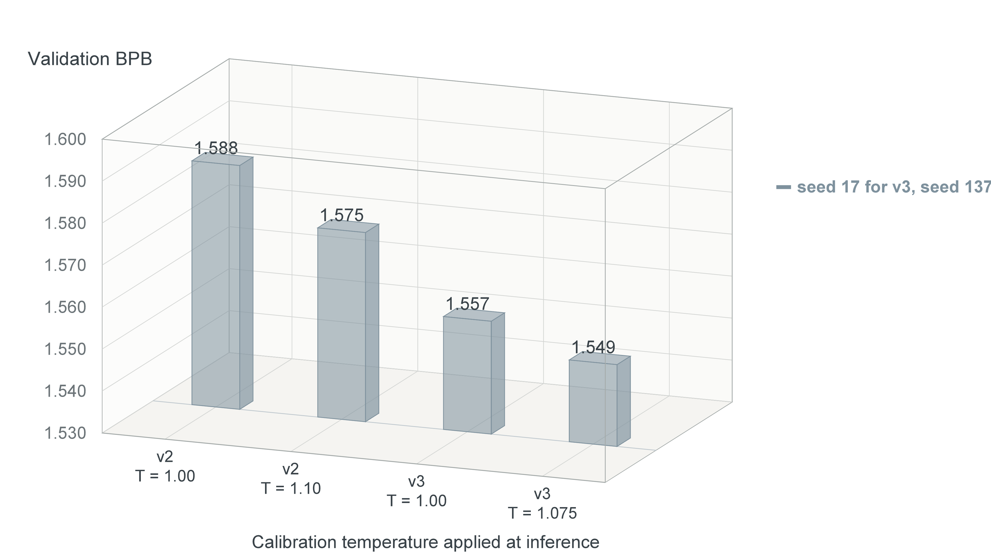
Fig. 4. Validation BPB before and after temperature scaling. The v2 value T = 1.10 is a post-freeze diagnostic and official v2 remains at T = 1.00; v3 selected T = 1.075 before its freeze.
Table 14. Calibration and the half-split generalisation check
Item | Value | Note
Diagnostic optimum T for v2 | 1.100 | post-freeze only; official v2 uses T = 1.00
Optimal T for v3 | 1.075 | validation BPB 1.556890 to 1.549498
Gain on the fitting half | 0.012501 | T fitted on the even half only
Gain on the held-out half | 0.013546 | scored on the odd half; no smaller than the fitting half
Inference cost | negligible | no extra parameters; one scalar division, assets +1 KB

One interaction is easy to miss: smaller batches carry more training noise and leave less calibration headroom (0.013023 for v2 against 0.007392 for v3). The batch-4 gain and the calibration gain therefore cannot be added and compared against batch 32; both must be compared under the same calibration regime, which is how this report treats them.

6.3 Resource thresholds and measurement protocols
Resource measurement uses a median of five repetitions. Each repetition loads one checkpoint in a fresh process and scores the complete test split in CPU FP32, with the baseline measured in the same invocation so the ratio never depends on a stale hard-coded number.
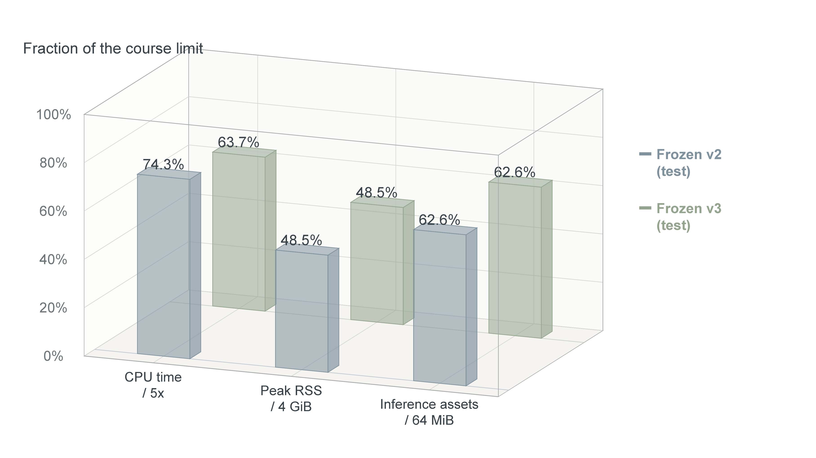
Fig. 5. Resource use of v2 and v3 on the test split, as a fraction of each limit. Both predictors remain below all three bounds, with nearly identical asset use.
Table 15. Test resource measurement (median of five, FP32, four threads)
Metric | v2 measured | v3 measured | Limit | Verdict
CPU time ratio | 3.713x | 3.187x | 5x | pass
Peak RSS | 1.940 GiB | 1.941 GiB | 4 GiB | pass
Inference assets | 40.033 MiB | 40.034 MiB | 64 MiB | pass

The compute limit is not the binding constraint because fixed overhead and the inefficiency of the reference implementation take a large share: the course baseline has only 1.09M parameters and its small matrix multiplications run far below the efficiency of a width-320 model, so scaling parameters by nearly ten raises the time ratio only to about three. This report also records that the ratio itself is unstable across sessions, so freezing always re-measures instead of trusting a single number.

7. How the supplementary ablation changes the subsequent direction
This section collects every direction that was rejected or left unresolved. They matter as much as the positive results: these negative results closed the three conventional routes of more regularisation, more capacity and more training, which left batch size and learning rate as the only remaining levers that cost nothing at inference.
Table 16. Every ablation of this round and its verdict
Direction | Validation BPB | Relative | Verdict | Consequence
droppath 0.1 | 1.650154 | +0.045020 | harmful | training-time regularisation closed
EMA 0.999 | 1.610504 | +0.005370 | harmful | weight averaging not adopted
width 256 | 1.627825 | +0.022691 | harmful | shrinking capacity is not viable
width 288 | 1.616887 | +0.011753 | harmful | shrinking capacity is not viable
depth 9 | 1.594198 | -0.010937 | unresolved | needs paired replication
token dropout 0.05 | 1.602067 | -0.003067 | unresolved | gain below the noise floor
embedding dropout 0.1 | 1.604153 | -0.000981 | unresolved | gain below the noise floor

7.1 Why regularisation fails here
Regularisation is negative or unresolved across the board, which runs against the common expectation that a small dataset wants more of it. The reason is that the limiting factor here is not how often the model has seen the training set, but that the training set itself holds only 3.6M tokens. In that regime the model has not exhausted its fitting capacity, and any perturbation, whether dropping branches, tokens, dimensions or averaging weights, removes signal it could otherwise have learned. The training-budget sweep in section 5 shows the same limit from another direction: beyond 20M targets no stable gain exceeds run variability.

7.2 Directions excluded by the resource limits
Width 384 with depth 8 still fits the 64 MiB asset limit (about 57 MiB) but pushes the CPU time ratio to between 4.5 and 5.0x, too close to the hard limit given the instability this report records. That direction is judged infeasible rather than refuted. Batches of 1 already rebounded in the measurement and need no further work.

8 Three Seeds and Best-Checkpoint Selection
v2 was selected from three seeds on validation (seed 137 scored 1.588095, seed 17 scored 1.600916 and seed 233 scored 1.611337, mean 1.600116). After establishing the noise floor this round, that three-seed selection advantage turns out to be only 0.012, the same order as the between-run standard deviation of 0.010, so a substantial part of it was selecting noise.
Table 17. Paired replications against the v2 three-seed spread
Source | Content | Mean | Standard deviation
This round, paired | three runs of one configuration (batch 32) | 1.613278 | 0.010223
v2 three seeds | seeds 137 / 17 / 233 | 1.600116 | 0.011642

8.1 How non-reproducible training changed the decision rules
Three rules follow and were applied to every conclusion here. A single-run difference below 0.02 is not interpreted. An adopted mechanism must show a monotone trend or a paired replication. And when selecting checkpoints or seeds, the mean and the spread are reported rather than only the best run. These rules are what forced the downgrade of the two earlier conclusions about the overfitting turning point and the scope of the learning-rate sweep.

8.2 Legitimacy boundary of the calibration temperature
Temperature calibration can be misread as tuning for a score, so its boundary is stated explicitly. It does not change the model's discriminative ability, only the calibration of its output distribution. The output stays normalised, strictly causal and stateless, and the scorer's normalization check still passes. T is a hyperparameter selected on validation, of the same nature as a learning rate or weight decay, and no test information was used. It also passed a half-split generalisation check, in which a temperature fitted on one half of validation gains no less on the other half. Both this report and the freeze manifest state plainly that the temperature was fitted on validation.

9 Correctness and submission requirements

9.1 Reproducing materials
The freeze manifest records the SHA-256 of the checkpoint, student.py, evaluate.py and the tokenizer. Training uses train_student.py and scoring uses the supplied evaluate.py unmodified. Per-run configuration, seed, training seconds, parameter count and checkpoint hash live in each run directory's metrics.json and are summarised in code/results/grid.tsv.
Table 18. Freeze record (v3)
Item | Value
Frozen at | 2026-09-26T12:53:30+08:00
Checkpoint | runs/2026-09-26_phase8/p8_bs4_lr1500/checkpoint_calibrated.pt
Checkpoint SHA-256 | ba65ec2e216ca5054e9624efa6577e1af9ce14944ced39a4c2f89c4c6acd65d7
student.py SHA-256 | 6888d7dfc53cd0ae1470d8842591c76025aeed8620367b86c43b772334cbfcd6
evaluate.py SHA-256 | 128bcb2dab0be0d427505bddb4671e3ab3a8f78e114be79a689c0f9029af133d
Tokenizer SHA-256 | 020d1bc6aa4449c4f352b2e03d0e0fb4f39287f15297705e421b1fa7d817262e
Parameters | 10,488,640
Test BPB (single run after freeze) | 1.571349

9.2 Assignment requirement coverage
Table 19. Course requirements and where the evidence lives
Course requirement | Where it is covered
Initial supplied baseline | section 4, Table 5 and Fig. 2
Comparison at equal processed targets | section 5.3, Table 9 (all at 20M targets)
Ablation of the key mechanism | sections 5.2, 5.3, 5.4 and section 7
Validation-based development and selection | sections 2.1 and 8
Prediction quality against computational cost | sections 5.3 and 6.3, including the resource table
Training costs, seeds and checkpoint ancestry | section 6.1, section 8 and Appendix A
The 5x CPU / 4 GiB / 64 MiB limits | section 6.3 resource table and figure
One test evaluation after freezing | section 6 Table 12 and section 9.1 Table 17

10 Conclusions, Limitations, and AI Disclosure

10.1 Conclusion
Under the fixed WikiText-2 text, BPE-2048 tokenizer, 256-token context and CPU FP32 scorer, frozen v3 reaches a complete test BPB of 1.571349, 25.22% below the course baseline and 0.039830 below the previously frozen v2. All three resource limits pass, the three resource limits pass; the parameter count matches v2, while temperature scaling adds one scalar division and about 1 KB to the inference assets.
The strongest methodological conclusion is that a batch change requires a fresh learning-rate sweep and that recipes must be compared under a common calibration protocol. The uncalibrated v3 validation score is 0.031 below frozen v2, but this joint gap also includes the seed, decay floor and checkpoint change and cannot be assigned to batch size and learning rate alone; temperature scaling supplies a separate paired gain of 0.007392 at the cost of one scalar division.

10.2 Limitations
First, non-reproducible training is the dominant methodological constraint. Three runs of one configuration have a standard deviation of 0.010, so no single comparison counts unless it is backed by a paired replication or a monotone trend, and two earlier conclusions were downgraded on that basis.
Second, batch 4 has one observation under the common 20M-target comparison, while the three batch-32 replications use 28.91M targets and estimate variability rather than a matched effect. A follow-up should repeat batches 32, 8 and 4 at least twice under the same budget and re-sweep the learning rate within each batch. The isolated 1.5e-3 and 2.5e-3 runs are close, but the weaker 2e-3 run between them prevents a continuous-plateau claim.
Third, the architecture and parameter count remain fixed, while the result combines a training and checkpoint recipe change with inference-time temperature scaling. A stronger experiment would preregister a paired 28.91M-target matrix, report both uncalibrated and independently calibrated validation BPB, and use means with confidence intervals to resolve the interactions among batch size, learning rate and decay floor before freezing another version.
Fourth, the calibration temperature improves calibration rather than discriminative ability. Although it passed the half-split check, its origin must be stated plainly and it must not be presented as an architectural improvement.

10.3 AI assistance disclosure
The experiment scripts, figure generation and report typesetting were produced with AI assistance, including the implementation of three training-only regularisation knobs (droppath, token dropout and embedding dropout), the calibration and freeze-manifest tooling, and the figure and Word generation pipeline. All experimental design, metric decisions and conclusions were confirmed by the author. No AI component took part in any selection on the test split, and no training data beyond the supplied text was used.
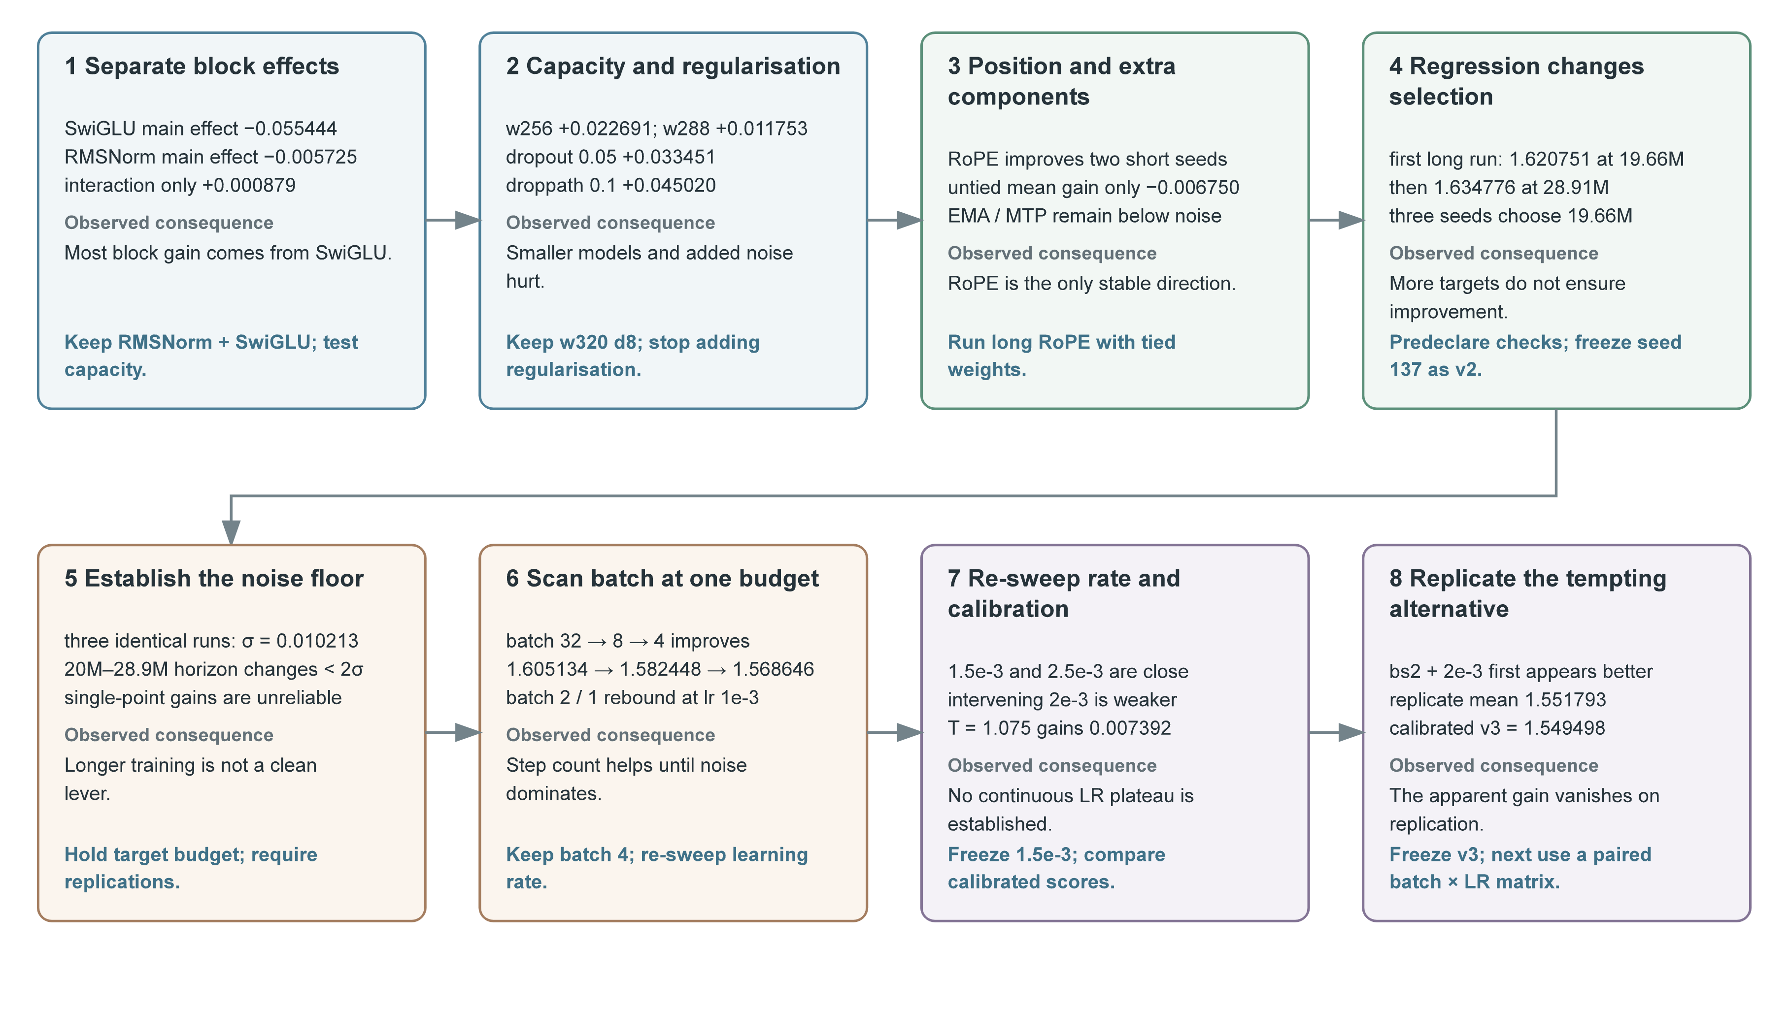
Fig. 6. The debugging path from v1/v2 structure, capacity, position and checkpoint selection to the v3 noise, batch, learning-rate and calibration checks; each observation directly determines the next experiment.

References
1. DASE7506 Project 1 course guide (GUIDE.md). 2. Supplied baseline implementation and scorer (model.py / evaluate.py / common.py, unmodified). 3. Vaswani et al., “Attention Is All You Need,” NeurIPS, 2017. 4. Zhang and Sennrich, “Root Mean Square Layer Normalization,” NeurIPS, 2019. 5. Shazeer, “GLU Variants Improve Transformer,” arXiv:2002.05202, 2020. 6. Su et al., “RoFormer: Enhanced Transformer with Rotary Position Embedding,” Neurocomputing, 2024. 7. Loshchilov and Hutter, “Decoupled Weight Decay Regularization,” ICLR, 2019. 8. Merity et al., “Pointer Sentinel Mixture Models,” ICLR, 2017. 9. This project's v1 and v2 technical reports and experiment index (code/results/ and run directories).

