DASE7506 Project 1 Language Model BPB Technical Report
WikiText-2 model optimization; the frozen v2 predictor reaches 1.611178 test BPB
Abstract: We train a decoder-only Transformer from random initialization under the fixed WikiText-2, BPE-2048 and 256-token causal protocol and report two predictors, both frozen before any test scoring. v1 is an 8-block, width-320 model with learned positions and tied weights; v2 keeps the same blocks but uses RoPE and selects its checkpoint on complete validation across three seeds. The frozen v2 predictor reaches 1.611178 test BPB, 23.32% below the 2.101265 baseline and 0.034974 BPB below v1, with CPU time, peak memory and assets at 3.713x, 1.939 GiB and 40.033 MiB. A tied-budget ablation attributes most of the gain to the SwiGLU block, and a late-training regression shows that checkpoints must be chosen on complete validation rather than on training loss.
The complete run index, all 33 retained experiments and the extended figure plate stay in the repository; this edition is the ten-page submission report.

1. Background and Mission Objectives
The task is to train a language model from scratch, improve its architecture or training, and reach the lowest reproducible test bits per byte (BPB) inside the resource limits. This project trains a compact decoder-only Transformer from random initialization under the fixed WikiText-2 data, BPE-2048 tokenizer, 256-token context and causal evaluation protocol.
The objective is the lowest BPB on the complete test split, with no external text, no pretrained weights and no tuning on test. Inside each independent window the model predicts the next token from the preceding text, and every target except the first token of a split is scored exactly once.
Table 1. Fixed conditions for operations and rigid upper limits
Category | Requirements | How this project complies
Data | Only use train for learning; validation selection; test without parameter adjustment | Fixed split use, freeze before testing
Evaluation | BPE-2048; context 256; independent causal windows; CPU FP32 | Fixed tokenizer and evaluator
CPU time | Not exceeding five times the baseline | Ultimately 2.875x for v1 and 3.713x for v2
Memory | Peak RSS does not exceed 4 GiB | Ultimately 1.948 GiB for v1 and 1.939 GiB for v2
Inference assets | Uncompressed assets must not exceed 64 MiB | Finally 40.345 MiB for v1 and 40.033 MiB for v2
Submission | Report no more than 10 pages; Code and checkpoint reproducible; Disclosure of AI assistance | This manuscript retains the complete material; Before submission, manually compress to 10 pages

2 Evaluation Indicators and Selection Agreement
Let B be the number of bytes of split original UTF-8 text. Fix the evaluator and accumulate negative logarithmic likelihoods for all scored targets, then convert nats to bits and divide by B.
The lower the BPB, the better. The total negative logarithmic likelihood of a complete split must be aggregated and then divided by bytes; simple averaging of BPB for batch or window is not possible. Token perplexity is only used as an auxiliary metric because course rankings are based on BPB.
Table 2. Report indicators and assessment methods
Indicators | Calculation or measurement | Purpose
BPB | Total NLL / ln(2) / UTF-8 bytes | The lower the main quality indicator, the better
Token PPL | exp(total NLL / number of targets) | Auxiliary explanations under fixed tokenizers
CPU time ratio | Candidate runtime / baseline runtime on the same machine | Determine if it exceeds 5 times
Peak RSS | Maximum resident memory for independent evaluation processes | Check if it exceeds 4 GiB
Inference assets | The uncompressed size of the file required for inference | Determine whether it exceeds 64 MiB

2.1 Data Usage and Freezing
Training data only updates parameters; validation selects the structure, learning rate, regularization, seed and checkpoint, and the test split is scored once after the freeze. Once the seed is chosen, SHA-256 hashes are recorded for the checkpoint, student.py, evaluate.py and tokenizer.json. Test scores never feed back into the architecture or the hyperparameter choice.
Fair comparisons hold the data, tokenizer, context, batch size and evaluator fixed, and every short run processes 9,830,400 training targets. When model size or budget changes, BPB and compute cost are reported together so extra compute is never booked as the benefit of a single mechanism.
Table 3. The scale and training budget of the main experiment
Experiment | Parameter count | Training targets | Validation BPB | Conclusion
Course baseline | 1.088M | 9.83M | 2.071087 | Reproduce the benchmark
Small LN + GELU | 1.084M | 9.83M | 2.101695 | block comparison
Small RMSNorm + SwiGLU | 1.082M | 9.83M | 2.040526 | Smaller control: 2.91% lower
w320 d8 | 10.571M | 9.83M | 1.820432 | Capacity brings a 10.79% improvement
w320 d8 Long Training | 10.571M | 28.91M | 1.622441 | Further improvement 10.88%

3 Models and Training Methods
The frozen v1 model has 8 decoder blocks of width 320 with 4 attention heads. Each block uses pre-RMSNorm, causal scaled dot-product attention and a SwiGLU feed-forward network, with no bias in the linear layers; the embedding is tied to the output head, positions are learned and dropout is 0, giving 10,570,560 parameters. v2 keeps every block and hyperparameter and only replaces the learned positions with RoPE, changing the count to 10,488,640.
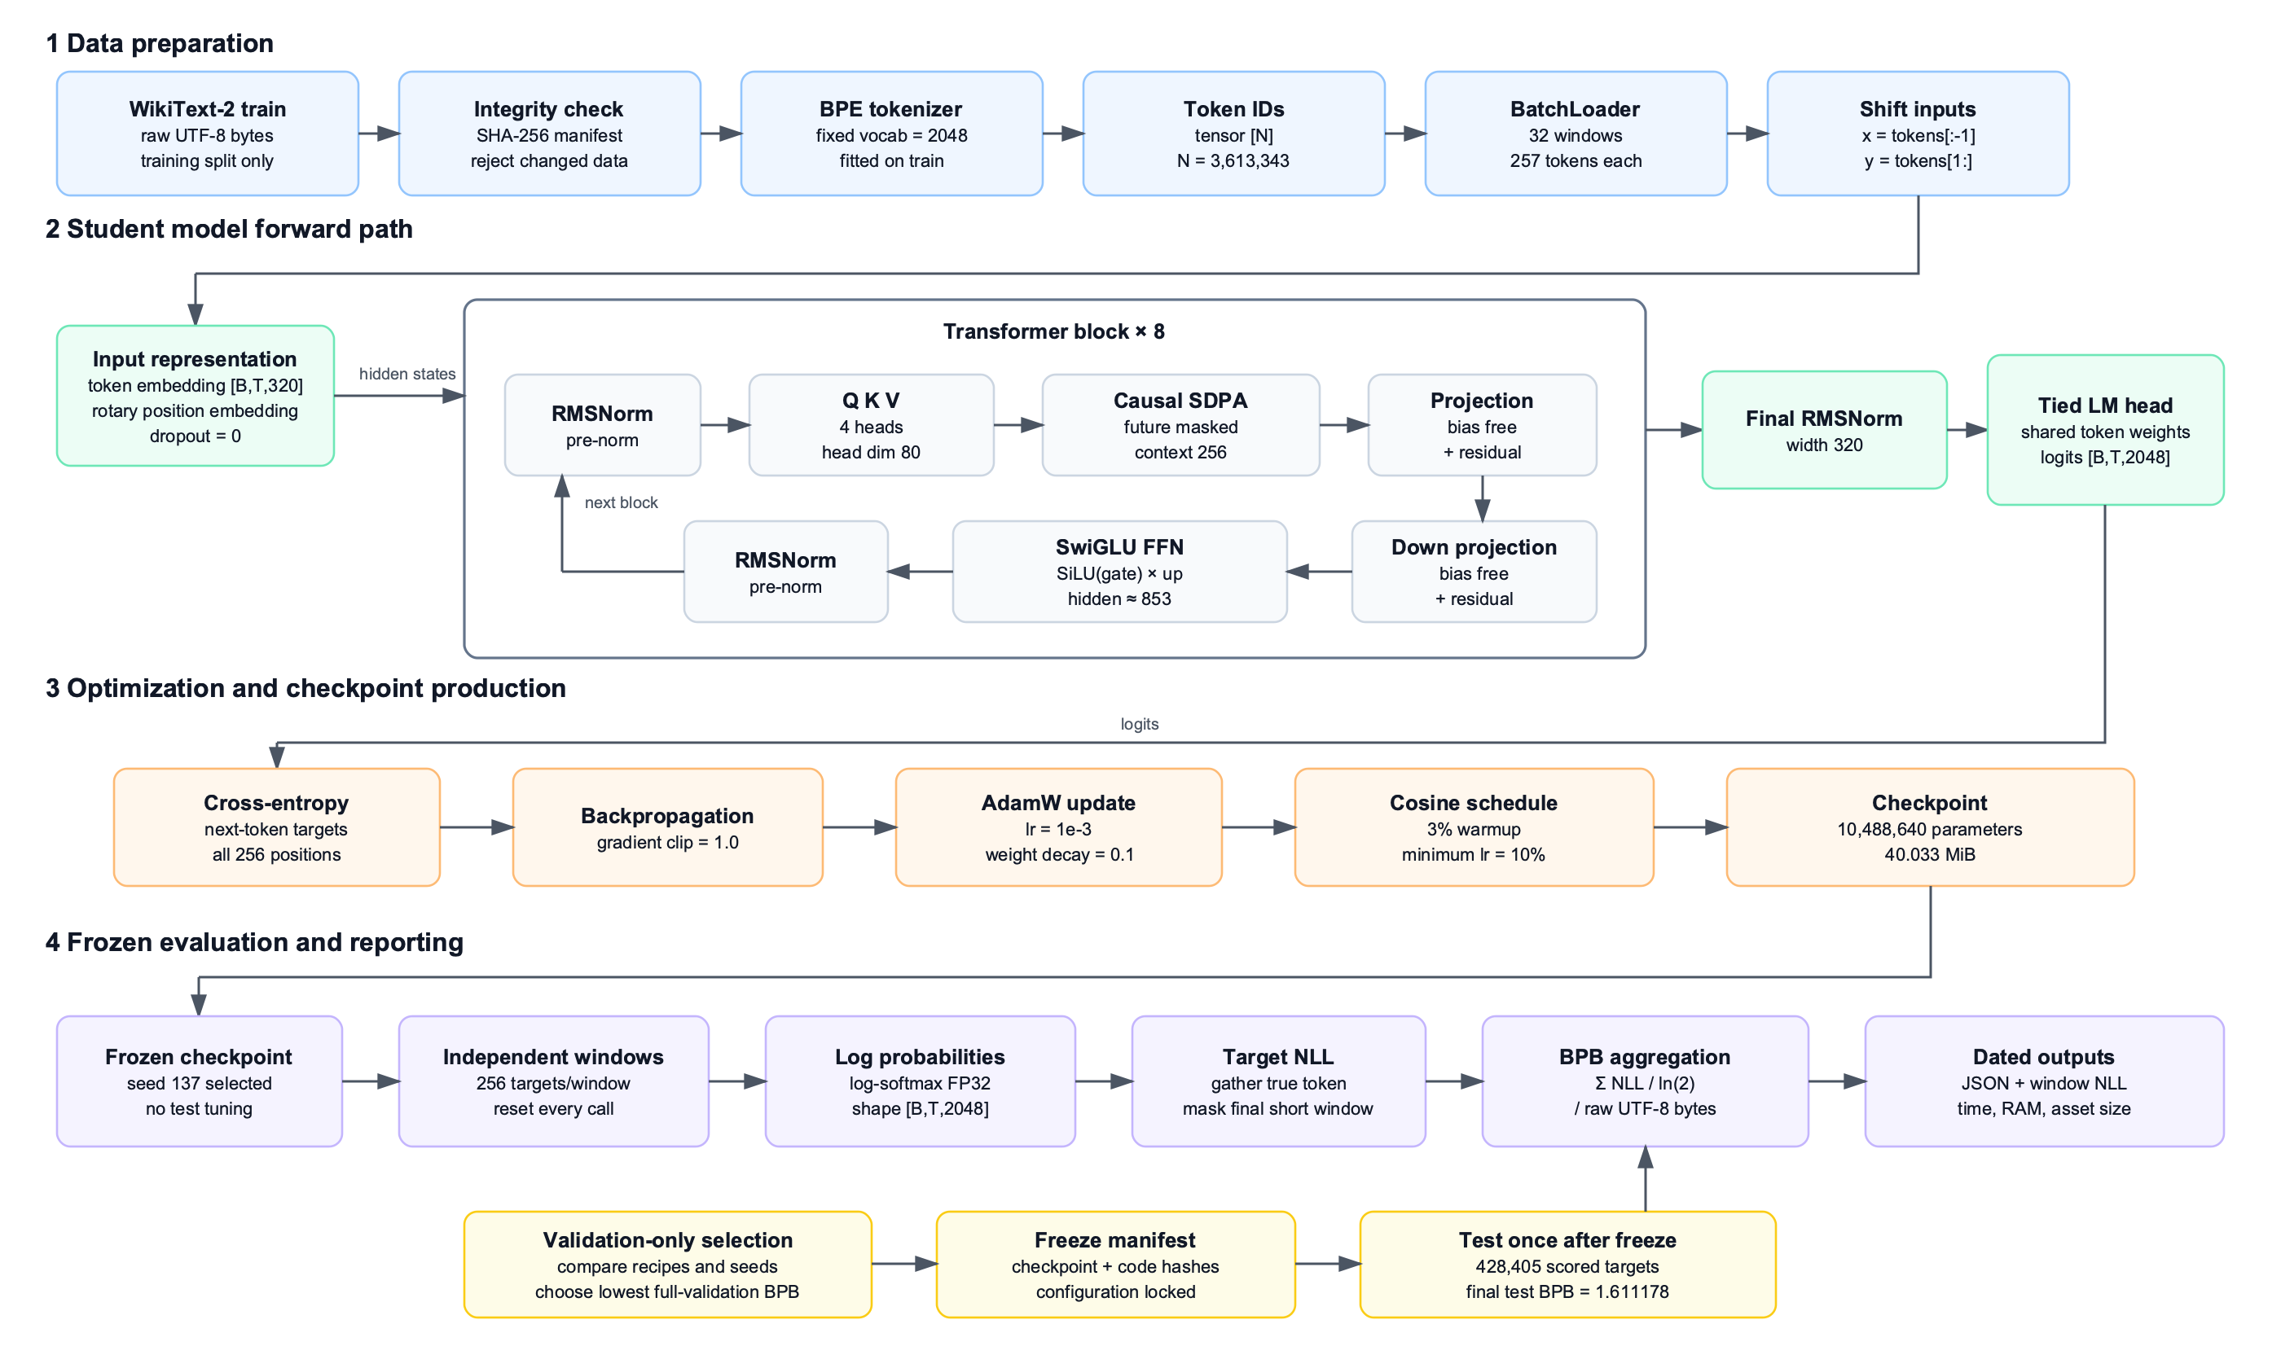
Fig. 1. Frozen v1 model structure, training data flow, and evaluation process
Each sample is a span of 257 consecutive tokens: the first 256 are the input and the last 256 the targets. A batch holds 32 windows, so each step processes 8,192 targets. AdamW uses peak LR 1e-3, weight decay 0.1 and betas (0.9, 0.95), warming up over 3% and then decaying to 10% on a cosine curve with gradient clipping at 1.0. Training runs on MPS in BF16; all reported scores are recomputed on CPU in FP32.
Every recipe and seed is trained independently from random initialization. The 28.91M-target long run is retrained with an extended schedule rather than continued from the 9.83M checkpoint. v1 keeps the final weights; the later RoPE runs additionally save the best checkpoint from the predeclared validation points.

4 BPB Optimization Process and Judgment Methods
The development of frozen v1 is linked to the same decision path as subsequent RoPE candidates. Arrows indicate that the next round of experiments is scheduled based on the previous round results, not direct continuation; Each group is trained from random initialization
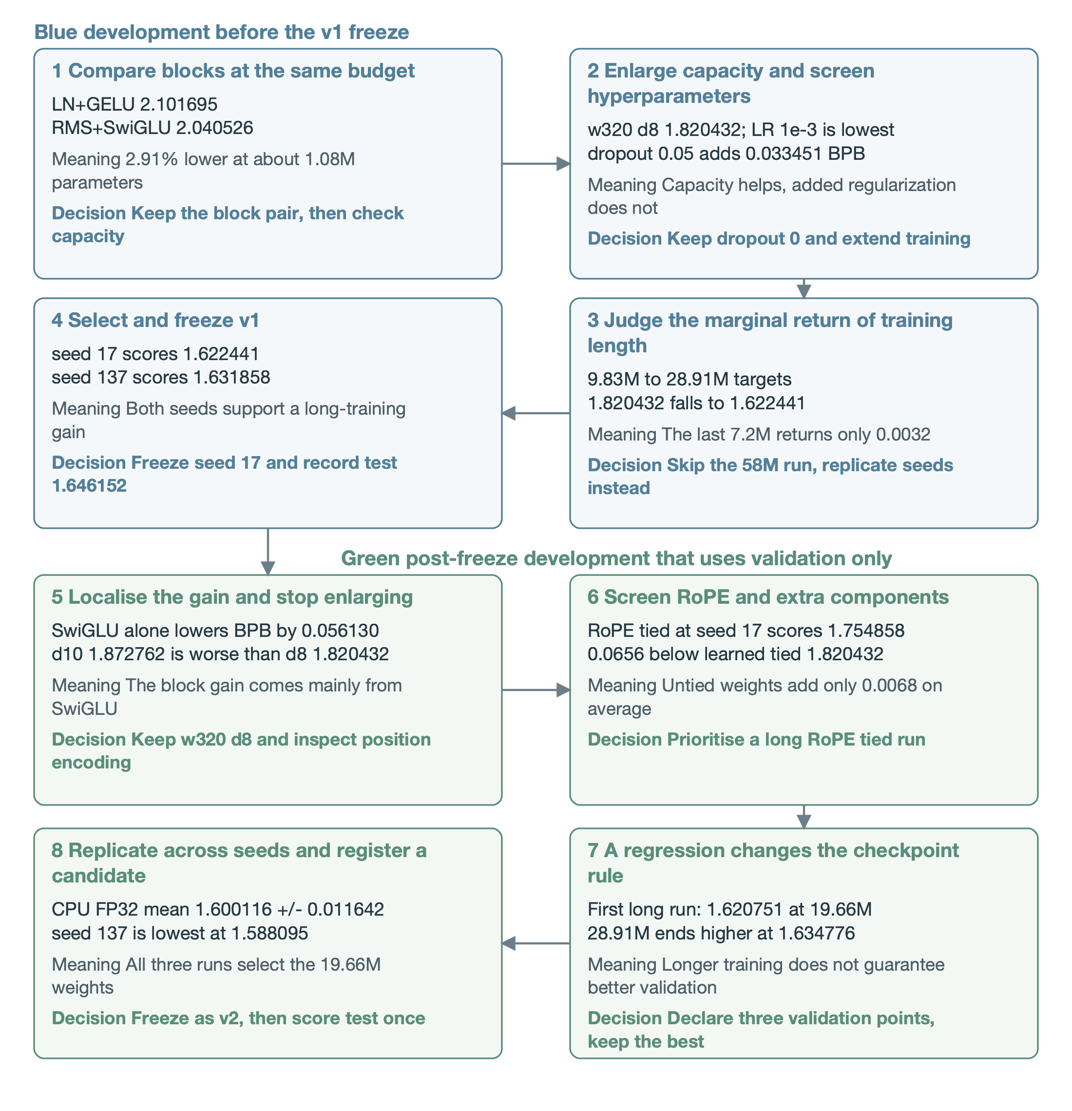
Fig. 2. Experimental data, the implications of results, and the complete process for subsequent decision-making. Boxes are read left to right and arrows mark planned decisions rather than automatic continuation; quoted values are validation BPB unless stated otherwise, short screens fix 9.83M targets, and three-seed statistics are recomputed in CPU FP32
The 2.071087 course baseline reproduces the supplied reference and cannot replace the 2.101695 controlled baseline used here. The block pair first returns 2.91% and widening to w320 d8 returns a further 10.79%, after which the budget moves to hyperparameters and training length. Section 7 isolates each component at a tied budget.

4.1 Numerical decomposition of optimization paths
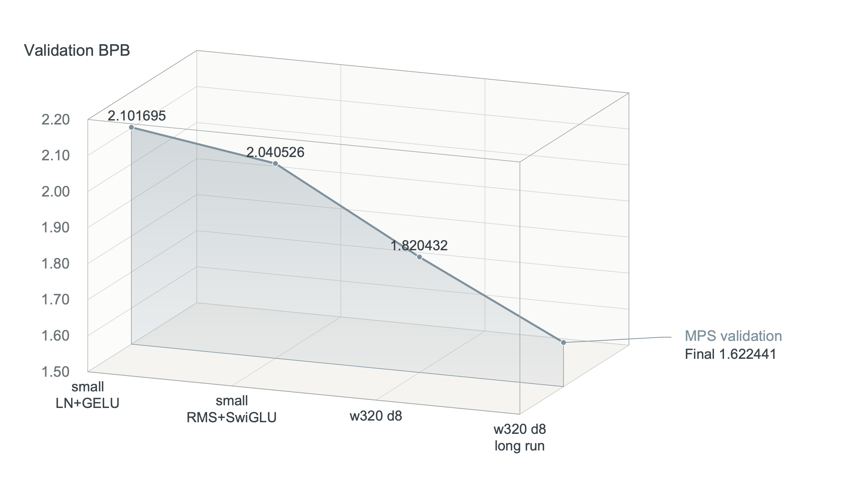
Fig. 3. Main optimization stages. Each point is an independent run; the connecting line only shows the development order. Vertical axes are truncated throughout, the translucent wall fill is not an error band, and the depth offset only separates series
The first question is whether replacing the block pays off at a matched parameter count and target budget. LN+GELU scores 2.101695 and RMSNorm+SwiGLU scores 2.040526, a 0.061169 BPB reduction that justifies the new block. The pair cannot split the contribution between normalisation and the feed-forward change, so Section 7.1 runs the 2x2 control.
Scaling to w320 d8 lowers the short-budget score to 1.820432; the size of the gain suggests the smaller model was capacity limited, so the learning rate is re-screened before any further scaling. Extending the budget lowers the score to 1.622441, but that step also changes the budget and the schedule, so the 0.197991 gap is not a purely structural improvement.
Table 4. Adjacent differences at each stage and interpretation boundaries
Adjacent comparison | BPB decreases | Relatively lower | Judgement supported by the comparison
Small block replacement | 0.061169 | 2.91% | The combination is worth continuing; A breakdown mechanism is needed
From the small model to w320 d8 | 0.220094 | 10.79% | Expansion is effective under the current short budget
w320 d8 Short to Long training | 0.197991 | 10.88% | Increasing training investment is effective
The decision sequence narrows one question at a time: first whether the block pair helps, then the right size and learning rate, and finally the marginal return of a longer budget. It is neither a full factorial search nor an exhaustive seed sweep.

5 Basis for Decisions on Hyperparameters and Training Length
With w320 d8 fixed, we first check whether the learning rate limits optimisation. Across six short runs at seed 17 and 9.83M targets, 1e-3 is lowest and 7.5e-4 trails by only 0.006146; 1.25e-3, 2e-3 and 4e-3 are all worse, so 1e-3 is fixed for long training.
Table 5. How different outcomes change the subsequent direction
Comparison | The result | Judgment | Follow-up actions
Peak LR | 1e-3 is 1.820432 | Scan the lowest point | Fixed 1e-3
Dropout 0.05 | +0.033451 BPB | Noticeably worse | Use no dropout in v1
Weight decay 0.2 | +0.000085 BPB | No meaningful gains have been observed | Keep the existing 0.1
Seed 137 | +0.009417 BPB | Both support long-term training gains | Choose the lower seed 17 according to the preset rules
58M targets | Not yet running | The last improvement was about 7.2M, only about 0.0032 | Don't double the training costs
Dropout 0.05 raises the score from 1.820432 to 1.853883 and weight decay 0.2 returns almost nothing. At this budget stronger regularization is not the priority, so dropout 0 and weight decay 0.1 are kept and the budget is spent on longer training. A single parity result cannot be read as proof that the two settings are equivalent.
Extending the budget from 9.83M to 28.91M targets lowers the score from 1.820432 to 1.622441, so the recipe still benefits from more updates. Over the final 7.2M targets the score improves only from 1.625607 to 1.622441, which is why the 58M run, at roughly double the cost, was not executed.
Adding seed 137 gives 1.631858. Both seeds support a long-training gain, but the 0.009417 spread shows that initialization still matters. We take the lower validation seed as prescribed; two seeds support the recipe but cannot estimate population variance.

5.1 Long Training Curves and Reasons to Stop Expanding Budgets
Table 6. BPB at each validation point of the long v1 recipe
Training targets | seed 17 | seed 137 | Seed 17 is lower than the previous point
7.225344M | 1.847600 | 1.846897 | —
14.450688M | 1.683248 | 1.682641 | 0.164352
21.684224M | 1.625607 | 1.635717 | 0.057641
28.909568M | 1.622441 | 1.631858 | 0.003166
Between the first two validation points seed 17 falls by 0.164352, then by 0.057641, and by only 0.003166 at the end. Because the marginal return collapses, the next seed replicates the recipe instead of doubling the budget. Seed 137 ends at 1.631858, 0.009417 above seed 17, and both curves confirm that the long recipe beats the short one.

6 Final Results and Resources After Freezing
Two predictors were frozen before any test scoring. v1 is the recipe selected on validation; v2 is the seed-137 RoPE run whose checkpoint is taken at the predeclared 19.66M-target point, with hashes recorded before the test split was scored. Each freeze records the checkpoint, implementation, evaluator and tokenizer hashes, and only the frozen configuration is scored. No test result selected, altered or rejected either predictor.
Table 7. Results on the complete test split
Model | Test BPB | Token PPL | NLL nats | Targets | UTF-8 bytes
Course baseline | 2.101265 | 80.8479 | 1,881,798.91 | 428,405 | 1,292,013
Frozen v1 | 1.646152 | 31.2239 | 1,474,220.05 | 428,405 | 1,292,013
Frozen v2 | 1.611178 | 29.0225 | 1,442,899.14 | 428,405 | 1,292,013
Relative to the course baseline, frozen v1 is 0.455113 BPB lower (21.66%) and frozen v2 is 0.490087 BPB lower (23.32%). Both score the same targets over the same raw byte count, so the gaps come from probability quality rather than from a change in score coverage. The 0.034974 BPB gap between v2 and v1 is measured under one frozen protocol.
Table 8. Test resource measurement of the frozen predictors
Indicator | Baseline | Frozen v1 | Frozen v2 | Course limit | Conclusion
CPU FP32 median time | 4.209 s | 12.103 s | 18.619 s | No more than 5x | 2.875x and 3.713x, within limit
Formal measurement range | 4.209-4.238 s | 12.096-12.164 s | 16.357-19.695 s | One protocol per predictor | One warm-up, three repeats
Peak RSS | 1.873 GiB | 1.948 GiB | 1.939 GiB | 4 GiB | Within limit
Inference assets | 4.168 MiB | 40.345 MiB | 40.033 MiB | 64 MiB | Within limit

6.1 Training and Search Costs
Training v1 took 1,143 s for seed 17 and 1,093 s for seed 137. The 33 retained non-smoke runs total 15,530 s (about 4.31 hours) by their train_seconds fields, excluding CPU re-scoring, resource measurement, data preparation and document generation.
The three long RoPE runs took about 1,436, 1,399 and 1,349 s. Although the selected weights come from 19.66M targets, all three searches ran to 28.91M, so the full search volume is disclosed. Times come from single-machine logs and indicate project investment, not a hardware-independent mechanism cost.

6.2 What does formal testing correspond to?
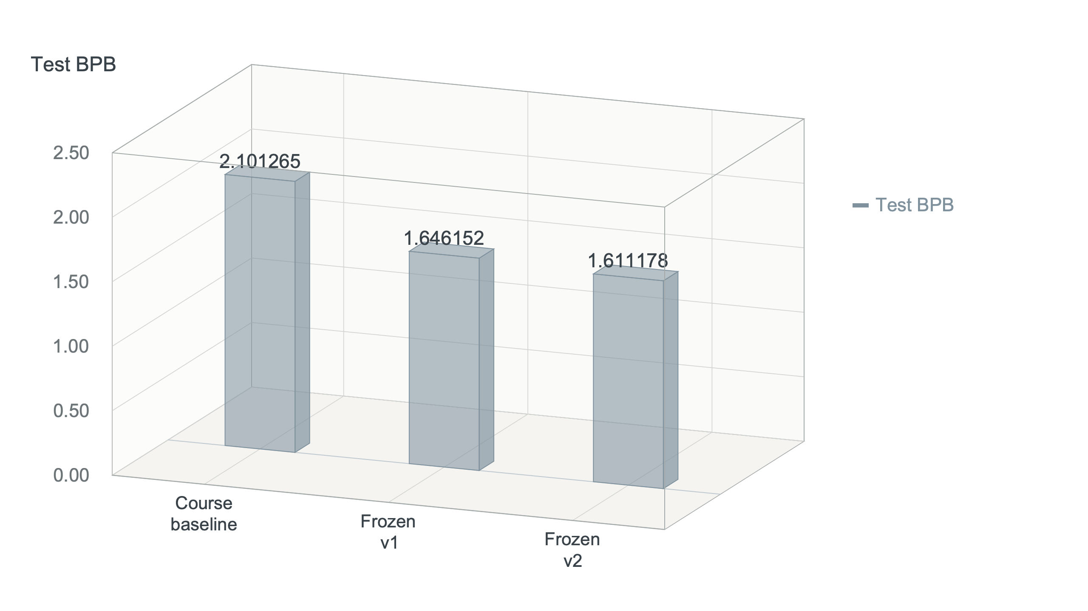
Fig. 4. Official test results of the frozen predictors. Bars start from zero so that the absolute BPB differences stay readable
All three models score the same test text over the same targets with the same tokenizer, so the BPB gaps are differences in total predictive negative log-likelihood on identical text. v2 improves on the baseline by (2.101265 - 1.611178) / 2.101265, about 23.32%, and on v1 by 0.034974 BPB. Token perplexity falls in step, but the ranking is expressed in BPB.
This section reports the two frozen predictors only. The validation score of 1.588095 that selected v2 belongs to the validation split and must not be subtracted from a test score; it is quoted only to document the selection rule that produced the v2 checkpoint.

6.3 Resource thresholds and measurement protocols
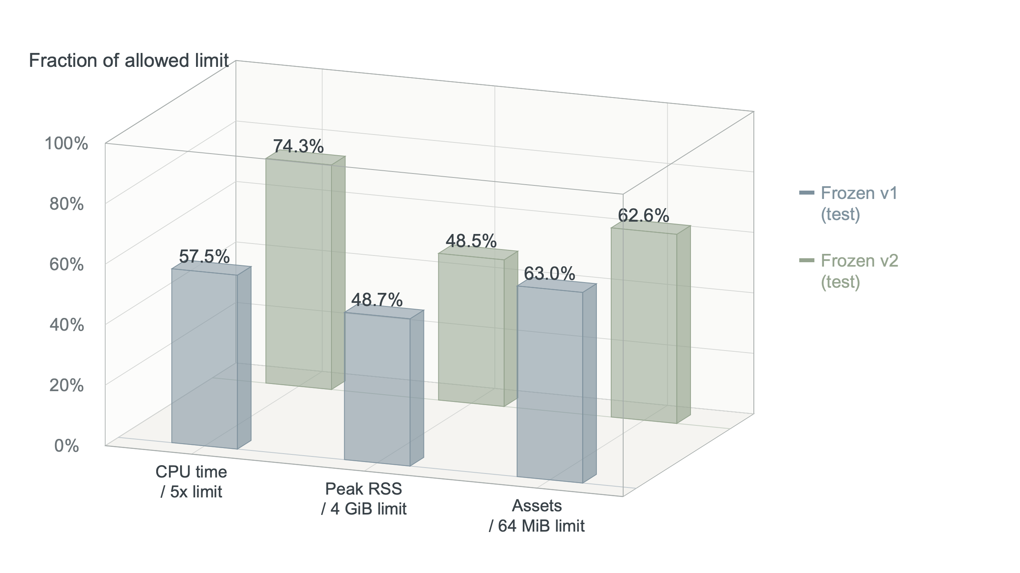
Fig. 5. Resource use against the course limits. Both frozen predictors stay below their respective limits; the standardised ratios are used only to assess compliance
Table 9. Resource records of the frozen predictors
Metric | Frozen v1 (test) | Frozen v2 (test)
Median CPU time (seconds) | 12.103 | 18.619
Range over three runs (seconds) | 12.096-12.164 | 16.357-19.695
Median baseline of the same protocol (seconds) | 4.209 | 5.014
CPU time ratio / limit 5x | 2.875x | 3.713x
Peak RSS / limit 4 GiB | 1.948 | 1.939
Inference assets / limit 64 MiB | 40.345 | 40.033
Measurements use CPU FP32 with four threads and three independent processes after one warm-up; the median time is reported and peak RSS is the largest value across processes. Both frozen predictors are measured on the test split under one protocol on one machine, so their time ratios share a baseline.
A lower BPB is only a valid entry when the time, memory and asset limits are met. The wider 384 model stays inside the 64 MiB asset limit, but its quality at the same budget is worse than w320 d8, so it was not carried into long training.

7. How the supplementary ablation changes the subsequent direction
The experiments below were run after the v1 test and use validation only, to explain the mechanism and to screen later candidates. Short runs are fixed at 9.83M targets and recorded on MPS. When an extra component returns less than 0.01 BPB it is not promoted to long training; that threshold controls search cost and is not a significance test.
Table 10. Normalization and FFN Ablation at the Same Budget
Normalization | FFN | Validation BPB | Compared to LN+GELU
LayerNorm | GELU | 2.101695 | 0
RMSNorm | GELU | 2.095283 | −0.006411
LayerNorm | SwiGLU | 2.045564 | −0.056130
RMSNorm | SwiGLU | 2.040526 | −0.061169
With LayerNorm fixed, SwiGLU returns 0.056130 BPB; with GELU fixed, RMSNorm returns only 0.006411. Most of the block gain therefore comes from the feed-forward replacement. This group uses seed 17 alone, so a single difference is not evidence of a stable cross-seed effect.

7.1 Splitting RMSNorm's Contributions to SwiGLU
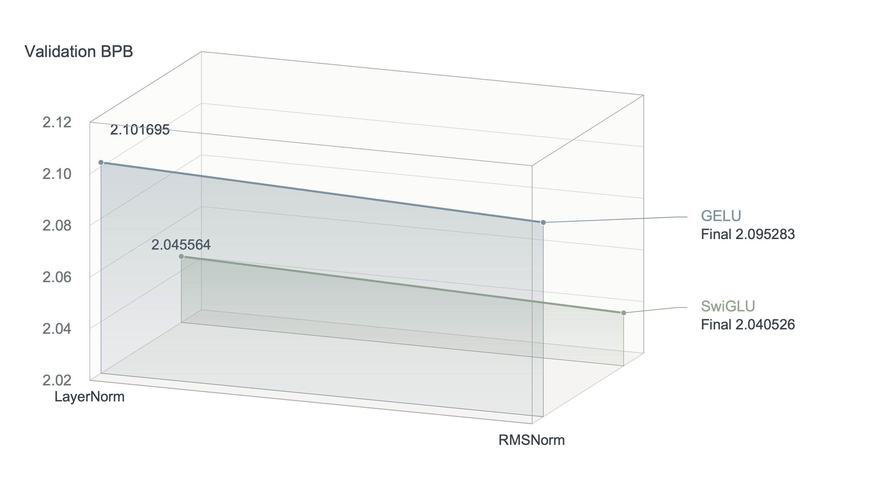
Fig. 6. 2×2 ablation of norms and FFNs. Two norms and two FFNs form a 2×2 control, all under the same short budget
SwiGLU alone brought about 0.056130 BPB improvement, and RMSNorm alone brought about 0.006411. The combination improvement was 0.061169, so this round of block earnings is mainly related to SwiGLU replacement. The two independent differences are not strictly summed, so the combined results cannot be written as completely independent mechanisms.
RMSNorm+SwiGLU is kept as the base block, and swapping the normalisation alone is dropped as a search direction. The attribution rests on seed 17 and is not yet shown to hold under a different seed.

7.2 Why Deeper, Wider Didn't Continue
Depth 10 scores 1.872762, 0.052330 worse than d8, and width 384 scores 1.829156, 0.008725 worse. Parameters, assets and recorded training time all grow while quality at this budget does not, so w320 d8 is retained.
This only rejects the priority of scaling immediately at matched targets and hyperparameters; a larger model may need a different learning rate or a longer budget, which the current runs do not cover. The search budget therefore moves to the positional representation.

7.3 Short experiments with position representation and output weights
Table 11. Comparison of position and weight sharing within the same seed
Setup | BPB | Reduction relative to learned tied | Assets MiB
Learned / tied | 1.820432 | 0.000000 | 40.345
Learned / untied | 1.786678 | 0.033754 | 42.846
RoPE / tied | 1.754858 | 0.065574 | 40.033
RoPE / untied | 1.745039 | 0.075393 | 42.533
Replacing learned positions with RoPE while keeping tied input/output weights lowers the score from 1.820432 to 1.754858, a 0.065574 gain. Untying the head also helps but adds a large output matrix. RoPE tied needs about 40.033 MiB, slightly less than the 40.345 MiB of learned tied, so RoPE is promoted to a long-training candidate.
Changing position representation and weight sharing at the same time mix two factors; you can't claim all benefits come from untied sharing just by looking at the lowest RoPE untied point. Next, under RoPE conditions, pair two identical seeds to check for additional untied contributions.

8 RoPE Across Three Seeds and Best-Checkpoint Selection
The first RoPE long training reached 1.620751 targets at 19.66M, but rebounded to 1.634776 at the end, with only the final weight saved. This observation directly changed the training process: before subsequent reruns, three validation points—9.83M, 19.66M, and 28.91M—were declared, and the lowest validation BPB weights were saved.
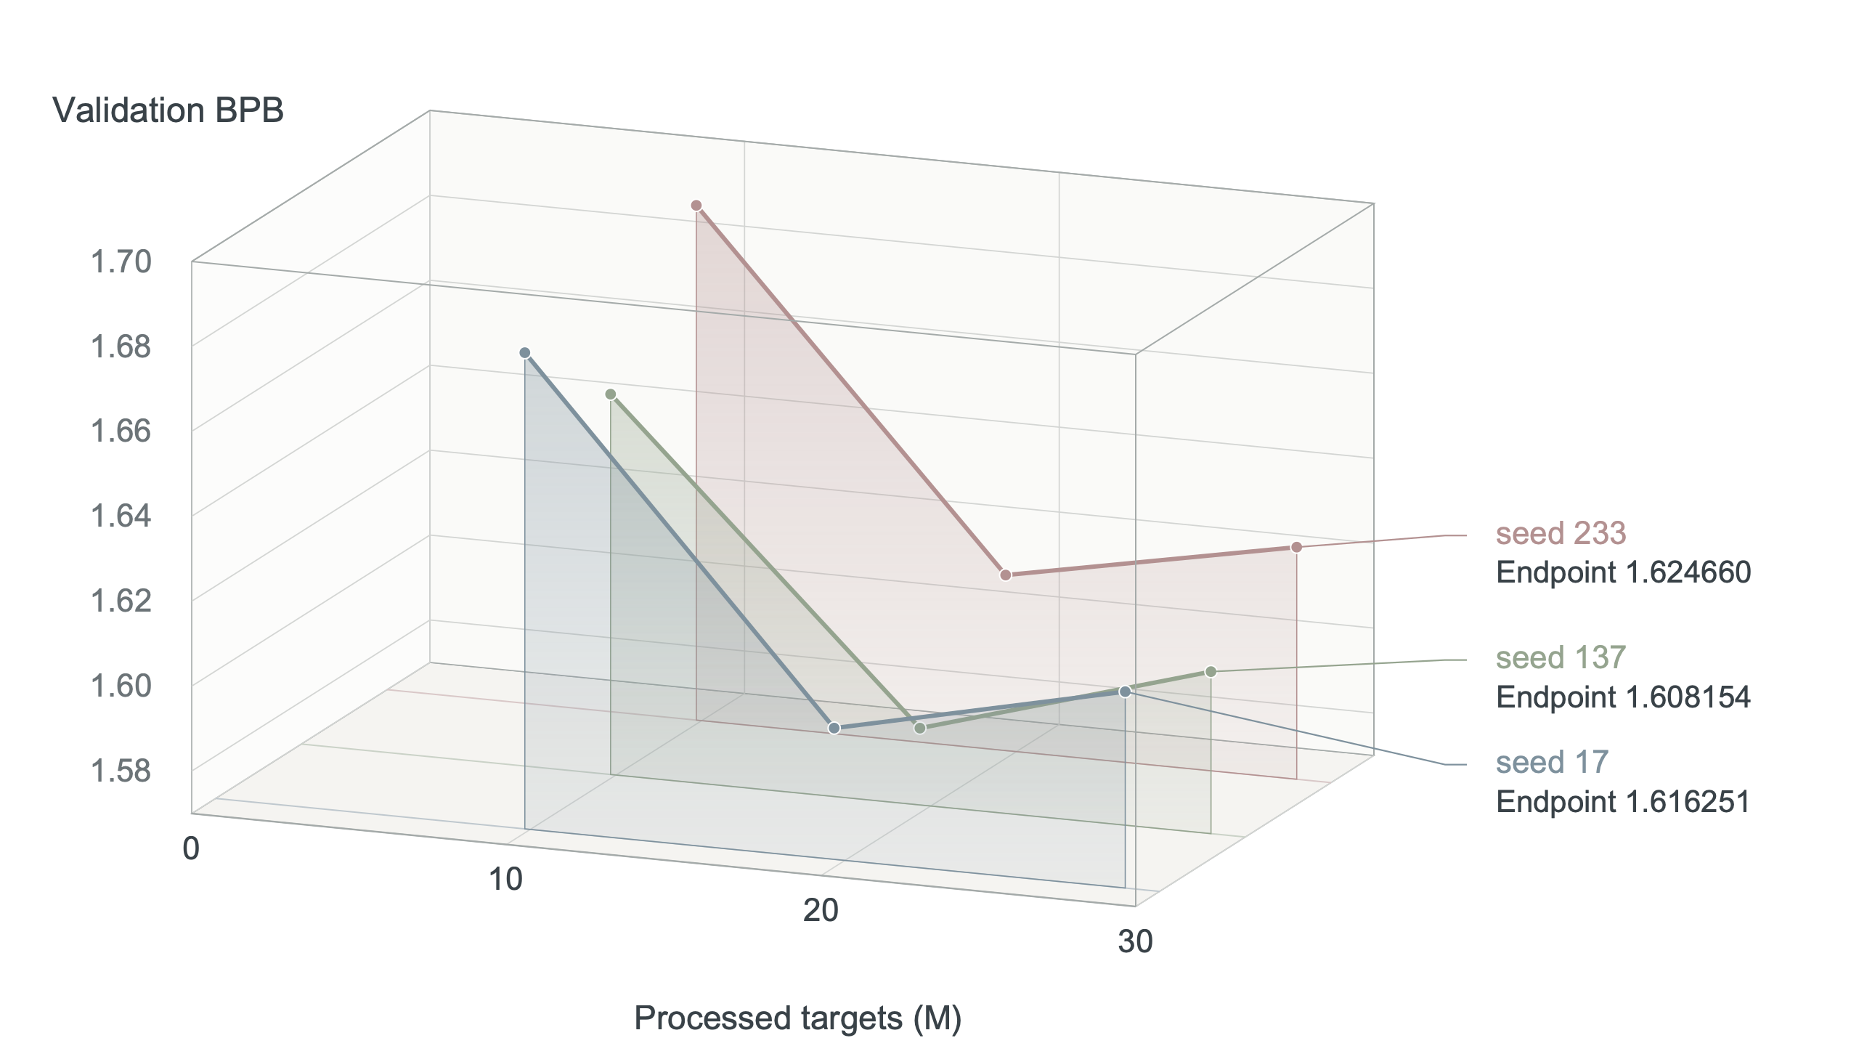
Fig. 7. Validation curves and selection locations for the three RoPE seeds
Table 12. Best-checkpoint CPU FP32 review against the end of training
Seed | Search targets | Selected targets | CPU FP32 BPB | End MPS BPB
17 | 28.91M | 19.66M | 1.600916 | 1.616251
137 | 28.91M | 19.66M | 1.588095 | 1.608154
233 | 28.91M | 19.66M | 1.611337 | 1.624660
The mean CPU FP32 validation for the three seeds is 1.600116, with a sample standard deviation of 0.011642. The weight of step 2400 is selected all times, but the search continues to 28.91M. The validation curve supports saving the best checkpoint instead of using the final weight.
Under the MPS caliber during training, the mean RoPE for seeds 17 and 137 was 1.594506, v1 was 1.627150, an improvement of 0.032644. Here, only the two seed subsets are compared; RoPE also changes checkpoint selection, so the entire difference cannot be attributed to position coding.
Table 13. Test resource check of the frozen v2 predictor
Indicator | Measured on test | Course limit | Outcome
CPU FP32 time ratio | 3.713x baseline | 5x | Within limit
Peak RSS | 1.939 GiB | 4 GiB | Within limit
Inference assets, uncompressed | 40.033 MiB | 64 MiB | Within limit
Seed 137 is registered as the candidate on the lowest CPU FP32 validation score, 1.588095 BPB. Resource measurement used the validation split, four threads, one warm-up and three independent process repeats, and the checkpoint hash was recorded. The candidate has since been frozen as v2 and scored once on test; the manifest records the hashes and the pre-test freeze timestamp.

8.1 How the first long run changed the weight-saving rule
The first long run reaches 1.620751 near 19.66M targets but ends at 1.634776, a regression of about 0.014025. Because only the last checkpoint was saved, the intermediate score could not be submitted, so independent re-runs were started under a new saving rule.
The re-run predeclares three validation points at 9.83M, 19.66M and 28.91M targets, saves the weights at each improvement and still completes the full search budget. This separates the training investment from the point at which the submitted weights were produced.

8.2 Pairing long schemes and comparison with candidate boundaries
Across the two shared seeds the long RoPE recipe averages about 0.032644 BPB below v1 in MPS validation; adding seed 233 gives a three-seed mean of 1.600116 with a sample standard deviation of 0.011642. The paired two-seed mean and the three-seed summary answer different questions and must not be mixed.
The CPU FP32 validation of seed 137 is 1.588095, so that run is registered as the v2 candidate, frozen with recorded hashes and scored once on test at 1.611178 BPB. The paired gap also includes the change of positional representation and of checkpoint rule, so it is not an isolated RoPE effect.

9 Correctness and submission requirements
Course code, data and tokenizer are checked through manifest hashes. Evaluation caches no validation or test answers, sees no future tokens, keeps no cross-window state and needs no network. Contract tests cover causality, probability normalisation, sample independence, window reset, misaligned target gradients and the final short window; trainer tests cover sampling, the schedule and best-checkpoint retention.

9.1 Reproducing Materials
The v1 checkpoint is code/runs/a_e8_lr1e3/checkpoint.pt, SHA-256 ab9ba8b6...6657; the v2 checkpoint is code/runs/2026-09-25_rope_long_best_seed137/checkpoint.pt, SHA-256 723b8f6f...4e68. Scores, resource measurements and freeze manifests are under code/results/2026-09-23/ and code/results/2026-09-26/. Environment: Python 3.13.12, PyTorch 2.7.1, NumPy 2.5.3 and tokenizers 0.21.4; Python 3.12 is recommended for release.

9.2 Assignment Requirement Coverage
Table 14. Course requirements and evidence locations
Course requirements | Evidence in this report or the repository | Status
From random initialization training, only the course train is used | Sections 1 and 3; README data rules | Done
Fixed BPE-2048, context 256, and evaluator | Sections 1 and 2; Hash check | Done
Initial baseline | Table 3 and the Section 5 sweep | Done
Comparison at the same number of processed targets | Table 3 shows a 9.83M comparison | Done
Ablation of the key mechanism | The 2x2 control in Table 13 and the checkpoint screening in Table 21 | Done
Validation freezes before development and testing | Sections 2 and 6; freeze manifests for v1 and v2 | Done
Quality and computational cost analysis | Table 3 and Table 4 with the reasons for stopping at 28.91M | Done
Training cost, seeds, and checkpoint ancestry | Sections 3, 5, 6, and 8; grid.tsv | Done
5x CPU, 4 GiB, and 64 MiB limits | Table 10 and Table 22 | Within limit
A report no more than 10 pages long with AI disclosure | Section 10 has disclosed AI; This material draft needs to be abridged | Compression required
Immutable code links and checkpoint download links | The last course submission must be submitted before the deadline | Pending external submission
Course website registration and subsequent peer review | Register 29 days before the date; Resubmit another copy after publication | Pending external submission

10 Conclusions, Limitations, and AI Disclosure

10.1 Conclusion
Two predictors were frozen before any test scoring: v1 lowers test BPB from 2.101265 to 1.646152 and v2 lowers it further to 1.611178, 23.32% below the baseline, with CPU time, memory and assets all inside their limits. The study keeps the efficient block pair, scales capacity, then fixes the learning rate, the regularization and the budget. A tied-budget control attributes most of the block gain to SwiGLU; the positional experiments and the late-training regression produce RoPE and the best-checkpoint rule.
The three RoPE seeds average 1.600116 in CPU FP32 validation with a sample standard deviation of 0.011642; seed 137 is lowest at 1.588095 and inside the resource thresholds, and freezing it yields the 1.611178 test score. Negative results also shaped the path: deeper and wider models were dropped, and untied weights, EMA and MTP were stopped below the 0.01 BPB threshold.

10.2 Limitations
v1 compares two seeds, the RoPE long recipe three and most short ablations only seed 17, so differences of a few thousandths remain uncertain and 0.01 BPB is a search threshold rather than a significance bound. The RoPE recipe also changes checkpoint selection, so the long-training gain is not attributable to position encoding alone. No 58M run was made, so a longer recalibrated budget is not excluded.
Training runs on MPS BF16 while official scores use CPU FP32, and not every short screen is re-verified on CPU. Resources are measured on one machine, so absolute times depend on hardware and load. Both frozen predictors are now measured on the test split under a single protocol.

10.3 AI assistance disclosure
OpenAI Codex assisted with code diagnosis, experiment planning, implementation review, script repair, result consolidation, figures and layout. Every training and evaluation number was produced by the project scripts and kept as machine-readable evidence. Codex supplied no external text, pretrained weights, or validation or test answers. The submitter is responsible for understanding the code and checking the evidence.

References
[1] DASE7506 Mini Project 1 Guide. GUIDE.md.
[2] DASE7506 MP1 Starter Code README. code/README.md.
[3] Vaswani et al. Attention Is All You Need. NeurIPS 2017.
[4] Zhang and Sennrich. Root Mean Square Layer Normalization. NeurIPS 2019.
[5] Shazeer. GLU Variants Improve Transformer. arXiv:2002.05202, 2020.
[6] Su et al. RoFormer: Enhanced Transformer with Rotary Position Embedding. arXiv:2104.09864, 2021.
[7] Loshchilov and Hutter. Decoupled Weight Decay Regularization. ICLR 2019.

