Group 13 Qwen Plus Experimental Results
  - Robot Instruction Ambiguity Detection
Two round Pilot evaluation and reproducibility report | 11 November 2026

Executive overview
Checklist achieved the highest Macro-F1 in both rounds (55.50% and 54.00%), whereas Few-shot achieved the highest Accuracy (56.00% and 55.00%). Zero-shot was perfectly repeatable across these two executions. Overall valid-label agreement was 97.83% (586/599). These are descriptive Pilot findings; no statistically significant ranking is claimed.
Both rounds used the same test set and identical v0.1-dev DRAFT prompts. This is a Pilot repetition study, not a frozen final experiment or validation on an independent test set.

Chapter 1 Experimental Setup
The task is to decide whether a kitchen robot can identify the intended action from an environment description and a user instruction. CLEAR means the instruction is sufficiently specified to proceed. NEEDS_CLARIFICATION means material ambiguity or missing essential information prevents a reliable choice of action. The model returns exactly one label; extra explanations are invalid under the strict evaluator.
The held-out input file contains 200 instructions arranged into 100 pairs. Each pair contains one CLEAR and one NEEDS_CLARIFICATION instruction, giving 100 examples per class. Categories comprise preferences (92), common_sense_knowledge (76), and safety (32). Pair members share an environment, making pair-level discrimination an additional diagnostic.
Design element | Configuration
Model | qwen-plus-2025-12-01
Generation | temperature=0; max_tokens=64
Execution | enable_thinking=false; stream=false
Prompt version | v0.1-dev; DRAFT
Strategies | Zero-shot; Few-shot; Checklist
Per round | 200 instructions × 3 strategies = 600 logical jobs

Zero-shot supplies the task definition without demonstrations. Few-shot adds four fixed labeled development examples. Checklist adds structured ambiguity checks. Each round independently executed the same stored messages and model configuration. Logical IDs deliberately repeat across rounds and identify sample_id plus strategy; run IDs distinguish the executions.
All analyses are offline. Ground-truth labels are joined after inference using the existing evaluation adapter. WANG's evaluate.py supplies strict parsing, scoring and core metrics; neither it nor analysis.py was edited. Original logs, CAI prompts and data remain unchanged.

Chapter 2 Overall Experimental Results
Figures 1 and 2 compare all 200 logical jobs per strategy. The historical first-round request failure counts as incorrect. Accuracy and Macro-F1 emphasize different aspects of performance, so a strategy ranking must identify the metric being used.
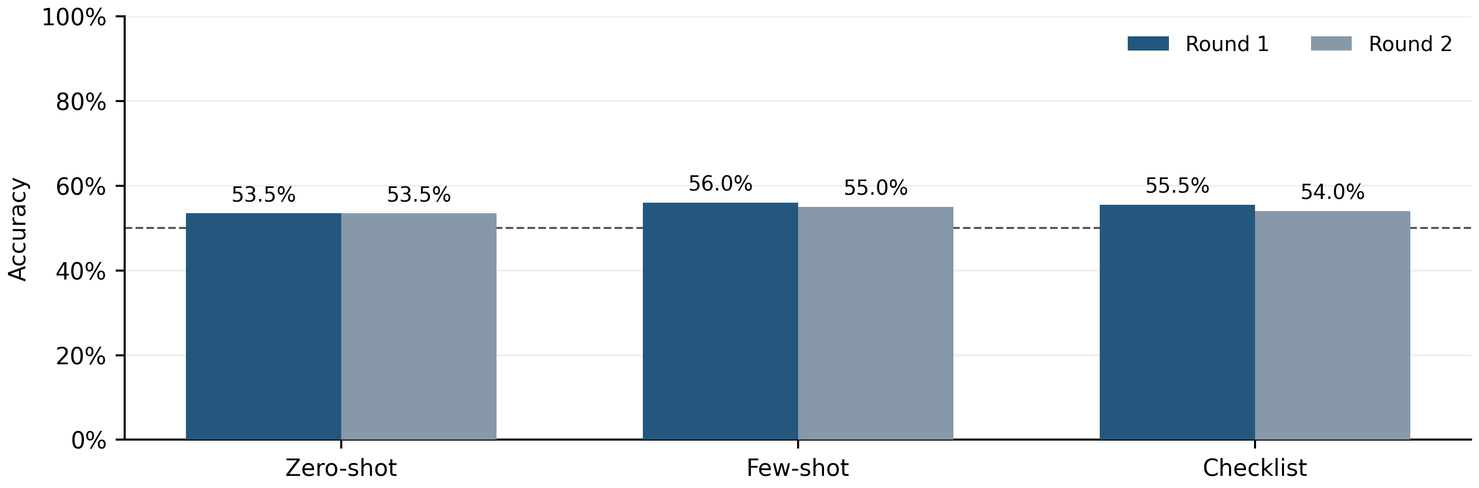
Figure 1. Round 1 vs Round 2 Accuracy Comparison. The dashed line is the 50% constant-class Accuracy baseline on this balanced test set.
Few-shot Accuracy decreased from 56.00% to 55.00%; Checklist decreased from 55.50% to 54.00%. Zero-shot remained unchanged. The largest observed gap is only a few percentage points.
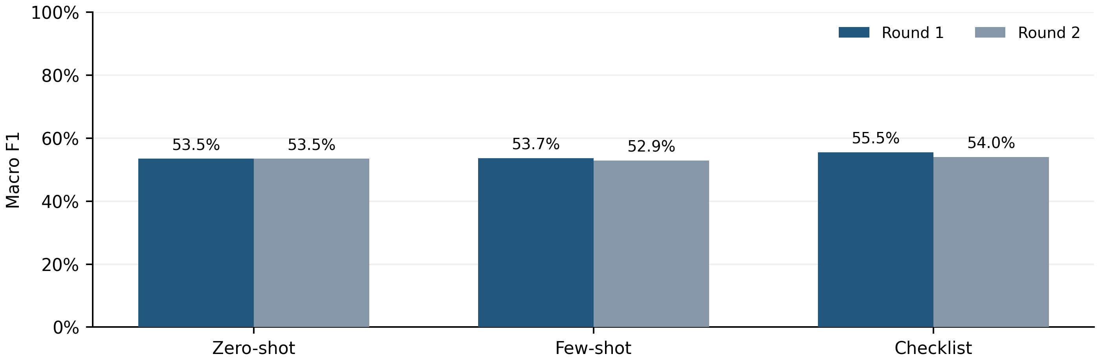
Figure 2. Round 1 vs Round 2 Macro F1 Comparison. Macro-F1 averages the two gold-class F1 scores; no failure class is included in this average.
Checklist leads Macro-F1 in both rounds. Few-shot has higher Accuracy but less balanced class performance, which lowers its Macro-F1. Figure 3 and the tables on the next page make this difference explicit.

Overall Results and Evaluation Denominators
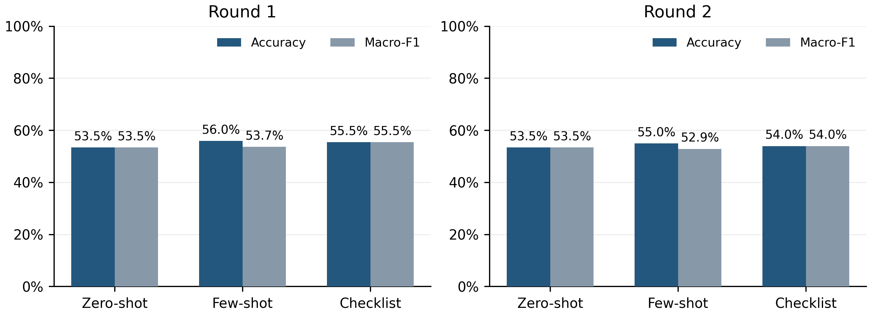
Figure 3. Accuracy and Macro F1 Grouped Comparison. All-job results are shown for each round; each bar uses 200 logical jobs.
Table 1. All-job metrics with failures counted as errors. Precision and Recall are macro averages.
Round / strategy | n | Accuracy | Precision | Recall | Macro-F1 | Valid rate
R1 Zero-shot | 200 | 53.50% | 53.50% | 53.50% | 53.50% | 100.00%
R1 Few-shot | 200 | 56.00% | 57.80% | 56.00% | 53.67% | 99.50%
R1 Checklist | 200 | 55.50% | 55.50% | 55.50% | 55.50% | 100.00%
R2 Zero-shot | 200 | 53.50% | 53.50% | 53.50% | 53.50% | 100.00%
R2 Few-shot | 200 | 55.00% | 56.07% | 55.00% | 52.92% | 100.00%
R2 Checklist | 200 | 54.00% | 54.00% | 54.00% | 54.00% | 100.00%

Table 2. Round 1 valid-output subset. The valid rate refers to the retained subset, not original coverage.
Round / strategy | n | Accuracy | Precision | Recall | Macro-F1 | Valid rate
Zero-shot | 200 | 53.50% | 53.50% | 53.50% | 53.50% | 100.00%
Few-shot | 199 | 56.28% | 57.80% | 56.17% | 53.81% | 100.00%
Checklist | 200 | 55.50% | 55.50% | 55.50% | 55.50% | 100.00%

Round 1 retains 599 valid predictions: 200 Zero-shot, 199 Few-shot and 200 Checklist. Round 2 retains all 600, so its valid-only and all-job results coincide. Valid-only filtering occurs after scoring complete input pairs; it does not remove the valid partner of the failed sample.
For a failed output, all-job Accuracy is zero for that job. Its true class receives a false negative for class F1 and Recall, but no other class receives a fabricated false positive. This preserves WANG's evaluator semantics. Precision is unaffected by a failure that predicts neither accepted label.

Chapter 3 Confusion Matrix Analysis
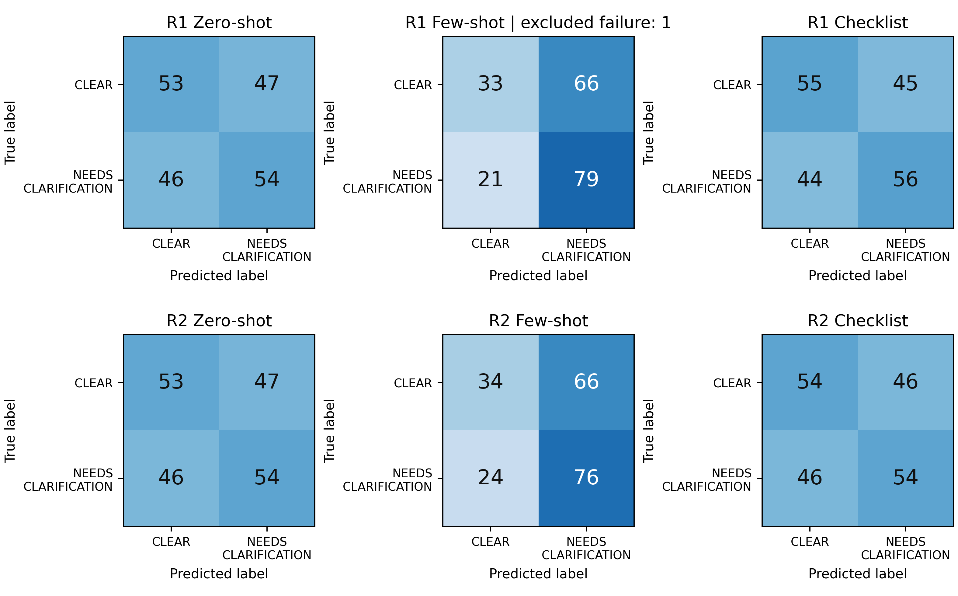
Figure 4. Confusion Matrices for All Strategies and Rounds. Rows are gold labels and columns are predictions. All panels use a 0–100 count scale. The R1 Few-shot matrix contains 199 valid outputs; one gold-CLEAR request failure is excluded and reported separately.
Table 3. Error diagnostics on all 200 jobs. NEEDS_CLARIFICATION is the positive class.
Round / strategy | FP | FN | Fail | CLEAR recall | NEEDS recall | Miss rate | Unnec. rate
R1 Zero-shot | 47 | 46 | 0 | 53% | 54% | 46% | 47%
R1 Few-shot | 66 | 21 | 1 | 33% | 79% | 21% | 66%
R1 Checklist | 45 | 44 | 0 | 55% | 56% | 44% | 45%
R2 Zero-shot | 47 | 46 | 0 | 53% | 54% | 46% | 47%
R2 Few-shot | 66 | 24 | 0 | 34% | 76% | 24% | 66%
R2 Checklist | 46 | 46 | 0 | 54% | 54% | 46% | 46%

FP counts CLEAR instructions labeled NEEDS_CLARIFICATION; FN counts ambiguous instructions labeled CLEAR. The additional R1 Few-shot failure belongs to CLEAR and is not inserted into either matrix prediction column. Consequently its CLEAR Recall is 33/100, although the valid-only matrix has only 99 gold-CLEAR rows.
Few-shot exchanges fewer missed ambiguities for more unnecessary questions. Checklist and Zero-shot show nearly balanced FP and FN counts, but both still misclassify many samples. Standalone versions of all six heatmaps are supplied with the multi-panel figure.

Chapter 4 Prompt Strategy and Prediction Bias
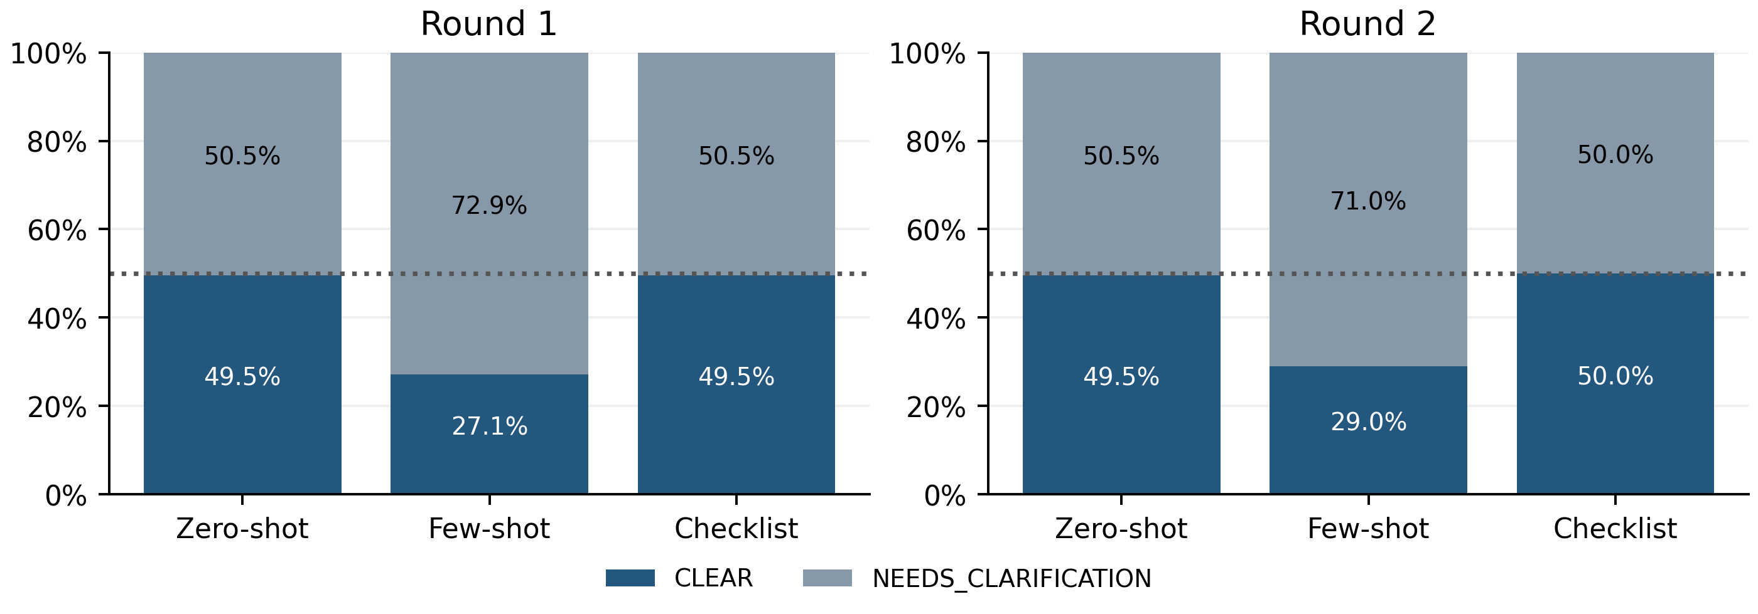
Figure 5. Prediction Label Distribution Among Valid Outputs. Label shares use valid predictions: n=199 for R1 Few-shot and n=200 otherwise. The dotted line marks the balanced 50% reference.
Few-shot predicts NEEDS_CLARIFICATION for 145/199 valid first-round outputs (72.86%) and 142/200 second-round outputs (71.00%). Its R1 valid subset contains 100 ambiguous and 99 clear gold labels, so the missing CLEAR sample cannot explain the large prediction imbalance.
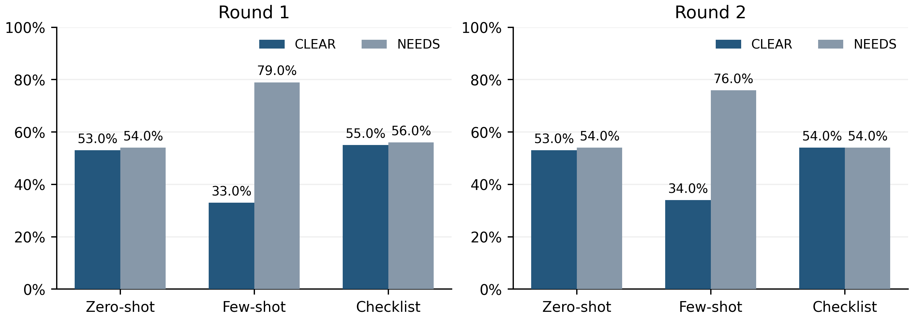
Figure 6. Recall for Each Gold Class. Recall uses the original 100 gold samples per class. NEEDS denotes NEEDS_CLARIFICATION.
The recall comparison confirms that the output imbalance has practical consequences. Few-shot recognizes more gold ambiguities, while correctly accepting only about one third of gold-CLEAR instructions. These observations describe the current test set and do not establish the internal cause of the bias.

Prediction Bias and Error Tradeoffs
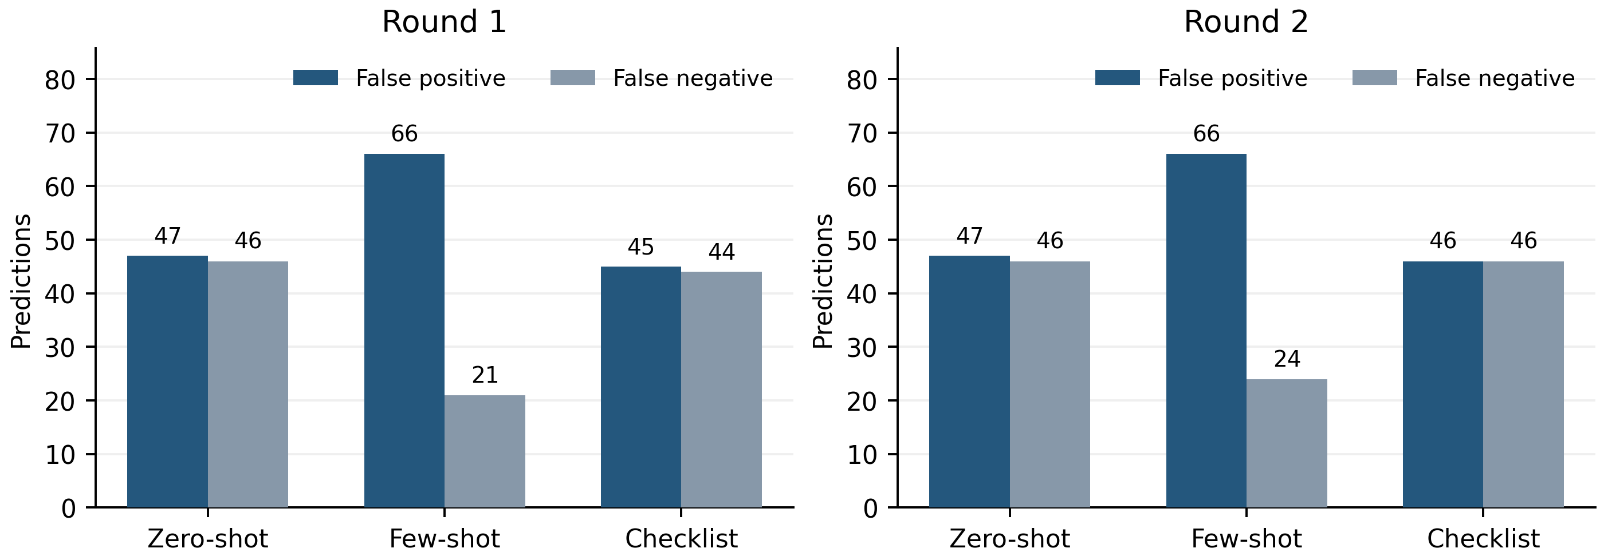
Figure 7. False Positives and False Negatives. Only accepted-label confusions are plotted. The separate R1 Few-shot failure is excluded from FP and FN bars.
Few-shot makes 66 false-positive clarification requests in each round, compared with 47 for Zero-shot and 45–46 for Checklist. Its ambiguity misses are 21 and 24, compared with 46 for Zero-shot and 44–46 for Checklist. Whether this tradeoff is operationally useful depends on the cost of missed ambiguity versus unnecessary interruption; this report does not assign those costs.
Table 4. Descriptive Accuracy by the existing dataset category. Denominators are fixed within each strategy and round.
Category | Round | n | Zero-shot | Few-shot | Checklist
common sense knowledge | R1 | 76 | 50.00% | 53.95% | 51.32%
common sense knowledge | R2 | 76 | 50.00% | 53.95% | 50.00%
preferences | R1 | 92 | 56.52% | 58.70% | 59.78%
preferences | R2 | 92 | 56.52% | 56.52% | 58.70%
safety | R1 | 32 | 53.12% | 53.12% | 53.12%
safety | R2 | 32 | 53.12% | 53.12% | 50.00%

Category sizes differ, and safety has only 32 instructions. These breakdowns are diagnostic rather than confirmed domain-level performance estimates. Preferences contributes six of the eight Few-shot label flips; common_sense_knowledge contributes three of the five Checklist flips.
A balanced prediction distribution is not evidence of good detection. Zero-shot predicts nearly equal class totals but misses 46 ambiguous instructions and over-clarifies 47 clear instructions in each round. Conversely, Few-shot's higher Accuracy should be interpreted alongside its low CLEAR Recall and lower Macro-F1.

Chapter 5 Reproducibility and Consistency
Predictions are aligned by sample_id and strategy. The primary agreement denominator includes only jobs with accepted labels in both rounds. A separate all-job rate retains the failed first-round job in the denominator and counts only matching valid labels.
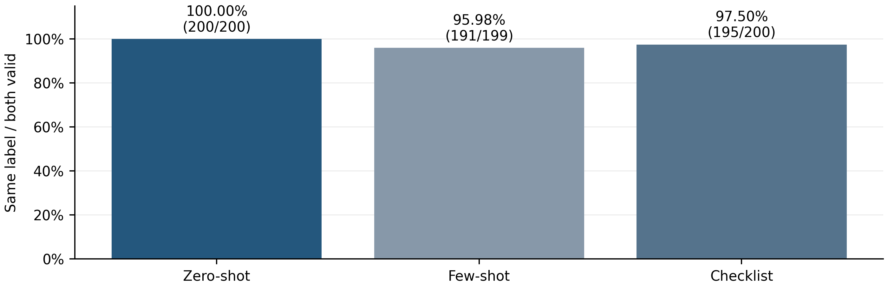
Figure 8. Cross Round Prediction Agreement. Counts above bars state matching valid labels / both-valid jobs. High agreement does not establish correctness.
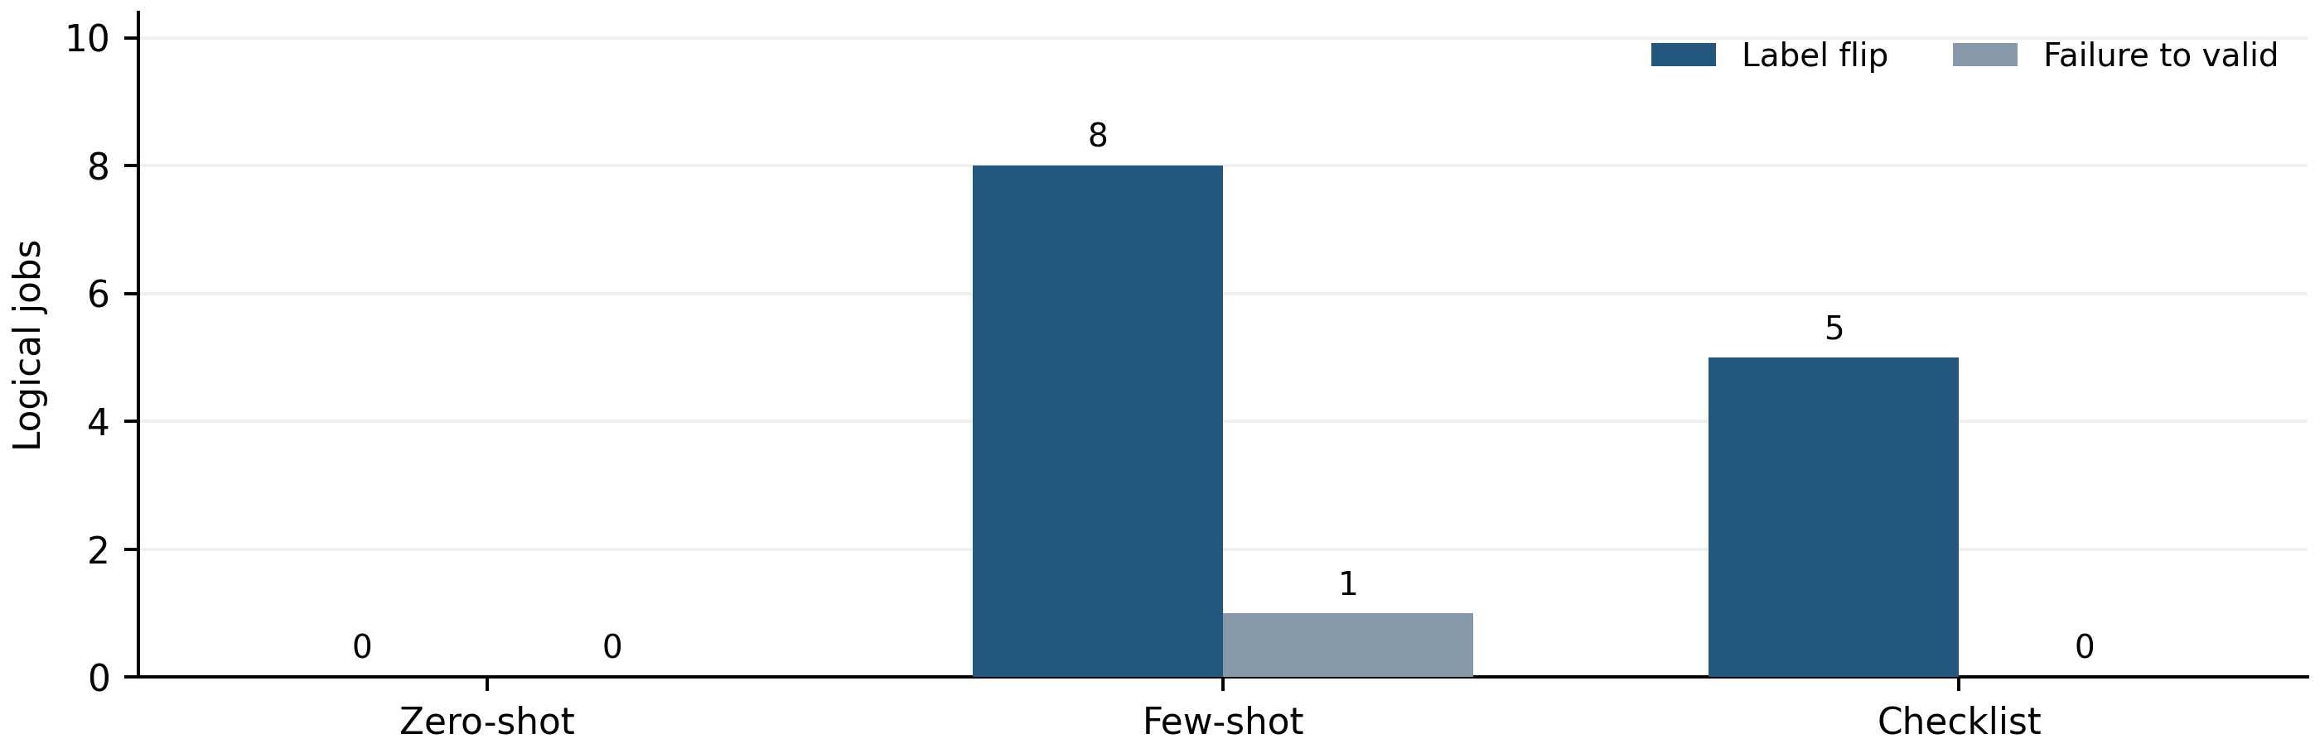
Figure 9. Label Flips and Validity Changes. A label flip requires two valid but different labels. The single failure-to-valid change is a distinct event.
Table 5. Agreement and coverage across rounds.
Strategy | Same / both valid | Agreement | Both-valid coverage | Same / all jobs
Zero-shot | 200/200 | 100.00% | 100.00% | 100.00%
Few-shot | 191/199 | 95.98% | 99.50% | 95.50%
Checklist | 195/200 | 97.50% | 100.00% | 97.50%
Overall | 586/599 | 97.83% | 99.83% | 97.67%

Consistency and Changes in Correctness
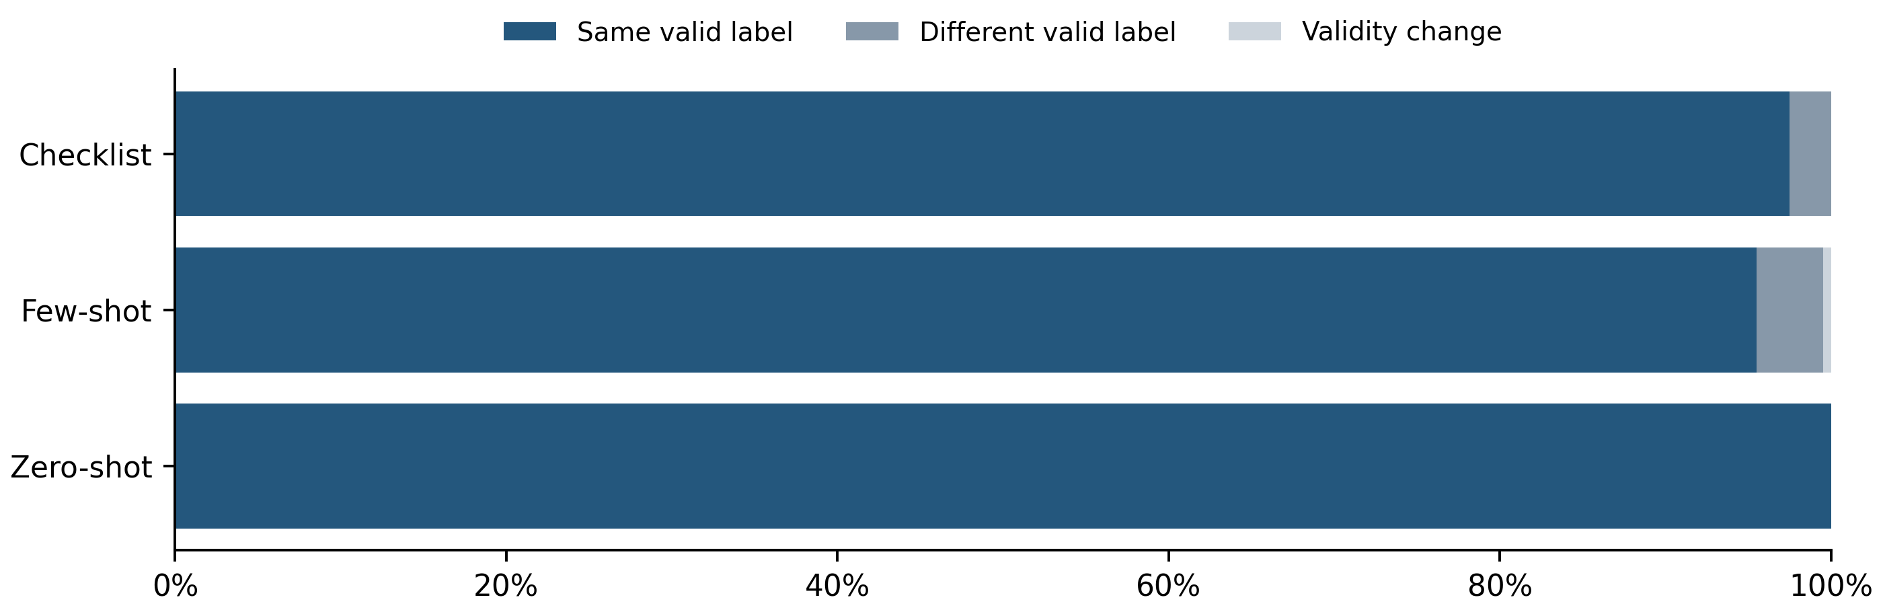
Figure 10. Agreement Composition Across All Logical Jobs. Each strategy uses all 200 jobs; validity changes remain visible rather than being silently dropped.
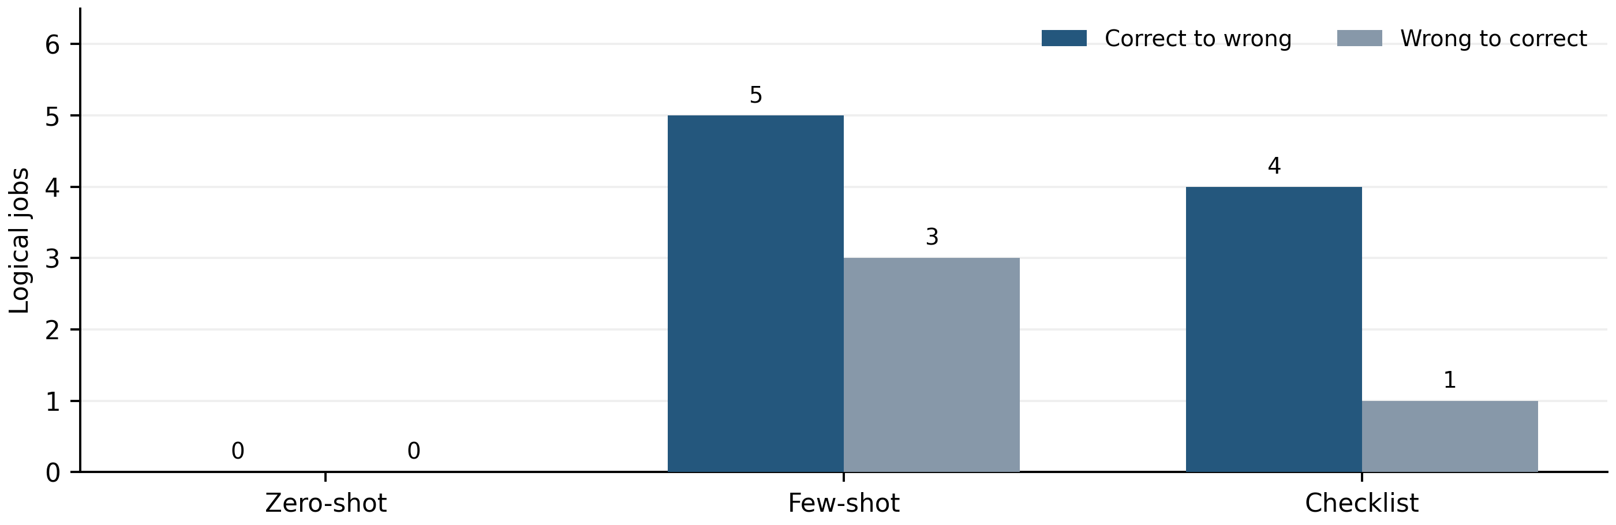
Figure 11. Correctness Transitions Between Rounds. Failure is incorrect under all-job scoring. The one failure-to-valid change remained incorrect, so it appears in neither transition bar.
Across all strategies, 586 jobs retain the same accepted label, 13 flip between labels, and 1 changes from failure to valid. Among valid flips, 9 change from correct to wrong and 4 improve from wrong to correct. Few-shot loses two correct predictions; Checklist loses three.
Table 6. Pair-level correctness requires both instructions in a pair to be correct.
Round | Zero-shot | Few-shot | Checklist
R1 | 11.00% | 17.00% | 15.00%
R2 | 11.00% | 13.00% | 14.00%

Zero-shot repeats every label yet has only 53.50% Accuracy and 11% pair-level correctness. Reproducibility measures whether outputs persist, whereas correctness measures agreement with gold labels. The two properties answer different questions. Temperature zero did not guarantee identical outputs for the other strategies; the logs do not identify the provider-side cause.

Chapter 6 Token Consumption and Latency
Token use is summed over completed attempt events, including retries. Unknown values remain unknown and are never imputed as zero. Round 1 totals below are known usage only; Round 2 has no unknown-usage attempts.
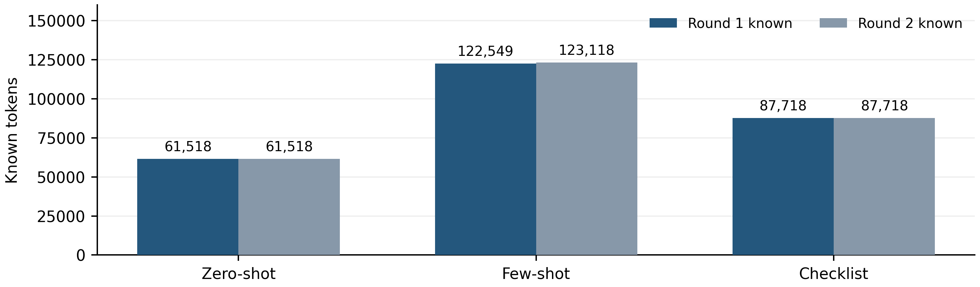
Figure 12. Input Token Consumption. Input tokens dominate the observed consumption; Few-shot includes the fixed development demonstrations.
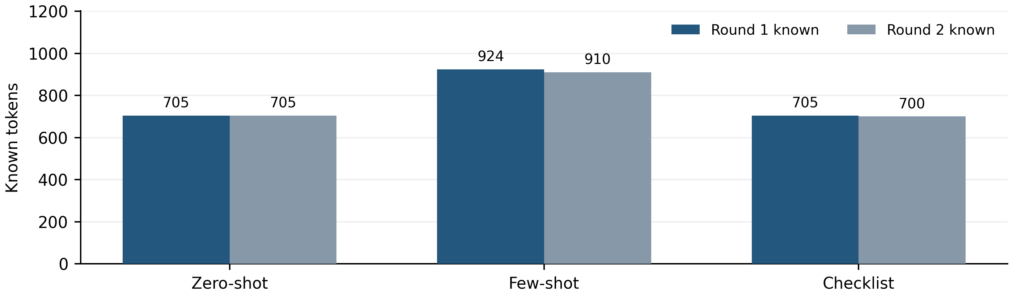
Figure 13. Output Token Consumption. Output token use reflects short accepted labels. Unknown usage on failed attempts remains unobserved.
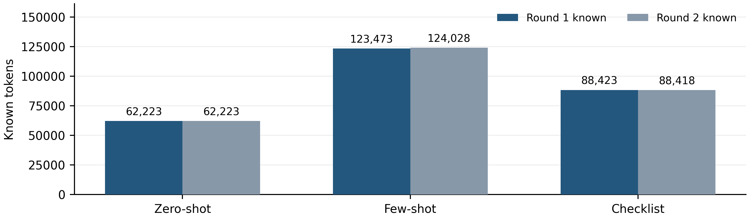
Figure 14. Total Known Token Consumption. R1 known total=274,119; R2 known total=274,669. Their difference is not a verified difference in actual cost.
On fully observed Round 2, average total tokens per logical job are Zero-shot 311.12, Few-shot 620.14, Checklist 442.09. Monetary charges are not estimated because billing data and unknown first-round usage are unavailable.

Latency and Calling Stability
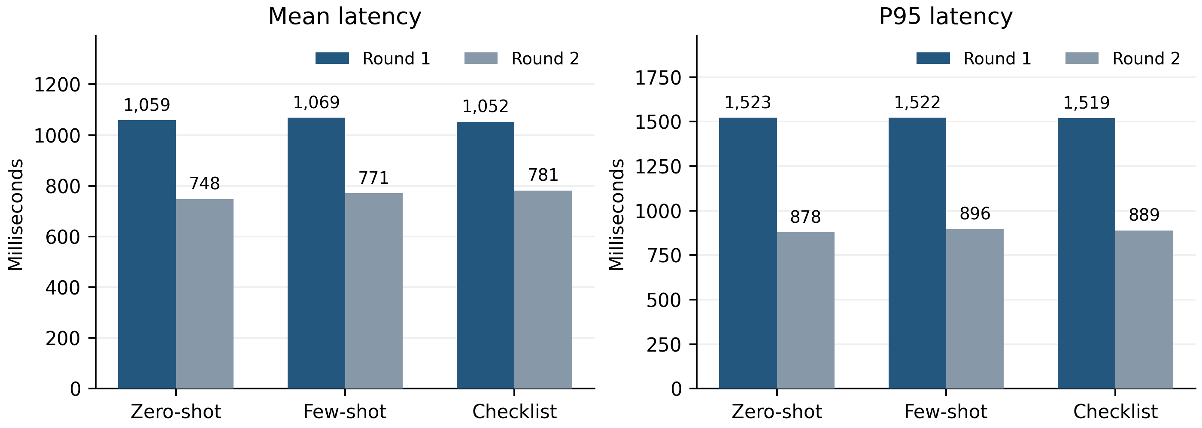
Figure 15. Mean and P95 Attempt Latency. Latency is per completed attempt, including failures; P95 uses linear interpolation. Backoff, manual pauses and recovery waits are excluded.
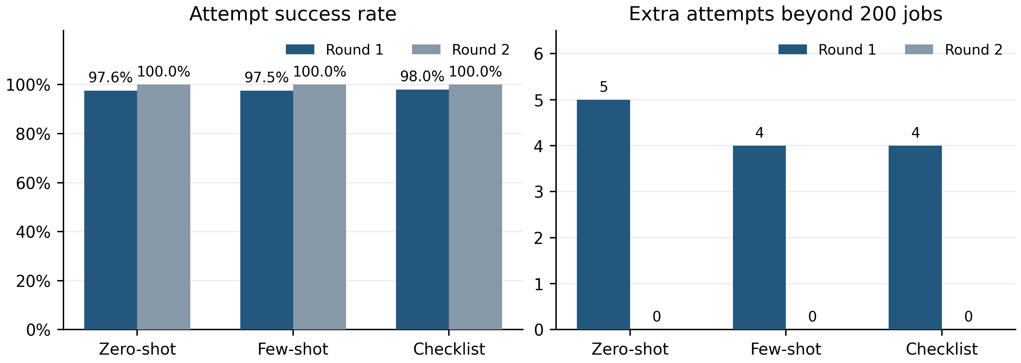
Figure 16. Request Success Rates and Retry Overhead. Attempt success means an accepted label was returned. Extra attempts equal completed attempts minus 200 logical jobs.
Table 7. Attempt counts, unknown usage and final validity.
Round / strategy | Calls | Retries* | Network errors | Unknown usage | Final valid
R1 Zero-shot | 205 | 5 | 5 | 5 | 100.00%
R1 Few-shot | 204 | 4 | 5 | 5 | 99.50%
R1 Checklist | 204 | 4 | 4 | 4 | 100.00%
R2 Zero-shot | 200 | 0 | 0 | 0 | 100.00%
R2 Few-shot | 200 | 0 | 0 | 0 | 100.00%
R2 Checklist | 200 | 0 | 0 | 0 | 100.00%

*Retries here denote extra attempts, not the number of logical jobs retried. Round 1 has 613 cumulative calls, 14 network-error attempts and one final Few-shot failure; ten logical jobs were retried. The latest R1 calls_this_run=568 covers only its recovery execution. Round 2 has 600 calls, no retries and no failed jobs.
Both rounds end with stopped_reason=null and zero remaining requests. R1 nevertheless had an earlier safety stop and recovery. R2 shows lower mean and P95 latency across all strategies, but Checklist includes a 6.74-second outlier. Network conditions and execution time differ between rounds, so these changes cannot be attributed causally to prompt strategy.

Chapter 7 Error Analysis
Cases below are selected deterministically from the observed predictions. Environment and instruction text are reproduced from test_inputs.csv; gold labels are retained unchanged. Each strategy cell shows R1 / R2. C means CLEAR, N means NEEDS_CLARIFICATION, and F means REQUEST_FAILED. Observations are separated from possible interpretations; no internal model reasoning is available.

Case 1 A clear instruction becomes a false positive
sample_id: s_e1bc09f221b5668b4c93 | pair_id: test_258 | category: safety | gold: CLEAR
Environment: a ladle, a knife block, a glass milk bottle, an oat milk bottle, a paring knife, a toaster, a croissant, a cutting board, a bottle of red wine, a bottle opener, a bottle of white wine
Instruction: Slice the croissant using the paring knife on the kitchen table.
Zero-shot R1 / R2 | Few-shot R1 / R2 | Checklist R1 / R2 | Any change
N / N | N / N | C / N | Yes

Observation: Checklist changes from CLEAR to NEEDS_CLARIFICATION for a gold-CLEAR instruction. This adds an unnecessary clarification in Round 2. Possible interpretation: the action or tool context may be treated inconsistently, but a label-only output does not establish which detail drove the change.

Case 2 An ambiguous instruction becomes a false negative
sample_id: s_334501733209efd4d348 | pair_id: test_717 | category: common_sense_knowledge | gold: NEEDS_CLARIFICATION
Environment: mussels, a cheese block, tomatoes, a penne, a chicken broth, oysters, a baking sheet, a cutting board, a knife
Instruction: Slice the tomatoes and cheese, and arrange them on a baking sheet to make a simple baked appetizer. Remove when done.
Zero-shot R1 / R2 | Few-shot R1 / R2 | Checklist R1 / R2 | Any change
N / N | N / N | N / C | Yes

Observation: Checklist changes from NEEDS_CLARIFICATION to CLEAR for a gold-ambiguous instruction. The phrase "Remove when done" leaves a completion condition unstated in the instruction. This is a plausible ambiguity cue, but the gold label does not identify a unique causal explanation for the model error.

Paired Instructions and Failure Recovery

Case 3 The clear member of pair test 17
sample_id: s_f37b3f728c5bb57a0411 | pair_id: test_17 | category: preferences | gold: CLEAR
Environment: a clean sponge, a dirty sponge, a dish soap, paper towels, olive oil, coconut oil, cheddar cheese slices, mozzarella sticks, cream cheese, cottage cheese, a fresh mozzarella package, a ceramic dinner plate, a ceramic plastic plate
Instruction: Robot, please use the clean sponge and dish soap to wash a ceramic dinner plate. Then, use the olive oil to grease the ceramic dinner plate.
Zero-shot R1 / R2 | Few-shot R1 / R2 | Checklist R1 / R2 | Any change
C / C | N / C | C / C | Yes

Observation: Few-shot changes from an incorrect clarification request to the correct CLEAR label. The instruction explicitly names a ceramic dinner plate. Compare with the next case rather than interpreting this improvement in isolation.

Case 4 The ambiguous member of pair test 17
sample_id: s_d0c79f390eed72de95ee | pair_id: test_17 | category: preferences | gold: NEEDS_CLARIFICATION
Environment: a clean sponge, a dirty sponge, a dish soap, paper towels, olive oil, coconut oil, cheddar cheese slices, mozzarella sticks, cream cheese, cottage cheese, a fresh mozzarella package, a ceramic dinner plate, a ceramic plastic plate
Instruction: Robot, please use the clean sponge and dish soap to wash a plate. Then, use the olive oil to grease the ceramic plate.
Zero-shot R1 / R2 | Few-shot R1 / R2 | Checklist R1 / R2 | Any change
C / C | N / C | C / C | Yes

Observation: Few-shot also changes to CLEAR here, but this gold label is NEEDS_CLARIFICATION. It predicts the same label for both pair members in each round. Thus it remains correct on exactly one member and fails pair-level discrimination despite the individual label changes.
The historical failed job s_9c65df4c253e6019484e (Few-shot; gold CLEAR) becomes NEEDS_CLARIFICATION in Round 2. Recovery improves valid-output coverage but not correctness. Its complete input and all strategy predictions are supplied in error_cases.csv.

Chapter 8 Discussion and Conclusion

Accuracy and balanced classification
Few-shot has the highest all-job Accuracy in both rounds, at 56.00% and 55.00%. Checklist has the highest Macro-F1, at 55.50% and 54.00%. There is no strategy that leads both metrics. Macro-F1 is a useful primary comparison when both gold classes matter equally; deployment decisions would additionally require an explicit cost for missed ambiguity and unnecessary user interruption.

Prediction bias and the baseline
Few-shot consistently favors NEEDS_CLARIFICATION, with 72.86% and 71.00% of valid outputs assigned that label. The gain in ambiguity Recall comes with low CLEAR Recall and many false-positive questions. Zero-shot and Checklist have balanced output totals but still substantial classification errors. Balanced predicted totals should therefore not be used as a proxy for discrimination.
All observed all-job Accuracies are numerically above the 50% constant-class baseline, but only by 3.5–6.0 percentage points. This report does not establish a statistically reliable improvement over that baseline or a significant advantage between prompts. No significance test is reported. The paired test design and repeated execution on the same items must be respected in any later uncertainty analysis. For reference, an always-one-class predictor has Macro-F1 of one third on a balanced two-class set, not 50%.

Repeatability and operational performance
Zero-shot has the highest repeatability: all 200 predictions match across rounds. Its Accuracy remains 53.50%, showing that the same error can be reproduced reliably. The overall both-valid agreement of 97.83% combines strong stability with modest correctness. Round 2 also has better observed calling stability, but the time-separated runs do not isolate the cause of network or latency differences.

Limitations
There are only 200 instructions and 100 pairs, and some category subsets are small. The repeated round adds another execution, not new independent test examples. The two runs share identical v0.1-dev DRAFT prompts and fixed development examples; prompt content has not been frozen as a final experimental artifact. Gold labels are used as supplied and were not re-adjudicated. Label-only outputs restrict causal error analysis. Unknown usage on 14 first-round network errors prevents a complete cost comparison. The results are limited to the recorded model version and settings.

Next steps
WANG can integrate the supplied analysis data and figures into a maintained analysis.py implementation, with denominator checks and reproducible exports. Independently review gold-label semantics and representative cases before final reporting, without silently changing this analysis. Evaluate any future prompt revisions using development data and a separately defined final protocol; do not optimize on these test outcomes. If uncertainty intervals are needed, jointly resample the 100 pairs as clusters across rounds and strategies and record the random seed and bootstrap count.
Conclusion: Checklist is the strongest observed strategy for Macro-F1, Few-shot leads Accuracy while over-predicting clarification, and Zero-shot is the most repeatable and uses the fewest known tokens. These are descriptive findings from a same-test-set Pilot repetition, not confirmed generalization or significance claims.

Appendix A Configuration and Metric Definitions
Table A1. Recorded configuration and experimental scope.
Item | Recorded value
Model | qwen-plus-2025-12-01
temperature | 0.0
max_tokens | 64
enable_thinking / stream | false / false
Prompt version / status | v0.1-dev / DRAFT
Model mode | qwen; real calls were completed before this offline report
Test design | 200 instructions; 100 pairs; 100 gold labels per class
R1 valid / all jobs | 599 / 600
R2 valid / all jobs | 600 / 600

Run identities
R1: group13-full-pilot-qwen200-20261111T090248Z-76877106
R2: group13-full-pilot-round2-20261111T153626Z-bc85f07d

Definitions and failure treatment
For class k, Precision = TPk / (TPk + FPk), Recall = TPk / (TPk + FNk), and F1 = 2TPk / (2TPk + FPk + FNk). Zero denominators return zero. Macro metrics average the CLEAR and NEEDS_CLARIFICATION class values. Accuracy is correct jobs divided by the chosen denominator. Valid rate is accepted labels divided by jobs in that scope.
For binary diagnostics, NEEDS_CLARIFICATION is positive. FP is gold CLEAR predicted NEEDS_CLARIFICATION; FN is gold NEEDS_CLARIFICATION predicted CLEAR. A failure is neither predicted class, but contributes an FN to its gold class in class metrics. Ambiguity Miss Rate includes all gold ambiguities not returned as NEEDS_CLARIFICATION. Unnecessary Clarification Rate counts only gold CLEAR predicted NEEDS_CLARIFICATION; failures are reported separately.
Both-valid agreement = matching valid labels / jobs valid in both rounds. All-job same-label rate = matching valid labels / all aligned jobs. Pair-level correctness = pairs with both labels correct / complete input pairs. The valid-only subset with one missing pair member has no reported pair score.
Token totals are sums of known usage fields over completed attempts, not only final predictions. Latency mean and P95 use completed-attempt milliseconds; P95 is a linearly interpolated quantile. Attempt success means an accepted label; final validity measures the result after retries. Extra attempts and retried logical jobs are distinct quantities.

Appendix B Data Provenance and Reproducibility
Every source prediction is reconciled with its final completed attempt. Checks cover unique logical IDs, complete sample/strategy coverage and order, label and pair joins, prompt/message hashes, snapshots, model configuration, event start/completion pairing, usage sums and final execution summaries. Recomputed core metrics match the prior offline analysis within floating-point tolerance. All protected source files are hashed before and after generation.
Table B1. SHA-256 prefixes for compact inspection. integrity.json contains every full 64-character hash.
Source file | SHA-256 prefix
data\processed\test_inputs.csv | a24c8c407b886658573d014b
data\processed\test_labels.csv | 97b56a0934486e5e40c67bdb
src\evaluate.py | f78e6781f89599fa08a02eed
src\evaluation_adapter.py | f55987c637eb2340686f1d34
results\pilot\R1\pilot_manifest.json | ed0334fddcb0f652441f744a
results\pilot\R1\predictions.jsonl | b29e3ef7f353d14cd308c807
results\pilot\R1\attempts.jsonl | 6c92c72960721851938962e6
results\pilot\R1\execution_summaries.jsonl | 1f8f7ffb7c218a8737a63ab3
results\pilot\R2\pilot_manifest.json | 2487c421a8393edf33dee432
results\pilot\R2\predictions.jsonl | f306c86930120139d770048c
results\pilot\R2\attempts.jsonl | 92c4ba4d90e008c5e4a1b5d5
results\pilot\R2\execution_summaries.jsonl | 7e60324fec8690b0ab3b9c9e

Rebuild command
From the repository root: python -B results/reports/generate_report.py --render
Required packages: python-docx, matplotlib, numpy, Pillow, PyMuPDF and pywin32 for Windows Word automation. README.md records installation and renderer details. Without --render the same raw-data checks, CSVs, figures and editable DOCX are rebuilt without launching Word.

Delivered analysis files
The reports directory contains the DOCX and PDF, this generation script, README.md, integrity.json, figure_manifest.json and package versions. figures contains 16 numbered main figures plus six standalone confusion matrices, each in PNG and SVG. data contains metrics, classification diagnostics, prediction distributions, attempt costs and latency, aligned predictions, disagreements, error cases, per-attempt records and the exact figure source values.
All plots are produced from the loaded raw records. PNG exports use 350 DPI; SVG files retain vector shapes and text. Word paragraphs and tables remain editable. src/analysis.py remains unchanged and empty; these deliverables provide an independent handoff rather than replacing WANG's module. No Qwen API call, experiment rerun, test-based prompt revision, commit or push is performed.

