This Project is to implement a traffic sign classifier by utilizing deep learning

**The dataset**

I downloaded Germany traffic sign dataset from suggested website, it consists of 3 types of data: ~35k training data, 4410 validation data and ~12k test data. Each data includes a 32*32 color traffic sign image and its corresponding label; there are 43 labels in totals. I plotted the label distribution for all the training data, it looks like this:

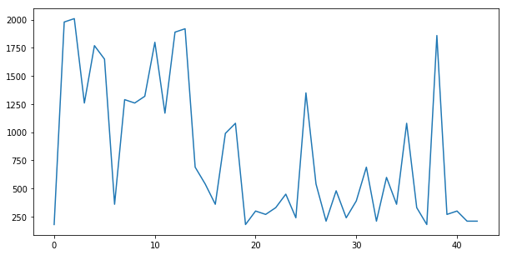

**Data preprocess**

* Training data shuffle: the purpose is to reduce variance and make sure the model remains general and overfit less
* Normalization: it’s to let training data have zero mean and equal variance. In the project, the color image has 3 channels: R, G and B. each channels ranges from 0 to 255; I take a formula update channel value to (pixel – 128.0) / 128.

**Model Architecture:**

The model is a typical LeNet architecture with some modifications.

* Layer1: a convolution layer, which takes input as the training data, applies a 1*1 stride filter to generate a 28*28 layer with depth as 6; then a ReLu activation function applied, and lastly followed by a max pool dropout to generate a 14*14 layer with depth as 6.
* Layer2: also a convolution layer, which takes input from Layer 1, applies a 1*1 stride filter to generate a 10*10 layer with depth as 16; then a ReLu activation function applied, and lastly followed by a max pool dropout to generate a 5*5 layer with depth as 6.
* Layer3: also a convolution layer, which takes input from Layer 2, applies a 1*1 stride filter to generate a 3*3 layer with depth as 32; then a ReLu activation function applied.
* Layer4: a full connection layer, which takes input from Layer3, flattens it as a 400 dimension layer, applied matrix multiplication and addition, generated a 120 dimension layer with ReLu applied.
* Layer5: a full connection layer, which takes input from Layer4, flattens it as a 120 dimension layer, applied matrix multiplication and addition, generated a 84 dimension layer with ReLu applied.
* Layer6: a full connection layer, which takes input from Layer5, flattens it as a 84 dimension layer, applied matrix multiplication and addition, generated a 43 dimension layer with ReLu applied, the output from this layer is our logits output of the entire training module.

**Data Training and Data Validation**

* Training parameter: epoch as 50, learning rate as 128 and batch size as 128
* Training operation: it’s an Adam optimizer taking a cross entropy mean as loss function. The cross entropy takes the logits calculated from above LeNet architecture.
* Training process: it runs 50 epoch, in each epoch
  + It shuffles the training data set.
  + It divides the training data set into batches with 128 as batch size, the optimizer runs each batch data.
  + After we finish train the data set, we calculate the accuracy from each epoch.
* The recognition accuracy was printed out for each epoch, it finally comes to 93.4% at epoch 39, then climb very slow to 93.5% in the last epoch.
* In the end, we save the session data to file so we can use later.

**Data test**

We load the session data from file (generated from training process), run the same validation operation as in validation process, we came up with a 85.5% accuracy.

**Test on new image**

* I downloaded a Germany traffic sign picture from website, it includes 25 small traffic sign pictures within.
* I cropped the original picture to get 25 small pictures, I then resized each small picture to 32*32; in the end I got 25 small picture with shape as 32*32*3.
* I used same way (pixel – 128.0)/128 to normalize each picture, loaded the session data from file, verified accuracy, surprisedly I got 100%. I had to check each picture and file signnames.csv to get the expected class though.
* I also analyzed the top 5 probability for those 25 pictures by utilizing tensor flow top_k activation function on soft max result on logits, I found out that most of top 1 is 100%, and the rest are 99%.
* The accuracy of the model upon those new images is 100%, better than the accuracy on test images which is 91.9%. I think the new images are brighter, test images seem blurred. This should be one of the reason of high accuracy on new images.
* Plotted new images like this:

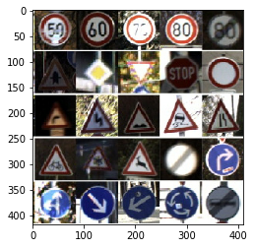

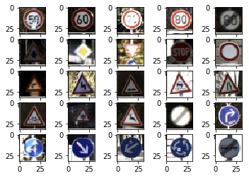

An image from test dataset:

