Part3
11 - shows the project folder opened in VS Code before running the Part 3 local end-to-end test.
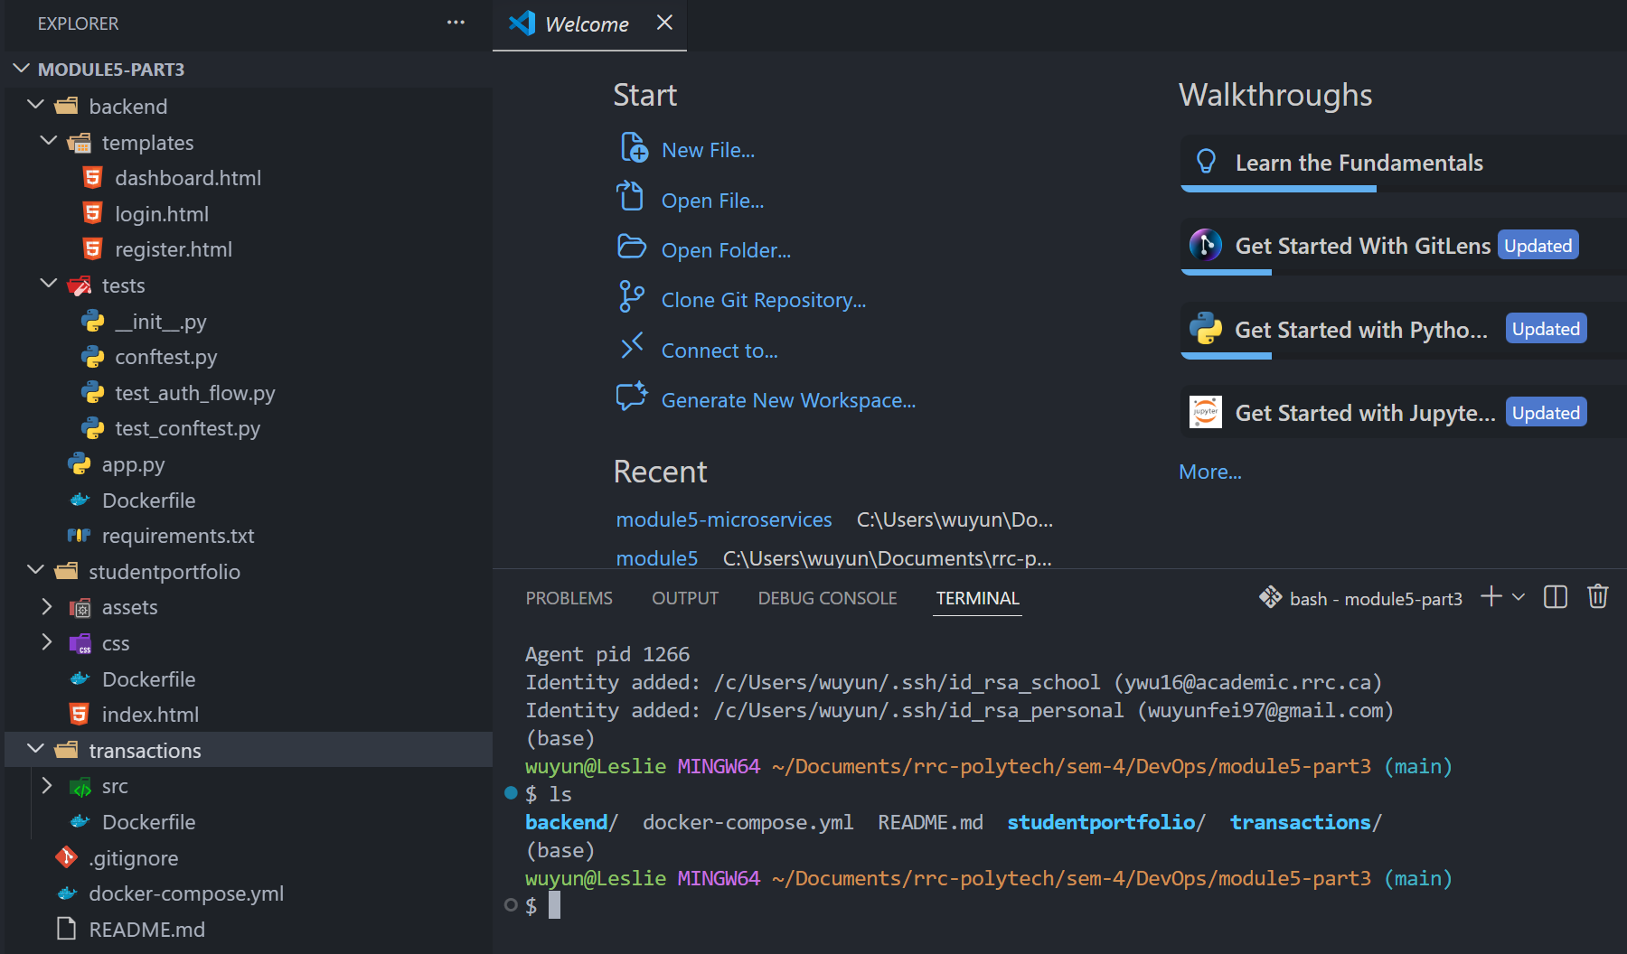
12 - This screenshot shows docker compose up --build -d completing successfully and confirms that all required containers started correctly.
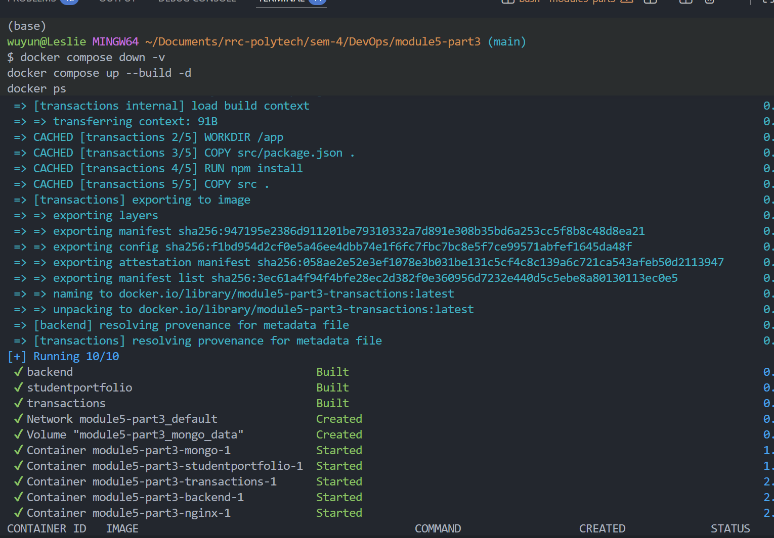
13 - This screenshot shows the Nginx logs successfully routing requests for the application and static files.
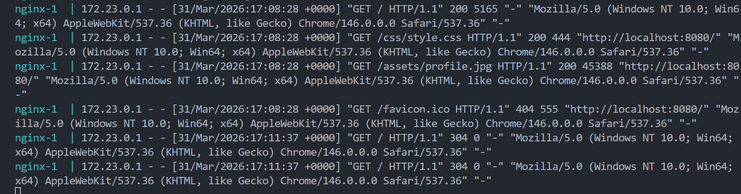
Part 3 explanation
For Part 3, I used Nginx as a reverse proxy to route requests to the services inside Docker Compose. To avoid port conflicts with containers that were already running on my machine, I mapped Nginx to port 8080 instead of port 80. The backend and transactions services were kept internal to the Docker network and were not exposed to the host. After running docker compose up --build -d, all containers started successfully. I then checked the Nginx logs and confirmed that requests for /, /css/style.css, and /assets/profile.jpg were being served through Nginx.

14 - This screenshot shows the branded login page after the user registration step was completed successfully.
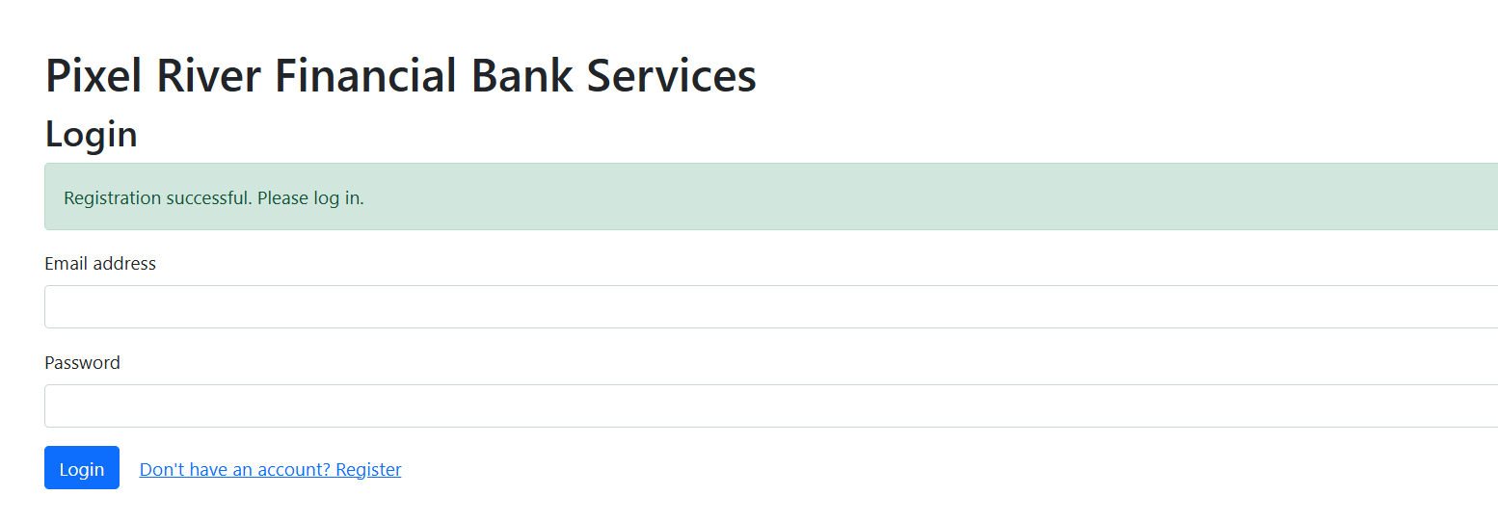
15
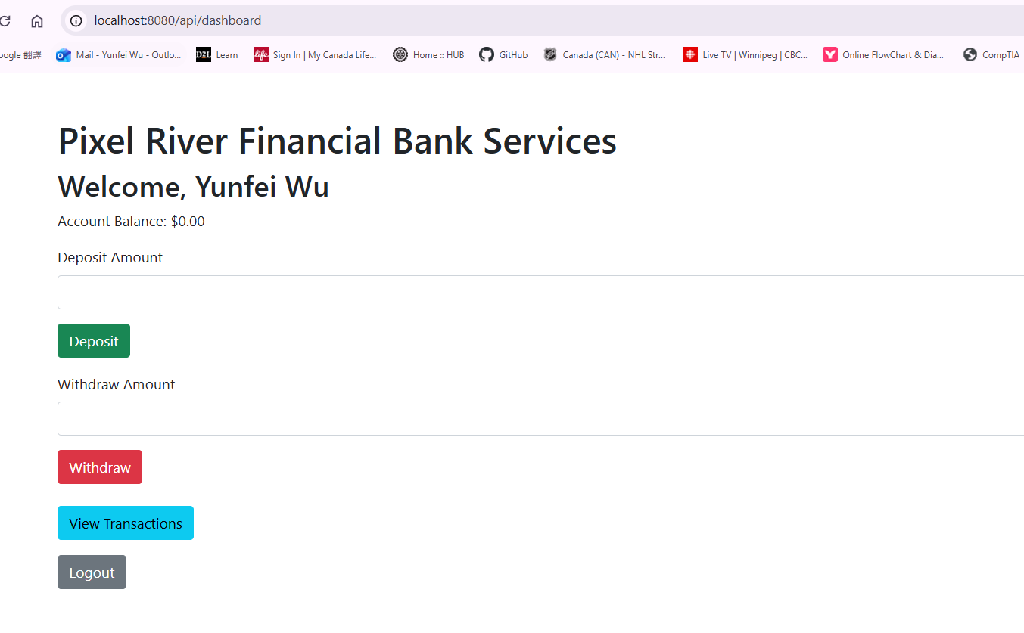
16
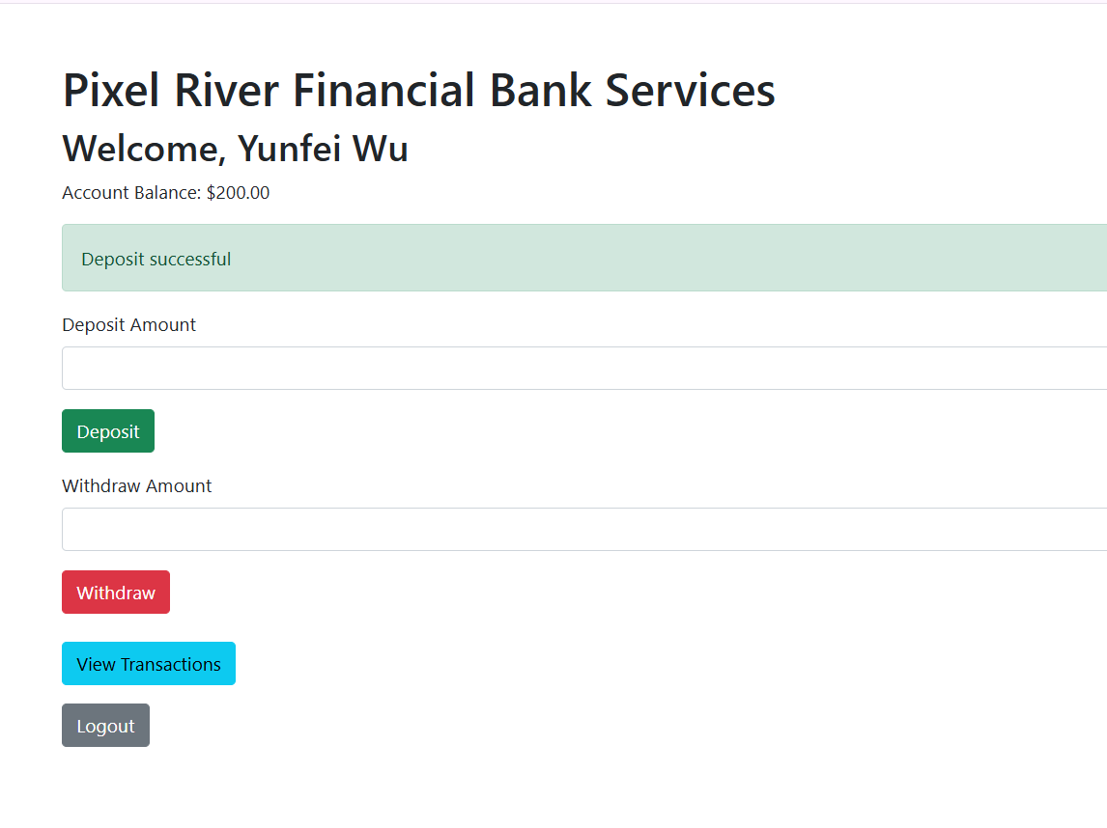
17
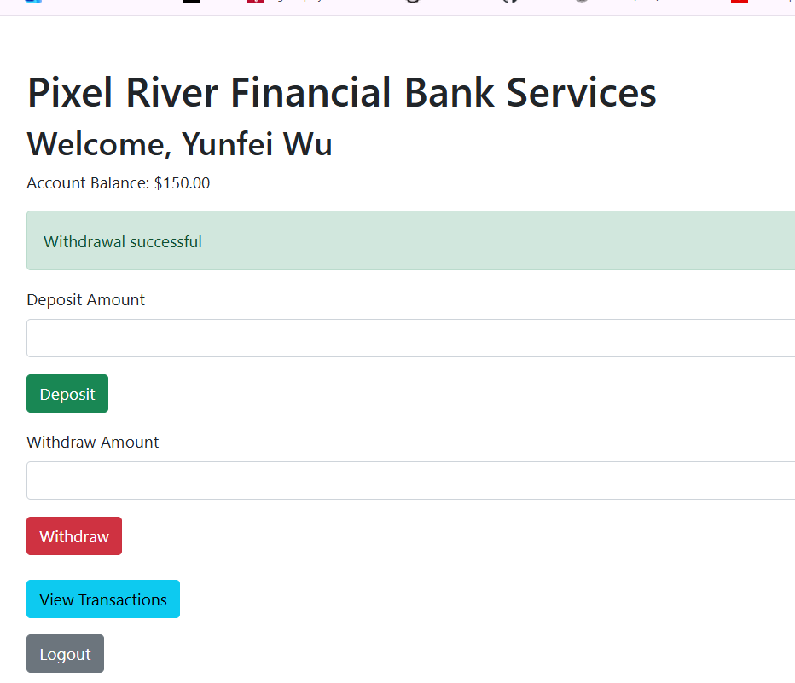
18
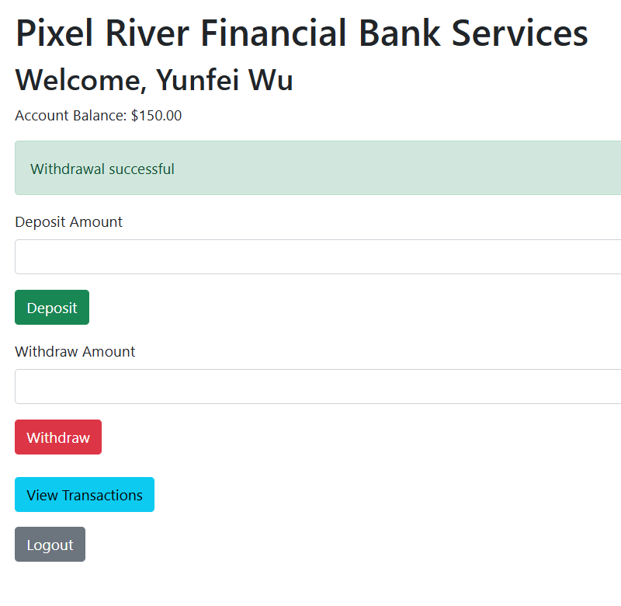
19 - This screenshot shows the MongoDB query result confirming that the registered user and transaction records were saved successfully.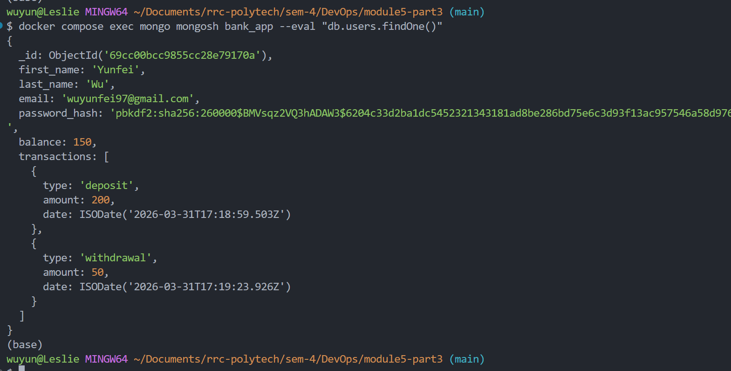
20
This screenshot shows the GitHub Actions workflow run completed successfully with a green checkmark.
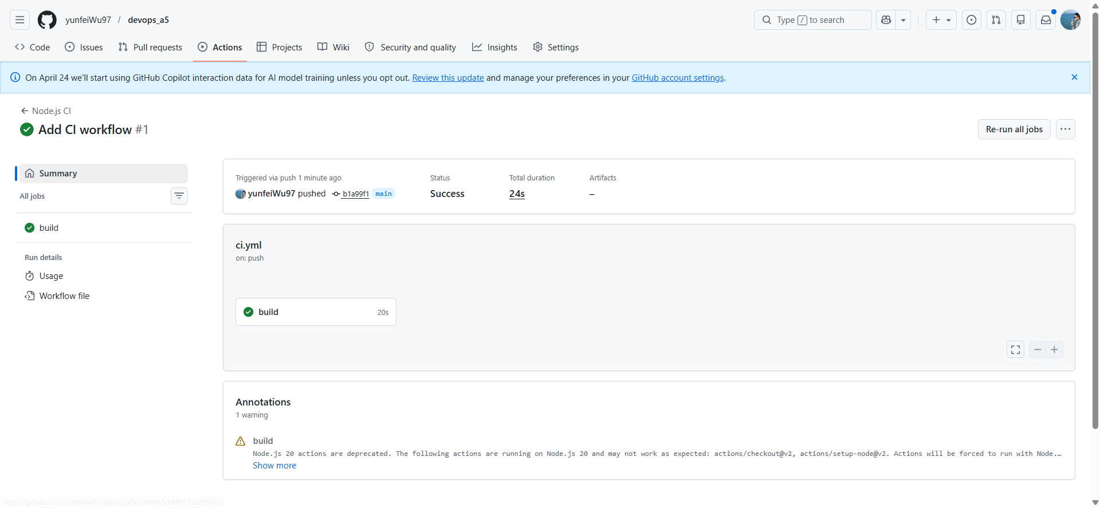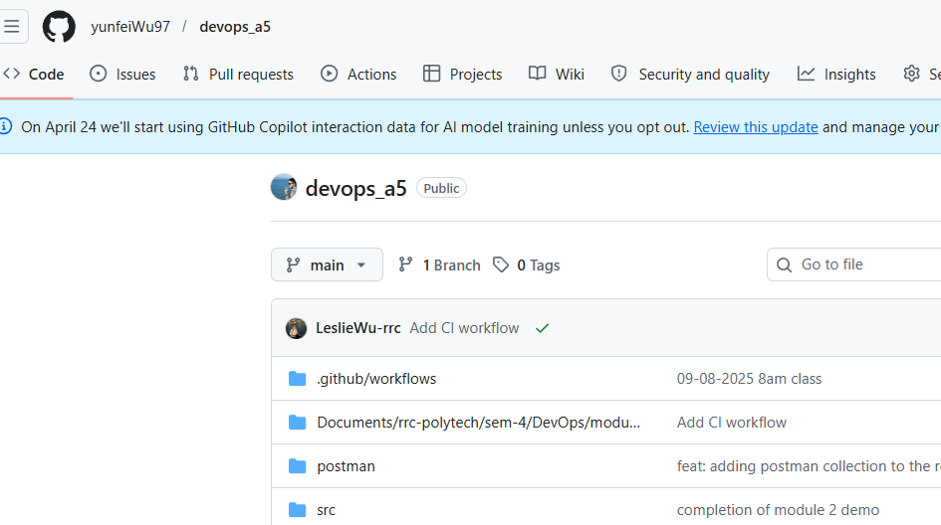
Part 3 explanation
For Part 3, I used Nginx as a reverse proxy to route requests between the frontend, backend, and transactions services inside Docker Compose. I ran docker compose up --build -d and confirmed that all containers started successfully. After that, I checked the Nginx logs to verify that requests were being routed correctly. I then tested the application by completing the register, login, deposit, withdrawal, and dashboard steps, and finally confirmed the saved transaction data in MongoDB and the CI workflow in GitHub Actions.

What is the CI GitHub Actions file?
The CI GitHub Actions file is a workflow file that tells GitHub what automated steps to run when code is pushed to the repository. In this project, it is used to automatically set up the environment, install dependencies, and run backend tests. This helps check whether the code is working properly before or after changes are pushed to the main branch.

