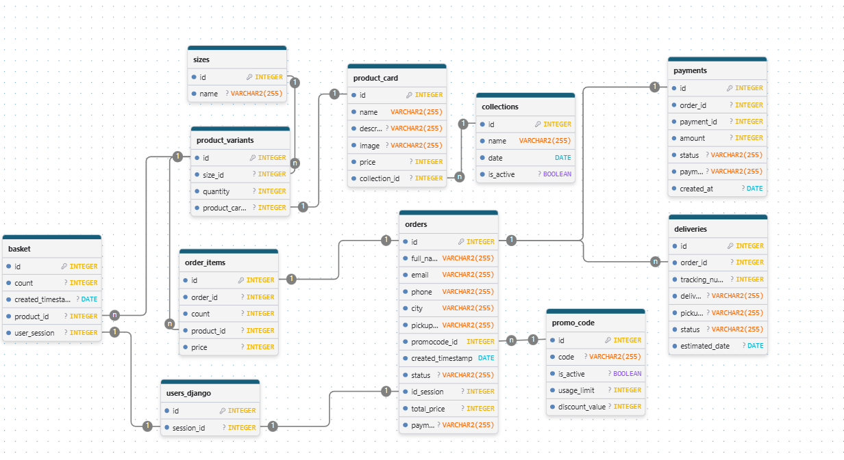
https://drawdb.vercel.app/editor?shareId=1b8032edbbf3310998b54c4e823a90ba

