In this assignment, we explored several deep learning architectures to improve weather time-series forecasting. Our evaluation focused on the Mean Absolute Error (MAE) for both validation and test datasets. The goal was to identify the best-performing model in terms of predictive accuracy.

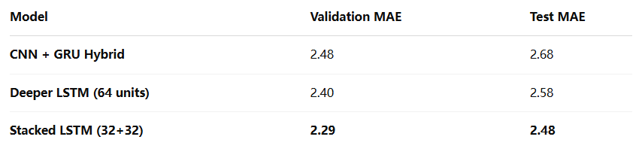

**CNN + GRU Hybrid Model**

This model combined a 1D convolutional layer for feature extraction with a GRU layer for sequential modeling.

**Deeper LSTM (64 units)**

Increasing the number of LSTM units improved both training and validation performance.

**Stacked LSTM with Dropout (32+32 units)**

This architecture achieved the best validation and test performance. Stacking LSTM layers allowed the model to capture both short-term and long-term dependencies. Dropout regularization helped prevent overfitting, resulting in the lowest MAE overall.

**Conclusion**

The Stacked LSTM model with two layers of 32 units each and dropout performed best. It achieved the lowest validation MAE of 2.29 and the lowest test MAE of 2.48. Based on this result, it is the recommended model for this weather forecasting task.