GLOBAL AI VIDEO
CHAMPIONSHIPS
A live-event and tournament property for an emerging creative medium

Two formats. One core idea: AI video needs a season, not another one-night awards show.

SEASON ZERO  Genre Championships using existing videos | LIVE FORMAT  Final Eight per category, fan-voted
EXPANSION  Nations Cup after the audience ritual exists | PARTNER ASK  Pressure-test and potentially co-produce the pilot

Prepared as a discussion document for experienced live-event / esports operators.

1. Executive summary
The opportunity. AI-native video now has enough supply, recognizable creators and comparative audience behavior to justify testing recurring competition, but almost no durable ritual. Work travels through feeds, spikes, and disappears. The competitive layer is still largely unclaimed: the first credible format may get to define the brackets, terminology, archive and expectations before an incumbent does.
The property. There are two complementary formats: (1) a Genre Championship built from existing work, and (2) a Nations Cup in which teams create under common constraints and a national winner becomes that country’s locked global entry. They should not be merged; they measure different things.
The launch recommendation. Start with an online-only Genre Championships pilot. Run two deep brackets — Music Video and Comedy / Meme — using existing, opted-in work. Qualifying happens online over one or two weeks; each category narrows to a Final Eight, and the live stream resolves the bracket by verified fan vote. Narrative / Drama can run as a showcase unless the accepted field is deep enough to justify a third bracket. The first edition should test one thing above all: whether voters return for later rounds. If quarterfinal voters do not come back for semifinals and finals, do not scale the property just because the stream looked good. A smaller one-category, regional, community or topical contest is also a legitimate first test; the two-bracket broadcast is an attractive launch configuration, not the minimum viable budget.
The award is not the product. The season is.
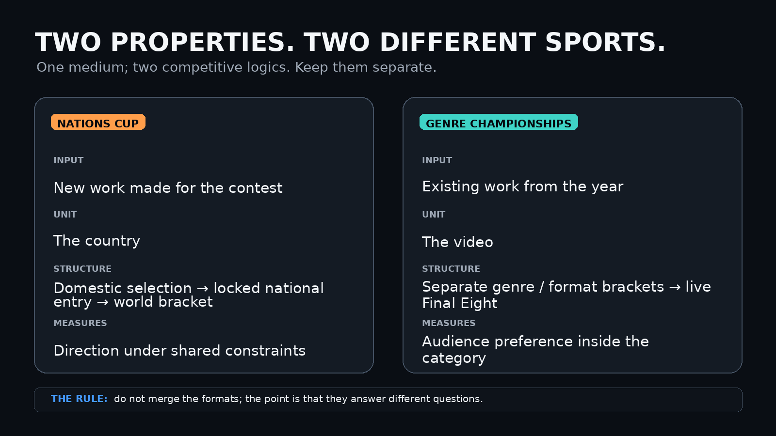
Two competition properties, deliberately separated by purpose.

Why an esports / live-event operator is a natural fit
- Bracket literacy: the audience understands progression, seeding, elimination and upset narratives immediately.
- Live production: the value is in pacing, voting windows, reveals, creator packages, co-streaming and a credible championship atmosphere.
- Community operations: creator outreach, moderation, rules enforcement and competitive integrity matter more than traditional award-show judging.

Why now: the competitive layer is still unclaimed
AI video is in a brief format-building window: the supply exists, recognizable creators and native forms are appearing, and no institution has yet become the default place where the work is compared, seeded, voted on and archived. Someone is likely to build that layer. The advantage should belong to people who understand competition, community and live format design rather than simply importing an awards-show template.
Preliminary audience signal. A non-exhaustive snapshot of 18 AI-video-related X posts and YouTube uploads shows approximately 83.2 million summed views and 408,000 likes as of October 20, 2026, spanning 12 X posts and six YouTube videos. These examples encompass music videos, experimental productions, agent-directed workflows, remixes, and viral formats. The counters are not deduplicated, do not measure unique viewers, and do not establish an addressable event audience or willingness to participate in a competition. Nevertheless, they demonstrate meaningful attention across multiple creators and styles without a unified competitive property. That makes a low-cost Season Zero experiment worth testing: recruit existing creators, organize opted-in videos into genre-specific brackets, and measure qualified voting participation, round-to-round audience retention, and creator engagement before considering expansion. The opportunity is not to manufacture interest in AI video, but to test whether existing interest can sustain a recurring spectator event. See the illustrative 18-example audience snapshot in Appendix B.
Supplementary grassroots supply signal. A separate, exploratory list of 33 additional X posts—11 newly identified examples and updated counters for 22 other posts—showed 1,049,307 summed post views and 9,883 likes in the author-supplied October 20, 2026 snapshot. This smaller, more recent sample is centered on AI-native music/slopcore and related creative shorts, with some animation and production-demo-adjacent work. Most entries still attract hundreds or thousands of views; a few breakout posts dominate the total. The two snapshots are selected observations, not a representative sample or proof of category-wide growth, and should not be pooled without verifying that no entries overlap.
Sampling limits and creator cadence. The follow-up discovery is concentrated on X and appears disproportionately US/Western; Instagram, Facebook, Reddit, TikTok, non-Western video communities, and adjacent AI meme and tools ecosystems were not systematically searched. The wider global supply is therefore plausibly larger than this sample, but its size is unknown. Creators are also returning with new releases: @anabology, for example, appears to publish roughly one or two projects a week in the observed period, not a measured average for the field. This is a promising sign of an independent, grassroots production culture rather than a collection of isolated technical demonstrations.

Outside X: the global opportunity is larger—and already being tested
China provides a concrete scale check. In a July 2026 analysis drawing on Douyin platform data, NewRank reported at least nine AI-labeled videos exceeding 100 million views in the first half of 2026. One AI-enhanced historical-memory short was reported at 295 million views and 18.67 million likes. The nine include traditional footage enhanced with AI effects, so this is evidence of broad AI-assisted video reach—not a count of fully generated music videos. Source: NewRank/36Kr survey.
A more directly comparable Chinese music-video example is the Chopstick Brothers’ AI-generated 逍遥仙. Its official Bilibili releases have million-plus plays on some uploads, and the announcement for a third MV explicitly promoted a Chopstick Brothers × MovieFlow AI fan-remix competition. This is a useful existing contest precedent: the opportunity is not to claim no such contests exist, but to build a recurring, multi-category spectator format with brackets and a durable archive. Source: official Bilibili contest announcement.
A third data point comes from a keyword-sampled, non-random dataset of 292,784 TikToks classified by visual origin. Among its tagged videos, AI-generated clips averaged 1.4 million views compared with 661,400 for real footage, while the likes-per-view rate was lower (3.9% versus 7.7%). The dataset is selected and classifier-labeled, so neither a market-wide growth estimate nor a causal test. It reinforces the distinction between initial curiosity/novelty and lasting audience loyalty. Source: Revid cross-platform study.
Together these sources support international discovery, language-aware nomination, and format-specific rules—not a single worldwide leaderboard. The figures span different platforms, denominators, production methods and dates and must not be added to the 18-plus-33 example counters.
Illustrative recent X releases: Claudia Explains: Euclid (@anabology) · French slopcore (@Extraltodeus) · NOW SERVING (@AstrablueAI) · Claude stickman animation (@Aygramm_). These are examples, not an independently sampled ranking.
That is the early-esports analogy worth taking seriously. The bet is not that AI video already has an esports-sized audience; it does not. The bet is that a new media category can be structured while its rituals are still fluid, then scaled only if repeat participation and return voting appear.

The reward loop already exists
ESEA already ran a primitive version of the loop: community-made media, recurring selection, status and return behavior. The proposal is to turn that familiar loop into a bracketed spectator property.
- The proposed property does not need to invent the idea of rewarding internet-native creative output. ESEA itself ran a recurring Clip of the Week / Month series; its archive reaches at least Week 160 in 2008. That is a primitive version of the same loop: community-created material, recurring recognition, status, and a reason to return.
- Today X formalizes a related incentive at platform scale through Original Content Rewards, which pays eligible creators based on qualified impressions for original content across formats. The opportunity here is not “invent creator rewards.” It is to turn an already-familiar reward loop into spectator IP: recurring awards become brackets, brackets become a season, and the season resolves in a live championship.
- A closer format precedent is Pwnisher’s recurring CG challenges. In the 2024 Kinetic Rush challenge, 3,733 artists from 122 countries built scenes from a shared animation template; earlier Alternate Realities and Infinite Journeys challenges each drew roughly 2,400 entries before a Top 100 reveal and prize selection. These are not AI contests, and that is precisely why they are useful here: they show that internet-native animation communities can support deep fields, recurring challenges, sponsor prizes and a reveal format long before anyone builds a league or venue around them.
- References: ESEA COTW archive · X Original Content Rewards · Pwnisher Kinetic Rush / Alternate Realities / Infinite Journeys challenge archives
- IP thinking: the goal is an annual property with repeatable formats, archives, rivalries and sponsor inventory — not a conference side event.

2. The two competition formats

A. Global AI Video Championships — existing work
Core rule: the videos already exist. The competition does not commission them. Creators opt in, works are placed into genre / format brackets, and fans choose the champion within each category.
The sport in one line: verified fans elect a champion from opted-in work inside a genre. Campaigning is legal; automation is not. The winner is the fan-elected champion, not a claim about which video was objectively best made.
The category is the sport. Music videos never have to beat memes; drama never has to beat short loops; series never has to beat a three-minute MV. Each bracket crowns its own champion.
- Music Video
- Narrative / Drama
- Comedy / Meme
- Sci-Fi / Worldbuilding
- Animation / Experimental
- Show / Animated Series
- Short / Loop or other emergent formats
Category policy should stay adaptive. Domestic scenes may run categories that make sense locally. A subgenre becomes a global bracket only when creator supply and audience demand can sustain it. Global categories should be discovered by the culture, not frozen permanently by organizers.

Subcategory awards without category explosion
Not every native format needs its own live bracket. Major championships should stay few enough to understand at a glance, while smaller awards recognize accomplishments that are real but do not yet justify a full division.
- Best Asset — awarded to the originator of an eligible reusable visual, audio, character, scene, template or other format seed that becomes a building block for other creators.
- Best Breakout Adaptation — awarded to the downstream edit, soundtrack pairing, caption, crop, timing change or other recontextualization that most clearly unlocks broad reuse of an eligible asset. It rewards social-distribution creativity without taking origin credit away from the asset creator.
- Best Meme — awarded to the strongest finished joke or meme entry, whether wholly original, a caption-layer adaptation, or a transformed remix of a shared asset.
Case study: the viral leprechaun-jig footage appears to be generative AI, but the original generator is not yet verified. A Reddit thread that predates the later @shushmovie attribution shows viewers already trying to identify the clip as a lost film; multiple commenters concluded it was AI after failing to match it to the old fantasy films being suggested. That thread points through to an Instagram account, CINEMOVRA. Later circulation has been associated with @shushmovie and fan references to TrippFrank. None can currently be established as the primary creator of this exact file. The version that appears to have broken out on X uses “Tip Toe Wing in My Jawdinz”; in the captured snapshot it reached 6.3 million views and 302 quote posts, and the same character/asset has circulated on YouTube and TikTok. Earlier versions with other audio appear to have circulated without traveling nearly as far, but the person who first paired this footage with that song is also not yet verified.
That uncertainty is useful rather than fatal: it shows why the format needs a provenance layer. The first derivatives mostly kept the plate intact and supplied a new caption across football, sneaker releases, drug/dream jokes, Argentine soccer, livestream culture, personal finance, paintball, relationships and trading. Newer derivatives have begun inserting politicians, athletes and other characters into the recognizable scene. The lifecycle is the point: likely generative-AI source / format seed → breakout adaptation → caption template → meme format → generative remix substrate. Best Asset should apply only after provenance and rights checks establish the verified originator of eligible AI-native material. Best Breakout Adaptation should likewise credit the verified person who discovered the packaging that unlocked broad reuse — soundtrack, crop, timing, caption or juxtaposition — without taking origin credit away from the asset creator. If either node cannot be established, the award remains unassigned rather than defaulting to the most visible repost. Later caption adaptations and transformed remixes remain eligible for Best Meme on their own execution. The awards should care about downstream cultural production — breadth of reuse, independent derivatives, cross-community spread, transformation depth and persistence — rather than simply which node accumulated the most views. Tung Tung Tung Sahur, introduced by Indonesian creator Noxa as an AI-generated meme character, is another clear example of the kind of native asset this system is meant to capture.
Credit the source. Reward the breakout. Let the downstream memes compete on execution.

B. AI Video Nations Cup — new work under constraint
Core rule: teams create for a common brief under a fixed time window, runtime, spend cap and disclosure rules. Each country chooses one winner. That exact winning video is then frozen and represents the country through the global bracket.
- Common brief / theme
- Fixed production window and runtime
- Spend ceiling
- Tool and model disclosure
- Human-intervention disclosure
- Mandatory production notes / manifest
- National winner locked for the world bracket — no rerender or “director’s cut”
Why it matters. The Nations Cup makes direction under constraint legible as a sport. It also encourages local stacks and workflows instead of reducing the event to a beauty contest between the same frontier APIs.

3. Recommended Season Zero
Season Zero should be intentionally small and online-only. The goal is not to simulate an awards gala or Eurovision scale; it is to prove that people will follow AI-video brackets, discover work through matchups, return to vote, and care about a live resolution. A physical final is an expansion reward for a format that already has rivals, not the test of whether rivals exist.
An event does not have to wait for a mature addressable market. One credible, modestly funded contest can be the experiment that tests the market—and can also help develop it by introducing creators, giving audiences a reason to compare work, and building repeat habits around a bracket. The question is not whether a new media property can already support a large business, but whether a small organizing investment creates measurable return participation and creator interest.
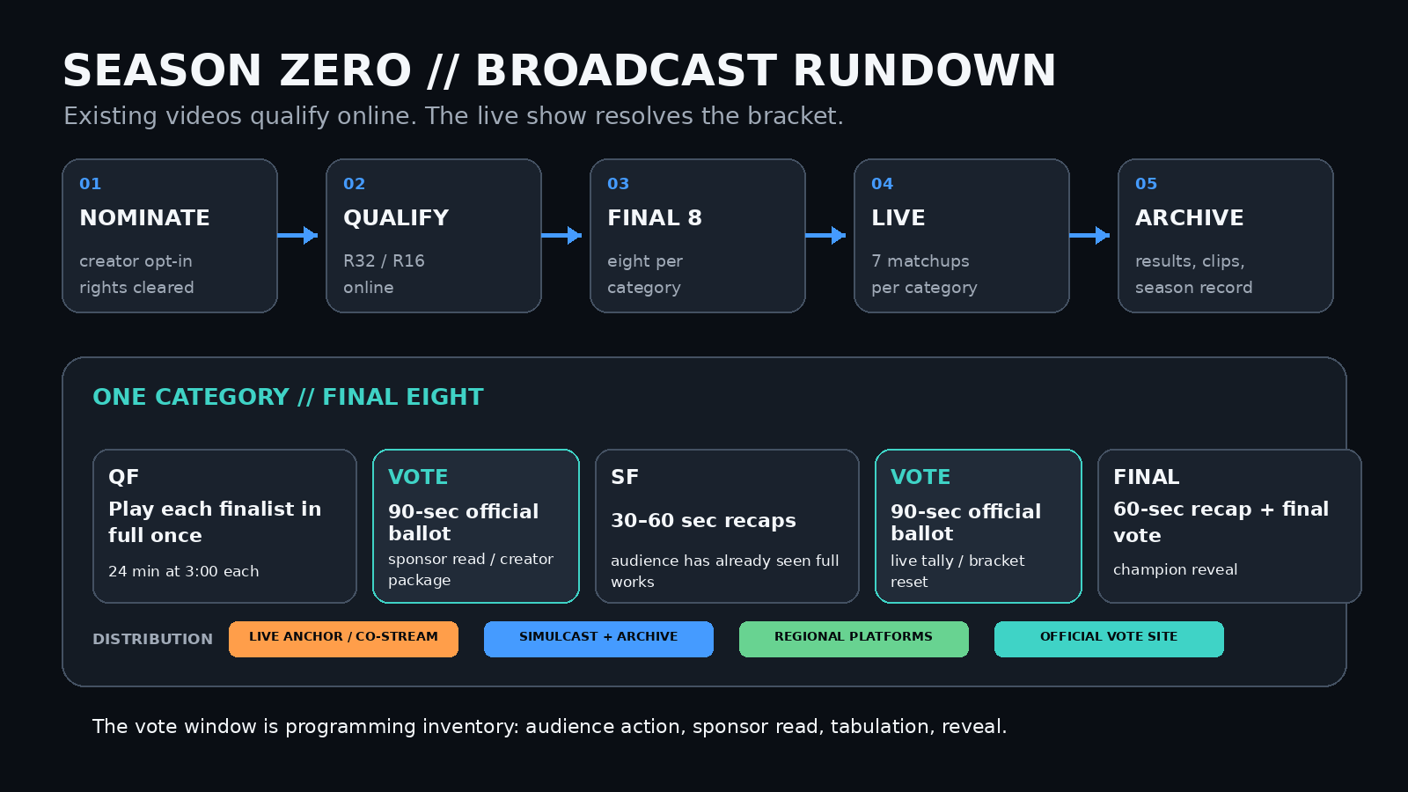

Base case
Element | Season Zero proposal
Championships | 2 core brackets: Music Video; Comedy / Meme
Showcase / third bracket | Narrative / Drama runs as a non-bracket showcase unless the rights-cleared field is deep enough to pass the same bracket gate.
Qualification | Open nominations + creator/rightsholder acceptance; public online qualifying over 1–2 weeks narrows each category to a Final Eight.
Live event | Online-only resolution stream. Target roughly 75–90 minutes for two categories; no venue, creator travel or ticketing required for the pilot.
Voting | One official cross-platform ballot; one verified vote per account per matchup. Real campaigning is allowed. Automation, purchased votes and duplicate identities are not.
Broadcast | One anchor stream + approved co-streamers; YouTube simulcast/archive; regional platforms where needed. Stream-platform polls are non-binding.
Success metric | Primary: quarterfinal-to-semifinal/final return voting. Secondary: completion, co-stream participation, creator opt-in, live watch time and year-two demand. If return voting is weak, do not scale regardless of peak concurrent viewership.
Live playback | Quarterfinals: full videos once, within a published runtime band. Semifinals/final: 30–60 second recaps of works already shown in full.
Voting stack | Own rules, branded ballot, data schema and audit record; rent authentication / anti-abuse plumbing. Rate-limit by identity and device, review suspicious clusters manually, and publish a same-night audit summary.
Budget posture | Price an online broadcast pilot after rights, runtime bands and bracket depth are fixed. A physical/ticketed final is a later expansion case, not a Season Zero requirement.
Provisional field-depth gate | Run a live bracket only with at least 24 rights-cleared eligible entries from at least 12 distinct creators. Seed two alternates before lock. Aim for at least 6 distinct creators in the Final Eight; max 2 finalist slots per creator.
Runtime bands | Publish category-specific runtime limits before nominations close so the rundown can be priced. Example pilot bands: Music Video up to ~4 minutes; Comedy / Meme up to ~60 seconds. Out-of-band work can be showcased without entering the live bracket.
Withdrawal rule | Before the first official matchup, the highest-seeded alternate replaces a withdrawn finalist. Once voting has begun, a withdrawal is a forfeit rather than a reseed.

Live pacing reality
A Final Eight still means seven decisions per category, but an online pilot can keep the show compact if runtime is controlled before seeding. Show every finalist in full once during the quarterfinal stage; semifinals and the final use 30–60 second recap packages because the audience has already seen the complete entries. The vote window then becomes the repeatable unit: open the official ballot for roughly 90 seconds, run a creator / editorial / sponsor package while votes tabulate, reveal the result, and reset. Short meme entries need story around them — seeding, creator context, campaign clips and the reveal — or the show feels like a poll account with better graphics. Long-form entries need a runtime band or they blow the rundown.
PLAY FULL ONCE → RECAP ON REPEAT → VOTE WINDOW → REVEAL

4. Proof of supply: the field is already diversifying
The pitch does not depend on one model or one viral meme lane. Existing work already spans auteur shorts, official music videos, domestic pop releases, and episodic animation.
Competition precedent — Pwnisher’s CG challenges show what “format development before event infrastructure” can look like. Kinetic Rush in 2024 drew 3,733 artists from 122 countries from a shared template; Alternate Realities and Infinite Journeys each drew roughly 2,400 entries. The model is online-first: common constraint, deep field, community distribution, Top 100 reveal, sponsor prizes. It does not prove this AI-video property will work, but it proves that a large creator field can organize around a recurring animation challenge without a physical event.
doopiidoo — Forest Never Sleeps — A compact authored world rather than a one-prompt gag; the August 2024 YouTube upload is above 550,000 views and credits Runway, Midjourney and Suno.
Washed Out / Paul Trillo — The Hardest Part — The first official music video created using OpenAI’s Sora; it received the 2024 Prix Ars Electronica Golden Nica in AI in Art.
Chopstick Brothers — 逍遥仙 — An official 2026 Chinese AI music video whose Bilibili upload alone exceeded 1.4 million plays, illustrating why non-English and domestic scenes must be part of discovery.
TARMAC — An adult animated workplace-comedy pilot: written, designed and performed by humans, finished with AI. Its creators outline a 15 × 10-minute first season.
DRAGGLiNS — A solo-creator AI-driven children’s series that launched in 2026 with four completed episodes and a weekly release plan.
Legenda Bertuah — An Indonesian AI-animated television series; ABC reported that 14 half-hour episodes had aired on free-to-air TV by April 2026.
Implication: “Show / Animated Series” is not a speculative future category. It may begin as a showcase if the global field is still thin, but the production form already exists. New subgenres should be allowed to graduate into their own brackets as supply develops.

Selected source links
• Forest Never Sleeps — YouTube
• Washed Out / Paul Trillo — Vimeo
• Prix Ars Electronica 2024 — The Hardest Part
• Chopstick Brothers — 逍遥仙 (Bilibili)
• TARMAC — official project site
• DRAGGLiNS — Animation World Network
• Legenda Bertuah — ABC News
• ESEA — Clip of the Week / Month archive
• X — Original Content Rewards
• Pwnisher — Kinetic Rush / Alternate Realities / Infinite Journeys challenge archives
• Reddit provenance thread — early AI/source discussion: https://www.reddit.com/r/whatsthemoviecalled/comments/1w46d5a/what_movie_is_this/

Audience behavior shows the raw materials
The view counts establish supply. The reactions establish something narrower but useful: the raw materials for fandom. On recent Anabology releases, viewers are already comparing one video with another, ranking new work against earlier releases, debating whether nostalgia changes the preference, and asking for detailed production records.
PREFERENCE SIGNAL  “I did like the first better.”  “This is my favorite one … would be interested on a poll of the ages.”  “Still holds up pretty well.” | PROCESS SIGNAL  “Did Claude one shot this video?”  “How are you doing this?”  “How much did that cost?”
FORMAT IMPLICATION  The Genre Championships formalize comparative taste that is already happening in public. | FORMAT IMPLICATION  The Nations Cup formalizes interest in workflow, cost, direction and production choices.
The useful signal is not that every comment is sophisticated; most are not. It is that the highest-information reactions already resemble the two behaviors the format needs: a ballot and a post-match breakdown. The event would give both a durable structure.
This is still only a preference signal, not proof of season behavior. Commenters comparing releases do not prove that people will learn a bracket and return days later for another matchup. That is the Season Zero hypothesis. If return voting is weak, the property fails its first test even if the final stream produces respectable reach.
Novelty is not the same as quality. In these selected posts, the largest breakouts often seem to involve either a recognizable creator or a distinctive new idea, format, or workflow. That is a plausible reading of a small observational sample, not a causal finding. Many of the modest-reach entries are visually accomplished; their limited distribution is not evidence of weaker craft. Season Zero should therefore combine open submissions, community nominations, and editorial discovery rather than allowing social-platform view counts alone to determine who reaches the bracket. A successful championship should help audiences discover unfamiliar talent, not simply replay the platform algorithm.

5. The hard parts — and how to design around them
Risk | What can go wrong | Season Zero response
Rights / clearance | A popular work is nominated but the creator, label or rights holder does not want it used. | Nomination is not entry. Require creator/rightsholder opt-in and a non-exclusive license covering full playback, recap clips, co-streaming and archive before bracket lock. Budget a dedicated clearance producer; expect Music Video to lose desirable nominees to rights complexity.
Fan-vote brigading | Large creators or model fandoms overwhelm smaller entries; bots distort results. | State the sport openly: real campaigning is legal; automation is not. Use one official ballot, verified accounts, per-identity and per-device rate limits, risk scoring, suspicious-cluster review and a published rejection policy. Release turnout and rejected-vote totals in a same-night public audit summary.
Model-company influence | A sponsor appears to be buying legitimacy or shaping eligibility. | Independent rules committee; no sponsor veto over entries or results; no tool requirement; no category named after a model during the competitive launch.
Eligibility fights | Hybrid work creates endless arguments over whether something is “AI enough.” | Use a material-use threshold: generative AI must play a meaningful role in visual production. Require disclosure; do not score “AI purity.”
Category drift | Organizers create too many thin brackets or force unlike work together. | Use a provisional gate: at least 24 rights-cleared eligible entries from at least 12 creators before a category becomes a live bracket. Otherwise run a showcase or wait a year.
Content / brand safety | Open nominations surface infringing, explicit, deceptive or otherwise unbroadcastable material. | Published eligibility policy, chain-of-title attestation, safety review, two pre-seeded alternates per bracket and a clear withdrawal / forfeit rule before bracket lock.
National scale | The Nations Cup promises 40 countries before 40 viable scenes exist. | Do not launch at Eurovision scale. Begin later with a 6–8 country invitational and grow only where domestic participation can support a real selection.
Voting-platform dependence | Building a custom platform consumes the pilot budget; relying on a stream poll fragments the vote across platforms. | Own the branded ballot, rules and data model; rent mature identity / anti-abuse components for Season Zero. Platform polls are engagement only.
Runtime variance | A 15-second meme and an 8-minute short cannot share the same live unit without breaking pacing and cost assumptions. | Publish runtime bands by category before nomination close. Out-of-band work can enter a showcase or a different format award, but not the same live bracket.
Creator resistance | Some artists reject the premise of turning creative work into a competition, or worry that brackets flatten art into popularity. | Participation is opt-in and the sport is explicit: verified fans elect a champion from accepted work inside a genre. No claim of objective artistic superiority is required. Do not pressure non-participants; let the debate create awareness rather than eligibility conflict.

Operator pressure-test: decisions before launch
This is a format proposal, not a finalized operating manual. An event producer should convert these open questions into an owned production plan and a signed rules pack before sponsors or creators are asked to commit.
- Schedule and owner: publish dates for nomination, invitation/opt-in, rights and identity checks, eligible-field lock, seeding, voting windows, appeal close, finals, prize payment, and archive release. Name a decision-maker and backup for each gate.
- Participant contract and rights: distinguish creators, songwriters, labels, performers, and owners of supplied footage; secure synchronized music and performance rights where needed, plus permission for replays, translations, promotional clips, regional streams, and approved co-streamers. Define a withdrawal cutoff and archival takedown process.
- Entry integrity: confirm who actually made each work, enforce AI-material-use declarations consistently, handle reused assets and recognizable real-person likenesses, and define a route for contested originality. For open calls, clarify minors, teams, employees, invited creators, and organizer/sponsor conflicts.
- Result and broadcast contingencies: establish tie-breaks, no-show/withdrawal and substitute rules, low-turnout invalidation criteria, vote-platform outages, suspicious ballots, stream latency, delayed results, and a final appeals authority. Rehearse the live vote handoff rather than assuming the website and broadcast clocks stay synchronized.
- Prize and finance administration: publish prize terms and payout timing; budget payment processing, tax documentation, currency and cross-border constraints, contractor agreements, insurance where appropriate, and a contingency reserve. Prize size should match operational capacity, not just publicity ambitions.
- Creator and audience care: provide participants with plain-English releases, asset/spec submission templates, moderation and conduct standards, accessible captions where feasible, clear promotional permissions, and timely post-event analytics. Assign someone to participant support during voting.
Small contests may use lighter machinery: a one-night thematic challenge does not need all of the flagship broadcast stack. It still needs fair entry rules, permission to screen content, a credible winner-selection method, and an accountable organizer.

Pilot scorecard: decide success criteria before the event
An experienced operator should set numeric targets only after pricing the chosen pilot and reviewing baseline channel sizes. Separate organic performance from paid or creator-driven traffic; raw livestream reach alone is not the decision metric.
Measurement | Record consistently | Decision it informs
Creator supply | Eligible entries, unique creators, share of invited vs open-call, opt-in/clearance completion | Enough depth to justify a bracket?
Audience participation | Verified voters, votes per matchup, rejected/flagged ballots, geography | Is the ballot credible and accessible?
Retention | Quarterfinal-to-semifinal-to-final repeat voters, return watch sessions | Are people following the season?
Discovery | First-time creator exposure, clicks to entrants, organic vs paid/co-stream referrals | Did the contest introduce new work?
Economics and experience | All-in spend, cost per returning voter, producer hours, creator satisfaction, rights exceptions | Repeat, redesign, or stop?
Decision rule: publish a short postmortem and choose one of four outcomes: rerun the same format, expand one variable, redesign the weak step, or discontinue. Avoid treating a single viral clip as proof of sustainable repeat participation.

6. Governance and commercial logic

Voting architecture: own the ballot, rent the plumbing
Season Zero should not become a software startup. The event should own the competition rules, ballot design, participant IDs, data schema, audit exports and public result record, while using mature third-party authentication and anti-abuse infrastructure underneath. Build custom infrastructure only after the audience behavior is proven.
Platform-native polls can still be used for chat engagement, but they should not be the canonical vote. Twitch polls can optionally permit additional Channel Point votes, while YouTube live polls are live-only and are not preserved in chat replay. More importantly, a cross-platform event needs one auditable ballot regardless of where the viewer watches.

Season Zero position
- Official vote: event-controlled web ballot with account verification, per-identity and per-device rate limits, risk scoring and manual review for suspicious vote clusters.
- Stream polls: non-binding engagement only; useful for chat energy, never the source of record.
- Data: retain matchup-level totals, turnout, region, rejected-vote counts and audit notes; show turnout during the broadcast and publish an intelligible audit summary the same night.
- Campaigning: creators may mobilize real fans. Automation, purchased votes and identity duplication are competitive-integrity violations.

Voting platform references
Twitch Polls — official help
YouTube Live Polls — official help

Competitive credibility
- Rules published before nominations open and frozen before bracket seeding.
- Independent competition / integrity committee with disclosed conflicts.
- Sponsor firewall: sponsors fund the property, not the outcome.
- Transparent eligibility decisions and a short appeals window before bracket lock.
- Public post-event data: vote totals or percentages, turnout, seeding methodology and disqualifications.
- Creator retains ownership; the event receives limited rights necessary to present and market the competition.

Distribution: the season lives everywhere
Season Zero should be designed as an online-native property, not a physical event streamed as an afterthought. The likely default is YouTube as the canonical anchor and archive, because the work already lives there and the replay, clips and searchable long tail matter; Twitch and approved co-streamers provide the live-energy layer and existing community distribution. Regional platforms can carry the same event where the audience already lives. Avoid an exclusive structure that prevents clipping, co-streaming or creator amplification.
YouTube is the stronger discovery-and-archive base for Season Zero: scheduled live streams can be promoted to subscribers, streams under 12 hours can be automatically archived, and clips can circulate after the event. Twitch is the stronger amplification layer for live reaction: its current co-streaming system supports allowlisted rebroadcasts and aggregated event analytics. The exact mix is negotiable, but the principle is not: distribution should serve the format rather than own it.
The voting window is also commercial inventory. A matchup can move naturally from playback → 90-second ballot → sponsor/creator package → result reveal without interrupting the competitive content.

Platform references
Twitch: Co-Streaming on Twitch (official, 2025)
YouTube: Promote your live stream — clips and automatic archive (official)
YouTube: Managing Clips (official)

Commercial model
Keep the format ask and the commercial ask separate. First price and pressure-test a credible online pilot: rights, runtime, bracket operations, host/producer/director, graphics, edit packages, vote desk and anti-abuse. Only after the field is cleared and the audience test is defined should sponsor inventory be packaged. Season Zero is IP development, not a promise of immediate profitability.
Creator ownership and format ownership should also stay separate. Creators keep ownership of their videos and grant the event only the limited, non-exclusive rights needed for playback, clipping, co-streaming, promotion and archive. The durable event IP is the competition system around the work: brand, category rules, bracket structure, voting and reveal mechanics, graphics language, historical archive and — later — the Nations Cup framework.
- Event / category sponsorships with an explicit competitive firewall
- Later editions: physical-final tickets, VIP / creator access and venue partnerships once the online format has earned rivals worth traveling for.
- Livestream advertising, platform partnership or co-stream inventory
- Merchandise built around brackets, champions and yearly visual identity
- Creator / finalist packages and post-event archive sponsorship
- Later: licensing the format to domestic organizers for Nations Cup selections
Sponsor caution. Model companies are obvious buyers, but overdependence on them can make the event look like vendor marketing. A mixed sponsor base — hardware, software, creator tools, consumer brands, media and venue partners — is healthier if available.

Budget posture
No fixed $75,000 floor. Start by costing the cheapest credible version of the specific test, rather than treating a professional broadcast as a prerequisite. A $50,000–$100,000 sponsor-backed event could offer meaningful prizes, stronger talent packages, more promotion and a polished final—and might attract wider creator attention—but smaller experiments can be useful first. The figures below are illustrative scope envelopes, not vendor quotes or guaranteed all-in costs. Even the leanest format needs creator permission, published rules and defensible voting.
- Community / topical micro-contest — low thousands to low five figures: one category, locality, language group, creator community or brief (for example AI music video, comedy/meme, horror short, or one-minute animation); online submissions, lightweight qualifying, a simple ballot and a modest award. No studio show required.
- Regional or multi-round trial — tens of thousands: more entrants and outreach, a hosted online final, paid moderation, graphics and clearer voting oversight. A city, country, language community, genre or narrowly defined format can have its own recurring competition without waiting for a world championship.
- Flagship Season Zero — approximately $50,000–$100,000 if warranted: two deeper genre brackets, a credible live broadcast, substantial prize pools and creator storytelling. The larger check buys stakes, reach and presentation, not the right to call smaller competitions invalid. Final pricing depends on rights, runtime, production partners and in-kind support.
A practical sponsor proposition: underwrite an experiment rather than fund a speculative league. A connected event organizer and one sponsor—or several smaller backers supplying cash, distribution, production or prizes—could test the format. Track opt-in entries, repeat creators, qualified voting, round-to-round return, audience discovery of smaller creators and cost per meaningful participant. Report weak results as clearly as strong ones.

7. Expansion path
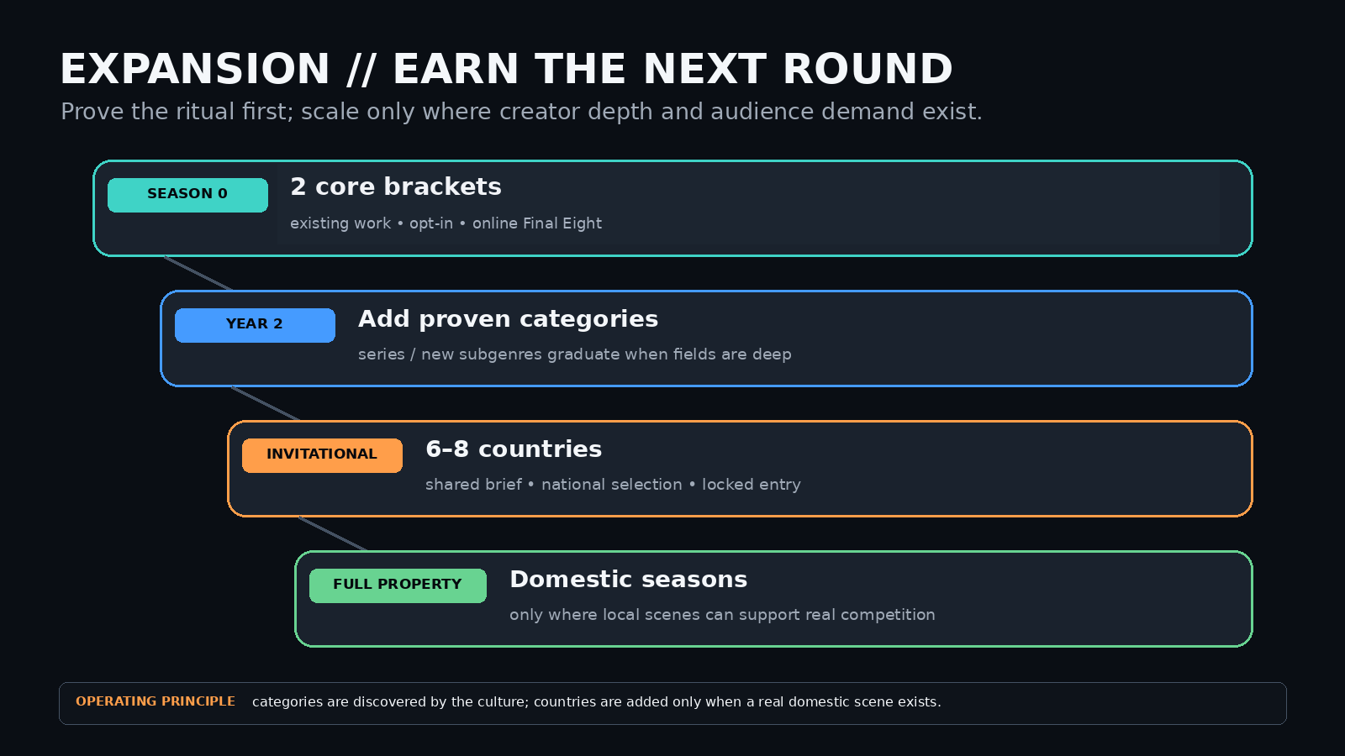

When to activate the Nations Cup
The Nations Cup is the more ambitious and potentially larger property, but it should come after the audience understands the ritual. A credible first test would be an invitational with roughly 6–8 countries that already have creator depth, rather than a paper federation of 40 flags with no domestic season behind them. If the Genre Championships prove the behavior, the Nations Cup is the long-horizon play: a World Cup for a medium that still has no incumbent competitive institution.
The same rule applies to venue scale. A physical final should be earned by an online season that has already produced repeat voters, recognizable rivals and creators people want to see in a room. A room manufactures atmosphere; it does not manufacture fandom.
The expansion trigger should be practical: enough local entrants to make a national selection feel competitive, a trusted domestic operator capable of running it, and an audience large enough that the winner feels chosen rather than appointed. This is where an experienced international esports network becomes unusually valuable: the central property does not need to invent every country operation from headquarters if credible regional partners already know how to run brackets, broadcasts, rules and communities locally.

How categories evolve
The same logic applies to genre and format brackets. Domestic competitions can experiment freely. A recurring local category — AI sitcom, vertical microdrama, fake broadcast, visualizer loop, game-cinematic short, or a format that does not yet have a name — becomes a global championship only when multiple scenes produce enough credible entries to sustain one. Subcategory awards can serve as the proving ground: if Best Asset, Best Loop or another native format repeatedly produces a deep field across multiple markets, it can be promoted into a standalone global bracket.
Local and topical versions are not merely consolation prizes or mandatory feeders into a global bracket. A Seattle-area animation contest, a French-language slopcore bracket, a Halloween horror short tournament or a creator-community music-video cup could be independently worthwhile and much cheaper to run. Where an event develops a durable scene, a local champion can later feed a larger regional or global championship; where it does not, it can stay a stand-alone cultural event. The structure should scale in both directions—from topic to genre, and from local scene to international field.
Do not predict the taxonomy. Let the medium reveal it.
The archive compounds too. After several editions, the property owns more than a trophy list: it has a searchable history of finalists, brackets, audience choices, category evolution, creator breakouts and production eras. Anyone can copy “AI awards”; five years of trusted results and cultural memory are much harder to copy.

8. The ask
This is a format hypothesis, not an attempt to play event operator. The first ask is judgment: does this have the bones of durable IP, which assumptions are naive, and what would have to change before an experienced operator would put a real show behind it?
This is not a request to commit to a global league, a venue or a predetermined budget. The immediate ask is to find the smallest credible contest that can be run, identify a capable organizer and a plausible sponsor or prize partner, then test whether creators and audiences return. A well-connected esports operator or AI-industry backer could open doors to creators, co-streamers, judges, sponsors and regional organizers that would otherwise take much longer to assemble.
What is already developed on the concept side. I am not asking an operator to invent the idea from a blank page. The two-format architecture, Season Zero scope, rules and eligibility logic, initial field and case studies, category-evolution model, voting principles and the editorial argument are already worked through enough to pressure-test. I can contribute directly to format development, research, curation, rules, editorial, creator-facing work or production support. What I am not claiming is operational expertise in rights, broadcast, integrity, budgeting or commercialization; those are exactly the areas an experienced operator should challenge and redesign.

Role flexibility
- I am not attached to a particular title, ownership structure or high-level operating role. I care more about seeing the format tested well than controlling it. If an experienced operator wants to run with the property, I would be happy contributing wherever I am most useful — format development, research, curation, rules, editorial, creator-facing work, production support, or a narrower role if that is what the first edition needs. The important point is that the concept has an owner and a body of work behind it; the event does not require me to pretend to be the showrunner.

What I would want from an experienced event partner
First step: one working session to pressure-test a micro-contest, a localized/topical championship and a larger online Season Zero; price the least costly credible option, define the evidence needed to scale, and identify one event operator plus one sponsor or prize partner willing to consider funding the test. Nothing in this first step requires a league, venue or exclusive role.
- A production reality check: price a simple one-category remote contest alongside the 75–90-minute, two-category online pilot, including staffing, broadcast workflow, graphics/edit, voting integrity and contingency. Keep venue economics out of both until there is evidence for a physical final.
- Voting / integrity input: validate the “own the ballot, rent the plumbing” Season Zero approach and identify a suitable identity / anti-abuse vendor stack.
- Rights and broadcast workflow: define licenses for full-video presentation, creator-approved clips, simulcast, co-streaming and regional distribution.
- Network / localization: identify a small number of trusted domestic or regional operators who could eventually run online qualifiers and, if the property earns it, national selections without centralizing every market into one production team.
- Sponsor-market reaction: which categories of sponsor would support the event without compromising credibility.
- If the concept survives that pressure test: a path to co-produce or host the online Season Zero, plus introductions to the production, rights, integrity or regional-operator partners needed to test it properly and define the thresholds that would justify a later physical final or Nations Cup invitational.

What the concept side brings
- Competition architecture and brand thesis
- Rules, eligibility and category framework
- Initial curation and creator outreach
- Editorial / story packages around finalists and production methods
- A roadmap from Genre Championships to a later Nations Cup
Prove that people will follow the bracket. Then build the world around it.
Season Zero is allowed to fail. If voters do not return for later rounds, creators do not opt in again, or the cleared fields are too thin, stop or redesign before adding venues, countries or more categories.

Appendix: Season Zero operating principles
1. Existing work, opt-in rights. Popularity can trigger nomination; creator/rightsholder acceptance creates eligibility. The event receives only the licenses needed to present, clip and promote the competition.
2. Fan vote is the point. Verified fans elect the champion; the result measures audience preference, not objective craft. Campaigning by real people is part of the sport. Automation, purchased votes and duplicate identities are not. Publish rejection rules and an audit summary.
3. The category is the sport. Genres and formats stay separate. A live bracket requires depth: provisionally 24 cleared eligible entries from 12 creators; otherwise run a showcase. Publish runtime bands before seeding.
4. Hybrid production is allowed and disclosed. Do not score “AI purity.” Generative AI must materially contribute to the visual production, and the workflow must be described clearly enough for eligibility review.
5. Archive the season; scale only after return behavior exists. Publish entries, brackets, vote results and production metadata. Do not add a venue, more categories or Nations Cup countries until the audience has shown that it will return for later rounds.

Appendix B: Illustrative AI-video audience snapshot
18 selected public X / YouTube examples · Figures supplied October 20, 2026
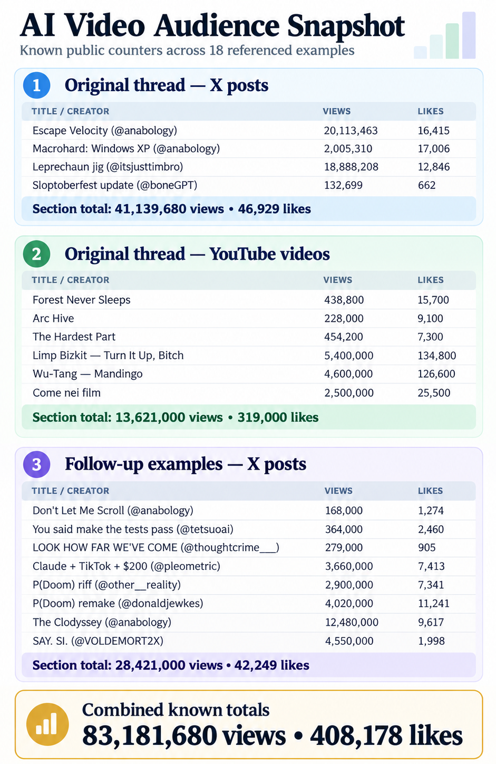
Source: project-collected public counters, October 20, 2026. X post views and YouTube video views are not identical measures; combined figures are not unique viewers. Sample is illustrative and non-exhaustive.

Appendix C: Additional X video examples and source links
33 supplementary posts · Snapshot supplied October 20, 2026
This exploratory set is separate from the 18-example audience graphic: 1,049,307 summed X post views and 9,883 likes. It illustrates creator variety, not a representative audience estimate or a growth-rate series. Snapshot figures have not been independently rechecked.
Link precision: all 33 entries now have exact X post URLs supplied by the author; the previously missing 22 were returned by a Grok-assisted source search and labeled VERIFIED there. These are traceable original-post candidates, but this document has not independently audited each video against its URL. The original engagement snapshots remain unchanged.

C1. Newly identified posts — 11 exact source links
Creator and example | Likes | Views | Source link
@KnightWorld  Me and my loyal friend Sir Cat (Grok Imagine) | 163 | 2,197 | Original X post
@Dustfinger2077  Pip and Pickle (Seedance 2.5) | 120 | 1,183 | Original X post
@thegreatest_sv  HyperFrames / Claude Code motion design demo | 53 | 2,071 | Original X post
@droidhotspot  MoonX — sequel to MarsX | 16 | 687 | Original X post
@colossalmeiraz  SI: Slopcore Intelligence | 7 | 369 | Original X post
@jboogx_creative  Fight scene previz (Seedance + Claude) | 14 | 603 | Original X post
@Alexneyef  Halloween boys (Wan 3.0) | 8 | 231 | Original X post
@KhaosCreator  Juliet Animation (Seedance 2.5) | 17 | 322 | Original X post
@singularitymuse  Droplets of Math (Grok Imagine) | 20 | 336 | Original X post
@poetrynthings  Grok Imagine cosmic short | 1 | 24 | Original X post
@Bilalvideograph  Teen Titans Starfire vs Blackfire | 1 | 2 | Original X post

C2. Updated earlier posts — 22 supplied original-post links
Creator and example | Likes | Views | Source link
@anabology  Claudia Explains: Euclid | 656 | 36,297 | Original X post
@anabology  Claudia loves me | 444 | 22,516 | Original X post
@tetsuoai  who are you playing for? | 315 | 22,496 | Original X post
@VOLDEMORT2X  THIS. IS. SI. | 270 | 3,582 | Original X post
@VOLDEMORT2X  ICON. SI | 168 | 2,255 | Original X post
@Extraltodeus  French slopcore (English subs) | 4,505 | 729,305 | Original X post
@Extraltodeus  ClaudiaGI – Demande à l’IA | 764 | 49,582 | Original X post
@AstrablueAI  NOW SERVING | 1,543 | 113,522 | Original X post
@ericshayhoward  I Hate This Job | 0 | 15 | Original X post
@oykucesur  Heat Signature | 0 | 4 | Original X post
@LeonWayou  瞬撃 -FLASH- | 2 | 23 | Original X post
@bunkeideploy  新星 (NOVA) | 0 | 4 | Original X post
@minima_ai  Universe Leaked | 48 | 1,397 | Original X post
@FarmGrok  War Paint Pony | 0 | 11 | Original X post
@replylikeagod  Frequencies of The New Earth | 1 | 23 | Original X post
@unplayed_keys  Grok Imagine short | 15 | 263 | Original X post
@RCEY28  One-shot slopcore | 10 | 972 | Original X post
@Diplomeme  Downtown Chicago Whale | 47 | 972 | Original X post
@Aygramm_  Claude stickman animation | 552 | 53,831 | Original X post
@mickeyxfriedman  Opus + open-source models | 28 | 1,545 | Original X post
@issatheblows  Claude motion design | 25 | 642 | Original X post
@boneGPT  Sloptoberfest promo | 70 | 2,025 | Original X post
Source notes: Counts were supplied October 20, 2026, and are time-sensitive; post views are not unique viewers. All 33 rows include original-post URLs supplied by the author, including 22 returned from Grok-assisted matching. Link-to-video identity and current counter values were not independently rechecked. This X-heavy, predominantly Western exploration is not a systematic global survey of creator communities, social networks, memes, or tools.

Appendix D: Global comparisons — sourced context, not a leaderboard
This appendix provides a small outside-X counterweight to the project’s 51 selected X/YouTube examples. All measurements refer to unlike populations and should be reported separately.
Ecosystem / observed signal | What the evidence establishes | Source
Douyin / China | NewRank reports 9 AI-labeled videos above 100M views in H1 2026; one AI-enhanced historical short: 295M views, 18.67M likes.  Caveat: Mix of fully synthetic content and conventional footage with AI effects; editorial compilation drawing on platform data, not direct access to post analytics. | NewRank via 36Kr
Chinese AI music + remix | Chopstick Brothers’ 逍遥仙: official Bilibili MV releases; third release announced a fan remix contest with MovieFlow.  Caveat: One-off remix contest differs from recurring genre-specific tournaments; claims of much larger cross-platform totals remain unverified here. | Bilibili official release
TikTok / tagged sample | In Revid’s tagged dataset, 9,940 AI-generated clips averaged 1.4M views against 661.4K for real footage; AI like rate 3.9% vs 7.7%.  Caveat: Keyword-targeted, non-random sample; AI tags via vision classifier; not estimated odds for a random upload. | Revid case study
YouTube / AI music channels | An industry report puts combined lifetime views of ten AI-music channels at around 840M, led by mikeeysmind, Let Babylon Burn and Xania Monet.  Caveat: Channel totals can include audio, lyric videos and non-AI visuals; not equivalent to fully AI-generated music-video views. Reported third-party figures. | Players Time report
Claims intentionally not incorporated into headline totals: the reported 38M+ cross-platform plays for 逍遥仙, an Instagram cat reel with 5.9M likes, and other unsourced repost or aggregate counts. They may be useful research leads but need identifiable original posts, a capture date and consistent definitions.
Editorial conclusion: global reach is demonstrably not confined to English-language X, while existing genre, remix and creator experiments imply a fragmented landscape. The proposed recurring bracket system must differentiate on rules, discovery, spectator ritual, multilingual participation and archival credibility rather than claiming to invent AI-video competitions.

