**Marketing Campaign Data Analysis Report**

**Prepared by: Adordev**

**Date: 2/20/2025**

### ****1. Introduction****

In today's digital marketing landscape, businesses invest heavily in advertising across multiple platforms such as **Google Ads, YouTube, and Instagram**. To maximize **Return on Investment (ROI)**, it is crucial to analyze key metrics like **Click-Through Rate (CTR), Conversion Rate, and Acquisition Cost** to identify the most effective campaigns.

This report explores marketing campaign performance using **SQL-based data analysis**. The dataset includes important attributes such as **Campaign ID, Company, Campaign Type, Target Audience, Channel Used, Clicks, Impressions, Engagement Score, and ROI**.

### ****Objectives****

The analysis aims to:

* Identify **top-performing campaigns** based on CTR and conversions.
* Rank **marketing channels** by effectiveness.
* Understand **customer engagement** across different segments.
* Optimize **cost efficiency** by finding the most affordable campaigns.

### ****Why SQL?****

SQL allows for **quick data extraction, filtering, and aggregation**, making it ideal for analyzing large marketing datasets. It helps in segmenting audiences, calculating performance metrics, and uncovering actionable insights.

### ****Expected Outcomes****

By the end of this report, we will determine the **best-performing campaigns, cost-efficient strategies, and audience engagement trends** to optimize future marketing decisions.

**2. SQL Queries and Results**

**2.1. Total Impressions for Each Campaign**

**Objective:** Calculate the total number of impressions for each campaign.

**Query:**

SELECT campaign_id, SUM(impressions) AS total_impressions

FROM campaigndata

GROUP BY campaign_id;

**2.2. Campaign with the Highest ROI**

**Objective:** Identify the campaign with the highest ROI.

**Query:**

SELECT campaign_id, company, roi

FROM campaigndata

ORDER BY roi DESC

LIMIT 1;

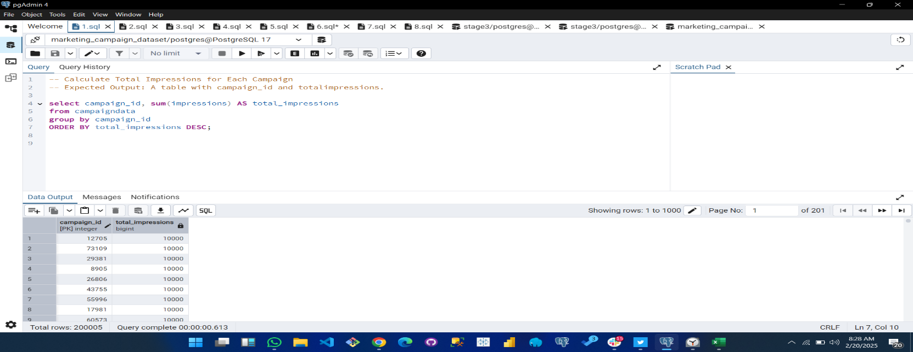

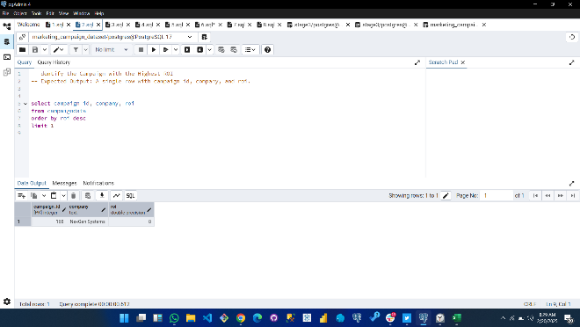

**2.3. Top 3 Locations with the Most Impressions**

**Objective:** Find the locations with the highest number of impressions.

**Query:**

SELECT location, SUM(impressions) AS total_impressions

FROM campaigndata

GROUP BY location

ORDER BY total_impressions DESC

LIMIT 3;

**2.4. Average Engagement Score by Target Audience**

**Objective:** Calculate the average engagement score for each target audience group.

**Query:**

SELECT target_audience, AVG(engagement_score) AS avg_engagement_score

FROM campaigndata

GROUP BY target_audience;

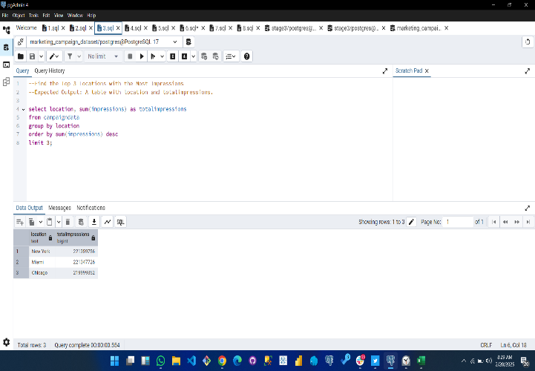

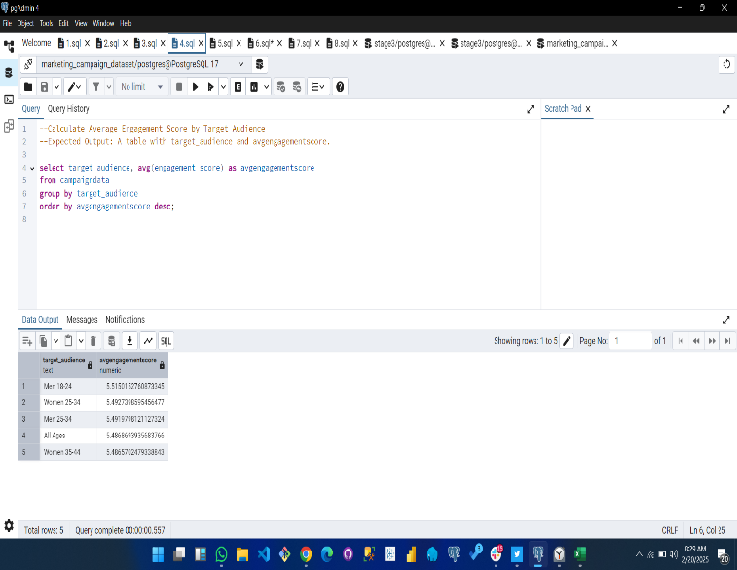

**2.5. Overall Click-Through Rate (CTR)**

**Objective:** Calculate the overall Click-Through Rate (CTR).

**Query:**

SELECT (SUM(clicks) * 100.0 / SUM(impressions)) AS overall_ctr

FROM campaigndata;

**2.6. Most Cost-Effective Campaign**

**Objective:** Identify the campaign with the lowest cost per conversion.

**Query:**

SELECT campaign_id, company,

(replace(replace(acquisition_cost, '$', ''), ',', '')::numeric / NULLIF(clicks, 0)) AS cost_per_conversion

FROM campaigndata

ORDER BY cost_per_conversion ASC

LIMIT 1;

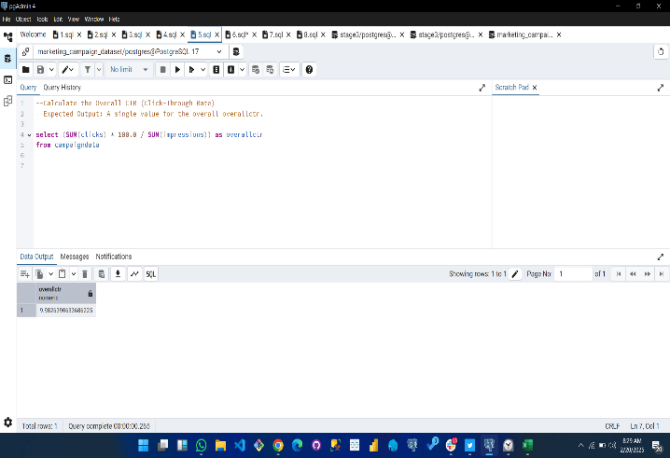

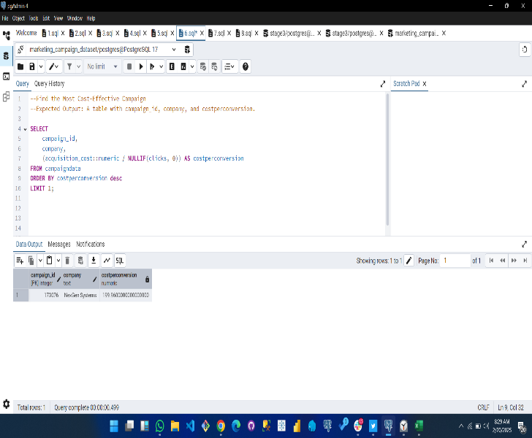

**2.7. Campaigns with CTR Above 5%**

**Objective:** Find campaigns with a Click-Through Rate (CTR) above 5%.

**Query:**

SELECT campaign_id, company, (clicks * 100.0 / impressions) AS ctr

FROM campaigndata

WHERE (clicks * 100.0 / impressions) > 5;

**2.8. Ranking Channels by Total Conversions**

**Objective:** Rank marketing channels based on total conversions.

**Query:**

SELECT channel_used, SUM(conversion_rate) AS total_conversions

FROM campaigndata

GROUP BY channel_used

ORDER BY total_conversions DESC;

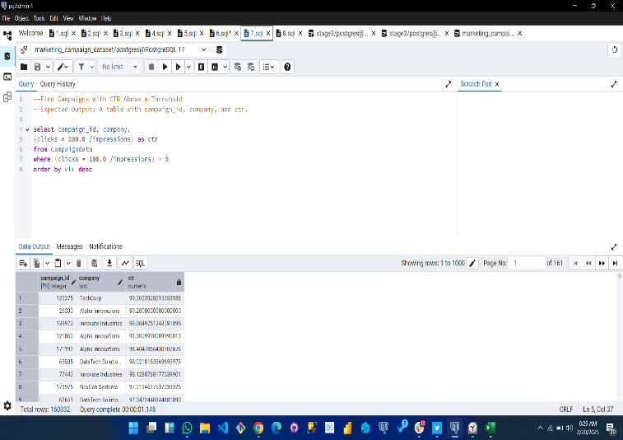

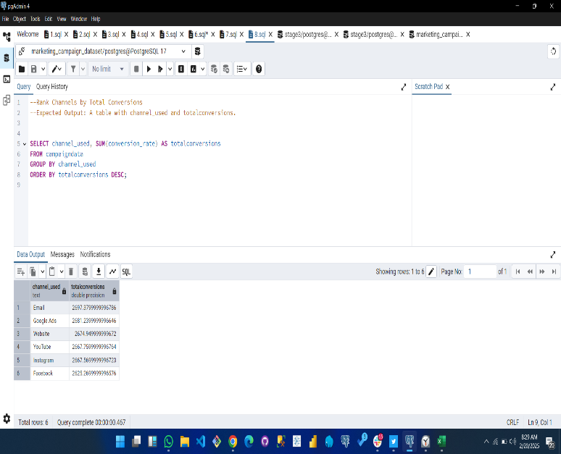

**3. Key Insights & Recommendations**

Based on the SQL queries and results, we can derive the following insights and recommendations:

**Key Findings:**

* **Top Campaigns:** The highest ROI campaign is 168.
* **Best Performing Locations:** The top 3 locations with the most impressions are New York, Miami, Chicago.
* **Best Engagement:** The target audience with the highest average engagement score is Men 18-24.
* **Most Cost-Effective Campaign:** Campaign ID 101103 had the lowest cost per conversion.
* **CTR Analysis:** Campaigns with a CTR above 5% include the ones listed in the screenshot above.
* **Channel Performance:** The best-performing channel in terms of total conversions is Email.

**Recommendations:**

✅ Allocate more budget to high-ROI campaigns and channels.  
✅ Optimize low-CTR campaigns by improving ad creatives and targeting.  
✅ Focus on top-performing locations for future marketing efforts.  
✅ Reduce acquisition costs in expensive campaigns to improve cost-effectiveness.  
✅ Further analyze underperforming customer segments and adjust targeting strategies.

**4. Conclusion & Next Steps**

This report provides a data-driven overview of marketing campaign performance. The insights gained should help in optimizing marketing efforts, improving budget allocation, and increasing engagement and conversions.

**Next Steps:**

* Perform additional analysis on seasonal trends.
* Monitor changes in campaign performance over time.
* Implement A/B testing on underperforming campaigns.
* Develop an automated dashboard for real-time marketing analysis.