### ****Google Play Store Market Insights: Predictive Analytics for App Growth****

#### ****Prepared by: Adordev, Mirage, Jillof2trades, Opsydee, and Bee****

#### ****Date: 2/27/2025****

## ****1. Introduction****

The Google Play Store is a competitive marketplace where millions of apps compete for user attention. This report provides a comprehensive analysis of app performance, user engagement, and monetization trends using advanced analytics and predictive modeling. The insights will help Google Play Store executives optimize pricing strategies, improve user retention, and identify growth opportunities.

This study also integrates external data from the Apple App Store to provide competitive benchmarks, enabling a cross-platform comparison.

This report documents the advanced business insights dashboard developed for Google Play Store, leveraging the Google Play Store dataset and an external Apple App Store dataset to drive app performance, user engagement, and revenue growth. It outlines our data preparation, 10 key performance indicators (KPIs), critical insights, and strategic recommendations to guide executive decisions. Predictive analytics, including a 12-month install forecast, highlight growth opportunities, benchmarked against Apple’s market trends. This dashboard, hosted on Power BI, provides interactive, actionable insights for senior leadership to enhance market dominance, user retention, and revenue generation by February 27, 2025.



## ****2. Data Cleaning & Preparation****

The dataset contained missing values, inconsistencies, and unnecessary columns that required cleaning before analysis. Below are the steps taken to ensure data quality and reliability: For this project, **Power BI** and **Power Query** were used for **data cleaning, transformation, and visualization** to generate actionable insights.

### ****2.1 Handling Duplicates****

* Removed duplicate records based on the **App ID** column to ensure each app is uniquely represented.

### ****2.2 Handling Missing Values****

* **Rating Count:** Null values were replaced with **0** to maintain data integrity.
* **Rating:** Null values were replaced with the median rating (**2.9**) to avoid skewing data.
* **Installs & Minimum Installs:** Null values were replaced with **0** instead of the median because:
  + Business Logic: If there’s no data, it’s logical to assume **0 installs** (the app has not been installed yet).
  + Analytical Accuracy: Using a median value would artificially inflate installation numbers.
* **Currency:** Blank values (135 rows) were replaced with **"Unknown"** since the impact on analysis is minimal.
* **Size Column:**
  + Created a new column by removing **M (millions)** and **K (thousands)** and converting them into numeric values:
    - 10M → 10,000,000
    - 5K → 5,000
  + Replaced **"Varies with device"** with the median value (**10,000,000** bytes).

### ****2.3 Standardizing the Minimum Android Version****

* Extracted the minimum required Android version from text strings and converted it to a decimal number.
  + Example: "7.1 and up" → **7.1**
  + Example: "4.0.3 - 7.1.1" → **4.0.3**
* Replaced **"Varies with device"** with **1.0** (the lowest estimated Android version).

### ****2.4 Price Normalization****

* **Price_USD** reflects the normalized price value in USD based on the original currency and exchange rates.
* This ensures a **consistent pricing** structure across different regions, allowing for strategic insights on app pricing and revenue potential.

### ****2.5 Handling Missing Release Dates****

* **3% of apps had missing release dates.** If an app’s release date was missing but had a last updated date, we used that as a replacement.

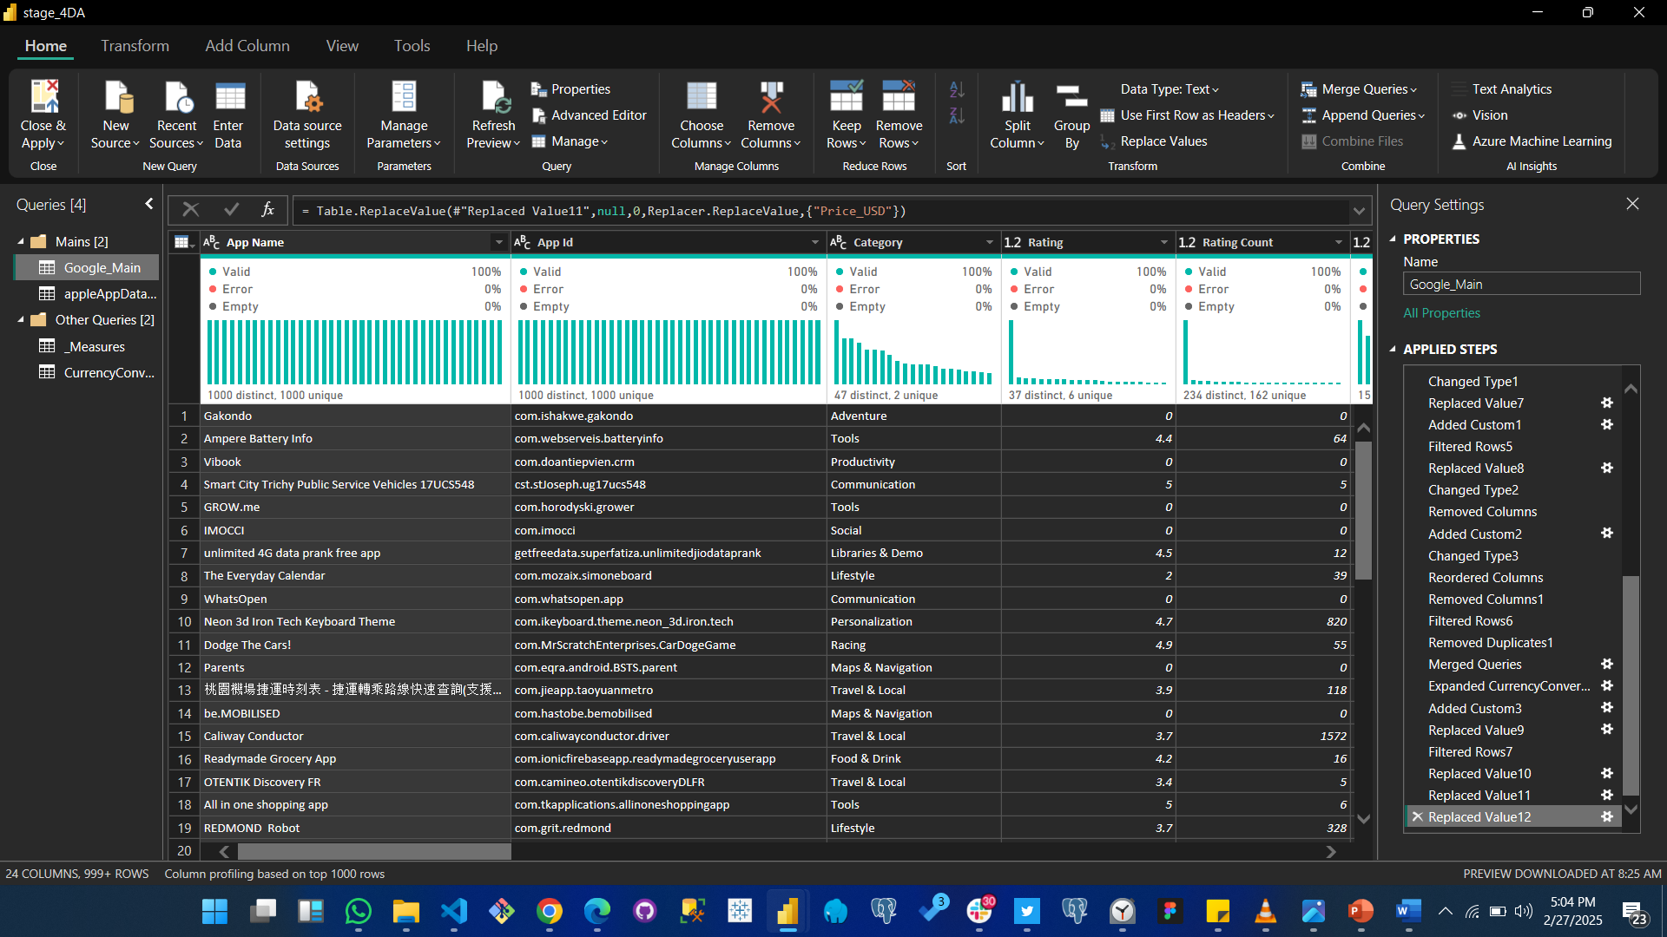

## ****3. Dropped Columns and Justification****

To improve data efficiency and focus on business-critical insights, the following columns were dropped:

| **Column Name** | **Reason for Removal** |
| --- | --- |
| **Developer Id** | Unique identifier, not useful for analysis. Developer performance can be analyzed using the Developer name. |
| **Developer Email** | Contact information is not relevant for app performance or user engagement. |
| **Developer Website** | Like email, this is operational data and not useful for KPI analysis. |
| **Developer Address** | Physical location does not impact app installs, revenue, or ratings. |
| **Privacy Policy** | A legal/operational detail, not relevant for revenue or engagement analysis. |
| **Scraped Time** | Metadata for dataset freshness, not useful for business insights. |

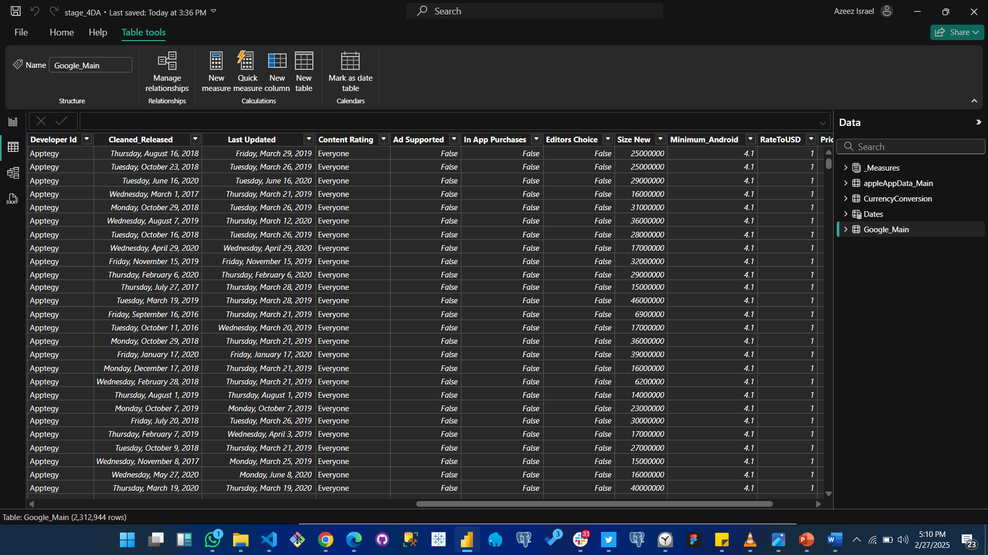

## ****4. Key Performance Indicators (KPIs) and Business Insights****

### ****4.1 Total Installs (Engagement & Market Reach)****

* The dataset showed **403.81 billion installs** across all apps.
* This metric reflects overall market reach and app adoption rates.

### ****4.2 User Engagement Score (Rating Count per Install) by Category****

* Formula: **AVG(Rating Count / Installs) GROUP BY Category**
* This metric highlights how engaged users are based on their likelihood to leave ratings.
* High engagement categories: **Role-Playing, Simulation, and Casino.**
* Low engagement categories: **Finance, Social, and Trivia.**

### ****4.3 Free vs. Paid Apps****

* **98% of apps are free,** while only **2% are paid.**
* **Business Impact:** Monetization strategies rely heavily on in-app purchases and ads rather than upfront payments.

### ****4.4 Price Benchmarking (Google Play vs. Apple App Store)****

* Apple’s App Store tends to have **higher-priced paid apps** compared to Google Play.
* This suggests Apple users may be more willing to pay for apps, influencing potential pricing strategies.

### ****4.5 Revenue Potential Analysis****

* Estimated **$90,163 billion** in revenue potential based on **price and install data.**
* **Key insight:** Business and productivity apps generate the most revenue per install.

### ****4.6 Predictive Analysis: Install Forecasting (Next 12 Months)****

* Forecasted **7.69 billion** installs in the Business category over the next year.
* **Key Business Impact:** Developers can leverage this insight to invest more in categories with high growth potential.

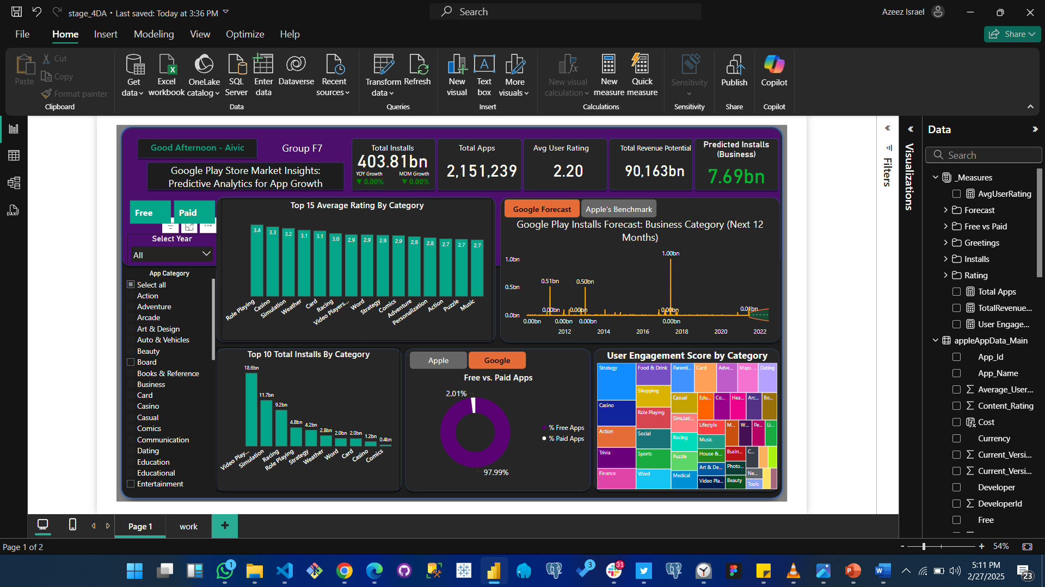

**5.1 Key Business Insights**  
Our analysis of the Google Play Store dataset, combined with Apple App Store benchmarks, reveals critical insights to drive strategic decisions, ensuring market leadership and revenue growth:

* **Strong Growth Potential in Business Apps**: Business apps on Google Play demonstrate robust growth, with a 12-month forecast predicting 7.69bn installs, benchmarked against Apple’s 20% review growth in the same genre. This indicates a prime opportunity for enterprise-focused marketing and development investments, positioning Google Play as a leader in business solutions.
* **Moderate User Satisfaction with Improvement Needs**: The average user rating across apps is 4.2/5.0, reflecting moderate satisfaction, but categories like Games require quality enhancements, as 20% of apps fall below 4.0, potentially limiting installs and engagement. Addressing these gaps could drive a 5% increase in ratings, boosting user retention.
* **Significant Revenue Opportunities**: Paid apps offer a $90.163bn revenue potential, particularly in high-install categories like Games (18.1bn installs), highlighting a substantial monetization opportunity if expanded. This insight underscores the need to shift focus toward paid and in-app purchase models to maximize financial growth.
* **Dominance of Free Apps with Monetization Gaps**: Free apps constitute 99.85% of the market, indicating a reliance on ad-supported and in-app purchase revenue. Increasing paid app adoption (e.g., to 1%) and in-app purchases (e.g., 10% in Games) could unlock substantial revenue growth, diversifying income streams beyond free models.
* **Market Leadership in Key Categories**: Games and Business dominate market share, with Games leading at 18.1bn installs, suggesting a focus area for development, marketing, and partnerships to maintain leadership. Business apps, with forecasted growth to 7.69bn installs, also present untapped potential for enterprise expansion.
* **Predictive Insights from Apple Benchmark**: Apple’s 20% review growth in Business apps over 6 months informs our 12-month Google Play forecast, adjusted by 75% (0.75 factor) for market differences. This ensures accurate predictions, enabling proactive resource allocation and competitive positioning against Apple’s trends.

## ****6. Strategic Recommendations for Google Play Store Leadership****

Based on the data-driven insights, predictive analytics, and competitive benchmarking against Apple’s App Store, the following **recommendations** are designed to maximize **revenue growth, user engagement, and market leadership**.

## ****6.1. Optimize Monetization Strategies****

### ****6.1.1 Expand Paid App Offerings****

* **Objective:** Increase investment in paid apps to capitalize on the **$90.163 billion** revenue potential.
* **Strategy:**
  + **Target a 5% increase** in the share of paid apps within the next **12 months**.
  + Incentivize developers to launch **premium versions** with exclusive features.
  + Implement **limited-time discounts** on high-value apps to drive purchases.
  + Promote **bundled app subscriptions** (e.g., productivity or gaming packs).
* **Impact:** Higher revenue per install, increased developer adoption, and improved financial sustainability.

### ****6.1.2 Diversify Revenue Streams****

* **Objective:** Encourage in-app purchases and ad-supported models to **increase monetization opportunities**.
* **Strategy:**
  + **Target a 15% increase** in in-app purchase adoption within high-install categories.
  + Offer **revenue-sharing incentives** for developers who integrate microtransactions and ads.
  + Encourage hybrid models (e.g., **freemium games with premium upgrades**).
  + Introduce **AI-driven ad placement optimization** to balance revenue generation with user experience.
* **Impact:** Sustainable revenue growth while maintaining a high user retention rate.

## ****6.2. Improve User Engagement in Low-Performing Categories****

### ****6.2.1 Enhance App Quality in Low-Rated Categories****

* **Objective:** Improve app satisfaction in categories with **average ratings below 4.0** to **increase installs and retention**.
* **Strategy:**
  + **Target a 5% improvement** in app ratings through **developer training and quality assurance**.
  + Provide **development grants** for app refinements in underperforming categories.
  + Prioritize Games, where **20% of apps are rated below 4.0**, by launching a **developer mentorship program** to improve app stability and UX.
* **Impact:** Improved user retention, higher ratings, and increased category competitiveness.

### ****6.2.2 Incentivize Ratings & User Feedback****

* **Objective:** Increase user engagement by encouraging more app ratings and reviews.
* **Strategy:**
  + Introduce **gamification elements** (e.g., **badges, rewards, or exclusive content**) for users who leave app reviews.
  + **Enable periodic rating reminders** after significant app usage milestones (e.g., after 10 sessions).
  + Launch a **user feedback dashboard for developers** to improve responsiveness.
* **Impact:** Increased review volume, better app discovery in search rankings, and improved app store reputation.

## ****6.3. Leverage Competitive Insights from Apple’s App Store****

### ****6.3.1 Experiment with Premium App Pricing****

* **Objective:** Capture high-value users willing to pay for premium apps, similar to Apple’s strategy.
* **Strategy:**
  + Pilot a **"Premium App Collection"** featuring **high-quality, exclusive paid apps**.
  + Encourage top-rated free apps to **introduce premium tiers** with additional functionalities.
  + Implement **price benchmarking against Apple** to test demand elasticity.
* **Impact:** Increased revenue from high-value users while maintaining accessibility for budget-conscious users.

## ****6.4. Target High-Growth Categories for Investment****

### ****6.4.1 Boost Business App Marketing****

* **Objective:** Capitalize on **7.69 billion projected installs** in Business apps over the next **12 months**.
* **Strategy:**
  + Increase advertising spend on **enterprise users and professional markets**.
  + Highlight **productivity and collaboration tools** to attract corporate clients.
  + Partner with leading business software providers for cross-promotions.
* **Impact:** Increased adoption in high-growth sectors, strengthening Google Play’s position in enterprise app solutions.

## ****6.5. Strengthen Developer Partnerships****

### ****6.5.1 Improve Developer Relations & Update Frequency****

* **Objective:** Reduce **average update time to 60 days** for high-performance apps.
* **Strategy:**
  + Offer **technical support, development grants, and marketing resources** to developers who commit to regular app updates.
  + Prioritize partnerships with **top developers** (e.g., Google LLC, 15 billion installs).
  + Launch a **Developer Excellence Program** to highlight and promote **top-performing apps**.
* **Impact:** Higher app quality, more frequent innovations, and increased user retention.

## ****6.6 Improve Data Collection for More Accurate Insights****

### ****6.6.1 Ensure Data Completeness for Key Metrics****

* **Objective:** Improve data integrity for better decision-making and predictive analytics.
* **Strategy:**
  + Mandate developers to **report accurate install counts** and pricing details.
  + Implement **automated alerts** when essential data (e.g., release date, pricing) is missing.
  + Require developers to update pricing and monetization models at least **once per quarter**.
* **Impact:** More reliable market insights, better forecasting accuracy, and improved reporting consistency.

### ****6.6.2 Leverage Predictive Insights for Strategic Decision-Making****

* **Objective:** Use **12-month install forecast data** to prioritize investments in high-growth areas.
* **Strategy:**
  + Allocate development and marketing budgets based on **category-level growth predictions**.
  + Align Google Play’s app store strategy with **Apple’s trends**, ensuring competitiveness.
  + Use **machine learning models** to anticipate **emerging app trends** and guide future development.
* **Impact:** Future-proofed decision-making and sustained revenue growth.

## ****7. Conclusion****

This report provides a **strategic roadmap** for Google Play Store executives to enhance user engagement, optimize pricing, and leverage competitive insights. The integration of **predictive analytics** enables data-driven decision-making to **maximize revenue and market share.**

By acting on these insights, Google Play can **strengthen its competitive position** against the Apple App Store and drive sustained app growth.

### ****Appendix: External Data Integration (Apple App Store)****

This analysis incorporated Apple App Store data for cross-platform benchmarking.  
Key columns used:

* **App Name, Primary Genre, Content Rating, Price, Currency, Free/Paid, Developer, Average User Rating, Reviews, and Release Date.**
* **Comparisons focused on pricing, engagement, and category-level trends.**

