Yunis Ni

Lesson 5: If-elif-else Statements

1. Make a list of 5 or more usernames, including an admin account. Imagine you are writing code that will welcome people to your application on login. Loop through the list and print your

greeting.

a. If the admin account logs in, give them a special greeting. They’re the admin, after all!

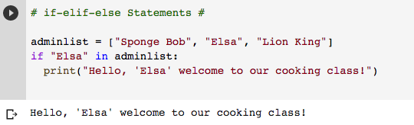

b. Other users can get the generic greeting

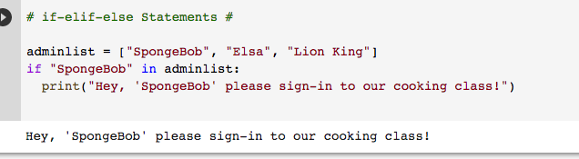

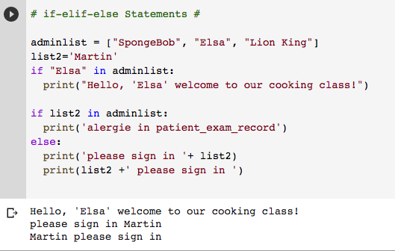

2. Store numbers 1-10 in a list

a. Loop through the list

b. Use an if-elif-else chain inside your loop to print the ordinal ending for  
 each number –for example – 1 st , 2 nd , 3 rd … etc.

