

SOFTWARE REQUIREMENT
SPECIFICATION

Library Entry and Exit Recording System
Version 1.1 | October 7, 2026
Table of Contents
I. Record of Changes 3
II. Software Requirement Specification 4
1. Overall Requirements 4
1.1 Context Diagram 4
1.2 Main Business Processes 5
1.3 User Requirements 6
1.4 System Functionalities 9
1.5 Entity Relationship Diagram 11
2. Detailed Functional Requirements 14
3. Nonfunctional Requirements 24
4. Business Rules and Data Constraints 25
5. External Interface Requirements 28
6. Acceptance and Delivery Criteria 29
7. References and Glossary 30
Appendix A API Traceability 31

I. Record of Changes
Date | A* / M / D | In charge | Change Description
2026-10-07 | A | Project team | Create SRS for library entry/exit workflows based on implementation guidance v1.0.
2026-10-07 | M | Project team | Replace student_code with shared code and add email for all account roles.
2026-10-07 | A | Project team | Add staff shift scheduling and complete backend/AI MVP API traceability.
*A - Added M - Modified D - Deleted
Version 1.1 specifies the MVP requirements and its acceptance criteria. Functional requirements describe required behavior; implementation and verification results are maintained separately.

II. Software Requirement Specification

1. Overall Requirements
The Library Entry and Exit Recording System records student attendance at a fixed library kiosk, using facial recognition as the main method and rotating QR as a fallback. Librarians monitor current occupancy and handle verified manual access, including external guests. Administrators manage accounts, devices, operational settings, analytics and staff schedules.
This SRS defines the behaviors required for one library and provides a common reference for the backend, AI and App teams. The initial handover consists of backend and internal AI APIs, a migrated database, a reproducible Docker development environment and Swagger contracts. Role-specific client flows are specified here so the App team can develop independently; final visual UI designs remain a separate deliverable.
Scope excludes public self-registration, email verification or email-based reset, employee attendance/payroll, shift swaps/leave, recurring shift schedules, multiple library branches and report exports. Guest profiles are not login accounts.

1.1 Context Diagram
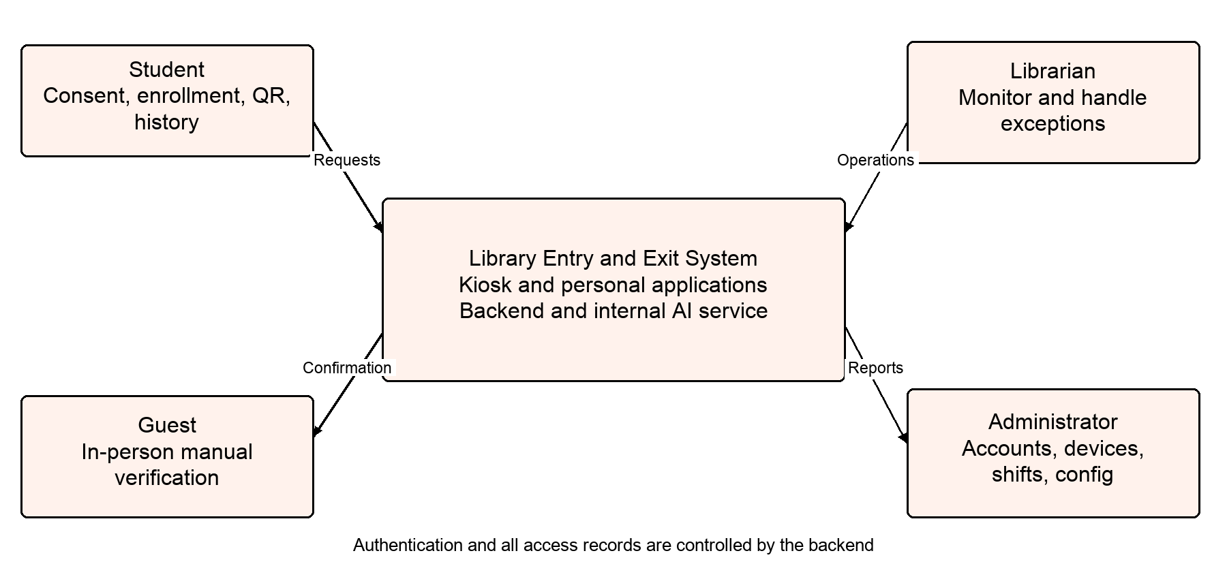
Figure 1 Context diagram and human interactions
Students supply consent and enrollment evidence, obtain rotating QR tokens and view their own records. Librarians record verified exceptions and read live occupancy/history. Admins control accounts, devices, shifts and operational settings. Guests participate through librarian-assisted manual access and do not authenticate as users.
All clients communicate with Spring Boot. FastAPI performs internal embedding extraction, matching and liveness; it reads only an authorized candidate view. PostgreSQL stores authoritative relational/session data and pgvector embeddings. The backend owns all business writes and validates every identity before access changes.

1.2 Main Business Processes
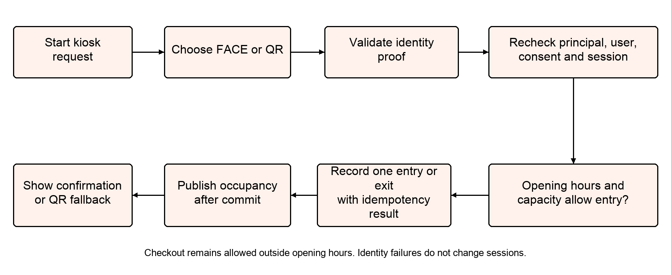
Figure 2 Shared access recording process for FACE and QR

Enrollment
A student reads the current biometric policy, grants explicit consent and submits 3–5 images. The backend validates ownership and version, AI extracts consistent embeddings, and the backend replaces enrollment atomically. Original images are not retained. Deletion revokes consent and removes embeddings while preserving access history.

FACE entry and exit
An ACTIVE kiosk obtains a one-use challenge and captures a short clip. AI verifies dynamic liveness, anti-spoofing and a calibrated identity match. The backend rechecks account/consent/enrollment and applies shared session rules. FACE failure suggests QR without modifying sessions.

QR fallback
The student opens a 30-second QR in the personal App. The kiosk submits its token with an intent-specific key. The backend validates and consumes it in the same transaction that creates or closes the session. QR remains available during AI downtime.

Manual and guest access
A librarian verifies the person, finds or creates the appropriate profile, chooses explicit CHECK_IN/CHECK_OUT and records a reason. User/visitor identity is exclusive; current hours/capacity rules still apply. Manual checkout can resolve a LOCKED student’s open session.

Monitoring and automatic checkout
Staff load REST snapshots and subscribe to occupancy events. Entry/exit and capacity changes carry increasing revisions after commit. Due sessions close at their stored closing-time/max-duration cutoff, with a clear automatic reason.

Staff scheduling
Admin creates concrete shifts, assigns ACTIVE librarians and updates or cancels assignments. Overnight and adjacent shifts are supported; overlapping active assignments are rejected transactionally. Librarians view their own schedules, independently of login permissions.

1.3 User Requirements

1.3.1 Actors
# | Actor | Description
1 | Student | ACTIVE STUDENT account; owns personal QR, presence/history, consent and enrollment. Participates in kiosk entry/exit.
2 | Librarian | LIBRARIAN account; monitors occupancy, handles manual/guest access, reads history/config and own shifts.
3 | Administrator | ADMIN account; manages users, kiosks, configuration, analytics and staff scheduling; may perform librarian operations.
4 | Kiosk device | Separate service principal bound to a provisioned device; captures FACE/QR, reports heartbeat and reads own runtime config.
5 | Guest | External visitor verified by staff; manual access only, without a login account or student code.
6 | System scheduler | Internal actor that automatically closes due sessions and performs safe request recovery/cleanup.
The internal AI service is a supporting component rather than an additional human account role. A kiosk is not a fourth user role. Operators access public service health; internal AI readiness/inference require service authentication.

1.3.2 Use Cases (UC)
ID | Use Case | Feature | Use Case Description
UC01 | Log in | Authentication | A valid token family is created.
UC02 | Refresh access | Authentication | The old refresh token is revoked; absolute family expiry is unchanged.
UC03 | Log out | Authentication | The family can no longer access protected APIs.
UC04 | View own profile | Account | Own profile is displayed without changing data.
UC05 | Change own password | Account | Old password and tokens are invalid.
UC06 | Get rotating QR | Student access | A short-lived token is available for kiosk scanning.
UC07 | View personal presence and history | Student access | Only the student’s own records are displayed.
UC08 | Grant biometric consent | Biometrics | At most one current ACTIVE consent exists.
UC09 | Enroll or replace face | Biometrics | Current model/consent-linked embeddings are stored; original images are deleted.
UC10 | Delete face data | Biometrics | The identity is excluded from recognition immediately.
UC11 | Issue face challenge | Kiosk access | A one-use challenge is persisted.
UC12 | Record FACE entry or exit | Kiosk access | One access result and recognition attempt are recorded; occupancy publishes after commit.
UC13 | Record QR entry or exit | Kiosk access | Exactly one session effect is committed.
UC14 | Recover access result | Reliability | The client knows whether the original intent completed.
UC15 | Monitor occupancy | Library operations | Staff see current students/guests, capacity warning and duration without email.
UC16 | Record manual access | Library operations | One audited session change is committed without an artificial kiosk actor.
UC17 | Find or register guest | Library operations | A server-assigned GUEST reference code identifies the guest.
UC18 | View shared access history | Library operations | Authorized staff can reconcile access records.
UC19 | Manage user accounts | Administration | Accounts are managed without physical history deletion.
UC20 | Reset user password | Administration | The old password/tokens are invalid.
UC21 | Manage kiosk inventory | Administration | Device inventory and status reflect administrative changes.
UC22 | Provision or rotate kiosk credentials | Device security | The ACTIVE device authenticates independently of user accounts.
UC23 | Report kiosk health and read runtime config | Device operations | Device monitoring and runtime behavior use current server state.
UC24 | Create edit or cancel shift | Scheduling | A valid dated schedule is maintained.
UC25 | Assign replace or cancel staff | Scheduling | Assignments remain nonoverlapping; assignment/shift versions increase.
UC26 | View own work schedule | Scheduling | The librarian sees only their personal work assignments.
UC27 | Read or edit operational configuration | Administration | Runtime settings change without rebuilding clients.
UC28 | View access and recognition analytics | Administration | Reports reflect actual logs and recognition attempts.
UC29 | Automatically close expired sessions | Scheduled operation | Due sessions close without a fabricated manual/FACE/QR actor.
UC30 | Expose service health | Operations | Operators can distinguish process health from real-model readiness.

1.3.3 Use Case Diagrams
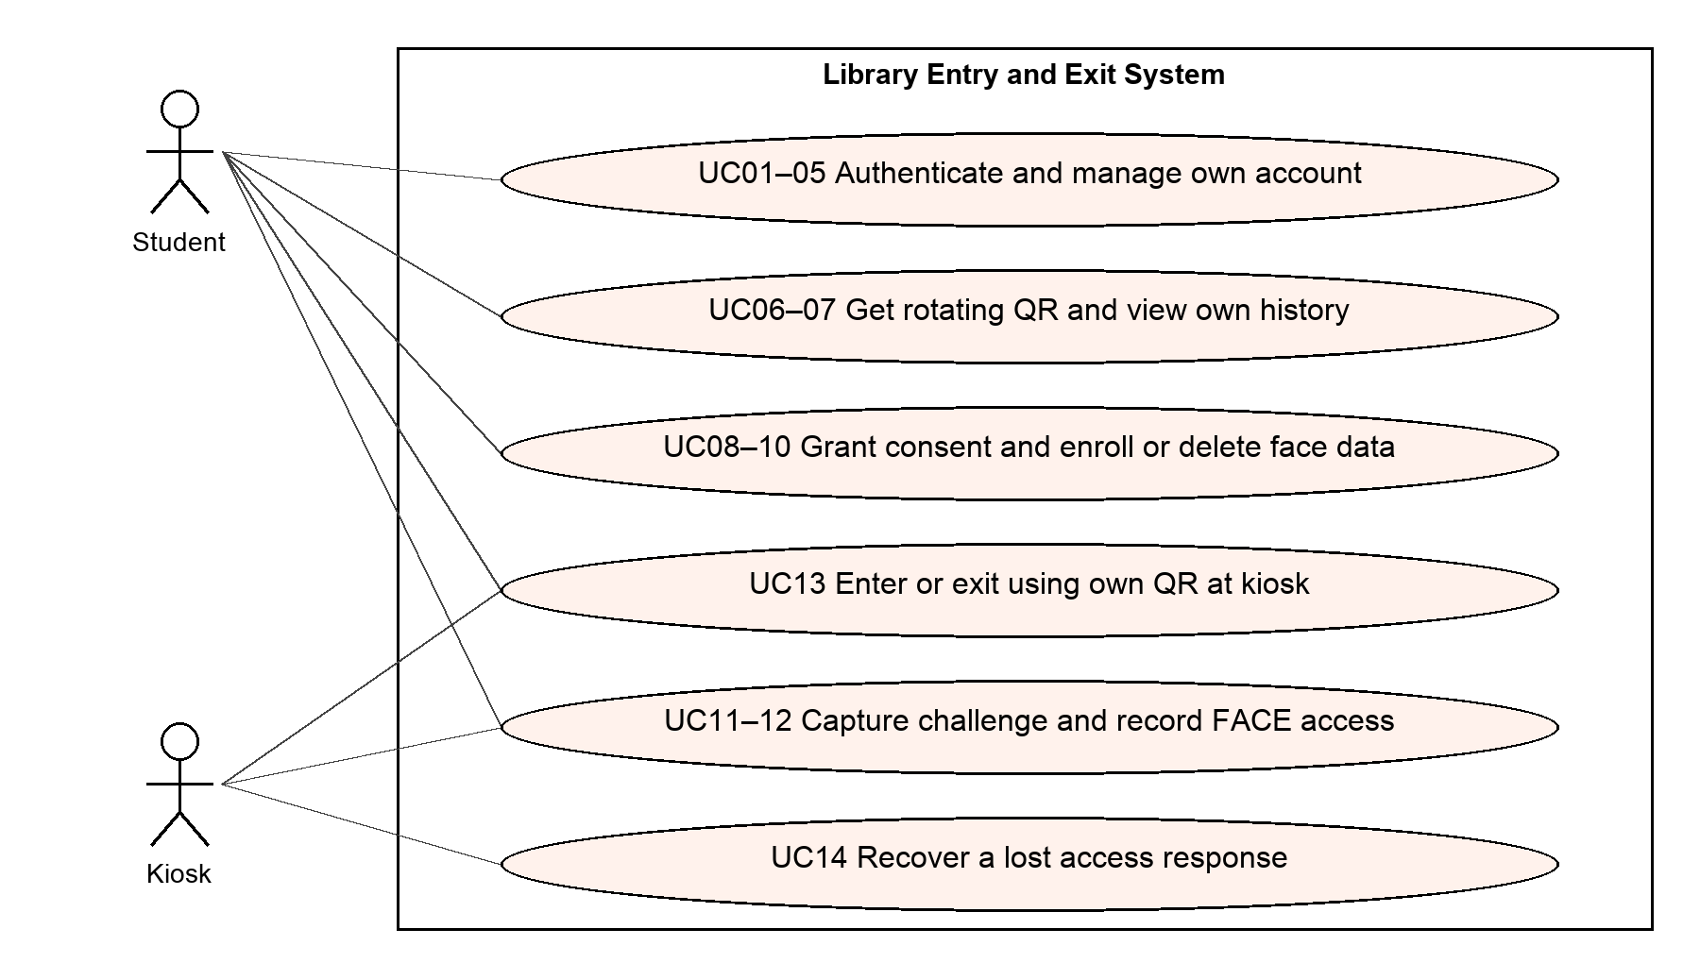
Figure 3 Student and kiosk use cases
Association lines identify participation; UC13 involves a student presenting QR and the kiosk submitting it. Identity validation is part of FACE/QR processing, while session recording is shared. Guest participation is represented by the manual-access use case in the librarian workflow.
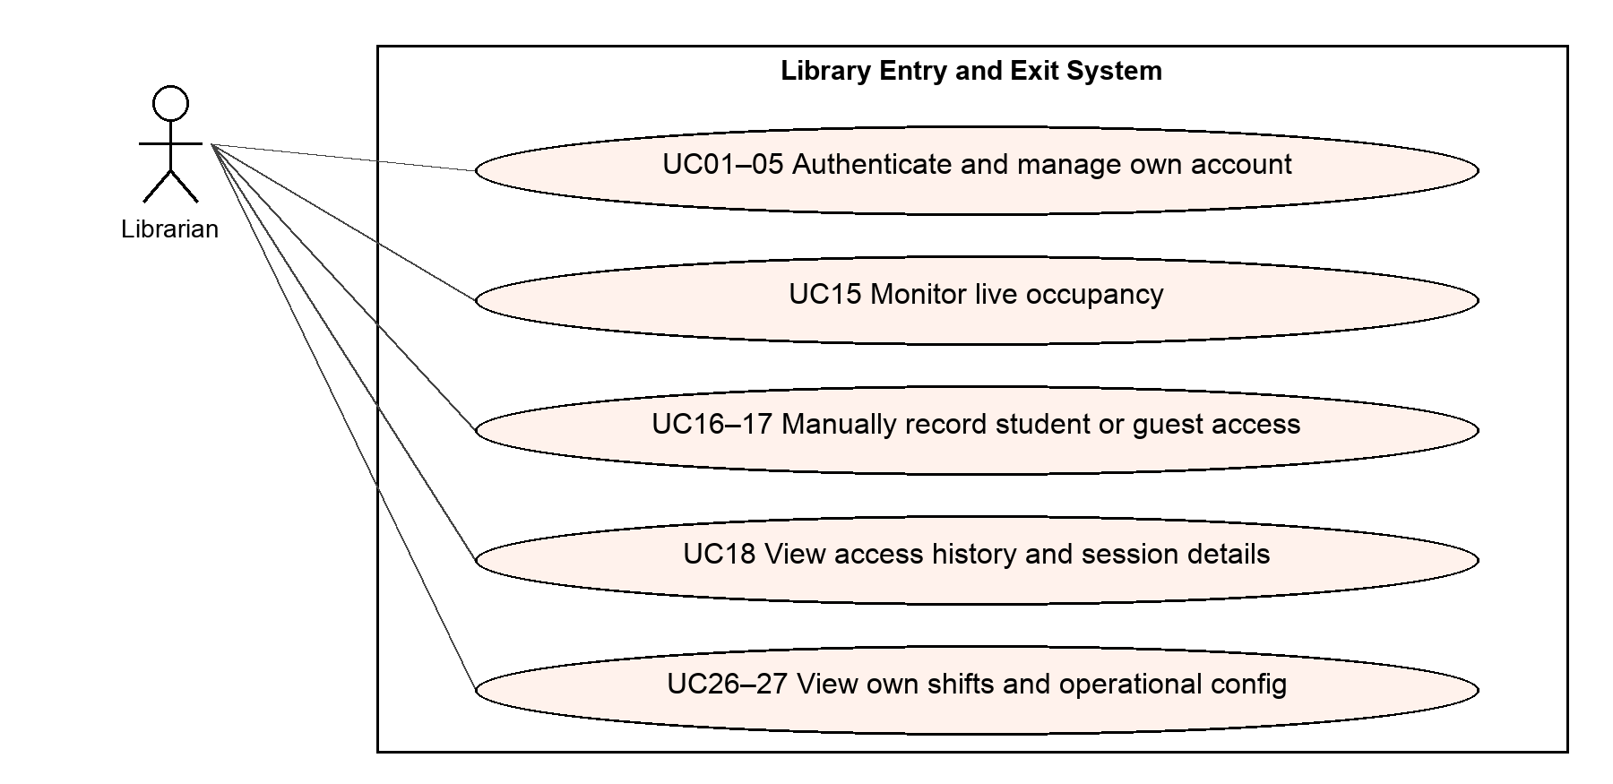
Figure 4 Librarian use cases
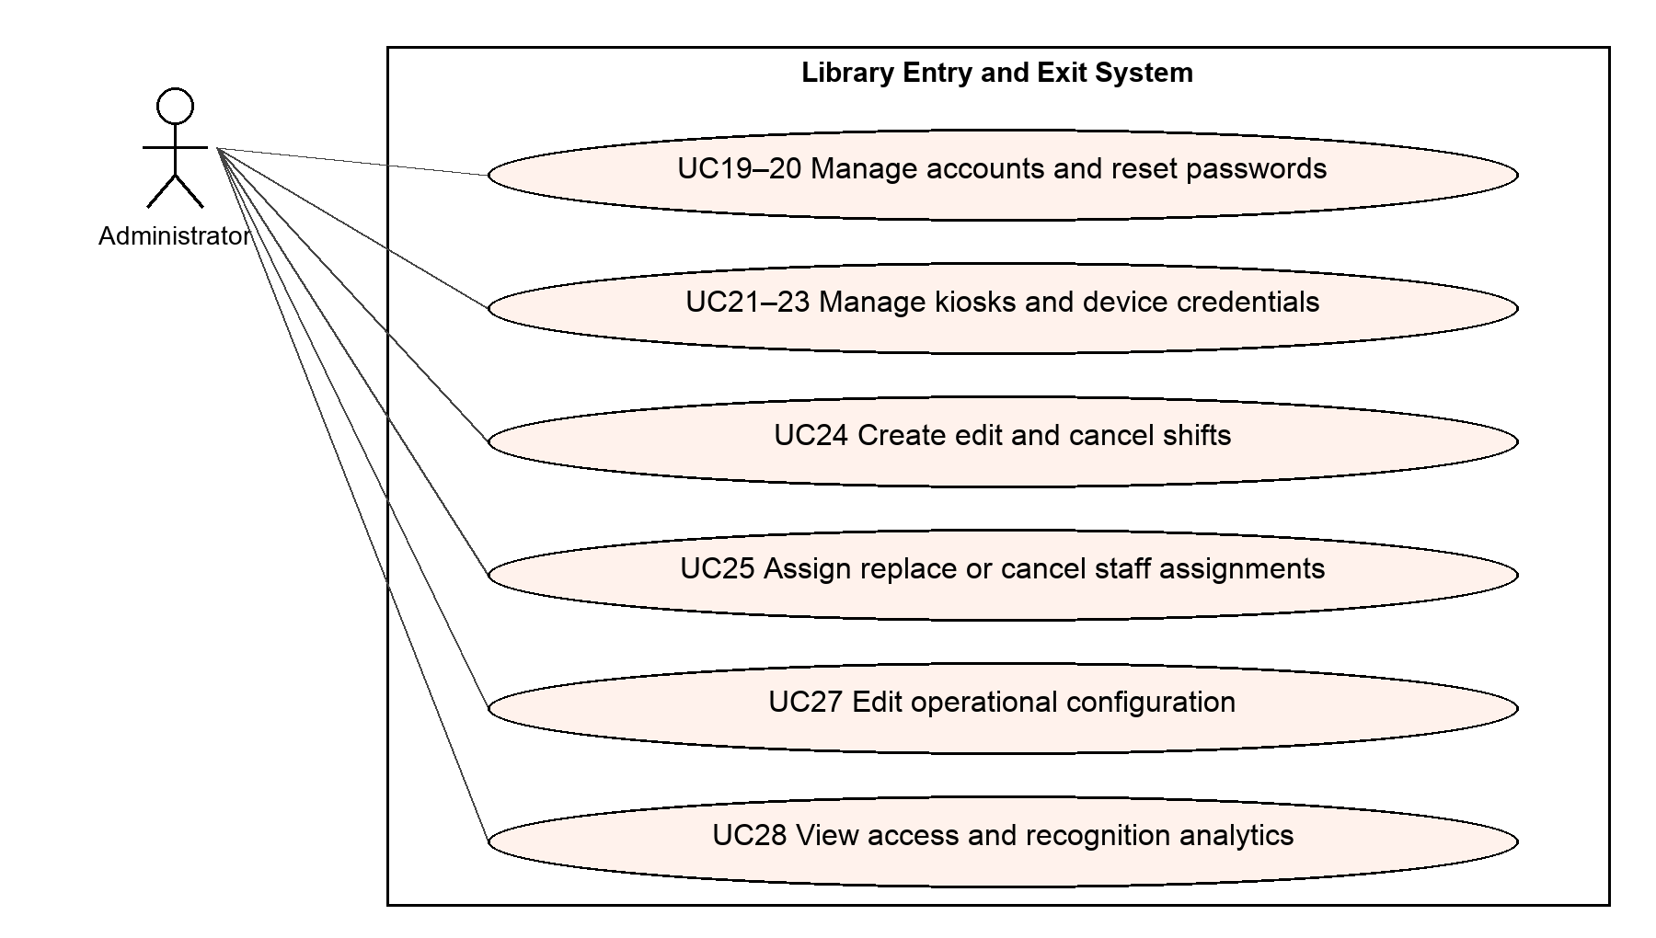
Figure 5 Administrator use cases
Admin also has authorized monitoring/manual/history capabilities. Shared authentication and profile operations apply to all human roles. UC29 is an internal scheduled process and UC30 is an operations interface, not an interactive student workflow.

1.4 System Functionalities
The system separates student self-service, kiosk capture, librarian operations and administrative management. Screen visibility follows roles, but backend authorization and record ownership must still be enforced independently of navigation.

1.4.1 Screens Flow
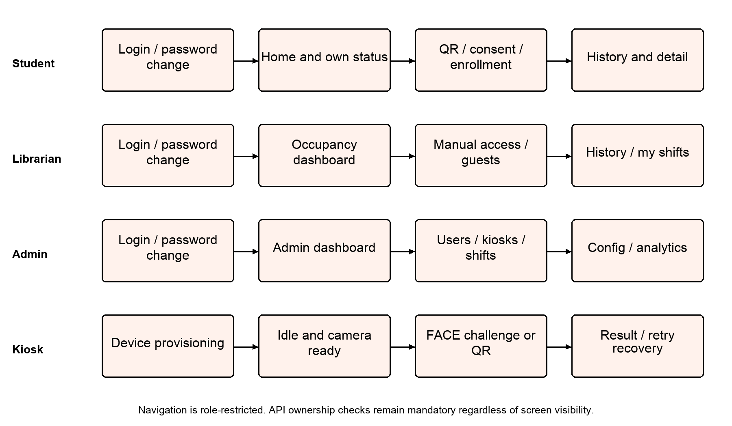
Figure 6 Logical screen flows by role
Student screens expose own code/email, presence, personal QR, consent/enrollment and history. Librarian screens expose occupancy, manual actions, guests, shared history and personal scheduling. Admin screens add accounts, kiosk management, complete scheduling, configuration and analytics. Kiosk screens handle device provisioning, capture, QR fallback and result recovery; they do not request a student login at the gate.

1.4.2 Screen behavior and states
Area | Required states | Behavior
Authentication | Loading, invalid credentials, locked, password change required | Route by role; restrict forced-change accounts until password change succeeds.
Kiosk | Idle, capture, processing, success, no match, AI/camera unavailable | Offer QR after two consecutive face failures, before enrollment or camera failure, and immediately for AI downtime; retain intent key for recovery.
Enrollment | No consent, not enrolled, uploading, rejected set, enrolled, deleted | Require explicit current-policy consent; preserve old enrollment on upload failure; expose deletion.
Occupancy | Snapshot loading, connected, disconnected, stale revision, near capacity | Subscribe and fetch snapshot; discard old events; refetch after reconnect; do not expose email.
Scheduling | Active, cancelled, stale version, overlap conflict | Show staff codes and dates; keep prior assignment after failed replacement; preserve cancellations for history.

1.5 Entity Relationship Diagram
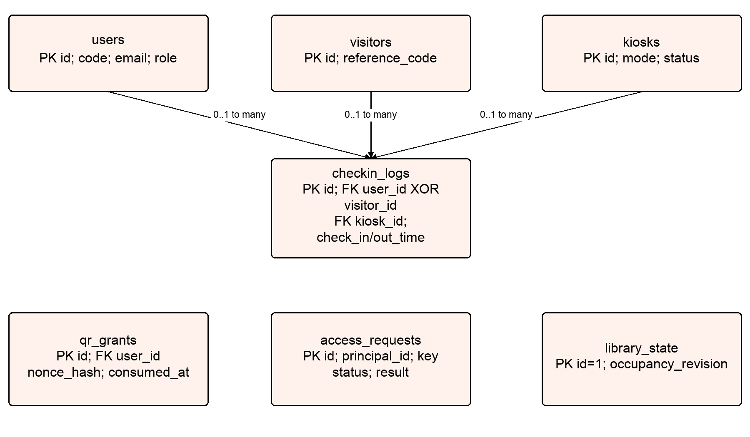
Figure 7 Access and identity ERD subview
checkin_logs has exactly one user_id or visitor_id. Both FKs are nullable individually, but a CHECK XOR requires one subject. The kiosk/actor references describe each direction separately. access_requests deduplicates recording intents, qr_grants protects single-use QR, and library_state serializes occupancy changes; dotted or implied processing links are not additional foreign keys.
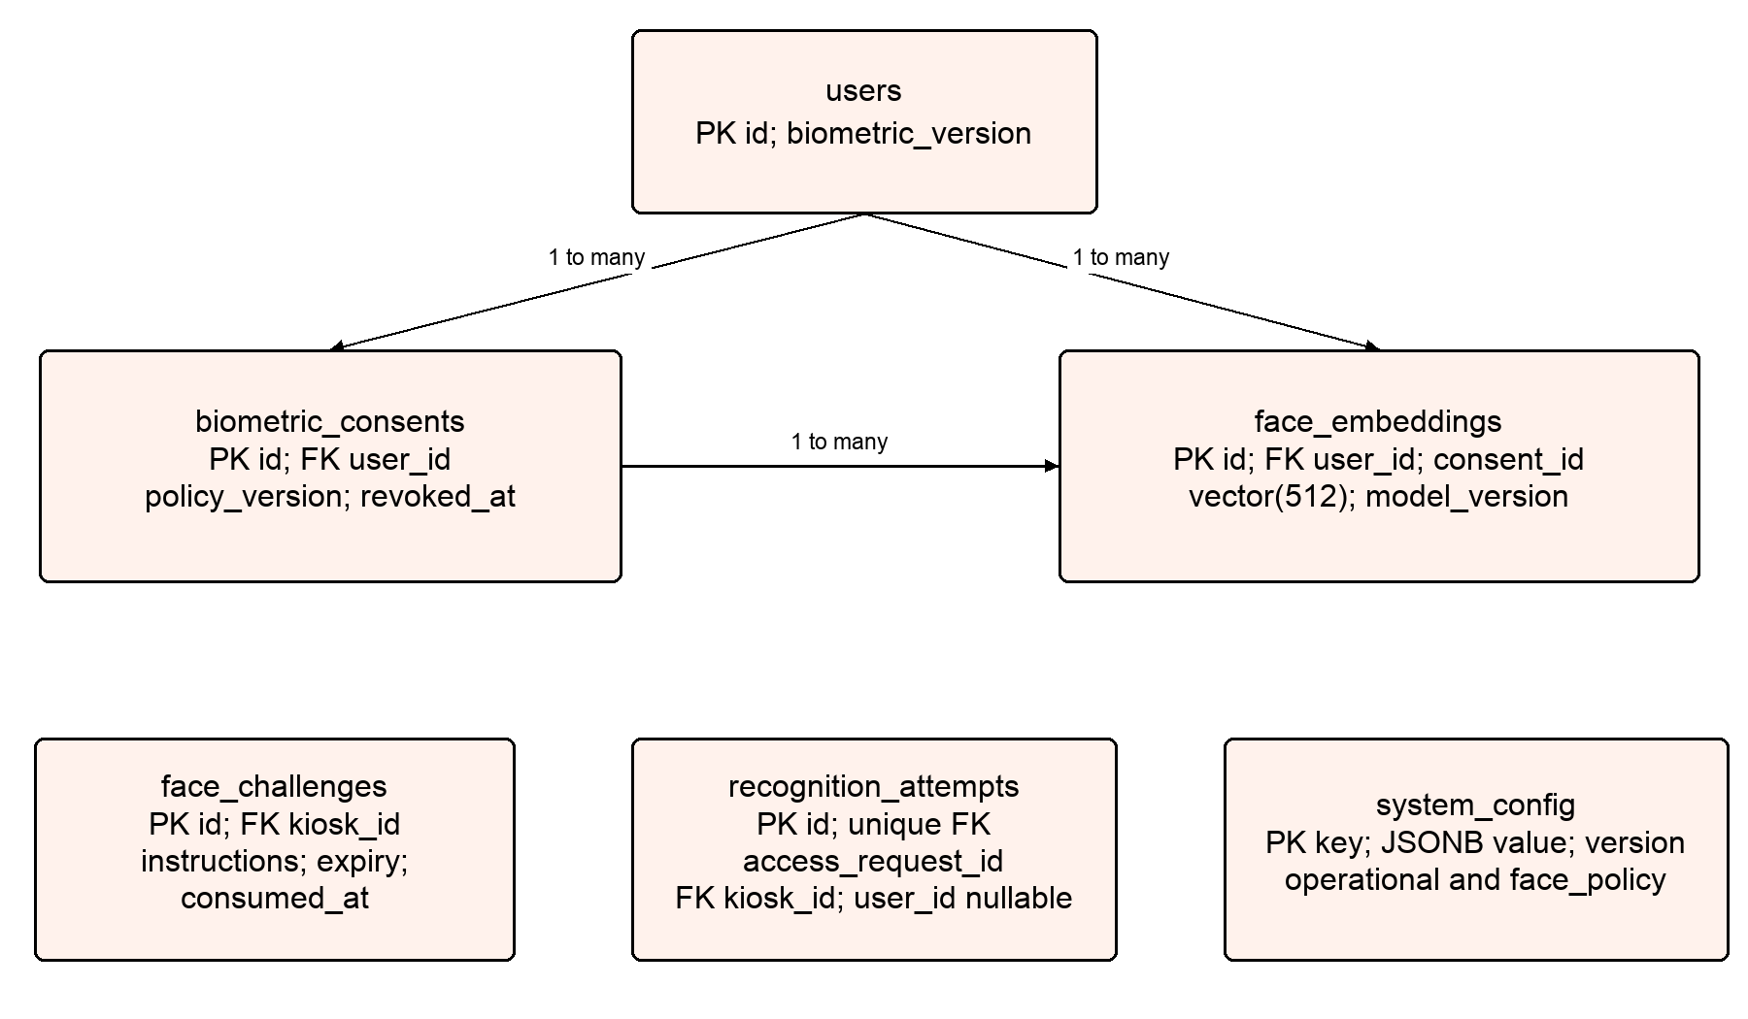
Figure 8 Biometric and recognition ERD subview
face_embeddings has a composite consent_id/user_id foreign key to biometric_consents(id,user_id). Each recognition_attempt references one unique access_request and the originating kiosk; optional user_id is present only when appropriate. face_challenges references kiosks, while policy/configuration control candidate eligibility and calibration.
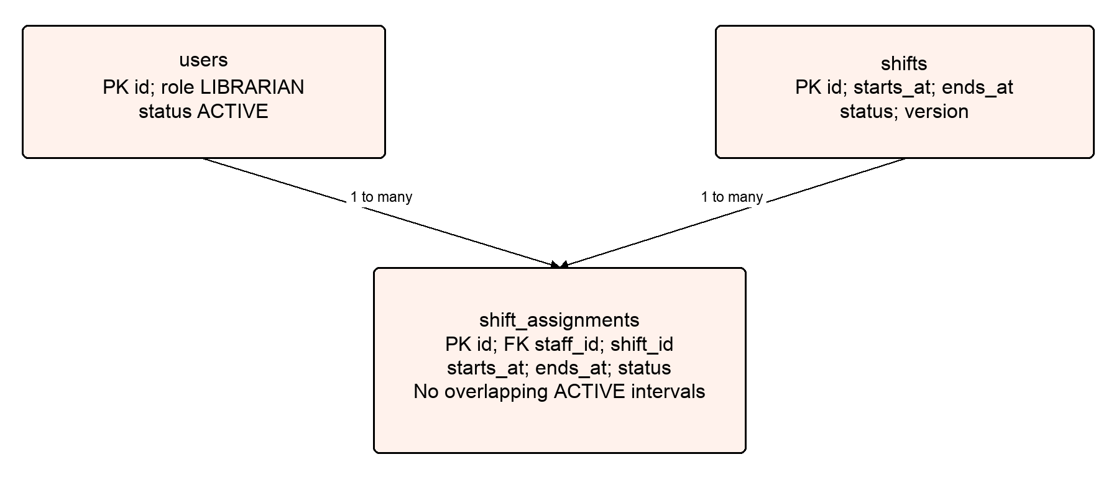
Figure 9 Staff scheduling ERD subview
Each shift has many staff assignments and each staff account has many assignments. Copy shift boundaries into assignments and reject overlapping ACTIVE intervals per staff member. Adjacent intervals use [start,end), allowing one shift to begin when another ends.

Entities Description
# | Entity | Description
1 | users | Shared account identifiers, role/status, password hash, auth/biometric versions and optimistic version.
2 | auth_refresh_tokens | Hashed refresh tokens, families, absolute expiry, revocation and replacement links.
3 | kiosks | Device code/name, gate mode, revocation, hashed credential/version and heartbeat metadata.
4 | biometric_consents | Policy-versioned consent grants and revocation; at most one current active consent per person.
5 | face_embeddings | 512-dimensional vectors associated with current user, consent and model version; no original images.
6 | visitors | Staff-created guest identities with unique reference codes, without login accounts.
7 | checkin_logs | Entry/exit sessions, exclusive user/visitor identity, directional methods/actors/reasons and scheduled cutoff.
8 | access_requests | Principal-scoped idempotency keys, request digest, processing deadline and terminal response.
9 | qr_grants | Hashed one-use QR nonces, expiry and consumption time.
10 | system_config | Versioned JSONB operational settings and face-policy notice/version.
11 | library_state | Single-row occupancy revision and transaction serialization point.
12 | face_challenges | Persisted kiosk-bound one-use instructions, model/config versions and expiry.
13 | recognition_attempts | One real inference attempt per access request, outcome, model, distance, liveness and latency.
14 | shifts | Concrete dated intervals, active/cancelled state, creator and optimistic version.
15 | shift_assignments | Staff membership, copied intervals, status, assigner and version with DB overlap exclusion.
16 | audit_events | Actor/target/action metadata for traceability without secrets or biometric payloads.
The complete field/type/constraint specification is maintained in docs/backend-ai-spec.md. The ERD is split into readable subviews; auth_refresh_tokens and audit_events retain user/actor relations even though they are not shown in every diagram. Historical sessions are never cascade-deleted through account/device changes.

2. Detailed Functional Requirements
Every use case below is an MVP requirement. The normal flow, alternative outcomes and postconditions are testable acceptance obligations. API operationIds map to Appendix A and the versioned OpenAPI contracts.

2.1 UC01 Log in
Actors: Student, Librarian, Admin
Preconditions: An ACTIVE account exists.
1. Enter code or email and password.
2. Normalize the identifier and verify credentials.
3. Issue access/refresh tokens and route by role; require a password change when flagged.
Alternative and error flows: Wrong credentials use the same error; LOCKED accounts receive no tokens.
Postconditions: A valid token family is created.
API traceability: login

2.2 UC02 Refresh access
Actors: Student, Librarian, Admin
Preconditions: A valid unrevoked refresh token exists.
1. Submit the refresh token.
2. Rotate it atomically and issue a new token pair.
Alternative and error flows: Reuse revokes the family; a lost response requires login rather than automatic retry.
Postconditions: The old refresh token is revoked; absolute family expiry is unchanged.
API traceability: refreshTokens

2.3 UC03 Log out
Actors: Student, Librarian, Admin
Preconditions: The caller is authenticated.
1. Submit the caller-owned refresh token.
2. Revoke its family and invalidate family access tokens.
Alternative and error flows: Repeat logout returns 204; another user’s token returns 404.
Postconditions: The family can no longer access protected APIs.
API traceability: logout

2.4 UC04 View own profile
Actors: Student, Librarian, Admin
Preconditions: A user access JWT exists.
1. Open the profile screen.
2. Read the current principal’s code, email, role and enrollment state.
Alternative and error flows: No caller-supplied userId is accepted; password/hash is never returned.
Postconditions: Own profile is displayed without changing data.
API traceability: getMyProfile

2.5 UC05 Change own password
Actors: Student, Librarian, Admin
Preconditions: The caller knows the current password.
1. Submit currentPassword and a different valid newPassword.
2. Update the hash and revoke old token families.
3. Clear forced-change state and issue new tokens.
Alternative and error flows: Reject invalid/current-equal passwords; after a lost response log in with the new password.
Postconditions: Old password and tokens are invalid.
API traceability: changeMyPassword

2.6 UC06 Get rotating QR
Actors: Student
Preconditions: The account is ACTIVE and has STUDENT role.
1. Open personal QR.
2. Issue a 30-second QR_ACCESS token with a fresh nonce.
3. Render QR locally and refresh after 25 seconds.
Alternative and error flows: An access JWT cannot substitute for QR; request a new QR when needed.
Postconditions: A short-lived token is available for kiosk scanning.
API traceability: issueMyQr

2.7 UC07 View personal presence and history
Actors: Student
Preconditions: The caller is authenticated.
1. Read current presence and open session if any.
2. Filter paginated personal history and open a session detail.
Alternative and error flows: Other users’ session IDs return 404; outside status has currentSession=null.
Postconditions: Only the student’s own records are displayed.
API traceability: getMyAccessStatus, listMyAccessHistory, getMyAccessSession

2.8 UC08 Grant biometric consent
Actors: Student
Preconditions: The student is ACTIVE and the current policy is available.
1. Read the policy and capture limits.
2. Explicitly accept its current version.
3. Persist consent under a user lock.
Alternative and error flows: accepted=false or outdated policy is rejected; existing same-policy consent is returned.
Postconditions: At most one current ACTIVE consent exists.
API traceability: getFacePolicy, grantFaceConsent

2.9 UC09 Enroll or replace face
Actors: Student
Preconditions: Current-policy consent exists and biometricVersion was read.
1. Capture 3–5 images of one person and submit version.
2. Validate every image and extract consistent normalized embeddings.
3. Replace the full embedding set atomically and increment version.
Alternative and error flows: Invalid images, stale version, consent revocation or locking preserve the old enrollment.
Postconditions: Current model/consent-linked embeddings are stored; original images are deleted.
API traceability: getMyFaceEnrollment, enrollMyFace, extractEmbeddings

2.10 UC10 Delete face data
Actors: Student
Preconditions: The caller owns the biometric data and sends its current version.
1. Request deletion.
2. Delete embeddings, revoke consent and increment biometricVersion transactionally.
Alternative and error flows: Already-empty state with matching version is returned without another increment; history remains.
Postconditions: The identity is excluded from recognition immediately.
API traceability: deleteMyFaceEnrollment

2.11 UC11 Issue face challenge
Actors: Kiosk
Preconditions: The device is ACTIVE; real AI and calibration are ready.
1. Request a challenge.
2. Store a 60-second kiosk-bound challenge: BLINK then random TURN_LEFT/RIGHT.
3. Return instructions and capture limits.
Alternative and error flows: Unready real AI returns 503; expired/wrong-kiosk challenges are invalid.
Postconditions: A one-use challenge is persisted.
API traceability: issueFaceChallenge

2.12 UC12 Record FACE entry or exit
Actors: Kiosk; Student participates
Preconditions: A valid challenge and an enrolled ACTIVE student exist.
1. Capture a challenge clip and submit it with an intent-specific Idempotency-Key.
2. Validate liveness and model-specific identity distance/margin through AI.
3. Recheck user, consent, versions and session under locks; record entry/exit once.
Alternative and error flows: No match/liveness failure recommends QR; timeout/mock/unready model never creates a session.
Postconditions: One access result and recognition attempt are recorded; occupancy publishes after commit.
API traceability: recordFaceAccess, recognizeFace

2.13 UC13 Record QR entry or exit
Actors: Kiosk; Student participates
Preconditions: An ACTIVE kiosk scans a valid student QR.
1. Submit token with an intent-specific Idempotency-Key.
2. Validate purpose, signature, expiry, nonce and current student status.
3. Record entry or exit using shared session logic and consume QR atomically.
Alternative and error flows: Invalid/reused QR, cooldown or gate-state conflict is rejected; retries do not toggle state.
Postconditions: Exactly one session effect is committed.
API traceability: recordQrAccess

2.14 UC14 Recover access result
Actors: Kiosk, Librarian, Admin
Preconditions: The client retained the original intent key.
1. Query the request status using that key.
2. Return processing state or the original result/error without resending evidence.
Alternative and error flows: Another principal’s key, missing or expired records return 404.
Postconditions: The client knows whether the original intent completed.
API traceability: getAccessRequestStatus

2.15 UC15 Monitor occupancy
Actors: Librarian, Admin
Preconditions: An authorized staff access JWT exists.
1. Fetch count and paginated people snapshots.
2. Subscribe to the occupancy topic and discard old revisions.
3. Refetch snapshots/list after changes or reconnect.
Alternative and error flows: Unauthorized subscriptions are rejected; disconnection does not guarantee event replay.
Postconditions: Staff see current students/guests, capacity warning and duration without email.
API traceability: getOccupancy, listOccupants

2.16 UC16 Record manual access
Actors: Librarian, Admin
Preconditions: The operator has verified the person directly.
1. Select exactly one user or visitor and explicit CHECK_IN/CHECK_OUT.
2. Enter a reason and send an Idempotency-Key.
3. Apply shared hours/capacity/session rules and record the directional actor/reason.
Alternative and error flows: LOCKED users may check out manually; check-in requires ACTIVE STUDENT; no duplicate session.
Postconditions: One audited session change is committed without an artificial kiosk actor.
API traceability: recordManualAccess

2.17 UC17 Find or register guest
Actors: Librarian, Admin
Preconditions: The guest requires manual access.
1. Search existing guest profiles by reference code/name.
2. Create a new profile only when required.
3. Use its visitorId for manual access.
Alternative and error flows: Identical names are not automatically merged; no student code/account/password is required.
Postconditions: A server-assigned GUEST reference code identifies the guest.
API traceability: listVisitors, createVisitor, getVisitor

2.18 UC18 View shared access history
Actors: Librarian, Admin
Preconditions: Staff authorization is valid.
1. Search/filter paginated history by subject, dates, method and session status.
2. Open detail with actors/reasons for both entry and exit.
Alternative and error flows: Student callers cannot use staff routes; userId and visitorId filters are mutually exclusive.
Postconditions: Authorized staff can reconcile access records.
API traceability: listAccessHistory, getAccessSession

2.19 UC19 Manage user accounts
Actors: Admin
Preconditions: An authorized ACTIVE Admin exists.
1. Search and create accounts with shared code/email.
2. Edit fields, roles or status with the current version.
3. Revoke tokens on role/status changes.
Alternative and error flows: Reject duplicate normalized identifiers and stale versions; protect the last ACTIVE Admin; no role change with an open student session.
Postconditions: Accounts are managed without physical history deletion.
API traceability: listUsers, createUser, getUser, updateUser

2.20 UC20 Reset user password
Actors: Admin
Preconditions: The target user exists and current version is supplied.
1. Set a valid new password.
2. Revoke old tokens and require a password change at next login.
Alternative and error flows: No password echo/email; resetting LOCKED users does not unlock them.
Postconditions: The old password/tokens are invalid.
API traceability: resetUserPassword

2.21 UC21 Manage kiosk inventory
Actors: Admin
Preconditions: Admin authorization is valid.
1. List/register devices and select ENTRY/EXIT/AUTO mode.
2. Read/update device name, mode or revocation status with version.
Alternative and error flows: Code is immutable; revocation invalidates tokens immediately; PATCH cannot reactivate without rotation.
Postconditions: Device inventory and status reflect administrative changes.
API traceability: listKiosks, createKiosk, getKiosk, updateKiosk

2.22 UC22 Provision or rotate kiosk credentials
Actors: Admin; Kiosk authenticates
Preconditions: The device exists; version is current for rotation.
1. Issue or rotate a random one-time-visible credential.
2. Store only its hash and increment credentialVersion.
3. Exchange valid kiosk credentials for a KIOSK-purpose token.
Alternative and error flows: Lost secrets require lookup/rotation; old secrets and tokens stop working.
Postconditions: The ACTIVE device authenticates independently of user accounts.
API traceability: rotateKioskCredential, loginKiosk

2.23 UC23 Report kiosk health and read runtime config
Actors: Kiosk
Preconditions: An ACTIVE kiosk token exists.
1. Send heartbeat every 30 seconds.
2. Read capture/QR/runtime configuration for the authenticated device.
Alternative and error flows: Offline is derived after 90 seconds; telemetry cannot override identity; thresholds/secrets are omitted.
Postconditions: Device monitoring and runtime behavior use current server state.
API traceability: heartbeatKiosk, getKioskRuntimeConfig

2.24 UC24 Create edit or cancel shift
Actors: Admin
Preconditions: Admin authorization is valid.
1. Create a concrete dated shift with end after start and duration ≤24 hours.
2. Edit times/name with version and update all ACTIVE assignments atomically.
3. Cancel the shift and its assignments while retaining history.
Alternative and error flows: Any new staff overlap rolls back the whole edit; CANCELLED shifts cannot reopen.
Postconditions: A valid dated schedule is maintained.
API traceability: listShifts, createShift, getShift, updateShift, cancelShift

2.25 UC25 Assign replace or cancel staff
Actors: Admin
Preconditions: An ACTIVE shift and ACTIVE LIBRARIAN staff exist.
1. Assign 1–100 distinct staff as one batch using shift.version.
2. Replace a staff member atomically using assignment.version.
3. Soft-cancel an individual assignment when required.
Alternative and error flows: Concurrent overlap or duplicate assignment rejects the operation; failed replacement retains the old staff.
Postconditions: Assignments remain nonoverlapping; assignment/shift versions increase.
API traceability: listShiftAssignments, assignStaff, replaceAssignedStaff, cancelAssignment

2.26 UC26 View own work schedule
Actors: Librarian
Preconditions: The employee has LIBRARIAN role.
1. List own assignments in an overlapping date range.
2. Open an assigned shift and inspect schedule/status.
Alternative and error flows: Unassigned shift details return 404; schedules do not restrict login outside working hours.
Postconditions: The librarian sees only their personal work assignments.
API traceability: listMyShifts

2.27 UC27 Read or edit operational configuration
Actors: Librarian reads; Admin edits
Preconditions: An authorized staff account exists.
1. Read current hours, capacity, duration and calibrated face settings.
2. Admin submits a versioned partial update.
3. Validate and apply configuration atomically with audit.
Alternative and error flows: Invalid/stale values fail without partial writes; null calibration disables real FACE.
Postconditions: Runtime settings change without rebuilding clients.
API traceability: getSystemConfig, updateSystemConfig

2.28 UC28 View access and recognition analytics
Actors: Admin
Preconditions: Access/recognition records exist or the selected range is empty.
1. Select a timezone-aware range and DAY/HOUR buckets for access.
2. Read entry/exit/method/duration statistics and real-recognition outcomes/latency.
Alternative and error flows: Empty buckets contain zero; failure rate is null with no attempts; mock/enrollment are excluded.
Postconditions: Reports reflect actual logs and recognition attempts.
API traceability: getAccessAnalytics, getRecognitionAnalytics

2.29 UC29 Automatically close expired sessions
Actors: System scheduler
Preconditions: A session has reached its stored checkout cutoff.
1. Run every 60 seconds and lock due open sessions.
2. Close at the stored closing-time/max-duration cutoff.
3. Record reason and publish occupancy after commit.
Alternative and error flows: Races/repeated runs produce one closure; downtime does not change the original cutoff.
Postconditions: Due sessions close without a fabricated manual/FACE/QR actor.
API traceability: Internal scheduled operation; no public endpoint.

2.30 UC30 Expose service health
Actors: Development and operations team
Preconditions: The service process is running.
1. Read backend/AI process health.
2. Check authenticated AI readiness for models, checksum, liveness and candidate view.
Alternative and error flows: AI downtime does not fail backend DB health; mock readiness cannot enable real FACE.
Postconditions: Operators can distinguish process health from real-model readiness.
API traceability: backendHealth, aiHealth, aiReady

3. Nonfunctional Requirements
ID | Requirement | Verification
NFR01 | Recognition performance: Target 1–2 seconds for capture-to-match-to-response on representative kiosk/server hardware. Report measured p50/p95 and test conditions; the target is not a proven result. Public FACE processing has a 15-second total bound. | Measure capture, network, detector, embedding, query and backend transaction stages using consented representative data.
NFR02 | Identity and authorization: Separate user/kiosk/service token purposes; enforce ACTIVE state, role/ownership, family validity and credential epochs on protected requests. | Role matrix, token expiry, revocation and cross-user/device tests.
NFR03 | Biometric privacy: Obtain versioned consent before enrollment; retain embeddings and metadata only. Delete original images/clips and temporary files on success/error; do not log secrets or biometric payloads. | Inspect storage/logs and exercise consent deletion and concurrent enrollment/recognition.
NFR04 | Consistency: At most one open session per subject; same-intent retries produce one result; capacity counts and shift overlap rules survive concurrent writes. | Real PostgreSQL concurrency tests; no H2-only claim for vector/range constraints.
NFR05 | Availability and degradation: QR works when AI is unavailable. Backend readiness depends on DB/schema; real AI readiness requires verified models/liveness/calibration and candidate-view access. | Stop AI and verify QR; test missing model, unavailable DB and timeout without session writes.
NFR06 | Recognition quality: Use calibrated distance/liveness/identity-gap thresholds for the selected models. Reject ties, spoofing, no match, invalid vectors and simulated results. | Report FAR/FRR and spoofing results on representative consented data; no invented accuracy claim.
NFR07 | Reproducible environment: Versioned Flyway migrations, pinned dependencies/images/model hashes, idempotent dev seed and isolated project volumes. Verify each advertised CPU architecture. | Fresh clone/build/smoke test; migration of fresh/existing DB; arm64/amd64 results recorded separately.
NFR08 | Realtime integrity: Events publish after commit with increasing revision and consistent snapshot. Reconnect retrieves REST state; delivery while disconnected is not guaranteed. | Rollback produces no event; stale revisions discarded; unauthorized/expired sockets closed.
NFR09 | Input and resource limits: Reject unknown JSON fields, malformed images/clips and excessive uploads. Bound inference queues, timeouts and rate limits; one running FACE request per kiosk. | MIME/content validation, image bombs, overload, timeout and rate-limit tests.
NFR10 | Maintainability and handover: Runtime Swagger must match design paths, operationIds, DTOs, errors, permissions and retry rules. App developers can integrate without reading service implementation. | OpenAPI diff, request/response schema validation and end-to-end contract tests.

4. Business Rules and Data Constraints

BR01 Account identifiers
users.code is required, trimmed/uppercase, 3–32 characters matching [A-Z0-9][A-Z0-9_-]{2,31}. email is required, trimmed/lowercase, max 254 characters. Both are system-wide UNIQUE. Roles are explicit, never inferred from code prefixes.

BR02 Passwords and forced changes
Passwords require 12–64 characters and ≤72 UTF-8 bytes; never trim. Admin create/reset requires next-login change; old password/token families are invalid after a reset/change. Protect the last ACTIVE Admin transactionally.

BR03 Token lifetimes
User access tokens last 15 minutes. Refresh families expire absolutely 7 days after login; rotation does not extend expiry. Kiosk tokens last 1 hour and include device credentialVersion.

BR04 QR and gate modes
QR tokens last 30 seconds with distinct QR_ACCESS purpose and single-use nonces. AUTO toggles from open-session state; ENTRY only enters, EXIT only exits. Validity cannot be interpreted as a guarantee against proxy attendance.

BR05 Idempotency and cooldown
QR/FACE/MANUAL require a client UUID intent key, scoped by principal type/id, retained 24 hours. Different method/path/payload conflicts; in-progress returns 409 with Retry-After:1. QR/FACE have a 10-second different-key cooldown; explicit manual actions do not.

BR06 Claim and finalization
Claim in a short transaction before inference; deadline 60 seconds. Finalize request → library_state → subject → session/evidence under locks. Session effect, evidence consumption, revision and stored response are atomic. Determined failures are replayable; expired workers cannot commit.

BR07 Hours and capacity
Business timezone is Asia/Ho_Chi_Minh. Reject entry outside opening slots; always allow checkout. Default capacity 250, warning ratio 0.9, enforcement=false. Serialize capacity decisions with occupancy state when enforcement is enabled.

BR08 Automatic checkout
Every 60 seconds close due sessions at the cutoff frozen at entry: earlier closing time/max duration, ignoring null max duration. Store entry_config_version. Configuration changes apply to future entries; downtime/retry does not shift or duplicate closure.

BR09 Subject and directional history
Sessions reference exactly one user or visitor. Guests use MANUAL only. Record method/kiosk/operator/reason separately by direction; automatic closure has no fabricated operator/method. checkout time cannot precede entry.

BR10 User locking and role changes
Locking preserves open sessions for manual staff checkout. Changing away from STUDENT requires no open session and atomically revokes consent/deletes embeddings. Locking alone does not delete enrollment.

BR11 Consent and enrollment
Only ACTIVE STUDENT users may enroll with current-policy consent. Consent/re-enrollment/deletion take user locks and advance biometricVersion. Entire replacement sets succeed or old enrollment remains. Current candidates must include matching consent/version; no gallery cache in MVP.

BR12 Image and clip limits
Enrollment accepts 3–5 JPEG/PNG images, each ≤5MiB, total ≤25MiB, max 16MP per image. FACE accepts MP4 clips of 1–3 seconds, ≤10MiB, ≤1280x720, ≤30fps, without audio. Decode actual content and require one face per enrollment image.

BR13 Challenge and liveness
A 60-second persisted challenge is bound to kiosk/config/model and requires BLINK followed by random TURN_LEFT/RIGHT. Dynamic completion plus model-based anti-spoofing are mandatory. Old/wrong-kiosk/config-changed challenges cannot create sessions.

BR14 Matching decisions
Use normalized finite nonzero 512-dimensional vectors. Group by distinct user and choose minimum distance per identity. Reject identity ties; with two or more candidates require calibrated distance gap; with one candidate gap=null. NO_MATCH/LIVENESS_FAILED never writes sessions.

BR15 AI readiness and statistics
Real FACE stays disabled until model/calibration/liveness are valid. Null calibration fields disable it. Mock results always simulated=true and cannot create real FACE logs. Count actual real inference, including timeouts, once per request; exclude pre-inference upload rejection, enrollment and mock.

BR16 Guest identity
Server assigns unique GUEST reference codes. Names are not unique and cannot auto-merge identities. Guests have no password/email/login account; staff must verify them in person.

BR17 Shift intervals
Shifts are dated, 0 < duration ≤24 hours, including overnight intervals. ACTIVE LIBRARIAN users only. ACTIVE assignments copy shift times; per-staff DB exclusion rejects overlapping [start,end) intervals but accepts adjacent shifts.

BR18 Scheduling updates
Lock shift then staff in stable UUID order. Batch assignment and time edits are all-or-nothing. Staff replacement is atomic. Soft cancellation preserves history, increments assignment/shift versions and releases active intervals. Cancelled shifts cannot reopen.

BR19 Schedule permissions
Admin reads/manages all shifts. Librarians read only their own assignments and assigned shift details, including cancelled history. Shift scheduling does not restrict account login outside shifts.

BR20 Configuration defaults
Mon–Sun 08:00–22:00, maxCapacity=250, nearCapacityRatio=0.9, enforcement=false, maxDuration=null, cooldown=10; face model/distance/gap/liveness initially null. One opening slot per weekday; overnight slots are allowed. Policy version changes use migration in MVP.

BR21 Queries and pagination
page=0,size=20,max size=100; sorting only from route allowlists. History default range: previous 30 days; shifts: previous 7 to next 30 days by overlap. Maximum range 366 days; HOUR analytics max31 days. Ranges are [from,to).

BR22 Telemetry and realtime
Heartbeat every30 seconds; offline after90 seconds. Occupancy excludes email and uses revisioned after-commit events. Capacity/warning changes also emit CONFIG_CHANGED. Clients may not SEND to the server/broker topic.

BR23 Secrets and audit
Hash credentials/refresh/QR nonces; kiosk credentials returned once without secret replay. JWT, AI service and request-HMAC keys are distinct. Audit actor/action/target without tokens, passwords, images or embeddings.

BR24 Versioned updates and retry
Unknown fields and unsupported nulls are rejected; PATCH needs version and at least one other field. Stale mutations return409. After a lost versioned response, read state before deciding; never blindly resubmit a new version. Only access recording uses persisted intent replay.

5. External Interface Requirements

5.1 Public backend API
Clients call /api/v1 business APIs over HTTP in local development and HTTPS in deployed environments. JSON uses camelCase; IDs are UUID strings; timestamps include an ISO-8601 timezone offset. Infrastructure health is /actuator/health. Use separate user/kiosk bearer security schemes and a Flutter Web CORS allowlist.
Swagger UI is /swagger-ui/index.html and exported OpenAPI is /v3/api-docs (JSON) or /v3/api-docs.yaml. The complete design declares 54 backend HTTP operations, including authentication, account/detail/password, personal access, kiosk/runtime, QR/FACE/manual, request recovery, visitors, history, occupancy, shifts/assignments, configuration, analytics, biometrics and health.
Shared errors contain code, message, fieldErrors, traceId, timestamp and fallbackRecommended. Distinguish 400/401/403/404/409/413/422/503 and documented rate-limit errors. Access results include requestId/sessionId/action/subject/method/occurredAt/occupancy/simulated=false; never return embeddings or raw credentials in ordinary account/device reads.

5.2 Internal AI API
FastAPI is internal and called by backend only. Process health GET /api/v1/health is public to operations; GET /api/v1/ready, POST /api/v1/embeddings and POST /api/v1/recognize require X-Service-Key. The App never calls the AI host or selects the recognized student identity.
Embedding multipart uses images. Recognition multipart contains clip, challengeId, stored challengeInstructions, modelVersion, maxCosineDistance, minDistanceGap and livenessMinScore. AI returns typed outcomes and model metadata; MATCHED includes non-null userId/consentId/biometricVersion and passed liveness. The backend validates the response and rechecks all eligibility before session writes.

5.3 Realtime interface
Native WebSocket /ws uses STOMP1.2 without SockJS. CONNECT supplies Authorization: Bearer user accessToken; only LIBRARIAN/ADMIN subscribe to /topic/occupancy. Heartbeats are 10000,10000. Client SEND is blocked; token expiry/revocation/role changes close the connection.
Events include eventId, occurredAt, revision, count, maxCapacity, nearCapacity and change/action. Session events include change.sessionId; CONFIG_CHANGED does not. CONNECT → SUBSCRIBE → fetch REST snapshots; refetch on newer revisions and reconnect. Full identities/emails are not published in the topic. The OpenAPI x-realtime extension documents this separate protocol.

5.4 Deployment and device interfaces
The team development stack runs PostgreSQL16 with pgvector/btree_gist, Java21/Spring Boot3.3.4 backend and Python3.11/FastAPI AI through dedicated Docker Compose. The default AI execution path is CPU; mock and real modes are explicit. Model assets use a checksum-verified manifest and persistent cache. Advertised arm64/amd64 support requires separate build and smoke-test evidence.
The App team receives backend host/port, environment-variable instructions, dev account seeding and Swagger. Android emulators use 10.0.2.2; physical phones use the host machine’s reachable IP. DB/AI are internal or localhost-only. Preserve team volumes; isolated test projects must not reset the dev database.

6. Acceptance and Delivery Criteria
AC01 A teammate can clone the repository, configure .env, run one documented Docker command and open Swagger. Fresh/existing database migrations and repeated dev seeding pass.
AC02 All 54 backend and 4 internal AI operations have implementations, permission/error/schema tests and matching runtime Swagger. Appendix A traceability is complete.
AC03 Login by code/email, password changes/resets, token rotation/revocation, last-Admin protection, device credentials and user/kiosk separation pass negative and concurrency tests.
AC04 QR/manual/FACE share session logic. Same-intent retries never toggle state; concurrent devices cannot open duplicate sessions or exceed enforced capacity. Request recovery returns the original result.
AC05 Realtime shows committed occupancy revisions only; ownership is enforced; guest/manual directional actors/reasons and automatic cutoffs are correct.
AC06 Overnight/adjacent shifts work; overlapping concurrent assignments fail; multi-staff edits and replacements roll back atomically; own-schedule access is correct.
AC07 Current-policy consent, enrollment replacement/deletion and concurrent revocation are verified. No original image/clip or secret appears in persistent storage/logs.
AC08 Real model matching/liveness are tested on representative consented data, including spoofing and latency/FAR/FRR measurement. Mock results cannot create real FACE logs. QR remains operational with AI down.
AC09 Runtime OpenAPI exports, image/model versions, tested CPU architectures and any unresolved measured quality limits are included in handover evidence. A completed coding plan alone is not acceptance evidence.

6.1 Integration milestones
Stage | Deliverable | Acceptance scope
M0 | Docker, health, Swagger, schema | Foundation starts and migrates correctly.
M1 | Accounts, login, kiosks, QR sessions | App team starts real API integration before AI completion.
M2 | Monitoring, manual/guest, shifts, config, analytics | Management workflows and transactional rules pass.
M3 | Enrollment, matching, liveness, FACE fallback | Real model quality and safe degradation verified.
M4 | Complete handover | All acceptance criteria, runtime contracts and Docker checks pass.

7. References and Glossary
ID | Reference | Location
R01 | Original user-provided library entry/exit implementation guidance, version1.0. | Tai_lieu_huong_trien_khai_He_thong_ghi_nhan_ra_vao_thu_vien.docx
R02 | User additions recorded October7,2026: staff scheduling, shared code and email. | docs/yeu-cau-bo-sung.md
R03 | Backend/AI scope, database constraints and initial design rules. | docs/backend-ai-spec.md
R04 | Implementation order and task gates. | docs/superpowers/plans/2026-10-07-backend-ai.md
R05 | Complete API inventory, schemas, errors, roles and acceptance tests. | docs/api/api-mvp-ready-to-code.md
R06 | Backend design contract, OpenAPI3.0.3, version1.0.0-design. | docs/api/openapi-mvp.yaml
R07 | Internal AI design contract, OpenAPI3.0.3, version1.0.0-design. | docs/api/openapi-ai-internal.yaml
R01 provides the original business scope. R02 records user-requested changes. R03–R07 resolve initial implementation defaults such as lifetimes, cooldowns, concrete shift rules, idempotency and calibration; those are specified design decisions rather than implementation results. The supplied SRS reference controls this document’s structure and visual format.
Term | Meaning
Occupancy | Number/list of currently open student or guest sessions.
Enrollment | Consent-linked registration of a current facial embedding set.
Embedding | Normalized 512-dimensional face feature vector, not an original image.
Liveness | Dynamic challenge plus anti-spoofing checks against fake facial evidence.
Idempotency | One saved outcome for repeated submissions of the same principal-scoped access intent.
FAR / FRR | False acceptance rate / false rejection rate measured for a calibrated model.
Kiosk principal | Authenticated device identity independent of human account roles.
STOMP | Messaging protocol used over WebSocket for occupancy updates.

Appendix A API Traceability
The following inventory maps every design operation to an SRS use case. It is a navigation and coverage matrix; OpenAPI remains the authoritative detailed request/response schema. Shared getShift/listShiftAssignments authorization also serves UC26 schedule viewing.

Backend operations
UC | Method and route | operationId
UC01 | POST /api/v1/auth/login | login
UC02 | POST /api/v1/auth/refresh | refreshTokens
UC03 | POST /api/v1/auth/logout | logout
UC04 | GET /api/v1/me | getMyProfile
UC05 | PUT /api/v1/me/password | changeMyPassword
UC19 | GET /api/v1/users | listUsers
UC19 | POST /api/v1/users | createUser
UC19 | GET /api/v1/users/{userId} | getUser
UC19 | PATCH /api/v1/users/{userId} | updateUser
UC20 | PUT /api/v1/users/{userId}/password | resetUserPassword
UC07 | GET /api/v1/me/access-status | getMyAccessStatus
UC06 | POST /api/v1/me/qr | issueMyQr
UC07 | GET /api/v1/me/access-history | listMyAccessHistory
UC07 | GET /api/v1/me/access-history/{sessionId} | getMyAccessSession
UC21 | GET /api/v1/kiosks | listKiosks
UC21 | POST /api/v1/kiosks | createKiosk
UC21 | GET /api/v1/kiosks/{kioskId} | getKiosk
UC21 | PATCH /api/v1/kiosks/{kioskId} | updateKiosk
UC22 | POST /api/v1/kiosks/{kioskId}/rotate-credential | rotateKioskCredential
UC22 | POST /api/v1/kiosks/token | loginKiosk
UC23 | POST /api/v1/kiosks/heartbeat | heartbeatKiosk
UC23 | GET /api/v1/kiosks/me/config | getKioskRuntimeConfig
UC13 | POST /api/v1/access/qr | recordQrAccess
UC16 | POST /api/v1/access/manual | recordManualAccess
UC14 | GET /api/v1/access/requests/{idempotencyKey} | getAccessRequestStatus
UC18 | GET /api/v1/access-history | listAccessHistory
UC18 | GET /api/v1/access-history/{sessionId} | getAccessSession
UC15 | GET /api/v1/occupancy | getOccupancy
UC15 | GET /api/v1/occupancy/people | listOccupants
UC17 | GET /api/v1/visitors | listVisitors
UC17 | POST /api/v1/visitors | createVisitor
UC17 | GET /api/v1/visitors/{visitorId} | getVisitor
UC24 | GET /api/v1/shifts | listShifts
UC24 | POST /api/v1/shifts | createShift
UC24 | GET /api/v1/shifts/{shiftId} | getShift
UC24 | PATCH /api/v1/shifts/{shiftId} | updateShift
UC24 | POST /api/v1/shifts/{shiftId}/cancel | cancelShift
UC25 | GET /api/v1/shifts/{shiftId}/assignments | listShiftAssignments
UC25 | POST /api/v1/shifts/{shiftId}/assignments | assignStaff
UC25 | PATCH /api/v1/shifts/{shiftId}/assignments/{assignmentId} | replaceAssignedStaff
UC25 | DELETE /api/v1/shifts/{shiftId}/assignments/{assignmentId} | cancelAssignment
UC26 | GET /api/v1/me/shifts | listMyShifts
UC27 | GET /api/v1/system-config | getSystemConfig
UC27 | PATCH /api/v1/system-config | updateSystemConfig
UC28 | GET /api/v1/analytics/access | getAccessAnalytics
UC28 | GET /api/v1/analytics/recognition | getRecognitionAnalytics
UC08 | GET /api/v1/face-policy | getFacePolicy
UC08 | POST /api/v1/me/face-consent | grantFaceConsent
UC09 | GET /api/v1/me/face-enrollment | getMyFaceEnrollment
UC09 | POST /api/v1/me/face-enrollment | enrollMyFace
UC10 | DELETE /api/v1/me/face-enrollment | deleteMyFaceEnrollment
UC11 | POST /api/v1/access/face-challenge | issueFaceChallenge
UC12 | POST /api/v1/access/face | recordFaceAccess
UC30 | GET /actuator/health | backendHealth

Internal AI operations
UC | Method and route | operationId
UC30 | GET /api/v1/health | aiHealth
UC30 | GET /api/v1/ready | aiReady
UC09 | POST /api/v1/embeddings | extractEmbeddings
UC12 | POST /api/v1/recognize | recognizeFace

