COMP 3613 — Assignment 2
Student Awards
Test Planning, Test Implementation and Test Reporting
Name: Stephen Seeraj
Student ID: 816042947
Repository: https://github.com/yunlongdev/COMP3613_Assignment_1
Deployed app: https://faststarter-n80u.onrender.com

1. Project Description
Student Awards is a web application, built with FastAPI and SQLModel, that rewards students for community service. Students log volunteer hours and submit them for validation. An administrator reviews each submission and approves or rejects it. Only approved hours count towards a student's balance and their position on the public leaderboard. Students can spend their balance on prizes, which reduces both their balance and the prize's available stock.
The application supports three student workflows and one administrator workflow:
- Log Volunteer Hours (student): submit an activity name, date, hours and description. New entries start as Pending.
- View Leaderboard (student and public): see every student ranked by total approved hours. No login is needed.
- Redeem Prize (student): view the current balance and available prizes, then redeem a prize whose cost the balance covers.
- Approve / Reject Hours (admin): review pending submissions and approve or reject each one.
Access control: the leaderboard is public. Student pages require a signed-in user. The admin dashboard and the approve/reject actions require the admin role. Sign-in uses a JWT stored in an HTTP-only cookie, and the role is always read from the database.
Technology: Python 3.13, FastAPI, SQLModel/SQLAlchemy, Jinja2 templates, SQLite (development and tests) and PostgreSQL (Render). Code is layered as routers, services and repositories.

2. Use Case Diagram
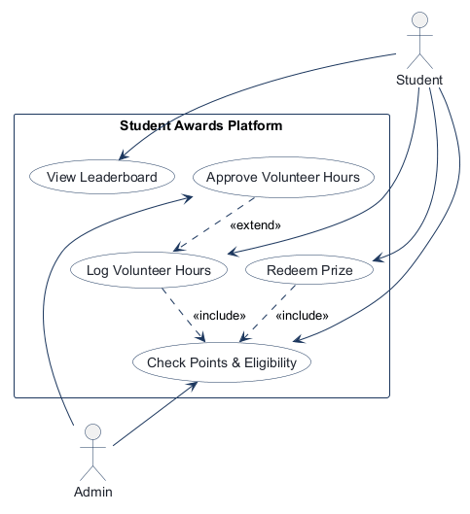
Students log hours, view the leaderboard and redeem prizes. Both logging hours and redeeming a prize include Check Points & Eligibility. Approve Volunteer Hours extends Log Volunteer Hours and is performed by the Admin; points are added only after approval.

3. Entity Relationship Diagram
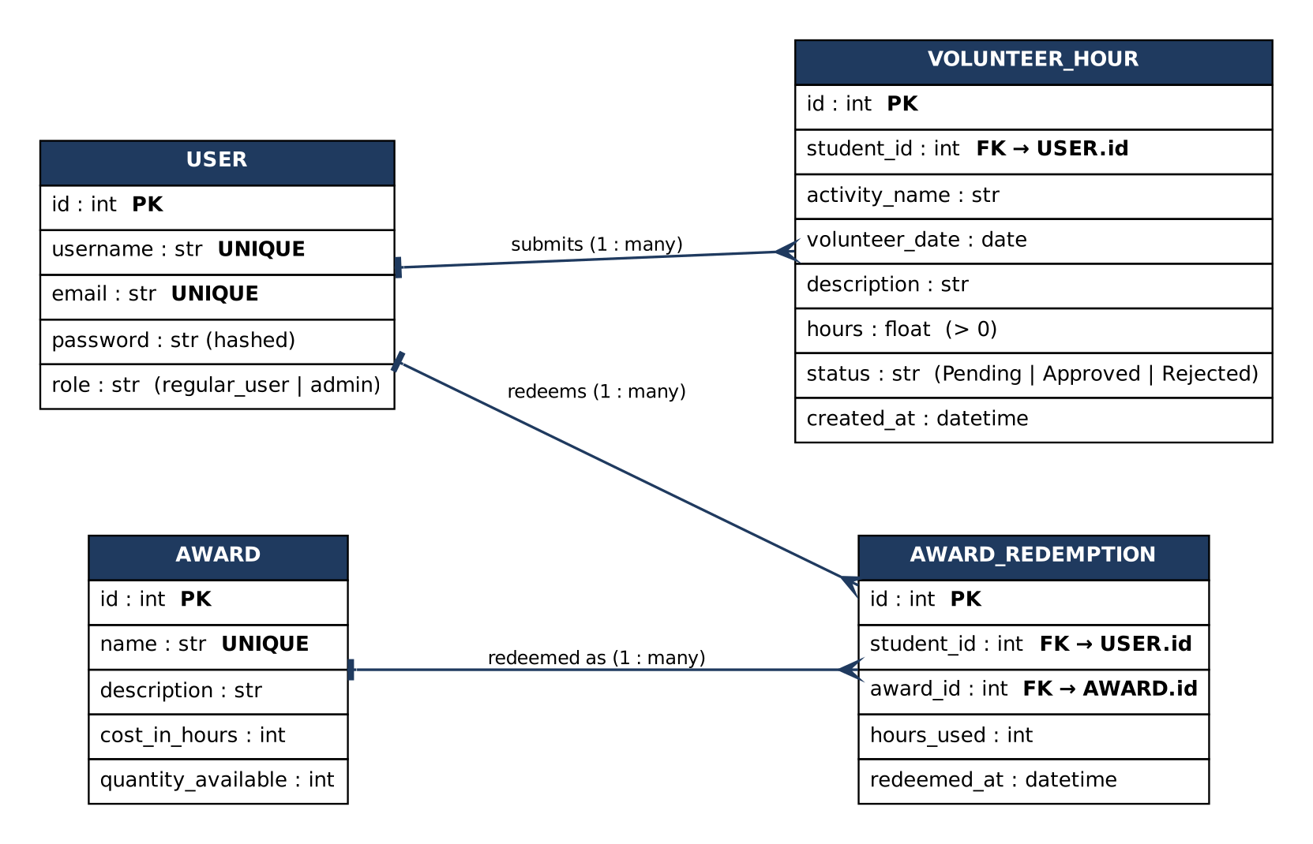
The ERD reflects the implemented models in app/models/user.py. Students and admins share the USER table and are distinguished by the role column. Only Approved VOLUNTEER_HOUR rows count towards a balance; balance = approved hours minus the sum of hours_used in AWARD_REDEMPTION.

4. Application Wireframe
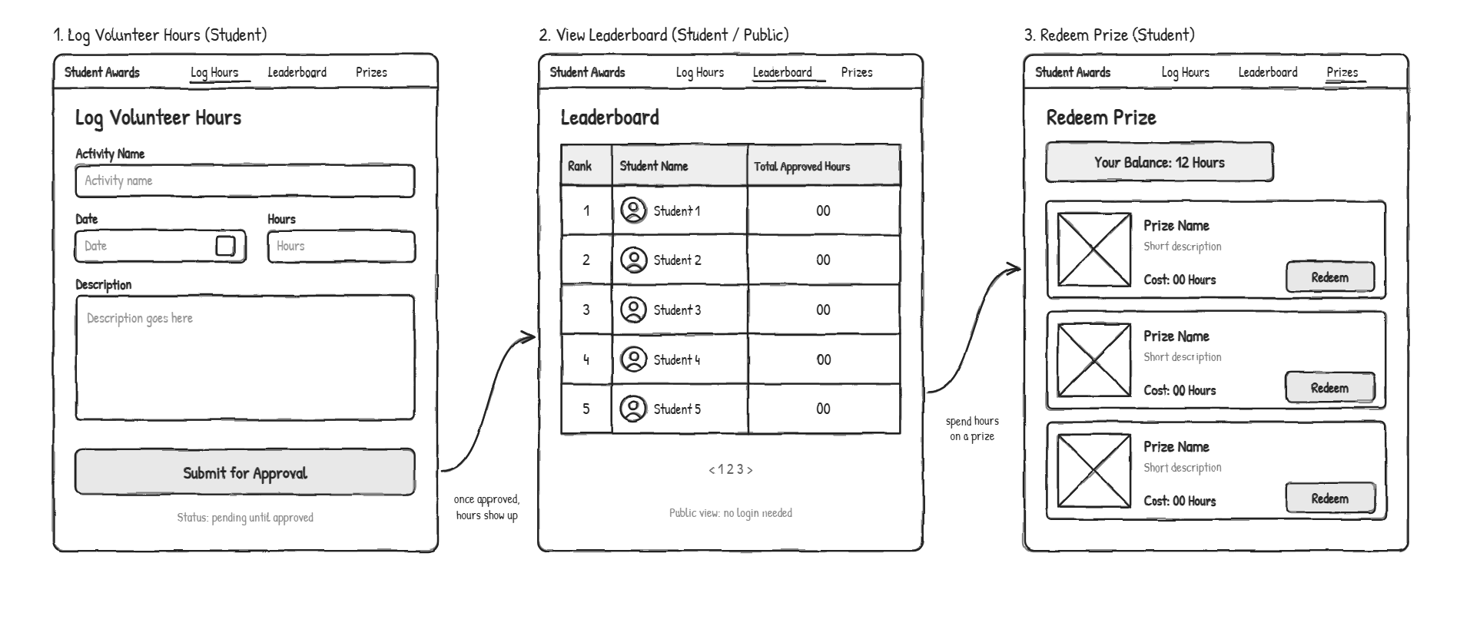
Wireframe 1 is Log Volunteer Hours, Wireframe 2 is the Leaderboard and Wireframe 3 is Redeem Prize. The User Acceptance Tests in section 5.1 refer to these screens.

5. Test Plans
Three levels of testing are planned. Unit tests check one module in isolation (services, repositories and utilities, each against its own in-memory database). Integration tests drive the real HTTP routes end to end (router, dependency, service, repository, database). User Acceptance Tests are performed by a person using the browser, against the wireframes.

5.1 User Acceptance Test Plan
Tester Name: ______________________________
Tester Position: ___________________________
Date of Test (DD/MM/YYYY): ______ / ______ / __________
Test data: sign in as the seeded accounts bob / bobpass (student) and admin / adminpass (admin), or register your own student. Mark the Success column with a tick when the criteria are met.
Test Case | Pre-conditions | Test Steps | Test Criteria | Success (✓)
1.1  Register | None. Not signed in. | 1. Open /register.  2. Enter a new username, email and password.  3. Press Register. | You are taken to the Sign in page and see "Registration completed! Sign in now!".
1.2  Duplicate registration | A user named bob already exists. | 1. Open /register.  2. Enter username bob with any email and password.  3. Press Register. | You stay on the Register page and see "Username or email already exists".
1.3  Student login | A student account exists. | 1. Open /login.  2. Enter bob / bobpass.  3. Press Sign in. | You land on Log Volunteer Hours (Wireframe 1). The top bar shows Log Hours, Leaderboard, Prizes and "Welcome, bob".
1.4  Invalid login | None. | 1. Open /login.  2. Enter bob with a wrong password.  3. Press Sign in. | You return to the Sign in page and see "Incorrect username or password". You are not signed in.
2.1  Log hours (Wireframe 1) | Signed in as a student. | 1. Open Log Hours.  2. Enter Activity Name "Food drive", pick a date, Hours 3, a description.  3. Press Submit for Approval. | You see "Volunteer hours submitted for approval." and the form is ready for another entry.
2.2  Hours below minimum | Signed in as a student. | 1. Open Log Hours.  2. Fill in all fields but enter 0 for Hours.  3. Press Submit for Approval. | The form is not submitted (the hours field enforces a minimum of 0.5) and no entry is created.
2.3  Pending hours earn nothing | Student has submitted hours that are not yet reviewed. | 1. Open Prizes (Wireframe 3).  2. Read Your Balance. | Balance does not include the pending hours.
3.1  Admin sees pending hours | Student has a pending entry. Signed in as admin. | 1. Sign in as admin / adminpass.  2. Look at the Pending volunteer approvals table. | The table lists the student, activity, date and hours, with Approve and Reject buttons.
3.2  Admin approves | A pending entry is shown (3.1). | 1. Press Approve on the entry. | You see "Volunteer hours approved." and the entry leaves the pending table.
3.3  Admin rejects | A second pending entry exists. | 1. Press Reject on the entry. | You see "Volunteer hours rejected." and the entry leaves the pending table.
3.4  Student blocked from admin | Signed in as a student. | 1. Type /admin into the address bar and press Enter. | An Unauthorized (401) page is shown with a Return to Login button. The approvals are not visible.
4.1  Public leaderboard (Wireframe 2) | At least one student has approved hours. Not signed in. | 1. Open /leaderboard without signing in. | The page loads without asking for a login and shows a table with Rank, Student Name and Total Approved Hours.
4.2  Leaderboard ranking | Two students have different approved hours. | 1. Open Leaderboard.  2. Compare the order with the hours shown. | Students are listed from most to fewest approved hours. Pending and rejected hours are not counted.
5.1  Prizes and balance (Wireframe 3) | Signed in as a student with approved hours. | 1. Open Prizes.  2. Compare Your Balance to the approved hours. | Balance equals approved hours minus hours already spent. Each prize card shows name, description and cost. Redeem is disabled for prizes costing more than the balance.
5.2  Redeem a prize | Balance is at least the cost of a prize. | 1. On Prizes, press Redeem on an affordable prize. | You see "You redeemed <prize name>." and the balance falls by exactly the prize cost.
5.3  Cannot afford a prize | Balance is lower than a prize's cost. | 1. On Prizes, look at that prize's Redeem button. | The Redeem button is disabled and no hours can be spent on it.
6.1  Log out | Signed in. | 1. Press Log out.  2. Use the browser Back button, or open /app. | You return to the Sign in page. Student pages show the Unauthorized page until you sign in again.

5.2 Unit Test Plan
Tool: pytest. Every test gets a fresh in-memory SQLite database from tests/conftest.py, so tests are isolated and independent. 77 unit test functions across 5 files in tests/unit/.
ID | Unit under test | Scenario and input | Expected result | Test class
U-01 | VolunteerHourService.submit_hours | Valid entry: student, "Tutoring", 2.5 hours | Saved with status Pending and float hours | TestSubmitHours
U-02 | submit_hours | Activity name and description padded with spaces | Stored trimmed | TestSubmitHours
U-03 | submit_hours | Hours of 0, -1 and -0.5 | ValueError "greater than zero"; nothing saved | TestSubmitHours
U-04 | list_for_student, get_pending | Entries for two students; Pending, Approved and Rejected mix | Only that student's entries; only Pending entries | TestListing
U-05 | approve, reject | Existing entry id | Status becomes Approved or Rejected | TestApproveAndReject
U-06 | approve, reject | Unknown id 9999 | ValueError "not found" | TestApproveAndReject
U-07 | get_balance | No hours; mixed statuses; redemptions; two students | 0 with no hours; only Approved counted; redemptions subtracted; per student | TestBalance
U-08 | get_leaderboard | Several students, mixed statuses, an admin | Descending by approved hours; pending and rejected score 0; admins excluded; zero-hour students listed; entries summed | TestLeaderboard
U-09 | AwardService.list_awards | Awards with different costs and stock | Sorted by cost ascending; out-of-stock hidden | TestListAwards
U-10 | AwardService.redeem | Balance above cost | Redemption records hours_used = cost; stock reduced by 1 | TestRedeem
U-11 | redeem | Balance exactly equal to cost (boundary) | Redemption succeeds | TestRedeem
U-12 | redeem | Balance 14.5 for a 15-hour prize | ValueError "Insufficient hours"; stock unchanged | TestRedeem
U-13 | redeem | Prize with stock 0; unknown prize id | ValueError "out of stock"; ValueError "Award not found" | TestRedeem
U-14 | AuthService.register_user | Valid details | Regular user created; password stored hashed | TestRegisterUser
U-15 | register_user | Duplicate username; duplicate email; invalid email | Exception raised in each case | TestRegisterUser
U-16 | AuthService.authenticate_user | Correct credentials | JWT whose sub is the user id and role is regular_user | TestAuthenticateUser
U-17 | authenticate_user | Wrong password; unknown user | None returned | TestAuthenticateUser
U-18 | UserRepository lookups | get_by_username and get_by_id, existing and missing | User returned; None when missing | TestUserRepository
U-19 | UserRepository.search_users | Filter text; page size 2 | Matches username or email; pagination totals correct | TestUserRepository
U-20 | update_user, delete_user | Valid and unknown ids | Updated or deleted; exception for unknown id | TestUserRepository
U-21 | UserService.get_all_users | Two users | Both returned | TestUserService
U-22 | encrypt_password, verify_password | Hash, rehash, verify right and wrong password | Hash differs from plaintext and is salted; verify true and false | TestPasswordHashing
U-23 | create_access_token | Claims, expiry, negative expiry | Claims and exp present; expired token rejected on decode; input not mutated | TestAccessToken
U-24 | access_token_cookie_kwargs | Development and production settings | Dev: lax, not secure. Prod: secure, samesite none. Always httponly | TestCookieFlags
U-25 | mask_secret, mask_database_uri | Secrets and database URLs | Only the tail shown; password hidden | TestConfigMasking
U-26 | sqlalchemy_uri, is_db_not_ready_error | postgres:// URLs; known and unknown errors | Scheme rewritten; DB-not-ready errors recognised, others not | TestSqlalchemyUri, TestIsDbNotReadyError
U-27 | Pagination | 21 items per 10; first and last pages | 3 pages; prev/next flags correct | TestPagination

5.3 Integration Test Plan
Tool: pytest with FastAPI's TestClient. The real application is used end to end; only the database session is replaced with a per-test in-memory database. Redirects are inspected as 303 responses unless a test needs the flash message on the destination page. 73 integration test functions across 5 files in tests/integration/.
ID | Area | Scenario and input | Expected result | Test class or file
I-01 | Health and public pages | GET /health, /login, /register, / | 200; health returns {"ok": true} | test_auth_flow
I-02 | Registration | POST /register with valid data | 303 to /login; student saved with hashed password; confirmation message | TestRegister
I-03 | Registration | Duplicate username or email; missing field | Redirect back to /register with error; missing field gives 422 | TestRegister
I-04 | Login | Student and admin credentials | 303 to /app or /admin; access_token cookie set | TestLogin
I-05 | Login | Wrong password; unknown user; missing credentials | 303 to /login with error and no cookie; 422 when missing | TestLogin
I-06 | Logout | Sign in, log out, request /app | 303 to /login; /app then returns 401 | TestLogout
I-07 | Authorization: anonymous | GET /app, /app/log-hours, /app/prizes, /admin | 401 Unauthorized page | TestAnonymousVisitors
I-08 | Authorization: anonymous | POST submit hours, redeem, approve, reject | 401; no data changed | TestAnonymousVisitors
I-09 | Authorization: public | GET /leaderboard without login | 200 | TestAnonymousVisitors
I-10 | Authorization: roles | Student requests /admin and posts approve or reject | 401; entry status unchanged | TestStudentCannotUseAdminFeatures
I-11 | Authorization: roles | Admin opens /admin | 200 with pending approvals panel | TestAdminAccess
I-12 | Authorization: tokens | Garbage, wrongly signed, expired, deleted-user token; role claim set to admin | All give 401; role is read from the database | TestInvalidTokens
I-13 | Log hours | POST /app/volunteer-hours with valid data | 303 to /app/log-hours; Pending row saved for the student; success message | TestSubmitHours
I-14 | Log hours | Hours 0 and -3 | Error shown; nothing saved | TestSubmitHours
I-15 | Log hours | Missing activity, invalid date, non-numeric hours | 422; nothing saved | TestSubmitHours
I-16 | Log hours | Pending entry, then view Prizes | Balance still 0.0 Hours | TestSubmitHours
I-17 | Admin approval | Dashboard with and without pending entries | Entries listed; empty-state message | TestAdminApproval
I-18 | Admin approval | Approve a pending entry | 303 to /admin; status Approved; leaves pending list; message; student balance rises | TestAdminApproval
I-19 | Admin approval | Reject a pending entry | Status Rejected; message; balance unchanged | TestAdminApproval
I-20 | Admin approval | Approve unknown id | "Volunteer hour not found" error shown | TestAdminApproval
I-21 | Leaderboard | Students with approved, pending and admin hours; empty database | Ranked by approved hours; pending and admin excluded; empty-state message; works when signed in | TestLeaderboard
I-22 | Prizes page | Balance, available prizes, sold-out prize | Balance and prizes shown; sold-out hidden; Redeem disabled when unaffordable, enabled when affordable | TestPrizesPage
I-23 | Redeem | Affordable prize | 303 to /app/prizes; stock down by 1; redemption row saved; balance deducted; success message | TestRedeem
I-24 | Redeem | Insufficient hours; only pending hours | "Insufficient hours"; stock, balance and redemptions unchanged | TestRedeem
I-25 | Redeem | Out-of-stock prize; unknown id; non-integer id; last item twice | Out-of-stock and not-found errors; 422 for non-integer; second redeem of last item refused | TestRedeem
I-26 | JSON API | GET /api/users | 200 JSON list; each item has only id, username, email; no password; [] when empty | TestUsersApi
I-27 | End to end | Register, log 12 hours, fail to redeem, admin approves, appears on leaderboard, redeem | Every step behaves as specified; final balance 2.0 Hours | test_full_journey_register_log_approve_rank_redeem

6. Implementation
Repository: https://github.com/yunlongdev/COMP3613_Assignment_1

6.1 Test layout
tests/
conftest.py shared fixtures
unit/
test_volunteer_hour_service.py U-01 .. U-08
test_award_service.py U-09 .. U-13
test_user_and_auth_service.py U-14 .. U-21
test_security.py U-22 .. U-25
test_database_helpers.py U-26, U-27
integration/
test_auth_flow.py I-01 .. I-06
test_authorization.py I-07 .. I-12
test_volunteer_hours.py I-13 .. I-20
test_leaderboard_and_prizes.py I-21 .. I-25
test_api_and_end_to_end.py I-26, I-27
postman/
StudentAwards_API.postman_collection.json
Local.postman_environment.json
Render.postman_environment.json

6.2 Running the tests from the command line
pip install -r requirements.txt
pytest tests/unit -v # unit tests
pytest tests/integration -v # integration tests
pytest # everything (150 tests)

6.3 Unit tests
Unit tests call services, repositories and utilities directly with an isolated database. Example from tests/unit/test_award_service.py:
def test_insufficient_balance_changes_nothing(self, service, session, student, make_award):
award = make_award(cost=15, stock=3)
with pytest.raises(ValueError):
service.redeem(student.id, award.id, balance_hours=1)
assert AwardRepository(session).get_by_id(award.id).quantity_available == 3

6.4 Integration tests
Integration tests send real HTTP requests through the whole stack, signing in through /login so the cookie is set exactly as in the browser. Example from tests/integration/test_authorization.py:
def test_student_cannot_approve_own_hours(self, client, session, student, make_hour, login):
entry = make_hour(student.id)
login("bob", STUDENT_PASSWORD)
response = client.post(f"/admin/approve-hour/{entry.id}")
assert response.status_code == 401
session.refresh(entry)
assert entry.status == "Pending"

6.5 API tests (Postman)
The collection postman/StudentAwards_API.postman_collection.json holds 44 requests in 10 folders with 96 assertions: public endpoints, anonymous and role-based authorization, registration and login, logging hours, admin approve and reject, leaderboard, redemption, the JSON API and logout. It registers a fresh student on every run and reads the pending entry ids out of the admin page, so it can be re-run without editing. Run it in order with the Collection Runner.
python manage.py init --drop # seed bob, admin and 3 prizes (stock 10)
python manage.py run # start the app on http://localhost:5000
# Postman: import the collection and Local environment, select Local, press Run.
# Each run redeems one prize. Re-seed with init --drop after about 10 runs.

Example test script from the collection (login as student):
pm.test("Status is 303 See Other", function () { pm.response.to.have.status(303); });
pm.test("Redirects to student home /app", function () {
pm.expect(pm.response.headers.get("Location")).to.match(/\/app$/);
});
pm.test("access_token cookie is set", function () { pm.expect(pm.cookies.has("access_token")).to.be.true; });

7. Test Reports

7.1 Unit Tests Report
[ INSERT SCREENSHOT ]
Unit tests: all passing
Run: pytest tests/unit -v and screenshot the terminal showing the final line (77 passed).

7.2 Integration Tests Report
[ INSERT SCREENSHOT ]
Integration tests: all passing
Run: pytest tests/integration -v and screenshot the terminal showing the final line (73 passed).

7.3 Postman Collection Run Report
[ INSERT SCREENSHOT ]
Postman Collection Runner: all passing
Run the collection against Local, then screenshot the Runner results (44 requests, 96 tests passed, 0 failed).

7.4 User Acceptance Test Report
The completed User Acceptance Test table (section 5.1) is the UAT report. Have a tester other than the developer follow each test case, fill in the tester name, position and date, and tick the Success column for every case that meets its criteria. Add the completed table or a photo or scan of it here.

7.5 Defect found during testing
ID | Found by | Defect | Resolution
D-01 | Integration tests: TestAnonymousVisitors, TestStudentCannotUseAdminFeatures; Postman folder 2 | Requests without permission were refused by showing the Unauthorized page, but with HTTP status 200 instead of 401, so clients could not tell that access was denied. | app/main.py: the 401 handler now returns the page with status_code=401. All authorization tests pass.

