German Ilyin

System Overview

General View
Here is the general view of my system.
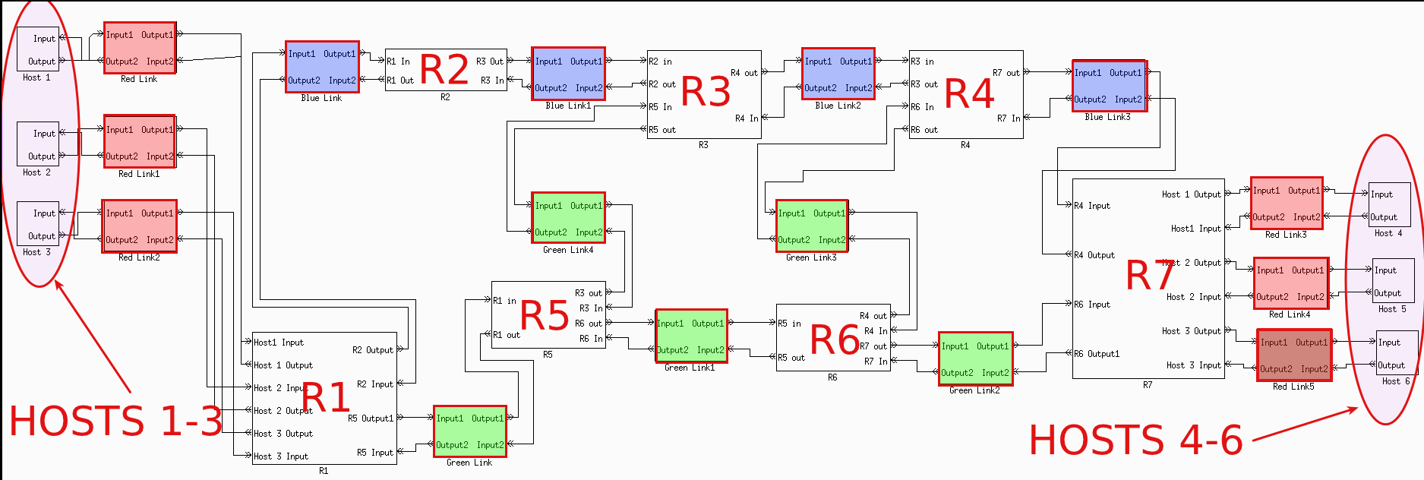
It consists of 6 host blocks, 7 router blocks, 6 red link blocks, 4 blue link blocks and 5 green link blocks.

Host

Host General View
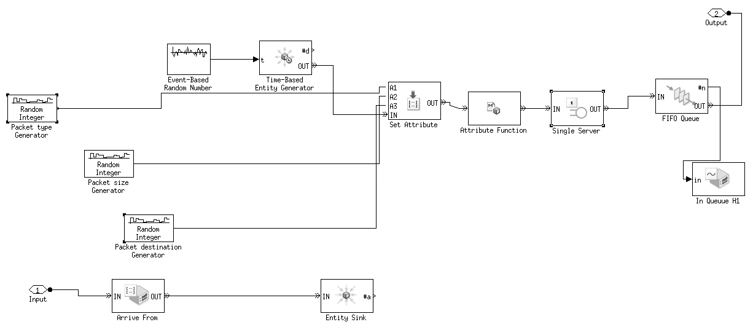
The main parts of one host block are 3 Random Integer Blocks, Event Based Random Number, Time Based Entity generator, Set Attribute block. Other blocks are not required but necessary for observation and etc.

Host Entity generation
For Entity generation we use Event-Based Random Number(EBRN) block. It's set to use Poisson distribution.
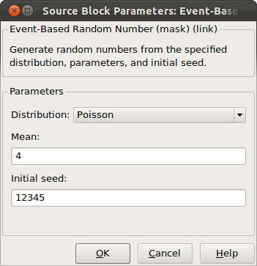
Time based Entity generator is connected to EBRN on port t. So the generation of each next entity depends on Poisson distribution of EBRN.
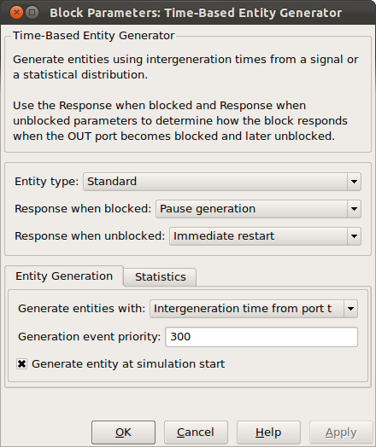

Host Entity Attributes generation
Each of them is used for Packet type generation, Packet size generation, Packet destination generation. This block uses uniform distribution.
