LABWORK #1

By German Ilyin
Table of Contents
Input and Output 3
Arithmetic 3
Algebra 4
Symbolic Expressions, Variable Precision, and Exact Arithmetic 5
Managing Variables 6
Errors in Input 7
Online Help 7
Variables and assignments 7
Solving Equations 8
Vectors and matrices 10
Matrices 11
Functions/Built-in 12
Functions/User-defined 12
Graphics 13
Graphing with ezplot 13
Modifying Graphs 14
Graphing with plot 14
Plotting Multiple Curves 15

Input and Output
>> % this is a comment :)
>> 1/2 + 1/3

ans =

0.8333

>> % simple arithmetic operation

>> ezplot('x^3-x')

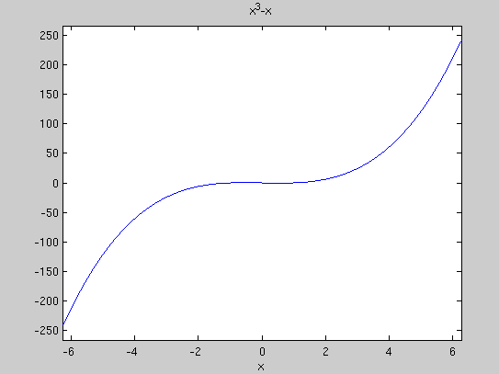
>> % Easy to use function plotter
>> % EZPLOT(FUN) plots the function FUN(X) over the default domain
>> % -2*PI < X < 2*PI, where FUN(X) is an explicitly defined function of X.

Arithmetic
>> 3^2 - (5 + 4)/2 + 6*3

ans =

22.5000

>> ans^2 + sqrt(ans)

ans =

510.9934

>> u = cos(10)

u =

-0.8391

>> v = sin(10)

v =

-0.5440

>> u^2 + v^2

ans =

1

>> % simple arithmetic operations with trigonometric functions.
>> % everything is double valued, percision is kept till 15'th digit.
>> % by default doubles are displayed shortly to display more than 4 digits use:

>> format long

>> u

u =

-0.839071529076452

>> format short
>> u

u =

-0.8391

Algebra

>> % there is such stuff as symbolic calculations
>> % pretty cool stuff
>> syms x y
>> % to declare somthing as a symbolic object we use command syms
>> (x - y)*(x - y)^2

ans =

(x - y)^3
>> % to expand symbolic expression use
>> expand(ans)

ans =

x^3 - 3*x^2*y + 3*x*y^2 - y^3

>> % to factor symbolic expression use
>> factor(ans)

ans =

(x — y)^3

>> % to simplify symbolic expression use
>> simplify((x^3 - y^3)/(x - y))

ans =

x^2 + x*y + y^2

>> simplify(sin(x)*cos(y) + cos(x)*sin(y))

ans =

sin(x + y)

>> % there is also such function `simple`.
>> % it's function is same with `simplify` but it's a little bit wiered

Symbolic Expressions, Variable Precision, and Exact Arithmetic
>> % here we get very small result but not zero as expected.
>> % Because of loss of percision
>> cos(pi/2)

ans =

6.1232e-17

>> % sym converts an expression into a symbolic object
>> cos(sym('pi/2'))

ans =

0
>> sym('1/2') + sym('1/3')

ans =

5/6

>> % Variable precision arithmetic. Calculates with set D percision
>> % Using SYMs gives best percision
>> vpa('sqrt(2)',50)

ans =

1.4142135623730950488016887242096980785696718753769

>> 3^45

ans =

2.9543e+21

>> % Here percision is lost
>> vpa(3^45)

ans =

2954312706550833610752.0

>> % Here percision is not lost
>> vpa('3^45')

ans =

2954312706550833698643.0

Managing Variables

>> % shows all defined variables, their size and type
>> whos
Name Size Bytes Class Attributes

u 1x1 8 double
v 1x1 8 double
x 1x1 112 sym
y 1x1 112 sym

>> u = pi

u =

3.1416

>> v = 'pi'

v =

pi

>> w = sym('pi')

w =

pi

>> % here we see what are types of variables we just defined
>> whos
Name Size Bytes Class Attributes

u 1x1 8 double
v 1x2 4 char
w 1x1 112 sym
x 1x1 112 sym
y 1x1 112 sym

>> % functions expect appropriate type. Error accure If wrong type is specified
>> sin('pi')
??? Undefined function or method 'sin' for input arguments of type 'char'.

>> % we can clear some variables from memory
>> clear x y
>> whos
Name Size Bytes Class Attributes

u 1x1 8 double
v 1x2 4 char
w 1x1 112 sym

>> % or clear all of them. This is good aproach on start of new calculations
>> clear
>> whos

Errors in Input
>> % We forgot multiplication sign. Marker shows expected place of error.
>> 3u^2
??? 3u^2
|
Error: Unexpected MATLAB expression.

Online Help
>> % commands help, more, lookfor, lookfor -all are used to find help
>> help solve
SOLVE Symbolic solution of algebraic equations.
SOLVE('eqn1','eqn2',...,'eqnN')
SOLVE('eqn1','eqn2',...,'eqnN','var1,var2,...,varN')
SOLVE('eqn1','eqn2',...,'eqnN','var1','var2',...'varN')
>> help solve
>> help more
>> more on
>> lookfor factor

Variables and assignments
>> % simple assignment
>> x = 7

x =

7

>> % variable y is indeed undefined
>> x^2 - 2*x*y + y
??? Undefined function or variable 'y'.
>> % creating an symbolic expression
>> syms y
>> x^2 - 2*x*y + y

ans =

49 - 13*y

>> clear x; syms x y
>> z = x^2 - 2*x*y + y

z =

x^2 - 2*y*x + y

>> 5*y*z

ans =

5*y*(x^2 - 2*y*x + y)

>> more off

Solving Equations
>> % solve function solves equations
>> solve('x^2 - 2*x -4 = 0')

ans =

5^(1/2) + 1
1 - 5^(1/2)

>> % the result is sym object
>> whos
Name Size Bytes Class Attributes

ans 2x1 112 sym

>> % to cast result to double do double()
>> double(ans)

ans =

3.2361
-1.2361

>> whos
Name Size Bytes Class Attributes

ans 2x1 16 double

>> % here x will contain solutions of x and y solutions of y
>> [x, y] = solve('x^2 - y = 2','y - 2*x = 5')

x =

2*2^(1/2) + 1
1 - 2*2^(1/2)

y =

4*2^(1/2) + 7
7 - 4*2^(1/2)

>> % getting first element in array
>> x(1)

ans =

2*2^(1/2) + 1

>> y(1)

ans =

4*2^(1/2) + 7

>> % here result is vector
>> sol = solve('x^2 - y = 2','y - 2*x = 5')

sol =

x: [2x1 sym]
y: [2x1 sym]

>> % which has two attributes x and y
>> sol.x

ans =

2*2^(1/2) + 1
1 - 2*2^(1/2)

>> sol.x(1)

ans =

2*2^(1/2) + 1

>> % here result is double
>> solve('sin(x) = 2 - x')

ans =

1.1060601577062719106167372970301

>> solve('exp(-x) = sin(x)')

ans =

0.5885327439818610774324520457029

>> % fzero finds point at which equation is zero near some set point
>> fzero(inline('exp(-x) - sin(x)'),0.5)

ans =

0.5885

>> % inline converts string expression into inline function
>> inline('sin(x) = exp(-x)')

ans =

Inline function:
ans(x) = sin(x) = exp(-x)

Vectors and matrices
>> % this is a vector aka array
>> Z = [2,3,4,5]

Z =

2 3 4 5
>> % also can be defined by range. Step is 1 by default
>> x = 1:9

x =

1 2 3 4 5 6 7 8 9

>> % range with step 2
>> s = 0:2:8

s =

0 2 4 6 8

>> % access to first element of vector. Indexing starts from 1 not 0 as C or Java
>> s(1)

ans =

0

>> % transposition of vector or matix by '
>> s'

ans =

0
2
4
6
8

>> % . defines that operation is done on each element of the array
>> s.^2

ans =

0 4 16 36 64

Matrices
>> % matrix can be set like this. Rows separated by ;
>> A = [1,2,3,4;5,6,7,8;9,10,11,12]

A =

1 2 3 4
5 6 7 8
9 10 11 12
>> % adding scalar and assigning result to B
>> B = A+2

B =

3 4 5 6
7 8 9 10
11 12 13 14

>> % summation
>> A+B

ans =

4 6 8 10
12 14 16 18
20 22 24 26

>> % multiplication. Here error is poped out because of invalid sizes.
>> A*B
??? Error using ==> mtimes
Inner matrix dimensions must agree.

>> % we need to transpose one of them
>> A*B'

ans =

50 90 130
122 226 330
194 362 530

Functions/Built-in
>> % there are many biult-in functions, use lookfor, google :)
>> log(exp(3))

ans =

3

>> i

ans =

0 + 1.0000i

>> Inf

ans =

Inf

>> sin(sym('2*pi/3'))

ans =

3^(1/2)/2

>> vpa(sin(sym('2*pi/3')),20)

ans =

0.86602540378443864676

Functions/User-defined
>> % we can define inline functions like this
>> f = inline('x^2 + x + 1')

f =

Inline function:
f(x) = x^2 + x + 1

>> f(4)

ans =

21
>> % to be able to operate on matrices we use:
>> f = inline(vectorize('x^2 + x + 1'), 'x')

f =

Inline function:
f(x) = x.^2 + x + 1

>> f(1:5)

ans =

3 7 13 21 31
>> % we also can specify more than one argument
>> g = inline('u^2 + v^2','u','v')

g =

Inline function:
g(u,v) = u^2 + v^2

>> g(3,4)

ans =

25

Graphics

Graphing with ezplot
>> % most simple way of plotting is ezplot
>> % set sym of string representation of function and limits
>> ezplot('x^2+x+1',[-2 2])

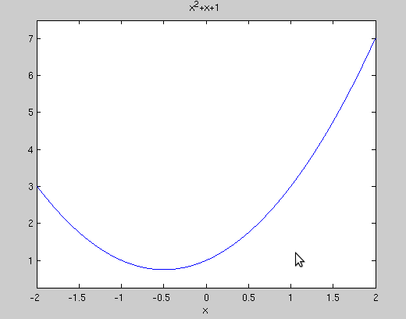
>> % here we use sym expression
>> % the result is same with previous
>> syms x
>> ezplot(x^2+x+1, [-2 2])
>> % the curve looks same as previous, but axis is different
>> ezplot(x^2+x+3, [-2 2])

Modifying Graphs
>> % we can modify title of graph
>> title 'A parabola'
>> % and axis ranges
>> axis([-2 2 1 4])

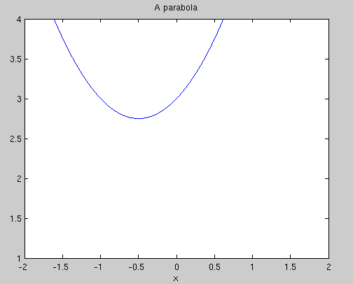

Graphing with plot
>> % plot is operation on values
>> X = [1,2,3];
>> Y = [4,6,2]

Y =

4 6 2
>> % X vector contains is x values and Y vector Y values
>> plot(X,Y)
>> % or it can be calculated
>> X = -2:0.1:2;
>> plot(X,X.^2+X+1)
>> % or using inline function
>> f = inline(vectorize('x^2+x+1'),'x')

f =

Inline function:
f(x) = x.^2+x+1

>> plot(X,f(X))

Plotting Multiple Curves
>> % to combine two graphs on one plot use hold on
>> hold on
>> % first one
>> plot(X,f(X))
>> X = [1,2,3];
>> Y = [4,6,2]

Y =

4 6 2
>> % second one
>> plot(X,Y)
>> % hold off for disabling combination of graphs starting from this point
>> hold off
>> title 'Combined plots'

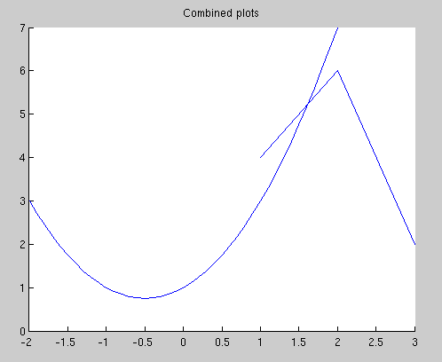

>> X = -2:0.1:2;
>> plot(X, sin(X), X, exp(-X))
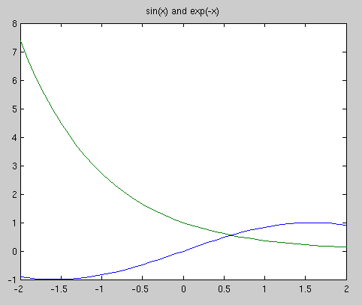
>> title 'sin(x) and exp(-x)'

