LABWORK #2

By German Ilyin

Table of Contents
LABWORK #2 1
By German Ilyin 1
Supressing Output 3
Data Classes 3
String Manipulation 4
Symbolic and Floating Point Numbers 4
Functions and Expressions 5
Substitution 5
More about M-Files 6
Variables in Script M-Files 6
Variables in Function M-Files 6
Complex Arithmetic 7
More on Matrices 7
Solving Linear Subsystems 8
Calculating Eigenvalues and Eigenvectors 9
Doing Calculus with Matlab 9
Differentiation 9
Integration 10
Limits 11
Sums and Products 11
Taylor Series 12
Default Variables 12

Two-Dimensional Plots
This section is appointed to explaining of graphics, ways of drawing curve in x-y plane.Describes two main techniques for plotting such curves: parametric plotting and implicit plotting.

Parametruc Plots
When y is not expressed as a function of, but x and y are both expressed as function of some parameter(in our case it is T — runs from 0 to1), we can draw x-y curve as follow:
>> T = 0:0.01:1;
>> plot(cos(2*pi*T), sin(2*pi*T))
>> axis square

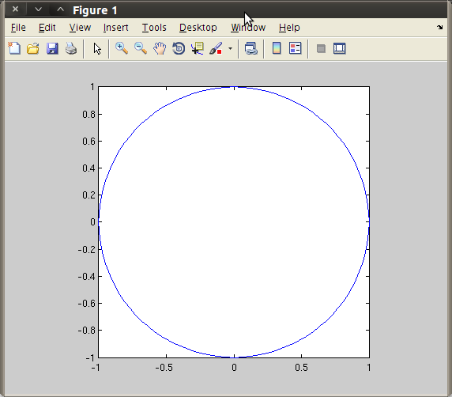

We can draw this parametric plotting in such way:

>> ezplot(’cos(t)’, ’sin(t)’, [0 2*pi]);
>> axis square

and obtain same picture

Contour Plots and Implicit Plots
>> [X Y] = meshgrid(-3:0.1:3, -3:0.1:3);
>> contour(X, Y, X.ˆ2 + Y.ˆ2)
>> axis square

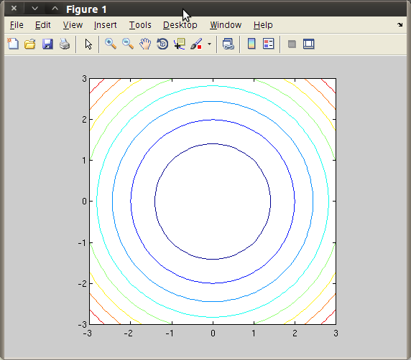

The level curves of x^2 + y^2 are circles centered
at the origin, and the levels are the squares of the radii of the circles

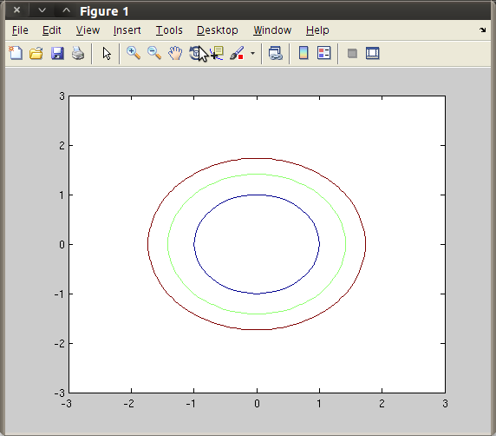

>> contour(X, Y, X.ˆ2 + Y.ˆ2, [1 2 3])

With additional vector argument to command contour we can plot the circle with radii 1,sqrt(2),sqrt(3). The number of elemens in vector argument must be at least 2.

But if you want to plot single level set,you must specify the same level twice. For example,if we want to plot circle of radii 1,in vector argument we must specify the level 1 twice as follow

>>contour(X, Y, X.^2 + Y.^2,[1 1])

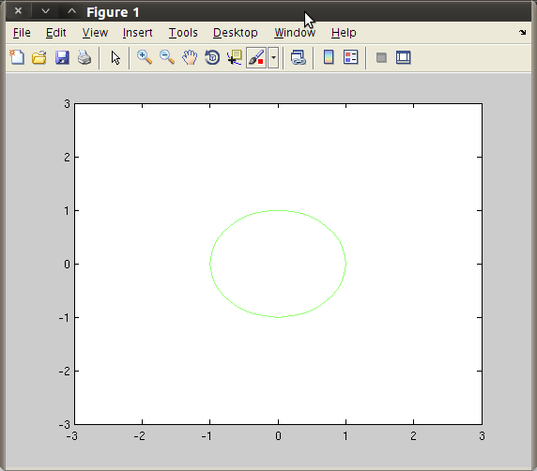

Another example of plotting lemniscate x^2 − y^2 = (x^2 + y^2 )^2

>>[X Y] = meshgrid(-1.1:0.01:1.1, -1.1:0.01:1.1);
>> contour(X, Y, (X.ˆ2 + Y.ˆ2).ˆ2 - X.ˆ2 + Y.ˆ2, [0 0])
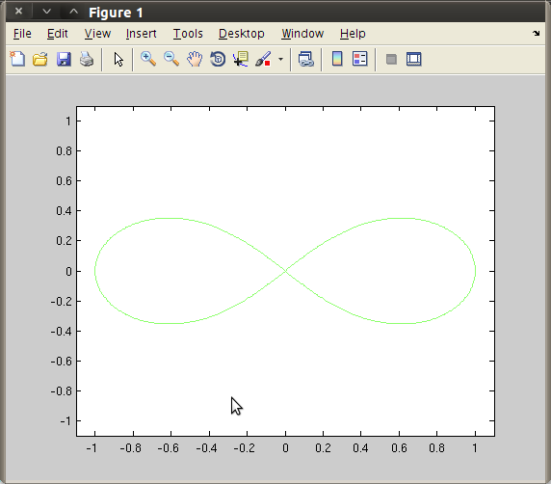
>> axis square

The same curves we can plot with commant excontour

>> ezcontour(’xˆ2 + yˆ2’, [-3, 3], [-3, 3]);
this result of this code is similar to

>> [X Y] = meshgrid(-3:0.1:3, -3:0.1:3);
>> contour(X, Y, X.ˆ2 + Y.ˆ2)

Field Plots
quiver — is used to plot array of arrows

>> [x, y] = meshgrid(-1.1:.2:1.1, -1.1:.2:1.1);
>> quiver(x, -y); axis equal; axis off

This piece of code plots a vector field with a “saddle point,” corresponding to a combination of an attractive force pointing toward the x axis and a repulsive force pointing away from the y axis
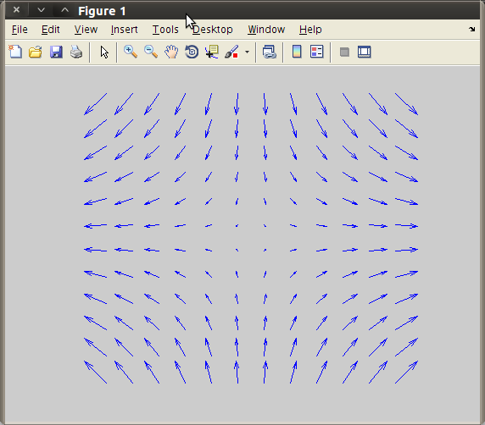

Three-Dimentional Plots

Curves in Three-Dimensional Space

To plot 2 dimentional curve we use basic commmand plot3, it works in the same ways as plot, difference is that it take 3 vector(x,y,z).
Example:

>> T = -2:0.01:2;
>> plot3(cos(2*pi*T), sin(2*pi*T), T)
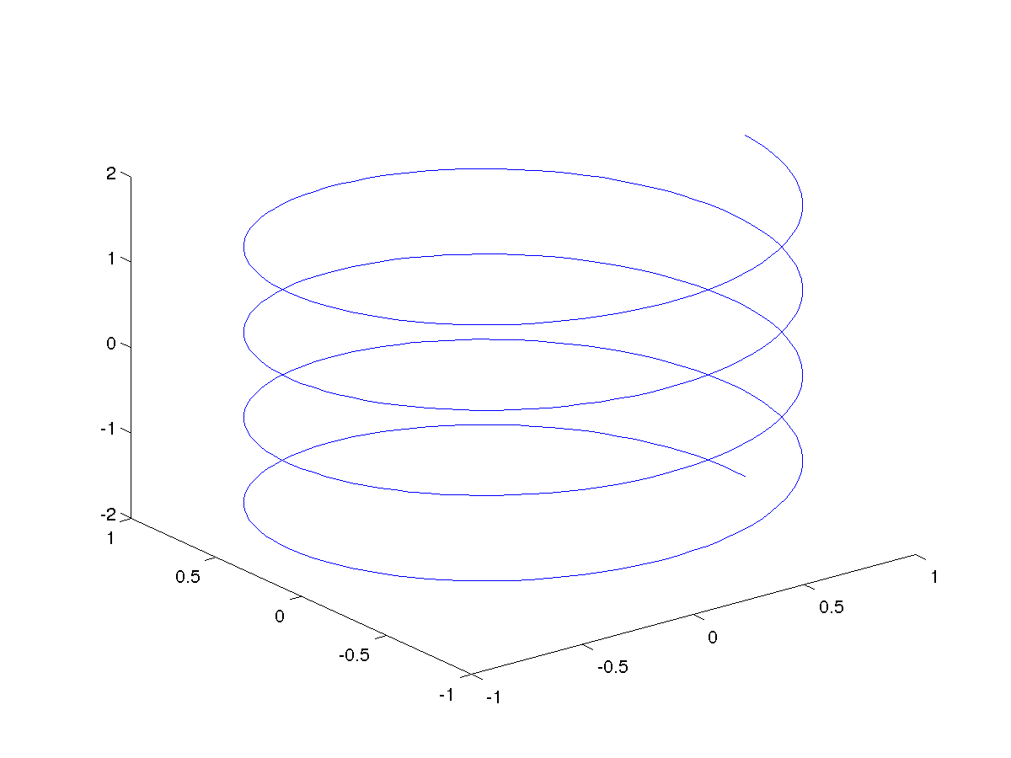

We can obtain the same curve by typing
>> ezplot3(’cos(2*pi*t)’, ’sin(2*pi*t)’, ’t’, [-2, 2])
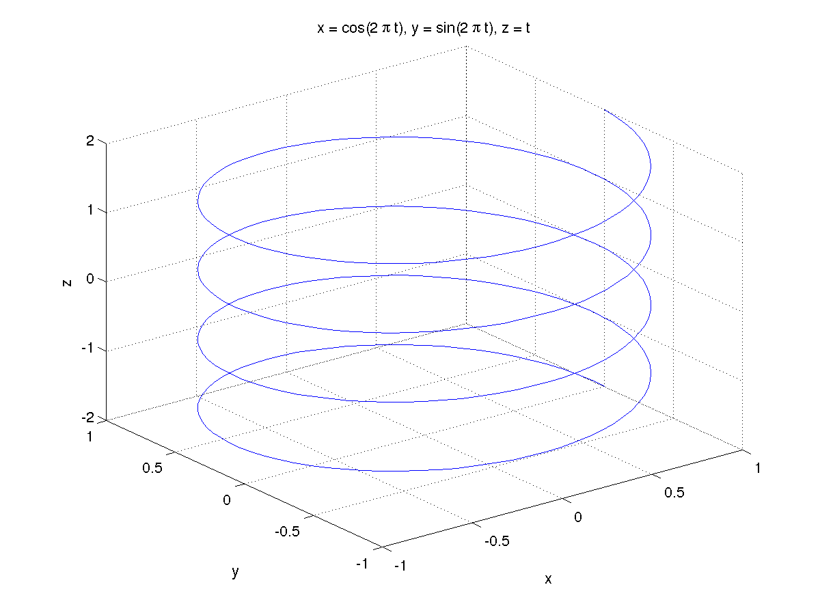

Surfaces in Three-Dimensional Space
Plotting surface in 3-space using command mesh

>> [X,Y] = meshgrid(-2:.1:2, -2:.1:2);
>> Z = X.ˆ2 - Y.ˆ2;
>> mesh(X, Y, Z)

First we give grid ti X and Y, and plot the Z as z = f(x,y)
In this example we plot the z = x^2-y^2

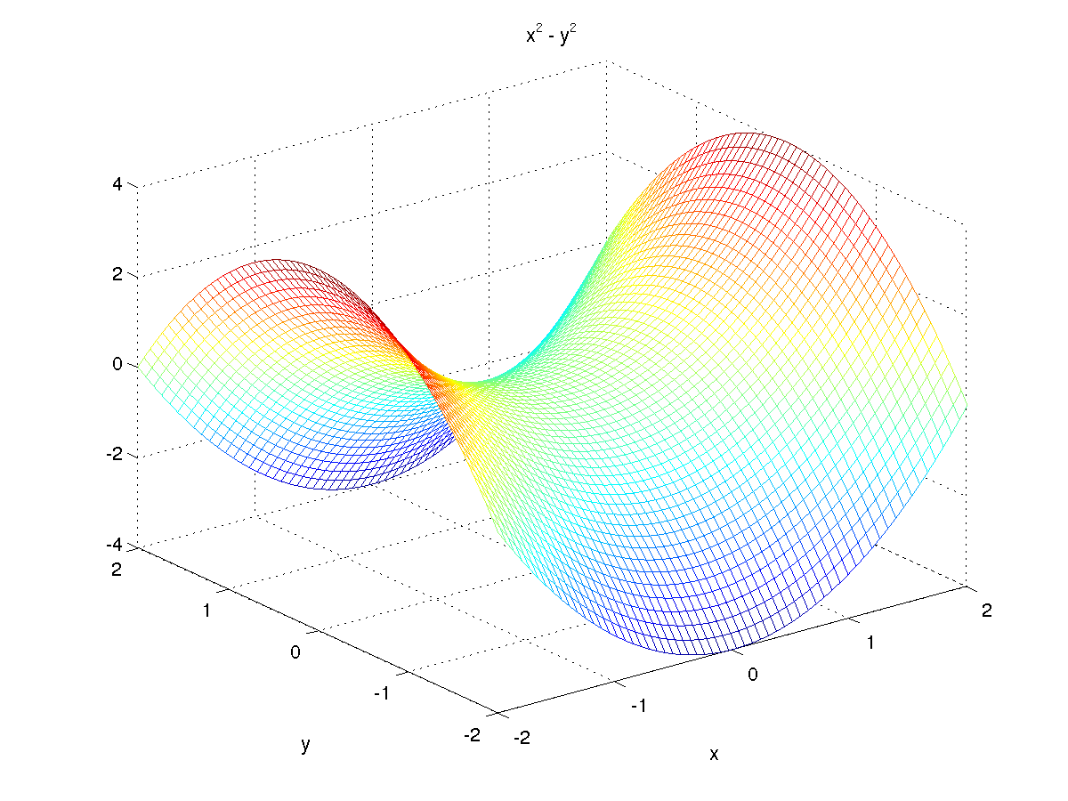

The same result we can get from

>> ezmesh(’xˆ2 - yˆ2’, [-2, 2], [-2, 2])

In this example we consider the case when we represent the equation in the form of z = f(x,y).

If we want to plot the surface where we cannot to do such representation, it's better to parameterize the surface in some coordiane system.

x^2+y^2+z^2=1
r^2+z^2=1
r = sqrt(1-z^2)
and
x = sqrt(1-z^2)cosΘ
y = sqrt(1-z^2)sinΘ

>> [theta, Z] = meshgrid((0:0.1:2)*pi, (-1:0.1:1));
>> X = sqrt(1 — Z.ˆ2).*cos(theta);
>> Y = sqrt(1 - Z.ˆ2).*sin(theta);
>> surf(X, Y, Z);
>> axis square ;

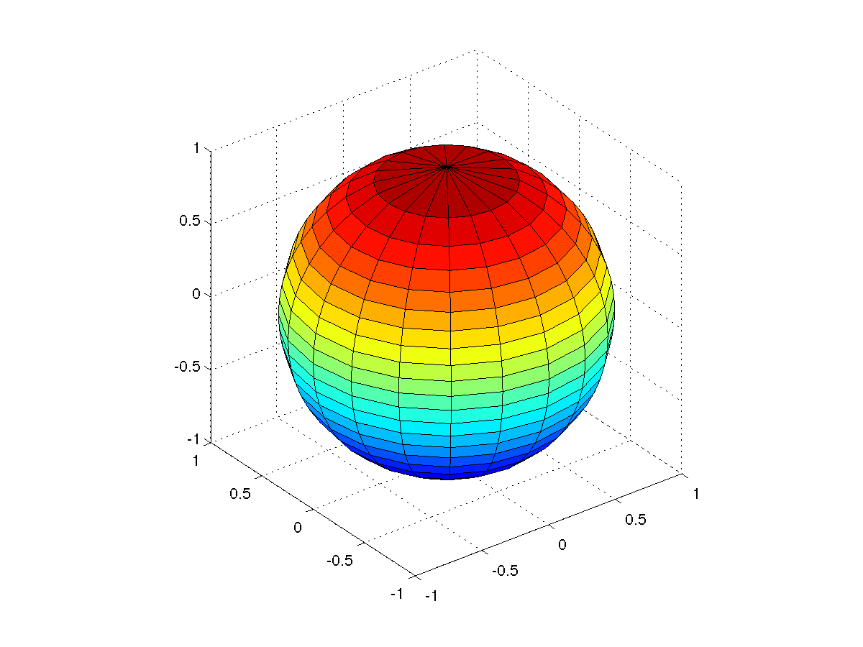

As in the previous example, this operation can be simplified with code

>> ezsurf('sqrt(1-s^2)*cos(t)','sqrt(1-s^2)*sin(t)','s',[-1,1,0,2*pi])
>> axis equal;
and we obtain almost similar example.

Special Effects

Combining Figures in One Window
>> x = 0:0.05:40;
>> for j = 1:4, subplot(2,2,j)
plot(x, besselj(j*ones(size(x)),x))
end

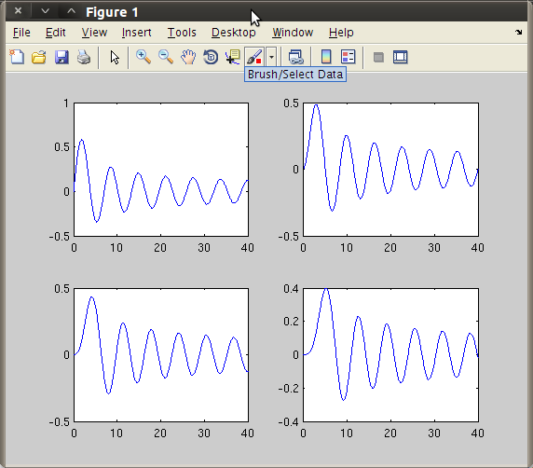

Animations
Simple animation of circular motion.
>> t = 0:0.01*pi:2*pi;
>> figure; axis equal; axis([-1 1 -1 1]); hold on
>> comet(cos(t), sin(t))
First we assign the grid to x and y,obtain coordinate system,and draw the circle with radii 1.
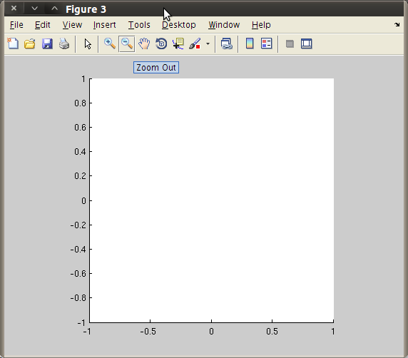
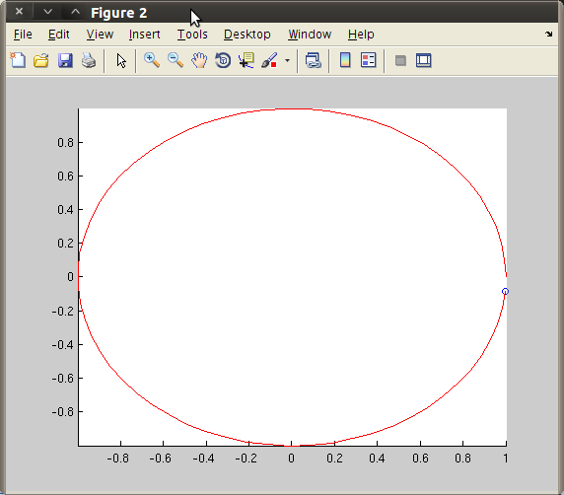

Using gerframe and movie:

>> x = 0:0.01:1;
>> for j = 0:50
plot(x, sin(j*pi/5)*sin(pi*x)), axis([0, 1, -2, 2])
M(j+1) = getframe;
end
>> movie(M)

Customizing and Manipulating Graphics

Change of Viewpoint

Change of Plot Style

Full-Fledged Customization

Quick Plot Editing in the Figure Window

Sound

