**Practical 5.**

**Aim:** Develop RMI Application with database connectivity.   
The backend database can be Oracle, MySQL, Postgress, IBMDB2 etc.  
  
The RMI application should have following choices to interact with the database  
table.   
1] Insert  
  
2] Update  
  
3] Delete  
  
4] Select  
  
5] Select with Where Condition

**Code: Files are attached with the document.**

**Output :**

**Client Side:**

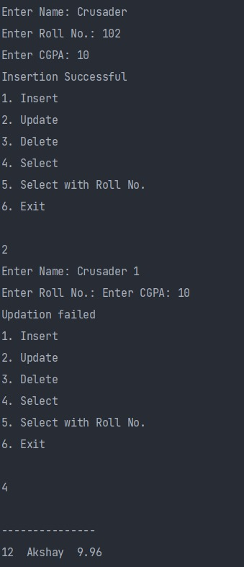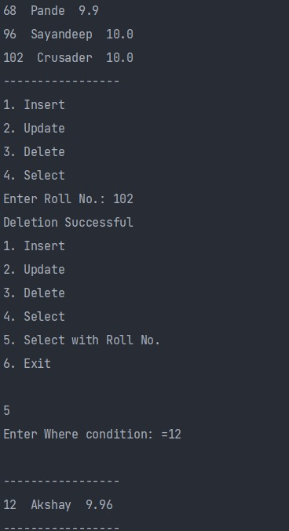

**Server Side:**

