**Practical 6:**

**Aim: Implementation of 3pc protocol using java RMI**

**Output:**

**Server**

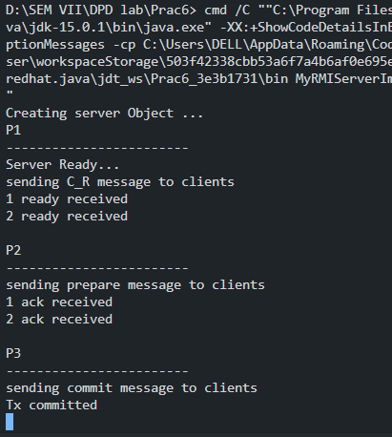

**Participant 1:**

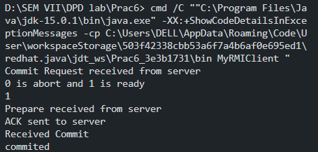

**Participant 2:**

