badface_clear

**讀檔案**

library(readr)  
data<-read_csv("C:/Users/student/Desktop/專題/all_rate.csv")

## Rows: 160121 Columns: 142

## -- Column specification --------------------------------------------------------  
## Delimiter: ","  
## chr (2): Name, Label  
## dbl (140): Sex, Country, Eye_R_S_W, Eye_R_B_W, Eye_L_S_W, Eye_L_B_W, Eye_R_H...

##   
## i Use `spec()` to retrieve the full column specification for this data.  
## i Specify the column types or set `show_col_types = FALSE` to quiet this message.

face<-data

**絕對值(右臉寬-左臉寬)**

face$profile<-abs(face$face_R_width_W-face$face_L_width_W)

**看前5筆**

head(face$profile)

## [1] 0.03025969 0.27953678 0.19500737 0.18276992 0.11319639 0.35371712

**側臉數值的直方圖**

hist(face$profile)

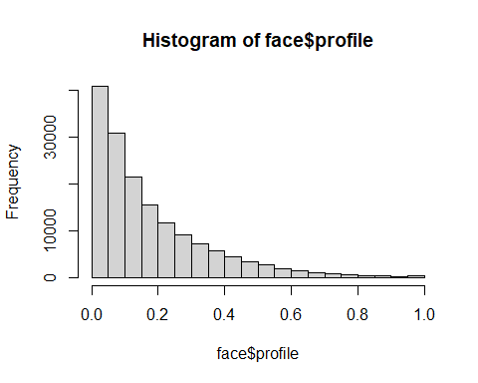 **把臉部比例差大於0.2的刪掉,只留<0.2的**

newface<-subset(face,face$profile<0.2)

**用新臉來處理眼睛**

newface$eyebigsmall<-newface$Eye_R_H4_L/newface$Eye_L_H4_L

**畫圖(眼睛大小眼差距過大)**

hist(newface$eyebigsmall)

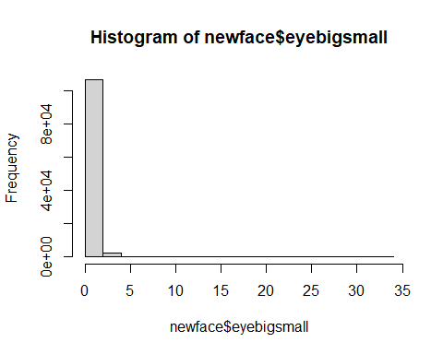 **新資料表(大小眼用0.8<x<1.2過濾)**

newfaceeye<-subset(newface,newface$eyebigsmall>0.8&newface$eyebigsmall<1.2)

hist(newfaceeye$eyebigsmall)

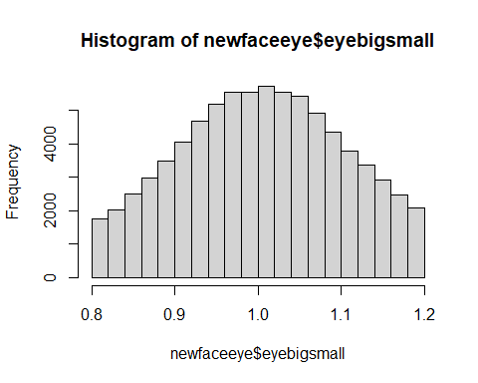

**右眼分布圖**

hist(newfaceeye$Eye_R_H4_L)

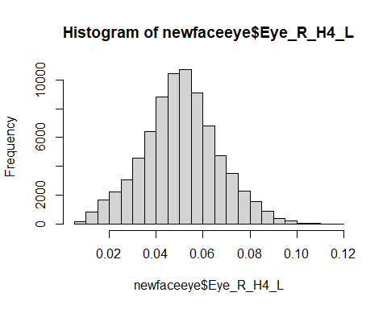 **對左右閉眼只留0.009以上的**

newfaceeyesleep<-subset(newfaceeye,newfaceeye$Eye_R_H4_L>0.009)  
newfaceeyesleep<-subset(newfaceeyesleep,newfaceeyesleep$Eye_L_H4_L>0.009)

**最終各類別的筆數** 1.原本各Label的數量

ftable(face$Label)

## actor boss doctor model ordinary_people politician singer sport  
##   
## 10554 3972 614 2158 136094 1866 4388 475

2.調整後的數量

ftable(newfaceeyesleep$Label)

## actor boss doctor model ordinary_people politician singer sport  
##   
## 5389 2080 381 1348 64659 1456 2712 357

3.刪除的數量

ftable(face$Label)-ftable(newfaceeyesleep$Label)

## actor boss doctor model ordinary_people politician singer sport  
##   
## 5165 1892 233 810 71435 410 1676 118

**匯出csv**

write.csv(newfaceeyesleep,"all_clear_rate_p.csv",fileEncoding = "UTF-8")