实验步骤：

I. 安装MIB Browser软件

II. 通过MIB Browser软件get网段内任一交换机的端口数量（MIB中Interface组中的ifNumber对象）

III. 通过Get-next继续获取该交换机Interface组除端口外的其余对象信息（对象及对象个数自选），查看对象标识及实例标识，并解释两者的区别

IV. 计算该设备任一端口收/发包的总数（Interface组）

Total Input Packets = ifInUcastPkts +ifInNucastPkts

Total Output Packets = ifOutUcastPkts +ifOutNucostPkts

V. 计算该设备任一端口收/发UDP包的百分率(UDP组)

Percent UDP Receive= udpInDatagrams/Total Input Packets

Percent UDP Send= udpOutDatagrams/Total Output Packets

VI. 计算该设备任一端口的利用率（Interface组）

需要对 x 时刻和 y 时刻的端口接收和发送字节总数进行查询

Total bytes = (ifInOctets (y) – ifInOctets (x))

+ (ifOutOctets (y) – ifOutOctets (x))

Total bytes per second = Total bytes/(y-x)

Utilization = Total bytes per second * 8/ifSpeed

1. **端口数量**

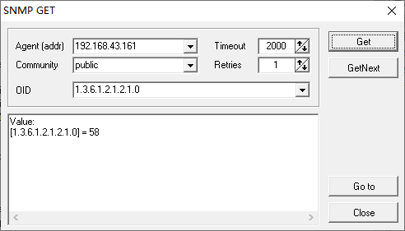

端口数量为58个

1. **IfIndex对象**

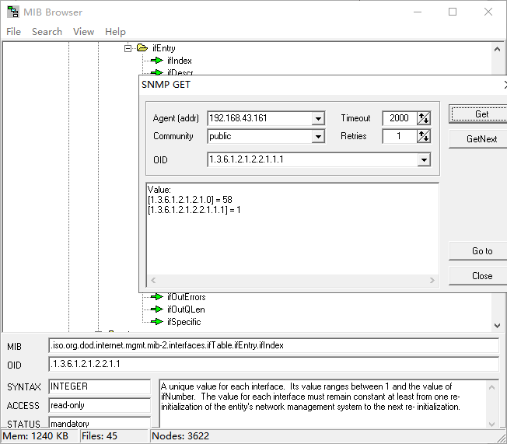

对象标识及实例标识

对象标致：1.3.6.1.2.1.2.2.1.1 表示：.iso.org.dod.internet.mgmt.mib-2.interfaces.ifTable.ifEntry.ifIndex这个对象

实例标识：1.3.6.1.2.1.2.2.1.1.1表示.iso.org.dod.internet.mgmt.mib-2.interfaces.ifTable.ifEntry.ifIndex的第一个端口的编号。



1. **计算该设备任一端口收/发包的总数（Interface组）**

Total Input Packets = ifInUcastPkts +ifInNucastPkts

Total Output Packets = ifOutUcastPkts +ifOutNucastPkts

这里我们选择第二个端口作为我们的研究对象

* 1. 首先获得端口 ifInUcastPkts的值：13469

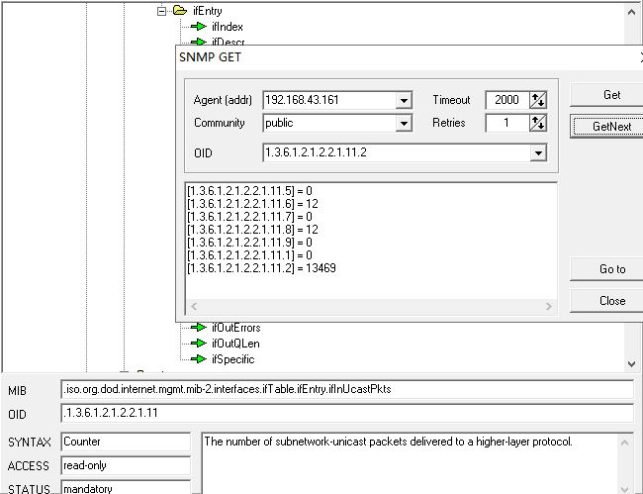

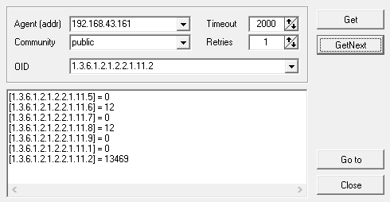

* 1. 获得端口ifInNucastPkts的值：628

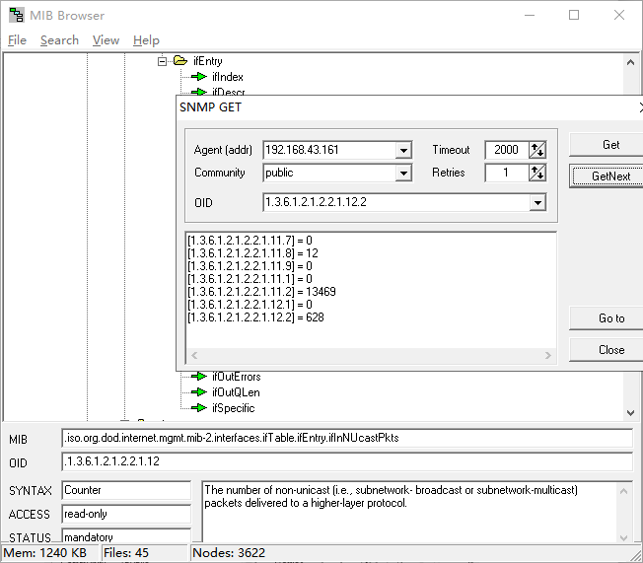

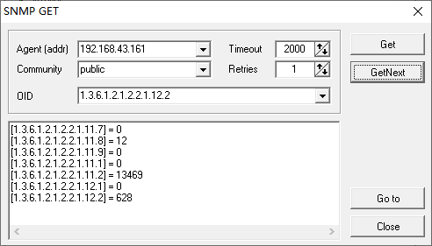

Total Input Packets = 13469+628 = 14097

* 1. 获取端口ifOutUcastPkts对象实例的值：16436

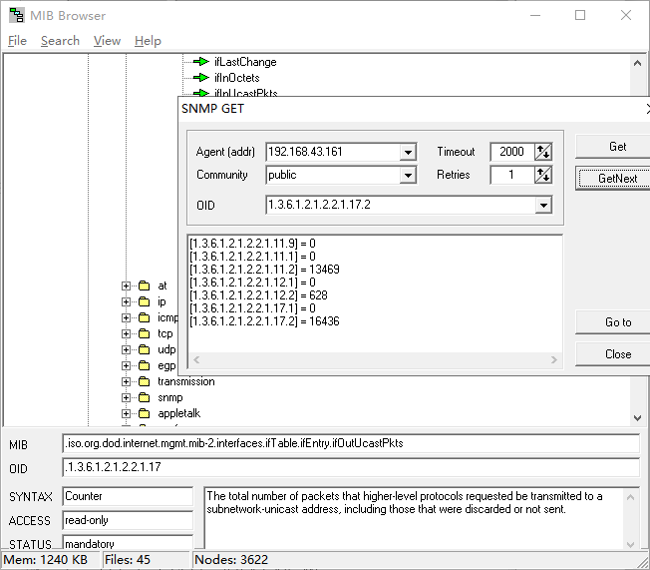 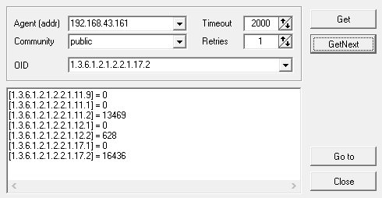

* 1. 获取端口ifOutNucostPkts对象实例的值:1941

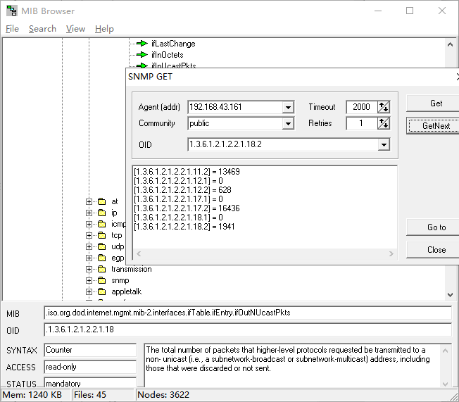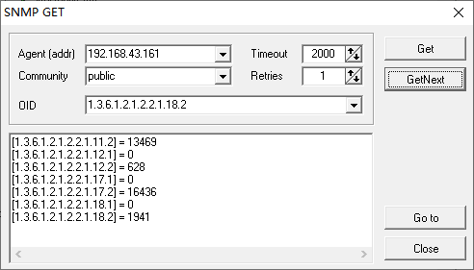

Total Output Packets = ifOutUcastPkts +ifOutNucastPkts = 16436+1941=18377

1. **计算该设备任一端口收/发UDP包的百分率(UDP组)**

Percent UDP Receive= udpInDatagrams/Total Input Packets

Percent UDP Send= udpOutDatagrams/Total Output Packets

* 1. 获取端口udpInDatagrams对象实例的值：7234

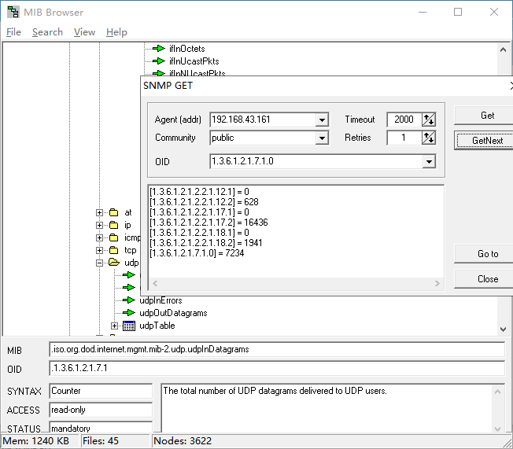

* 1. 获取端口udpOutDatagrams对象实例的值：16224

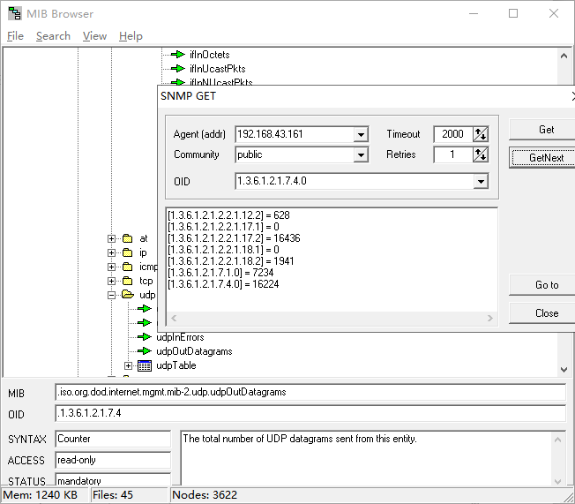

Percent UDP Receive= udpInDatagrams/Total Input Packets = 7234/14097=0.513Percent UDP Send= udpOutDatagrams/Total Output Packets=16224/18377=0.883

1. **计算该设备任一端口的利用率（Interface组）**

需要对 x 时刻和 y 时刻的端口接收和发送字节总数进行查询

Total bytes = (ifInOctets (y) – ifInOctets (x))

+ (ifOutOctets (y) – ifOutOctets (x))

Total bytes per second = Total bytes/(y-x)

Utilization = Total bytes per second * 8/ifSpeed

时刻

X = (39.860207+39.879946)/2=39.87

Y = (53.905691+53.911968)/2=53.91

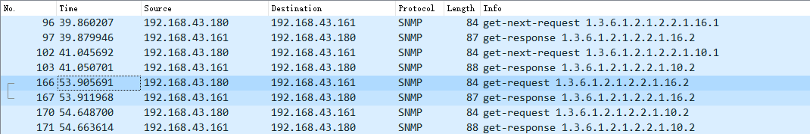

ifOutOctets(x) = 5491621

ifOutOctets(y) = 5493490

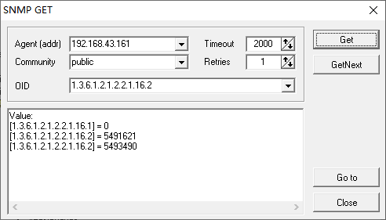

ifInOctets(x) = 11806427

ifInOctets(y) = 11806883

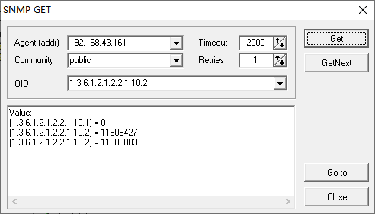

ifSpeed = 58500000

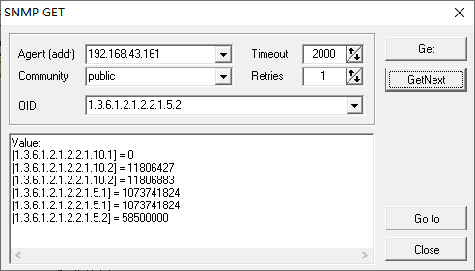

ifOutOctets(x) = 5491621

ifOutOctets(y) = 5493490

ifInOctets(x) = 11806427

ifInOctets(y) = 11806883

ifSpeed = 58500000

X = (39.860207+39.879946)/2=39.87

Y = (53.905691+53.911968)/2=53.91

Total bytes = (ifInOctets (y) – ifInOctets (x)) + (ifOutOctets (y) – ifOutOctets (x))

=(11806883-11806427)+( 5493490-5491621) = 2325

Total bytes per second = Total bytes/(y-x) = 2325/(53.91-39.87)= 165.60

Utilization = Total bytes per second * 8/ifSpeed=165.60*8/58500000=2.26*10^(-5)