# **几种常用信号平滑去噪的方法（附Matlab代码）**

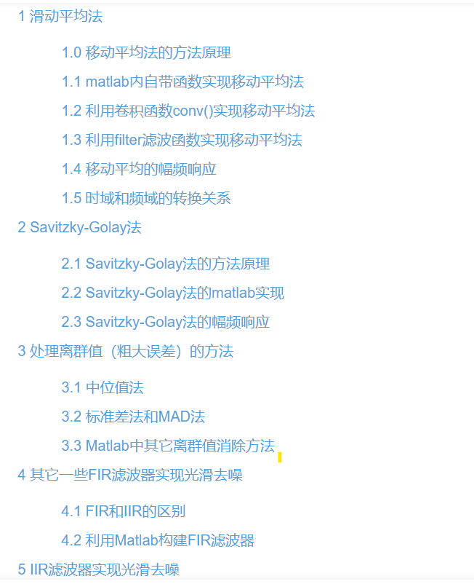

[(17条消息) 几种常用信号平滑去噪的方法（附Matlab代码）_hyhhyh21的博客-CSDN博客_信号去噪](https://blog.csdn.net/weixin_42943114/article/details/107693068?ops_request_misc=%7B%22request%5Fid%22%3A%22165129017416782395398063%22%2C%22scm%22%3A%2220140713.130102334..%22%7D&request_id=165129017416782395398063&biz_id=0&utm_medium=distribute.pc_search_result.none-task-blog-2~all~top_positive~default-1-107693068.142^v9^pc_search_result_control_group,157^v4^control&utm_term=%E4%BF%A1%E5%8F%B7%E5%8E%BB%E5%99%AA&spm=1018.2226.3001.4187)

# **常用信号去噪与信号回归方法的原理及MATLAB实现**

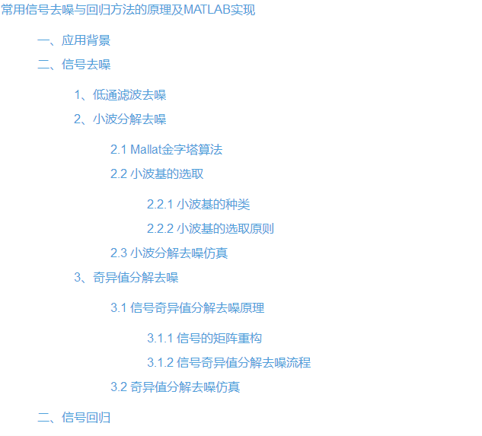

https://blog.csdn.net/AIMZZY/article/details/106267154?ops_request_misc=%257B%2522request%255Fid%2522%253A%2522165129034016782395372994%2522%252C%2522scm%2522%253A%252220140713.130102334.pc%255Fall.%2522%257D&request_id=165129034016782395372994&biz_id=0&utm_medium=distribute.pc_search_result.none-task-blog-2~all~first_rank_ecpm_v1~rank_v31_ecpm-13-106267154.142^v9^pc_search_result_cache,157^v4^control&utm_term=%E4%BF%A1%E5%8F%B7%E5%8E%BB%E5%99%AA&spm=1018.2226.3001.4187

# **图像去噪及Matlab实现**

https://blog.csdn.net/zhangquan2015/article/details/78991694?ops_request_misc=%257B%2522request%255Fid%2522%253A%2522165129034016782395372994%2522%252C%2522scm%2522%253A%252220140713.130102334.pc%255Fall.%2522%257D&request_id=165129034016782395372994&biz_id=0&utm_medium=distribute.pc_search_result.none-task-blog-2~all~first_rank_ecpm_v1~rank_v31_ecpm-15-78991694.142^v9^pc_search_result_cache,157^v4^control&utm_term=%E4%BF%A1%E5%8F%B7%E5%8E%BB%E5%99%AA&spm=1018.2226.3001.4187