# **基于**[深度](https://so.csdn.net/so/search?q=%E6%B7%B1%E5%BA%A6&spm=1001.2101.3001.7020" \t "https://blog.csdn.net/qq_41773806/article/details/_blank)**学习的日志数据异常检测**

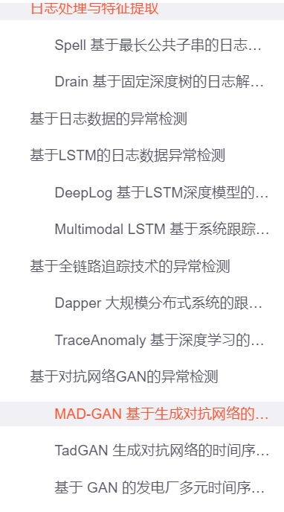

[(17条消息) 基于深度学习的日志数据异常检测_王清欢Randy的博客-CSDN博客_基于日志的异常检测](https://blog.csdn.net/qq_41773806/article/details/111773951?ops_request_misc=%7B%22request%5Fid%22%3A%22165130126116781435461828%22%2C%22scm%22%3A%2220140713.130102334.pc%5Fall.%22%7D&request_id=165130126116781435461828&biz_id=0&utm_medium=distribute.pc_search_result.none-task-blog-2~all~first_rank_ecpm_v1~rank_v31_ecpm-15-111773951.142^v9^pc_search_result_control_group,157^v4^control&utm_term=%E5%BC%82%E5%B8%B8%E6%A3%80%E6%B5%8B%E5%92%8C%E8%AF%84%E4%BB%B7%E7%B1%BB%E9%97%AE%E9%A2%98&spm=1018.2226.3001.4187)

# **机器学习笔记之异常检测**

举例：比如制造飞机引擎，当生产的飞机引擎从生产线上流出时，需要进行QA(质量控制测试)，而作为这个测试的一部分，测量了飞机引擎的一些特征变量，比如引擎运转时产生的热量，或者引擎的振动等等。

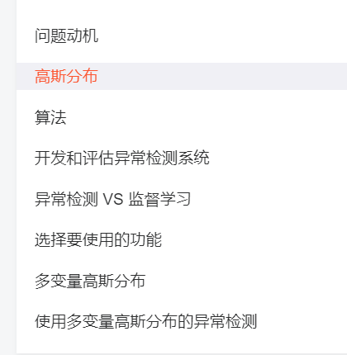

[(17条消息) 机器学习笔记之异常检测_Steven·简谈的博客-CSDN博客_机器学习异常检测算法](https://blog.csdn.net/weixin_44613063/article/details/89423421?ops_request_misc=%7B%22request%5Fid%22%3A%22165130126116781435461828%22%2C%22scm%22%3A%2220140713.130102334.pc%5Fall.%22%7D&request_id=165130126116781435461828&biz_id=0&utm_medium=distribute.pc_search_result.none-task-blog-2~all~first_rank_ecpm_v1~rank_v31_ecpm-22-89423421.142^v9^pc_search_result_control_group,157^v4^control&utm_term=%E5%BC%82%E5%B8%B8%E6%A3%80%E6%B5%8B%E5%92%8C%E8%AF%84%E4%BB%B7%E7%B1%BB%E9%97%AE%E9%A2%98&spm=1018.2226.3001.4187)

# **异常检测中的评价指标——TPR/FPR/P/A/F/R**

[(17条消息) 异常检测中的评价指标——TPR/FPR/P/A/F/R_柚子敲好吃的博客-CSDN博客_异常检测评价指标](https://blog.csdn.net/whether_you/article/details/80571485?ops_request_misc=%7B%22request%5Fid%22%3A%22165130126116781435461828%22%2C%22scm%22%3A%2220140713.130102334.pc%5Fall.%22%7D&request_id=165130126116781435461828&biz_id=0&utm_medium=distribute.pc_search_result.none-task-blog-2~all~first_rank_ecpm_v1~rank_v31_ecpm-2-80571485.142^v9^pc_search_result_control_group,157^v4^control&utm_term=%E5%BC%82%E5%B8%B8%E6%A3%80%E6%B5%8B%E5%92%8C%E8%AF%84%E4%BB%B7%E7%B1%BB%E9%97%AE%E9%A2%98&spm=1018.2226.3001.4187)

# **sklearn中的评价指标介绍(异常检测过程记录)**

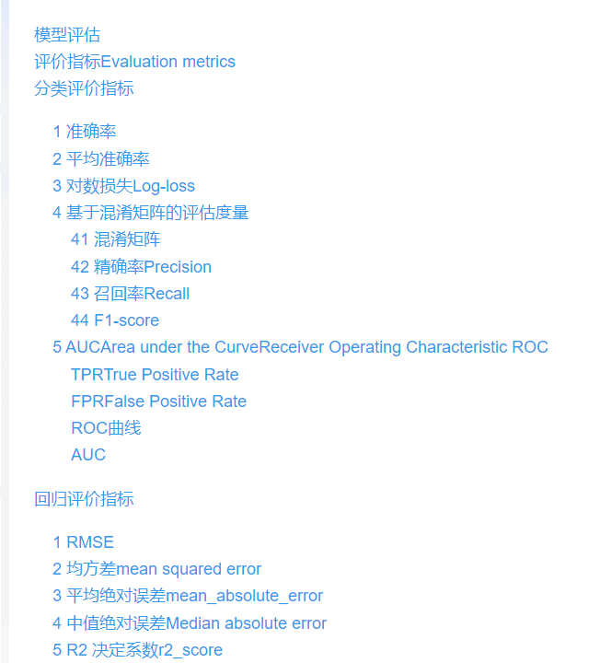

[(17条消息) sklearn中的评价指标介绍(异常检测过程记录)_Jasminexjf的博客-CSDN博客_异常检测的评价指标](https://blog.csdn.net/Jasminexjf/article/details/88681444?ops_request_misc=%7B%22request%5Fid%22%3A%22165130126116781435461828%22%2C%22scm%22%3A%2220140713.130102334.pc%5Fall.%22%7D&request_id=165130126116781435461828&biz_id=0&utm_medium=distribute.pc_search_result.none-task-blog-2~all~first_rank_ecpm_v1~rank_v31_ecpm-17-88681444.142^v9^pc_search_result_control_group,157^v4^control&utm_term=%E5%BC%82%E5%B8%B8%E6%A3%80%E6%B5%8B%E5%92%8C%E8%AF%84%E4%BB%B7%E7%B1%BB%E9%97%AE%E9%A2%98&spm=1018.2226.3001.4187)