**Cake**

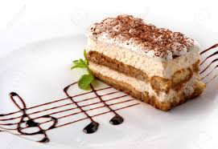

**Tiramisu Cheese cake**

**RM3.50**

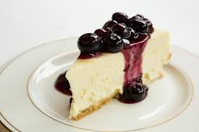

**Blueberry Cheese cake**

**RM3.50**

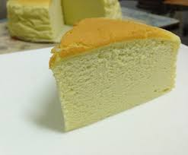

**Pandan Cheese Cake**

**RM3.50**

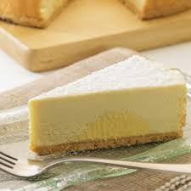

**Durian Cheese cake**

**RM3.50**

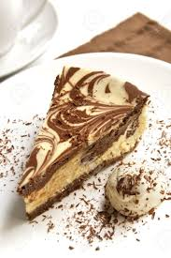

**Marble Cheese cake**

**RM3.50**

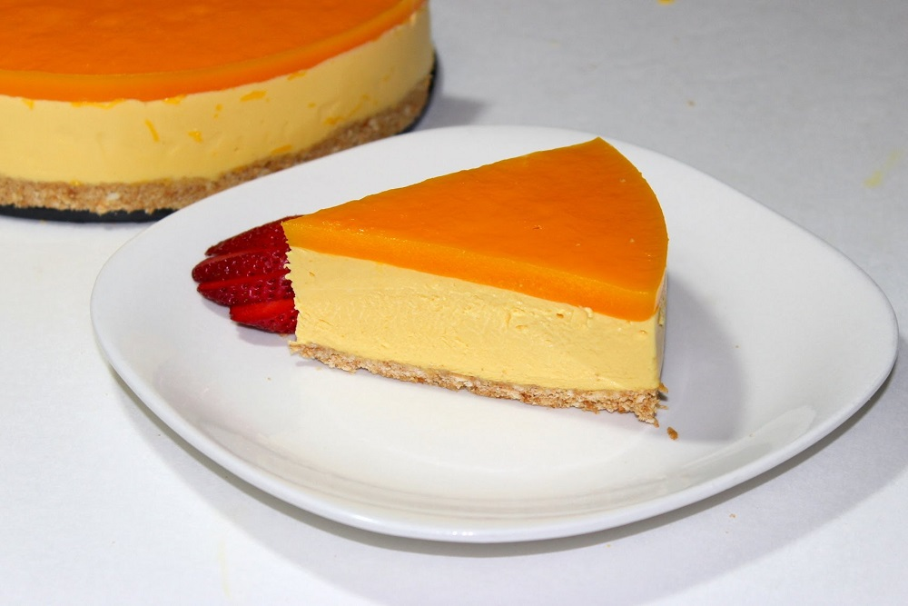

**Mango Cheese cake**

**RM8.00**

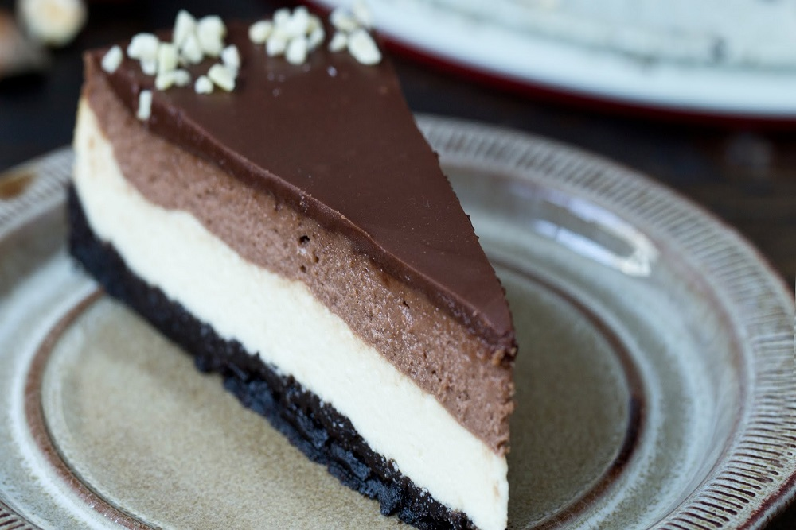

**Nutella Cheese cake**

**RM3.50**

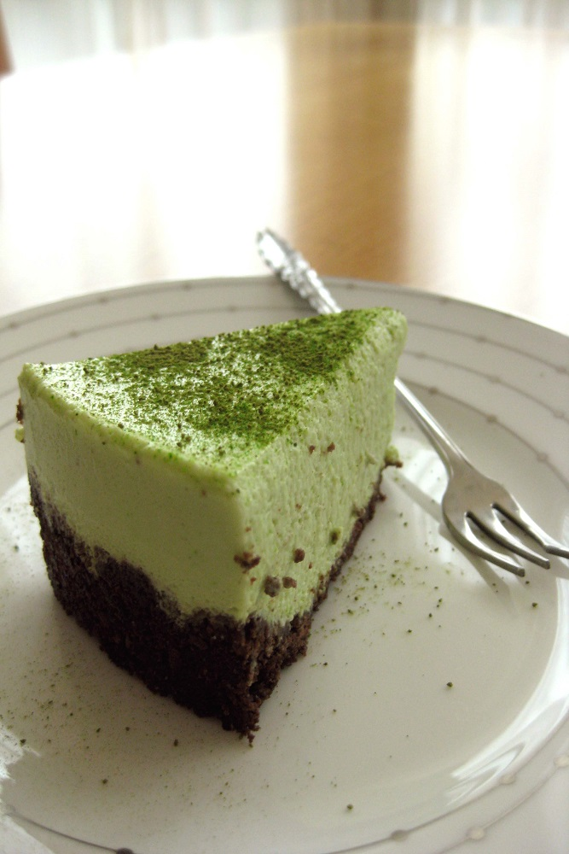

**GreenTea Cheese cake**

**RM3.50**

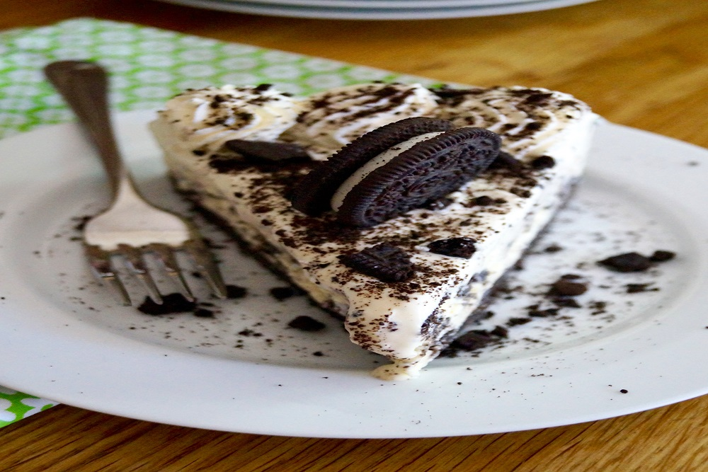

**Oreo Cheese Cake**

**RM3.50**

HOT CUP

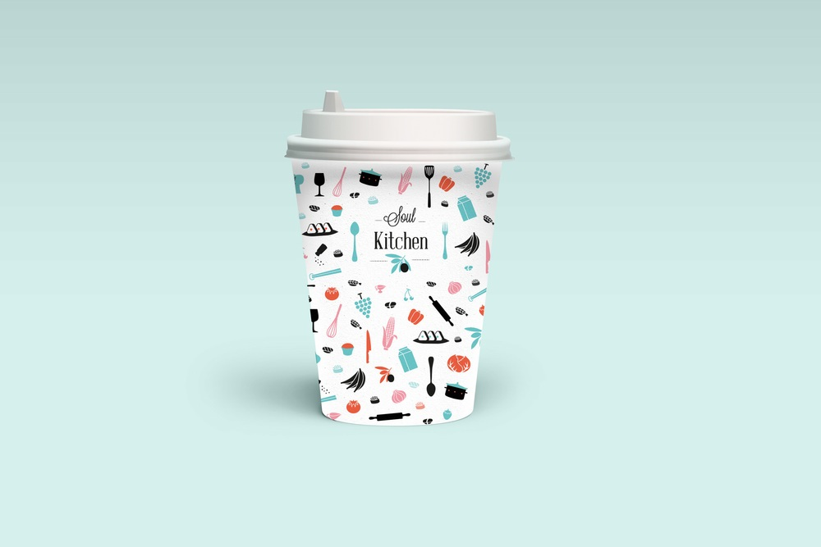

|  |  |
| --- | --- |
| **White Coffee**  **Chocolate**  **Mocha**  **Latte**  **Hazelnut**  **Caramel** | **RM2.00** |

Soda Lemonade

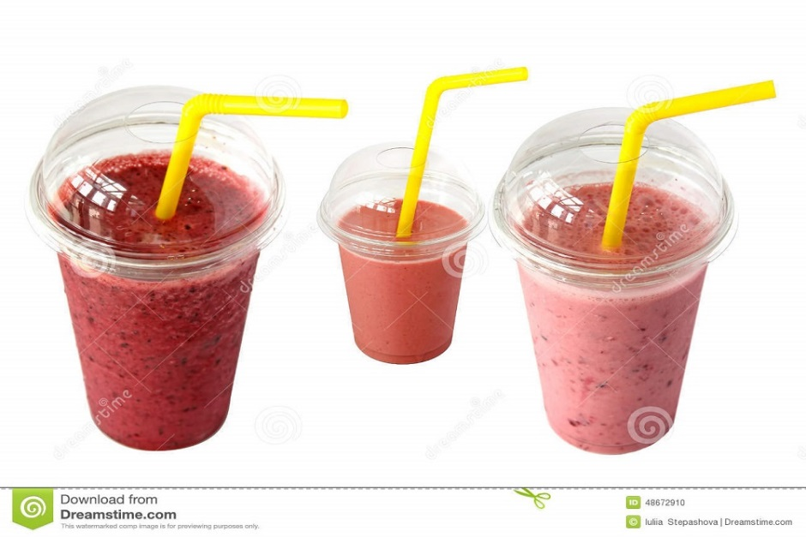

|  |  |
| --- | --- |
| **Mango**  RM3.00 (M)  RM5.00 (L) | **Strawberry**  RM3.00 (M)  RM5.00 (L) |
| **Blackcurrant**  **RM3.00 (M)**  **RM5.00 (L)** | **Kiwi**  **RM3.00 (M)**  **RM5.00 (L)** |

SHAKE



|  |  |
| --- | --- |
| **Green Tea Latte**  **Milk Tea Tiramisu**  **White Vanilla**  **Coffee Hazelnut**  **Chocolate Caramel**  **Mocha Strawberry** | **RM3 (M)**  **RM5 (L)** |

SAVORIES

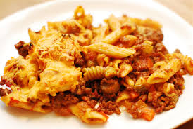  
**Baked Beef Pasta**

RM4.50(M)

RM9.00(L)

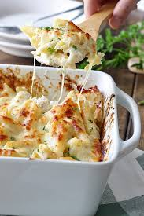

**Baked Creamy Chicken Pasta**

RM4.50(M)

RM9.00(L)

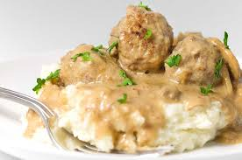

**Blackpepper Meatball Mushroom**

RM4.00

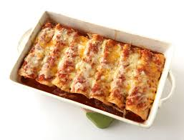

**Chicken Enchiladas**

RM4.00(M)

RM8.00(L)

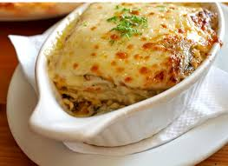

**Chicken Lasagna**

RM6.00(M)

RM10.00(L)

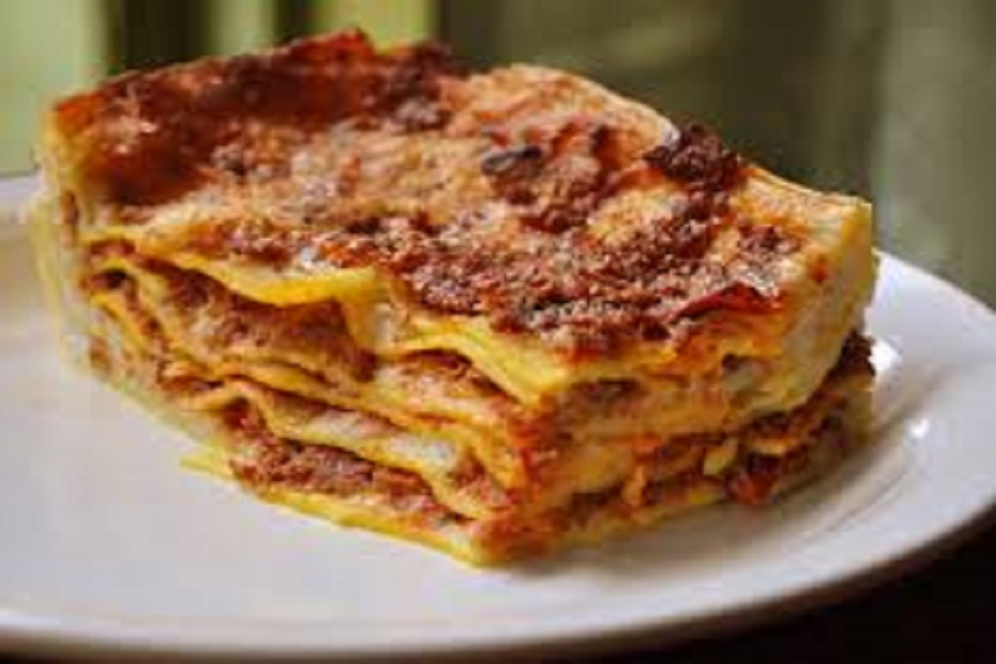

**Baked Beef Pasta**

RM4.50(M)

RM9.00(L)