**Cheese Cake Bar**

|  |  |  |
| --- | --- | --- |
|  |  |  |
| **Tiramisu Cheese cake**  **RM3.50** | **Oreo Cheese Cake**  **RM3.50** | **Pandan Cheese Cake**  **RM3.50** |
|  |  |  |
| **Marble Cheese cake**  **RM3.50** | **Blueberry Cheese cake**  **RM3.50** | **Durian Cheese cake**  **RM3.50** |
|  |  |  |
| **Nutella Cheese cake**  **RM3.50** | **GreenTea Cheese cake**  **RM3.50** | **Mango Cheese cake**  **RM8.00** |

**Hot Cup**

**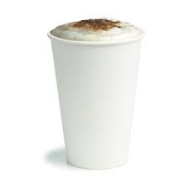**

|  |  |
| --- | --- |
| **White Coffee**  **Chocolate**  **Mocha**  **Latte**  **Hazelnut**  **Caramel** | **RM2.00** |

**Soda Lemonade**

|  |  |
| --- | --- |
| **C:\Users\Baiti Arifah\Pictures\images (1).jpg** | C:\Users\Baiti Arifah\AppData\Local\Microsoft\Windows\Temporary Internet Files\Content.Word\images.jpg |
| **Mango**  RM3.00 (M)  RM5.00 (L) | **Strawberry**  RM3.00 (M)  RM5.00 (L) |
| C:\Users\Baiti Arifah\AppData\Local\Microsoft\Windows\Temporary Internet Files\Content.Word\Acai_Lemonade-20160303094039.png | C:\Users\Baiti Arifah\AppData\Local\Microsoft\Windows\Temporary Internet Files\Content.Word\download.jpg |
| **Blackcurrant**  RM3.00 (M)  RM5.00 (L) | **Kiwi**  RM3.00 (M)  RM5.00 (L) |

**Shake**

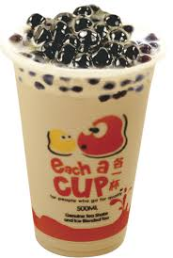

|  |  |
| --- | --- |
| **Green Tea Latte**  **Milk Tea Tiramisu**  **White Vanilla**  **Coffee Hazelnut**  **Chocolate Caramel**  **Mocha Strawberry** | **RM3 (M)**  **RM5 (L)** |

**Savories**

|  |  |  |
| --- | --- | --- |
| C:\Users\Baiti Arifah\AppData\Local\Microsoft\Windows\Temporary Internet Files\Content.Word\images (3).jpg | C:\Users\Baiti Arifah\AppData\Local\Microsoft\Windows\Temporary Internet Files\Content.Word\download.jpg | C:\Users\Baiti Arifah\AppData\Local\Microsoft\Windows\Temporary Internet Files\Content.Word\download (1).jpg |
| **Blackpepper Meatball Mushroom**  RM4.00 | **Chicken Enchiladas**  RM4.00(M)  RM8.00(L) | **Baked Beef Pasta**  RM4.50(M)  RM9.00(L) |
| C:\Users\Baiti Arifah\AppData\Local\Microsoft\Windows\Temporary Internet Files\Content.Word\images.jpg | C:\Users\Baiti Arifah\AppData\Local\Microsoft\Windows\Temporary Internet Files\Content.Word\download.jpg | C:\Users\Baiti Arifah\AppData\Local\Microsoft\Windows\Temporary Internet Files\Content.Word\download (1).jpg |
| **Baked Creamy Chicken Pasta**  RM4.50(M)  RM9.00(L) | **Beef Lasagna**  RM6.00(M)  RM10.00(L) | **Chicken Lasagna**  RM6.00(M)  RM10.00(L) |