Software Design – Mini project1
Jake Jung

- Project overview

The mini project was about data mining and processing. We should get the data from websites and by using and analyzing the data, make some useful results.
In the mini project, I tried to analyze political bias of American media. To accomplish the goal I used google search engine from pattern, and typed same keyword related to the political issues. I chose 4 journals which are known for supporting democrats and republicans. For the pro-democrats media I picked New york times journal and CBS news and for pro- republican media wallstreet journal and fox news was chosen.
First, I tried to go to each media's site and get the articles related to the presidential candidates, but it was hard to get articles from the sites and some sites such as nytimes.com had an limited access on it. Therefore I used google search and added 'site: ' in the last of the keyword. By using this method I could get articles and data which were written by journals easily. I used “Donald Trump opinion site:nytimes.com”, “Donald Trump opinion site:cbsnews.com”, “Donald Trump opinion site:wsj.com”, “Donald Trump opinion site:foxnews.com” and harvested the urls.

After getting the urls I saved the urls in the local files because google had limited queries per day. Then I loaded the local files from other python cord and by using simple process turned the string to arrays of neat urls.

For the last step, I should analyz the contents of each urls which was the hardest. I tried with the simple basic steps which is making arrays or words representing each parties and get the number of the word in each sites. However it was really hard to make an word that can evaluate each parties and the analysis results showed no implications. Trying some more steps by myself I tried googling and could find good free political and sentiment analysis tool from indico. By using the machine learning based analysis tool I could manage to analyze the urls much more efficiently. The indico API provided results related to the preferred party based on its text and I sumed up all the results of each site and made a statistics.
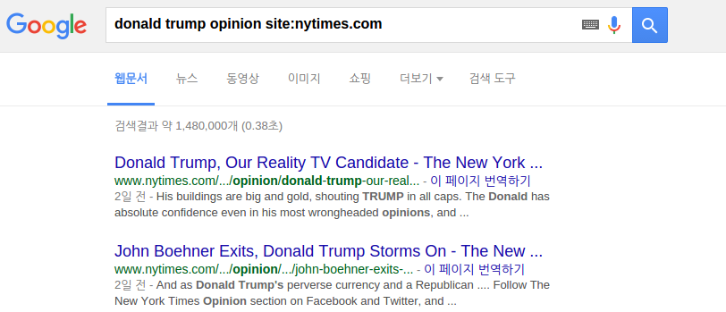
- Implementations

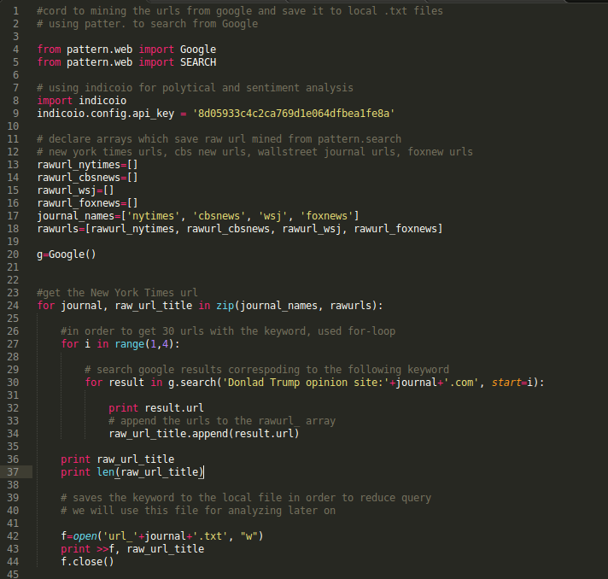
Briefly speaking the cord is about getting web data by using patter google search engine and append the url string to rawurl_site array and then save each sites url to different files. By using

for i in range(1,4):
I could get 30 results from each keyword, and by using
for journal, raw_url_title in zip(journal_names, rawurls)
I could get total 120 results by the loop.

At first I made the cord messy because we should get articles from 4 sites I used 4 different for-loops which changes the word after site(ex donald trump opinion site:nytimes.com, donald trump opinion site:cbsnews.com). However by using for loop with arrays I could shortened the cord like above and now if I want to harvest another site's result about donald trump I can just add the site's name in the jornal_names array and rawurls array.

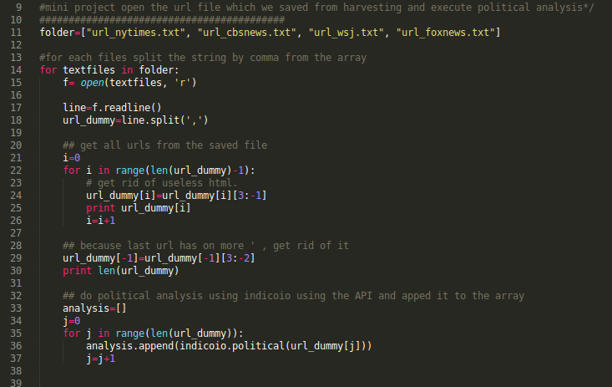
I could get the raw urls from the MP1.py cord however the raw_urls include some html symbols and to make it to perfect urls we have to get rid of some strings around the urls. So by using the MP2 cord I could get perfect urls and put those to the indicoio API for political analysis like below.
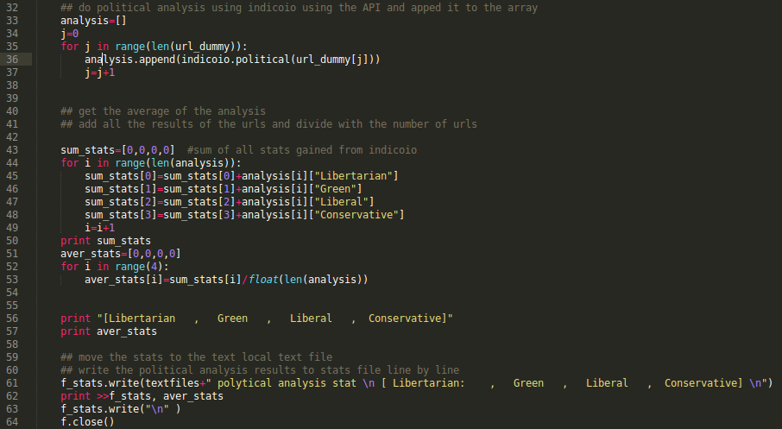
The indicoio give the data in dictionary type and I got the average data of each 30 results and saved the average political analysis into stats.txt.

- Output/ Results
I uploaded the results files with various keywords to the github
url_1 : Donald trump opinion
url_2: Donald trump poll
url_3: Presidential candidates

The url files are the result urls from each keywords and the stats files are the political analysis of each keyword. You can see the detail result files in the github.

Following graphs are the results of “Donald Trump opinion” in each sites.

1. Newyork Times

2. CBS news

3. Wallstreet journal

4. Foxnews

