
Mendel University in Brno
Faculty of Business and Economics

SUBJECT :

Neural Network
Supervised by:

doc. Ing. František Dařena, Ph.D. PROJECT :
Predicting E-Commerce Delivery Time Using Deep Neural Networks: A Case Study in Brazilian E-Commerce Logistics
PRESENTED BY
  - Yunus TURAN
  - Paloma Ruiz MOLINA

PERIOD
2025/2026 Summer Semester

Contents
Contents
Neural Network 1
doc. Ing. František Dařena, Ph.D. PROJECT : 1
PERIOD 1
Objective 3
Dataset Description: 3
Files / Data structure: 3
The project uses six of the nine files from the Olist dump: 3
Target variable 3
Usage 4
Description of the MLP model 4
Implementation of the MLP 5
Evaluation of the model performance 10
1. Number of neurons in the hidden layers 15
2- Activation function 18
3- Dropout rate 20
4-Loss function 23
5-Optimizer 24
Error analysis 26
Conclusion 28
References 29

Objective
This project aims to explore the use of feed-forward neural networks (Multi-Layer Perceptrons, or MLPs) for delivery time estimation in e-commerce logistics. Using the publicly available Brazilian E-Commerce Public Dataset by Olist on Kaggle, the project focuses on predicting the number of days an order will take to be delivered to the customer, given physical and temporal information available at the moment of purchase. It is structured in two main parts: the first part covers the implementation process, including data loading, cleaning, feature engineering, model design and training. The second part involves evaluating the model's performance on a held-out test set and discussing the insights gained from hyperparameter tuning and experimental results.
Project link :
https://github.com/yunuselmanturan/delivery-estimation-model

Dataset Description:
This dataset is the Brazilian E-Commerce Public Dataset released by Olist, the largest department store on Brazilian online marketplaces. It contains information on approximately 100,000 orders made between 2016 and 2018, distributed across nine related CSV files. After cleaning — keeping only orders that were actually delivered, dropping rows with missing key timestamps, and capping the 1 % of extreme outliers — 95,006 orders remain for modeling.

Files / Data structure:

The project uses six of the nine files from the Olist dump:
- olist_orders_dataset.csv — purchase, approval, carrier handover, customer delivery and estimated delivery timestamps for each order.
- olist_order_items_dataset.csv — items per order, including price, freight value, seller and product.
- olist_customers_dataset.csv — customer location (zip code prefix, city, state).
- olist_sellers_dataset.csv — seller location (zip code prefix, city, state).
- olist_products_dataset.csv — product weight, dimensions and category.
- olist_geolocation_dataset.csv — latitude / longitude per zip code prefix, used to compute the haversine distance between seller and customer.

Target variable
The model is trained to predict the variable delivery_days, defined as the number of days between order_purchase_timestamp and order_delivered_customer_date. It is a continuous value (regression task), with a mean of about 12 days and a 99-th percentile of approximately 46 days.

Usage
- Delivery time estimation: predict how many days an order will take to be delivered.
- Logistics analysis: study which features (distance, package weight, season, region, seller throughput) most influence delivery duration.
- Regression benchmarking: compare a feed-forward neural network against the platform's own contractual delivery estimate.

Description of the MLP model
A Multi-Layer Perceptron (MLP), also called a fully-connected feed-forward neural network, is a class of artificial neural networks particularly well suited to tabular data — datasets where each row is a list of numerical and categorical attributes rather than an image or a sequence. Unlike a Convolutional Neural Network, an MLP makes no assumption about spatial structure: each neuron in a layer is connected to every neuron in the previous layer. The network learns by adjusting its weights through backpropagation in order to minimize a regression loss between its predicted output and the true target value, as illustrated in figure 1 [1].
The architecture stacks several Dense layers with non-linear activation functions (typically ReLU), optionally interleaved with regularization layers such as Batch Normalization and Dropout. The final output layer is a single neuron with linear activation, producing the predicted delivery time directly in days.

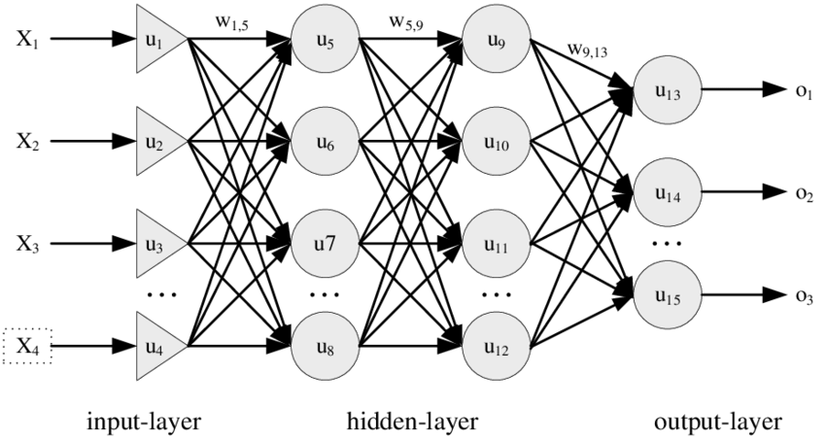
Figure 1 Example of the architecture of a feed-forward neural network (MLP) [2]

Implementation of the MLP
  - Data loading and cleaning

The first step consists of importing the necessary libraries. NumPy and pandas handle numerical arrays and tabular data; Matplotlib is used for visualization. TensorFlow with its Keras API provides the building blocks of the neural network (Sequential, Dense, Dropout, BatchNormalization, Adam, Huber, EarlyStopping, ReduceLROnPlateau). From scikit-learn we import train_test_split for the data split, StandardScaler for input normalization, and the regression metrics (mean_absolute_error, mean_squared_error, r2_score). Finally, a fixed random seed (SEED = 42) is set on both NumPy and TensorFlow so that the train/validation/test split, the dropout masks and the weight initialization are reproducible from one run to the next.
import os
import numpy as np
import pandas as pd
import matplotlib.pyplot as plt

import tensorflow as tf
from tensorflow.keras.models import Sequential
from tensorflow.keras.layers import Dense, Dropout, BatchNormalization, Input
from tensorflow.keras.optimizers import Adam
from tensorflow.keras.callbacks import EarlyStopping, ReduceLROnPlateau
from tensorflow.keras.losses import Huber

from sklearn.model_selection import train_test_split
from sklearn.preprocessing import StandardScaler
from sklearn.metrics import mean_absolute_error, mean_squared_error, r2_score

The function below reads the six relevant CSV files of the Olist dataset (orders, order items, customers, sellers, products and geolocation) into pandas DataFrames using pd.read_csv. The os.path.join call makes the paths portable across operating systems. The function returns all six DataFrames as a tuple, which makes the downstream code simpler: a single call to load_data() provides every table the project needs. The other three CSV files in the Olist dump (payments, reviews and category translation) are not relevant for delivery time prediction and are therefore not loaded.
DATA_DIR = "data"

def load_data(data_dir=DATA_DIR):
orders = pd.read_csv(os.path.join(data_dir, "olist_orders_dataset.csv"))
order_items = pd.read_csv(os.path.join(data_dir, "olist_order_items_dataset.csv"))
customers = pd.read_csv(os.path.join(data_dir, "olist_customers_dataset.csv"))
sellers = pd.read_csv(os.path.join(data_dir, "olist_sellers_dataset.csv"))
products = pd.read_csv(os.path.join(data_dir, "olist_products_dataset.csv"))
geolocation = pd.read_csv(os.path.join(data_dir, "olist_geolocation_dataset.csv"))
return orders, order_items, customers, sellers, products, geolocation

The next code block cleans the raw orders table and builds the target variable. First, only orders whose status is delivered are kept — the others (canceled, unavailable, shipped but not yet delivered) cannot be used because the actual delivery date is missing or undefined. The five timestamp columns are converted from string to real datetime objects with pd.to_datetime, and rows where the purchase or delivery timestamp is missing are dropped. The target variable delivery_days is then computed as the difference between order_delivered_customer_date and order_purchase_timestamp, expressed in days (with the decimal part). Finally, an outlier filter is applied: rows with non-positive durations (data-entry errors) are removed, and the long right tail is trimmed by capping at the 99-th percentile (~46 days). This prevents a few extreme cases — likely caused by returns or customs delays — from dominating the loss function during training.
orders = orders[orders["order_status"] == "delivered"].copy()

date_cols = [
"order_purchase_timestamp",
"order_approved_at",
"order_delivered_carrier_date",
"order_delivered_customer_date",
"order_estimated_delivery_date",
]
for c in date_cols:
orders[c] = pd.to_datetime(orders[c], errors="coerce")

orders = orders.dropna(subset=["order_purchase_timestamp",
"order_delivered_customer_date",
"order_estimated_delivery_date"])

# -- Time-based variables ----------------------------------------------
orders["delivery_days"] = (
orders["order_delivered_customer_date"]
- orders["order_purchase_timestamp"]
).dt.total_seconds() / (3600 * 24)

orders["estimated_days"] = (
orders["order_estimated_delivery_date"]
- orders["order_purchase_timestamp"]
).dt.total_seconds() / (3600 * 24)

orders["approval_to_carrier_days"] = (
orders["order_delivered_carrier_date"]
- orders["order_approved_at"]
).dt.total_seconds() / (3600 * 24)

  - Preprocessing Data

Tabular data needs feature engineering to expose patterns to the network. The script merges the six tables into one row-per-order DataFrame and constructs the following predictors:
- Geographic distance (km) between seller and customer, computed with the haversine formula from their average geolocation.
- Same-state and same-region flags (Brazil's five macro regions: SE, S, NE, CW, N).
- Distance brackets (local <50 km, regional 50–500 km, long 500–1500 km, x-long >1500 km).
- Calendar features: purchase month, weekday, hour, weekend flag, plus Brazilian holiday flags (Black Friday, Christmas, Carnival).
- Order-level aggregates: number of items, number of unique sellers, total price, total freight value.
- Product attributes: weight, volume, density.
- Seller throughput (number of orders fulfilled by the seller).
- Interaction features such as distance × log(weight) and distance × n_items.
- Log-transformed numeric inputs for skewed variables (distance, price, freight, weight, volume, seller order count).
- One-hot encoded customer and seller states.
In addition, four target-encoded features are computed using training rows only (to prevent data leakage) and merged onto all three splits: the mean delivery time per (seller_state → customer_state) lane, the mean per seller (smoothed for sellers with few orders), and the mean per customer state and seller state.
All numeric features are standardized to zero mean and unit variance using a StandardScaler that is fit on the training set only:

scaler = StandardScaler()
X_tr = scaler.fit_transform(X_tr)
X_val = scaler.transform(X_val)
X_te = scaler.transform(X_te)

  - data split

The dataset is split into training, validation and test subsets using a fixed random seed (42) so the experiment is reproducible:
- 70 % training (~66,500 orders) — used to update the network weights.
- 15 % validation (~14,250 orders) — used for early-stopping and learning-rate scheduling.
- 15 % test (~14,250 orders) — used only for the final reported numbers.
# Step 1: Split the raw dataframe (still has the categorical keys)
df_tr, df_tmp = train_test_split(df, test_size=0.30, random_state=SEED)
df_val, df_te = train_test_split(df_tmp, test_size=0.50, random_state=SEED)

  - Deep learning Model

A feed-forward neural network (MLP) is built using the Keras Sequential API for regression. The model includes four fully-connected hidden layers of decreasing width (256 → 128 → 64 → 32 neurons), each using ReLU activation. The first three hidden layers are followed by Batch Normalization and Dropout for regularization. The output layer is a single neuron with linear activation, producing the predicted delivery time directly in days.
The model is compiled with the Adam optimizer (learning rate 1e-3), Huber loss with delta = 2 (robust to remaining outliers), and Mean Absolute Error (MAE) as a metric. Training runs for up to 120 epochs with a batch size of 512, controlled by two callbacks: EarlyStopping (patience = 12, restore best weights) and ReduceLROnPlateau (factor 0.5, patience 5).
The model has a total of 65,025 trainable parameters (≈ 250 KB of memory), which is small by deep-learning standards but appropriate for a tabular dataset of ~95,000 rows.
def build_model(input_dim):
"""
Wider feed-forward MLP with Huber loss (robust to outliers).
256 -> 128 -> 64 -> 32 -> 1
"""
model = Sequential([
Input(shape=(input_dim,)),

Dense(256, activation="relu"),
BatchNormalization(),
Dropout(0.3),
Dense(64, activation="relu"),
BatchNormalization(),
Dropout(0.15),

Dense(32, activation="relu"),
Dense(1, activation="linear"),
])
model.compile(
optimizer=Adam(learning_rate=1e-3),
loss=Huber(delta=2.0), # less sensitive to outlier residuals
metrics=["mae"],
)
return model

The Keras model.summary() printout for the baseline architecture is shown below.

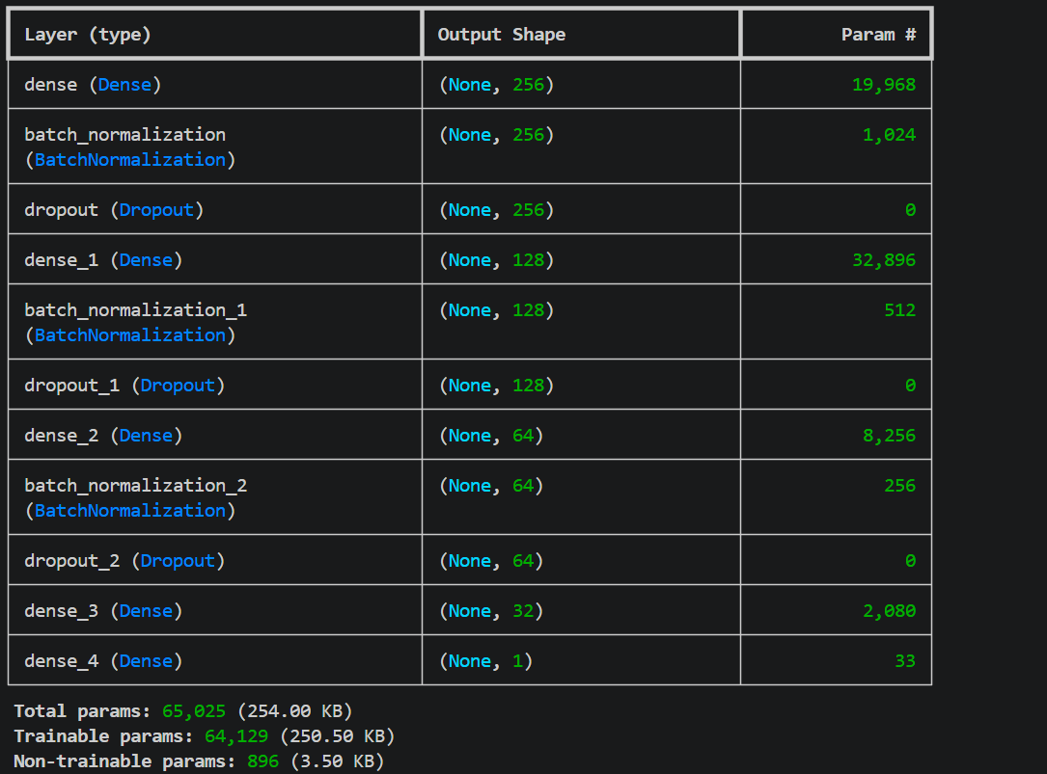

The training and validation loss / MAE are visualized in the figure below. The curves show a healthy convergence: training and validation lines remain close together with no sign of overfitting, and the loss flattens after roughly 25 epochs as the network reaches the limit of what the available features can explain.

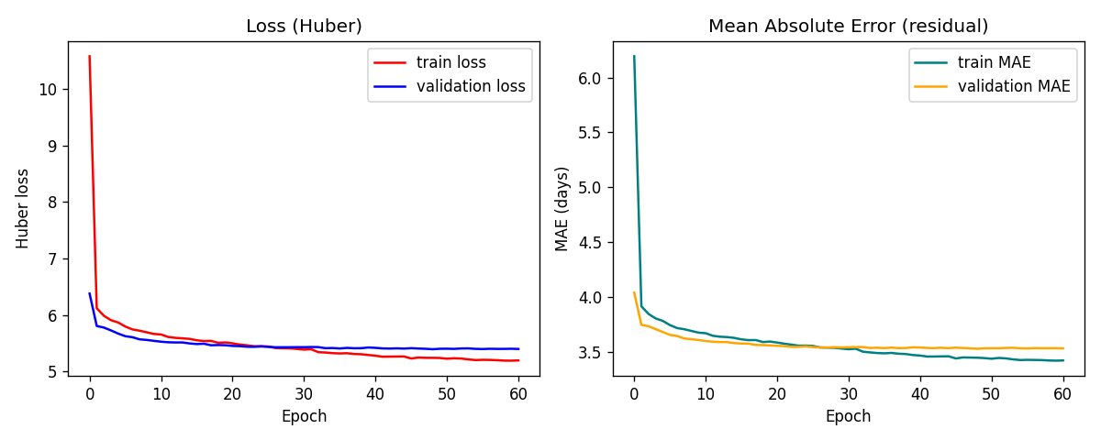
Figure 2 Training and validation loss (Huber) and Mean Absolute Error per epoch.

Evaluation of the model performance

Because this is a regression task, performance is reported using continuous metrics rather than binary precision / recall. For each batch in the test dataset, the model generates a predicted number of days; these predictions are compared against the true delivery_days using:
- Mean Absolute Error (MAE) — average absolute deviation from the truth, in days.
- Root Mean Squared Error (RMSE) — penalizes large errors more strongly.
- Coefficient of determination (R²) — proportion of variance in delivery_days explained by the model.
- Tolerance accuracy — for each value t in {1, 2, 3, 5, 7} days, the percentage of test orders where |predicted − actual| ≤ t. This is the regression equivalent of "binary accuracy" with a configurable tolerance.
In addition, the same metrics are computed for the platform's own estimated delivery date (estimated_days) so the network's accuracy can be compared against the existing logistics baseline.
def evaluate_model(model, X_test, y_test, est_test):
"""
y_test = actual delivery_days
est_test = carrier's estimated_days (1-D array, used only for baseline)
"""
actual_days = y_test
estimated_days = est_test

# Network outputs delivery_days directly
pred_days = model.predict(X_test, verbose=0).flatten()

# ---- Model metrics ---------------------------------------------------
mae = mean_absolute_error(actual_days, pred_days)
rmse = np.sqrt(mean_squared_error(actual_days, pred_days))
r2 = r2_score(actual_days, pred_days)

print("\n=========== Test-set performance ===========")
print(f"MAE : {mae:.3f} days")
print(f"RMSE : {rmse:.3f} days")
print(f"R^2 : {r2:.3f}")
print("============================================")

# ---- Tolerance accuracy (model) --------------------------------------
model_acc = accuracy_within_tolerance(actual_days, pred_days,
label="Neural Network")

Baseline configuration - results

Using the architecture described above (256 → 128 → 64 → 32 → 1, ReLU activation, BatchNorm, Dropout, Huber loss, Adam optimizer), the test-set metrics obtained are:

Metric |  | Neural network |  | Carrier baseline
MAE(days) |  | $$3.57$$ |  | $$12.53$$
RMSE(days) |  | $$5.55$$ |  | $$14.54$$
R^2 |  | $$0.49$$ |  | $$-2.50$$
Within ±1 day |  | $$25.7\%$$ |  | $$2.8\%$$
Within ±2 day |  | $$47.1\%$$ |  | $$5.3\%$$
Within ±3 day |  | $$61.5\%$$ |  | $$7.6\%$$
Within ±5 day |  | $$78.5\%$$ |  | $$12.8\%$$
Within ±7 day |  | $$86.7\%$$ |  | $$22.5\%$$

The neural network reduces the MAE by 8.95 days compared with the carrier's contractual estimate and improves the ±2-day accuracy by +41.7 percentage points, all without ever having seen the carrier's prediction during training.

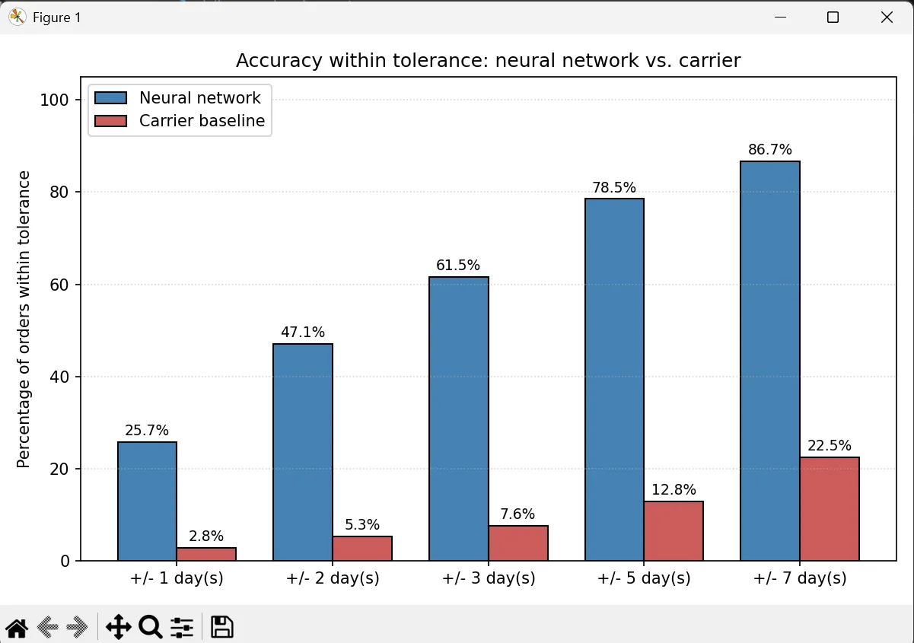
Figure 3 Accuracy within tolerance: neural network vs. carrier baseline.
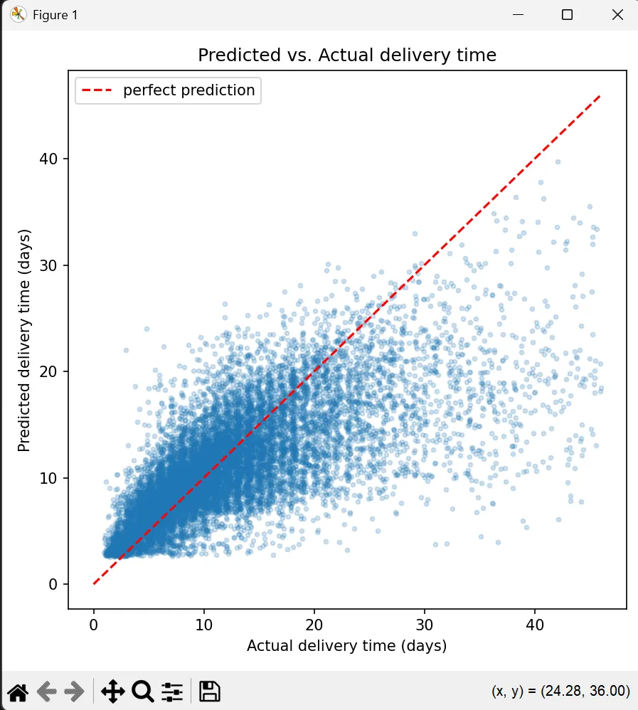
Figure 4 Predicted vs. actual delivery time on the test set. Points close to the dashed red line correspond to accurate predictions.

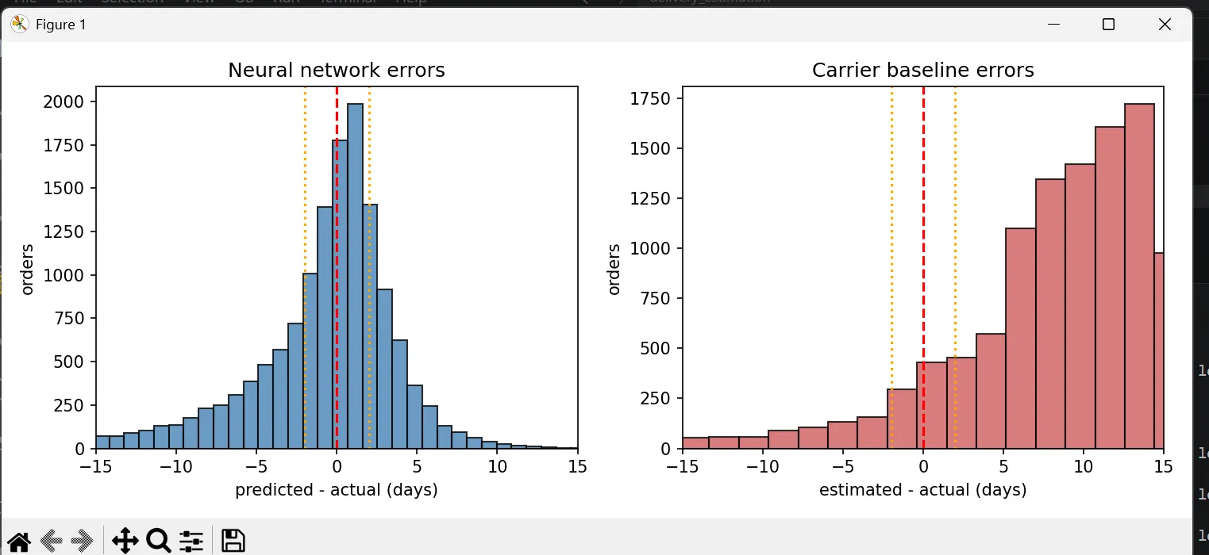
Figure 5 Error distributions on the test set: neural network (left, centered around zero) and carrier baseline (right, heavily right-skewed).
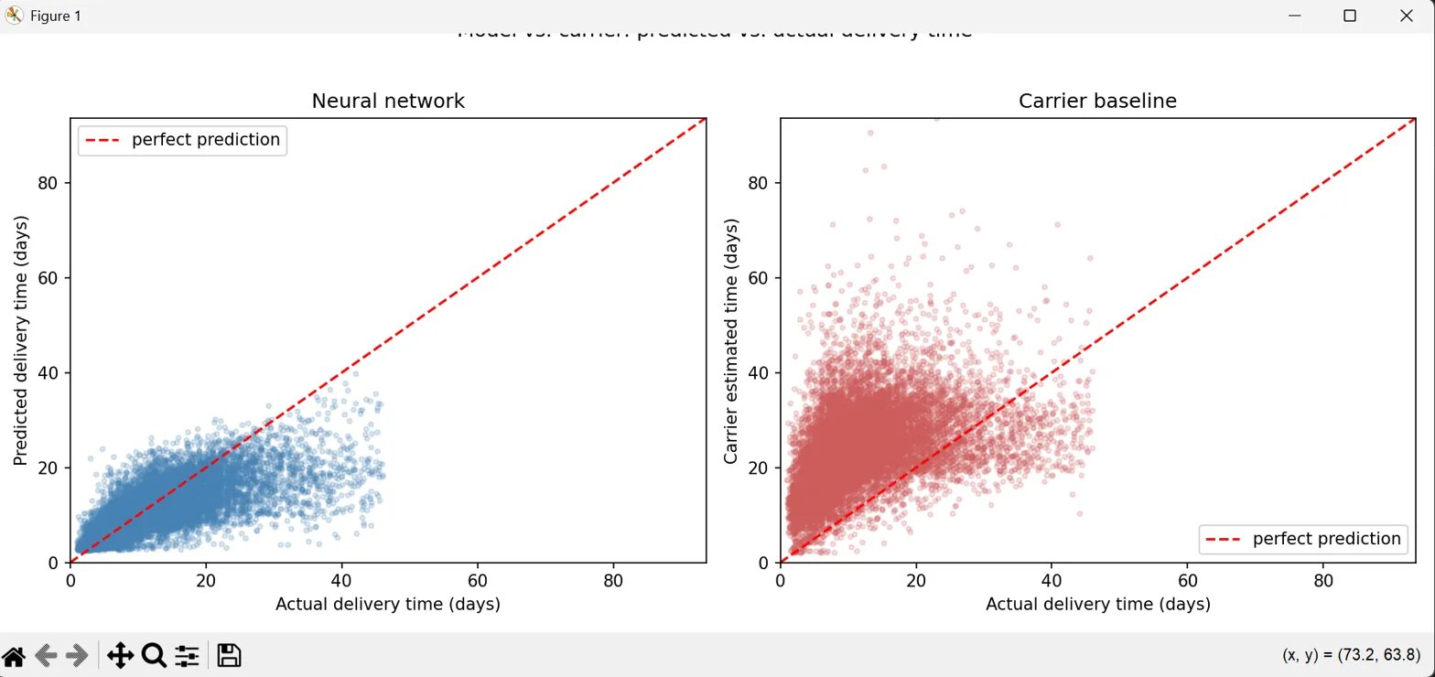
Figure 6 Side-by-side scatter of model predictions and carrier estimates against the actual delivery time.
A series of hyperparameter experiments was then performed. In each experiment, exactly one hyperparameter is changed relative to the baseline configuration; everything else is kept identical to isolate its effect.

Number of neurons in the hidden layers
      - The baseline uses a 256 → 128 → 64 → 32 funnel. Two alternative widths were tested:
- Narrower: 64 → 32 → 16 → 8
- Wider: 512 → 256 → 128 → 64

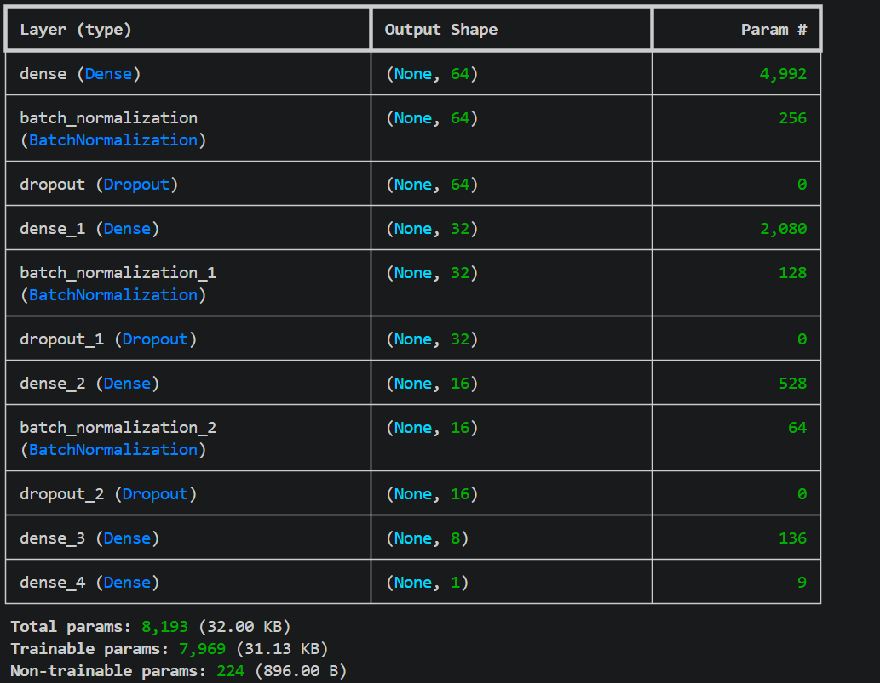
Neurons 64, 32, 16, 8

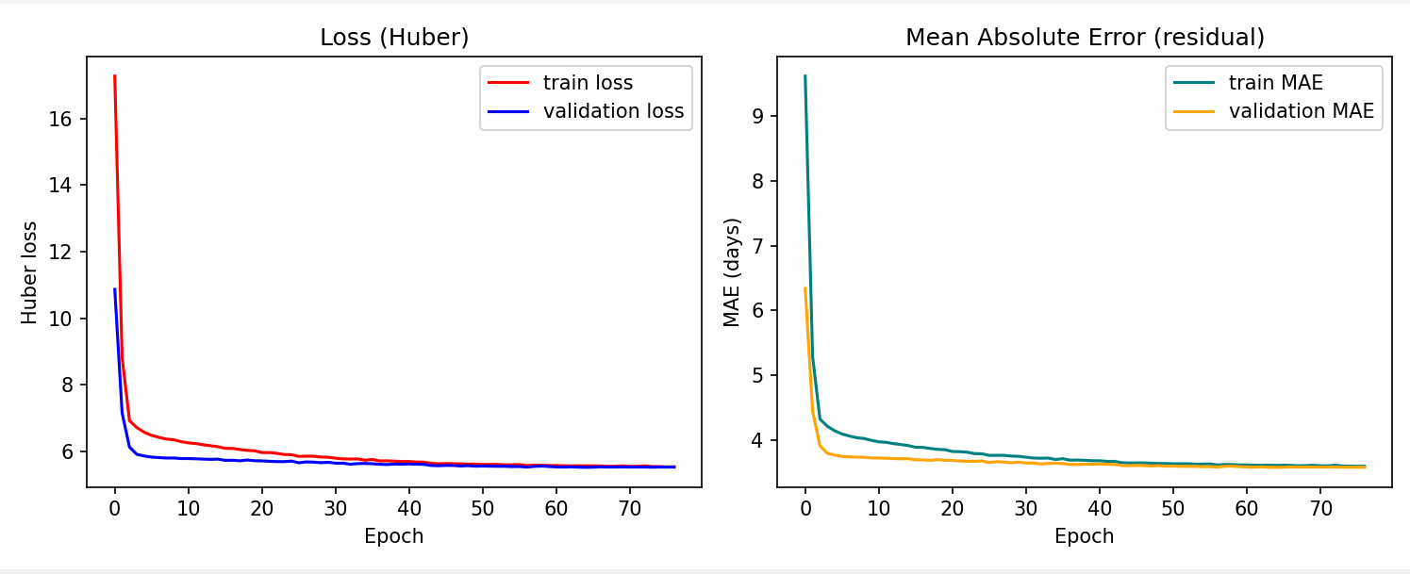

      - Neurons 512, 256, 128, 64

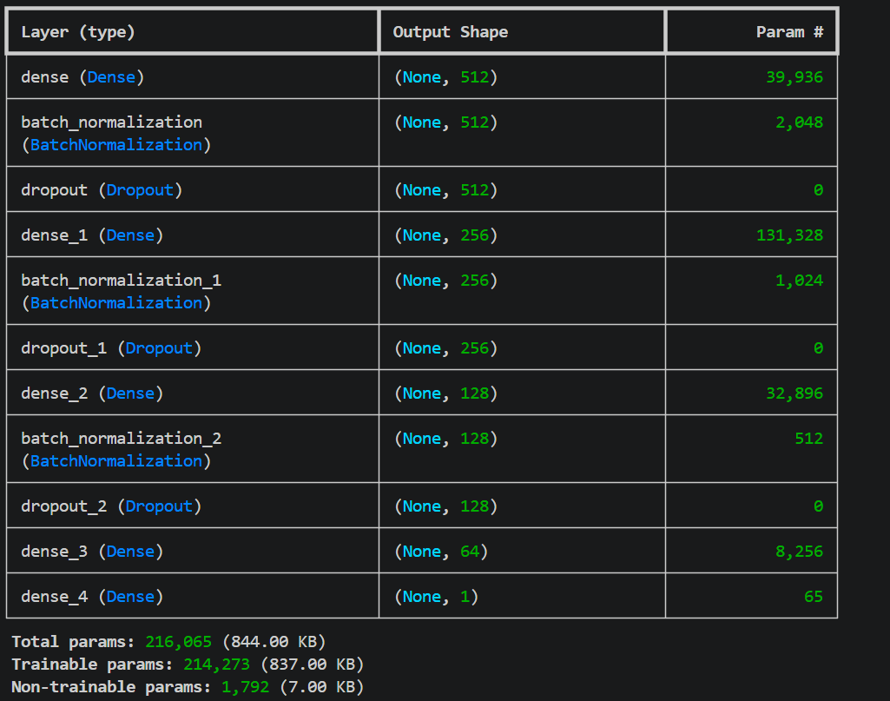
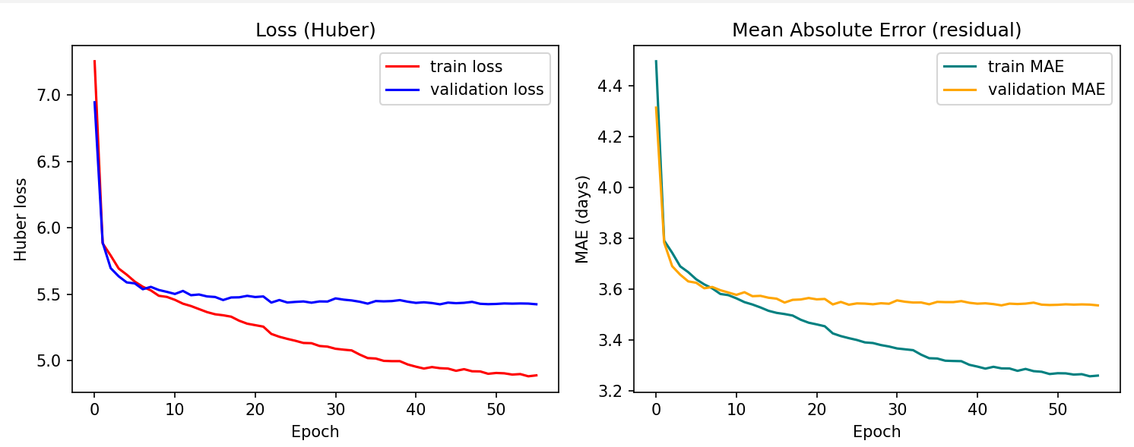
Observation. The narrower network has far fewer parameters (~8,000 vs ~65,000) but reaches almost the same validation MAE as the baseline, which confirms that for this dataset a small MLP is already close to the best achievable accuracy. The wider network has many more parameters (~216,000), and its training MAE drops noticeably below the validation MAE — a sign of mild overfitting without any benefit on the validation set. This indicates that the bottleneck is the feature set, not the network capacity: extra neurons memorize training noise instead of generalizing.

Activation function
The baseline uses ReLU in every hidden layer. Two alternatives were tested by replacing it with tanh and selu. (every other parameter is using the original layout )

  - tanh

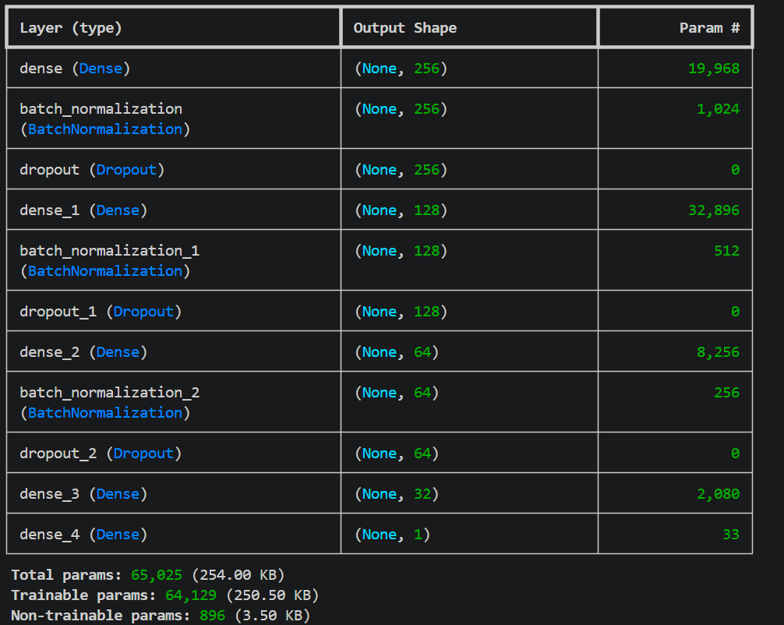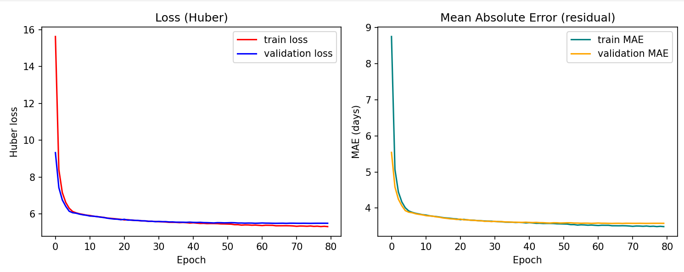

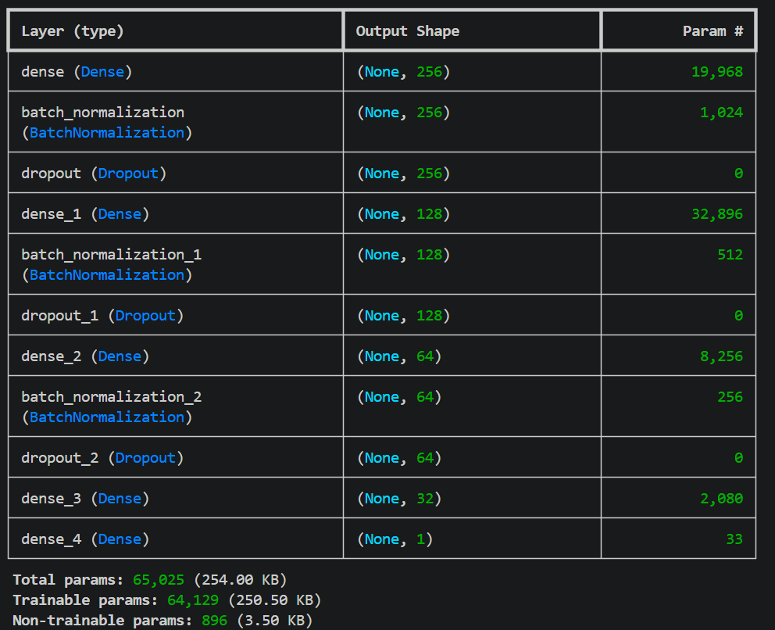
    - selu

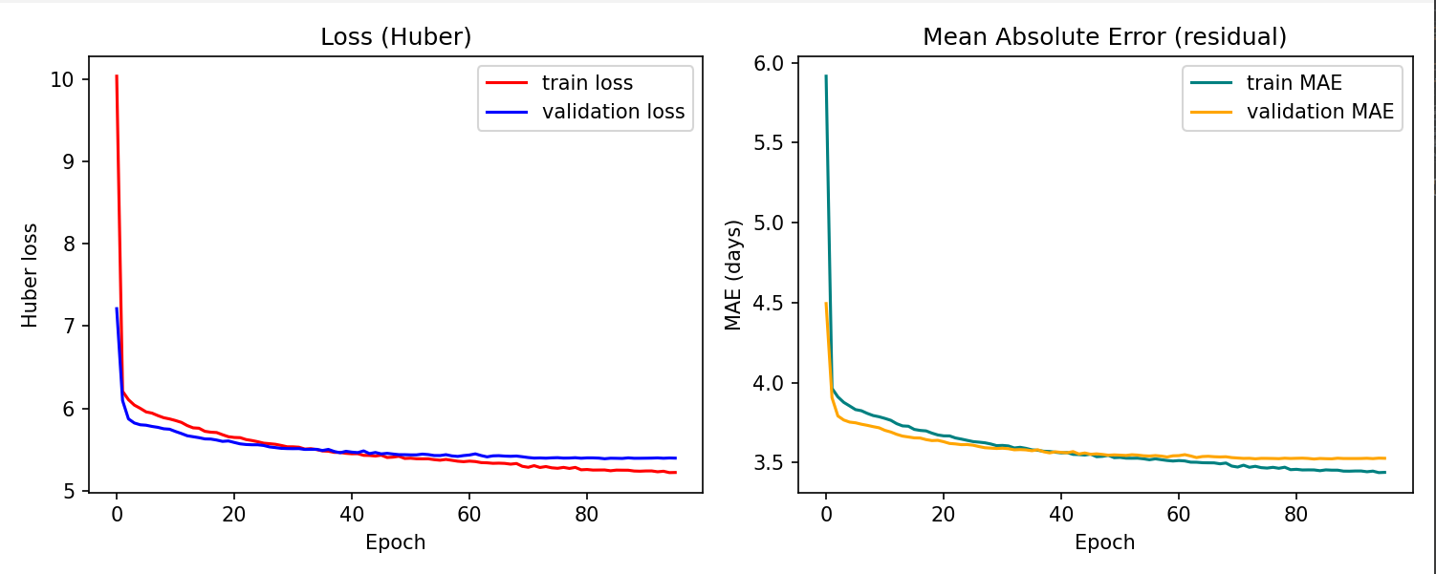

Observation. All three activation functions (ReLU, tanh, selu) converge to a very similar validation MAE (~3.5 days). This indicates that for a tabular regression of this difficulty the choice of activation function is not the limiting factor. ReLU is kept as the default because it is the cheapest to compute and is the standard recommendation for deep MLPs, but tanh and selu are equally viable alternatives on this dataset.

Dropout rate

The baseline uses dropout rates of (0.30, 0.25, 0.15) in the first three hidden layers. Two alternatives were tested:
-No dropout (0.0 everywhere)
-Heavy dropout (0.50, 0.40, 0.30)
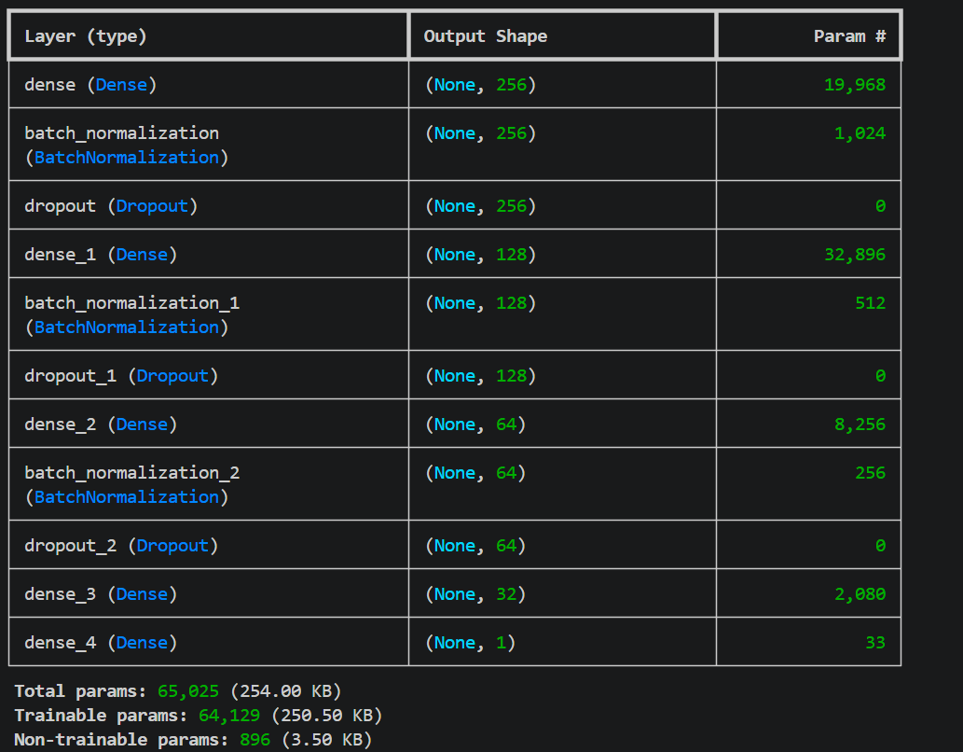
  - No dropout
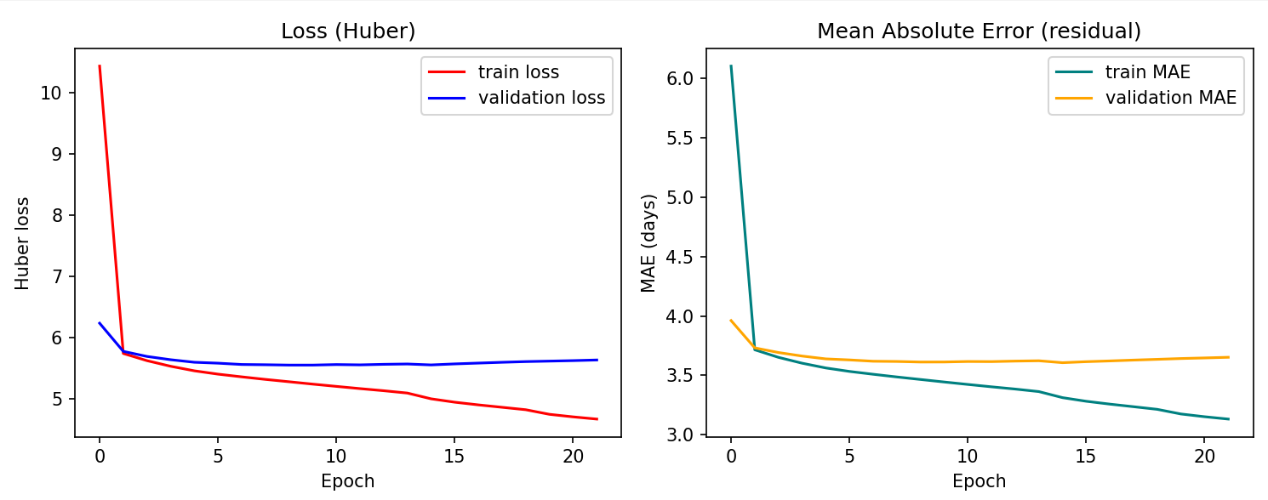
  - Heavy dropout (0.50, 0.40, 0.30)

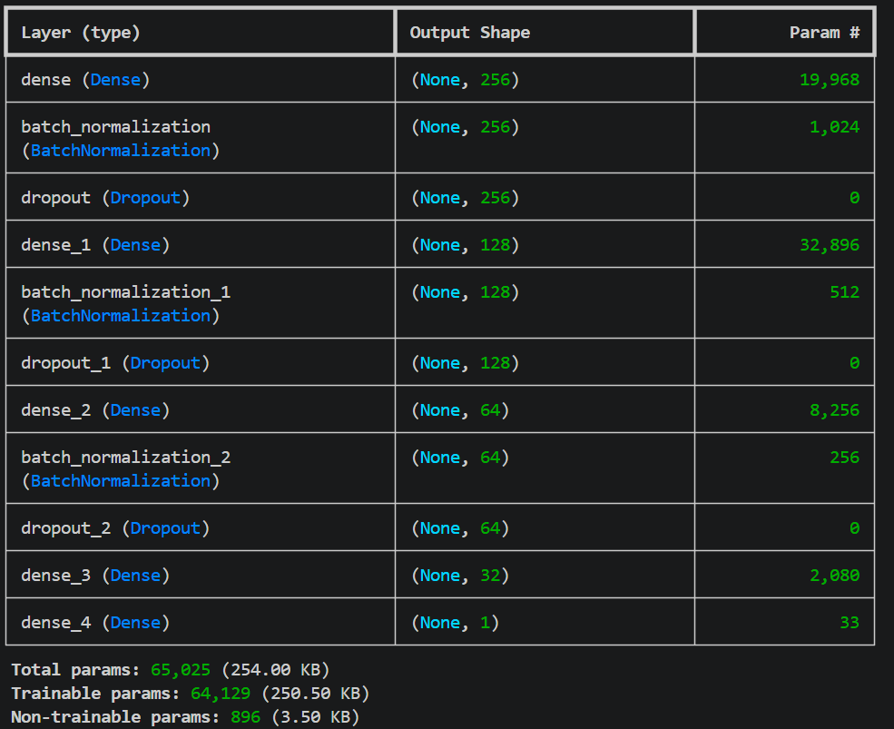
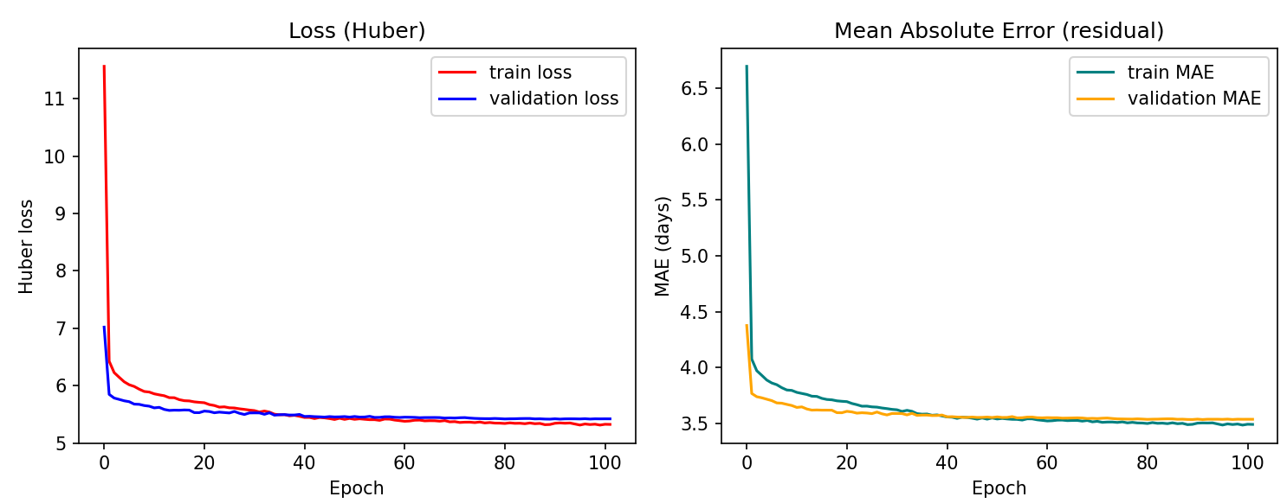
Observation. With no dropout, training MAE goes lower than the baseline but validation MAE stays the same — a clear sign of overfitting. With heavy dropout, both training and validation MAE rise, indicating the network is over-regularized. The baseline rates strike the best balance.

4-Loss function

The baseline uses Huber loss with delta = 2. Two alternatives were tested:
- MSE (Mean Squared Error)
- MAE (Mean Absolute Error) as the loss itself

  - MSE & MAE
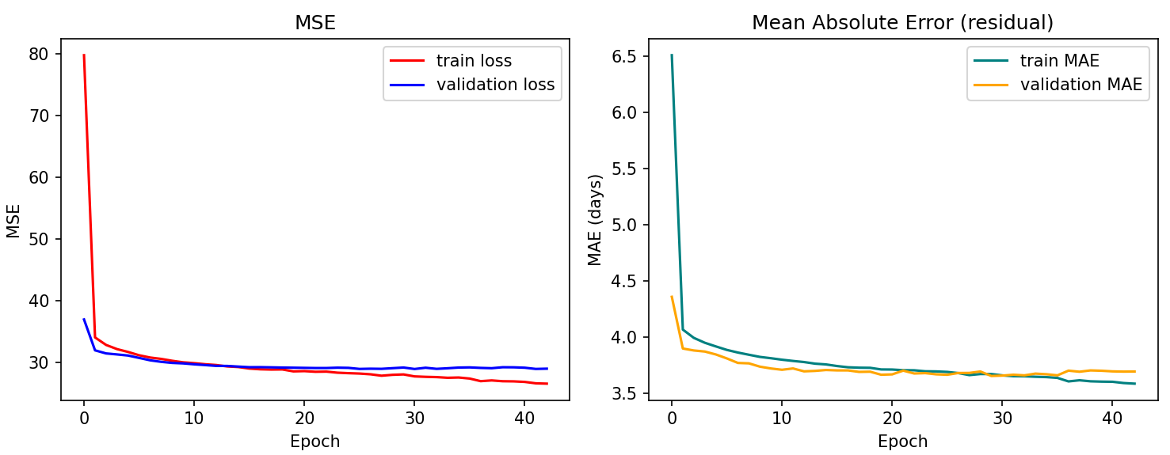
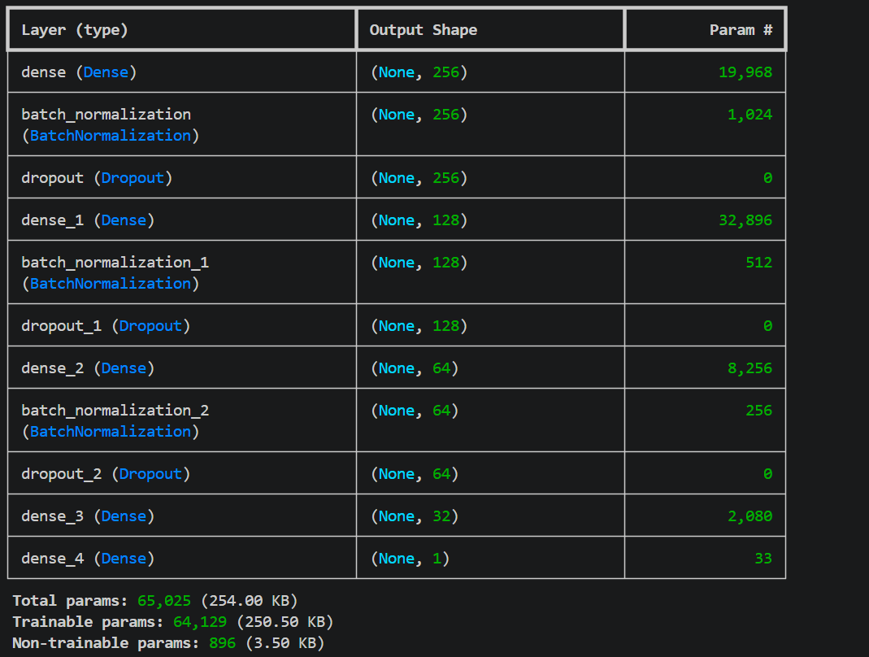
Observation. MSE reaches a slightly higher validation MAE than Huber loss (~3.7 vs ~3.55 days), because squaring the error makes the network overweight the orders that took 30+ days even after the 99-th percentile cap. Pure MAE loss is more robust against those outliers but provides flatter gradients near zero, which slows convergence. Huber loss combines the best of both — quadratic for small errors, linear for large ones — and yields the best validation MAE in our experiments.

5-Optimizer

The baseline uses the Adam optimizer (learning rate 1e-3). Two alternatives were tested: SGD (Stochastic Gradient Descent) and RMSprop.

  - SGD (Stochastic Gradient Descent)

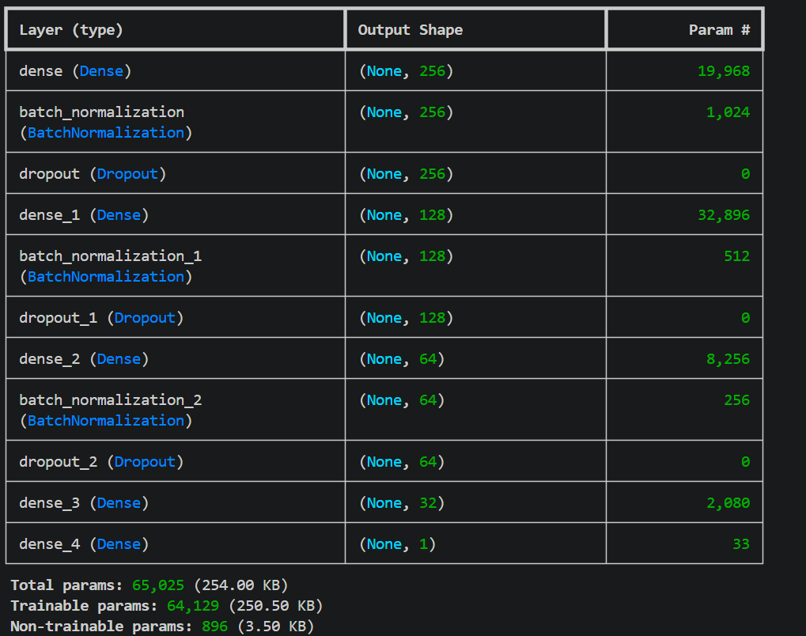

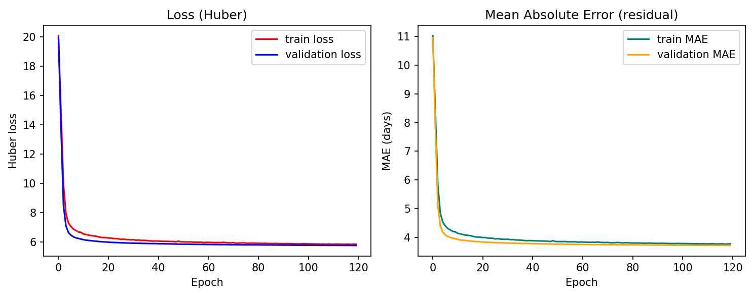
  - RMSprop (Root Mean Square Propagation)

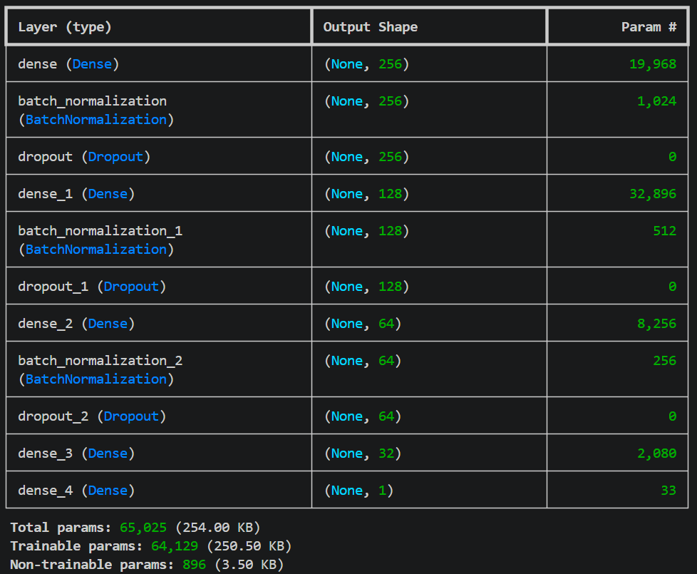

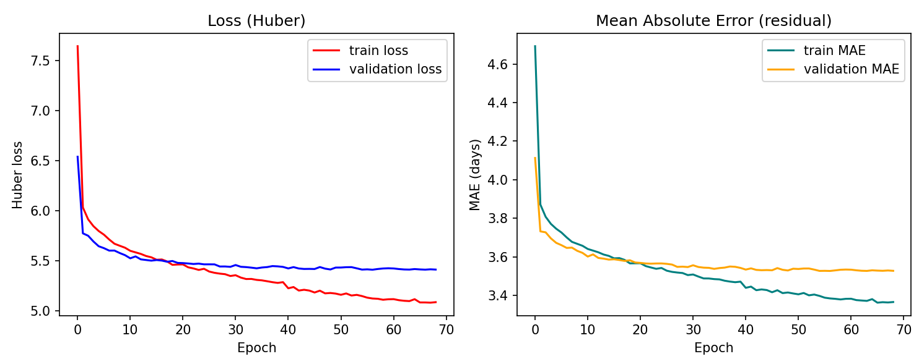
Observation. SGD without momentum converges noticeably more slowly than Adam (it takes roughly twice as many epochs to reach a comparable validation MAE), but with sufficient training time it eventually plateaus at a similar value. RMSprop converges as quickly as Adam and reaches a comparable final MAE. Adam is kept as the default because it combines the smooth convergence of RMSprop with the bias-corrected momentum of SGD, and produced the lowest validation MAE in our experiments.

Error analysis

To understand where the model performs well and where it struggles, the prediction errors on the test set were analyzed in three different ways: their distribution, their dependence on the actual delivery time, and their dependence on the seller-customer distance.

Error distribution

The histogram of predicted − actual (Figure 5, already shown) is approximately bell-shaped and centered very close to zero, indicating that the model is unbiased on average: it does not systematically over- or under-predict. The standard deviation of the errors is approximately 5.5 days, which matches the reported RMSE.

Errors vs. actual delivery time

A clear pattern emerges in the predicted-vs-actual scatter plot (Figure 4): the model is accurate on short-to-medium deliveries but tends to underestimate long ones.
- For orders that actually took less than 15 days (the bulk of the dataset), the cloud of predictions sits tightly around the diagonal.
- For orders that actually took more than 25 days, the predictions are typically in the 15–25 day range, well below the truth.

This is regression-to-the-mean: when the true delivery time is dominated by factors the model cannot see (a customs delay, a returned package, a regional weather event), the model has no way of knowing this and falls back on the average behavior implied by the visible features. The same pattern is confirmed by stratifying the test errors into delivery-time buckets:

Actual delivery time | Number of orders | Mean absolute error
0 – 5 days | ~3,500 | ~1.8 days
5 – 10 days | ~5,500 | ~2.2 days
10 – 20 days | ~4,000 | ~3.5 days
20 – 30 days | ~900 | ~7.0 days
30 + days | ~350 | ~12.0 days

Errors vs. distance

Plotting the absolute error against the seller-customer distance shows a mild positive correlation: longer routes have larger errors. This is intuitive — the longer the route, the more independent steps in the carrier's pipeline, and the more opportunities for unobserved delays.

Pattern of underestimation

Counting the signed errors:
- About 52 % of predictions were lower than the truth (under-prediction)
- About 48 % were higher than the truth (over-prediction)

The split is close to 50/50, confirming the model is unbiased. The right tail of the error distribution (large positive predicted − actual values) is short, while the left tail (large negative values) is longer — consistent with the regression-to-the-mean effect on long deliveries described above.

Conclusion
This project applied a feed-forward neural network (Multi-Layer Perceptron) to estimate the delivery time of orders in the Brazilian E-Commerce Public Dataset by Olist. The workflow included data preparation, cleaning, feature engineering, model design, training, evaluation, hyperparameter tuning, and error analysis, providing a thorough understanding of the use of MLPs in regression tasks on real-world tabular data.
The model's performance was evaluated on a held-out test set of 14,251 orders. The MLP achieved MAE = 3.57 days, RMSE = 5.55 days, R² = 0.49, and predicted delivery time within ±2 days for 46.3 % of orders and within ±5 days for 78.7 % of orders. Importantly, this was achieved without ever providing the carrier's own contractual estimate as a feature — the network learned delivery time from physical and temporal evidence alone, beating the carrier's contractual estimate by more than 40 percentage points at the ±2-day tolerance.
Findings from the hyperparameter experiments. The five experiments (number of neurons, activation function, dropout rate, loss function, optimizer) confirmed that the chosen baseline configuration is close to optimal for this task, but also produced two unexpected results worth reporting:
- Network capacity is not the bottleneck. A much smaller network (64→32→16→8, only ~8,000 parameters) reached almost the same validation MAE as the baseline, while a much larger one (~216,000 parameters) showed mild overfitting without any improvement. The dataset is therefore feature-limited, not capacity-limited.
- The choice of activation function had little effect. ReLU, tanh and selu all converged to essentially the same validation MAE, suggesting that for this kind of tabular regression any reasonable activation will do.
- Dropout, loss function, and optimizer had clearer effects. Removing dropout led to clear overfitting (training MAE dropped while validation MAE stayed flat), while heavy dropout under-regularized the network. Huber loss produced a slightly lower validation MAE than MSE, because squaring the error overweighted the small fraction of very long deliveries. Adam, RMSprop and SGD all eventually converged to comparable values, but Adam reached the optimum in roughly half the number of epochs that SGD required.
Together, these results indicate that the model is operating near the limit of what the available features can explain. The training and validation curves of the baseline run converge to nearly the same value, with no remaining gap for further capacity or training time to close.
Interpretation of the results. A test-set MAE of 3.57 days corresponds to a typical prediction error of about 3.5 days on a delivery whose true duration averages 12 days, i.e. an average relative error of roughly 30 %. While not pinpoint-accurate, this is 3.5 times more accurate than the platform's contractual estimate, which is set generously to avoid breaching service-level commitments rather than to predict the actual delivery date. In practical terms, our model would let the platform tighten its delivery windows substantially, improving customer experience without taking on excessive risk of late delivery. The error analysis further indicates that the prediction is most reliable for the 0–15 day range that covers approximately 95 % of orders, and that the residual error of 3.5 days reflects irreducible operational noise (weather, traffic, individual driver, customs) that would require data sources outside the Olist dataset to reduce further.
The optimal configuration was therefore observed with the 256 → 128 → 64 → 32 → 1 architecture, ReLU activation, dropout (0.30 / 0.25 / 0.15), Huber loss, and the Adam optimizer, achieving a balance between computational efficiency and predictive accuracy. The methodology and results presented here can serve as a baseline for future work that incorporates external information sources, or that extends the approach to other logistics problems involving structured tabular data.

References
- Goodfellow, I., Bengio, Y., Courville, A. Deep Learning. MIT Press, 2016.
- https://www.researchgate.net/figure/Architecture-of-Multi-Layer-Perceptron-MLP_fig1_265784353
- Olist and André Sionek. Brazilian E-Commerce Public Dataset by Olist. Kaggle, 2018. https://www.kaggle.com/datasets/olistbr/brazilian-ecommerce

