

T.C.
HALİÇ UNIVERSITY
ENGINEERING FACULTY
DEPARTMENT OF SOFTWARE ENGINEERING

SMART CAFE ORDERING SYSTEM

GRADUATION PROJECT

Yunus Emre TERCAN
(21091000143)

Advisor: Mehmet Fatih MİNTAŞ

May 2026

PLAGIARISM REPORT

Add your plagiarism report to this page.

ETHICAL DECLARATION
I hereby declare that I have completed this study titled “Smart Cafe Ordering System”, which I prepared as my graduation project, from beginning to end under the responsibility of my advisor Asst. Prof. Dr. Mehmet Fatih MİNTAŞ, that I have collected the data/samples myself, that I have conducted/had the experiments/analyses conducted in the relevant laboratories, that I have fully cited the information I have received from other sources in the text and bibliography, that I have acted in accordance with scientific research and ethical rules throughout the study process, and that I accept all legal consequences in the event that the contrary is revealed.
Yunus Emre TERCAN

PREFACE
As I reach the final days of my education while doing the "Smart Cafe Ordering System" project, I would like to thank my professors so much for teaching me unique knowledge throughout my university life and enabling me to reflect this knowledge onto this project. They made me learn different things every single day in my university life, which I started knowing nothing at all. They are all unique and very important professors; I thank them once again.
Also, I offer my thanks to my advisor, Asst. Prof. Dr. Mehmet Fatih MİNTAŞ, who took an interest in me during this project process, guided me with his knowledge, showed me the way, and helped me improve my project with his ideas to bring it to a good level.
Finally, I want to thank my family so much for always being by my side throughout my education, never holding back their support even for a single day, and believing in me. Especially my mother supporting me right by my side every time I struggled is the most important factor that enabled me to reach these days.
Yunus Emre TERCAN

LIST OF CONTENTS
Page No

PLAGIARISM REPORT i
PREFACE iii
LIST OF CONTENTS iv
ABBREVIATIONS AND SYMBOLS vi
LIST OF TABLES vii
LIST OF FIGURES vii
ABSTRACT ix
ÖZET x
1. INTRODUCTION 1
1.1. General Information 1
1.1.1. Third Degree Title 1
1.2. Purpose 1
1.2.1. Third Degree Title 2
1.3. Scope 2
1.3.1. Third Degree Title 2
2. LITERATURE SURVEY 3
3. SIMILAR APPLICATIONS 4
3.1. Second Degree Title 4
3.1.1. Third Degree Title 4
4. MATERIALS AND METHODS 5
4.1. Second Degree Title 5
4.1.1. Third Degree Title 5
5. DIAGRAMS 6
5.1. Use-Case Diagram 6
5.1.1. Explanation of the Use-Case Diagram 6
5.2. Class Diagram 6
5.2.1. Explanation of the Class Diagram 6
5.3. Activity Diagram 6
5.3.1. Explanation of the Activity Diagram 7
5.4. Sequence Diagram 7
5.4.1. Explanation of the Sequence Diagram 7
5.5. Database Diagram 7
5.5.1. Explanation of the Database Diagram 7
6. FINDINGS AND RESULTS 8
6.1. Second Degree Title 8
6.1.1. Third Degree Title 8
7. DISCUSSION 9
7.1. Second Degree Title 9
7.1.1. Third Degree Title 9
8. CONCLUSION AND RECOMMENDATIONS FOR FUTURE WORK 10
REFERENCES 11

ABBREVIATIONS AND SYMBOLS
AIC : Akaike Information Criteria
ANN : Artificial Neural Network
App : Appendix

The above are given as examples. All abbreviations and symbols used must be written here.

LIST OF TABLES
Page No
Table 1. Name of table…….………………………… ……………….………………………2

Table headings should be added here.

Bir araştırmada elde edilen toplu veriler tablo ve şekillerle sunulur. Tablo dışında kalan tüm çizimler veya resimler “Şekiller” başlığı altında toplanmalıdır. Grafik/harita/diyagram/nota/plan/fotoğraf vb. belgeler bu gruba girer. Tablo ve şekiller sayfa içinde sağ ve sol yazı sınırlarına göre ortalanarak yerleştirilirler. Hiçbir tablo ya da şekil bir sayfayı geçmemelidir. Çok fazla içerikle verilmesi gerektiği takdirde veya taşma durumunda olanlar ya küçültülmeli ya da “Ekler” bölümünde sunulmalıdır. Tablo ve şekiller nedeniyle sayfa içinde boşluk bırakılmamalı, boş yerlere izleyen metinler kaydırılmalıdır. Bu amaçla metin içi açıklamalarda “… aşağıdaki tabloda verilmiştir:” anlatımı yerine, “… yararları Tablo 2.1’de verilmiştir” gibi şekil ve tablo ile bağlantı kuran anlatımlar kullanılmalıdır. Projede yer alan çizelge ve şekillere metin içerisinde atıf yapılır. Başka kaynaklardan alınan çizelge ve şekillere, çizelge adı veya şekil adından sonra kaynakça gösterilmelidir.
Tablo ve şekillere, ilk rakam bölüm numarası (eklerde harf), ikinci rakam tablonun / şeklin bölüm içindeki sıra numarası olmak üzere, ana bölümlerde “Tablo 1.1 ”, “Şekil 1.1” ; eklerde “Tablo A1”, “Şekil B1” biçiminde sıra numarası verilir. Tablo numaraları ve başlıkları tablonun üzerine, şekil numaraları ve başlıkları ise şeklin altına, tablo veya şeklin sol kenar hizasından başlayacak biçimde, 10 punto açık karakterle, sözcüklerin ilk harfleri büyük olarak yazılır.
Tabloların/şekillerin alıntı yapılması durumunda, alt kısma şekil ya da tablo yazısının başlangıcıyla hizalı olarak kaynak alıntısı yazılır. Tablo adı satırıyla kaynak satırı arasında bir satır arası (12 nk) aralık bırakılır.
Tablo ile tablo adı ve kaynak yazıları arasında yarımşar satır (6 nk), şekil ile şekil adı arasında da yine yarım satır boşluk bırakılır. Şekille ya da tablo adı ile üst metin arasında ve tablo, şekil adı ya da kaynak yazısı ile alt metin arasında 1,5 +0,5 satır arası (24 nk) boşluk bırakılmalıdır.
Tablo ve şekiller listesi hazırlanması gerekmektedir. Bu listeler “Kısaltmalar” sayfasından sonra verilir. Bu sayfalarda “TABLO LİSTESİ” veya “ŞEKİL LİSTESİ” başlığı, sayfa üst kenarından 5 cm aşağıdan ortalanarak yazılır. 1,5 satır arası (18 nk) verilerek sağa dayalı “Sayfa No:”, sonra da tablo/şekil numaraları isimleriyle birlikte 1,5 satır arası aşağıdan sola dayalı olarak sırayla 1 satır arasıyla açık karakterlerle yazılır ve karşılarına yer aldığı sayfa numarası verilir.

LIST OF FIGURES
Page No
Figure 1.1. Honda-made robot named Asimo ……………………… ………………………1

Figure captions should be added here.
Data obtained in a study are presented in tables and figures. All drawings or images other than tables should be grouped under the heading “Figures.” Graphs/maps/diagrams/notes/plans/photographs, etc. fall into this group. Tables and figures are centered within the page according to the right and left margins. No table or figure should extend beyond the page. If too much content is required or if there is overflow, they should either be reduced in size or presented in the “Appendices” section. No space should be left on the page for tables and figures; the following text should be shifted to fill any empty space. For this purpose, instead of explanations within the text such as “... is given in the table below,” explanations that link to the figure and table, such as “... the benefits are given in Table 2.1,” should be used. Tables and figures included in the project are referenced within the text. Tables and figures taken from other sources should be cited after the table or figure name.
Tables and figures are numbered as follows: the first number indicates the section number (letters in appendices), and the second number indicates the sequence number of the table/figure within the section. In the main sections, they are numbered as “Table 1.1” and “Figure 1.1”; in the appendices, they are numbered as “Table A1” and “Figure B1.” Table numbers and titles are written above the table, while figure numbers and titles are written below the figure, starting from the left edge of the table or figure, in 10-point bold font with the first letter of each word capitalized.
When tables/figures are cited, the source citation is written at the bottom, aligned with the beginning of the table or figure caption. A line space (12 pt) is left between the table title line and the source line.
Leave half a line (6 pt) between the table and the table title and source text, and half a line between the figure and the figure title. Leave 1.5 + 0.5 lines (24 pt) between the figure or table title and the upper text, and between the table, figure title, or source text and the lower text.
A list of tables and figures must be prepared. These lists are provided after the “Abbreviations” page. On these pages, the heading “TABLE LIST” or “FIGURE LIST” is centered 5 cm below the top edge of the page. With 1.5 line spacing (18 pt), “Page No:” is aligned to the right, followed by the table/figure numbers and names with 1.5 line spacing below, aligned to the left, in clear characters with 1 line spacing between them, and the page number where they appear is given opposite them.

ABSTRACT
SMART CAFÉ ORDERING SYSTEM

In abstract, the subject covered in the graduation project is briefly introduced, the methods used and the results achieved are stated.
The abstract should be between 200-500 words.
At the end of the abstract, the keywords used in the graduation project are written in italics. A minimum of 3 and a maximum of 5 keywords must be stated.
Keywords : Word1, Word2, Word3.

ÖZET
AKILLI KAFE SİPARİŞ SİSTEMİ

Abstract should be translated to Turkish and given here.

Anahtar Kelimeler : Kelime1, Kelime2, Kelime3.

INTRODUCTION
At the beginning of this chapter, the Smart Cafe Ordering System is introduced, information about the subject of the study is given, and the importance of the system is emphasized. Within this section, general information about the project is provided. Also, the purpose of developing the project and the scope of the project is presented under subheadings. Lastly, a general framework is drawn about the literature research, the examined similar applications, and the results obtained from the project in the following chapters of the thesis.

General Information
Under this heading, the current situation of sectors like food and service is examined. Also, some difficulties experienced when the traditional ordering system is used, and the state of these sectors against the digitalizing world are detailed under subheadings.

Impact of Mobile Technologies on Daily Life
In recent years, it is seen that the inclusion of technology in human life has increased visibly. Today, technological devices are accepted as an inseparable and indispensable part of daily life. Especially with the development of technology used in smartphones, the limited communication experienced in the past are replaced by smartphones. Because of this, communicating with each other is made much simpler (Yıldırım et al., 2019). Nowadays, it is seen that smartphones are owned not only by people in a specific age group but by people of all ages. Also, it is observed that these devices are needed at every moment of the day, and an important part of the day is spent by using these devices.

Challenges of Traditional Ordering Systems
Some changes in expectations in the food and beverage sector are observed due to the widespread use of technology, which has become almost like a part of the human body. Various hygiene problems are encountered because paper menus in traditional cafes and restaurants are handed out repeatedly instead of being given to each customer separately (Avşar, 2022). Also, long waiting times are experienced to ask for a menu from the waiter or to place an order after deciding. Because of this, processes like ordering and asking for the bill are slowed down. All of these are considered as major time losses caused by traditional systems.

Digitalization in the Sector and QR Menus
The service sector was directly affected by the increased hygiene awareness in society after the COVID-19 pandemic (Avşar, 2022). Today, it is seen that traditional paper menus are replaced by QR menus. Also, this new system is used by most businesses. This step of digitalization is being taken to offer a different service experience to customers and to catch up with the needs of the modern world. Thanks to QR menus, the menu is accessed instantly by just scanning the code on the table with a smartphone. By doing this, touching a physical menu used by someone else is avoided. Also, the time lost while waiting for a waiter to bring the menu is saved.

Purpose
The main purposes of the developed Smart Cafe Ordering System are explained, and information is given in this part of the thesis. It is aimed at solving the problems caused by the traditional ordering methods mentioned in the previous chapter and to improve the user experience. The general goals of the project are detailed under subheadings such as customer experience, business efficiency, and digital management.

Improving Customer Experience
In traditional cafe and restaurant businesses, long waiting times and the lost time during these periods are seen as the main problems that negatively affect the customer experience. Especially during busy hours, giving menus and taking orders cannot be done at the same time by waiters. Also, informing the kitchen about the taken orders takes extra time. Because of these reasons, the waiting time for the customers gets very long, and this situation causes a big-time loss. Also, in some businesses, only the names of the products are written on the menus without any images. However, the appearance and the ingredients of the products are wanted to be seen by the customers before ordering. Additionally, it is known that a hygiene problem is felt by the customers in places that use physical menus.
It is aimed to minimize these mentioned problems with the developed Smart Cafe Ordering System. This project is developed by focusing on customer satisfaction to reduce the time loss. With this system, the digital menu is easily accessed by the customer by scanning the QR code with a smartphone right after sitting at the table. On this system, the desired product can be selected, its image can be examined, and an order note can be written if needed. All of these can be done online without waiting for a waiter. Since the order is instantly sent to the kitchen screen or the waiter's screen, the time spent waiting for a waiter is eliminated and time is saved. As a result, a fast, practical, contactless, and fully customer-controlled ordering experience is provided by this project without causing any hygiene concerns.

Increasing Operational Efficiency
When traditional cafe and restaurant businesses are examined, not only the difficulties experienced on the customer side but also the difficulties experienced by the employees stand out. During busy and crowded hours, keeping track of which customer has just arrived, which customer wants to order, or which customer wants the bill can be a very hard task. Also, in these busy hours, not hearing the customer clearly due to the noisy environment and forgetting or giving missing details to the kitchen are natural problems. These problems are seen very often. Errors caused by this human factor lead to product and material waste. Also, time is lost, and this causes a bad experience for both the business and the customer. Besides, the workload of the waiters is seriously increased by operations like constantly running from table to table, bringing menus, taking orders, and bringing the bill.
With the developed Smart Cafe Ordering System, it is aimed to minimize these problems and difficulties experienced by businesses and employees. In this system, since the orders are selected by the customers directly on their phone screens and sent to the kitchen instantly, the workload of the waiters, such as bringing menus and taking orders, is aimed to be reduced. Also, thanks to the feature of adding notes to the orders, problems like the waiter reporting the note or the product to the kitchen incompletely are eliminated. The moment the order is placed, it is displayed on the kitchen staff's screen. If a note is written, it is seen directly by the kitchen staff. This gives the opportunity to prepare the order faster and completely.
For the waiters, the system provides great advantages. Instead of constantly watching the customers to see if they need anything, prepared orders or requests for the bill are seen instantly on the screen by the waiters. Also, a waiter can be called by the customer through the system instantly when there is a problem. By doing this, the customer is taken care of quickly, and the stress and workload of the waiters are reduced. Another feature that speeds up the process is that the payment method can be chosen by the customers while asking for the bill. Also, if they want to split the bill, how many people will pay and how much they will pay can be selected. For example, if a table asks for the bill and cash is selected as the payment method, the table is taken care of instantly without the need to bring a POS machine. On the other hand, if the POS machine is selected and the bill is split, the amounts wanted to be paid by the customers can be entered into the POS machines by the waiter in advance, and the payment is taken quickly. This is very important to save time. By minimizing the time loss this much, the table circulation rate in the business is increased. Because of this, more customers can be hosted, and the efficiency of the business is directly increased.

Digital Management and Tracking
Menu management is seen as another major problem in traditional cafe and restaurant businesses. Even if businesses try to save money by making the menu like a book or just a piece of paper, the menus must be printed again at the printing house when a change is needed. For example, if adding or removing a product or changing the prices is wanted, a new printing process is required. A significant financial loss and a major paper waste are caused by this situation. Also, calculation errors can be made while checking paper receipts one by one manually to control the end-of-day orders. Besides paper waste, this is known as a very hard process for the employees.
With the developed Smart Cafe Ordering System, it is aimed to minimize these management difficulties, digitize the process, and track the operations easily online. The menu can be updated easily by the business owners using the admin panel created in the system. During the update, the price and image of a product can be changed, a product can be deleted, or a new product can be added. Also, if a product is out of stock, it can be removed from the system with a single click. Since these changes are instantly reflected on the QR code panel scanned by the customers, no problems are experienced. Thanks to this digitalization, the financial loss and paper waste caused by reprinting paper menus are prevented.
In addition to this, since the order records are kept in the database, which product sold how much and which product has more demand can be easily seen from the admin panel. In traditional systems, paper receipts had to be collected one by one by the employees to calculate and check for financial deficits at the end of the day. However, in this system, the exact sales amounts of the products and the total revenue can be directly viewed through the daily report feature on the admin panel.

Scope
In this section, the boundaries and the coverage of the developed Smart Cafe Ordering System are explained. Digitalizing the ordering, service, and management processes in traditional businesses is aimed as the main purpose of the project. The overall scope of the study is detailed under subheadings such as the modules of the system, the target audience, and the project boundaries.

System Modules and Capabilities
Four main interactive modules are included in the developed Smart Cafe Ordering System. These modules are named the customer panel, waiter panel, kitchen panel, and admin panel. The specific features and capabilities of each module are explained in the following sub-divisions.

Customer Panel
The customer panel is the first module, and it can be called the starting point for interaction with the other modules. A unique QR code is created for each table, and the process is started by scanning this code with a smartphone. Right after the scan, the website of the customer panel is accessed automatically.
The available products are listed on this designed website. These items are not ordered randomly. A "best-selling products" section is placed on the first screen to give ideas. Thanks to this part, a decision can be made easily by looking at the most ordered items. If the desired item is not found here, the separated food or beverage sections can be clicked. These food and drink sections are also divided into subcategories. By doing this, the products in the desired category are reached easily. For a specific product, the search bar at the top of the page can be used to find it quickly.
When the item is found, its picture is shown. By clicking on a meal, its image is displayed in a larger size, and ingredient details are seen if they are added to the database. Also, unwanted ingredients, like mushrooms, can be easily stated in the note section. Another feature in this panel is about mandatory choices. For instance, a sugar preference is required while ordering Turkish coffee. The desired option can be directly selected and added to the cart without typing a note. To order multiple portions, the product quantity can be increased or decreased using the plus and minus buttons in the cart.
After placing the order, the status of the product is tracked instantly in the "My Orders" tab. "Received" is written on the screen when the order is placed. The status is changed to "Ready" when it is prepared by the kitchen staff. Finally, it is shown as "Delivered" when the order is brought to the table.
To ask for the bill, trying to make eye contact with a waiter is not needed. The "Ask for the Bill" button in the cart section can be used simply. Right after this, credit card, cash, or splitting the bill can be chosen as the payment method. If the split option is chosen, new choices appear on the screen. It is asked whether the bill will be split based on the consumed items (itemized splitting) or divided equally by the number of people. In both splitting methods, the number of payers is selected first. Then, a chance to choose a separate payment method for each person is provided. By doing this, how many POS machines are needed is easily understood by the waiter. Therefore, the ordering process is completed without any time loss.

Waiter Panel
Access to the waiter panel is restricted only to the waiters, and by doing this, the organization among the staff is maintained more easily. The live status of the tables can be tracked, and the placed orders can be viewed on this panel. The preparation stage of the orders and whether they are ready in the kitchen can be seen. If an order is prepared by the kitchen staff, it is displayed on the waiter panel and delivered to the customer quickly. If an ordered product is not going to be prepared by the kitchen but given directly by the waiter (such as a beverage from a fridge), it is shown as ready for delivery on the panel without being sent to the kitchen. Thus, waiting for the kitchen unnecessarily is prevented. Notifications can also be sent to the waiter when the bill is requested or an issue occurs. Since these notifications are designed with blinking lights on the screen to catch attention, the situation is noticed instantly. The bill can be brought immediately if requested, or the table that sent a "call waiter" request can be seen and attended to without delay.
A manual order creation section is included in the waiter panel to prevent any dissatisfaction when a customer without a smartphone or with a dead battery cannot scan the QR code. In this section, an order can be created by selecting the table, the desired product, the quantity, and a note if needed. Even though the order is created by the waiter, it follows the same flow as a regular customer order and is dropped to the relevant panel instantly. Any potential issues are avoided in this way. Incorrectly entered orders can also be canceled from the panel. By doing this, the item is removed from the kitchen screen instantly, and the problem is solved without preparing unnecessary items and wasting products. Sometimes, customers may want to move to a better, empty table. Instead of rejecting the customer to avoid system confusion, table changes can be made easily by using the "move table" feature. The orders are cleared from the previous table and transferred to the new one.
The panel displays the payment details when the customer sends a request. It shows how many people are paying and the preferred payment methods. If the customer does not send a request, the waiter selects the payment type on a special screen. This is done before the table is closed. Thus, taking a POS machine to the table unnecessarily is prevented if a cash payment is requested. A receipt can be generated instantly with the "Get/Print Receipt" button, and a physical copy containing the table's orders and payment methods can be printed. Through these features, time loss is minimized, customer satisfaction is aimed to be increased, and the workload of the waiters is intended to be reduced.

Kitchen Panel
The kitchen panel is used as the point where orders are received, viewed, and prepared. A different type of environment is created in the kitchen compared to the front of the house. Direct communication is not used between these areas. Instead, an indirect connection is established through the system for both waiters and the kitchen staff.
When an order is entered into the system, it is automatically shown on the kitchen panel without refreshing the page. Orders for each table are color-coded to make reading easier and to avoid any mix-ups. The quantity of each product is also displayed on the panel. By doing this, making too much or too little of a certain item is prevented. Bad experiences for the guests are avoided since the product quantities are handled correctly. Also, food waste is stopped because no extra products are prepared by mistake. Any special requests are shown next to the products so the preparation is done based on these notes.
The "mark as ready" button is clicked once the food is prepared. At that moment, an instant alert is sent to the waiter panel. To stop any confusion, the order is removed from the kitchen screen. Actions like walking to the kitchen to check an order or chefs shouting across the room are no longer needed. A faster and more professional process is aimed with this system.

Admin Panel
The Smart Cafe Ordering System is managed and edited easily through the admin panel, even from a distance. This panel is seen as the main brain of the system; products are controlled and changes are made to the details by the owner or manager. Daily receipts are taken to check on specific days, and the products sold in the system are compared with the actual cash on hand at the end of the day. At the same time, the total sales quantity of each product is examined from here.
A list of products on the menu is viewed in the product list section. Items are deleted, prices are changed, or images are updated from this part. Separately, if an item is not in stock at that moment, the "out of stock" option is selected so it is hidden from the customers' menu, preventing any potential trouble for the guest.
New products are added to the menu in the product addition section; images, names, and descriptions for the menu are entered here. Products are placed into whichever category or sub-heading is needed. For example, if a meat dish is added, the "Food" section is selected first, and then "Red Meat" is chosen for the sub-heading. Options are added easily if a choice like the cooking level is left to the guest. Also, the preparation place is managed here; "Kitchen" is selected for items made in the back, or "Service" is chosen if a ready product is delivered directly by the waiter.
Orders and products for a specific date are displayed by selecting the day in the daily receipt section. While the total revenue is shown, payments are viewed separately as card or cash to see how much was paid with each type. With the receipt cleaning option, old data that takes up unnecessary space in the database is cleared.
A list of the most sold products is kept in the top seller’s section. Products with higher sales are shown at the top. The demand for new items is checked through this screen to see if guests are interested. With the data obtained from here, ideas are formed about which types of products should be added to the menu based on guest interest.

Target Audience and Project Boundaries
The main target audience of the smart cafe ordering system is determined as cafe and restaurant businesses that want to speed up their service processes and move to a digital infrastructure. A suitable structure is offered for businesses that want to keep full operational control in their hands while taking steps toward digitalization. The system is built around three main user groups: customers, service staff, and business managers. It is aimed to speed up the operation by allowing customers to access the menu and place orders digitally by scanning the QR codes on their tables, while the staff is enabled to manage these order and service processes digitally as well.
When the scope of the project is examined, it is seen that the system is limited to in-house processes only. Services like remote online ordering or home delivery are not included in the system's scope. The process is started only when the customer comes to the establishment and sits at a table; so, the orders placed are kept within the boundaries of the business. Thanks to this structure that does not involve any courier or delivery processes, order security is maintained at the highest level, and drops in service quality caused by outside factors are prevented. The system is designed to focus purely on customers who come to receive on-site service.
The most obvious limit of the system is seen during the bill request and payment phase. At this stage, the payment is made face-to-face by the waiter, like traditional cafes. Requesting the bill through the system makes things faster; yet this physical waiting period at the table is sometimes considered a disadvantage. Still, this is a consciously chosen "hybrid" process, where the payment method (card or cash) is selected digitally, but the actual transaction is completed through the waiter. The main reason for keeping this process hybrid is to prevent potential security weaknesses. If a fully integrated online payment infrastructure was added to the system, customers who paid the bill from their own devices would just leave the table directly. But this situation would create serious operational difficulties for the service staff. Whether each leaving customer paid their bill or not would have to be constantly checked by the waiter on the panel. Also, due to possible technical glitches in online payment systems, situations could arise where the payment fails even if the customer leaves thinking they paid. In such a scenario, awkward situations would be experienced, like the waiter having to chase after the leaving customer to ask for the bill. By keeping the payment process in a hybrid structure, the staff's doubts about the collection are cleared up, and the customer is allowed to leave the establishment with peace of mind by making the payment directly to an authorized staff member.
In terms of technical usability, the system is developed to run directly on a web browser with a simple interface, without requiring any app installation, so that it appeals to every customer profile. With this approach, customers who might visit the place only once are enabled to place orders without dealing with the trouble of downloading and later deleting an app. On the business side, a great economic advantage is provided by eliminating extra costs like mobile app development, publishing in app stores, and regular maintenance.

LITERATURE SURVEY
Within the scope of this review, QR menu systems, which are very popular in cafe and restaurant businesses today, are examined. The review was not limited to academic studies only; examples from daily life were also considered. The aim of this review is to determine the position of the developed smart cafe ordering system among other systems and to identify which needs it answers.

Digitalization in the Cafe and Restaurant Sector
In a world that is becoming more digital every day, the food and beverage sector has also been affected by this transformation. In this period, where people spend most of their time on smartphones, access to many services has become possible in a short time, and people's waiting threshold has dropped significantly. Therefore, a search for methods to assist customers faster has been initiated in the market. Driven by this situation, a transition to QR menu systems has been observed in cafes and restaurants within the food and beverage sector.
It has been observed that the spread of switching to the QR menu system occurred especially after the Covid-19 pandemic. The hygiene factor, which was not prioritized much before in public areas, has become a priority for people. QR menu systems have become popular because touching a menu by more than one person is now considered disturbing and is not preferred.

Emergence of QR Code Based Menu Systems
This digitalization process, which yields positive results for cafes and restaurants, has facilitated the operations of both customers and businesses. For instance, when a change was desired in old-type menus, this process was significantly difficult and costly. Even for the slightest change, menus had to be reprinted and updated for all tables.
After switching to the QR menu system, when a change is desired in the menu, the update made through the system is automatically reflected on all tables; thus, changes can be made easily and without cost.
The main value of QR codes lies in their interactive power; the reason for their fast response is that they easily connect the offline world to online content. A bridge is established between physical and digital worlds. After the QR code is scanned by the user, a transition is made from the offline environment to unlimited online content, and access to any kind of designed file is provided (Fahmy & Al-Azab, 2016).
When customers went to a cafe using an old-type menu, the waiter was contacted to request the menu, and after it was examined, the waiter was expected to come again to place the order. In the currently popular QR menu systems, the first stage is bypassed, and a decision on the order can be made directly from the menu, but waiter assistance is still required to transmit the order; this situation can constitute a significant problem for customers during busy hours.

Market Usage of QR Code Menu Systems
In market reviews, it was seen that the number of businesses using QR code-based menus is quite high. The fact that these systems generally work web-based and the menu can be easily accessed without users downloading any application has ensured that customers develop a positive attitude towards the business (Avşar & Karakaş Tandoğan, 2022). This is because it is known that users today act with the thought of how they can reach what they want faster instead of waiting.
However, it is observed that many of these systems do not cover the ordering process. Examination of products by people is enabled, but the waiter is still expected to be able to place an order. This process indicates that digitalization is not fully integrated into the ordering part.
The limitation of the QR menu system in this way is an indicator that service speed is not fully met. Especially during busy hours, even though the menu is accessed quickly with the QR system, the waiter is waited for to order. In this case, the process can be prolonged, and situations where customers leave the venue due to lack of attention and do not return are frequently observed.

Limitations of Current QR Menu Systems
Although the currently used QR menu system facilitates operations, some deficiencies stand out. For example, after the menu is viewed from the phone, the customer has to wait for the waiter to be able to order. If the ordering capability is integrated into this QR system, the placement of the order and its arrival at the table will be accelerated.
It is seen that user experience is shaped not only by information presentation but also by interaction. The fact that the ordering process is not digitalized emerges as a factor limiting the user experience.
In addition to this, another problem emerging regarding QR codes is the possibility that not everyone is aware of QR code usage or owns a mobile phone with a camera. Also, users may be directed to a web address that cannot be viewed properly on a mobile phone. If the code on the table is damaged, scanning may not be performed (Singh, 2016). To eliminate this problem, it may still be necessary to keep some old-type menus in cafes.

Need for Table-Based Digital Ordering for Cafes
Considering the limitations of existing systems, it has been observed that the need for being able to order from a digital environment has increased. In such systems, once the customer is in the cafe, the QR code can be scanned, and access can be provided to both the menu and the order panel of their own table. When an order is desired to be placed, instead of waiting for any employee and verbally stating the orders, the desired products can be selected from the digital environment to create an order, and this situation speeds up the process considerably.
This digital environment is a system that can be easily used from every phone with a camera and internet without needing any application. The process is completely shortened, and orders are directed to employees with table information. In this way, possible misunderstandings in orders or confusion in the bill are prevented.

Accessing the Order Panel with QR Code
Not limiting QR codes only to looking at products from the menu but also enabling ordering from the order panel offers a more comprehensive solution. With QR codes that will be different for every table, after the code is scanned, both the menu and the panel where orders can be placed are accessed.
Through this panel, the desired product can be viewed by the customer and added to the cart to place an order. It can be seen how much the cart amount will be when which products are added; the calculation of the total amount of the cart by the system instead of the user stands out as a separate convenience.
After the order is placed, the order process can be viewed; statuses such as preparing, ready, or being brought by the waiter can be easily followed on the phone. Thanks to this, when a possible delay occurs in the order, the status of the order and when it will be delivered can be seen.
At the same time, the bill can be requested through this panel, the payment method can be selected beforehand, or if a group of friends wants to split the bill, transactions can be performed through this panel. The biggest advantage provided by this structure is that the payment is taken by the waiter immediately when the bill is requested, instead of waiting for the waiter for the bill, and the process proceeds faster compared to old-type businesses.

Staff Panel and Digital Management of Orders
The currently popular QR menu system provides convenience for employees; there is no need to take menus to customers. However, situations such as following tables, making eye contact, and attending to multiple tables at the same time are still experienced to be able to take orders. This situation both tires the employee and creates a need for an increase in the number of personnel; because a certain number of personnel may remain insufficient during busy hours and may cause the business to reflect a negative profile.
With the QR order panel, the jobs of both the customer and the employee will become quite easy. Since the order can be seen instantly by the waiter or the kitchen section the moment it arrives, time-wasting situations like taking orders manually will be eliminated. For example, when a cafe system using only a QR menu is considered, the menu is selected from the phone by the customer, but the waiter is called to place the order. Then, the waiter goes to the kitchen to transmit the order and goes again to bring the order when it is ready. This process is a system that is both long and can tire the employees.
In the new system, everything can be followed from the digital panel by the waiter and the kitchen section; the kitchen section prepares the order seen from the system without waiting for the waiter to transmit the order, and the order is taken and delivered to the table by the waiter. Similarly, in the bill requesting part, the process can be sped up by seeing the payment method from the system and taking the POS device or change accordingly, without situations like going to the table and bringing change after payment is made.
One of the advantages provided to business owners by this new system can be the optimization of staff numbers. For example, in a business where 5 waiters work, operations can continue with 2 waiters; because everything is in the digital system, elements where waiters would waste time are eliminated, and most things operate quite systematically.

Manager Panel and Business Management
One of the significant advantages provided by QR code-based ordering systems is that ease of tracking is offered in business management processes. Changes regarding product contents, pricing, and product images in the menu presented to customers can be performed practically through this panel.
In addition to this, statistical data such as the quantity of products sold and the most preferred popular products can be viewed via the manager panel. Thanks to this structure, strategic decisions can be made by analyzing the sales performance of products, and detailed information can be obtained regarding which product types receive more demand.

General Evaluation
As a result of the research, it was observed that the QR menu system is widely used but is mostly evaluated only as a menu viewing tool and does not speed up processes like ordering very much. Also, it was seen that features like table-based order taking, central order management, and recording of sales data are not included in most systems.
For this reason, in the system developed and improved within the scope of the study, a QR code order panel is targeted instead of a QR code menu. Thanks to this panel, the customer's order process is accelerated, working conditions of employees are improved, and the manager is enabled to view past orders and how much of which product is sold. As a result, considering the concept of "time," which becomes more important for people in the developing and changing world, it is evaluated that such a system aims to save people's time.

SIMILAR APPLICATIONS
In the similar applications section, existing platforms that are widely used in the restaurant and cafe industry are examined as alternatives to the developed Smart Cafe Ordering System. The working principles and target audiences of the selected applications are analyzed, and the operational and hardware differences between the developed project and these systems are explained under subheadings.

Adisyo
Adisyo is a cloud-based process management tool and POS system designed specifically for use in restaurants and cafes, enabling the detailed tracking of services (Adisyo, 2026). Parameters such as the type, quantity, and price of the items ordered by customers are documented and recorded online via an internet connection through the cloud-based system. The system is mainly operated through software, mobile applications, and integrated ordering devices allocated to the establishment's staff. The order-taking process is carried out by the customer scanning a QR code to access the menu and verbally conveying the desired items to the waiter. Then, this received order is entered into the system for that specific table by the waiter using the device provided by the Adisyo system (Figure 3.1). A separate tablet is allocated for the kitchen or bar area within the system, and once the order is entered by the waiter, it is simultaneously transmitted to the tablet in the relevant section.
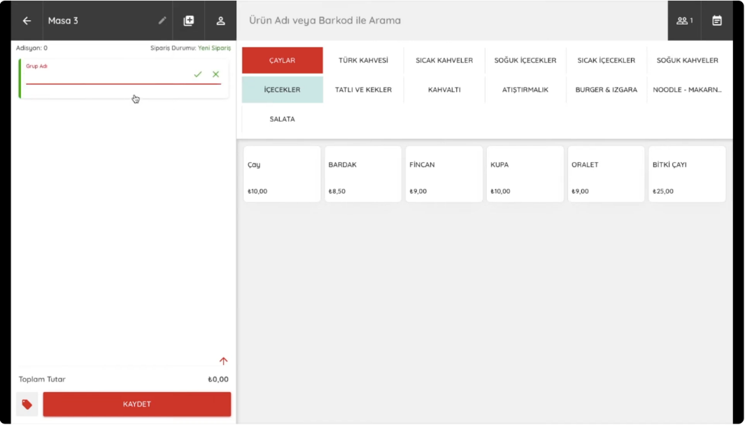
Figure 3.1. Adisyo Order-Taking and Menu Screen Used by Staff.
Source: Adisyo, 2022
Processes like bill calculation, invoice creation, and reporting (Figure 3.2) are also automated by the Adisyo System, rather than being limited to just order taking and routing. In addition, the receipts and bills issued through the system are designed to include financial obligations such as tax office information, printing details, and legal serial numbers.
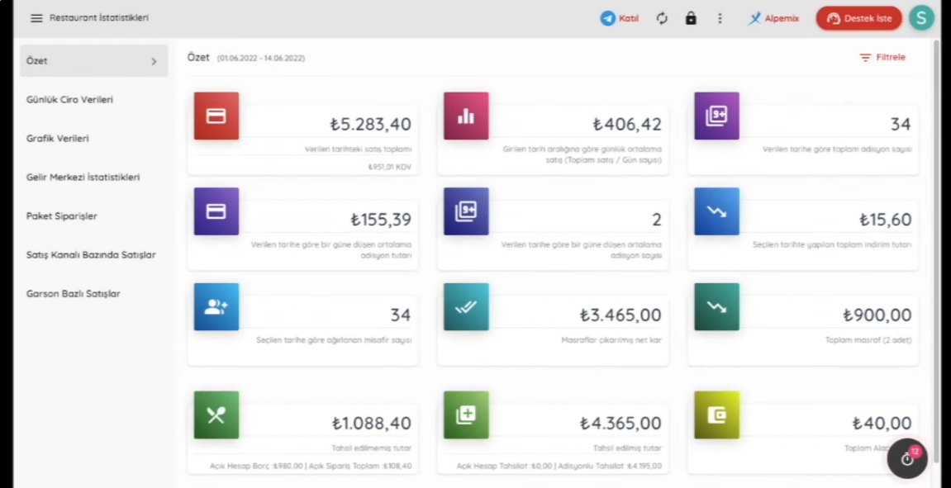
Figure 3.2. Adisyo Detailed Reporting and Financial Statistics Panel
Source: Adisyo, 2022

Differences Between the Smart Cafe Ordering System and Adisyo
Convenience is provided by Adisyo in the food and beverage sector through features like stock control, easy waiter-kitchen communication, and taxation. Yet, serious differences exist between this platform and the Smart Cafe Ordering System.
The first difference is observed in who handles the ordering or order-taking process. In the Adisyo system, the menu must be reviewed, and a decision must be made by the customer, who is then expected to wait for the waiter to attend to the table so the order can be taken and transmitted to the kitchen screen. This waiting period being long is a frequently encountered problem in busy and crowded establishments. The order is taken by the waiter after seeing that the customer is ready, but items or specific customer notes might be forgotten by the staff on the way to the tablet. In the Smart Cafe Ordering System, this operational burden is completely taken off the staff. The entire process is handed over to the customer, meaning a waiter is not needed as a middleman to transmit the order to the kitchen. The desired items are added to the cart, and the order is placed directly through the customer panel after the QR code is scanned.
As the second major difference, the main purpose and target audience of the Adisyo system diverge from the Smart Cafe Ordering System. Adisyo is built as a system that keeps official invoice records, tax number integrations, and deep financial logs, requiring the working staff to receive training before use. Such an aim does not exist in the Smart Cafe Ordering System; the main goal is purely set to speed up processes like order taking and order preparation in establishments. Thanks to a simple usage design, the project is kept away from being a complex system where staff might get confused or require training to operate it.

FineDine
FineDine is an AI-supported digital menu and order management platform designed to replace traditional paper menus in restaurants, cafes, and hotels (FineDine, 2026). The system is primarily presented to customers in two different ways: through special tablets permanently placed on tables by the establishment or via QR codes scanned by customers from their own smart devices. After the digital menu is accessed, high-resolution product images are reviewed (Figure 3.3), orders are created, and these requests are transferred directly to the kitchen panel.
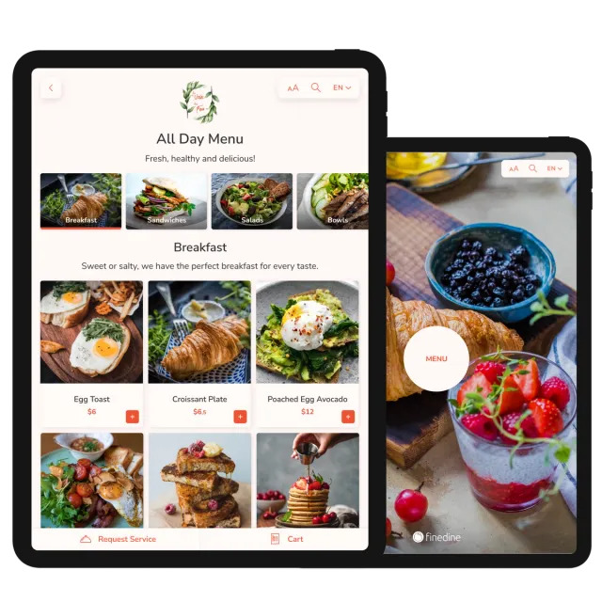
Figure 3.3. FineDine Tablet Menu Interface
Source: FineDine, 2026
An AI-supported algorithm that recommends new products based on past customer preferences and multi-language support are hosted within the application. Once the ordering process is completed, the opportunity to make online payments directly from personal devices (Figure 3.4) via credit card and leave the table is offered to customers through virtual POS infrastructures integrated into the platform.
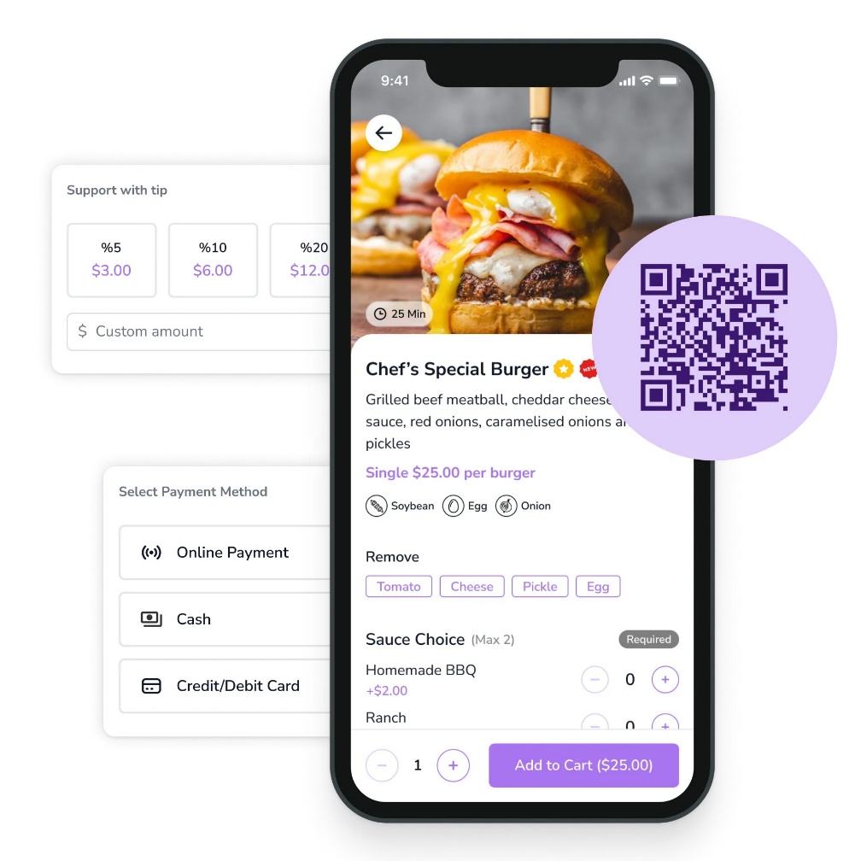
Figure 3.4. FineDine Mobile Application and Online Payment Screen
Source: FineDine, 2026

Differences Between the Smart Cafe Ordering System and FineDine
Although an advanced infrastructure for table ordering is provided by FineDine, clear structural contrasts exist regarding security, cost, and operational flow when compared to the Smart Cafe Ordering System.
The first and biggest difference is observed in how the payment and collection steps are completed. A fully integrated online payment infrastructure is found in the FineDine system, allowing the establishment to be left directly by the customer after the bill is paid from a personal phone or tablet. Serious security and control vulnerabilities are created for the service staff by this situation. Constant checks must be made by the waiter to ensure whether the payment was actually completed by a departing customer or if a technical error occurred during the online transaction. To prevent such complexities and situations like leaving the table without paying, the Smart Cafe Ordering System is specifically structured with a hybrid payment design. Even though the order is placed digitally and the bill is requested digitally, the final payment transaction is handled face-to-face at the table by the waiter using traditional methods. In this way, collection security is maximized.
The second major difference is seen in the hardware expectations on the customer side and installation costs. Integrating special tablets to every table is generally preferred for the FineDine system to operate at full efficiency and to present a luxury menu experience. This situation translates into high hardware costs for businesses, risks of theft or breakage of devices, and continuous charging and maintenance obligations. In the Smart Cafe Ordering System, no technological hardware is needed at the customer tables. The ordering process is carried out entirely through the customer's personal smartphone. On the establishment side, only basic panels (such as tablets or computer screens) used by the kitchen and service staff to track orders are found. By eliminating the expense of purchasing a separate device for each table, the system installation cost is minimized.
The third difference is observed in the target audience profile addressed by the systems. High-budget, premium segment restaurants and luxury hotels are targeted by FineDine through AI recommendations, deep data analytics, and luxury tablet menus. The Smart Cafe Ordering System is developed in a much more accessible and lean structure focusing only on ordering speed, enabling small and medium-sized standard cafe businesses to adapt to the digitalization process quickly and without extra financial burdens.

GetirYemek
GetirYemek is an application that enables users to order food or beverages online directly to their current locations (GetirYemek, 2026). The operational logic of the application begins with the selection of a delivery address by the user; based on this chosen location, cafes and restaurants capable of making deliveries are listed (Figure 3.5). After selecting a preferred establishment from this list and adding products to the cart, the payment is completed online by the customer. Since the system operates in integration with restaurants and cafes, the placed order is instantly reflected on the relevant business's panel.
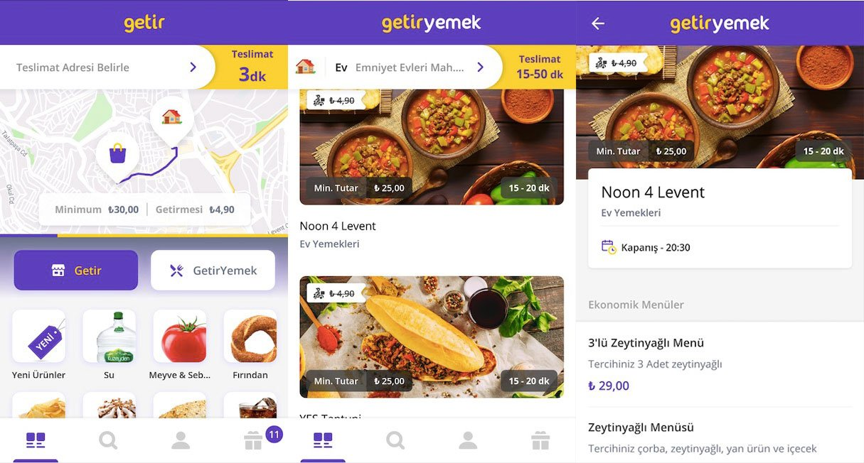
Figure 3.5. GetirYemek Restaurant Listing Screen
Source: Webrazzi, 2019
Following the approval of the order by the restaurant, a tracking panel—which can also be monitored by the customer—is created within the application. Once the order is marked as ready on the panel by the business, a motorcycle courier is assigned by the system to perform the delivery. The moment the product is picked up from the establishment by the courier, a live map tracking feature is activated on the user's application (Figure 3.6). Through this feature, the courier can be viewed instantly by the customer, ensuring clear awareness of the arrival time. Concerns about being available at the exact moment of delivery are eliminated, allowing the customer to comfortably focus on daily tasks.
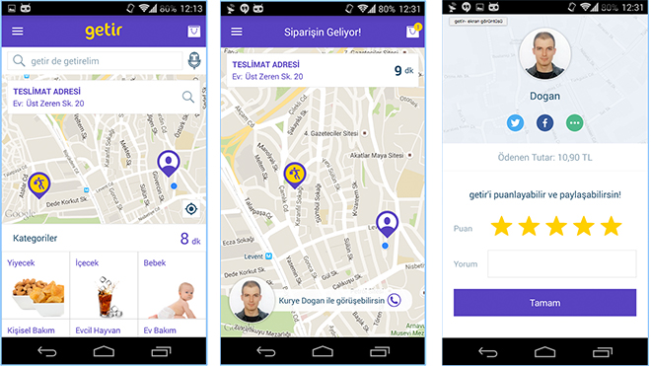
Figure 3.6. GetirYemek Live Courier Tracking Screen
Source: LOG, 2015

Differences Between the Smart Cafe Ordering System and GetirYemek
A very important place in the food sector is held by GetirYemek, and its foundation is constantly grown through various investments. Even with this massive reach, the developed Smart Cafe Ordering System stands apart with entirely different structural dynamics.
The first basic difference is seen in the physical location of the service. GetirYemek acts as a bridge for individuals who want to receive food at home or work instead of visiting a physical establishment. Going to a restaurant is not always possible for everyone. People might not want to step outside, or they might try to avoid dealing with heavy traffic. In such scenarios, platforms like GetirYemek are heavily preferred to get things done quickly. The Smart Cafe Ordering System is built for a different focus entirely. Faster service is targeted directly at customers who visit the cafe, ensuring their time spent inside the venue is much more enjoyable.
A second major contrast appears in the cost for businesses and the commission rates taken by these platforms. A ready customer network, active advertising, and courier logistics are provided by apps like GetirYemek, and in return, high commission fees are cut from every single order. When looked at over time, these cuts can easily overshadow the actual earnings of the cafes. The profit margins of the businesses are seriously dropped by this setup. The Smart Cafe Ordering System is an internal network that handles only the order-taking and tracking stages inside the establishment. Attracting outside customers is not part of the plan. Therefore, continuous financial burdens like per-order cuts, which can put a business in a difficult spot, are left out. A much more practical and budget-friendly setup is offered just by giving the business a digital management tool.

OddMenu
Changes in the food sector have been brought about by the rapid spread of global digitalization. The transition from traditional physical menus to digital alternatives inside cafes can be given as a prime example of this shift. Support is provided to establishments by platforms like OddMenu to create these digital catalogs. Any desired product edits or additions are handled by the cafes directly through the system (OddMenu, 2026). Afterward, these fixed menus are easily accessed by customers by simply scanning the QR codes placed on the tables using their smartphones. Following this scan, a fully categorized digital menu is brought to the screen (Figure 3.7).
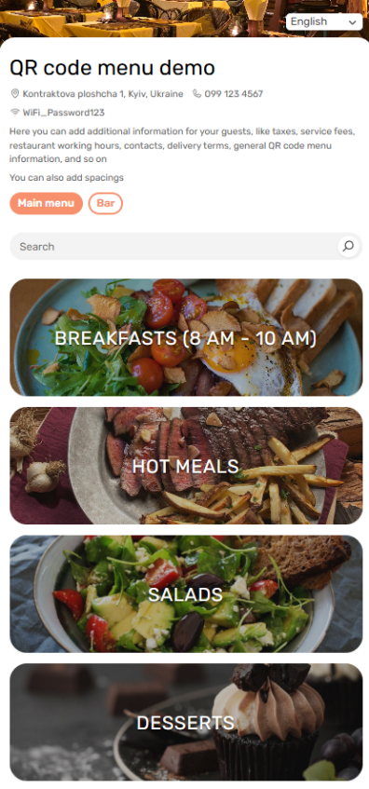
Figure 3.7. A Read-Only Digital Menu Interface
Source: OddMenu, 2026
An interactive environment is not offered by this setup. Features that engage the customer digitally, such as adding a product to a virtual cart, placing a direct order, or making an online payment, are completely left out. The sole purpose of the system is to carry a readable menu into the digital space for fast access, while also ensuring that any menu updates can be effortlessly managed by the business. Once a desired item is chosen from the digital display, the actual ordering process is carried out by physically calling a waiter. Consequently, the overall time spent just to place an order is prolonged unnecessarily.

Differences Between the Smart Cafe Ordering System and OddMenu
Online platforms like OddMenu are utilized as a way to eliminate paper menus, aiming to save both paper and time for the business. Even though certain operational advantages are provided, these benefits remain quite limited. Systems of this nature only assist in preparing a readable menu; the remaining stages are continued in the old, traditional style.
One of the most obvious shortcomings is the total absence of an ordering process within the system. Looking at the OddMenu infrastructure, customers are only allowed to view products and examine their prices. For the desired items to be requested, a waiter must still be waited for. The process of the waiter taking the order, keeping it in mind, or writing it on paper to relay it to the kitchen is conducted entirely manually. In the Smart Cafe Ordering System, since this manual routine wastes time and occasionally leads to mix-ups, orders are allowed to be placed automatically by the customer straight through the interface. By incorporating this feature, potential confusion is prevented, the flow is accelerated, and customer satisfaction is targeted to be increased.
Another major difference is seen in the effort required by customers to communicate with the staff. When a problem occurs or a specific request needs to be made in the Smart Cafe Ordering System, an instant notification is sent to the staff the moment the "Call Waiter" button on the customer panel is pressed, ensuring immediate attention. In establishments relying on static systems like OddMenu, situations such as struggling to make eye contact, waving hands, and still going unnoticed by the waiter are frequently experienced. This specific issue becomes much more prominent during rush hours, as attending to multiple customers simultaneously cannot be managed easily by the service staff.
The final contrast is defined by the payment and table-based financial tracking capabilities. Static QR catalogs used by platforms like OddMenu have absolutely no connection to the cafe's cash register or live table tracking systems. The single goal of such static catalogs is to ensure easy menu access for the customer. In the Smart Cafe Ordering System, since the QR code scanned at the table automatically grants access to that specific table's customer panel, live table tracking is handled much more comfortably by the employees. When the checkout stage is reached, the process of asking for the bill requires forced interaction with a waiter in static-menu venues. In the Smart Cafe Ordering System, the total bill can be viewed instantly, and the cost can be split based on the total price or specific products whenever desired. At the same time, preferred payment methods can be selected right from the screen. An operational level like this is completely unreachable with a static menu setup.

MATERIALS AND METHODS
In the materials and methods section, the software technologies, system architecture, and basic algorithmic processes that build the infrastructure of the Smart Cafe Ordering System and make it run are examined and explained in detail. First, the programming languages preferred from both the server side and the user interface, the libraries used, and the database management systems allowing data storage are explained together with their usage purposes and methods. After describing the technical infrastructure, the general structure of the four main modules (Customer, Waiter, Kitchen, and Admin) working in an integrated way just like the limbs of a system is examined. How they operate in perfect harmony with each other is also described. In the last part, the working logic of the functions that separate the project from traditional, static menus, such as real-time data transmission, QR code-based table matching, and separate bill splitting and payment method preference for each table, is revealed.

Software Technologies Used
Under the Software Technologies Used heading, the tools preferred for both the back-end operations and the front-end interface of the Smart Cafe Ordering System are examined. The programming languages, libraries, and database systems forming the foundation of the project are detailed sequentially under subheadings. Up-to-date web technologies are utilized to ensure the system operates simultaneously and received orders are transferred to the required modules instantly.

JavaScript
To manage both the frontend and backend of the Smart Cafe Ordering System within a single ecosystem, JavaScript was selected as the core language (Figure 4.1). Since it works across both the server and the browser, the entire project was unified under one code base to gain structural flexibility. The debugging process was also completed much faster this way. When data was pulled from the database, it was directly processed in JSON (JavaScript Object Notation) format before reaching the user screens. Data transfer speed was kept high through this native format. Because of this fast data flow, user waiting times were kept low and a better customer experience was targeted.


Figure 4.1. JavaScript Logo
Source: Wikipedia, 2026

Node.js
Node.js was integrated as the server-side runtime to allow JavaScript to run outside the browser environment (Figure 4.2). The core backend logic, panel access control, and API requests from user panels were all handled within this environment. Since cafe traffic tends to spike during weekends or busy shifts, the server often faces a flood of simultaneous requests for orders and assistance. To keep the application from freezing or crashing during these high-pressure moments, the event-driven and non-blocking I/O structure of Node.js was the preferred choice. If a problem like this were to lock the entire system, both the customers would face issues and the business would suffer financial loss. All concurrent demands from tables, or notifications from waiter and kitchen staff, were processed rapidly in order without slowing down the server. Extra features like real-time communication and admin file uploads were also added to the project through the large NPM ecosystem.

Figure 4.2. Node.js Logo
Source: Wikipedia, 2026

Express.js
The Node.js-based Express.js framework was chosen to manage and control the server-side routing and Hypertext Transfer Protocol (HTTP) requests of the Smart Cafe Ordering System (Figure 4.3). Express.js, which offers a lightweight and flexible structure on Node.js, was used in the project to make complex server codes more organized and manageable.

Figure 4.3. Express.js Logo
Source: Eddy, 2023
In the system, requests coming from tables, data sent to waiter panels, and admin operations are all handled through separate endpoints. Thanks to the simplified and basic routing mechanism of Express.js, defining and managing these endpoints was carried out efficiently. Also, through the middleware support provided by Express.js, user authorization and data validation processes were integrated into the system without breaking the structure and logic of the main code.
Especially during high-traffic moments, the quick processing of incoming HTTP GET, POST, and DELETE requests and their transfer to the correct functions kept the response time of the system at a minimum. This modular structure provided by Express.js both reduced the margin of error on the backend side of the project and made it easier to add new features.
Specific libraries are used to manage the server settings and security. The express-basic-auth library is added to protect the admin, kitchen, and waiter panels. Only the staff can access these panels by using a username and password. Private information such as the database connection string is managed with the dotenv library. Also, the cors library is used so that the front-end and back-end can share data. These libraries are used to build a more secure and stable system structure.

MongoDB
The management of all system data, ranging from menu details to live table statuses, was handled through MongoDB (Figure 4.4). A document-oriented NoSQL approach was picked because cafe data is often dynamic and needs to be accessed very quickly. Instead of using rigid and fixed tables, data was stored in a document-oriented structure, which allowed different types of information to be kept together in a single record. Speed was a main concern for the project, so this specific database model was used to ensure that requests from the waiter and kitchen modules were answered without any lag.

Figure 4.4. MongoDB Logo
Source: World Vector Logo, 2026

Mongoose
Mongoose is a library designed to act as an interface between Node.js and MongoDB. It was added to the project as an ODM (Object Data Modeling) tool to manage the connection between the backend and the database (Figure 4.5). Although MongoDB allows for a lot of flexibility, a fixed data standard was necessary to keep the cafe system stable. Specific structures were built for every data type to ensure all stored information remained organized. This was done to avoid data conflicts and to force every entry to meet specific requirements before being written to the database. By handling validation through these schemas, the backend was made more secure and potential errors were blocked at the server stage.

Figure 4.5. Mongoose Logo
Source: The Node Way, 2024

Socket.IO
To transfer data instantly between modules and deliver notifications to the relevant panels without any time loss within the Smart Cafe Ordering System, the Socket.IO library was used (Figure 4.6). In a cafe setting, when an order is placed or a waiter is called by a customer scanning a QR code through the customer panel, it is very important for this information to drop into the kitchen and waiter panels instantly. This needs to happen without requiring a page refresh on the screens open on the staff panels. A live connection was created between the server and the clients using the two-way communication of Socket.IO.

Figure 4.6. Socket.IO Logo
Source: Ably, 2023
Because of this event-based system, browsers were no longer required to constantly check the server for new data. This way, the system load was kept to a minimum. Whenever an action was made by any user, the update was sent straight to the needed modules by the server. With this process, possible delays in the service flow provided to the customer were prevented, and the synchronization among all modules of the system was made much smoother. Also, communication was kept stable even during temporary network issues, thanks to the ability of the Socket.IO library to handle connection drops automatically.

Multer
In the product adding and editing section of the Smart Cafe Ordering System's admin panel, the Multer library was used to upload menu item images to the server (Figure 4.7). During the addition of new products or the updating of current images, files were sent to the server as multipart/form-data. Following this transfer, the photos were displayed directly on the customer panel. The Multer middleware was implemented to handle these file uploads within the Node.js and Express.js environment.

Figure 4.7. Multer Logo
Source: augusto-dmh, 2024
File extensions like JPEG or PNG, along with file sizes, were controlled on the server side. In this way, the system was protected from oversized, unsupported, or dangerous file uploads. Images were then saved into specific folders in the server directory with unique names. Because of these unique names, any image that needed to be edited was found much more easily. Finally, a direct link was created between the path of the uploaded physical file and the product record in the MongoDB database.

HTML, CSS and Frontend Scripting
To create the user-facing side of the Smart Cafe Ordering System and to present the functions of its four different modules (Customer, Waiter, Kitchen, and Admin panels), modern web technologies were used. During the design and creation of the visual architecture, HTML5, CSS3, and JavaScript were brought together to structure the content, offer a comfortable layout, and handle user interactions. The main goal was to make these languages work together as an integrated unit.
HTML5, which is considered the foundation of the interface development process, is known as a markup language rather than a programming language (Figure 4.8). Since it does not hold any functions, it is simply used to display written codes on a website. This language was chosen to build the skeletal structure and the semantic layout of each panel. Dynamic contents on the customer panel—like the available products, their categories, the position of the search bar, product images, cart details, option menus inside the cart, and the exact placement of payment buttons—were all organized inside the hierarchical structure of HTML. Showing plain text was not the only purpose here. The technical base needed to send user inputs perfectly to the server was also established in this layer using form elements and structural tags. Waiters and kitchen staff have many physical duties and cannot look at their screens constantly. Because of this, their specific panels were structured so that incoming texts and order details could be read and understood at a quick glance.

Figure 4.8. HTML5 Logo
Source: Wikipedia, 2026
For the visual design and the shaping of user experience (UX), CSS3 was used (Figure 4.9). In a typical cafe environment, the system is accessed from completely different devices. A customer might log in with a smartphone, while a tablet or a laptop might be used by the waiter or the kitchen staff. Because of this hardware difference, a responsive design was created to ensure a comfortable view on every device. By applying the Flexbox and Grid systems provided by CSS, flexible interfaces were built to adapt to any screen size automatically. This step was taken so the QR-based interface on customer phones, the wide order lists on kitchen monitors, and the admin panel on standard computers could all be displayed in their most suitable layouts. Visual adjustments were also made through CSS to speed up the daily operations. Waiters are constantly moving around to deliver orders or talk to customers. To prevent them from losing focus when they return to the panel, notifications were designed to be highly noticeable. In a similar way, color codes were applied to the kitchen screen to easily separate preparing, ready, and delivered orders.

Figure 4.9. CSS3 Logo
Source: Wikipedia, 2026
In the final step that completes the dynamic nature of the system, the frontend features of JavaScript were applied. As mentioned in earlier sections, JavaScript served as the core language of the project. Document Object Model (DOM) manipulation was performed to stop constant page reloads. This approach allowed the staff to see new order alerts or bill requests instantly without manually refreshing their screens, providing a much smoother experience. The reaction time of the entire system was kept to a minimum by handling processes like reflecting real-time Socket.IO data onto the interface, managing button clicks to communicate with the backend, and running form checks directly on the screen. As a result, by using HTML, CSS, and JavaScript together, a professional interaction space was built. Rather than focusing just on looking good, this interface was designed specifically to serve operational speed, run without errors, and guide the users easily.

System Structure
The system architecture of the Smart Cafe Ordering System is explained in detail in this section. To keep the user roles distinct, a modular framework was put in place. In this way, each module was designed individually. When a modification is required, changes can be made directly on the specific module. Based on this, the smart cafe ordering system was designed and structured with four distinct interfaces: customer, waiter, kitchen, and administrator panels. A single central database was utilized by all these modules. This ensures that the data flow is managed through a single point without confusion. Data synchronization between the interfaces is achieved in real time without the need for page reloads. The actual order progression is carried out across the customer, waiter, and kitchen screens. Meanwhile, all managerial monitoring tasks are confined to the admin module. Graphical layouts and working mechanics for each part are broken down in the upcoming headings.

Customer Panel
The customer panel is designated as the first interaction point where users engage with the system. The general design presented to the users entering this interface is shown in Figure 4.10. Access to the system is provided by scanning unique, independent QR codes generated specifically for each table via smartphones. The interface was designed with user satisfaction in mind. A simple, visually appealing layout was targeted so that users can easily examine products and place orders without getting lost among complex buttons. A product search engine is located at the top of the main screen, allowing desired items to be found, examined, and priced easily.
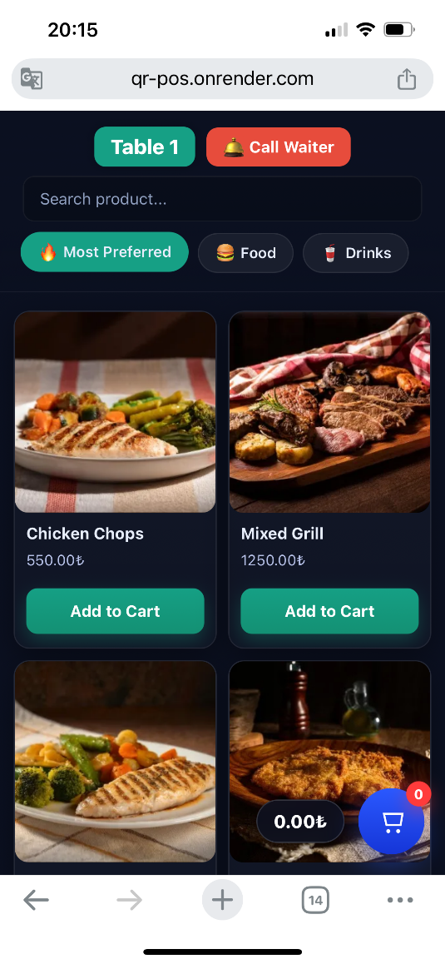
Figure 4.10. Customer Panel Main Interface
Upon opening the panel, the most preferred items section is shown first. This allows popular choices to be seen instantly. Menu items are divided into main categories like food and beverages, which are then broken down into subcategories. In this way, desired products are accessed much faster. Each menu item includes a visual and a price tag. When a specific product is tapped, its image is enlarged and the ingredients are listed on the screen. Product variations (such as portion size or sugar amount) can be selected directly on the screen. Therefore, manual note entry is not required for standard choices. However, a separate order note field is provided for special requests or ingredient removals. These specific notes are then reflected on the kitchen panel during preparation. A short animation is shown when an item is added to the cart. Through this visual feedback, the location of the cart is easily noticed by the user.
Inside the cart screen, the selected items are listed. Quantities can be adjusted via "+" and "-" buttons, or the entire cart can be cleared using the trash bin icon. The total calculated price is kept visible on the screen at all times. Thus, the exact payable amount is known without repeated checks, helping the customer decide whether to order more or ask for the bill. Even after the cart is emptied upon delivery, this on-screen total is maintained to show the sum of all past orders. After the order is confirmed via the customer panel, the data is transmitted instantly to the kitchen and waiter panels. The "My Orders" section was integrated into the panel so that the instant status of current orders (e.g., "preparing") can be tracked and previously ordered items can be viewed.
In addition to basic ordering steps, a waiter call request can be sent with a single click using a highly visible button on the main screen. If an issue occurs or assistance is needed, the waiter can be called instantly. Various options are offered to users during the payment stage. If the bill is to be paid by a single person without splitting, a payment request can be created directly by simply selecting the payment method (cash or credit card). In case a bill split is requested, "person-based" or "item-based" splitting operations can be performed through the system. Through a single screen, different payment methods can be selected for each split portion, and instant notifications can be sent to the waiter panel. As a result, manual waiter calls and bill confusion at the table are prevented.

Waiter Panel
The waiter panel is designed as the main employee interface where the flow of orders, customer requests, and table statuses are handled in real time. The general screen design for this section is illustrated in Figure 4.11. Access is granted only after a valid username and password are provided on the initial login screen. This centralized configuration was established so the entire floor operation could be coordinated from just one dashboard. Since it acts as a bridge between the kitchen and the guests, the panel also maintains a direct line to the customer's device when needed.
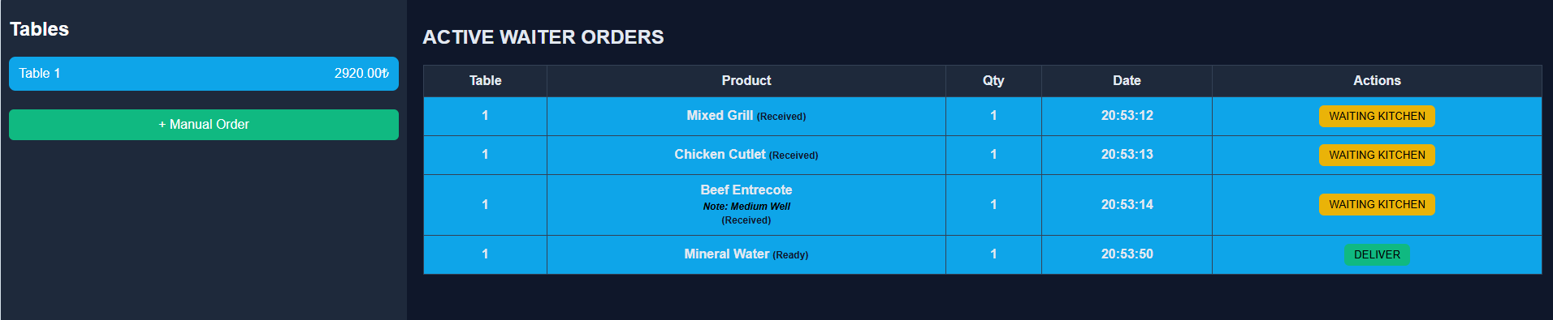
Figure 4.11. Waiter Panel Management Dashboard
On the left side of the screen, every active table is listed along with their current bill totals. These statuses are monitored second by second to keep the staff updated. Right at the top, critical notification areas are placed to handle the communication between guests and waiters. Requests like ”Tables Calling Waiter” or “Tables requesting bill” are handled dynamically, so they update in the background without needing a page refresh. A flashing visual effect is integrated into these alerts to prevent them from being overlooked during a busy rush. These notification fields are only triggered when an actual request exists; otherwise, they remain hidden to avoid any unnecessary screen clutter.
The progress of items within the kitchen is also tracked through this dashboard. While a meal is being prepared, it is shown with a “Waiting Kitchen” status. Once the kitchen staff marks an item as ready, the update is reflected on the main screen so the waiter knows it is time for service. By clicking on a specific table, a detailed view opens up, giving the staff full control over that table’s orders. If a mistake is made or a guest changes their mind, items can be removed using the "Delete" button. This action also clears the entry from the kitchen panel so food is not wasted. As products are delivered, they are marked as such, which then triggers an instant update on the customer’s phone. Once a guest's specific need is satisfied, the "Customer Attended" option is used to clear the alert.
Manual override options are provided to prevent service delays in cases where a guest’s device runs out of battery or loses internet connection. Through a dedicated “+ Manual Order” button, staff can input orders themselves, which are then transmitted to the kitchen just like a standard digital request. The system also handles table changes via a "Move Table" function, ensuring all order data is transferred without risking billing errors or confusion. During the checkout phase, the chosen payment methods and split bill details are listed for a quick review. Receipts are printed directly from the integrated unit with a single tap on the "Get Receipt" button. The waiter selects the payment method before closing the table if the customer did not send a request. Cash, card, or split options are available on this screen. After this step, the 'Close Table' command is used to reset the spot for new customers. The table record is cleared in the database.

Kitchen Panel
The kitchen panel is designated as the technical module that manages the preparation stage of orders placed by customers and coordinates the cooking process. The general design of this interface, which operates together with the waiter and customer panels, is shown in Figure 4.12. The interface was designed with the aim of keeping the kitchen staff's attention strictly on the orders. A simple, non-distracting, and functional table layout was targeted so that staff can focus solely on their tasks.
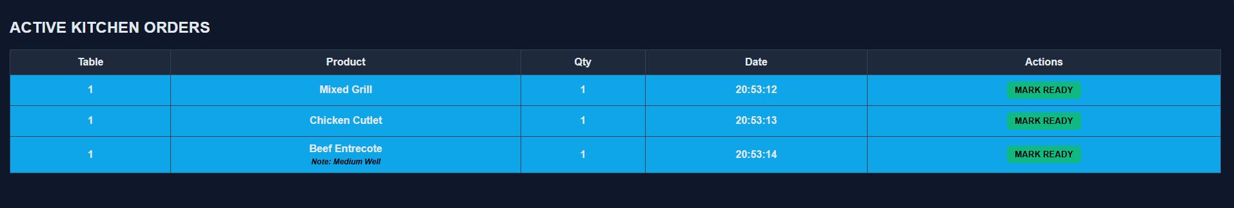
Figure 4.12. Kitchen Panel Main Interface
The basic operation of the panel relies on the instant display of requested items. Orders containing products meant for kitchen preparation are dropped directly into the "Active Kitchen Orders" list. This happens regardless of whether the order is placed by the customer or entered manually by a waiter. Inside the table, critical details like the table number, product name, requested quantity, and system entry time are provided. Thus, the kitchen staff can clearly see which table is waiting for a specific product and the total waiting time, preventing any operational confusion.
In order to prevent chaos in the system and lighten the workload of the staff, a visual grouping system is applied. Orders placed by the same table are shown within the same color block in the table. Through this color coding, similar products coming from different tables are prevented from being mixed up. Therefore, mistakes such as preparing a later order before an earlier one are avoided, and the accuracy of the kitchen operation is increased. For example, "Mixed Grill" orders coming from different tables are represented with different colors according to their table numbers. Through this visual separation of both the tables and the order times, the staff's attention is focused easily.
On the right side of each order row, a "Mark Ready" button is located. When the preparation process of a product is completed, the kitchen staff presses this button to indicate that the product is ready, and the system is updated. As soon as this action is performed, the "Waiting Kitchen" status next to the order on the waiter panel changes to "Ready". This means the waiter can take the product to the table. Also, the order status on the customer panel is updated simultaneously. Therefore, communication between the kitchen and the service staff is completed entirely through the digital panels. Loud kitchen noise or verbal confirmations are no longer needed to coordinate the service. By keeping this workflow digital, preparation and delivery delays are shortened, helping support customer satisfaction and the working efficiency of the establishment.

Admin Panel
The admin panel is designated as the central management module where business officials control the digital menu, track financial data, and oversee general system operations. The general design presented to the users entering this interface is shown in Figure 4.13. Through an administrator account holding full system authority, the list of items on the menu can be controlled in detail. Since the panel has a web-based infrastructure, all of these management operations can also be performed remotely via smartphones. In this way, the operational strategies of the establishment are coordinated through a single screen, even if the administrator is not physically present at the restaurant.
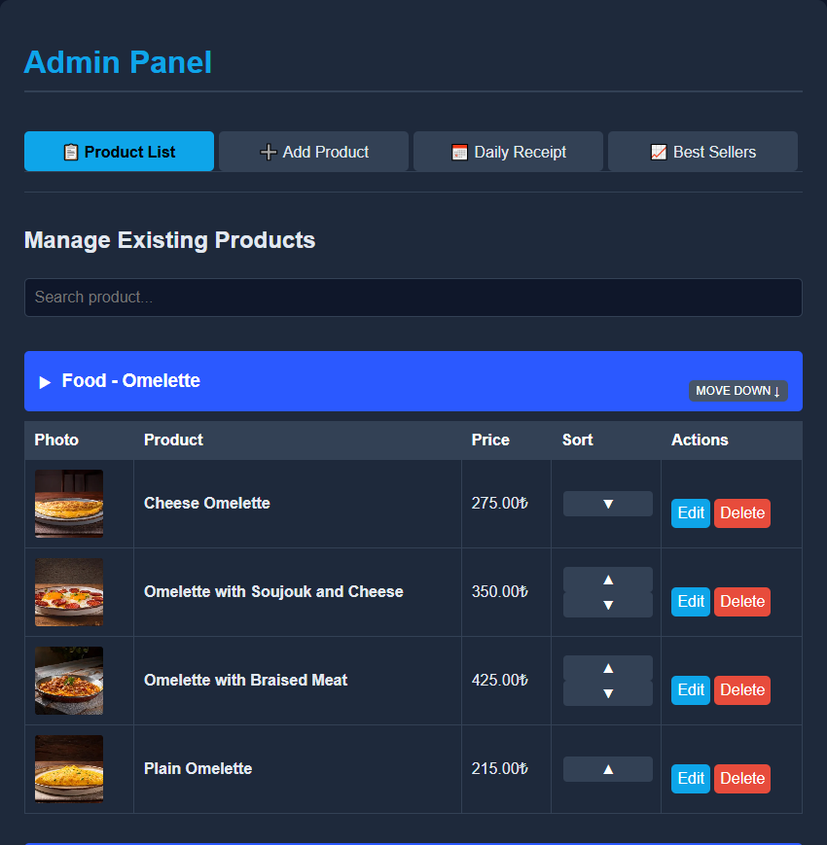
Figure 4.13. Admin Panel Management Interface
One of the main functions of the panel is product management. Through the "Add Product" interface, a new item can be easily added to the database by entering necessary details like the name, category, price, and a visual. A flexible control mechanism is also provided for existing menu items. Product prices can be updated, images can be changed, and descriptions can be rewritten if the ingredients of a product change. If an item is temporarily out of stock, it can be hidden from the menu rather than deleted completely. Once the stock is replenished, it can be made active again for customer access. Items that will no longer be sold can be removed from the system permanently. The display order of the categories and products on the customer menu is also organized through this panel. Thanks to the 'move up' and 'move down' functions, the visual ranking of the items is adjusted and the menu layout is kept under full control. In this way, specific products or subheadings are highlighted by the administrator without needing any software updates.
The operational flow configurations of the products are also managed through this panel. When adding an item to the system, the administrator determines whether it is a ready-made product to be served directly by the waiter, or an item that requires preparation and needs to be sent to the kitchen screen. Product options can also be added to speed up the ordering process. For example, instead of having a customer manually write the doneness level of a steak in the order note field, pre-defined options can be offered directly on the screen. Therefore, a more practical selection is provided to the customer without requiring them to type out their requests.
Financial tracking and reporting operations are handled through the admin panel as well. Inside the "Daily Receipt" section, sales data for any selected day is listed. On this screen, exactly how many of each item were sold and the total revenue generated for that day can be examined easily. When the staff checks the register for shortages at the end of the day, the system shows how much of the daily revenue was collected via credit card and how much was paid in cash. In addition, past daily records take up space in the database over time. Thus, the list of records for any desired day can be permanently cleared from the database with a single click by the administrator.
A "Best Sellers" list is integrated into the panel to help determine the future strategies of the business. Through this list, which ranks items from the most ordered to the least ordered of all time, a detailed sales analysis is performed. By looking at these numbers, it becomes clear exactly how much of each product was sold and which item types are preferred more by the customers. As a result, the administrator is provided with a clear idea regarding what to add or remove from the menu.

Functional Methods
The functional methods that create the basic infrastructure of the Smart Cafe Ordering System are explained generally in this section. An uninterrupted data flow without delays was targeted so that processes like menu viewing by the customer, order transmission to other panels, instant status tracking by customers and staff, and payment operations are kept connected within the system. Since the project was built on a completely web-based viewing architecture rather than a mobile application, all methods were structured for comfortable daily use across the customer, waiter, kitchen, and administrator modules. A layout was targeted so that desired operations can be accessed and executed easily instead of being complex. The technical operation steps of these processes, which provide communication and integration between the modules, are explained in detail in the following subheadings.

QR-Based Access Method
Order placement requires an initial system login. This is handled by scanning the QR code on the table with a smartphone. When the code is scanned, the user is automatically sent to a web-based customer panel. The platform is accessed directly without any software downloads. A specific link is embedded inside every QR code to pair it with the physical table number. This ensures that only the panel for the current table is accessed. Confusion in the system is prevented through this method. It is aimed at increasing customer satisfaction and making the staff's job easier. Also, tables that have not been scanned are not shown on the waiter panel. Even before an order is placed, the table is immediately marked as active on the staff monitors once the code is scanned.

Order Management Method
Three different panels are directly involved in the order management part: customer, waiter, and kitchen. The admin panel is included in the order management part indirectly. After the QR code is scanned and the customer panel is accessed, the products in the menu are seen. This panel is designed in a simple structure to increase user experience, and easy access to the product is provided. A search button is provided to find the desired product, and headings and subheadings are included to examine the products. The desired product is added to the cart, and if a note is wanted to be added, it can be written in this section. The moment the order is placed, the requested products and specified notes are transferred directly to the kitchen and waiter panels. If there is a product that will not be prepared in the kitchen and will be delivered directly by the waiter, it is not shown on the kitchen panel. Adding new products to the menu or making edits to those products is done by the admin.

Real-Time Update Method
The panels in the system are updated instantly to speed up all order processes. When an order is placed by a customer, it is instantly dropped into the waiter and kitchen panels. The page does not need to be constantly refreshed by the staff to check for new orders or customer requests. The system is updated automatically in the background. Any change is immediately reflected on the panels. Once a given order is ready to be delivered by the kitchen, the ready button is pressed. This status is instantly shown on the waiter panel. The exact status of the order can be tracked moment by moment in the orders section on the customer panel. When the bill is requested or the call waiter button is used by the customer, it is immediately reflected on the waiter panel. Saving the customer's time is the main purpose of these instant events. Processes like ordering and asking for the bill are accelerated to increase customer satisfaction.

Payment and Bill Splitting Method
Different choices are presented at the checkout step. The "Ask for Bill" button in the cart is clicked to start the process. A single payment method, like cash or card, is chosen for undivided checks. For divided bills, the total cost can be split evenly among the group. A specific payment method can also be assigned to each individual payer. Another splitting option is based strictly on the consumed items. The number of paying people is entered first. Specific products are then selected for each person to pay. After distributing the food items, a distinct payment type can be picked for each guest. The final request is transmitted directly to the staff monitors. A blinking visual is shown on the screen to grab the waiter's focus. The exact number of paying guests and their transaction types are viewed clearly by the staff. Taking a POS machine to the table unnecessarily is prevented if a cash payment is selected. The required POS machines are prepared in advance if card payments are requested. The bill is requested digitally, but the actual payment is collected physically at the table. Security vulnerabilities for the business are prevented through this method. Customers are allowed to leave the cafe comfortably after the physical transaction. The payment process is accelerated through these steps, and the table circulation rate of the establishment is increased. Customers can cancel their payment request if they change their mind. The table goes back to the active ordering state after this cancellation. Also, customers cannot place new orders while a payment request is active. Daily Sales Report Method.
Cafe revenues are tracked through the Daily Receipt section of the admin panel rather than using paper receipts. Total orders and the overall revenue for the selected date are displayed on the screen. Payment methods, showing exact cash and card totals, are also listed separately. End-of-day register calculations are checked by the staff and the manager to prevent financial errors through this automated process. A list of products is viewed in the Best Sellers section of the admin panel. High-demand items and rarely preferred products are identified through this list. New menu ideas or price updates are formed by the manager based on these sales data.

DIAGRAMS
In this section, the design, the general structure, and how the Smart Cafe Ordering System works are presented by using some diagrams. Each diagram is used to show how the system works and especially how the users interact with the application during the normal operation of the system, and to make it easier to follow. In order to see the technical infrastructure and the general working logic of the project in a simple and clear way, use case, class, activity, sequence, and database diagrams are presented and explanations about these diagrams are given in the following subsections.

Use-Case Diagram
The general functions of the system and the interactions of different actors are shown in Figure 5.1.
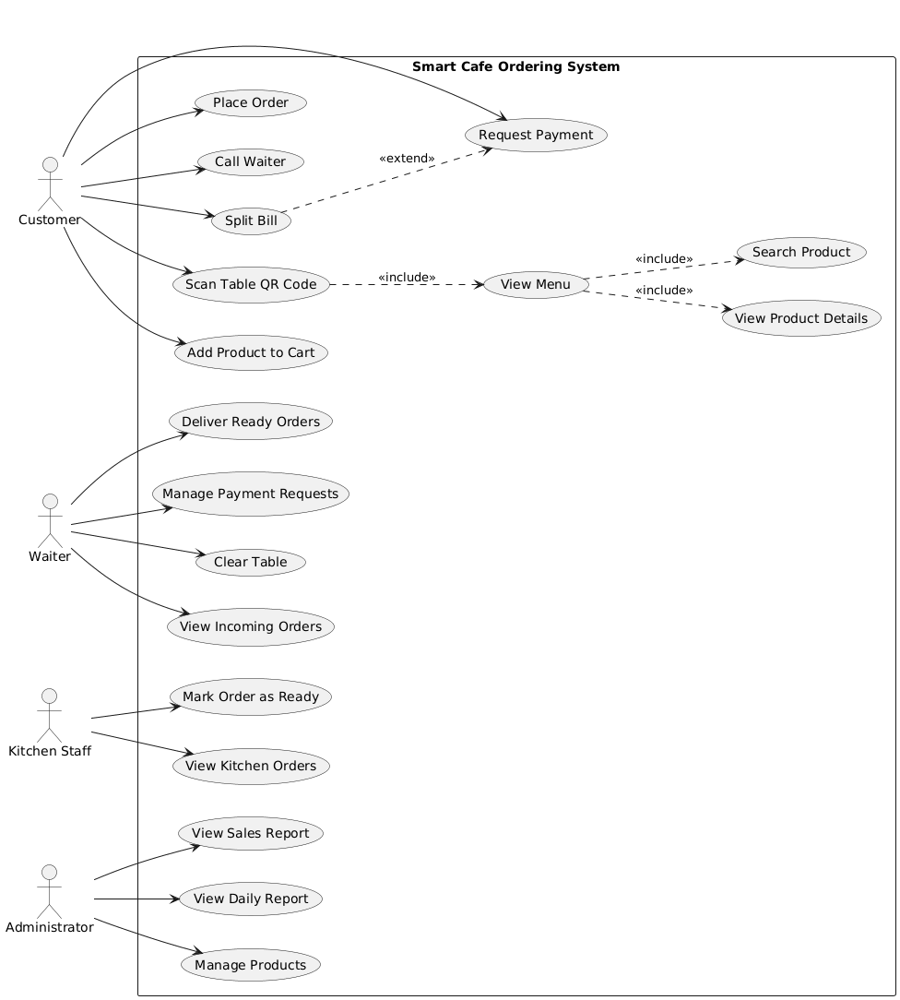
Figure 5.1. Use Case Diagram of the Smart Cafe Ordering System

Explanation of the Use-Case Diagram
The sole aim of the Use Case diagram (Figure 5.1) is to explain the working of the system in a comprehensible manner. Four different structures are included within the system, in general. These are the customer, waiter, kitchen staff, and administrator.
To access the customer screen, a QR code must be scanned. Products can be seen, and orders can be made here. Also, the bill can be requested, and split method can be used on this screen.
On the waiter panel, there is a screen showing customers requesting the bill, ready products to be carried to tables, and table orders.
On the kitchen staff panel, there is a screen that shows products that need to be prepared. When they are ready, they are marked as ready, and a notification is sent to the waiter.
On the administrator panel, there are also options for tracking products, adding new products, changing prices, and changing the image of products.
Thanks to this diagram, it can be seen which areas are accessed from which panel and how this system works.

Main Scenario
The main scenario of the system is the order placement process. The steps of this scenario are carried out in the following order:
- The QR code on the table is scanned by the customer to open the application.
- The menu is viewed and the desired products are added to the cart on the customer screen.
- The order is confirmed by the customer and sent to the relevant panel automatically.
- The products are seen and prepared by the kitchen staff.
- When the preparation is done, the order is marked as ready on the kitchen panel.
- A notification is sent to the waiter panel to carry the ready products to the table.
- The order is delivered to the customer by the waiter.

Sub Scenario: Payment Process
This part shows how the payment is made. The steps are:
- The bill is requested from the customer screen.
- The split option is chosen if the group wants to pay separately.
- This request is seen on the waiter panel.
- The payment is taken by the waiter.
- The table is marked as empty.

Sub Scenario: Administrator Operations
This part shows what the administrator does. The steps are:
- The admin panel is opened.
- New items are added to the menu.
- Prices and photos of the products are changed.
- Everything is saved to the database.
- The new menu is shown on the customer screen.

Class Diagram
The technical structure of the system and the data models are shown in Figure 5.2.
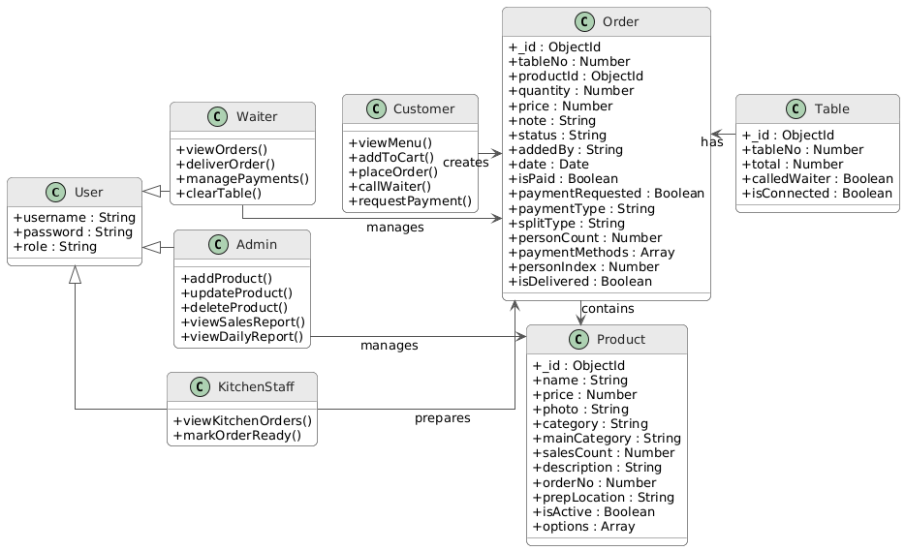
Figure 5.2. Class Diagram of the Smart Cafe Ordering System

Explanation of the Class Diagram
The class diagram represents the conceptual structure of the system and the roles defined within it. Looking at the class diagram presented in (Figure 5.2), what is seen in detail is the software architecture of the project, the core objects of the system, and the hierarchical relations of these objects with each other.
The 'User' class is used to show the roles in the system. These roles are not kept in database tables. They are managed in the server files for safety. This diagram explains the access logic of the staff. This base class is divided into 3 parts. The 'Admin', 'Waiter', and 'KitchenStaff' classes are separated so that they can log in to their own authority areas with their own credentials and have special functions. For example, important and large management operations such as adding a new product to the system, updating the price of the product, and checking general sales data are done by a person in the 'Admin' class. While duties like tracking the orders coming from the tables instantly, approving payment requests, closing the table, and delivering the prepared products are taken by the 'Waiter' class; the 'KitchenStaff' class only views the contents of the orders dropping on its screen, prepares the products, and updates the order status from the system when the preparation stage is finished and it is ready to be delivered. Thanks to this update, the products to be delivered drop to the waiter panel.
The 'Customer' class, which works separately from the staff structure, represents the customers in the cafe. Functions such as viewing the menu via QR code, adding products to the cart, placing an order, calling a waiter with one button when needed, and requesting the payment or splitting the bill with one button are used by this class. The main center that provides communication and connection between all these different user types is the 'Order' class. Data like the referenced product, product price, ordered quantity, payment method, and the current delivery status of the order are kept in this class by updating them second by second, instantly.
Finally, the 'Product' class, which contains the technical details of the food and drinks in the menu, and the 'Table' class, which tracks the current account amounts and instant status of the tables, are directly integrated into this order cycle. In summary, this diagram shows in which stages and with the help of which classes and functions the operations in the cafe are managed without problems and fluently in the background.

Activity Diagram
The activity diagram shows the step-by-step flow of the system, as presented in Figure 5.3.
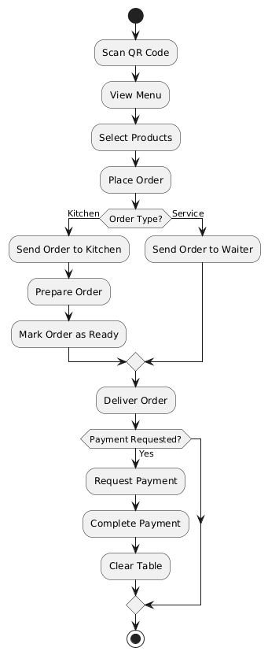
Figure 5.3. Activity Diagram of the Smart Cafe Ordering System

Explanation of the Activity Diagram
How the workflow and operation in the Smart Cafe Ordering System happen from the start to the last step is shown step by step in the activity diagram in Figure 5.3.
The customer is the one who starts the process, and the process is started when the QR code on the table is scanned. When the system is entered by scanning the QR code, the customer panel is seen. In this panel, the menu is viewed, the wanted products are chosen and added to the cart, and the order is given by confirming the cart. After this step, the type of products in the given order is checked and the process is divided into two. If the order is a product that must be prepared in the kitchen, it is sent to the kitchen screen. The order is prepared by the kitchen staff, and it is marked as 'ready' when it is ready to be delivered. This product marked as ready drops on the waiter's screen, and this means it is ready for delivery. If the order is a ready product that does not need preparation in the kitchen and will be served directly, it drops right on the waiter's screen. Then, the product is taken and delivered directly to the table by the waiter.
This process moving in two different ways joins again when the order is delivered to the customer by the waiter. After the delivery is done by the waiter, the customer's payment request is waited for by the system. Of course, a new order can be given by the customer during this wait, and payment is requested anytime they want. After the payment request is sent to the system by the customer, the customer's table passes to the payment stage. After the payment process is taken by the waiter, the table is closed and cleared from the system by the waiter. This way, a table's whole order cycle from start to finish is completed.

Sequence Diagram
The communication between the system components and the interaction order of the objects are shown in Figure 5.4.
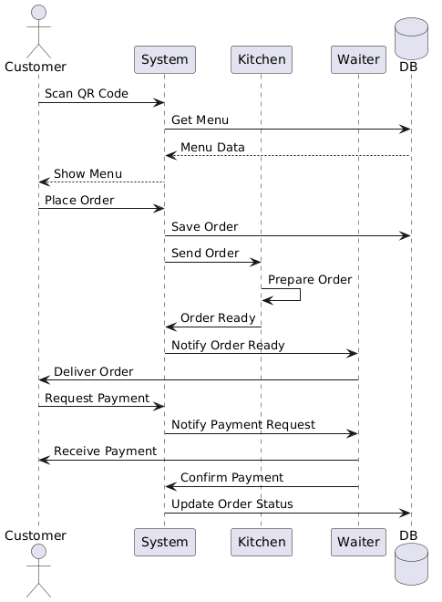
Figure 5.4. Sequence Diagram of the Smart Cafe Ordering System

Explanation of the Sequence Diagram
The sequence diagram of the system is given in Figure 5.4. In the first step, the QR code is scanned by the customer to reach the menu and then the products in the menus are pulled from the database and shown on the customer screen. After selecting the desired products to order from the screen, the customer places the order.
The moment the order is created, this information is saved in the database. Products that need to be prepared in the kitchen drop directly to the kitchen screen. If it is a ready-made product that does not require kitchen preparation, it drops directly to the waiter screen instead. The products assigned to the kitchen are prepared by the kitchen staff, and once ready, a notification is sent to the system. Through this message, the waiter is informed and the product is delivered to the table.
In the last stage, the customer requests the bill and a notification is sent to the waiter. After the payment is collected, approval is given to the system from the waiter's screen. Then, the order status in the database is updated.

Database Diagram
The database diagram and the relationships between the collections are shown in Figure 5.5.
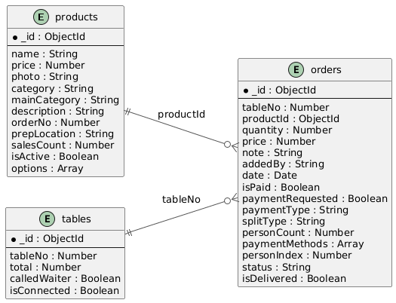
Figure 5.5. Database diagram of the Smart Cafe Ordering System

Explanation of the Database Diagram
The database of the system is organized within MongoDB Atlas and the data is stored in document-based collections. When the database diagram is examined (Figure 5.5), there are 3 different collections and thanks to these collections the system works and they communicate with each other.
The first collection, the 'tables' collection, contains information opened separately for each table in business and this way it is ensured that separate information about each table can be obtained at the same time. Here, the special number for each table, the total price of the current account at the table and information on whether the customer called a waiter or not are kept. Another structure, the 'products' collection, includes the menu content of the system and ensures that the products are visible on the customer panel. In this collection, technical details such as product names, prices, preparation locations (kitchen or service), categories for easy inspection on the customer screen, and options that can be preferred in some products are included. Also, the 'orderNo' data is kept here to determine the exact display sequence of the products on the screen. The 'prepLocation' field determines if the item goes to the kitchen or the waiter panel. In this way, the order routing process is kept organized.
The 'orders' collection at the center of the system acts as a bridge between the 'tables' and 'products' collections and allows them to communicate with each other. When an order is placed by the customer; information such as the product reference, the table number that placed the order, the quantity ordered and the price of the product is recorded in this collection. Additionally, the tracking of the entire process such as the status of the order (whether it is ready or not), whether a payment request is sent and the payment type selected for payment is carried out through this collection. Thanks to the connections and communication of these three collections, it is ensured that the data remains as a whole and the system operates in a smooth, fluent way.

FINDINGS AND RESULTS
Actual interface outputs and experimental results of the Smart Cafe Ordering System are documented in this chapter. Functional data is collected from each module and this way the operational integrity of the project is verified. Here, functions such as real-time synchronization, bill splitting and administrative reporting are observed under specific cafe scenarios. Thanks to these findings, the capacity of the system to handle daily service needs without errors is evaluated through database records and panel synchronization.

System Interface and Order Workflow Results
The initial phase of the ordering process and the data generated on the customer panel are examined under this heading. Following the QR code scan, active order data is created within the customer cart screen. When Figure 6.1 is analyzed, product names, requested quantities, and the automatically calculated total amount are seen. Here, it is verified that the system successfully registers the initial inputs of the customer.
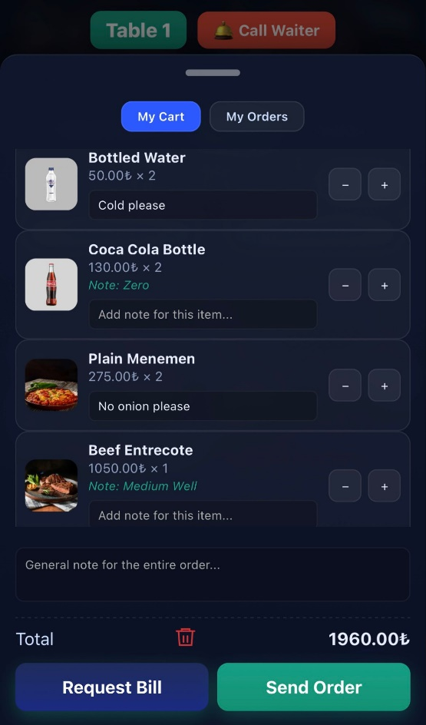
Figure 6.1. Customer cart screen with active order data
After cart confirmation, the data is sent to the relevant panel. Kitchen items go to the kitchen screen. Service items go directly to the waiter panel. The reflection of incoming orders is shown in Figure 6.2. Thanks to this interface, information such as table numbers, ordered items, and time details is monitored through color-coded groupings. This way, the uninterrupted data flow between the customer and the kitchen staff is confirmed.
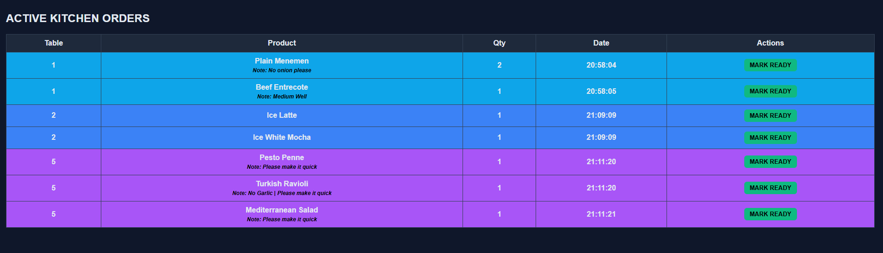
Figure 6.2. Kitchen panel displaying incoming orders and table details
As the preparation phase progresses, order status updates are forwarded to the service staff. The reflection of these status changes on the waiter panel is shown in Figure 6.3. Through this screen, transitions between phases like 'Waiting Kitchen' and 'Ready' are tracked. At the same time, active call notifications are observed on the same interface. Thanks to this synchronization, the physical service workflow is managed without delay.
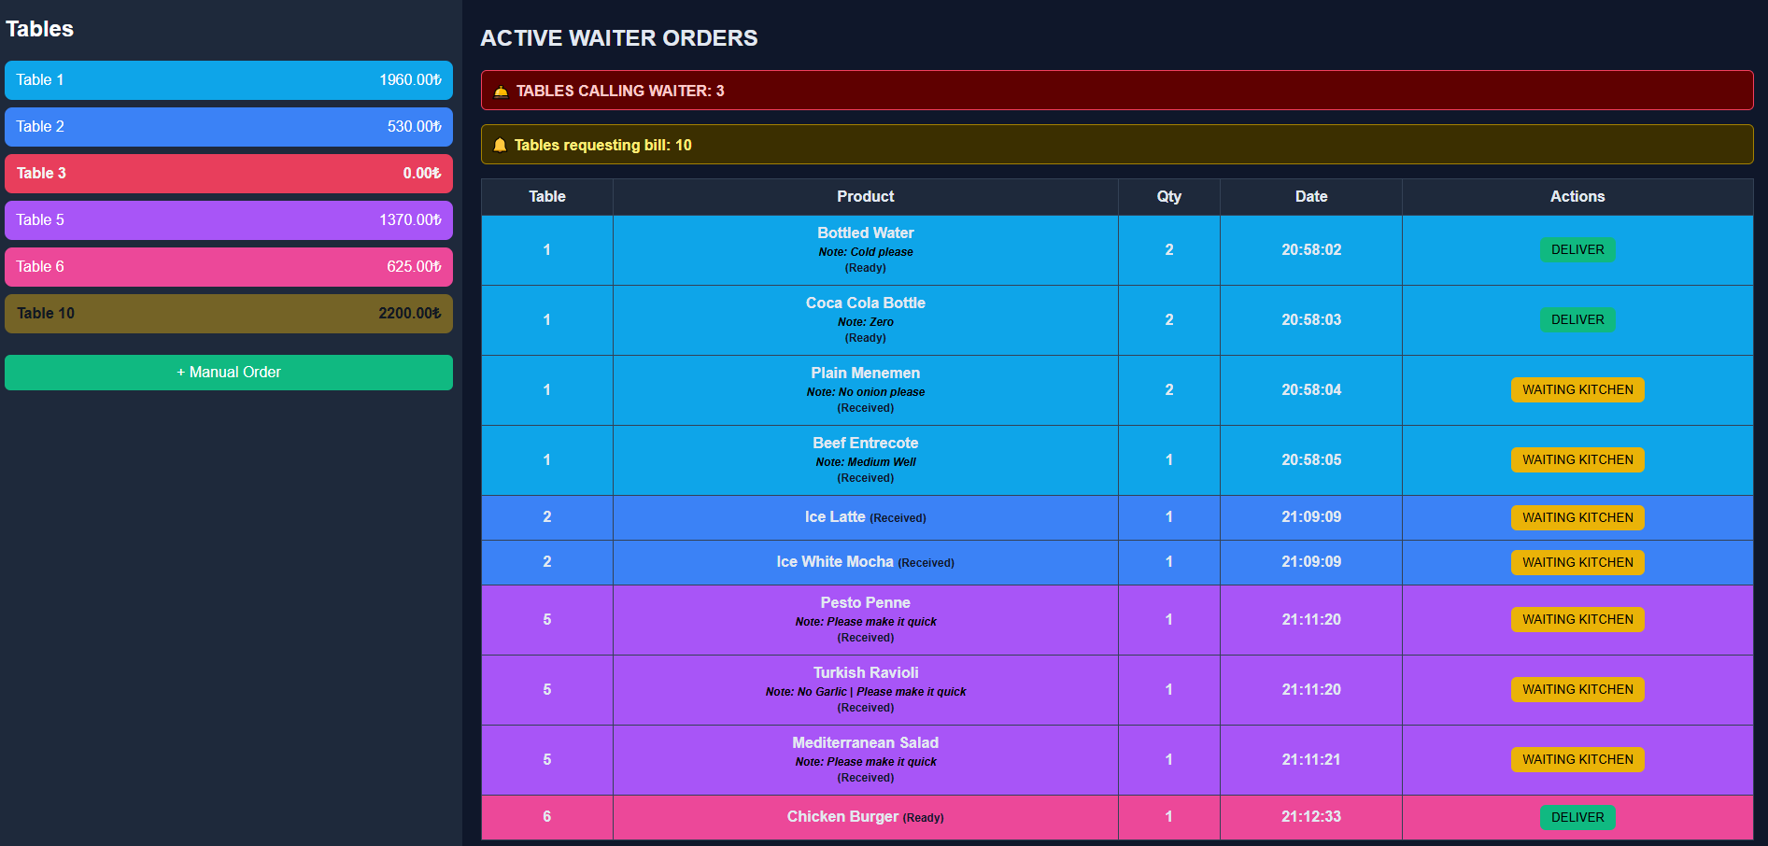
Figure 6.3. Waiter panel showing order status updates and active notifications

Payment and Bill Splitting Results
The bill payment section is the final step of the order process. This request is made digitally as shown in Figure 6.4. Here, the total amount that needs to be paid is shown to the customer. A payment type like cash or credit card is selected on this screen. After this step, the waiter is expected to come to the table to collect the bill.
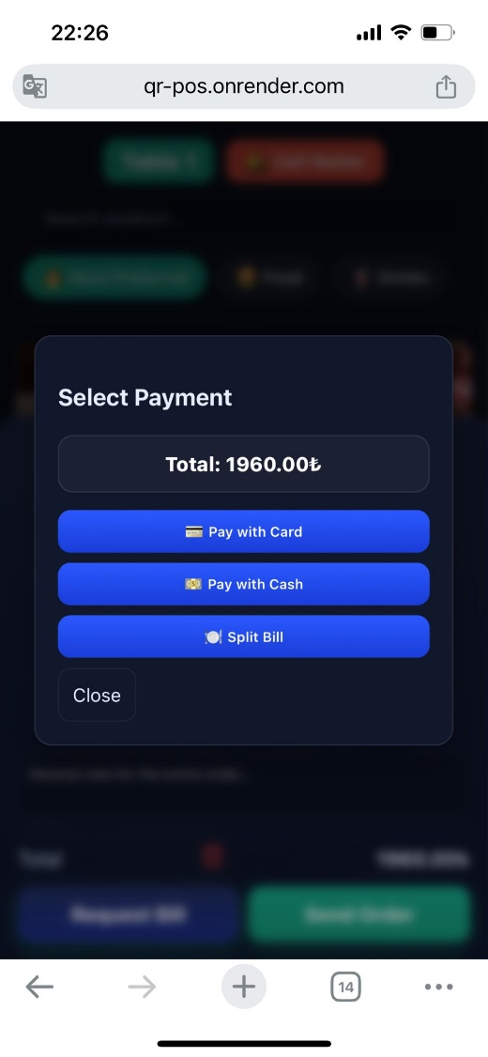
Figure 6.4. Payment request and payment method selection interface
Two different options are offered in the system for sharing the bill. The first option is dividing the total bill by the number of people. During this step, the amount to be paid by each person is seen and the payment method is selected for each individual. Then, these payment choices are sent to the waiter. The other method is item-based splitting and the interface for this process takes place in Figure 6.5. In this method, the consumed products are chosen by the people who want to pay for them. Following this, the payment method is selected for each paying person.

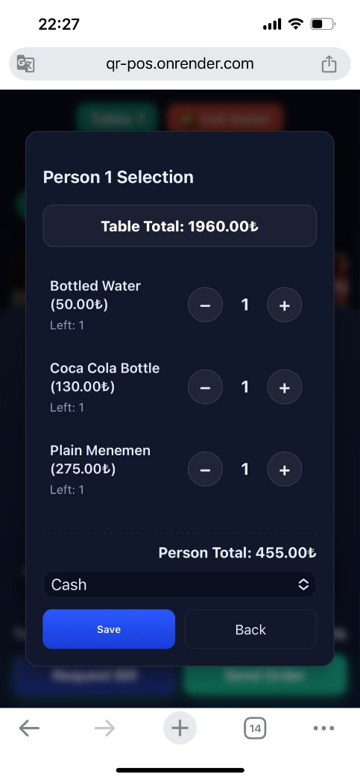
Figure 6.5. Bill splitting configuration based on products and individuals
After the bill is requested by the customer, this notification is transferred to the waiter panel. The related table is selected from the left menu. Following this action, details like the number of paying guests and the chosen payment methods take place in Figure 6.6. With the help of this screen, the necessity of carrying a POS device to the table is understood. Lastly, an instant printout is taken from the receipt printer by using the 'get receipt' button.
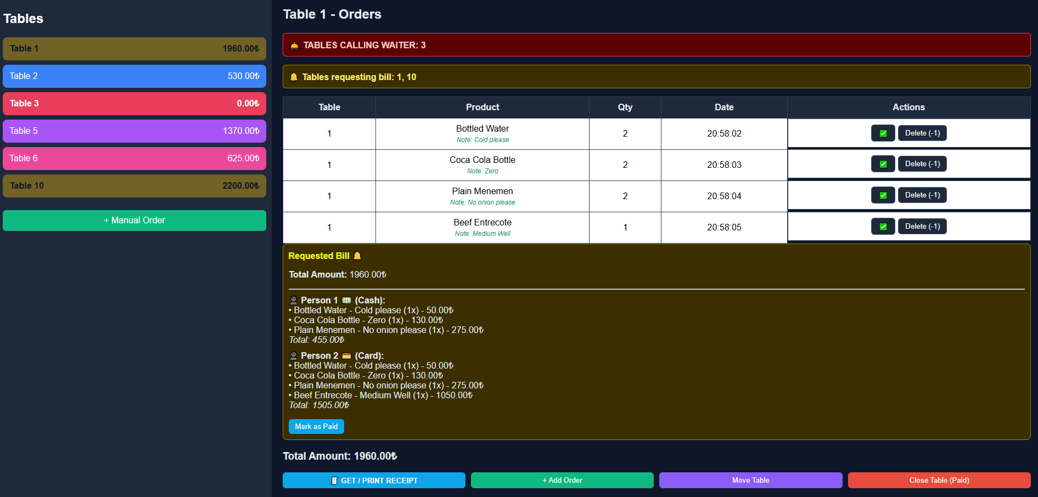
Figure 6.6. Split payment details and receipt generation on the waiter panel

Administrative Reporting Results
A daily receipt section is created in the admin panel. This part provides remote control of the cafe's daily revenue in a digital environment. The view of this screen takes place in Figure 6.7. On this page, the daily revenue of a specific date is displayed. Also, the types of the received payments are examined. If needed, these records can be deleted from the system by the administrator.
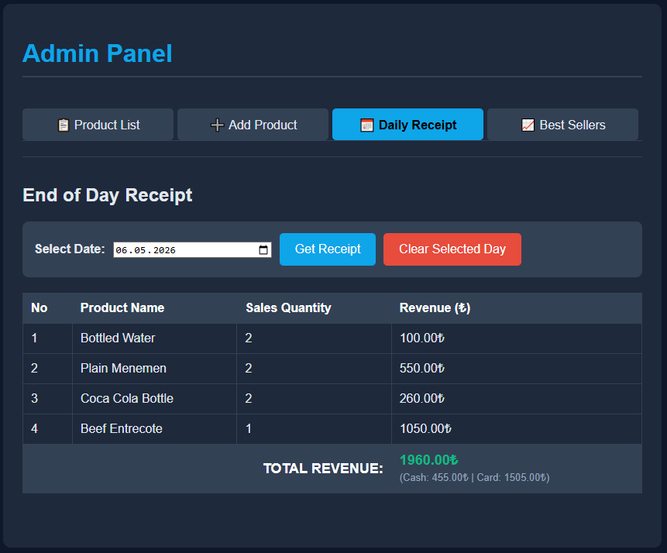
Figure 6.7. Daily receipt screen and revenue details in the admin panel
The best sellers section is another module in the admin panel. The interface of this part takes place in Figure 6.8. In this section, a list is prepared to provide statistical data to the manager. To achieve this, the most purchased items are tracked in the database. On this screen, products are ordered from the most sold to the least sold. Through these statistics, the popularity of the products is easily understood by the cafe management.

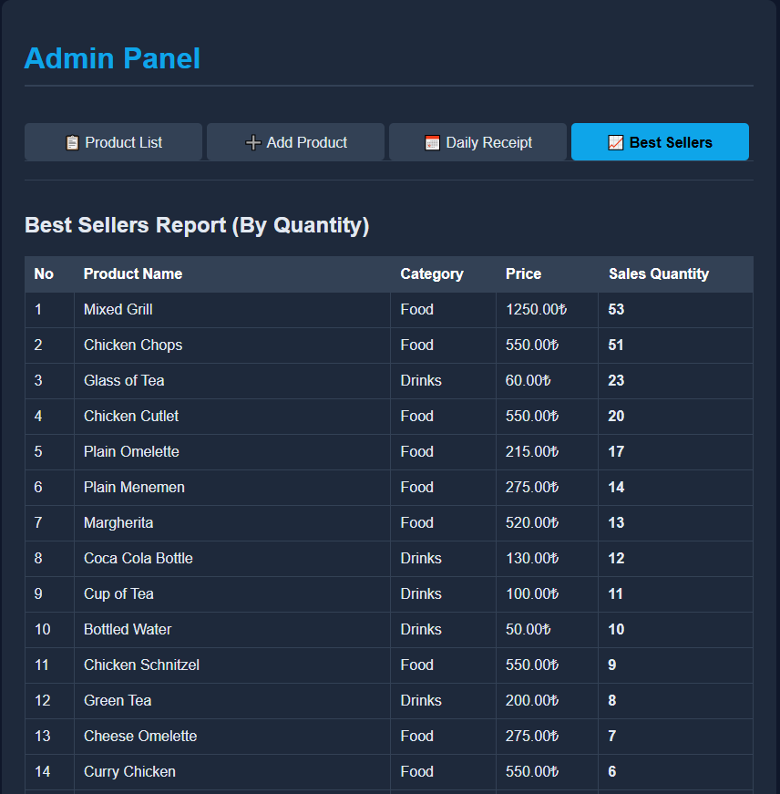
Figure 6.8. Best sellers screen and product statistics in the admin panel
The product list in the admin section is used for managing the items in the menu. When a product is out of stock, it is taken out of the customer menu through the edit settings. This change is reflected on the customer panel immediately. The evidence of this hidden status takes place in Figure 6.9. Even if the item is not shown to the customers, it remains visible on the admin dashboard. By doing this, the reactivation of the product is not forgotten by the manager when it becomes available again.
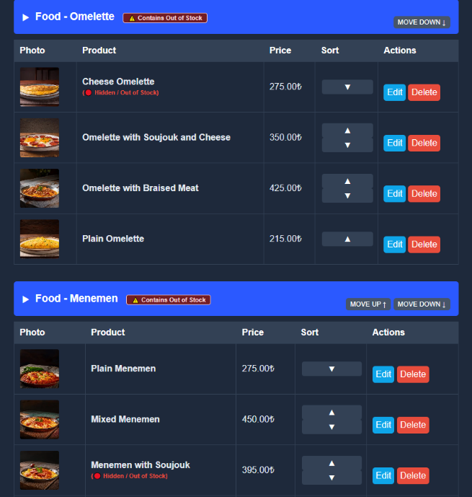
Figure 6.9. Product visibility management and status update in the admin panel

Functional Verification Results
In this section, the accuracy of the basic functions of the developed system is tested. Critical operations belonging to the customer, kitchen, waiter, and admin panels are checked end-to-end. The expected results are compared with the observed outputs in the system. The obtained verification results are presented in Table 6.1.
Table 6.1. Functional Verification Results of the Smart Cafe Ordering System
Module | Test Scenario | Expected Result | Actual Result | Status
Customer | Table Connection | Correct table matching should be established. | Correct table number was displayed. | Passed
Customer | Order Placement | Selected items should be saved as an order. | Order was saved and cart was cleared. | Passed
Kitchen | Real-time Synchronization | Confirmed order should appear without refresh. | Order was displayed without page refresh. | Passed
Waiter | Payment Notification | Bill request should appear on waiter panel. | Related table card was highlighted. | Passed
Waiter | Item-based Splitting | Selected items should be calculated correctly. | Split amounts were calculated correctly. | Passed
Admin | Revenue Matching | Cash and card totals should match daily revenue. | Values matched recorded daily revenue. | Passed
Admin | Visibility Setting | Hidden product should not appear on menu. | Product was removed from customer menu. | Passed

DISCUSSION
The results and findings obtained in Section 6 are discussed in this section. These findings are compared with the literature review in Section 2 and the similar applications examined in Section 3. Through this discussion, the specific features that distinguish the designed smart cafe ordering system from existing platforms and traditional operations are explained. During these comparisons, references are made to the figures and tables presented in Section 6.

Discussion of Order Workflow and Interface Results
Physical menus and waiter presence are used in traditional cafe operations. This situation is discussed in Section 2. Time is often wasted during rush hours. Communication mistakes are also experienced. The ordering process was completely digitized to solve these issues. Direct ordering from personal phones was provided to customers. The customer cart interface is shown in Figure 6.1. The "Order Placement" test is located in Table 6.1. Once the order is confirmed, the active selection is cleared for new items. Still, the total bill is kept on the screen for session tracking. Waiting times caused by traditional methods are eliminated through this process.
Similar applications are reviewed in Section 3. A broader ordering structure is provided by the developed project. Platforms like OddMenu are built just for displaying menus. In systems like Adisyo, tablet entries are still made by waiters. This intermediary step is eliminated in this work. The entire process is made digital. Customer orders are forwarded directly to the relevant panel based on each product's preparation location. This specific data flow is shown in Figure 6.2. Page reloads are bypassed by the system. This situation is confirmed by the "Real-time Synchronization" test in Table 6.1.
Customer requests are delivered to the staff instantly. This is evaluated as an important factor for service speed. Waiter interfaces are updated with table calls and order statuses. This specific panel is shown in Figure 6.3. The limits of standard digital menus are bypassed by doing this. A fast communication network is created among the customers, the kitchen, and the waiters.

Discussion of Payment and Bill Splitting Results
Payment processes are considered a major problem in traditional cafes. This situation is examined in the Section 2 literature review. Manual calculations are usually made by staff. Waiters are called to the table just to bring the bill. An item-based bill splitting module was integrated into the system to solve these issues. Customers are allowed to select specific items for payment. The split bill interface is shown in Figure 6.5. The accuracy of this process is verified by the "Item-based Splitting" test in Table 6.1. Math errors are completely prevented in this way.
Other applications are evaluated in Section 3. Digital payments are supported by some of these platforms. However, security risks occur if customers leave the table without staff knowledge. A hybrid payment notification system is used in this project to prevent this. Waiter panels are alerted instantly after a payment request is created. This specific alert screen is displayed in Figure 6.3. Also, this notification mechanism is confirmed by the "Payment Notification" test in Table 6.1. Checkout confusion is stopped as a result. A safe payment flow is provided for both customers and business owners.

Discussion of Administrative Reporting Results

Discussion of Functional Verification Results

CONCLUSION AND RECOMMENDATIONS FOR FUTURE WORK
In this section, the original results obtained from the study should be presented in order. Recommendations for future research to improve and expand the study are provided.

REFERENCES
REFERENCES are listed in this section.
This section is written with 1 line spacing.
Footnotes are not used in writing references, text methods should be used.
The date of access to the relevant site should also be added when citing information found on websites.

