**PRACTICAL ASSESSMENT -2**

Question 1. Creating json files

Streamdata.json

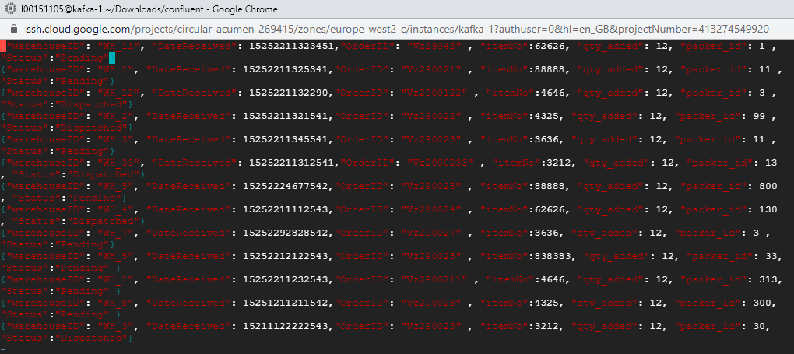

Customerdata.json

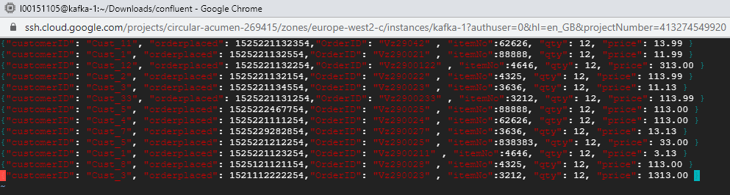

Customerstream.json

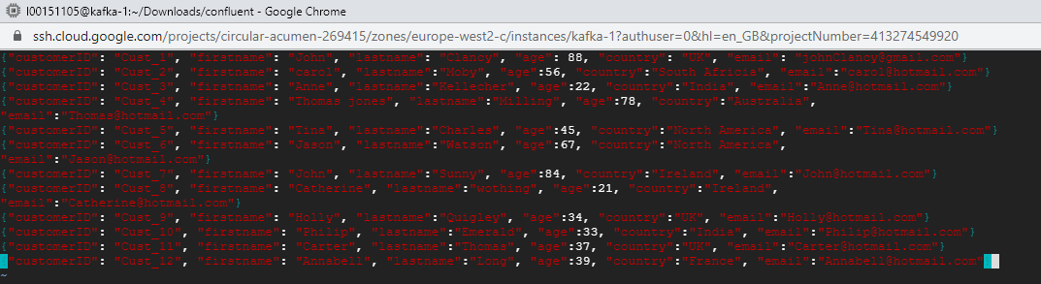

All the json files created

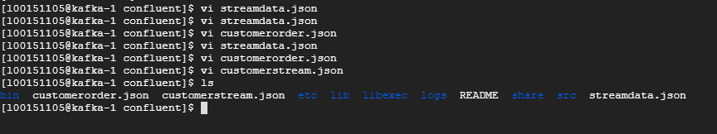

Question 2:

Creating the topics of the json files which we have created earlier



Show the topics list which we have created now

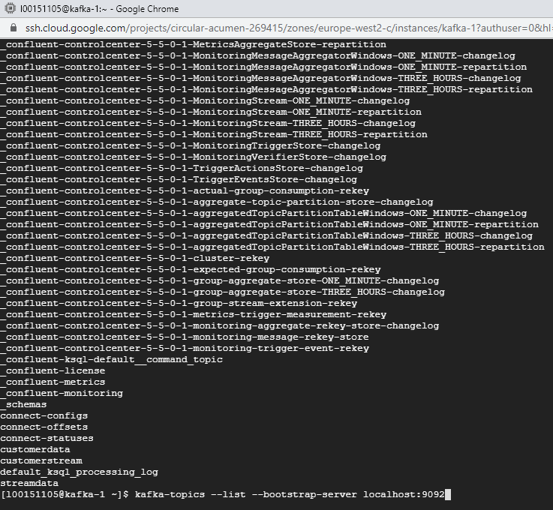

Question 3:

Creating the producer for all the topics

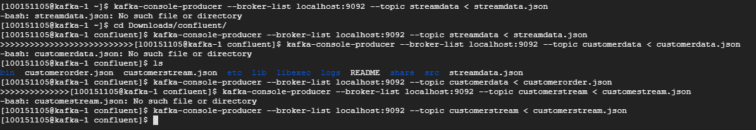

Showing the data using the consumers

Showing the customer stream data topics from json files

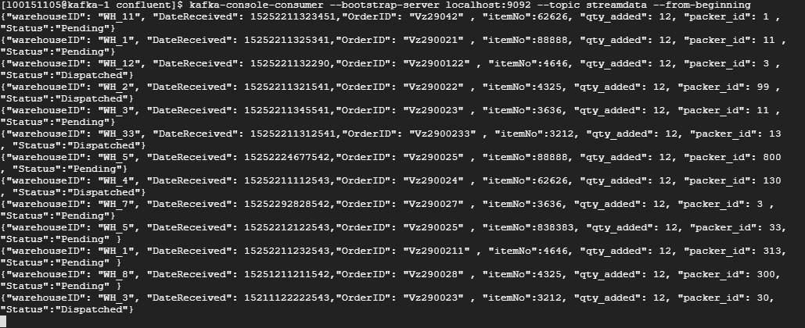

Showing customer order data through consumers for viewing the data

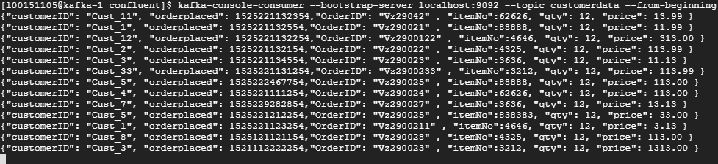

Showing the customer stream data through consumers for viewing the data

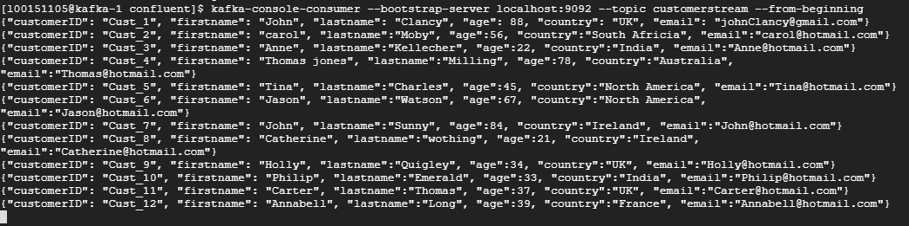

Question 4:

Creating streams

For cust_L00151105

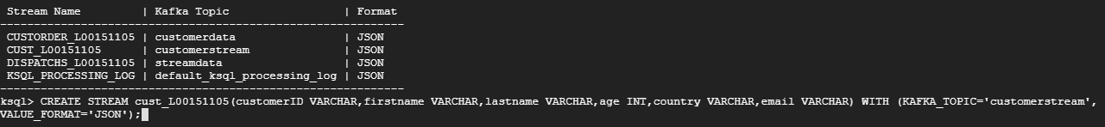

For CUSTORDER_L00151105

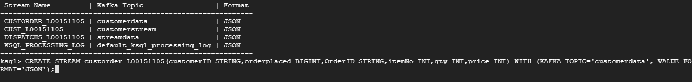

For DISPATCHS_L00151105

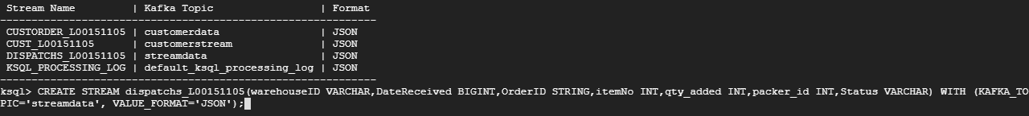

Question 5:

Creating stream

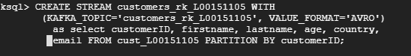

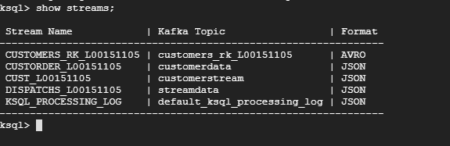

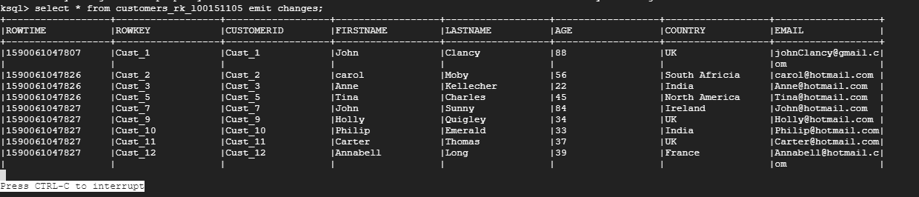

Creating the table

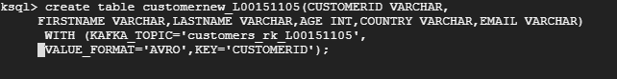

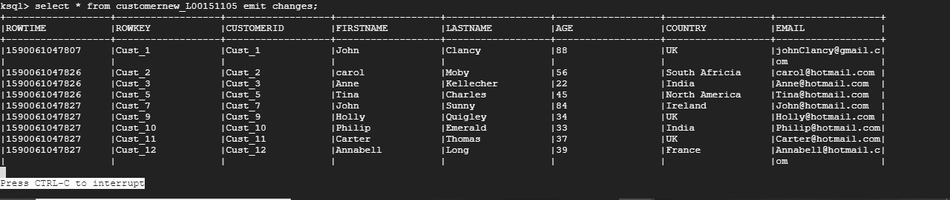

Question 6:

Create a stream called OrdDispatch_L000?? which will store all orders that have been dispatched from the warehouses. This stream should only include order number, item number, status from the dispatches stream and customerid, date of orderplaced, and price from the customer order stream. Both streams should be joined within a 1 hour period.

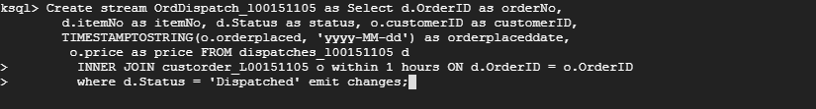

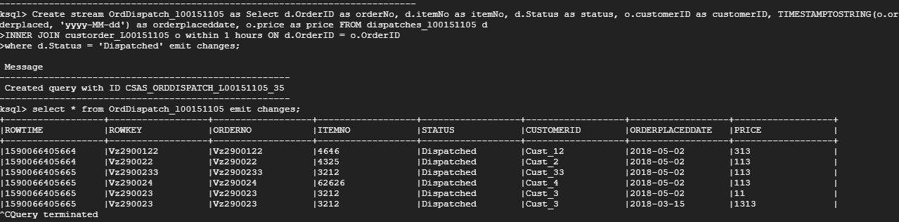

Question 7:

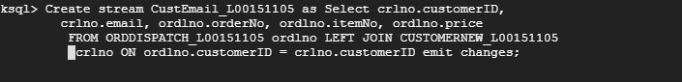

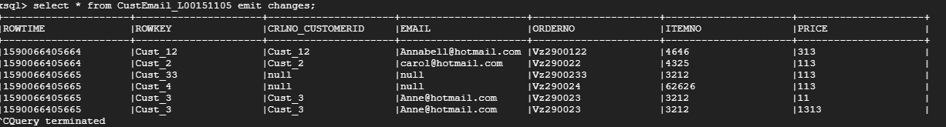

Question 8:

Create a table called CustPurchase_L00?? which will aggregate the item cost per customer order. The table should include customerid, orderid, TotalAmountSpent only.



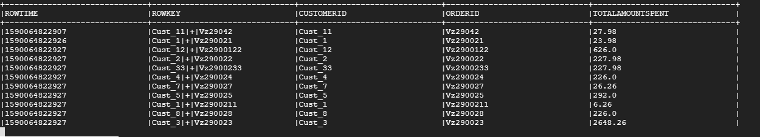

Question 9:

Create a window that aggregates the number of orders dispatched by a packer over a 1 hour period. The window should include the warehouse id, packer_id, datereceived in timestamp format, and a count of the orders dispatched. Create a Kafka table called ‘PkrDispatch_L00??’ to store these windows for further processing



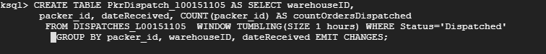

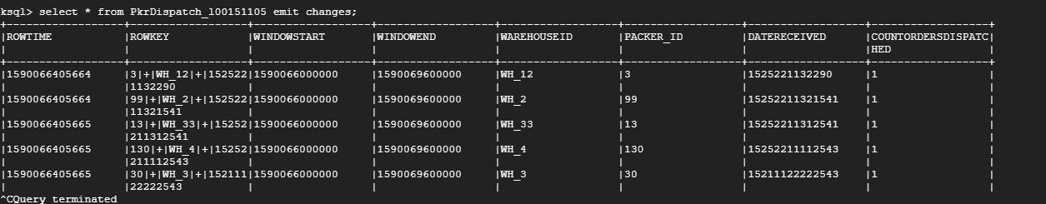

Perform a select statement on this table listing all information. Format the ROWTIME, window start and end times using TimestampToString function.

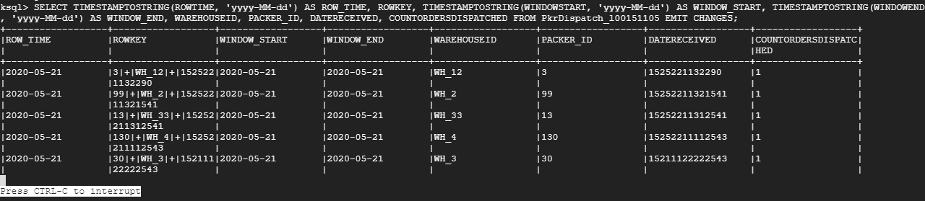

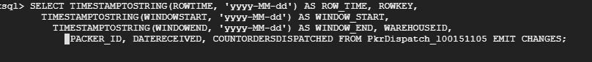

Question 10.

Create a window that aggregates the number of pending orders per warehouse. This window should be created every 30 minutes and the window duration should be over a 60 minute period. The window should show the warehouseid, and the total number of orders pending. Create a Kafka table called ‘OrdPending_L00??’ to store these windows for further processing.

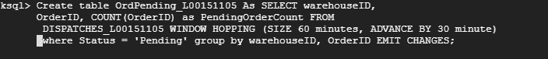

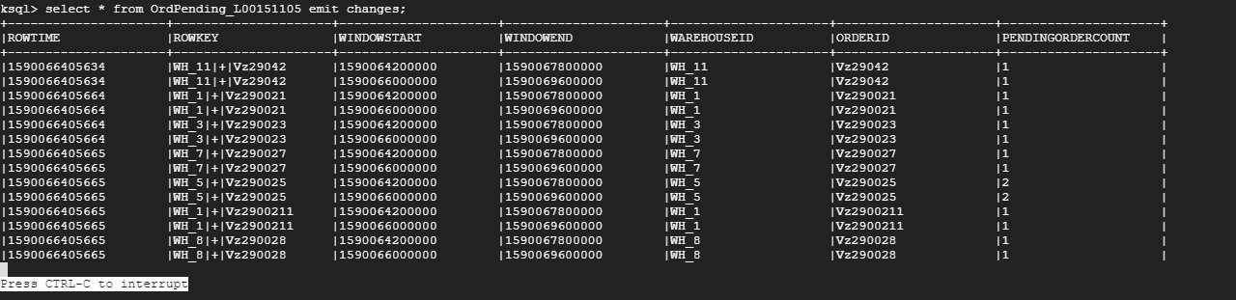

10(b)

Perform a select statement on this table listing all information. Format the ROWTIME, window start and end times using TimestampToString function.

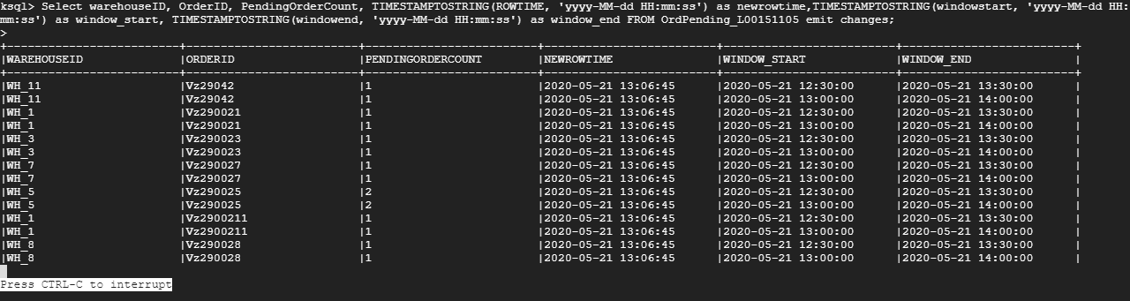

Question(11a)

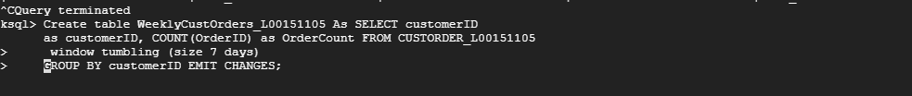

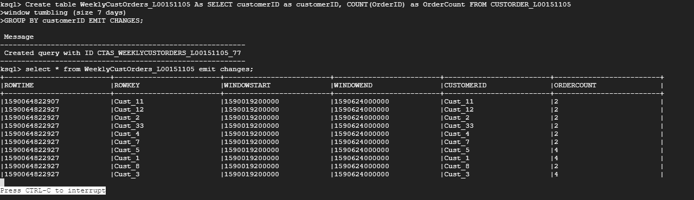

11(b)

