

Production Operations and Planning

ENM - 319

Berkay GÜLMÜŞ

Yusuf Can YAVUZ

Furkan AKARSU

BİM – 213

Alper ARSLAN

Yunus Yavuzhan AFŞAR

# ENM-319 PRODUCTION AND OPERATIONS PLANNING & BIM-213 DATA STRUCTURES and ALGORITHMS PROJECT- MIDTERM REPORT

Our goal is in this assignment making a basic decision support system and use it in the forecast process. In the way of our goal; first, we meet on the zoom application on 10th of November and talked about our next reunion and plan.

We met in person on 27th November until then we made group sessions with our group and talked about how to make our project better.

As a result in our discussions and face to face meeting we planned our working share and then we created the table below and the flowchart.

As industrial engineering department we divided our tasks and gave everyone a task to complete. When we make these tasks, we will choose the best solution for this problem by using the methods below.

* Exponential smoothing method
* Double exponential smoothing method
* Regression analysis
* Deseasonalized regression analysis

|  |  |  |
| --- | --- | --- |
| **Tasks** | **Responsible Person** | **Task’s Due time** |
| **Preparation of midterm report** | **Every group member** | **01.12.2021** |
| **Solution of exponential and double exponential smoothing method** | **Berkay GÜLMÜŞ** | **12.12.2021** |
| **Solution of regression analysis** | **Yusuf Can YAVUZ** | **12.12.2021** |
| **Solution of Deseasonalized regression analysis** | **Furkan AKARSU** | **12.12.2021** |
| **Comparison and report to IT department** | **Every group member** | **15.15.2021** |

Firstly, as the IT department, we are going to make a table, showing the outlines of our software according to the data we received and process it into the algorithm. We will design the interface and integrate the algorithms and the data into the software.

|  |  |  |
| --- | --- | --- |
| **Tasks** | **Responsible Person** | **Task’s Due time** |
| **Creating an algorithm that takes data of last 2 years which we can process** | **Alper ARSLAN and**  **Yunus Yavuzhan AFŞAR** | **18.12.2021** |
| **Combine the algorithm and received data into the software** | **Alper ARSLAN** | **24.12.2021** |
| **Design the interface and integrate it into the software** | **Yunus Yavuzhan AFŞAR** | **29.12.2021** |

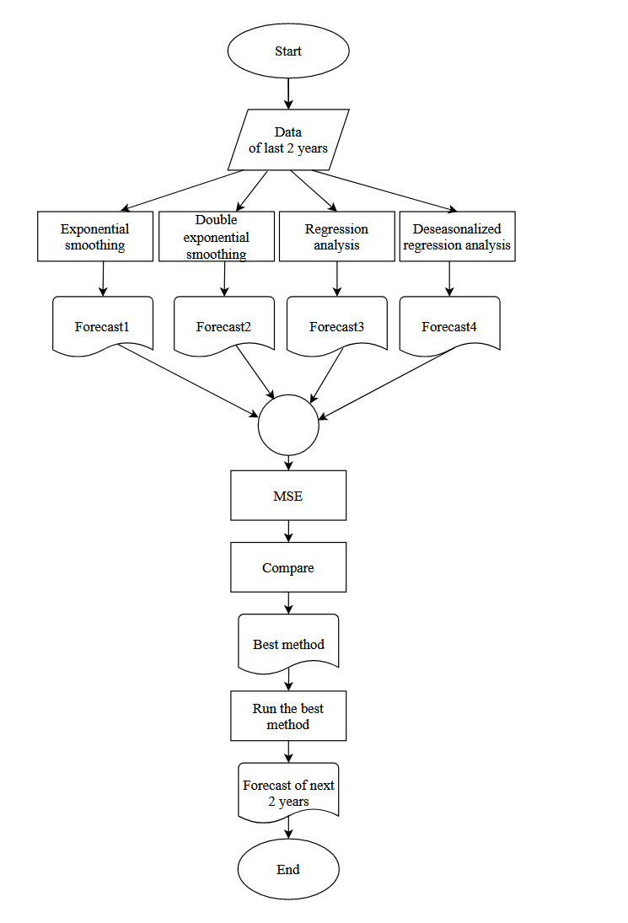

# Explaining the Flow Chart

1. Get the data of last 2 years from the company.
2. Estimate the result by using Exponential Smoothing Method and find Forecast1.
3. Estimate the result by using Double-Exponential Smoothing Method and find Forecast2.
4. Estimate the result by using Regression Analysis and find Forecast3.
5. Estimate the result by using Deseasonalized Regression Analysis and find Forecast4.
6. The MSE method should be calculated for each forecast that occurs.
7. The estimates after calculating the MSE should be compared.
8. At the end of the comparison, the best method must be chosen.
9. Forecast the following 2 years using the best method.