PANDA: Plugging and Abandonment Network of Decision Agents - a multimodal agentic system designed to support PA-DEP attainable bottom reviews
University of Pittsburgh

1. High-Level Executive Summary
As foundation models, multimodal systems, and AI agents are increasingly integrated into real-world workflows, ranging from routine public administration to corporate decision making, the role of data is expanding substantially. Data are no longer used solely to support pretraining and post-training processes for developing high quality large language foundation models. They are also becoming essential for constructing runtime states, preserving organizational memory, and documenting decision rationales. Together, these functions provide the informational foundation for effective agentic systems that can deliver more reliable, context-aware, and transparent decision support.
Over several decades, many institutions have accumulated substantial volumes of data and records of regulatory outcomes. However, these records are predominantly focused on final results and rarely capture the decision process as it unfolded. In particular, they often lack replayable decision traces that show who had access to which information, which version of the applicable rules was used, what alternatives were considered, why a case was escalated or granted an exception, and what rationale supported the final determination. This limitation is especially consequential because regulatory decisions are often case-specific and dependent on the sequence of preceding events. A single case may involve multiple rounds of applications, consultations, supplementary submissions, reviews, and adjudications. Nevertheless, the structured databases used by enterprises and public institutions generally prioritize the preservation of the most recent or final state. Although original case files may contain fragments of the relevant history, they rarely integrate the information available at the time of decision, the governing rules, the reasoning process, the supporting sources, and the eventual outcomes into a unified and auditable record. The absence of such records substantially complicates the development and training of AI agents intended to support regulatory decision making.
Using Pennsylvania’s attainable bottom application process for oil and gas well plugging as a case study, this study investigates whether partial decision traces can be reconstructed from historical archives designed primarily to preserve final states. The broader objective is to enable AI agent architectures to learn from and represent decision processes, thereby assisting human experts in conducting more informed and consistent reviews. At the same time, because many historical records contain irreversible losses of material, contextual information, and supporting evidence, we developed an agent harness framework to reduce hallucinations and improve the reliability of agent generated predictions and assessments. First, we decomposed each decision trace into the following elements: case, index time, actor, observed state, request or action, attempted alternatives, source evidence, applicable rule and version, decision and rationale, uncertainty or override, and later outcome. Importantly, later outcomes were explicitly separated from the information available at the time of decision to prevent retrospective information from contaminating the reconstructed decision state. Second, to derive reliable evidence chains from complex and heterogeneous source materials, we developed a multimodal, multiagent evidence processing pipeline. Building on this pipeline, we established an auditable research chain linking each extracted claim to a source tuple consisting of the file, page number, original text, and visual state. The reconstruction process therefore combined multimodal interpretation of heterogeneous PDF documents with direct source verification. Third, all reconstructed cases were developed within an agent harness framework that incorporated numerical, evidentiary, and chronological safeguards. For example, three distinct temporal fields, requested date, approved date, and certificate date, were maintained to reduce temporal contamination during data construction. At the same time, to assess the accuracy of the multimodal extraction process, multiple independently operating AI agents were assigned different review roles and used to conduct sampled audits and source page verification. Cases involving ambiguity, incomplete evidence, or unresolved disagreement were referred to domain experts for adjudication through an expert human-in-the-loop process.
The source corpus comprised 635 dockets containing PDF materials and approximately 1,700 individual PDF documents. Following evidence extraction, cleaning, reconciliation, and review through the multimodal and multiagent pipeline, the resulting dataset contained 633 unique case records and 10,856 detailed evidence records. These materials supported the reconstruction of partial decision traces and the development of an AI agent intended to assist expert review. The current system focuses on supporting the assessment of the attainable bottom standard applied by the Pennsylvania Department of Environmental Protection (PA-DEP) in well plugging reviews. In particular, it assists reviewers in examining whether reasonable efforts were made to clean out a well to its total depth and in interpreting the adequacy of those efforts in light of the available evidence and physical constraints. The system is thus named PANDA (Plugging and Abandonment Network of Decision Agents), a multimodal agentic system designed to support PA DEP attainable bottom reviews. Given the limitations of the historical data, the current PANDA is not designed to make final regulatory determinations. Instead, the system supports the review process through two distinct evidentiary dimensions: evidence of effort and contextual evidence of difficulty. The first dimension (Model A) documents the actions taken and the sources supporting those actions, whereas the second (Model B) characterizes wellbore conditions and other physical constraints. Neither dimension, whether considered independently or jointly, conclusively establishes the adequacy of the effort. Rather, they provide partial and context dependent indications of adequacy, subject to the current scope, quality, and limitations of the available data.
More specifically, within the current architecture, Model A is used only to prioritize cases or evidence for reviewer attention, while Model B identifies coarse grained empirical reference cases. Neither model substitutes for an explicit legal or regulatory standard, and important gaps remain in the formal representation of applicable rules. Qualified reviewers must therefore verify the reconstructed facts, interpret them under the relevant legal and regulatory framework, and retain responsibility for the final judgment.
This narrowed division of labor reflects three corrections to the problem definition that emerged during early development: locating the historically recorded final event within an approved case was not equivalent to predicting a regulatory decision; case-level shortfall risk and modeled difficulty did not measure the adequacy of operator effort; and final-state dockets could not reliably reconstruct the information set available at the application index time. A related construct correction followed: because the absence of a formal effort narrative cannot be read as the absence of effort, the modeling target was narrowed to documented nonroutine difficulty (DN). Sections 3.3 through 3.5 present the audits behind these corrections.
Future research would benefit from the native capture of complete decision traces at the time each request is submitted, the development of independent evaluation standards by domain experts, and external validation using holdout datasets defined by operator, time period, and document template. In parallel, feedback collected from experts using PANDA can provide additional training signals and support the iterative refinement of the agent system. Subject to sufficient data quality and appropriate validation, this feedback may be incorporated through reinforcement learning from human feedback or related human-supervised learning approaches. Prospective studies of human–AI interaction will also be necessary to determine how PANDA affects review quality, consistency, efficiency, transparency, and accountability in practice.
Keywords: Auditable Regulatory AI; Harness Engineering; Multi-agent systems; Multimodal large language models; Decision trace reconstruction and Provenance; Human-in-the-loop; Attainable Bottom; Well Plugging and Abandonment

2. Methodologies: Multimodality, Multiple Agents, and Partial Decision Trace Reconstruction

2.1 Why Multimodal Processing Is Necessary
Historical case files typically contain scanned text, handwritten numerical values, checkboxes, official stamps, wellbore schematics, tables extending across multiple pages, and application materials with inconsistent formats. Although optical character recognition (OCR) can improve document retrieval, text-only OCR may fail to preserve critical visual semantics, such as whether a checkbox has been selected, which column contains a particular numerical value, or which form corresponds to a specific stamp. Accordingly, this study treats OCR as a tool for retrieving candidate evidence rather than as an authority for establishing facts. OCR may indicate where relevant information is likely to appear, rendered page images may invalidate interpretations supported only by OCR, and the final authority to accept a factual claim remains with the researcher or a qualified reviewer.
The established pipeline submits PDF files directly to a multimodal model interface. For each visually extracted field, it records the source file, page number, original quotation, evidence type, temporal track, and depth track. The subsequent full-corpus evidence review was conducted on a case-by-case basis across 635 source file directories. Seventeen exceptionally large PDF files, corresponding to 14 cases, were rendered in advance at 150 dpi to avoid transmission constraints.

2.2 Provenance as an Integral Component of Structured Output
A structured field can be considered complete only when the question of where the information was obtained can be answered. For visual evidence, this study uses the following provenance tuple:
e = (c, s, p, q, v, κ, τ) ∈ E
where c is the case or docket identifier, s is the source artifact, p is the page locator, q is the verbatim quotation, v is the recorded visual state, κ is the review track, and τ is the timing field. E denotes the evidence corpus. At the current data freeze, |E| = 10,856.
Some well attributes and historical labels were obtained from a legacy Excel register provided by DEP. The most accurate formulation is therefore that every field should be traceable to an original PDF page, the legacy register, or a deterministically generated derivative ledger. It would be inaccurate to claim broadly that every field was derived directly from a PDF page. Repairs to evidence pointers identified during subsequent audits further demonstrate that the correctness of a field value does not necessarily imply the correctness of its provenance path. Citation accuracy must therefore be evaluated as an independent endpoint rather than treated as interchangeable with field value accuracy.
It is worth noting, however, that this provenance tuple constitutes an evidence object, but it does not represent a complete decision trace. In an ideal situation, a complete trace would additionally require information about the actor, the selected action and available alternatives, iterative revisions, the applicable version of the governing rules, the final rationale, and any human override. Some of these elements were never recorded in the historical PDF files examined in this study, whereas others could not be reliably linked to the available evidence. The pipeline can therefore reconstruct only observable fragments of the decision process. It cannot use narratives generated by a large multimodal model to fill gaps in the actual historical deliberation. Figure 2 maps the resulting provenance chain from the source archive, through the frozen canonical table, to every model input element.
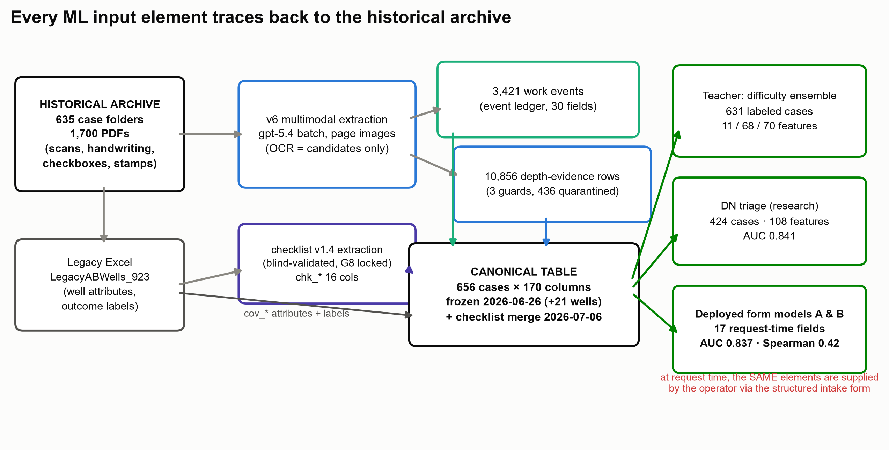
Figure 2. Provenance of machine learning input elements. Left: the historical archive (635 case folders, ≈1,700 PDFs containing scans, handwriting, checkboxes, and stamps) and a legacy Excel register (923 wells with attributes and outcome labels). Middle: v6 multimodal extraction over rendered page images, with OCR used only to nominate candidates, yields 3,421 dated work events and 10,856 depth-evidence rows (436 quarantined by deterministic guards), which are merged with the blind-validated checklist extraction into the canonical table (656 cases × 170 columns). Right: the three model families each consume a subset of that table — the locked difficulty-ensemble teacher (631 labeled cases), the 108-feature DN-triage research model (424 cases), and the deployed 17-field form models A and B. At request time, the same elements are supplied by the operator through the structured intake form.

2.3 Strict Separation of Depth and Temporal Tracks
During the early development of the extraction pipeline and associated experiments, we observed that PDF records frequently contained multiple dates and temporally distinct observations. Without careful cleaning, classification, and alignment, information recorded after the original decision could contaminate the downstream dataset, introduce temporal leakage, and undermine the validity of machine learning models and their predictions. Therefore, to reconstruct and replay the state of each case at the time of the original decision, the pipeline separates the extracted information into at least three temporal tracks.
- The requested track records the stopping depth and supporting rationale proposed or reported by the operator when the application was submitted.
- The approved track records the depth subsequently approved, modified, or restricted by the relevant regulatory authority.
- The certificate and final state track records the final conditions observed after completion, including plugging certificates and other outcome related information.
The pipeline also retains total depth, observed obstruction depth, maximum depth reached, and proposed stopping depth as distinct fields, with each field linked to its own provenance and temporal attributes. Using the final depth documented in a completion certificate as a proxy for the application stage would introduce temporal leakage by incorporating information that became available only after the original decision. Likewise, using the subsequently approved attainable bottom depth as a predictive feature could create circularity, because a post-decision state would be used to explain or predict the decision that produced it. The separation of temporal tracks is therefore not merely a matter of database organization. It is essential for preventing later outcomes from overwriting the original decision state and for enabling a valid reconstruction and replay of the partial decision trace.

2.4 Deterministic Safeguards, Quarantine, and Negative Authority
After multimodal extraction, the system applies three categories of deterministic safeguards. These safeguards assess numerical plausibility, consistency between the evidence and the current operational context, and consistency across temporal tracks. Suspicious results are neither silently corrected nor discarded as ordinary missing values. Instead, they are placed in quarantine for further review. The final artifacts contain 10,856 depth evidence records and 436 quarantine records. They also document 21 current job context safeguard events. This design assigns different forms of negative authority to different system components. OCR may generate candidate information, but it cannot independently establish a fact. Visual evidence from the rendered page may invalidate a candidate interpretation supported only by OCR. Deterministic safeguards may prevent a suspicious field from entering downstream analysis. Researchers or qualified reviewers may ultimately accept, correct, or reject the field. The value of combining multiple components therefore does not lie primarily in majority voting. Rather, it lies in the ability to identify and localize errors along the provenance chain.

2.5 Multiagent Blind Review and Human Oversight
Given limited access to domain experts, the project implemented a layered internal review process that combines independent blind coding by multiple AI agents, a frozen emission vocabulary, source page verification, and researcher adjudication. This process was designed to identify ambiguous definitions, incorrect evidence pointers, and disagreements among readers, and it supported the retirement of unreliable fields, revision of classification checklists, and repair of provenance links. Because the agents may share correlated model errors, the procedure is described as internal AI agent blind review with researcher adjudication rather than as external validation by independent human experts. More specifically, two AI agents independently code cases from a new request-stage cohort, after which a third AI agent reviews and adjudicates disagreements. The evaluation assesses classification accuracy, depth error, citation accuracy, track contamination, and temporal contamination. Any unresolved ambiguity is then escalated to a qualified human expert, particularly when a source page cannot be located, extracted text conflicts with the rendered page image, temporal tracks are inconsistent, a consequential regulatory rule applies, system components produce conflicting conclusions, or the case falls outside the training or reference distribution. Through this layered design, the project seeks to preserve the accuracy, completeness, and fidelity of the extracted data while ensuring that consequential judgments remain subject to qualified human review.
Each model or agent claim is evaluated through five questions that must be answered jointly. Strong performance on one dimension cannot compensate for failure on another.
1. Measurement validity asks whether a field was read from the correct source file, page, visual state, and depth track.
2. Temporal validity asks whether the field existed at the proposed decision index time.
3. Construct validity asks whether the target actually measures the concept that the system is claimed to judge.
4. Extrapolation validity asks whether evaluation blocks the county, operator, document template, and time structures that will challenge the system in practice.
5. Authority validity asks whether the preceding evidence is sufficient to authorize the specific consequence assigned to the component.
V_claim = V_measurement ∧ V_time ∧ V_construct ∧ V_extrapolation ∧ V_authority.
These dimensions are conjunctive rather than compensatory. Agent readiness therefore depends on decision-trace readiness. Predictive accuracy acquires high consequence meaning only when fields are correctly measured, available at index time, aligned with the construct, evaluated under realistic blocked structures, and authorized for the proposed consequence. Authority validity is narrower than general usefulness: evidence may support retrieval or queue ordering without supporting approval, refusal, or an adverse legal action.

2.6 The Three Control Layers
The historical research instrument distinguishes three control layers. The S layer, referred to as Pre Screens, determines whether a case falls within the study scope and whether the request, decision state, and depth value are assigned to the correct information track. The C layer, referred to as the Checklist, evaluates which decision-relevant evidence is explicitly documented and linked to an identifiable source. The G layer, referred to as the Go or No Go Gates, determines whether an extraction or classification instrument is sufficiently reliable to be frozen, expanded, or used to support a specified research claim. The locked historical instrument incorporates the S and C layers, whereas the current runtime uses a separate checklist developed for operational review. Although these instruments are conceptually related, they are not interchangeable. The G layer serves as an offline research governance framework rather than as an online score applied to an individual submission. At the same time, all three layers follow a fail-closed evidence contract. Any field that may influence a consequential determination must be linked to a source file, page number, quotation or precisely described visual state, information track, and timing attribute. A checkbox is coded according to the visible mark rather than the wording of the printed label. A date must appear explicitly in the source and must not be inferred. A numerical value from one document cannot be combined without documentation with a descriptive label from another document. When evidence cannot be linked to an identifiable source, the field is recorded as absent or unknown rather than completed through model inference. Appendix B provides the detailed definitions and frozen status of the S, C, and G control layers.
Summary of Part One:
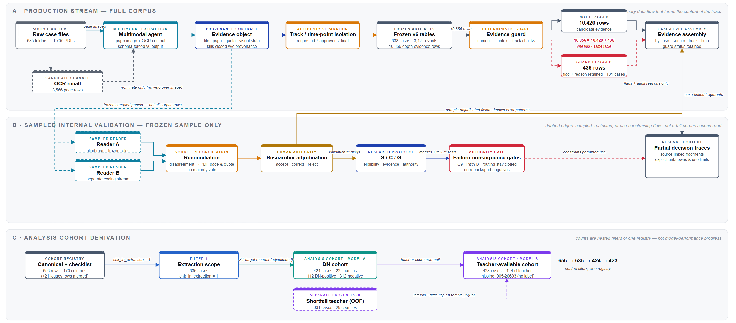
Figure 1. Historical multimodal, multi-reader research pipeline.

As shown in Figure 1, the pipeline recovers auditable evidence from 635 self-contained regulatory case folders (≈1,700 PDFs) and is organized into three bands. In the production stream (Band A), a multimodal extraction agent reads page images - with OCR serving only to nominate candidates, never to overrule the image and emits schema-forced records bound to a provenance contract (file, page, verbatim quote, and visual state; fields lacking full provenance fail closed). Depth values are then isolated by track and time point (operator-requested ≠ DEP-approved ≠ final/certificate state) to prevent outcome-state leakage, yielding frozen v6 artifacts of 633 cases, 3,421 events, and 10,856 depth-evidence rows. A deterministic evidence guard partitions these 10,856 rows into 10,420 unflagged candidate rows and 436 flagged rows (spanning 181 cases) that are retained with flags and audit reasons rather than deleted; the two subsets are complementary states of a single table under one flag, not separate datasets. Band B is a sampled internal validation sidecar: two independent readers blind-code a frozen sample under frozen rules, disagreements are reconciled against the original page rather than by majority vote, and a researcher adjudicates; the resulting S/C/G protocol and failure-consequence gates (G9, Path-B, routing) keep unvalidated uses closed. This band validates the extraction instrument—it is not a second full-corpus read nor an external gold standard. Band C derives the analysis cohorts from one canonical registry (656 canonical rows; 635 directories with PDF sources, of which 633 cases were successfully extracted; 424 adjudicated target-request cases, of which 112 are DN-positive; and 423 cases with a non-null frozen teacher score); these counts reflect different eligibility filters rather than a single attrition funnel or model-performance progression. The final output is therefore a set of source-linked partial decision-trace fragments with explicit unknowns and use boundaries, not a reconstruction of the complete historical deliberation.

3. Decision Trace Framework, Models, and Architecture

3.1 Decision Trace Framework for Reasonable Effort Review
For case i at decision time t, the ideal decision trace is represented as an ordered structured record:
T_i(t) = (S_i(t), E_i(t), D_i(t), L_i(t), P_t, R_i(t), A_i(t), U_i(t), Π_i(t)).
S_i(t) denotes the observable state at the time of review. E_i(t) represents provenance-linked evidence concerning documented efforts and actions. D_i(t) describes the well configuration and difficulty context observable at that time. L_i(t) represents the deliberative record, including the application, agency feedback, and revisions. P_t denotes the applicable rule or policy version. R_i(t) represents the submitted request or claim. A_i(t) denotes the authorized action and its stated rationale. U_i(t) records uncertainty, exceptions, and human overrides. Π_i(t) represents the provenance relationships that connect trace elements to supporting sources. Any later outcome, denoted by O_i, is stored separately and must not overwrite or retrospectively complete the trace as it existed at decision time t.
The framework distinguishes information available at or before the decision from information produced afterward. Let X_i≤t denote the observable projection available by time t and let X_i>t denote information generated after the decision. Historical datasets often combine both types of information. Consequently,
Pr(O_i | X_i≤t, X_i>t)
is generally an archival outcome model rather than a model of the reasonable effort determination that could have been made at the request stage.

The normative determination can instead be conceptualized as:
A_i†(t) = H(S_i(t), M_Pt(E_i(t)), D_i(t), L_i(t), R_i(t), P_t, U_i(t), Q_t).
M_Pt represents the admissibility or acceptance of evidence under the applicable policy, while Q_t represents the review standard applied by a qualified reviewer. The provenance relation Π_i(t) supports auditability and verification of the inputs to the determination.
This formulation emphasizes that reasonable effort is not a direct function of observed effort or well difficulty alone. The determination also depends on evidence admissibility, policy version, deliberation, uncertainty, and professional review. It therefore cannot be treated as an automatically observable target in historical structured data.
Thus, for descriptive purposes, the framework organizes the record into two evidence channels. The first, the documented effort channel, records dated attempts, methods, tools, depths reached, encountered obstructions, remedial actions, outcomes, and supporting sources. The second, the difficulty context channel, records information available at the application stage, including total depth, well age, casing conditions, coal intervals, freshwater intervals, observed obstructions, and maximum reached depth. It is important to note that county and formation may be retained as contextual grouping variables for evaluation or descriptive analysis. They are not interchangeable with well specific condition variables, and they are not serving inputs to the current versions of Model A or Model B.

3.2 Latent Difficulty and Effort as an Unidentified Causal Decomposition
Reasonable effort is relative to the physical and regulatory context. The same set of actions may produce different outcomes in wells with different geology, casing conditions, depths, or obstructions. Conversely, the same shallow stopping outcome may arise from severe objective difficulty, insufficient effort, or both.
Outcome_i = f(D_i, E_i, P_t, Z_i, ε_i).
D_i denotes latent objective well difficulty, E_i denotes latent operator or contractor effort, P_t denotes the applicable policy context, and Z_i includes other factors such as agency actions and unmeasured conditions. The ideal scientific question is whether a shallow stop is primarily attributable to high D_i, low E_i, or their joint effect. Difficulty proxies may include formation, county, total depth, well age, casing configuration, freshwater and coal intervals, obstruction type, and observed obstruction depth. Effort proxies may include fishing, milling, cleanout, tool use, number of attempts, service records, dated work records, and attempted and failed evidence.
These proxies are not the latent factors themselves. The current archive cannot isolate D_i and E_i because observed variables are mixed descendants of several processes. Difficulty affects obstruction, tool choice, maximum reached depth, and final shortfall. Effort affects attempt count, tool choice, maximum reached depth, and final shortfall. DEP decisions and policy affect approved depth, whether work continues, and the final certificate. Documentation behavior is influenced by the operator, difficulty, request strategy, and later review, and it determines what becomes observable.
Thus, the use of many tools may indicate strong effort, a difficult well, more complete documentation, or additional work compelled after agency feedback. Tool count is not a pure effort variable. County and formation are contextual proxies rather than complete measures of objective difficulty. The equation is therefore an aspirational causal factorization, not an identified model in the current data. Identification would require stronger assumptions, prospective request-time traces, independent expert labels, or designs that separate physical difficulty, chosen actions, policy responses, and documentation mechanisms. Figure 3 illustrates the practical consequence of this heterogeneity: across difficulty quintiles of the historical reference cases, the median approved proportional shortfall spans a 7.6-fold range.
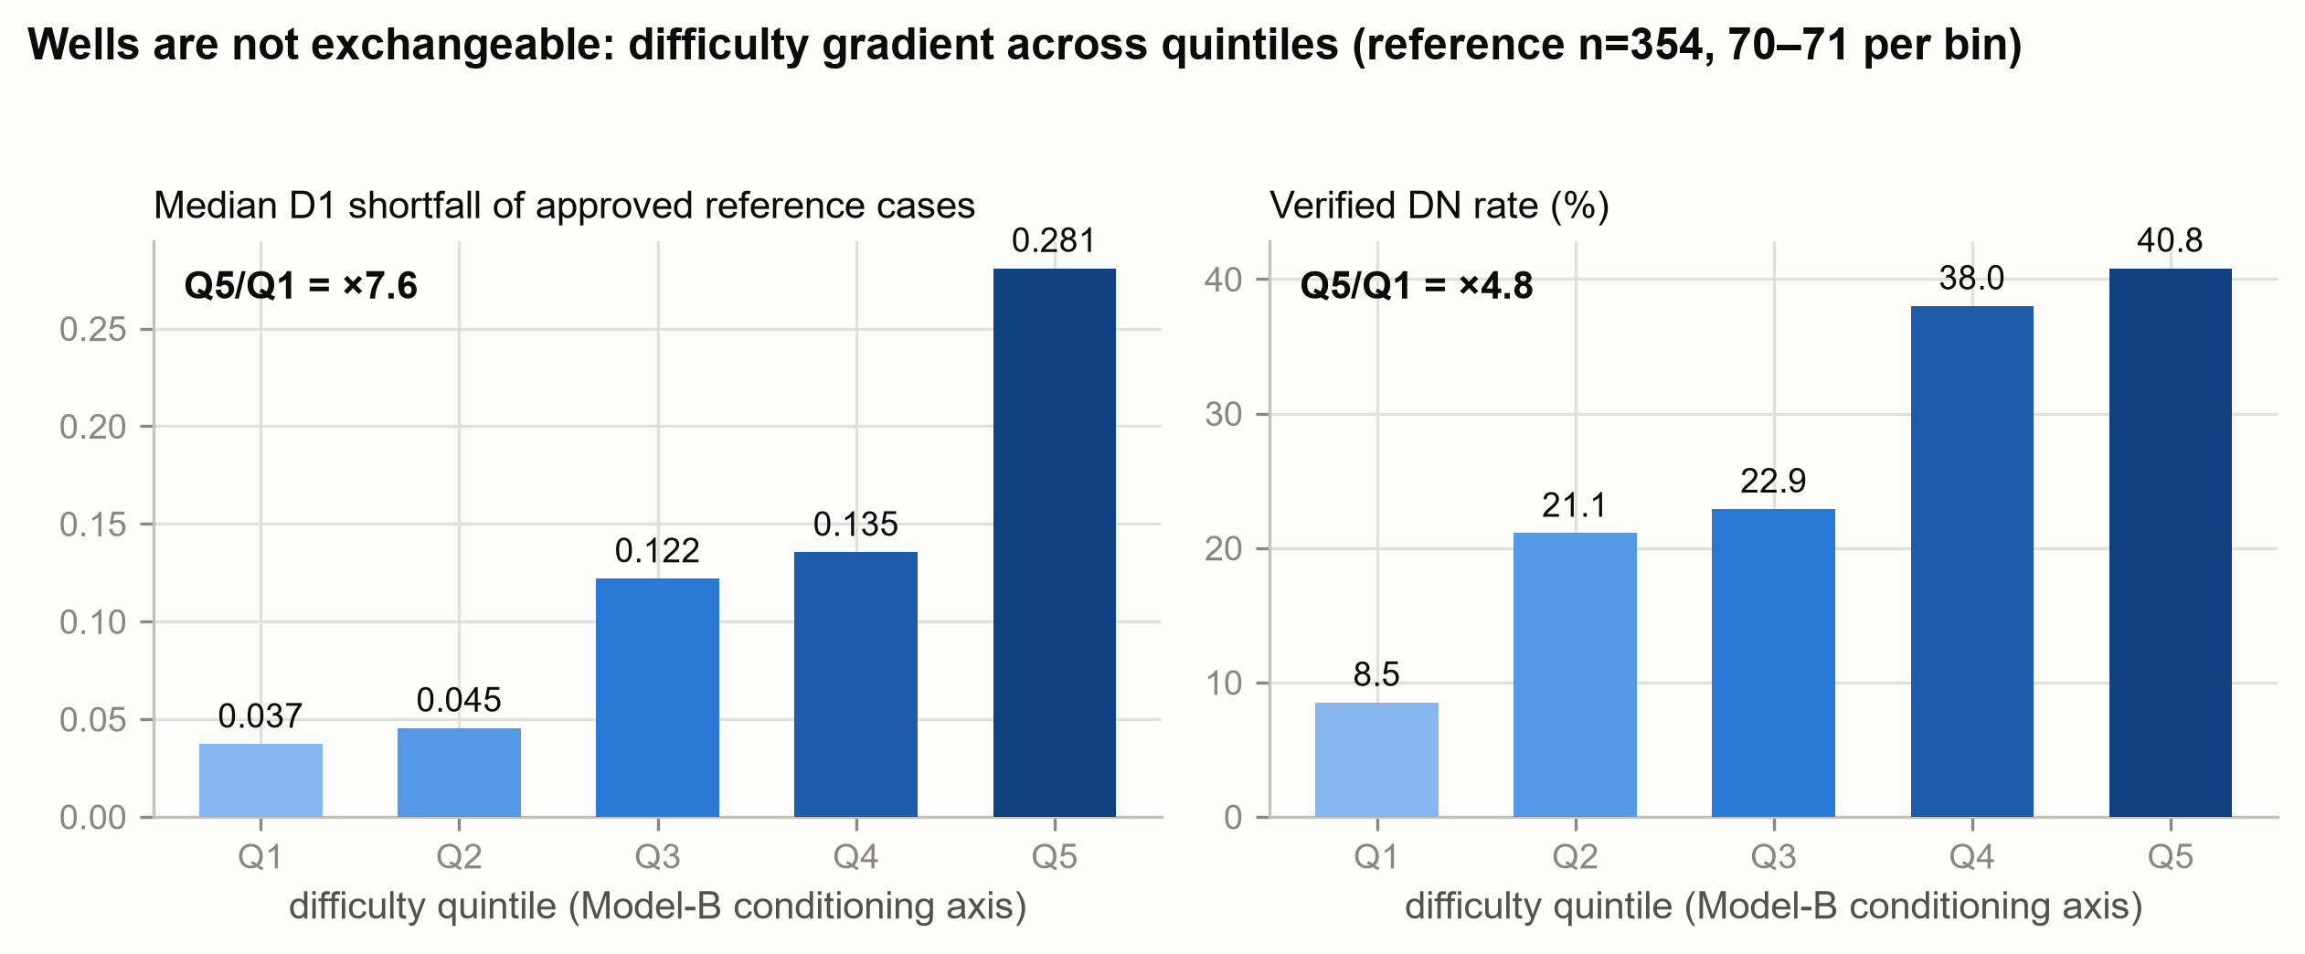
Figure 3. Wells are not exchangeable: difficulty gradients across quintiles of the historical reference cases. The 354 code-defined reference cases (audited refusals and suspicious total-depth values excluded; 70–71 cases per bin) are binned by the locked difficulty-ensemble score. Left: the median proportional shortfall (D1) of approved reference cases rises from 0.037 (Q1) to 0.281 (Q5), a 7.6-fold spread. Right: the verified documented-difficulty (DN) rate rises from 8.5 to 40.8 percent (×4.8), indicating that the conditioning axis co-varies with independently verified difficulty documentation.

3.3 Three Problem Definition Corrections and One Construct Refinement
The modeling program changed direction after three substantive corrections and one narrower construct refinement.
1. Locating the historical final event within an approved case was not the same as predicting a regulatory decision. The label was largely determined by sequence position and the deepest event.
2. Case-level shortfall risk or modeled difficulty was not equivalent to the adequacy of operator effort.
3. A final-state docket could not reliably reconstruct the information set available at the application index time.
4. The absence of a formal effort narrative could not be interpreted as the absence of effort. The construct was therefore narrowed to documented nonroutine difficulty (DN).
This evolution establishes that a model cannot uniquely infer the decision state from the final state. Information and deliberation that were never preserved cannot be recovered merely by adding features or model complexity. Sections 3.4 and 3.5 provide the empirical audits that motivated the narrower architecture. Figure 4 documents the evidentiary basis for the construct refinement: effort documentation is structurally sparse in the historical archive.
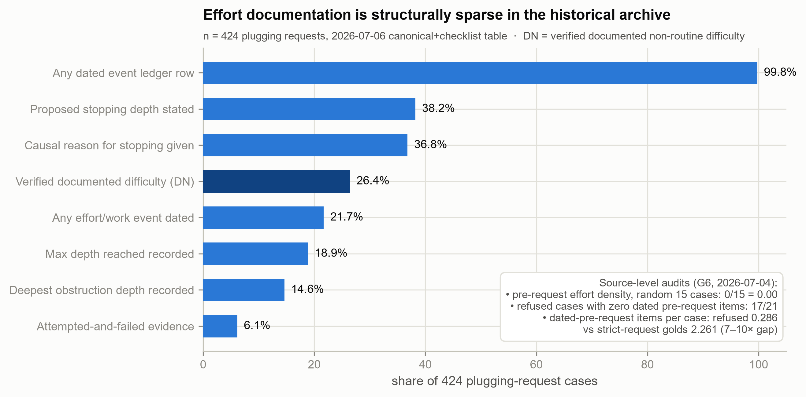
Figure 4. Effort documentation is structurally sparse in the historical archive (n = 424 plugging-request cases). Bars show the share of cases carrying each class of effort-related evidence, from any dated event ledger row (99.8 percent) down to explicit attempted-and-failed evidence (6.1 percent). Inset: preregistered source-level audits (G6) found a pre-request effort-density base rate of 0 of 15 in randomly drawn cases, and 17 of 21 refused cases carry no dated pre-request entry. This scarcity motivated narrowing the construct to documented nonroutine difficulty (DN).

3.4 Target Audit I: Why the Early Step Location Model Was Retired
The project initially attempted to identify the event within each approved case that had historically been recorded as the final stopping location. The final audit contained 103 audited cases, while an initial subset of 75 cases contributed 379 usable event records to the event-level modeling analysis. Because different analyses used different subsets, every metric requires an explicit denominator.
Cross validation was grouped by case. A gradient boosting model using event depth relative to total depth achieved an AUC of 0.916. When event depth relative to the approved attainable bottom was included, gradient boosting and random forest models achieved AUC values of 0.954 and 0.958, respectively.
These values initially appeared strong. However, a parameter-free rule that selected the deepest event in each case matched the historical label in 79 of 103 cases, corresponding to case-level top-1 accuracy of 76.7 percent. By comparison, the effort only gradient boosting model achieved event-level AUC of approximately 0.717 and case-level top-1 accuracy of 64.1 percent. Event-level AUC and case-level top-1 accuracy measure different properties and should not be presented as interchangeable. Because the task selects one event within each case, case-level ranking metrics are more closely aligned with the intended use. The AUC of 0.916 is best interpreted as evidence of a positional shortcut. The historically selected event was usually the deepest event in the sequence. This result is not necessarily target leakage if total depth was available at the request stage, but it shows that sequence geometry dominated the available process evidence.
Features defined relative to the approved attainable bottom create a more serious problem. The approved attainable bottom is produced by the final regulatory process and therefore contains information from the decision the model was intended to reproduce. The AUC values from 0.954 to 0.958 reflect target leakage rather than prospective decision performance.
The correct interpretation is not that predictive performance improved from approximately 0.72 to approximately 0.96. The documented effort variables contained limited information about the historical event label, the total depth ratio reproduced a structural property of the event sequence, and the approved bottom ratio incorporated a final decision outcome. The event location modeling track was therefore retired and is not interpreted as a prospective approval or adequacy model. This audit also establishes a general requirement: before fitting a complex model, the target should be compared with parameter-free baselines based on rank, maximum value, sequence position, and fields created after the outcome.

3.5 Target Audit II: Why Historical Shortfall Is Not an Effort Adequacy Label
The project next constructed a case-level historical shortfall proxy for 631 cases using the official Excel register provided by DEP. Historical shortfall was defined as:
Δ_i = total depth_i − approved attainable bottom_i.
This quantity is observable, but it does not have a unique substantive interpretation. A positive historical shortfall may reflect a range of factors, including difficult geological or mechanical conditions, an authorized adjustment to the attainable bottom, completion circumstances, documentation requirements, or genuinely insufficient effort. It should therefore not be interpreted as direct evidence of inadequate effort.
The archive is also affected by selection. An archive dominated by approved or completed cases may contain extensive evidence for difficult cases that were eventually resolved. Cases that were rejected, returned for additional documentation, or abandoned earlier may leave a materially different record. A model trained on the observed archive may therefore learn documentation and approval processes rather than the underlying adequacy of effort.
To examine label sensitivity, the project identified 89 cases in which certificate depth was approximately equal under a prespecified tolerance to the approved attainable bottom. The retained ensemble achieved an AUC of 0.7567 under the original labels. After cases interpreted as completed according to the authorized plan were excluded, the AUC decreased to 0.7423. When the same cases were relabeled as negative, the AUC decreased to 0.6885. This analysis is not an estimate of deployment performance and does not prove that every relabeled case is a true negative. It does show that model performance is materially sensitive to reasonable alternative treatments of apparently compliant completion cases. Historical shortfall therefore cannot be treated as validated ground truth for insufficient effort.
On the basis of this target audit, the available PDF extractions and DEP shortfall data are not sufficient to validate a deployable adequacy classifier or an autonomous decision agent. The research objective was therefore narrowed to two decision support tasks.

3.6 Revised Two Model Decision Support Architecture
The revised architecture contains two functionally separated models.
Model A assigns a triage score to cases with stronger documented evidence of nonroutine difficulty and uses that score to prioritize human review.
Model B selects a coarse historical reference context and determines whether the current proposed shortfall lies in the upper tail of that reference distribution.
The models do not reproduce the full reasonable effort determination. They do not replace policy interpretation, evidence admissibility review, professional judgment, or human authorization. They are also not statistically independent. They share serving fields, and Model B inherits the semantics and limitations of its historical teacher model. Their roles are separated by function, not by the data generating process.

Model A: Documented Difficulty Trace Triage
Documented nonroutine difficulty, abbreviated as DN, is defined as traceable documentary evidence that the current campaign involved at least one nonroutine difficulty. DN is a documentary construct. It is not a measure of latent engineering difficulty, and the absence of a formal effort narrative is not a negative DN label or evidence that no effort occurred.
Two DN model artifacts exist and should not be conflated.
The 108-feature archival research model includes post-work variables such as certificate or completion related optical character recognition evidence. It is suitable only for retrospective research and is not the Model A artifact loaded by the current runtime.
The current runtime Model A is a 17-field, request-stage-compatible histogram gradient boosting classifier trained on 424 cases, including 112 DN positive cases. The reported mean AUC of 0.8366 with a standard deviation of 0.1097 belongs to this form model rather than to the separate 108-feature archival artifact.
The Model A evaluation used StratifiedGroupKFold with county as the grouping variable across five seeds and five folds. The training script summarized AUC values from valid held-out folds. The mean was 0.8366 and the fold level standard deviation was 0.1097. This value is not an accuracy of 83.66 percent. The reported standard deviation is not a repeat level standard deviation, not a confidence interval, and not evidence that the output is a calibrated probability. Figure 5 shows why the 17-field configuration is sufficient: in the 108-feature research model, only seven features carry non-zero permutation importance.
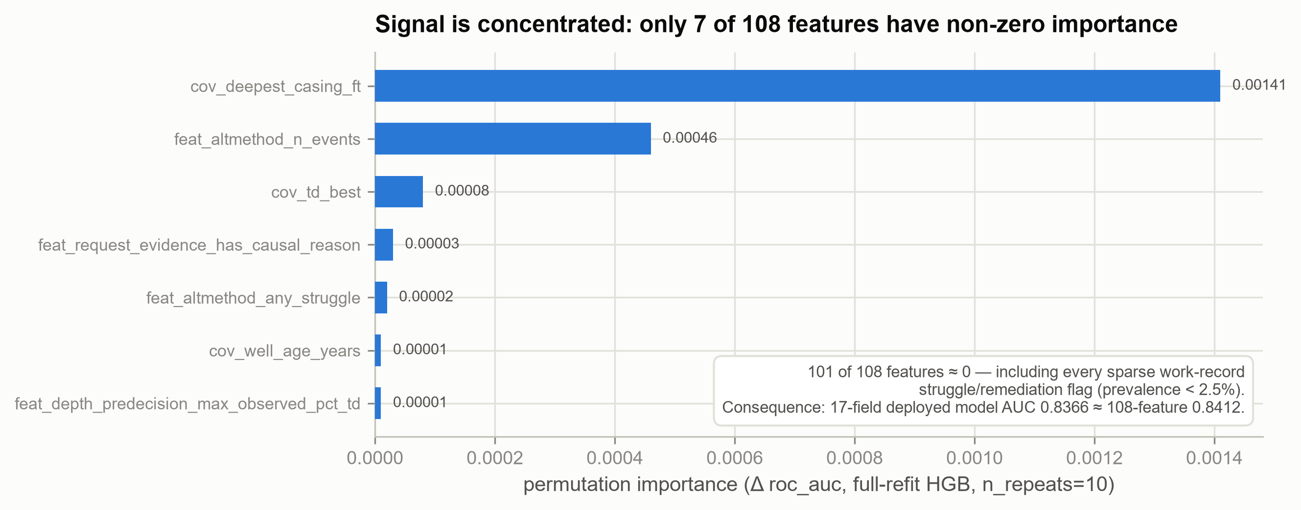
Figure 5. Signal concentration in the 108-feature DN-triage research model. Under permutation importance (full-refit histogram gradient boosting, 10 repeats), only seven of 108 features have non-zero importance; the remaining 101, including every sparse work-record flag with prevalence below 2.5 percent, contribute approximately zero. Consequently, the 17-field deployed configuration (mean AUC 0.8366 ± 0.1097) performs comparably to the 108-feature research artifact (0.8412 ± 0.1136). Importance values support relative ordering only and should not be read as effect sizes.
Model A produces dn_score, which ranks the human review queue. A higher score indicates that the available record more closely resembles historical DN positive records. The score does not determine a difficulty category, assess the sufficiency of effort, estimate approval probability, or enter the preliminary routing matrix.
Queue ranking changes the order and timing of review, so Model A is not operationally consequence free. Evaluation should include precision and recall at the intended review capacity, lift over random ranking, workload reduction at fixed recall, and subgroup queue burden across county, operator, document quality, and other relevant groups.

Model B: Empirical Context and Reference Selection
Model B is a teacher approximation model. Its target is not an expert labeled measure of objective engineering difficulty. It approximates the score produced by a frozen historical shortfall ensemble.
Model B is trained on 423 retrospective cases for which teacher scores and the required serving fields are available. It maps 17 serving fields to the teacher score and applies frozen cutpoints to select one of five reference bins, Q1 through Q5.
The frozen Model B teacher target is supplied through an out-of-fold score artifact rather than through direct in sample teacher predictions. This reduces one route by which teacher overfitting could be transmitted into Model B. It does not validate the meaning of the shortfall teacher, and any evaluation of bin cutpoints and P90 thresholds must still estimate those quantities from the training partition only.
Model B does not use county, formation, operator, or permit identity as serving inputs. It does not construct a geographic profile. Its output is best described as a coarse empirical reference selector rather than a direct estimate of geological or causal difficulty.
The original training script looped over five seeds, but each seed only changed row order before GroupKFold was called with shuffling disabled. The held-out county sets were therefore unchanged. The reported value of 0.418 with a standard deviation of 0.047 is a fold mean Spearman correlation and fold level standard deviation from one set of five county-grouped folds. It is not the result of five-by-five independent repeated cross validation and is not a confidence interval.
Model B achieved exact bin agreement of 35.5 percent with the teacher and agreement within one adjacent bin of 72.3 percent. Thus, 27.7 percent of cases differed from the teacher by at least two bins. These results indicate modest agreement and should be interpreted relative to simple baselines and the downstream effect of bin errors. Figure 6 visualizes these empirical boundaries for both models.
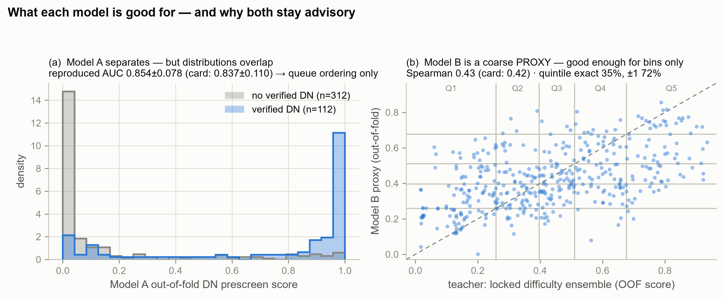
Figure 6. Empirical performance boundaries of the two runtime models. (a) Out-of-fold Model A scores by label (verified DN, n = 112; no verified DN, n = 312): the distributions separate well enough to support queue ordering but overlap too much to support automated adjudication. (b) Out-of-fold Model B predictions versus the frozen teacher score (n = 423); grid lines mark the frozen quintile edges. Exact bin agreement with the teacher is 35.5 percent and within-one-bin agreement is 72.3 percent, which is why the interface labels the output as a proxy, never displays the raw score, and preserves human override of the selected bin. Panel headline values are independent reproductions from the frozen artifacts (AUC 0.854 ± 0.078; Spearman 0.43); the model card values (0.8366 ± 0.1097; 0.418 ± 0.047) remain the official estimates.

The proposed request-stage configurations of Model A and Model B use the following 17 fields:
1. Total depth.
2. Well age.
3. Casing count.
4. Deepest casing depth.
5. Coal seam indicator.
6. Freshwater indicator.
7. Document count.
8. Total current work event count.
9. Cleanout event count.
10. Effort or work event count.
11. Alternative method form submitted.
12. Attempted and failed narrative present.
13. Causal explanation present.
14. Maximum reached depth.
15. Obstruction depth or obstruction indicator.
16. Maximum reached depth divided by total depth.
17. Proposed stop entered indicator.
The numerical proposed stop value is not a serving feature and is used only to calculate D1_request. County, formation, operator, and permit identity are not serving inputs. Certificate and completion fields are excluded from request-stage configurations. The 17 fields are only a limited projection of the documented effort trace and should not be interpreted as a complete effort history.

3.7 Runtime Reference Logic and Decision Boundaries
At runtime, Model B follows this sequence:
ŝ_B(x) → Q̂ ∈ {1, 2, 3, 4, 5} → P_90,Q̂ → tail flag.
For the current request, the proposed proportional shortfall is calculated separately:
D1_request = clip((TD − proposed stop) / TD, 0, 1).
The numerical proposed stop value is not an input to Model B. It is used only in the downstream calculation of D1_request.
Before clipping, the system should validate that total depth is positive, the proposed stop is present, units are consistent, and the proposed stop lies within an admissible range. Clipping should not conceal impossible or invalid inputs.
If D1_request exceeds the historical ninetieth percentile associated with the selected reference bin, the system generates a tail flag. The teacher, bin cutpoints, and percentile thresholds must be estimated only from training data and frozen before evaluation or deployment. Figure 7 illustrates the reference logic: the same proposed shortfall can exceed the ninetieth percentile of approved peers in one reference bin while remaining within the historical norm in another.
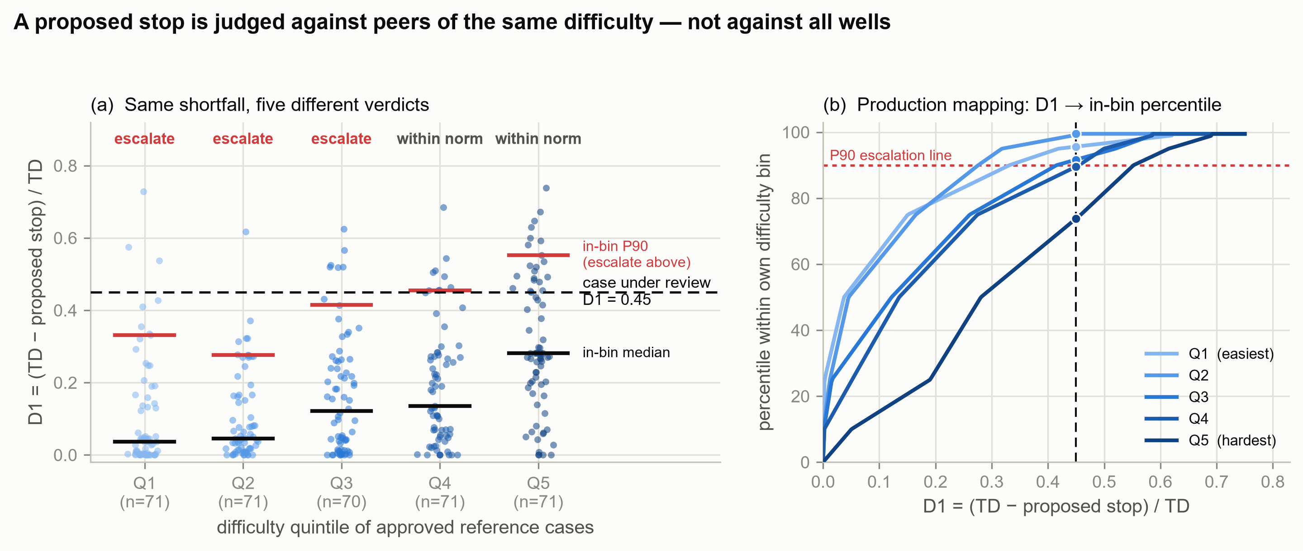
Figure 7. A proposed stop is judged against approved peers of comparable difficulty rather than against all wells. (a) Proportional shortfall (D1) of the 354 code-defined historical reference cases by difficulty quintile; black bars mark the in-bin median and red bars the in-bin ninetieth percentile (the escalation line). A hypothetical request proposing D1 = 0.45 (dashed line) exceeds the ninetieth percentile of its approved peers in Q1–Q3 but lies within the historical norm in Q4–Q5. (b) The frozen production mapping from D1 to in-bin percentile: the same D1 = 0.45 maps to the 95.6th, 99.5th, 91.7th, 89.5th, and 73.8th percentiles in Q1 through Q5, respectively. The non-monotonic ninetieth percentile between Q1 (0.332) and Q2 (0.276) reflects finite-sample quantile noise at 70–71 cases per bin and should not be over-interpreted.

The tail flag is combined with checklist status to form a preliminary two-by-two routing matrix. Model A does not enter this matrix. It only determines review priority.
The operational distinction is therefore clear: Model A determines which cases are reviewed earlier, while Model B determines which historical reference scale is applied. Neither model makes the final determination. However, an incorrect reference bin can change the tail flag and alter the initial routing outcome. Figure 8 quantifies why the conditioning matters: a single pooled threshold would concentrate flags on the most difficult quintile, whereas in-bin thresholds hold each quintile near the nominal rate.
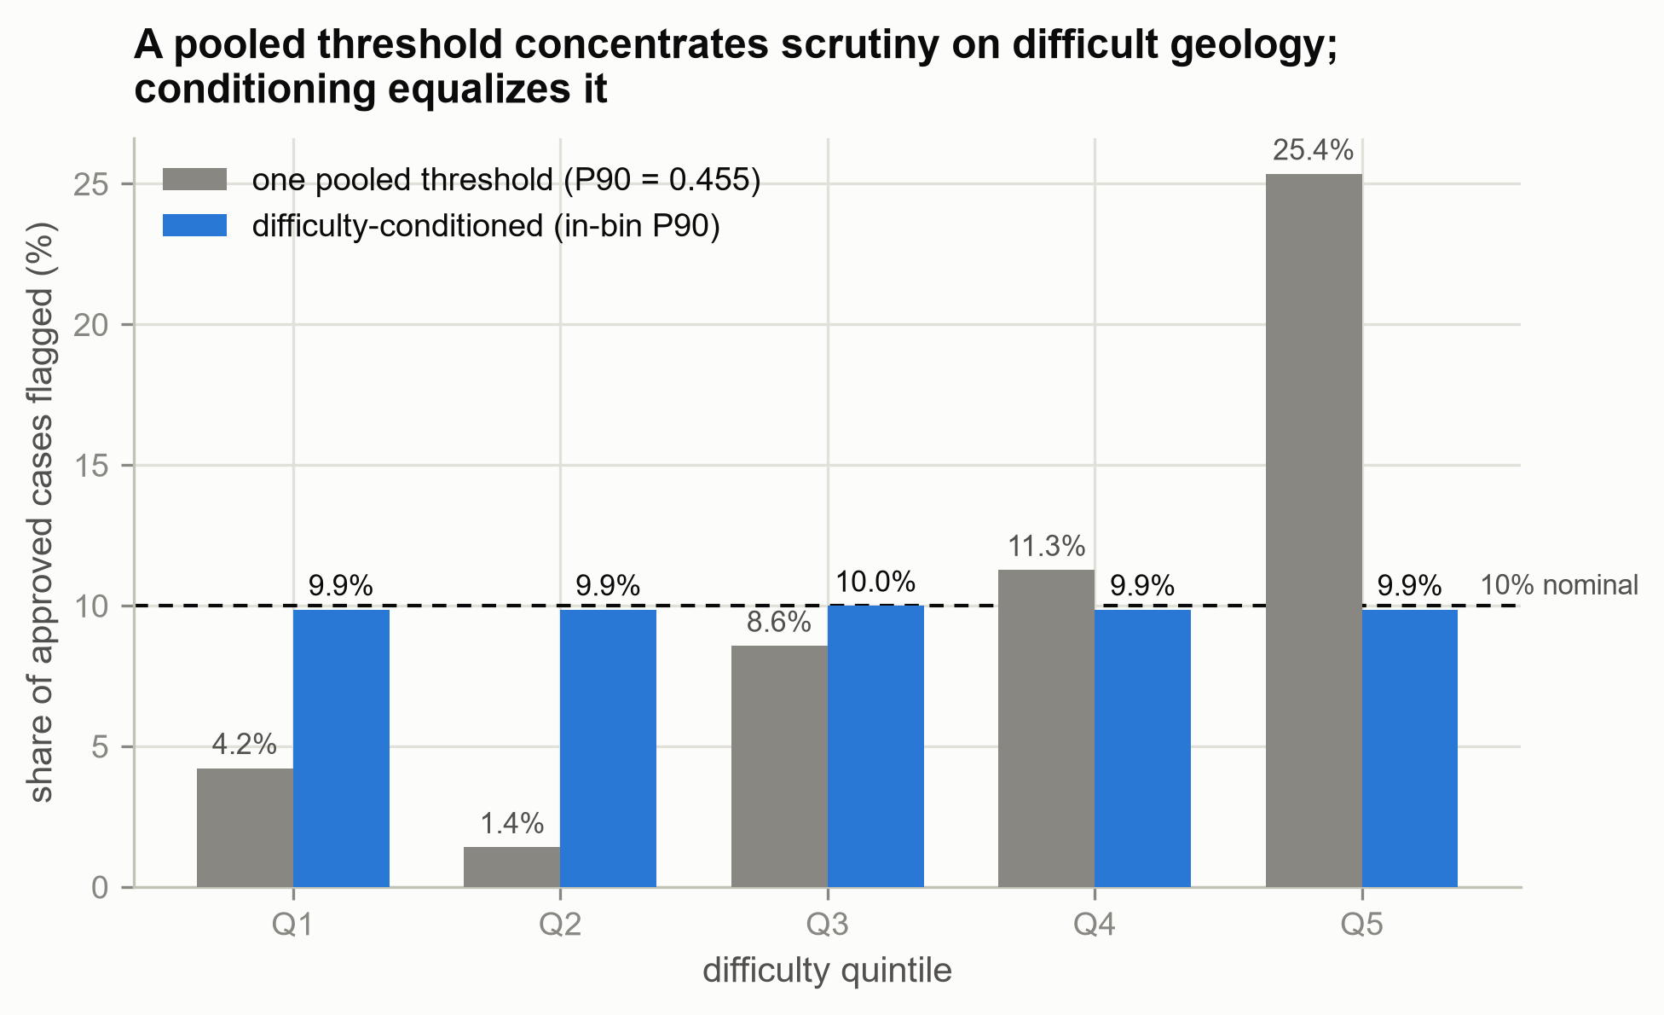
Figure 8. The cost of not conditioning on difficulty. Under a single pooled ninetieth-percentile threshold (0.455), the share of historical reference cases flagged per difficulty quintile ranges from 1.4 percent (Q2) to 25.4 percent (Q5), an 18-fold disparity that penalizes difficult geology rather than anomalous requests. In-bin thresholds hold every quintile at 9.9 to 10.0 percent, matching the nominal 10 percent level (dashed line); out-of-fold calibration of the overall tail rate passes at 10.17 percent against a 10 ± 5 percentage-point criterion.

4. Agent Architecture: From Trace-Poor Archives to Prospective Decision-Trace Production

4.1 Multiagent Roles in Extraction and Runtime
In this project, the multimodal multiagent framework performs different functions at different stages. During data extraction and audit, multiple agents support case-level multimodal extraction, independent blind rereading, source reconciliation, failure analysis, and researcher adjudication. The runtime prototype, however, is not an autonomous agent system capable of independent planning, task delegation, or negotiation among agents. Instead, it is a hybrid pipeline that integrates two optional large multimodal model services, two conventional machine learning models, deterministic validation rules, similarity based retrieval, and a human review interface.
Accordingly, the manuscript uses the term multiagent evidence engineering to describe the research and audit workflow, while hybrid authority architecture refers to the operational runtime. The central design contribution lies not in the number of agents involved, but in the separation of evidentiary authority from routing consequences and in the generation of prospective decision traces.

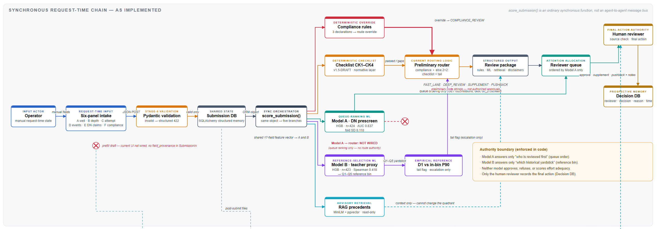

Figure 9. Current agent architecture of PANDA

As shown in Figure 9, the runtime system is a synchronous module chain, not an autonomous multi-agent conversation: an operator completes a six-panel structured intake (well, depth, attempt, event ledger, DN claims, and compliance declarations), which passes Pydantic validation, is persisted to a submission database, and is then fanned out by an ordinary synchronous function, score_submission(), to five branches sharing a common 17-field feature vector where applicable. Authority is deliberately stratified. Deterministic compliance rules can override the route to COMPLIANCE_REVIEW; the CK1–CK4 checklist and an empirical tail flag—D1 compared against the frozen in-bin P90 reference selected by Model B—jointly determine a preliminary 2×2 route (FAST_LANE, DEEP_REVIEW, SUPPLEMENT, PUSHBACK), which are code strings pending prospective validation rather than authorized dispositions. Model A (HGB, n = 424, AUC 0.837) has no edge into the router by construction: its only wired effect is ordering the reviewer queue. Model B (HGB, n = 423, Spearman 0.418) selects only the historical reference bin; neither model approves, refuses, or scores effort adequacy. RAG precedent retrieval is read-only and enters the review package as context without altering the route. The final action—approve, supplement, pushback, or compliance review, as shown in Table 1—can be recorded only by a qualified human reviewer, and the resulting decision table (reviewer, decision, reason code, timestamp) seeds a prospective clean-label memory. Backend sidecars for PDF upload, vision-based form prefill (P4), and claim-level visual reconciliation (P3, with asynchronous verification jobs) are implemented but not yet wired into the current UI; all sidecar flow is strictly advisory and cannot modify the checklist, the routing quadrant, or the final action.

Table 1. Current preliminary routing matrix
Checklist status | Model B selected tail flag | Preliminary routing label | Permitted interpretation
Pass | No | FAST_LANE | Lower nominal escalation priority. This label must not be interpreted as approval.
Pass | Yes | DEEP_REVIEW | Documentation is more complete, but the proposed shortfall lies in the upper tail of the selected empirical reference bin.
Fail | No | SUPPLEMENT | Additional materials specified by the checklist are required.
Fail | Yes | PUSHBACK | Missing materials and a tail flag warrant higher intensity human review only.

4.2 Minimum Authority by Component
The appropriate role of each component is defined by the narrowest consequence supported by its evidence and validation status. Table 2 distinguishes permitted functions from prohibited interpretations.
Table 2. Minimum authority of current and target architecture components
Component | Permitted function | Current effect on the preliminary quadrant | Prohibited interpretation
Prefill LMM | Proposes editable field values and candidate source pages. | Indirect only after the user accepts the field. | Automatic establishment of fact or approval.
Reconciliation LMM | Returns verified, mismatch, not found, and related source comparison flags. | No. The current role is advisory. | A validated veto or an externally validated review result.
Model A | Performs DN prescreening and orders the human review queue. | No. | Effort adequacy, objective difficulty, or approval probability.
Model B | Approximates the frozen teacher score and selects a historical reference bin. | Indirectly, through the tail flag. | Objective difficulty, effort score, or approval probability.
Historical anomaly table | Compares current request D1 with the selected historical reference distribution. | Yes, as the tail dimension. | A violation, misconduct, or a conclusion that the request should be refused.
CK1 through CK4 | Prompts review of material completeness, timeliness, and numerical conflict. | Yes. | The complete legal standard or an unverified automatic veto.
Compliance rules | Produce a red flag from three declared fields. | Currently overrides the quadrant. | A legal adjudication with validated recall.
Retrieval augmented generation | Returns similar text context. | No direct effect. | A verified precedent, approval likelihood, or the internal reasoning of a model.
Human reviewer | Verifies sources, interprets the applicable rule, and selects the final action. | Final action authority. | Delegation of professional responsibility to the model.
Decision trace ledger | Should version the state, source, rule, revision, acceptance, reason, override, and later outcome. | Not fully implemented. | A claim that the current log is clean gold data or complete historical deliberation.

5. Conclusion

5.1 Core Thesis: Agent Readiness Is Decision-Trace Readiness
The central proposition of this work is that agent readiness is determined by decision-trace readiness: whether an AI agent can safely support a regulatory decision depends less on the capability of its models than on the completeness, provenance, and temporal integrity of the decision records it learns from and operates on. We operationalize this proposition through a five-validity framework in which every model claim must answer five questions jointly: measurement validity — was the field read from the correct file, page, visual state, and track; temporal validity — did the field exist at the proposed decision index time; construct validity — does the label actually measure the concept the system claims to judge; extrapolation validity — does the evaluation block the county, operator, document-template, and time structures the system will face in practice; and authority validity — is the accumulated evidence sufficient to authorize the specific consequence assigned to the component. Formally, V_claim = V_measurement ∧ V_time ∧ V_construct ∧ V_extrapolation ∧ V_authority. These dimensions are conjunctive rather than compensatory: strong performance on one cannot offset failure on another, and predictive accuracy acquires high-consequence meaning only when all five hold simultaneously. This thesis was not a starting assumption. It was earned through three successive corrections to our own problem definition, is grounded in a structural property of the historical data itself, and ultimately dictated the architecture of the system we built. The remainder of this section traces that argument.

5.2 How the Thesis Emerged: Three Corrections to the Problem Definition
The first line of support is empirical: each time the project tried to extract more judgment from the archive than the archive actually records, the attempt failed in an instructive way. Three corrections resulted. First, the early task of locating which step within an approved case became the final step turned out not to predict any regulatory decision; its apparent signal was driven largely by the label construction itself, which was dominated by the deepest recorded event. Second, case-level shortfall risk — and the modeled difficulty derived from it — proved not to be a measure of operator effort adequacy: a well may stop shallow because it is genuinely difficult, because effort was insufficient, or both, and the historical label cannot distinguish these. Third, final-state dockets could not reliably reconstruct the information set available at the application index time. A consequential sub-correction followed: the absence of a formal effort narrative in the file cannot be read as the absence of effort, which forced the project to narrow its construct from "effort" to documented nonroutine difficulty (DN). Read together, these corrections constitute a negative result that we regard as a finding rather than a limitation: the decision state cannot be uniquely inverted from the final state, and deliberation that was never recorded cannot be recovered by adding features or increasing model complexity. In the language of the framework above, the failures were failures of construct and temporal validity — and no gain in raw accuracy could have repaired them.

5.3 Why the Failures Were Structural: An Unidentified Causal Decomposition
The second line of support explains why these corrections were unavoidable rather than accidental. Our analysis showed that "reasonable effort" is inherently relative: the same effort applied under different geological and wellbore conditions produces different outcomes. The review problem is therefore best formalized as a latent causal factorization, Outcome = f(D, E, policy, other factors), where D denotes the objective difficulty of the well and E the effort invested by the operator or contractor; ideally, review would determine whether a shallow stop reflects high D, insufficient E, or their joint action. Neither latent factor, however, is directly observable in the archive — only proxies are: formation, county, total depth, casing configuration, and observed obstructions for D; fishing, milling, cleanout attempts, tool usage, attempt counts, and dated service records for E. And these proxies are severely confounded. A large tool count, for example, may indicate an exceptionally diligent operator, an exceptionally difficult well, an operator whose documentation practices are simply more complete, or additional work compelled by a prior DEP refusal. Documentation behavior is itself endogenous — shaped by the operator, the difficulty encountered, and the request strategy — and it determines what the archive allows us to observe at all. The historical data therefore cannot causally separate difficulty from effort. This is a property of the data-generating process, not a deficiency of any particular model, which is precisely why the thesis locates the binding constraint in the records rather than in the algorithms.

5.4 The Design Consequence: Narrower Authority, Not Stronger Models
The third line of support is architectural: if the constraint lies in the data, the correct response is to restrict what models are authorized to conclude, not to search for a stronger model. Rather than training a single system to judge effort adequacy — a construct the data cannot support — PANDA decomposes decision support into two restricted components aligned with the two evidentiary dimensions that are observable. Model A operates on documented nonroutine difficulty and is authorized only to order the human review queue; Model B approximates a frozen difficulty teacher and is authorized only to select a coarse historical reference bin against which the current request is compared. Neither model, alone or jointly, is permitted to score effort adequacy, estimate approval probability, or trigger an adverse action; deterministic compliance rules and checklist prompts carry the normative load, and final action authority remains exclusively with a qualified human reviewer. Model choice, in this setting, is not a search for the highest-accuracy predictor but a matching exercise governed by authority validity: each component receives the narrowest consequence that its evidence and validation status can support.
In sum, the three strands close a single loop. The corrections showed that the archive does not contain the judgments we hoped to model; the causal analysis showed that it structurally cannot; and the architecture shows how to build useful, accountable decision support anyway — by matching every component's authority to what the evidence can actually sustain. Agent readiness, in the end, is decision-trace readiness: the highest-leverage path to more capable regulatory agents is not larger models but the native capture of complete, source-linked decision traces, the agenda set out in our future work.

6. Future Work

6.1 A Generalizable Extraction Framework and Dataset Expansion
A central methodological contribution of this project is the demonstration that a multimodal, multiagent framework can efficiently and accurately extract structured, timeline-aware, and feature-engineered records from exceptionally heterogeneous and disordered document archives — records that are directly usable for machine learning and for the construction of agent runtime states. Because the pipeline's core components are domain-agnostic — provenance-bound structured output, strict separation of temporal and depth tracks, deterministic safeguards with quarantine rather than deletion, and layered multiagent blind review with human adjudication — the framework is not specific to attainable bottom review. It can be transferred, with modest schema adaptation, to other regulatory and institutional settings in which decades of decision-relevant information are locked inside scanned forms, handwritten annotations, checkboxes, and inconsistent templates. For the attainable bottom task itself, the most immediate extension, subject to continued funding, is to enlarge the training corpus: ingesting additional historical dockets beyond the current 633 cases and 10,856 evidence records, broadening coverage across counties, operators, time periods, and document templates, and thereby strengthening the blocked and external validation designs that the current cohort sizes (n = 424 for Model A and n = 423 for Model B) can only partially support.

6.2 Computational Cost and Efficiency
These benefits come with a nontrivial cost profile that future deployments must plan for explicitly. The extraction pipeline depends on a large volume of calls to frontier multimodal model APIs (e.g., OpenAI and Anthropic models of the GPT-5.6 or Claude Fable 5 class), because reliable interpretation of checkboxes, handwriting, stamps, and layout relationships currently requires the strongest available vision-language capabilities. Per-corpus processing costs therefore scale with both document volume and the number of independent reader passes used for validation. Future work should quantify this cost–accuracy trade-off directly, and evaluate mitigation strategies such as reserving frontier models for pages that deterministic safeguards or cheaper models flag as ambiguous, caching and reusing page-level extractions across schema revisions, and distilling stable, well-validated extraction behaviors into smaller or locally hosted models once the emission vocabulary is frozen. Any such substitution must, however, be re-validated through the same blind-review and gate procedures (Appendix B), since cost reduction cannot be allowed to silently degrade measurement validity.

6.3 Expert Feedback Collection and Reinforcement Learning from Human Feedback
The project's first forward path concerns the upcoming beta testing of PANDA within DEP workflows. During this phase, the agent system will mandatorily capture and persist expert feedback on every agent-generated judgment surfaced to a reviewer — including acceptance, correction, or rejection of prefilled fields, agreement or disagreement with checklist prompts, the preliminary route, and the retrieved reference cases, together with reviewer reason codes and free-text notes. This structured feedback stream serves two purposes. In the near term, it functions as a prospective audit of component-level error rates under real use, extending the internal validation reported here with genuinely external expert signal. In the longer term, and subject to sufficient volume, quality, and appropriate validation, this feedback may be incorporated into model refinement through reinforcement learning from human feedback or related human-supervised approaches. We emphasize the conditions on this path: expert feedback collected during operational review is subject to selection effects, inter-reviewer variation, and confounding between preference and correctness, and it must therefore be curated, deduplicated, and evaluated against held-out adjudicated cases before it is permitted to alter any component whose outputs carry routing consequences. Consistent with the authority framework in Section 4.2, feedback-driven updates should expand a component's authority only after the corresponding gate is re-opened and passed.

6.4 Recommendations for Prospective Data Collection
The second forward path is a recommendation to DEP that follows directly from this study's central finding: the dominant constraint on system performance is not model capacity but the completeness of the underlying decision records. The historical archive preserves final states while omitting most of the deliberation — actors, alternatives considered, applicable rule versions, and rationales — which is precisely why only partial decision traces could be reconstructed. If future submissions are captured natively in a structured, source-linked form (as prototyped by the six-panel intake, the proposed attempt-event schema in Appendix C, and the decision ledger), then each new case will arrive as a complete, replayable decision trace rather than requiring costly retrospective reconstruction. Better and more complete data collection at the point of decision would simultaneously reduce extraction cost, eliminate entire classes of temporal leakage risk, provide clean labels for future supervised and feedback-based learning, and improve the transparency and auditability of the review process itself. We therefore expect the system's performance ceiling to rise substantially as prospective trace capture matures — and we regard institutionalizing such capture as the single highest-leverage investment DEP can make in this line of work. Finally, prospective human–AI interaction studies measuring reviewer time, field acceptance and correction rates, routing risk, and decision consistency will be necessary to establish whether these anticipated gains materialize in practice.

Appendix A. Data Scope, Evaluation Conventions, and Internal Terminology

Appendix A.1 Data Scope and Analytical Denominators
The project used different scopes for different research questions. The counts in Table A1 should not be written as one cohort or as a simple attrition funnel.
Table A1. Data scopes and analytical uses
Data scope or artifact | Count | Research use and interpretation
Original directory inventory | 913 | Contains 912 roster or in scope directories and one known stray.
Directories with PDF dockets | 635 | Source file range for full document extraction, comprising approximately 1,700 PDFs.
Directories without local PDF sources | 277 | Must not be interpreted as negative evidence and may represent a digital availability selection mechanism.
v6 unique case table | 633 | Extraction records before the main analysis filter.
v6 quality assurance scope | 632 | Eligible records after removal of the known stray.
Frozen shortfall machine learning cohort | 631 | Contains 250 positive and 381 negative labels across 29 counties.
DN and plugging stratum | 424 | Contains 411 historical approved status cases and 13 audited refused cases. Individual analyses apply additional filters.
Cases with Model B teacher scores | 423 | Used for internal evaluation of the proxy regressor.
Historical anomaly reference set | 354 | Code defined scorable reference records after exclusion of audited refusals and suspicious total depth values. It should not be described as 354 confirmed approvals.
Canonical merged schema | 656 × 170 | Full research schema containing identity, source, quality assurance, checklist, and outcome columns. The 170 columns are not all model inputs.
In particular, 635, 656, 631, 424, 423, and 354 refer respectively to source directories with PDFs, the merged schema, the frozen shortfall cohort, the DN stratum, the Model B cohort, and the anomaly reference set. They are not successive losses from one denominator. Figure A1 summarizes which subsets of the canonical schema each model family consumes.
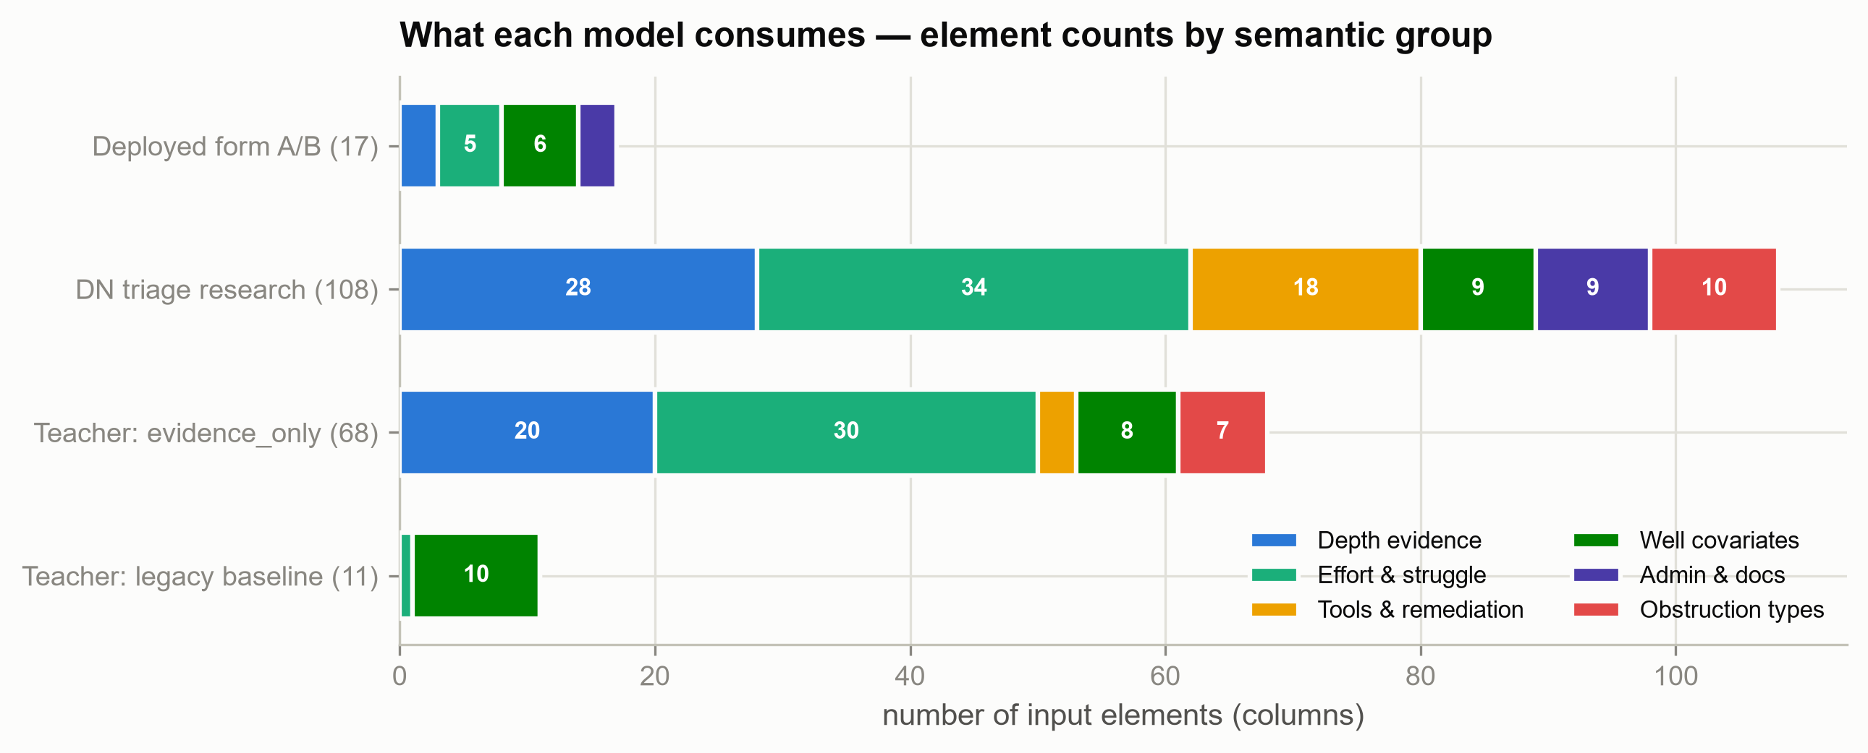
Figure A1. Element composition of each model family by semantic group. The deployed 17-field form models draw on six well covariates, five effort and event counts, three administrative fields, and three depth-evidence fields. The 108-feature research model additionally consumes tools-and-remediation, obstruction-type, and detailed depth-evidence columns; the teacher profiles (68 and 11 features) are shown for comparison. No checklist (label-side) or outcome (label or certificate) column enters any serving feature set.

Appendix A.2 Evaluation Design and Statistical Reporting
Different experiments used different cross validation designs and different dispersion summaries. The manuscript does not interpret every plus or minus value as the same uncertainty quantity.
1. The 631 case historical shortfall analysis used county-grouped StratifiedGroupKFold with five folds and five split seeds. Each seed produced full cohort out-of-fold predictions. A result such as 0.7400 ± 0.0090 reports the dispersion of five repeat level AUC values and is not a confidence interval.
2. Model A used county-grouped StratifiedGroupKFold with five seeds and five folds. The script pooled valid held-out fold AUC values. The 0.1097 associated with 0.8366 is fold AUC dispersion rather than repeat level dispersion or a confidence interval.
3. The Model B script shuffled rows for five seeds and then called GroupKFold with shuffling disabled. The held-out county sets did not change. The 0.418 ± 0.047 result is therefore a fold summary from one effective five fold county-grouped partition rather than an independent five-by-five repeated design.
4. The repeat zero evidence versus geography comparison used the same out-of-fold vector and reported both case bootstrap and county cluster bootstrap uncertainty. That estimand is not the same as the difference between five repeat means.
5. G9 used a two sided Fisher exact test and reported both refused side cluster collapse and tuning untainted sensitivity conditions under a frozen specification. A probability ordered p value and an equal tail interval are not guaranteed to form a strict dual pair.
6. Checklist results with small denominators use naive Clopper Pearson intervals to display denominator uncertainty. Repeated readers are nested within cases and share correlated model errors, so the observations are not treated as independent Bernoulli trials.
7. Path B used paired AUC differences across the same 25 grouped folds and applied prespecified absolute and incremental thresholds.
8. Classification results prioritize ROC AUC. Selected shortfall analyses also report average precision, Brier score, and precision near the top of the review queue. The regression proxy uses Spearman correlation and bin agreement. Except for explicitly reported bootstrap or exact intervals, standard deviations should not be read as population confidence intervals. The exploratory comparison set was not covered by a single multiplicity adjusted confirmatory analysis.

Appendix A.3 Terminology and Internal Codes
Table A3. Terms and internal codes used in the manuscript
Term | Definition and boundary
LMM | Large multimodal model used for candidate evidence extraction or visual reconciliation.
HGB | Histogram gradient boosting. Model A is a classifier and Model B is a regressor.
OOF | Out of fold prediction generated only for a case held out from the corresponding fit.
v6 | The sixth major revision of the historical multimodal extraction and modeling pipeline. It is not an external standard version.
G8 | An internal blind reading reliability gate for track separation, vocabulary, and field emission stability.
G9 | A frozen association gate comparing DN in audited refused and historical approved status cases. The primary comparison and both sensitivity conditions must pass before interpretation is opened.
Path B | A frozen ceiling break backtest that adds checklist features to the earlier y_needed_short task.
D1 | Shortfall normalized by total depth. Historical reference D1 and current request D1 use different depth sources and must be labeled separately.
CK1 through CK4 | The four draft runtime checklist items covering request form, effort evidence, decision relevant depth numbers, and depth number timeliness.
Quadrant | The preliminary two by two triage label formed by checklist pass or fail and tail yes or no. It is not an approval conclusion.
Decision trace | A replayable unit organized by case, time, source, action, rule, reason, and authority. The historical project reconstructs fragments rather than complete deliberation.

Appendix A.4 Frozen Artifacts and Reproducibility Notes
The following repository relative locations identify the principal frozen artifacts used by the current analysis. These paths are technical supplement material and may be moved to a separate reproducibility package at submission.
Table A4. Principal frozen data and model artifacts
Artifact | Frozen location or identifier | Interpretation
v6 case table | 06_processed_tables_final\case_level_v6.csv | 633 rows and 633 unique case identifiers. SHA256 DC703A56A194F6FC142C002D6FB4C386B83BEC869198584A7BA45B825624559B.
v6 depth evidence table | 06_processed_tables_final\depth_evidence_v6.csv | 10,856 rows. Exactly 436 rows have evidence_guard_quarantine = 1. SHA256 F595ADE988766CFA05E004A1B03286B51E20F8B61CFBBC81E5F0464AC6A0C3BF.
Model A runtime artifact | 17_agent\backend\artifacts\dn_prescreen_form.joblib | 17 field DN prescreen classifier trained on 424 cases. SHA256 597B94758A9DC278D61C8381B27C504214F37C7D779F6D01FA09D61AF711CB71.
Model B runtime artifact | 17_agent\backend\artifacts\difficulty_proxy_form.joblib | 17 field proxy regressor trained on 423 cases. SHA256 1E62AEB59E30423481F5FFD2A14F3E6848211C7E9D44FC9193236D30A060F219.
Model card | 17_agent\backend\artifacts\model_card.json | Frozen internal description of the two runtime models and their permitted uses.
Model B teacher OOF | 16_claude_Fable_5\artifacts\difficulty_ensemble_oof.csv | Out of fold teacher scores used by the proxy regressor.
Anomaly reference table | 17_agent\backend\artifacts\anomaly_reference_table.json | Frozen reference bins and tail thresholds used by the runtime.
The value 436 refers only to evidence_guard_quarantine = 1. It is not the total number of rows carrying any quarantine related flag. The depth table also contains broader depth and numeric quarantine flags that overlap and must not be added together. The current repository retains some historical absolute paths in configuration files, so a full pipeline rerun requires explicit redirection to the self contained raw input directory.

Appendix B. Historical S, C, and G Research Instrument

Appendix B.1 Overall Structure and Evidence Contract
S, C, and G control different levels of the research process. S decides whether the object and track are eligible. C audits whether request-time evidence is documented and source-linked. G decides what authority the research instrument has earned. A missing source is not a low-confidence invitation to guess. It is recorded as absent or unknown.
1. A consequential field should identify the source file, page, verbatim quotation or visual state, review track, and timing.
2. Depth values should carry a track tag such as operator requested, DEP approved, certificate achieved, anchor total depth, or plug geometry.
3. Checkbox state is determined by the actual visible mark, not by the printed label on the form.
4. A date must appear in the source or immediately adjacent evidence. An inferred date does not satisfy a date requirement.
5. A number from one document cannot be silently combined with a label from another.

Appendix B.2 Pre Screens S1 through S5
Table B2. Historical pre screens
Item | Question controlled | Effect of failure or permitted interpretation
S1 | Is the active request an attainable bottom, stopping depth, or plugging alternate method request? | Exclude administrative, restoration, bonding, notification, and other out of scope documents from the positive pool.
S2 | Which decision state is visibly marked on the decision capable document? | Read the actual mark, signature line, and visual layout. Printed words such as Denied do not establish the state when the box is empty.
S3 | Is the document a denial or an approval with or without conditions? | Conditions equal no with a signed approval line is an approval without added conditions. Standard condition text is not a refusal.
S4 | Is the typed depth a valid operator requested stopping value on the correct track? | Exclude floor clauses, regulation numbers, plug geometry, casing operations, total depth anchors, approved values, certificate values, and internally conflicting candidates.
S5 | Do a denial and a later approval concern the same request subject? | Require both date order and subject matching. Different requests in the same docket cannot be treated as a changed attainable bottom decision.

Appendix B.3 Checklist C1 through C7
An early version defined C3 as a pre request dated effort item. A denominator audit found near zero variance, so version 1.3 and the final version 1.4 changed C3 to documented nonroutine difficulty. Timing is retained as provenance rather than as a requirement that every event precede the request.
Table B3. Historical checklist fields
Item | Historical v1.4 content | Boundary and use
C1 | Identify the earliest dated request document in the current campaign. | Establishes the request time cutoff. No dated request means fail closed routing.
C2 | Classify the request target as numeric, qualitative, or unclassifiable. | A routing field rather than a pass score. Numeric targets must pass S4.
C3 | Documented nonroutine difficulty in the current campaign. | Records documented difficulty, not effort adequacy or objective difficulty truth. Timing is retained as provenance.
C4 | Corroboration level for C3. | Separates operator assertion, dated daily report, service record or dated form, and DEP inspection or witness.
C5 | Operator side maximum reached, tagged, or obstruction depth. | Excludes total depth, approved bottom, certificate bottom, tubing length, and plug geometry.
C6 | Substantive explanation for why the proposed bottom is attainable. | Template text and final outcome documents cannot fill the request time explanation.
C7 | Numeric total depth anchor with source. | Provides a reference for normalized shortfall and comparison. It is not a requested or reached depth.

Appendix B.4 Go or No Go Gates G1 through G11
G is a project level validation and authority layer. It does not produce a case score at runtime. Table B4 records the frozen result and the consequence permitted by each gate.
Table B4. Frozen gate status and authority consequence
Gate | Frozen result or status | Authority consequence
G1 | C2 request type agreement was 18 of 18 with no bad routing. Locked pass. | Numeric, qualitative, and unclassifiable routing is permitted within the historical instrument.
G2 | S1 in or out agreement was 17 of 18, or 94.4 percent. Locked pass. | Clearly incorrect request types may be excluded, with source pointers retained.
G3 | Requested, approved, and certificate depth tracks showed zero contamination in 58 blind encodings. Locked pass. | Outcome tracks cannot be used as request tracks.
G4 | Certificate or achieved depth received a procedural lock, but later coverage was 41 of 424, or 9.7 percent. | The field has a coverage limitation and cannot be treated as ordinary missing data.
G5 | Total depth anchor received a procedural lock and later coverage was approximately 359 of 424, or 84.7 percent. | Total depth is more available than certificate depth but is not universal.
G6 | C3 DN and C4 recoverability passed blind review. The earlier pre request dated effort field was retired because of near zero variance. | The project uses DN and preserves its documentary boundary.
G7 | Later deeper evidence class typing is deferred and linked to G9. | Pair based rates cannot regain routing authority before G7 and G9 open.
G8 | Checklist extraction precision passed the locked internal blind review: C1 18 of 18; C2 18 of 18; C3 17 of 18 plus 6 of 6; C4 level 5 of 5; C5 18 of 18 with 9 of 9 values; C6 18 of 18; and C7 18 of 18 with 19 of 20 values. | Supports scale extraction for the internal instrument but not external expert utility validation.
G9 | The main comparison produced 7 of 13 versus 105 of 411, odds ratio 3.40, nominal p value .0477. Cluster collapse and taint excluded sensitivity p values were .136 and .291. Blocked. | Does not authorize retrospective approval or refusal routing, adverse anomaly action, or a claim of validated adequacy discrimination.
G10 | Checkbox state determination passed version 1.4 review, including S2 6 of 6 and S3 10 of 10. Locked pass. | Visual state must be based on the actual mark and layout relationship.
G11 | S4 requested track validity achieved 24 of 24 binary agreement with no invalid value admitted. An unstable emission token was retired. Locked pass. | The valid requested value decision remains in force while the unstable token does not.
The current runtime checklist is the version 1.5 draft (CK1 through CK4) rather than the full locked historical instrument. CK1 through CK4 operate mainly on structured intake fields and do not yet reproduce the complete file, page, quotation, and visual state contract of C1 through C7. The historical instrument supports research discipline and internal extraction reliability. The runtime remains a prototype that requires prospective validation.

Appendix C. Prospective Attempt Event Vocabulary and Trace Schema

Appendix C.1 Current Value and Limits of Earlier Taxonomies
Earlier exploratory work produced candidate vocabularies with seven obstruction parent classes, nine deployment method terms, and 32 tool terms. The available arrays do not preserve the sample, feature space, algorithm, assignments, stability statistics, or expert validation required to call them reproducible clustering results. They should therefore be described as a candidate taxonomy or controlled vocabulary.
The seven candidate obstruction parents are casing issues, cement related events, debris and foreign objects, equipment problems, fluid and flow issues, formation and bottom issues, and hole integrity and collapse. These classes overlap and should support multiple labels with a retained detail field rather than forcing every event into one exclusive class.
Historical coverage is sparse. In the v6 event table, 3,216 of 3,421 events have unknown obstruction type and the same number have unknown deployment method. In the 424 case modeling cohort, only 197 of 2,874 events contain any tool token, or 6.9 percent. A missing tool record cannot be interpreted as proof that the tool was not used. Figures C1 through C3 characterize this sparsity at the element and event levels.
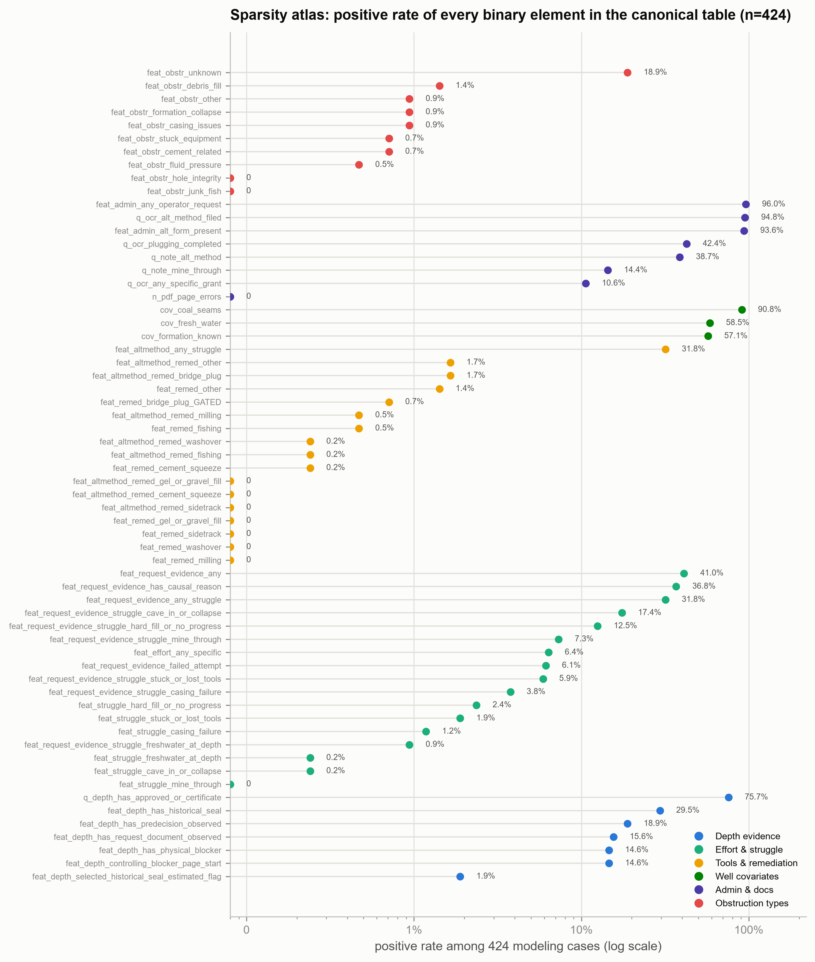
Figure C1. Sparsity atlas: positive rate of the 62 binary elements of the canonical table among the 424 modeling cases (logarithmic axis; color indicates semantic group). Administrative and well-attribute flags are near-saturated; request-narrative evidence occupies the middle range (roughly 30 to 41 percent); and work-record-level struggle, remediation, and obstruction detail flags lie almost entirely below 2.5 percent, with eight columns identically zero.
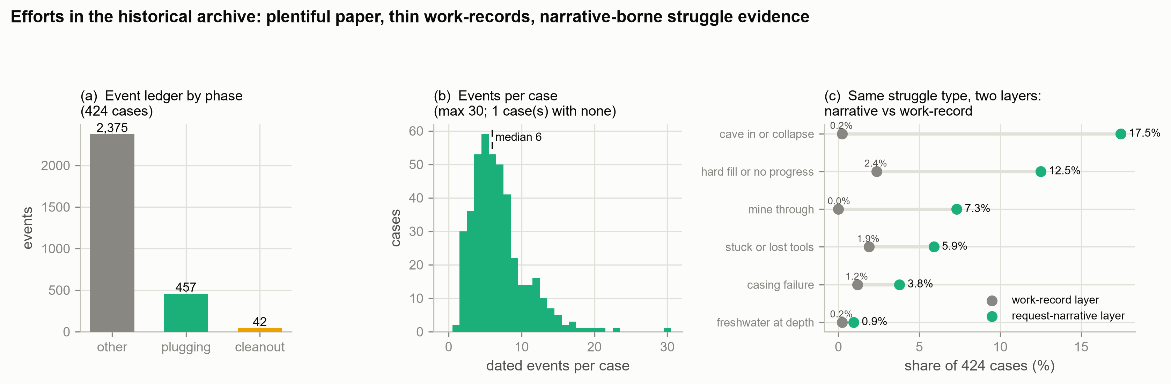
Figure C2. Efforts in the historical archive (424 modeling cases; 2,874 dated events). (a) Event ledger by phase: 2,375 of 2,874 events are typed only as “other.” (b) Dated events per case: median 6, maximum 30, and only one case lacks any dated event. (c) The same six struggle types on two documentation layers: request-narrative rates versus work-record rates — cave-in appears in 17.5 percent of cases at the narrative layer but only 0.2 percent at the work-record layer (≈74×). Struggle evidence, when present, resides almost entirely in application narratives rather than dated work records.
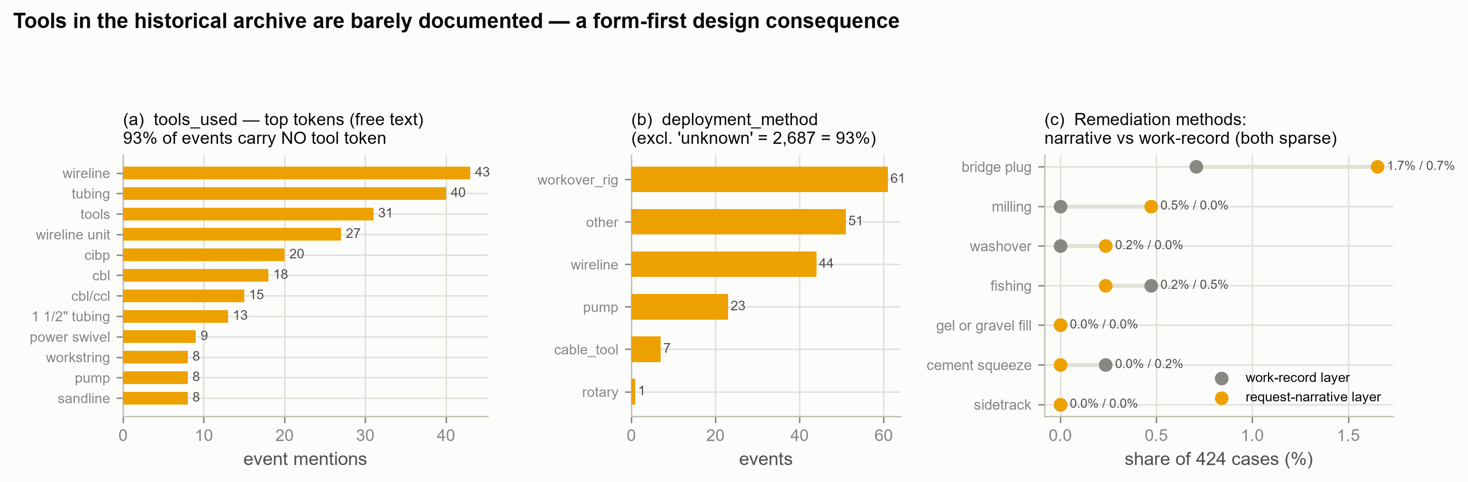
Figure C3. Tools in the historical archive (2,874 events, 424 cases). (a) Top free-text tool tokens; 93 percent of events carry no tool token at all. (b) Deployment method after excluding the approximately 93 percent recorded as unknown. (c) Seven remediation methods on both documentation layers, sparse everywhere (narrative-layer maximum 1.7 percent). Features that depend on tool or method usage are therefore not trainable from this archive, which is why they are excluded from the deployed models and instead collected prospectively through the structured intake form.
The candidate vocabularies are not current inputs to Model A or Model B. They should not be used to fill historical unknown values, count effort, infer objective difficulty, or trigger an adverse route. Their immediate value is structured prospective intake, reviewer retrieval, descriptive analysis, and error audit. Figure C4 records the current alignment between the historical extraction vocabularies and the production intake vocabularies, including the currently unmapped event-type dimension.
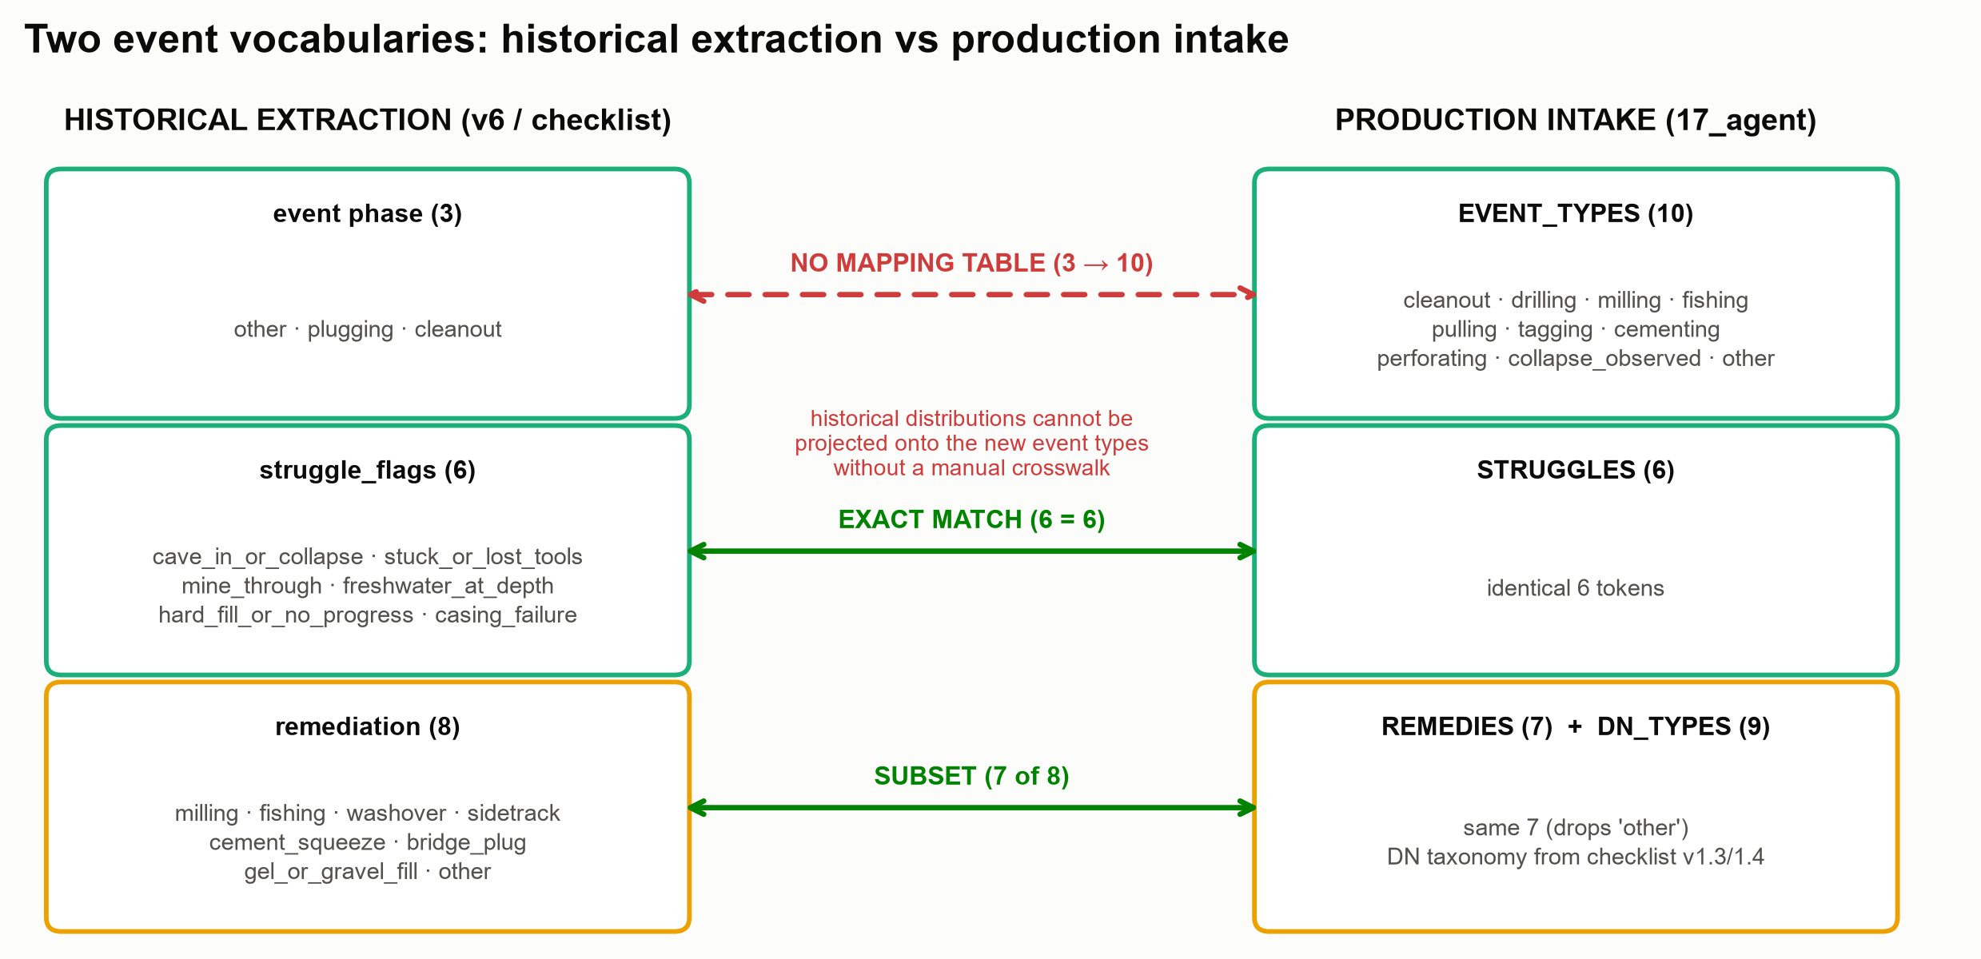
Figure C4. Alignment between the historical extraction vocabularies and the production intake vocabularies. The six struggle terms match token-for-token, and the production remedy list is a subset of the historical remediation vocabulary. However, no crosswalk yet exists between the ten production event types and the three historical event phases, so historical event-type distributions cannot be projected onto prospective intake data until such a mapping is built and validated.

Appendix C.2 Proposed Attempt Event Schema
Table C1. Proposed source-linked attempt-event schema
Field | Prospective decision trace purpose
attempt_id | Unique identifier for a specific attempt.
campaign and event_date | Separates current work, historical events, and request timing.
objective | States what the attempt was intended to accomplish.
deployment_method_raw and deployment_method_canonical | Preserves original language and a controlled mapping.
tools_raw and tools_canonical | Preserves source terms and normalized multiple choice values.
obstruction_parent and obstruction_detail | Uses a multiple label parent ontology while retaining detailed observed conditions.
attempted_depth_ft | Records the intended attempt depth with a track tag.
max_reached_ft | Records the achieved or tagged depth with a track tag.
obstruction_ft | Records the observed obstruction depth with a track tag.
result | Records succeeded, partial, failed, or unknown.
failure_reason | Stores a substantive causal narrative rather than a template checkbox.
source_file, page, and quote | Provides replayable evidence.
reviewer_acceptance | Records acceptance, correction, or rejection by a qualified reviewer.
missingness_state | Separates unknown, not documented, not applicable, and extraction failure.

Appendix C.3 Validation Sequence Before Model Use
1. Freeze the ontology and crosswalk, including parent classes, detail terms, synonyms, unknown, other, and multiple label rules.
2. Conduct blinded dual coding on a source stratified sample and measure agreement for presence calls and specific values.
3. Require every positive value to return to a file, page, and quotation or visual state. Do not infer request-time features from certificates or final outcomes.
4. Audit the missingness mechanism and distinguish not observed, not documented, not extracted, and not applicable.
5. Test coverage and drift across county, operator, time, document template, and source type.
6. Only after the ontology is frozen should incremental models be compared with the existing models under the same grouped and external validation design, including calibration, queue utility, and subgroup errors.
7. Conduct a prospective human and AI study of reviewer time, field acceptance, correction rate, and routing risk rather than relying only on AUC or Spearman correlation.
Before the first five steps are complete, the vocabularies may support collection, search, audit, and descriptive analysis. Before the final two steps are complete, they should not receive automatic routing or approval authority.

