Yun Chang

11/20/2016

Pset 4 Write Up

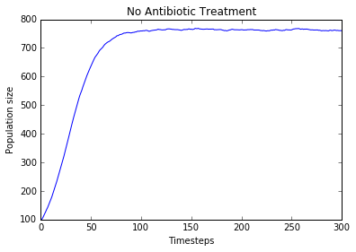Problem 2:

Simulation A:

At time-step 299, 95% confidence interval for bacteria population: 761.48 +/-5.122238665583633

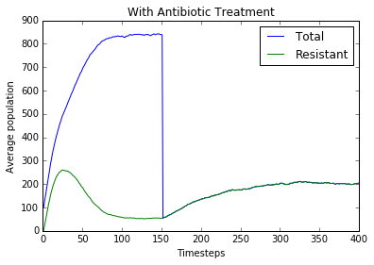Simulation A:

At time-step 299, 95% confidence interval for both the total and resistant bacteria population: 201.66+/-9.113913169478847

Before introducing the antibiotic, the total bacteria population is similar as that of problem 2, the case of no antibiotic or resistance, population increases towards the equilibrium (where the probability of producing an offspring equals to the probability of dying), and staying at the equilibrium.

Before introduction of the antibiotic, the amount of resistive bacteria increases then decreases because probability of mutation is lower when the population density increases and also because resistant bacteria is more likely to die. Eventually the amount of resistive bacteria also reaches a stable point where the total population is at equilibrium.

After introducing the antibiotic, the total bacteria population drops dramatically. All the bacteria cells without resistant are killed so total population drops down to the resistant population. The total/resistant population eventually increases to its equilibrium point (probability of producing an offspring equals the probability of death).

After introducing the antibiotic, the resistant bacteria population rises to reach new equilibrium. There are no more cells without resistance, so there are no more mutation happening. Stays at equilibrium population level where there is equal death and birth rate.

Simulation B:

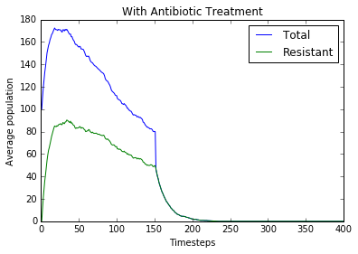

At time-step 299, 95% confidence interval for both the total and resistant bacteria population: 0+/-0

Before applying antibiotic, the total bacteria population grows because of the low population density giving a higher probability of reproduction. Population grows just a little before starting to decrease due to the higher population density decreasing the probability of reproduction, and also because of the high probability of mutation causing more resistive cells, which has a higher probability of death.

Before using the antibiotic, the resistant population grows then decreases, decreases slower than total population due to the high mutation probability, but decreases since overall population is decreasing due to the low birth rate.

After including antibiotic, the total bacteria population decreases to 0. This is due to the killing of the regular cells means that the whole population is resistive bacteria, and the death rate of resistive bacteria is higher than the birth rate, so the population decreases to 0.

After including antibiotic, the resistive bacteria population decreases to 0. Resistive bacteria makes up the whole population after applying antibiotic, so there are no more mutation happening to create more resistive bacteria; the whole system is dependent on birth rate/ death rate of the bacteria. The death rate is higher than the reproduction rate even when the population density is zero, so the bacteria population crashes and extinguishes.

**The difference between A and B** is in the birth rate. For A it is possible to reach equilibrium for a certain population density; however, for B, since birth_prob is less than death_prob, it is physically impossible for resistive bacteria population to reach equilibrium since it will only crash. It could be possible to reach an equilibrium if there were only non-resistive bacteria, but the mutation probability is quite high and the resistive bacteria has a higher death_prob than the birth_prob.