Pulan Yu

2/24/2020

## Part 1 Simulation

In this section, the exponential distribution in R will be investigated and compared with the Central Limit Theorem.

The exponential distribution will be simulated in R with rexp(n, lambda) where lambda is the rate parameter. The mean of exponential distribution is 1/lambda and the standard deviation is also 1/lambda. lambda was set to be 0.2 for all of the simulations.

The following shows a thousand simulation with R

lambda = 0.2  
 n = 1000  
 hist(rexp(n,lambda))

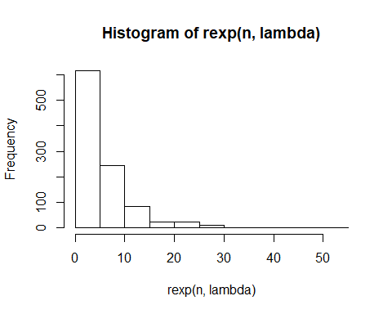

The distribution of averages of 40 exponentials can be ploted by

mns <- NULL  
 for (i in 1:1000){  
 mns <- c(mns,mean(rexp(40,lambda)))  
 }  
 mn <- mean(mns)  
 sd <- sd(mns)  
   
 hist(mns,freq = FALSE)  
 curve(dnorm(x,mean=mn,sd=sd),col="darkblue", lwd=2, add=TRUE)  
 abline(v = mn, col="blue", lwd=3)  
 text(mn+0.3,0.05,"mean")  
 abline(v = mn-sd, col="red", lwd=3)  
 text(mn-sd,0.5,"mean-sd")  
 abline(v = mn+sd, col="red", lwd=3)  
 text(mn+sd,0.5,"mean+sd")

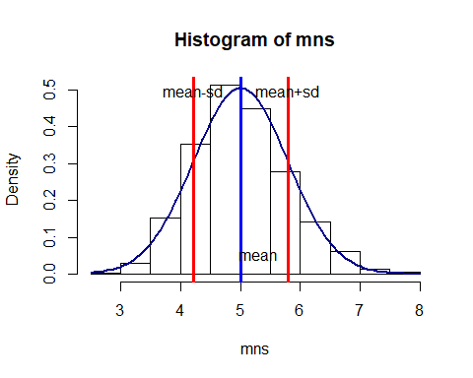

The theoretical mean is 1/lambda which is 5, and the sample mean is

mean(mns)

## [1] 5.006644

which is the thick blue bar in the above figure.

The theoretical standard deviation is also 1/lambda which is 5, so the theoretical variance is 25. The sample variance and standard deviation are

var(mns)

## [1] 0.6220034

sd(mns)

## [1] 0.7886719

respectively.

The standard deviation is showed in two red lines with the left being mean-sd and right being mean+sd.

The distribution is closely to a Gaussian distribution which can be seen from the figure since the histogram overlay with the gaussion distribution well.