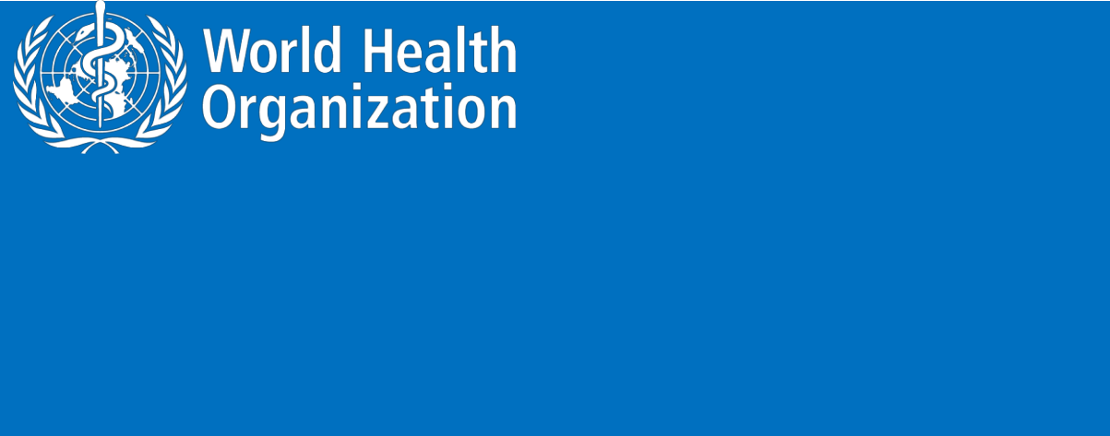**ZIKA VIRUS**

**Novel Coronavirus (2019-nCoV)**

**SITUATION REPORT - 4**

**24 JANUARY 2020**

**Data as reported by: 24 January 20201**

**SUMMARY**

**Situation update:**

* A total of 846 confirmed cases have been reported for novel coronavirus (2019-nCoV) globally;
* Of the 846 cases reported, 830 cases were reported from China;
* Eleven confirmed cases have been reported outside of China in six countries (see table-1),
* Of these 11 confirmed cases, 10 had travel history to Wuhan;
* One confirmed case in Vietnam had no travel history to any part of China but was a family member of a confirmed case who visited Wuhan. This suggests an instance of human to human transmission that occurred in Vietnam.
* Of the 830 confirmed cases in China, 375 cases were confirmed from Hubei Province;
* Of the 830 cases, 177 cases have been reported as severely ill2 ;
* Twenty-five deaths have been reported to date
* On 24 January 2020, the number of reported confirmed cases of 2019-nCoV has increased by 265 cases since the last situation report published on 23 January 2020, including China which reported additional 259 confirmed cases.

New epidemiological information reinforces the evidence that the 2019-nCoV can be transmitted from one individual to another. During previous outbreaks due to other coronavirus (Middle-East Respiratory Syndrome (MERS) and the Severe Acute Respiratory Syndrome (SARS)), human to human transmission occurred through droplets, contact and fomites, suggesting that the transmission mode of the 2019-nCoV can be similar. The strategic objectives of the response are to interrupt the transmission of the virus from one person to another in China, to prevent exportation of cases from China to other countries and territories, and to prevent further transmission from exported case if they were to happen. This can be achieved through a combination of public health measures, such as rapid identification, diagnosis and management of the cases, identification and follow up of the contacts, infection prevention and control in healthcare settings, implementation of health measures for travellers, awareness raising in the population, risk communication. WHO

1. The situation report includes information reported to WHO Geneva by 10 AM CET
2. Severe illness: According to any of the following criteria:
3. dyspnea; (2) respiratory rate more than 30 bpm; (3) hypoxemia; (4) chest X-ray with multi-lobar infiltrates or pulmonary infiltration progressed more than 50% within 24 - 48 hours.

1

continuously updates guidance and works closely with Member States to implement these measures.

On 22 and 23 January, WHO Director-General convened an Emergency Committee under the International Health Regulations (IHR) (2005) regarding the outbreak of novel coronavirus (2019-nCoV). The details are available [here.](https://www.who.int/news-room/detail/23-01-2020-statement-on-the-meeting-of-the-international-health-regulations-(2005)-emergency-committee-regarding-the-outbreak-of-novel-coronavirus-(2019-ncov))

WHO assesses the risk of this event to be very high in China, high at the regional level and high at the global level.3

**Figure 1. Countries, territories or areas with reported confirmed cases of 2019-nCoV, 24 January 2020**

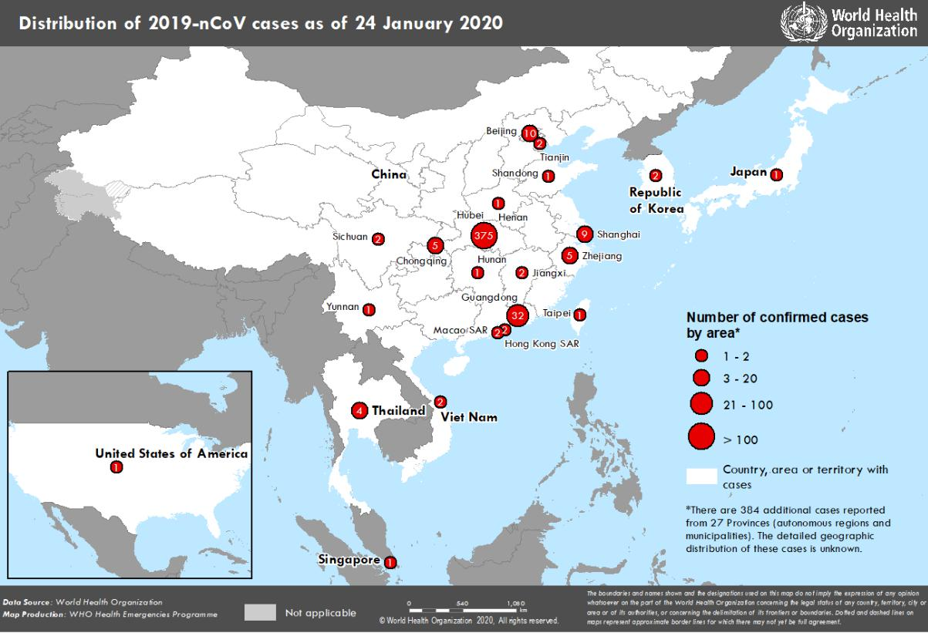

1. Note: Error in situation reports published on 23,24 and 25 January as originally published, which incorrectly summarized the risk for global level to be moderate.

2

**I. SURVEILLANCE**

**Reported incidence of confirmed 2019-nCoV cases**

**Table 1. Countries, territories or areas with reported confirmed cases of 2019-nCoV, 24 January 2020**

|  |  |  |  |  |  |  |  |  |
| --- | --- | --- | --- | --- | --- | --- | --- | --- |
| **WHO Regional Office** |  | **Country/Territory/Area** |  |  |  | **Confirmed** |  |  |
|  |  |  |  | **Cases** |  |  |
|  |  |  |  |  |  |  |  |
|  |  |  |  |  |  |  |  |  |
|  |  |  |  |  |  | |  |  |
|  |  | **China** |  | **Total** |  | **830\*** |  |  |
|  |  |  |  |  |  |  |  |  |
|  |  |  |  |  |  | |  |  |
|  |  |  |  | Unspecified4 |  | 384 |  |  |
|  |  |  |  |  |  | |  |  |
|  |  |  |  | Hubei Province |  | 375 |  |  |
|  |  |  |  |  |  |  |  |  |
|  |  |  |  |  |  | |  |  |
|  |  |  |  | Guangdong Province |  | 32 |  |  |
|  |  |  |  |  |  |  |  |  |
|  |  |  |  |  |  | |  |  |
|  |  |  |  | Beijing Municipality |  | 10 |  |  |
|  |  |  |  |  |  |  |  |  |
|  |  |  |  |  |  | |  |  |
|  |  |  |  | Shanghai Municipality |  | 9 |  |  |
|  |  |  |  |  |  |  |  |  |
|  |  |  |  |  |  | |  |  |
|  |  |  |  | Chongqing Municipality |  | 5 |  |  |
|  |  |  |  |  |  |  |  |  |
|  |  |  |  |  |  | |  |  |
|  |  |  |  | Zhejiang Province |  | 5 |  |  |
|  |  |  |  |  |  |  |  |  |
|  |  |  |  |  |  | |  |  |
|  |  |  |  | Jiangxi Province |  | 2 |  |  |
|  |  |  |  |  |  |  |  |  |
|  |  |  |  |  |  | |  |  |
|  |  |  |  | Sichuan Province |  | 2 |  |  |
|  |  |  |  |  |  |  |  |  |
|  |  |  |  |  |  | |  |  |
|  |  |  |  | Tianjin Municipality |  | 2 |  |  |
| **WHO WPRO Region** |  |  |  |  |  |  |  |  |
|  |  |  |  |  |  |  |  |
|  |  |  | Henan Province |  | 1 |  |  |
|  |  |  |  |  |  |  |
|  |  |  |  |  |  |  |  |  |
|  |  |  |  |  |  | |  |  |
|  |  |  |  | Hunan Province |  | 1 |  |  |
|  |  |  |  |  |  |  |  |  |
|  |  |  |  |  |  | |  |  |
|  |  |  |  | Shandong Province |  | 1 |  |  |
|  |  |  |  |  |  |  |  |  |
|  |  |  |  |  |  | |  |  |
|  |  |  |  | Yunnan Province |  | 1 |  |  |
|  |  |  |  |  |  |  |  |  |
|  |  |  |  |  |  | |  |  |
|  |  |  |  | Taipei Municipality |  | 1 |  |  |
|  |  |  |  |  |  |  |  |  |
|  |  |  |  |  |  |  |  |  |
|  |  |  |  | Hong Kong Special Administrative |  | 2 |  |  |
|  |  |  |  | Region |  |  |  |
|  |  |  |  |  |  |  |  |
|  |  |  |  |  |  |  |  |  |
|  |  |  |  |  |  | |  |  |
|  |  |  |  | Macau Special Administrative Region |  | 2 |  |  |
|  |  |  |  |  |  |  |  |  |
|  |  |  |  |  |  | |  |  |
|  |  | Japan |  |  |  | 1 |  |  |
|  |  |  |  |  |  |  |  |  |
|  |  |  |  |  |  | |  |  |
|  |  | Republic of Korea |  |  |  | 2 |  |  |
|  |  |  |  |  |  |  |  |  |
|  |  |  |  |  |  | |  |  |
|  |  | Viet Nam |  |  |  | 2 |  |  |
|  |  |  |  |  |  |  |  |  |
|  |  |  |  |  |  | |  |  |
|  |  | Republic of Singapore |  |  |  | 1 |  |  |
|  |  |  |  |  |  |  |  |  |
|  |  |  |  |  |  | |  |  |
| **WHO SEARO Region** |  | Thailand |  |  |  | 4 |  |  |
|  |  |  |  |  |  |  |  |  |
|  |  |  |  |  |  | |  |  |
| **WHO AMRO Region** |  | United States of America |  |  |  | 1 |  |  |
|  |  |  |  |  |  |  |  |  |
|  |  |  |  |  |  | |  |  |
| **Total Confirmed cases** |  | Total |  |  |  | 846 |  |  |
|  |  |  |  |  |  |  |  |  |

1. These cases are reported from 27 Chinese provinces, regions and cities in addition to unspecified cases mentioned in the situation report published on 23 January 2020. The distribution of these cases as per provinces, regions and cities is unknown.

3

**II. PREPAREDNESS AND RESPONSE:**

**WHO:**

* + WHO has published an [updated advice for international traffic in relation to the outbreak of](https://www.who.int/ith/2020-24-01-outbreak-of-Pneumonia-caused-by-new-coronavirus/en/) [the novel coronavirus 2019-nCoV;](https://www.who.int/ith/2020-24-01-outbreak-of-Pneumonia-caused-by-new-coronavirus/en/)
  + WHO has been in regular and direct contact with Chinese as well as Japanese, Korean and Thai authorities since the reporting of these cases. The three countries have shared information with WHO under the International Health Regulations. WHO is also informing other countries about the situation and providing support as requested;
  + On 2 January, the incident management system was activated across the three levels of WHO (country office, regional office and headquarters);
  + Developed the surveillance case definitions for human infection with 2019-nCoV and is updating it as the new information becomes available;
  + Developed interim guidance for laboratory diagnosis, clinical management, infection prevention and control in health care settings, home care for mild patients, risk communication and community engagement;
  + Prepared disease commodity package for supplies necessary in identification and management of confirmed patients;
  + Provided recommendations to reduce risk of transmission from animals to humans;
  + Utilizing global expert networks and partnerships for laboratory, infection prevention and control, clinical management and mathematical modelling;
  + Activation of R&D blueprint to accelerate diagnostics, vaccines, and therapeutics;
  + WHO is working with our networks of researchers and other experts to coordinate global work on surveillance, epidemiology, modelling, diagnostics, clinical care and treatment, and other ways to identify, manage the disease and limit onward transmission. WHO has issued interim guidance for countries, updated to take into account the current situation.

1. **COUNTRY RESPONSE:**

**China:**

* National authorities are conducting active case finding in all provinces;
* Search expanded for additional cases within and outside of Wuhan City;
* Active / retroactive case finding in medical institutions in Wuhan City;
* The Huanan Seafood Wholesale Market in Wuhan city was closed on 1 January 2020 for environmental sanitation and disinfection. Market inspection in expansion to other markets;
* Public education on disease prevention and environmental hygiene further strengthened in public places across the city, farmers’ markets in particular. As of 23 January, the National Health Commission revised protection standards and specifications for medical workers and strengthened prevention and control measures against 2019-nCoV in hospitals.

4

**Japan:**

* In addition to public health response measures mentioned in situation report published on 23 January, a request was sent to airlines and other relevant companies to expand measures such as in-flight announcements and distribution of health cards on fights and cruise ships originating from China (the distribution of health cards will begin on 24 January).

**Republic of Singapore:**

* The government of the Singapore has scaled up the national “Disease Outbreak Response System Condition” (DORSCON) alert level from green to yellow (Level 2 out of 4-level national crisis management system) on 21 January 2020;
* The Singapore health authority has strengthened surveillance for pneumonia cases in health facilities nationwide since 3 January 2020. Medical circulars had been disseminated to all registered medical practitioners informing them of the suspect case definitions, to notify the health authorities and isolate any suspect cases, and information on the first confirmed case;
* Border screening measures have been implemented for flights arriving from Wuhan at the international airport since 3 January 2020. Border health measures were further enhanced on 22 January 2020 with the expansion of temperature screening measures to screen all flights from China. Health advisory notices and posters have been issued and put up as well;
* Intensified border screening expanded to land and sea checkpoints;
* Public risk communication had been enhanced including the emphasis on social responsibility and personal hygiene practices;
* Contact tracing and other epidemiological investigations are underway.

**Viet Nam:**

* On 24 January, the Viet Nam Ministry of Health held the National Steering Committee followed by a press conference to inform the public of the two confirmed cases;
* Activated Public Health Emergency Operating Centres (PHEOC) to coordinate all information and direction to control the outbreak
* Strengthening disease screening in the point of entry and applying health declaration form for all passengers from China going through the international point of entries;
* Enhancing surveillance in the health care facilities and community;
* Strictly applying infection prevention and control measures at health care facilities and ensure supporting necessary personal protective equipment to prepare for a potential increase in demand;
* Strengthening risk communication activities and providing information on measures for prevention and control of 2019-nCoV;

**Hong Kong Special Administrative Region:**

5

* The Health Authority had enhanced laboratory surveillance for pneumonia cases to have early identification of severe community-acquired pneumonia associated with novel coronavirus.
* The Centre for Health Protection (CHP) of the Department of Health (DH) has enhanced surveillance of suspected cases and revised the reporting criteria of Severe Respiratory Disease associated with a Novel Infectious Agent.
* CHP has also set up a hotline (2125 1122) for the suspected and confirmed cases. The hotline operates daily from 8am to 9pm including public holidays. Persons who are regarded as close contacts and other contacts of the cases concerned should call the hotline.

**Macau Special Administrative Region:**

* The Health Bureau has launched a program to provide masks to Macao residents. Citizens can register with 56 negotiated pharmacies in Macau with permanent / non-permanent resident ID cards or identification cards for foreign employees.
* Each port of entry has begun to implement health declaration measures, which are set up in paper or electronic form.



**Resources:**

* Technical interim guidance for novel coronavirus, WHO: <https://www.who.int/health-topics/coronavirus>
* WHO travel advice for international travel and trade in relation to the outbreak of pneumonia caused by a new coronavirus in China:
* [https://www.who.int/ith/2020-](https://www.who.int/ith/2020-0901_outbreak_of_Pneumonia_caused_by_a_new_coronavirus_in_C/en/)

[0901_outbreak_of_Pneumonia_caused_by_a_new_coronavirus_in_](https://www.who.int/ith/2020-0901_outbreak_of_Pneumonia_caused_by_a_new_coronavirus_in_C/en/)C/en/Press statement by KCDC (in Korean): <https://www.cdc.go.kr/board/board.es?mid=a20501000000&bid=0015&list_no=365794&act=view>

[#](https://www.cdc.go.kr/board/board.es?mid=a20501000000&bid=0015&list_no=365794&act=view)

* Second Press statement by KCDC (in Korean): <https://www.cdc.go.kr/board/board.es?mid=a20501000000&bid=0015&list_no=365805&act=view>

[#](https://www.cdc.go.kr/board/board.es?mid=a20501000000&bid=0015&list_no=365805&act=view)

* Wuhan Municipal Health Commission's briefing on the pneumonia epidemic situation, (in Chinese):

<http://wjw.wuhan.gov.cn/front/web/list2nd/no/710>

* Disease outbreak news, Novel Coronavirus: <https://www.who.int/csr/don/en/>
* Thailand Ministry of Public Health situation update on novel coronavirus (in Thai): <https://ddc.moph.go.th/viralpneumonia/index.html>
* Press statement by Ministry of Health, Labour and Welfare, Japan on 16 January 2020 (in Japanese): <https://www.mhlw.go.jp/stf/newpage_08906.html>
* Press statement by Ministry of Health, Labour and Welfare, Japan on 6 January 2020 (in Japanese): <https://www.mhlw.go.jp/stf/newpage_08767.html>
* Notice sent out from Health and Food Safety Planning Division, Quarantine Station Operation Management Office (in Japanese):

<https://www.mhlw.go.jp/content/10900000/000582967.pdf>

* Situation report by WHO on Novel Coronavirus (2019-nCoV) <https://www.who.int/emergencies/diseases/novel-coronavirus-2019>
* Hong Kong SAR Department of Health, Press Release <https://www.info.gov.hk/gia/general/202001/23/P2020012300970.htm>

6



* Epidemic Prevention Measures, Macau SAR Health Bureau <https://www.ssm.gov.mo/apps1/PreventWuhanInfection/ch.aspx#clg17048>
* Press release on 23 January 2020, Ministry of Health Singapore. <https://www.moh.gov.sg/news-highlights/details/confirmed-imported-case-of-novel-coronavirus-infection-in-singapore-multi-ministry-taskforce-ramps-up-precautionary-measures>

7