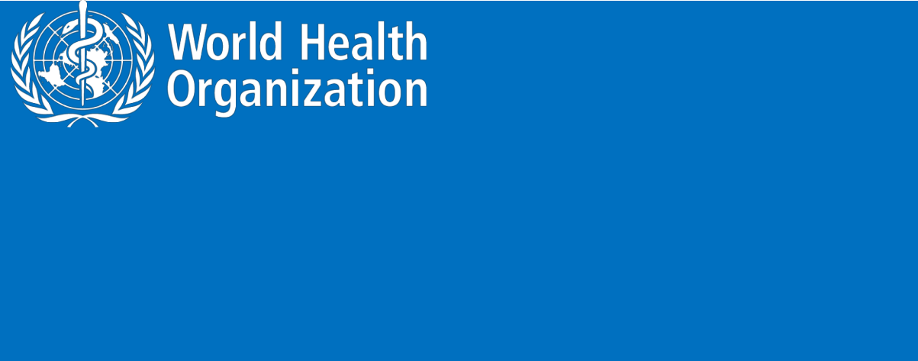**ZIKA VIRUS**

**Novel Coronavirus (2019-nCoV)**

**SITUATION REPORT - 6**

**26 JANUARY 2020**

**Data as reported by: 26 January 20201**

**SUMMARY**

**Situation update:**

* On 26 January 2020, the number of reported confirmed cases of novel coronavirus (2019-nCoV) has increased by 694 cases since the last situation report published yesterday.
* A total of 2,014 confirmed 2019-nCoV cases have been reported globally;
* Of the 2,014 cases reported, 1,985 cases were reported from China, including Hong Kong SAR (5 confirmed cases), Macau SAR (2 confirmed cases) and Taipei (3 confirmed cases).
* Twenty-nine confirmed cases have been reported outside of China in ten countries (see table-1).
  + Of these 29 exported cases, 26 had a travel history from Wuhan City, China.
* Among the three cases identified in countries outside of China:
  + One case in Australia had direct contact with a confirmed case from Wuhan while in China;
  + One case in Australia reported today; travel history is not yet known.
  + One case in Viet Nam had no travel history but was in contact with a confirmed case (his father with travel history to Wuhan), resulting from human to human transmission within a family.
* Of the 1,975 confirmed cases (excluding Hong Kong SAR, Macau SAR and Taipei), 324 cases have been reported as severely ill2 .
* Fifty-six deaths have been reported to date (52 deaths in Hubei province and 4 from outside Hubei).

WHO’s assessment of the risk of this event has not changed since the last risk assessment conducted on 22 January: very high in China, high at the regional level and high at the global level.3

1. The situation report includes information reported to WHO Geneva by 10 AM CET
2. Severe illness: According to any of the following criteria:

(1) shortness of breath; (2) respiratory rate more than 30 bpm; (3) hypoxemia; (4) chest X-ray with multi-lobar infiltrates or pulmonary infiltration progressed more than 50% within 24 - 48 hours.

3 Note: Error in situation reports published on 23,24 and 25 January as originally published, which incorrectly summarized the risk for global level to be moderate.

1

**Figure 1. Countries, territories or areas with reported confirmed cases of 2019-nCoV, 26 January 2020**

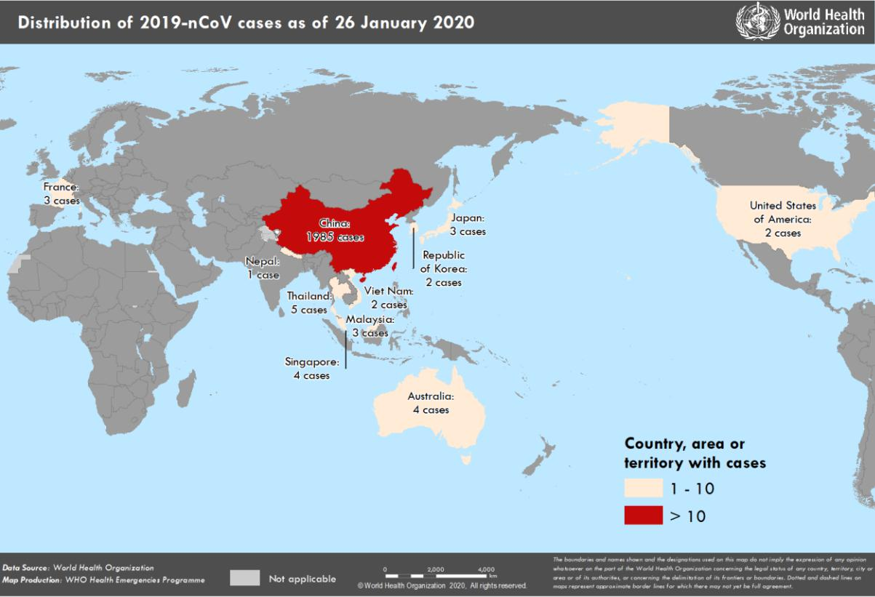

2

**I. SURVEILLANCE**

Limiting international spread of 2019-nCoV depends on understanding the global epidemiology. Key questions that global surveillance must answer include the following:

* How fast is 2019-nCoV spreading from China to other countries?
* Where are cases exported from and to?
* What types of exposures are reported by travellers originating in Wuhan or in other provinces in China reporting cases and human to human transmission?
* Are individuals symptomatic before travel and potentially detectable through exit or entry screening?
* Is there person-to-person transmission occurring in countries reporting imported cases?
* What is the clinical presentation of illness among travellers?

WHO requests countries to notify WHO of cases following the guidance included in <https://www.who.int/publications-detail/global-surveillance-for-human-infection-with-novel-coronavirus-(2019-ncov)>

**Reported incidence of confirmed 2019-nCoV cases**

**Table 1. Countries, territories or areas with reported confirmed cases of 2019-nCoV, 26 January 2020**

|  |  |  |  |  |  |  |
| --- | --- | --- | --- | --- | --- | --- |
| **WHO Regional Office** |  | **Country/Territory/Area** |  | **Confirmed Cases** |  |  |
|  |  |  |  |
|  |  |  |  |  |  |  |
|  |  |  |  | |  |  |
|  |  | **China**\* |  | **1,985** |  |  |
|  |  |  |  |  |  |  |
|  |  |  |  | |  |  |
|  |  | Japan |  | 3 |  |  |
|  |  |  |  |  |
|  |  |  |  |  |  |  |
|  |  |  |  | |  |  |
|  |  | Republic of Korea |  | 2 |  |  |
|  |  |  |  |  |
|  |  |  |  |  |  |  |
|  |  |  |  |  |  |  |
| **Western Pacific** |  | Viet Nam |  | 2 |  |  |
|  |  |  |  |
|  |  |  |  |  |  |  |
|  |  |  |  | |  |  |
|  |  | Singapore |  | 4 |  |  |
|  |  |  |  |  |
|  |  |  |  |  |  |  |
|  |  |  |  | |  |  |
|  |  | Australia |  | 4 |  |  |
|  |  |  |  |  |
|  |  |  |  |  |  |  |
|  |  |  |  | |  |  |
|  |  | Malaysia |  | 3 |  |  |
|  |  |  |  |  |
|  |  |  |  |  |  |  |
|  |  |  |  | |  |  |
|  |  | Thailand |  | 5 |  |  |
| **South-East Asia** |  |  |  |  |  |  |
|  |  |  |  |  |  |
|  |  | Nepal |  | 1 |  |  |
|  |  |  |  |  |  |  |
|  |  |  |  | |  |  |
| **Region of the Americas** |  | United States of America |  | 2 |  |  |
|  |  |  |  |
|  |  |  |  |  |  |  |
|  |  |  |  | |  |  |
| **European Region** |  | France |  | 3 |  |  |
|  |  |  |  |
|  |  |  |  |  |  |  |
|  |  |  |  | |  |  |
| **Total Confirmed cases** |  | Total |  | 2,014 |  |  |
|  |  |  |  |
|  |  |  |  |  |  |  |

*Confirmed cases in China include cases confirmed in Hong Kong SAR (5 confirmed cases), Macau SAR (2 confirmed cases) and Taipei (3 confirmed cases).

3

**Figure 2: Epidemic curve by date of onset of 2019-nCoV cases identified outside of China, 26 January 2020**

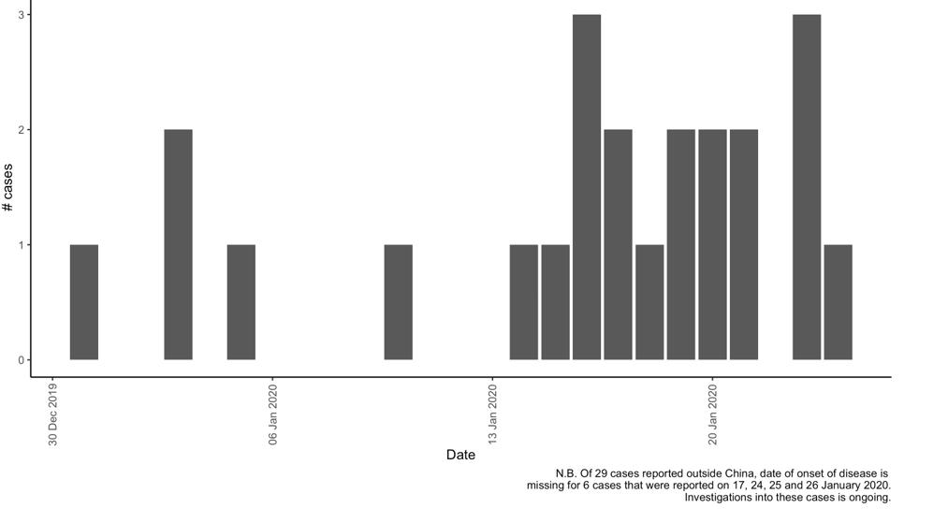

4

**II. PREPAREDNESS AND RESPONSE:**

**WHO:**

* WHO has been in regular and direct contact with Member States where cases have been reported. WHO is also informing other countries about the situation and providing support as requested.
* Developed the [surveillance case definitions and reporting forms for human infection with 2019-nCoV](https://www.who.int/publications-detail/global-surveillance-for-human-infection-with-novel-coronavirus-(2019-ncov)) and is updating it as the new information becomes available.
* Developed interim guidance for [laboratory diagnosis,](https://www.who.int/health-topics/coronavirus/laboratory-diagnostics-for-novel-coronavirus) [clinical management](https://www.who.int/internal-publications-detail/clinical-management-of-severe-acute-respiratory-infection-when-novel-coronavirus-(ncov)-infection-is-suspected)[, infection prevention](https://www.who.int/publications-detail/infection-prevention-and-control-during-health-care-when-novel-coronavirus-(ncov)-infection-is-suspected) [and control in health care settings,](https://www.who.int/publications-detail/infection-prevention-and-control-during-health-care-when-novel-coronavirus-(ncov)-infection-is-suspected) [home care for patients with suspected novel coronavirus](https://www.who.int/internal-publications-detail/home-care-for-patients-with-suspected-novel-coronavirus-(nCoV)-infection-presenting-with-mild-symptoms-and-management-of-contacts) , [risk communication and community engagement.](https://www.who.int/publications-detail/risk-communication-and-community-engagement-readiness-and-initial-response-for-novel-coronaviruses-(-ncov))
* Prepared [disease commodity package](https://www.who.int/internal-publications-detail/disease-commodity-package---novel-coronavirus-(ncov)) for supplies necessary in identification and management of confirmed patients.
* Provided recommendations to reduce risk of [transmission from animals to humans.](https://www.who.int/health-topics/coronavirus/who-recommendations-to-reduce-risk-of-transmission-of-emerging-pathogens-from-animals-to-humans-in-live-animal-markets)
* WHO has published an [updated advice for international traffic in relation to the outbreak of the](https://www.who.int/ith/2020-24-01-outbreak-of-Pneumonia-caused-by-new-coronavirus/en/) [novel coronavirus 2019-nCoV.](https://www.who.int/ith/2020-24-01-outbreak-of-Pneumonia-caused-by-new-coronavirus/en/)
* Activation of R&D blueprint to accelerate diagnostics, vaccines, and therapeutics.
* WHO is providing guidance on [early investigations.](https://www.who.int/emergencies/diseases/novel-coronavirus-2019/early-investigations/) The first protocol that is available is a: [Household transmission investigation protocol for 2019-novel coronavirus (2019-nCoV)](https://www.who.int/emergencies/diseases/novel-coronavirus-2019/early-investigations/) [infection.](https://www.who.int/emergencies/diseases/novel-coronavirus-2019/early-investigations/)
* WHO has developed an [online course](https://openwho.org/courses/introduction-to-ncov) to provide general introduction to emerging respiratory viruses, including novel coronaviruses.
* WHO is providing guidance on [early investigations,](https://www.who.int/emergencies/diseases/novel-coronavirus-2019/early-investigations/) which are critical to carry out early in an outbreak of a new virus. The data collected from the study protocols can be used to refine recommendations for surveillance and case definitions, to characterize the key epidemiological transmission features of 2019-nCoV, help understand spread, severity, spectrum of disease, impact on the community and to inform operational models for implementation of countermeasures such as case isolation, contact tracing and isolation. The first protocol that is available is a: [Household transmission investigation protocol for 2019-novel coronavirus (2019-nCoV) infection.](https://www.who.int/emergencies/diseases/novel-coronavirus-2019/early-investigations/)
* WHO is working with its networks of researchers and other experts to coordinate global work on surveillance, epidemiology, modelling, diagnostics, clinical care and treatment, and other ways to identify, manage the disease and limit onward transmission. WHO has issued interim guidance for countries, updated to take into account the current situation.
* Utilizing global expert networks and partnerships for laboratory, infection prevention and control, clinical management and mathematical modelling.

WHO is working with networks of specialists to analyze 2019-nCoV full genome sequences as they become available.

WHO has not received evidence that the virus has changed. WHO awaits further information from Chinese officials.

5

Current estimates of the incubation period range from 2-10 days, and these estimates will be refined as more data become available. Understanding the time when infected patients may transmit the virus to others is critical for control efforts. In previous outbreaks of other coronavirus, such as Middle East Respiratory Syndrome coronavirus (MERS-CoV), some individuals can be asymptomatic and transmit to others. Detailed epidemiological information from more people infected is needed to determine the infectious period of 2019-nCoV.

WHO has issued advice to people on how to protect themselves from 2019-nCoV infection, as for any virus that spreads via the respiratory route: <https://www.who.int/emergencies/diseases/novel-coronavirus-2019/advice-for-public>

In addition, it is vitally important in health care settings, that health care workers are able to protect themselves from infection. WHO guidance on infection prevention and control measures in health care facilities is here: <https://www.who.int/publications-detail/infection-prevention-and-control-during-health-care-when-novel-coronavirus-(ncov)-infection-is-suspected>

The strategic objectives of the response are to interrupt the transmission of the virus from one person to another in China, to prevent exportation of cases from China to other countries and territories, and to prevent further transmission from exported case if they were to happen. This can be achieved through a combination of public health measures, such as rapid identification, diagnosis and management of the cases, identification and follow up of the contacts, infection prevention and control in healthcare settings, implementation of health measures for travellers, awareness raising in the population, risk communication.

During previous outbreaks due to other coronavirus (Middle-East Respiratory Syndrome (MERS) and the Severe Acute Respiratory Syndrome (SARS), human to human transmission occurred through droplets, contact and fomites, suggesting that the transmission mode of the 2019-nCoV can be similar. The basic principles to reduce the general risk of transmission of acute respiratory infections include the following:

* Avoiding close contact with people suffering from acute respiratory infections.
* Frequent hand-washing, especially after direct contact with ill people or their environment.
* Avoiding unprotected contact with farm or wild animals.
* People with symptoms of acute respiratory infection should practice cough etiquette (maintain distance, cover coughs and sneezes with disposable tissues or clothing, and wash hands).
* Within healthcare facilities, enhance standard infection prevention and control practices in hospitals, especially in emergency departments.

WHO does not recommend any specific health measures for travellers. In case of symptoms suggestive of respiratory illness either during or after travel, the travellers are encouraged to seek medical attention and share their travel history with their health care provider. [Travel guidance](https://www.who.int/ith/2020-24-01-outbreak-of-Pneumonia-caused-by-new-coronavirus/en/) was 77updated on 24 January.

6

**III. COUNTRY RESPONSE:**

**China:**

* Public education on disease prevention and environmental hygiene further strengthened in public places across the city, farmers’ markets in particular. As of 23 January, the National

Health Commission revised protection standards and specifications for medical workers and strengthened prevention and control measures against 2019-nCoV in hospitals.

* National authorities are conducting active case finding in all provinces.
* Search expanded for additional cases within and outside of Wuhan.
* Active / retroactive case finding in medical institutions in Wuhan.
* The Huanan Seafood Wholesale Market in Wuhan was closed on 1 January 2020 for environmental sanitation and disinfection. Market inspection in expansion to other markets.

7

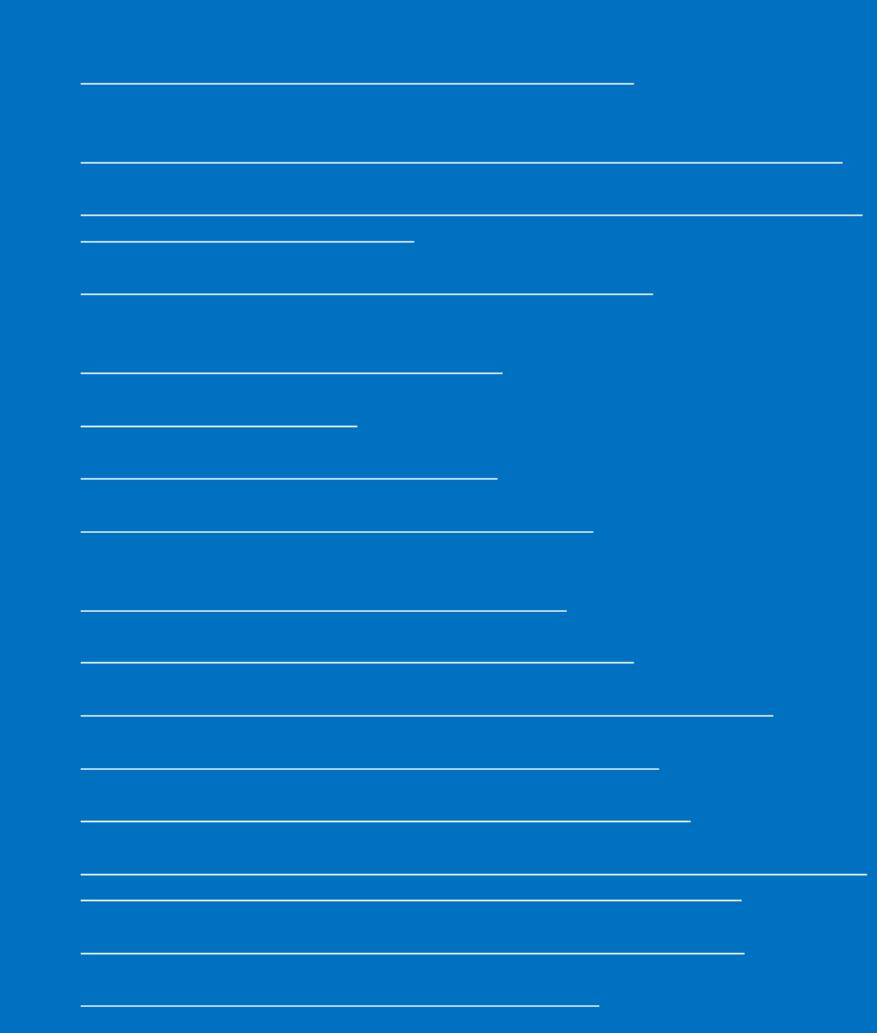

**Resources:**

* Technical interim guidance for novel coronavirus, WHO: <https://www.who.int/emergencies/diseases/novel-coronavirus-2019>
* WHO travel advice for international travel and trade in relation to the outbreak of the novel coronavirus 2019-nCoV <https://www.who.int/ith/2020-24-01-outbreak-of-Pneumonia-caused-by-new-coronavirus/en/>
* WHO: Regional Office for Europe: 2019-nCoV outbreak: first cases confirmed in Europe <http://www.euro.who.int/en/health-topics/emergencies/pages/news/news/2020/01/2019-ncov-outbreak-first-cases-confirmed-in-europe>
* Press statements by KCDC (in Korean): <https://www.cdc.go.kr/board/board.es?mid=a20501000000&bid=0015>
* Wuhan Municipal Health Commission's briefing on the pneumonia epidemic situation, (in Chinese):

<http://wjw.wuhan.gov.cn/front/web/list2nd/no/710>

* Disease outbreak news, Novel Coronavirus: <https://www.who.int/csr/don/en/>
* Thailand Ministry of Public Health situation update on novel coronavirus (in Thai): <https://ddc.moph.go.th/viralpneumonia/index.html>
* Press statement by Ministry of Health, Labour and Welfare, Japan (in Japanese): <https://www.mhlw.go.jp/stf/houdou/houdou_list_202001.html>
* Notice sent out from Health and Food Safety Planning Division, Quarantine Station Operation Management Office (in Japanese): <https://www.mhlw.go.jp/content/10900000/000582967.pdf>
* Situation report by WHO on Novel Coronavirus (2019-nCoV) <https://www.who.int/emergencies/diseases/novel-coronavirus-2019>
* CDC press release. First Travel-related Case of 2019 Novel Coronavirus Detected in United States <https://www.cdc.gov/media/releases/2020/p0121-novel-coronavirus-travel-case.html>
* Hong Kong SAR Department of Health, Press Release <https://www.info.gov.hk/gia/general/202001/23/P2020012300970.htm>
* Epidemic Prevention Measures, Macau SAR Health Bureau <https://www.ssm.gov.mo/apps1/PreventWuhanInfection/ch.aspx#clg17048>
* Press release on 23 January 2020, Ministry of Health Singapore. <https://www.moh.gov.sg/news-highlights/details/confirmed-imported-case-of-novel-coronavirus-infection-in-singapore-multi-ministry-taskforce-ramps-up-precautionary-measures>
* CDC press release. Second Travel-related Case of 2019 Novel Coronavirus Detected in United States <https://www.cdc.gov/media/releases/2020/p0124-second-travel-coronavirus.html>
* New South Wales Government: Health: Coronavirus cases confirmed in NSW <https://www.health.nsw.gov.au/news/Pages/20200125_03.aspx>

8