**Novel Coronavirus(2019-nCoV)**

**Situation Report - 7**

**Data as reported by 27 January 2020\***

**HIGHLIGHTS**

* WHO Director-General Dr Tedros Adhanom Ghebreyesus and colleagues are in Beijing to meet with government and health experts supporting the response.

The mission’s aim is to understand the latest developments and strengthen the partnership with China, in particular for the response.

* Current estimates of the incubation period of the virus range from 2-10 days, and these estimates will be refined as more data become available. Understanding the time when infected patients may transmit the virus to others is critical for control efforts. Detailed epidemiological information from more people infected is needed to determine the infectious period of 2019-nCoV, in particular whether transmission can occur from asymptomatic individuals or during the incubation period.

WHO requests countries to notify WHO of cases following the guidance included in: <https://www.who.int/publications-detail/global-surveillance-for-human-infection-with-novel-coronavirus-(2019-ncov)>

* WHO is continually monitoring developments and on standby to reconvene the Emergency Committee on very short notice as needed. Committee members are regularly informed of developments.

**SITUATION IN NUMBERS**

**Globally**

**2798** confirmed

**China**

**2741** confirmed

**5794** suspected

1. severe
2. deaths

**Outside of China**

1. confirmed

**11** countries

**WHO RISK ASSESSMENT**

**China** **Very High**

**Regional Level** **High**

**Global Level** **High**

**Figure 1. Countries, territories or areas with reported confirmed cases of 2019-nCoV, 27 January 2020**

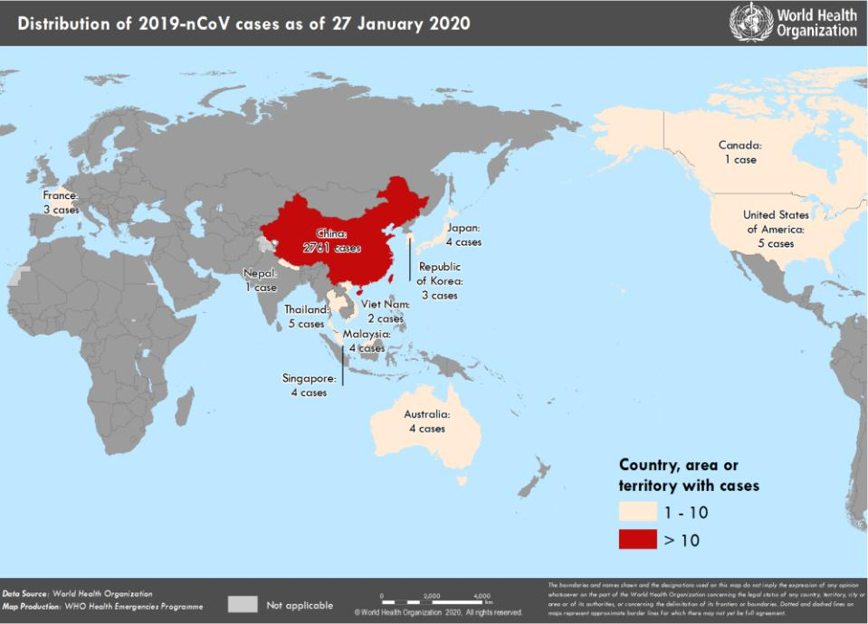

*The situation report includes information reported to WHO Geneva by 10 AM CET

**TECHNICAL FOCUS**

**Figure 2: Epidemic curve by date of onset of 2019-nCoV cases identified outside of China, 27 January 2020**

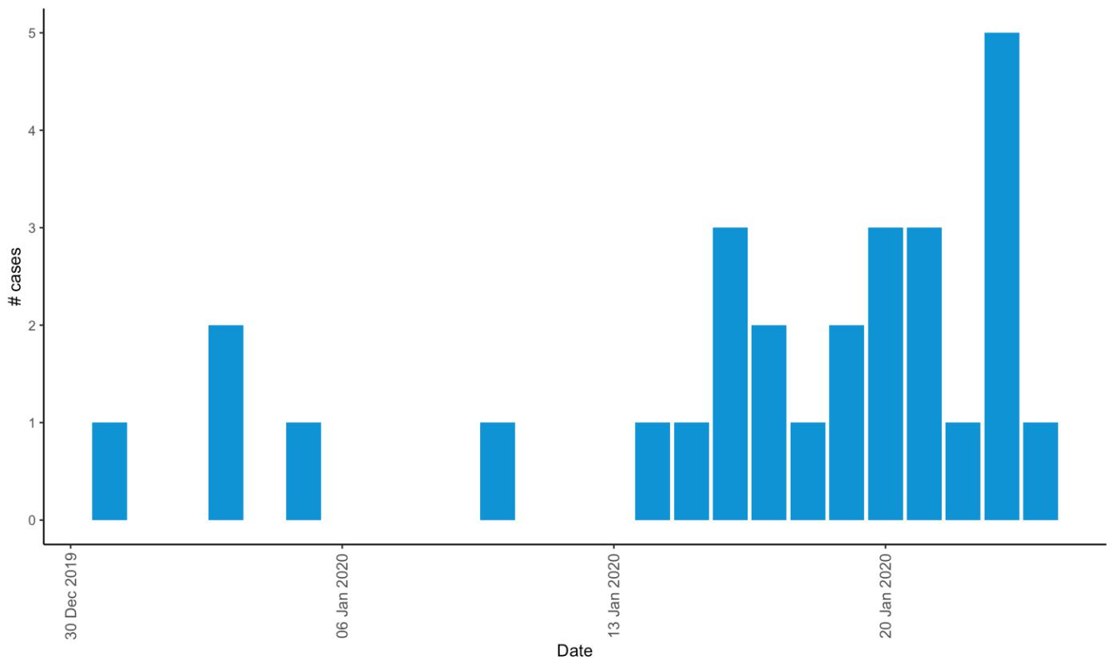

Among the 37 cases identified outside of China, three were detected without the onset of symptoms, while among the remaining 34 patients, there is information on date of symptom for 28 individuals. The epidemic curve for these individuals is shown in Figure 2.

The median age of cases detected outside of China is 45 years ranging from2 to 74 years, 71% of cases were male (information was missing on age for 6 cases, and on sex for 4 cases). Of the 27 cases for whom we have detailed information on date of symptom onset and travel date from China, 8 cases had symptom onset in China, 5 had onset on the same day as travel, and 14 developed symptoms after leaving China.

36 cases had travel history to China, of whom 34 had travel history in Wuhan city, or had an epidemiological link to a confirmed case with travel history to Wuhan. For the remaining two, investigations into their travel histories are ongoing. One additional case was the result of human-to-human transmission among close family contacts in Viet Nam.

**SURVEILLANCE**

**Table 1. Countries, territories or areas with reported confirmed cases of 2019-nCoV, 27 January 2020**

|  |  |  |  |  |  |  |
| --- | --- | --- | --- | --- | --- | --- |
|  | **WHO Regional Office** |  | **Country/Territory/Area** |  | **Confirmed Cases** |  |
|  |  |  |  |  |  |  |
|  |  |  | **China**\* |  | **2761** |  |
|  |  |  |  |  |  |  |
|  |  |  |  |  | |  |
|  | **Western Pacific** |  | Japan |  | 4 |  |
|  |  |  |  |  |  |
|  |  |  |  |  |  |
|  |  |  | Republic of Korea |  | 4 |  |
|  |  |  |  |  |  |  |
|  |  |  |  |  |  |  |
|  |  |  | Viet Nam |  | 2 |  |
|  |  |  |  |  |  |  |
|  |  |  |  |  | |  |
|  |  |  | Singapore |  | 4 |  |
|  |  |  |  |  |  |  |
|  |  |  |  |  | |  |
|  |  |  | Australia |  | 4 |  |
|  |  |  |  |  |  |  |
|  |  |  |  |  | |  |
|  |  |  | Malaysia |  | 4 |  |
|  |  |  |  |  |  |  |
|  |  |  |  |  | |  |
|  |  |  | Thailand |  | 5 |  |
|  | **South-East Asia** |  |  |  |  |  |
|  |  |  |  |  |  |
|  |  |  |  |  |  |
|  |  |  | Nepal |  | 1 |  |
|  |  |  |  |  |  |  |
|  |  |  |  |  | |  |
|  | **Region of the Americas** |  | United States of America |  | 5 |  |
|  |  |  |  |  |  |  |
|  |  |  |  |  | |  |
|  |  |  | Canada |  | 1 |  |
|  |  |  |  |  |  |  |
|  |  |  |  |  | |  |
|  | **European Region** |  | France |  | 3 |  |
|  |  |  |  |  |  |  |
|  |  |  |  |  | |  |
|  | **Total Confirmed cases** |  | Total |  | 2,798 |  |
|  |  |  |  |  |  |  |

*Confirmed cases in China include cases confirmed in Hong Kong SAR (8 confirmed cases), Macau SAR (5 confirmed cases) and Taipei (4 confirmed cases).

**STRATEGIC OBJECTIVES**

WHO’s strategic objectives for this response are to:

* Limit human to human transmission including, reducing secondary infections among close contacts and health care workers, preventing transmission amplification events, and preventing further international spread from China*;
* Identify, isolate and care for patients early, including providing optimized care for infected patients;
* Identify and reduce transmission from the animal source;
* Address crucial unknowns and about clinical severity, extent of transmission and infection, treatment options, and accelerate the development of diagnostics, therapeutics and vaccines;
* Communicate critical risk and event information to all communities and counter misinformation;
* Minimize social and economic impact through multisectoral partnerships.

*This can be achieved through a combination of public health measures, such as rapid identification, diagnosis and management of the cases, identification and follow up of the contacts, infection prevention and control in healthcare settings, implementation of health measures for travellers, awareness raising in the population, risk communication.

**PREPAREDNESS AND RESPONSE**

* WHO has been in regular and direct contact with Member States where cases have been reported. WHO is also informing other countries about the situation and providing support as requested.
* Developed interim guidance for [laboratory diagnosis,](https://www.who.int/health-topics/coronavirus/laboratory-diagnostics-for-novel-coronavirus) [clinical management](https://www.who.int/internal-publications-detail/clinical-management-of-severe-acute-respiratory-infection-when-novel-coronavirus-(ncov)-infection-is-suspected)[, infection prevention and control in](https://www.who.int/publications-detail/infection-prevention-and-control-during-health-care-when-novel-coronavirus-(ncov)-infection-is-suspected) [health care settings,](https://www.who.int/publications-detail/infection-prevention-and-control-during-health-care-when-novel-coronavirus-(ncov)-infection-is-suspected) [home care for patients with suspected novel coronavirus](https://www.who.int/internal-publications-detail/home-care-for-patients-with-suspected-novel-coronavirus-(nCoV)-infection-presenting-with-mild-symptoms-and-management-of-contacts) , [risk communication and](https://www.who.int/publications-detail/risk-communication-and-community-engagement-readiness-and-initial-response-for-novel-coronaviruses-(-ncov)) [community engagement.](https://www.who.int/publications-detail/risk-communication-and-community-engagement-readiness-and-initial-response-for-novel-coronaviruses-(-ncov))
* Prepared [disease commodity package](https://www.who.int/internal-publications-detail/disease-commodity-package---novel-coronavirus-(ncov)) for supplies necessary in identification and management of confirmed patients.
* Provided recommendations to reduce risk of [transmission from animals to humans.](https://www.who.int/health-topics/coronavirus/who-recommendations-to-reduce-risk-of-transmission-of-emerging-pathogens-from-animals-to-humans-in-live-animal-markets)
* WHO has published an [updated advice for international traffic in relation to the outbreak of the novel](https://www.who.int/ith/2020-24-01-outbreak-of-Pneumonia-caused-by-new-coronavirus/en/) [coronavirus 2019-nCoV.](https://www.who.int/ith/2020-24-01-outbreak-of-Pneumonia-caused-by-new-coronavirus/en/)
* Activation of R&D blueprint to accelerate diagnostics, vaccines, and therapeutics.
* WHO is providing guidance on [early investigations.](https://www.who.int/emergencies/diseases/novel-coronavirus-2019/early-investigations/) The first protocol that is available is a: [Household](https://www.who.int/emergencies/diseases/novel-coronavirus-2019/early-investigations/) [transmission investigation protocol for 2019-novel coronavirus (2019-nCoV) infection.](https://www.who.int/emergencies/diseases/novel-coronavirus-2019/early-investigations/)
* WHO has developed an [online course](https://openwho.org/courses/introduction-to-ncov) to provide general introduction to emerging respiratory viruses, including novel coronaviruses.
* WHO is providing guidance on [early investigations,](https://www.who.int/emergencies/diseases/novel-coronavirus-2019/early-investigations/) which are critical to carry out early in an outbreak of a new virus. The data collected from the study protocols can be used to refine recommendations for surveillance and case definitions, to characterize the key epidemiological transmission features of 2019-nCoV, help understand spread, severity, spectrum of disease, impact on the community and to inform operational models for implementation of countermeasures such as case isolation, contact tracing and isolation. The first protocol that is available is a: [Household transmission investigation protocol for 2019-novel coronavirus (2019-nCoV)](https://www.who.int/emergencies/diseases/novel-coronavirus-2019/early-investigations/) [infection.](https://www.who.int/emergencies/diseases/novel-coronavirus-2019/early-investigations/)
* WHO is working with its networks of researchers and other experts to coordinate global work on surveillance, epidemiology, modelling, diagnostics, clinical care and treatment, and other ways to identify, manage the disease and limit onward transmission. WHO has issued interim guidance for countries, updated to take into account the current situation.
* Utilizing global expert networks and partnerships for laboratory, infection prevention and control, clinical management and mathematical modelling.

**RECOMMENDATIONS AND ADVICE**

During previous outbreaks due to other coronavirus (Middle-East Respiratory Syndrome (MERS) and Severe Acute Respiratory Syndrome (SARS)), human to human transmission occurred through droplets, contact and fomites, suggesting that the transmission mode of the 2019-nCoV can be similar. The basic principles to reduce the general risk of transmission of acute respiratory infections include the following:

* Avoiding close contact with people suffering from acute respiratory infections.
* Frequent hand-washing, especially after direct contact with ill people or their environment.
* Avoiding unprotected contact with farm or wild animals.
* People with symptoms of acute respiratory infection should practice cough etiquette (maintain distance, cover coughs and sneezes with disposable tissues or clothing, and wash hands).
* Within healthcare facilities, enhance standard infection prevention and control practices in hospitals, especially in emergency departments.

WHO does not recommend any specific health measures for travellers. In case of symptoms suggestive of respiratory illness either during or after travel, the travellers are encouraged to seek medical attention and share their travel history with their health care provider. [Travel guidance](https://www.who.int/ith/2020-24-01-outbreak-of-Pneumonia-caused-by-new-coronavirus/en/) was updated on 24 January.

**Resources:**

* Technical interim guidance for novel coronavirus, WHO: <https://www.who.int/emergencies/diseases/novel-coronavirus-2019>
* WHO travel advice for international travel and trade in relation to the outbreak of the novel coronavirus 2019-nCoV
* <https://www.who.int/ith/2020-24-01-outbreak-of-Pneumonia-caused-by-new-coronavirus/en/>
* Readiness is the key to detect, combat spread of the new coronavirus:

<https://www.who.int/southeastasia/news/detail/27-01-2020-readiness-is-the-key-to-detect-combat-spread-of-the-new-coronavirus>

* WHO’s Eastern Mediterranean Region scales up preparedness for novel coronavirus <http://www.emro.who.int/media/news/whos-eastern-mediterranean-region-scales-up-preparedness-for-novel-coronavirus.html>
* Press statements by KCDC (in Korean): <https://www.cdc.go.kr/board/board.es?mid=a20501000000&bid=0015>
* Wuhan Municipal Health Commission's briefing on the pneumonia epidemic situation, (in Chinese): http://wjw.wuhan.gov.cn/front/web/list2nd/no/710
* Disease outbreak news, Novel Coronavirus: <https://www.who.int/csr/don/en/>
* Thailand Ministry of Public Health situation update on novel coronavirus (in Thai): <https://ddc.moph.go.th/viralpneumonia/index.html>
* Press statement by Ministry of Health, Labour and Welfare, Japan (in Japanese): <https://www.mhlw.go.jp/stf/houdou/houdou_list_202001.html>
* Notice sent out from Health and Food Safety Planning Division, Quarantine Station Operation Management Office (in Japanese): <https://www.mhlw.go.jp/content/10900000/000582967.pdf>
* Situation report by WHO on Novel Coronavirus (2019-nCoV) <https://www.who.int/emergencies/diseases/novel-coronavirus-2019>
* CDC press release. First Travel-related Case of 2019 Novel Coronavirus Detected in United States <https://www.cdc.gov/media/releases/2020/p0121-novel-coronavirus-travel-case.html>
* Hong Kong SAR Department of Health, Press Release <https://www.info.gov.hk/gia/general/202001/23/P2020012300970.htm>
* Epidemic Prevention Measures, Macau SAR Health Bureau <https://www.ssm.gov.mo/apps1/PreventWuhanInfection/ch.aspx#clg17048>
* Press release on 23 January 2020, Ministry of Health Singapore. <https://www.moh.gov.sg/news-highlights/details/confirmed-imported-case-of-novel-coronavirus-infection-in-singapore-multi-ministry-taskforce-ramps-up-precautionary-measures>
* CDC press release. Second Travel-related Case of 2019 Novel Coronavirus Detected in United States <https://www.cdc.gov/media/releases/2020/p0124-second-travel-coronavirus.html>
* New South Wales Government: Health: Coronavirus cases confirmed in NSW